How is Snomed CT (Jan.2013) ontology prepared for experiments?

1. RF2 files are downloaded from the official web site of Snomed CT. (<https://www.nlm.nih.gov/healthit/snomedct/archive.html>)

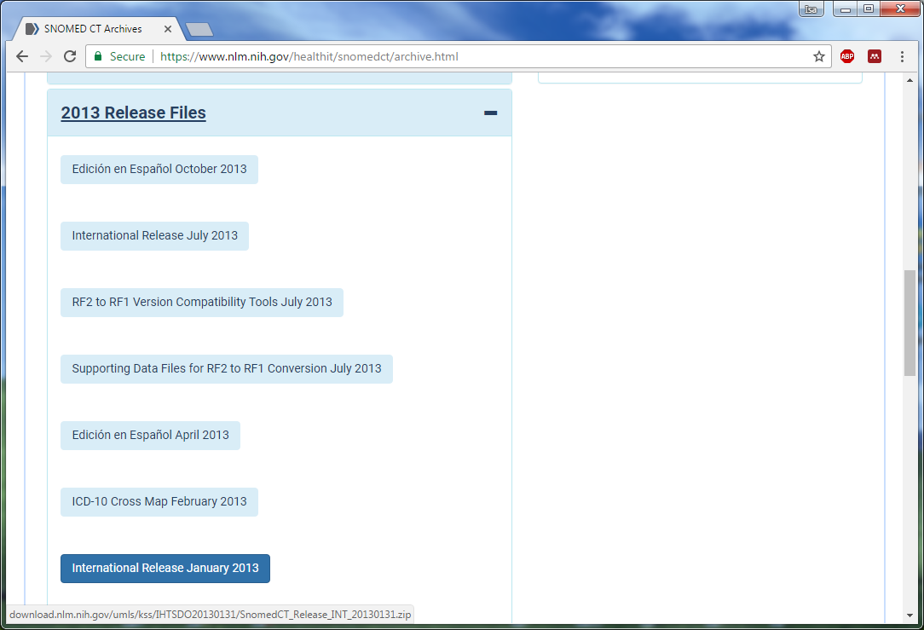

1. Project developed for converting RF2 files to OWL 2 ontology id downloaded.

(<https://github.com/termMed/rf2-to-owl>)

1. The only modification I made on the code is to change output ontology format from RDFXML to FunctionalSyntax after having an RDFXML format version, as some reasoners expect FunctionalSyntax.

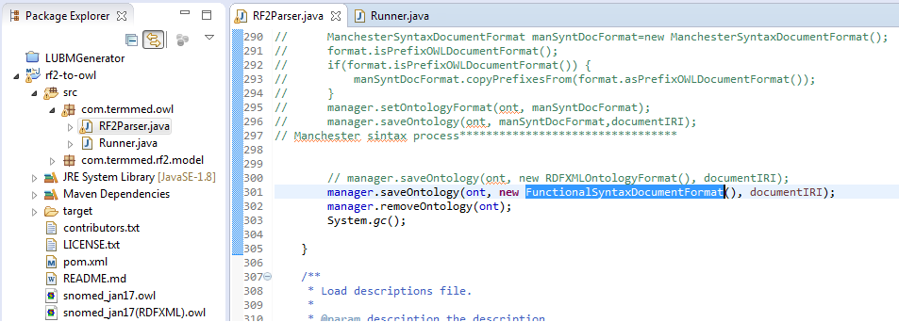

1. The 4 parameters used in this experiment for the application are:

"C:/Users/r01ig15/Downloads/SnomedCT_Release_INT_20130131/RF2Release/Snapshot/Terminology/sct2_Concept_Snapshot_INT_20130131.txt" "C:/Users/r01ig15/Downloads/SnomedCT_Release_INT_20130131/RF2Release/Snapshot/Terminology/sct2_StatedRelationship_Snapshot_INT_20130131.txt" "snomed_jan13.owl" "http://snomed.org/"

1. The output provided to Java console was:

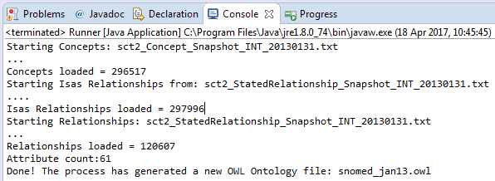

1. Axiom statistics of SNOMED CT (Jan.2013):

