How is Snomed CT ontology prepared for experiments?

1. RF2 files are downloaded from the official web site of Snomed CT. (<https://www.nlm.nih.gov/healthit/snomedct/international.html>)

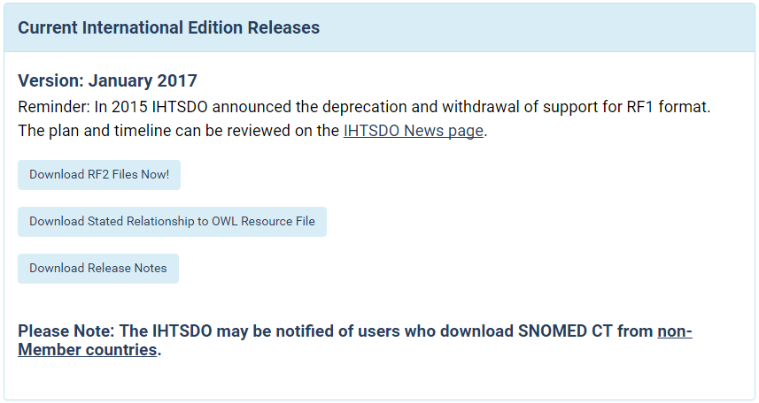

1. Project developed for converting RF2 files to OWL 2 ontology id downloaded.

(<https://github.com/termMed/rf2-to-owl>)

1. The only modification I made on the code is to change output ontology format from RDFXML to FunctionalSyntax after having an RDFXML format version, as some reasoners expect FunctionalSyntax.

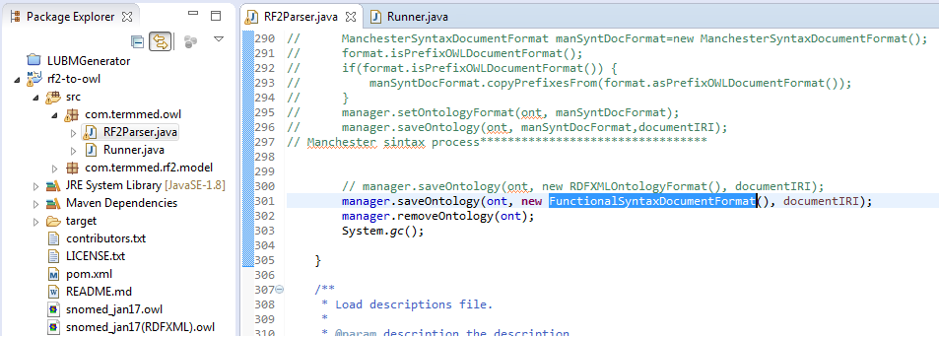

1. The 4 parameters used in this experiment for the application are:

"C:/Users/r01ig15/Desktop/SnomedCT_InternationalRF2_Production_20170131T120000/SnomedCT_InternationalRF2_Production_20170131T120000/Snapshot/Terminology/sct2_Concept_Snapshot_INT_20170131.txt" "C:/Users/r01ig15/Desktop/SnomedCT_InternationalRF2_Production_20170131T120000/SnomedCT_InternationalRF2_Production_20170131T120000/Snapshot/Terminology/sct2_StatedRelationship_Snapshot_INT_20170131.txt" "snomed_jan17.owl" "<http://snomed.org/>"

1. The output provided to Java console was:

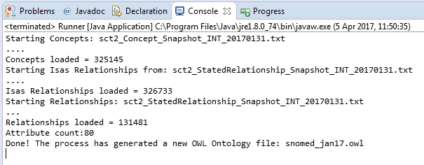

PS: One point I have noticed is that all axioms about “Annotation” are discarded in this conversion. But this doesn’t cause any negative effect on our experiment, because;

* ELK already discards annotation assertions,
* And, It would be unfair to keep annotation assertions in experiments with reasoners (other than ELK) which try to process these axioms or at least consume some memory to keep them.