**Name: Isaac Nii Okai Okai**

**ID: 10909577**

**Title: Project Report - "Chronicles of Wealth" Website**

**https://www.figma.com/file/DXUVTws6jfHqOaQ30GlVFq/ISAAC-NII-OKAI-OKAI?type=design&node-id=147%3A219&mode=design&t=HzsrQ8lnpNhR2j5E-1**

**Introduction**

The "Lives of Visionaries" website aims to bring the lives and wisdom of prominent figures like Elon Musk, Bill Gates, Jeff Bezos, Larry Pages, and Bernard Arnauld to the average person's doorstep. The project's goal is to provide valuable insights into these individuals' lives, accomplishments, and advice. This report outlines each phase of the project, including problem definition, user research findings, design sketches, prototype screenshots, and usability testing results.

**Problem Definition**

The project aimed to address the fact that influential individuals like Elon Musk, Bill Gates, Jeff Bezos, Larry Pages, and Bernard Arnauld often appear out of reach for the average person. The website sought to bridge this gap by curating their life stories, quotes, and advice, making it easily accessible to inspire and educate visitors.

**User Research Findings**

During the initial phase, I conducted user research to understand the target audience's preferences and expectations. The research revealed that users were interested in comprehensive overviews of the personalities' lives, inspiring quotes, and valuable advice. Additionally, users emphasized the importance of a user-friendly interface that encouraged easy navigation.

**Design Sketches**

Based on the user research findings, the team created design sketches to outline the website's layout and structure. The home page featured an intuitive and visually appealing design with sections for each visionary. The overview section presented in-depth biographies of each personality, while the quotes section compiled inspirational quotes. The advice section organized all the advice given by these visionaries.



**Prototype Screenshots**

Using the design sketches as a foundation, the team developed a clickable prototype of the website. The prototype included navigation menus, placeholder content, and interactive elements to simulate the user experience. It showcased the envisioned layout and functionality of the website.

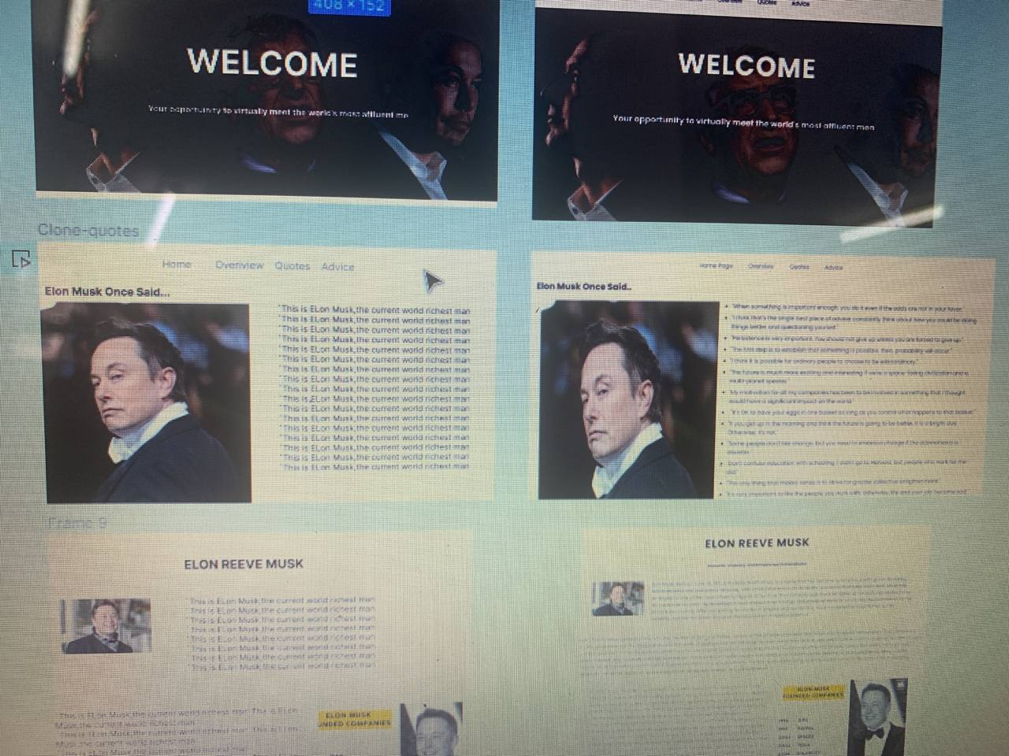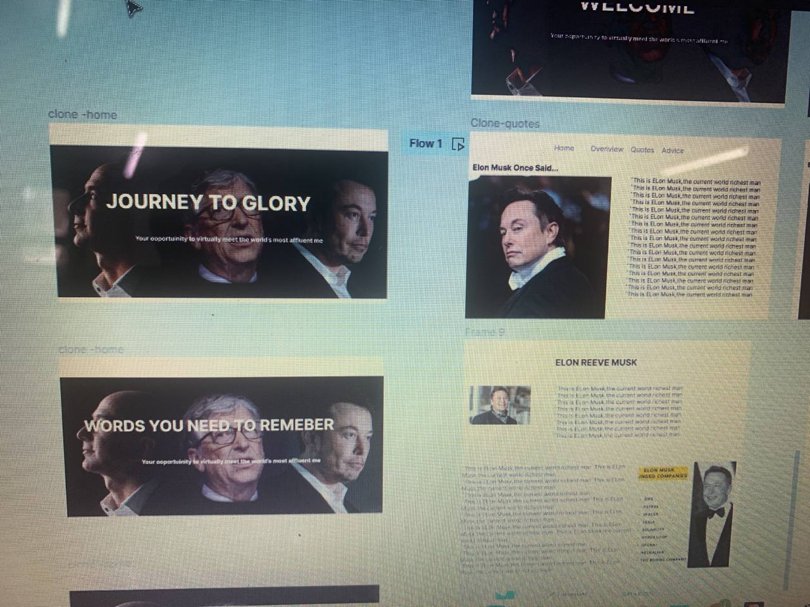

**Usability Testing Results**

The prototype underwent usability testing with a selected group of participants to gather feedback and identify potential improvements. The results indicated that users appreciated the website's content and design. However, some participants suggested minor adjustments to enhance user experience, such as clearer navigation labels and better organization of the advice section.

**Implementation and Development:**

Following the usability testing phase, the team proceeded with the implementation and development of the website. They incorporated APIs to retrieve data and information about the visionaries, ensuring the website provided up-to-date and accurate content. Advanced data handling techniques were used to compile and present advice given by the visionaries.

**Final Website Features**

The completed "Chronicles of Wealth" website boasts the following features:

* Home Page: A visually engaging landing page introducing the visionaries and their contributions.
* Overview Section: Detailed biographies and life stories of Elon Musk, Bill Gates, Jeff Bezos, Larry Pages, and Bernard Arnauld.
* Quotes Section: A compilation of inspiring and thought-provoking quotes from each visionary.
* Advice Section: A comprehensive collection of advice given by the visionaries on various topics.
* Responsive Design: The website is optimized for various devices, ensuring a seamless user experience on desktops, tablets, and smartphones.

The "Chronicles of Wealth" website successfully addresses the initial problem of making the lives and wisdom of influential personalities more accessible to the general public. The project's phases, including problem definition, user research, design sketches, prototype development, and usability testing, were vital in creating a user-friendly and informative platform. The website serves as a source of inspiration and knowledge, bringing the lives and insights of Elon Musk, Bill Gates, Jeff Bezos, Larry Pages, and Bernard Arnauld to the doorsteps of everyone who seeks their wisdom.