Godot Installation, Editor Orientation, and Scene Tree Basics
GAMDES1

Topic(s): | Godot Installation and Editor Orientation; Project Setup and Scene Tree Basics
Laboratory Activity No. | 1 |  |  |  | No. of Hours: |  |  | 3
Start Date: |  |  |  |  | Due Date:
Approach: | ☒ | Individual | ☐ | Group
Approach: | ☐ | Online | ☒ | Onsite |  | ☐ | Hybrid
Name(s):  Lastname, First Name  Arranged in alphabetical order | Bagsangi, Isaac

- Prerequisites
- 3rd Year Standing (course pre-requisite).
- Basic file management on the lab operating system: creating folders, moving and renaming files, and saving to a known location.
- No prior Godot Engine experience is required; this activity assumes none.
Students should have:
- A lab computer that meets Godot's minimum requirements, with rights to run or install the standalone editor.
- A stable internet connection for the initial download (or the editor pre-installed by the lab).
- A GitHub account for submitting course work.

- Learning Objective
Learning Objectives | Aligned Course Learning Outcomes (CLOs)
- Install the Godot Engine on a lab machine and launch the editor to the Project Manager. | CLO 3
- Identify the main editor panels (Scene, FileSystem, Inspector, Output, and the viewport) and state the purpose of each. | CLO 3
- Create a new Godot project and build a basic scene tree consisting of a root node and at least two child nodes. | CLO 3
- Save the project, publish it to a GitHub repository, and verify the project reopens with the scene tree intact. | CLO 3
Note: The laboratory learning plan leaves the CLO column blank for Week 1. These objectives are mapped to CLO 3 (build a playable Godot prototype), because the week establishes the Godot environment and scene-tree skills every later build week depends on. Adjust if you intend a different mapping.

- Setup and Procedure
Software Environment:
- Godot Engine 4.x, standard (non-.NET) build, from https://godotengine.org/download
- Git, and a GitHub account, for version control and submission.

Hardware Environment:
- Lab computer (Windows, Linux, or macOS) meeting Godot's minimum requirements, with keyboard and mouse.
- At least 500 MB of free disk space for the editor and the project folder.

- Problem/Procedure
This activity is mandatory.
Sample Problem: Annex A
Sample Procedure: Annex B
- Additional Instructions
  - Repository: Create one course repository named GAMDES1_Lastname_Firstname on GitHub. Place the Godot project at the repository root and save the main scene as Main.tscn. You will reuse this same repository for every lab this term.
  - Submission: Commit and push your project, tag the commit lab1, and submit the repository URL. Add one screenshot of your saved scene tree to a /docs folder or the README.
  - Deadline: Within the 3-hour laboratory session unless the instructor extends it. Late or unpushed work follows the class policy discussed during orientation.
- Rubric/Scoring Guide
Each criterion is scored on a 5-point band. The five criteria sum to a maximum of 25 points. (The syllabus does not fix lab-rubric criteria; this five-criteria, 25-point scheme is a judgment call you can revise.)
Criteria | Exemplary (5) | Proficient (4) | Developing (3) | Beginning (2) | Incomplete (1)
Installation & Editor Launch | Godot installed and launched independently; helped a peer troubleshoot. | Godot installed and launched independently, no help needed. | Installed and launched with minor guidance. | Installed and launched only with substantial help. | Editor not installed or not launched.
Project Creation & File Organization | Project created and named per convention; folder structure clean and logical. | Project created and correctly named; organized. | Project created; naming or organization partly off convention. | Project created but poorly named or disorganized. | No project created.
Scene Tree Construction | Root plus 2+ well-chosen child nodes; hierarchy correct and purposeful. | Root plus at least 2 child nodes; hierarchy correct. | Root plus 1 child node, or minor hierarchy error. | Root node only, or incorrect hierarchy. | No scene tree built.
GitHub Submission & Verification | Pushed and tagged lab1; verified reopen; screenshot included in the repo. | Pushed and tagged correctly; project verified to reopen intact. | Pushed, but not tagged or reopen not verified. | Committed locally but not pushed, or wrong repository. | Work not committed or pushed.
Panel Identification & Lab Conduct | Named all panels and their purposes; actively supported paired troubleshooting. | Named the main panels and their purposes; participated well. | Named most panels; participated. | Named few panels; limited participation. | Could not identify panels; did not participate.
Total | ____ / 25
- Reflection
  - Which editor panel was least familiar to you, and how did you work out what it does?
- The least familiar to me is the Inspector because there are many things that you can configure in an element.
  - What installation, setup, or Git issue did you or your pair-partner run into, and how did you resolve it?
- I am still not used with Git so pushing the project from my local directory to the git repository was hard, but by following the instructions we were able to finish it.
  - In your own words, what is the relationship between a node, a scene, and the scene tree?
- The scene tree shows the scenes, nodes, and the relationships of nodes in the project. Below each scene are nodes.

Git repo: https://github.com/Isaac-Bagsangi-UB/GAMDES1_Bagsangi_Isaac.git

- References
Introduction. (n.d.). Godot Engine documentation. https://docs.godotengine.org/en/stable/about/introduction.html
Godot Engine official channel. (n.d.). YouTube. https://www.youtube.com/@GodotEngineOfficial

ANNEX A
Problem

You have just joined the tools team at a small game studio. Before any design or programming work begins, every developer on the team must have a working Godot environment, be able to create, structure, and save a scene, and put the project under version control.
Your task: install the Godot Engine, create a project named GAMDES1_Lastname_Firstname, and build a basic scene whose tree contains a root node and at least two child nodes. Save the main scene as Main.tscn, publish the project to a GitHub repository, then close and reopen it to confirm the scene tree is intact. Capture one screenshot of the editor showing your saved scene tree.
The scene does not need to run any gameplay yet. What is being verified is that you can set up a project, reason about the node hierarchy, and save, publish, and recover your work reliably.
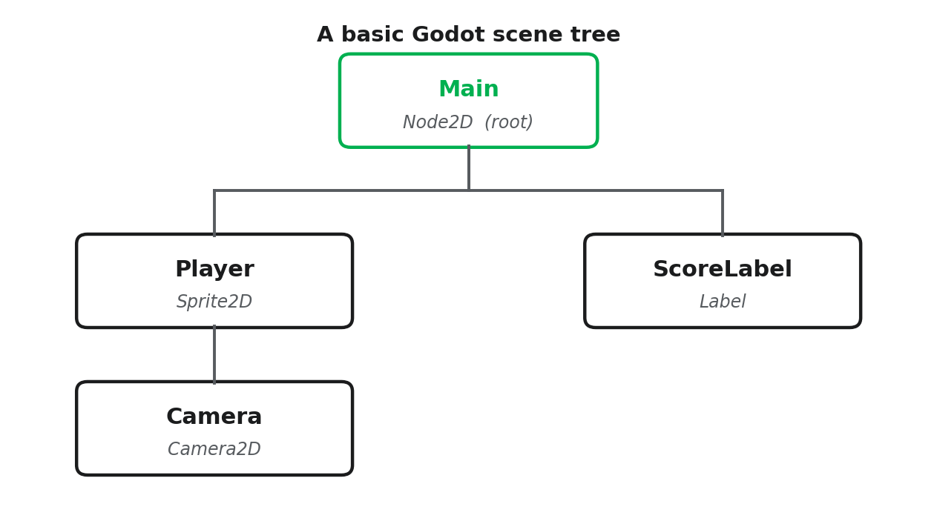
Figure 1. A basic Godot scene tree: one root node (Main) with child nodes beneath it.

ANNEX B
Procedure
This is a step-by-step guide for the setup task. Work through it in order; each stage builds on the previous one.
- Preparation: download and launch Godot
  - Open a browser and go to https://godotengine.org/download. Download the standard build of Godot 4.x for your lab's operating system (skip the .NET/C# build).
  - Extract the archive to your course working folder, then double-click the executable (for example Godot_v4.x-stable.exe) to launch the Project Manager.
  - If the lab machines already have Godot installed, launch it from the applications menu and skip the download.
- Create a new project
  - In the Project Manager, click New Project.
  - Set the project name to GAMDES1_Lastname_Firstname and choose (or create) an empty folder for it inside your course working folder.
  - Leave the renderer at its default, then click Create & Edit to open the editor.
- Orient yourself in the editor
  - Locate and identify these panels: the Scene dock (top-left, holds the scene tree), the FileSystem dock (bottom-left, holds project files), the Inspector (right, edits the selected node), the Output panel (bottom), and the central viewport.
  - Write one short sentence for each panel describing what it is for; you will use these in the Reflection section.
- Build the scene tree
  - In the Scene dock, click + (Add Child Node) and add a Node2D as the root. Rename it Main.
  - With Main selected, add two child nodes, for example a Sprite2D and a Label. Rename them meaningfully (e.g. Player and ScoreLabel).
  - Confirm the hierarchy shows the two nodes indented under the root, matching Annex A, Figure 1.
- Save the scene and project
  - Press Ctrl+S (or Cmd+S) and save the scene as Main.tscn in the project folder.
  - Confirm a project.godot file and your Main.tscn now appear in the FileSystem dock.
- Publish to GitHub
  - On GitHub, create one repository for this course named GAMDES1_Lastname_Firstname (private, or as your instructor directs). This single repository will hold your prototype and artifacts for the whole term.
  - In your project folder, add a .gitignore file containing the line .godot/ so Godot's import cache is not committed.
  - Initialize and make your first commit: git init, git add ., then git commit -m "Lab 1: project setup and scene tree".
  - Link the remote and push: git remote add origin <your-repo-URL>, git branch -M main, git push -u origin main.
  - Tag this submission and push the tag: git tag lab1 then git push origin lab1. Submit your repository URL.
- Verify and capture
  - Close the project back to the Project Manager, then reopen GAMDES1_Lastname_Firstname. Confirm your scene tree loads exactly as you left it.
  - Take a screenshot of the editor showing the saved scene tree, add it to a /docs folder or the README, commit and push it, and submit your repository URL.

