Isaac Ritchie – 26708965
Programming 2 – Task 1 Report (Alternative)

Initial plan:
- Safe input function
- Get non-empty string function
- Get valid integer function
- Get valid date function
- Get valid choice from given options function
- Display menu function
- Main function
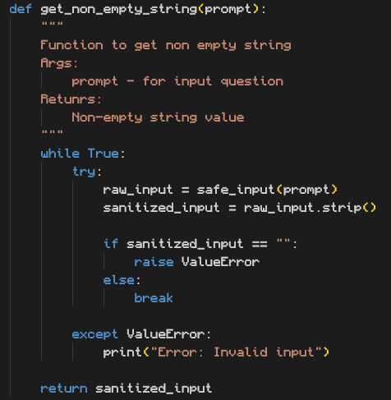
This is the function to get a non-empty string.
On testing it works as intended:
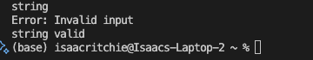

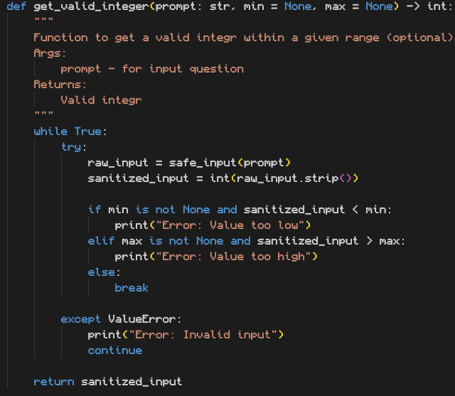
Here is the function to get a valid integer, have made the min and max values optional.
On testing it performed as intended:
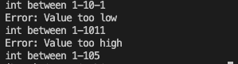

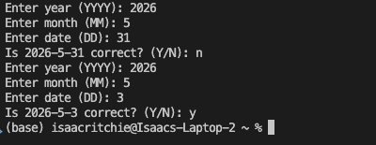
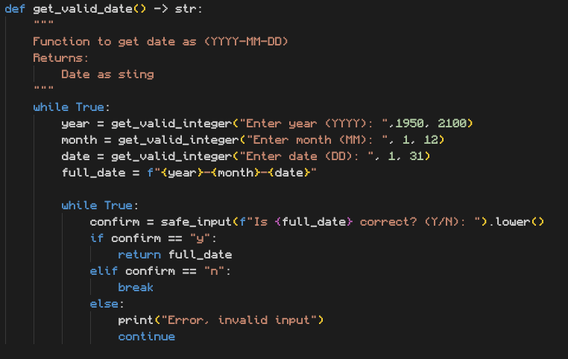
Here is the get valid date function.
On testing it performed as intended
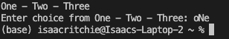

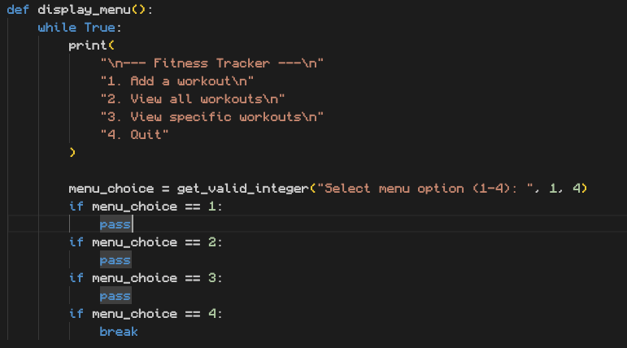
Here is the display menu function before adding any option functionality
On testing the menu displayed as intended:
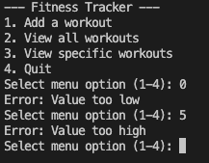

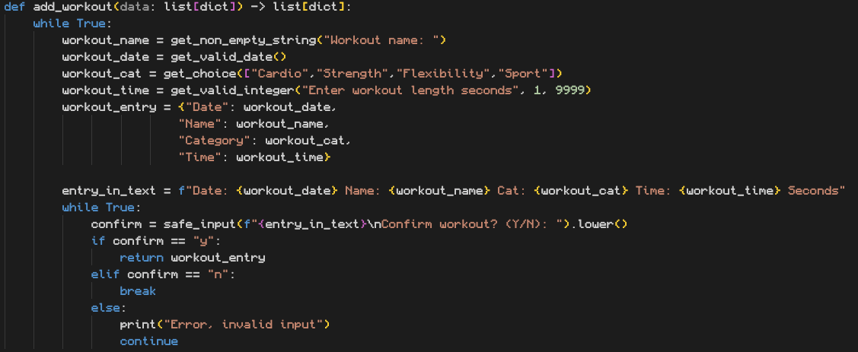
Here is the function that adds a workout to the saved workouts.
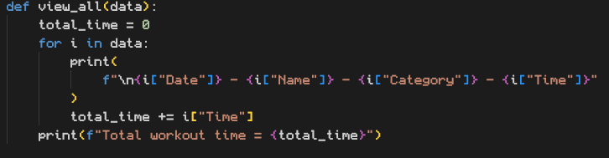
On testing the workout was returned as intended.
This is the function that views all before proper formatting was added.
On testing, it displays all values in the data :
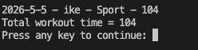
Here is the final formatting for the fitness tracker with the total time calculator
On testing: The only improvement is that if the name is too long it can distort the data view by pushing the columns out of place.
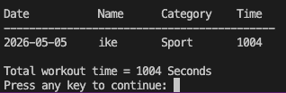

Overall, I am happy with the functionality of the fitness tracker, the testing was done periodically to stay on track while writing functions and it is all called through a main function. The code is modular and the functions are used multiple times for efficiency.
Furthermore the initial plan was accurate and no extra functions were needed.

