Isaac DiToro

Dr. Grinberg

CMSC 201

12 May 2025

**CMSC 201 Introduction to Java Project 6**

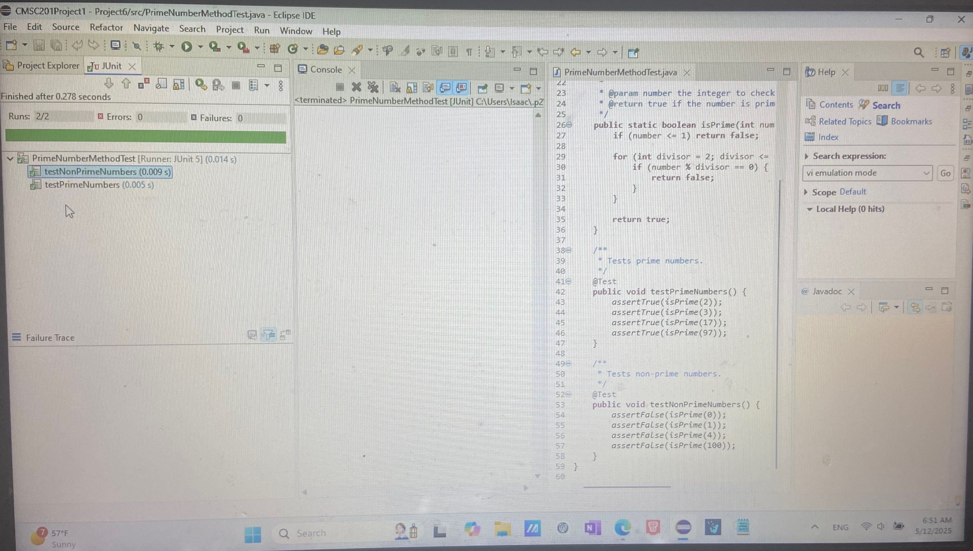

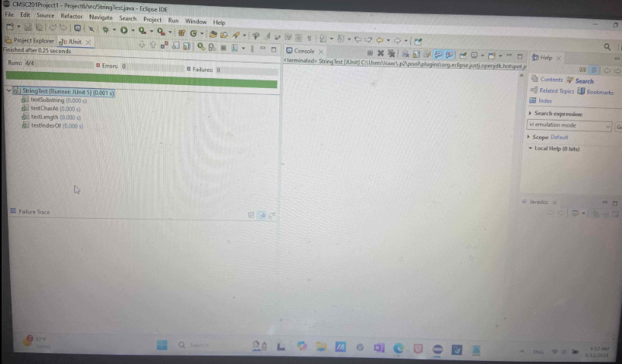

| **#** |  | **Y/N** | **Comments** |
| --- | --- | --- | --- |
|  | **Source java files** | **Y** |  |
|  | **Compressed files:** | **Y** |  |
|  | FirstInitialLastName_Project6_Moss.zip | **Y** |  |
|  | FirstInitialLastName_Project6Completed.zip | **Y** |  |
|  | **Program compiles** | **Y** |  |
|  | **Program runs** | **Y** |  |
|  | **Checklist is completed and included in the Documentation** | **Y** |  |
|  | **Documentation file:** |  |  |
|  | **Screenshots based** | **Y** |  |
|  | **Lessons Learned** | **Y** |  |

**What I learned:**

Throughout this project, I gained hands-on experience with unit testing in Java using JUnit. I learned how to write structured test cases for built-in classes such as String, as well as for custom logic like the isPrime method. I became more comfortable with Eclipse’s JUnit integration. I learned how to write structured test cases for built-in classes such as String, as well as for custom logic like the isPrime method. I became more comfortable with Eclipse’s JUnit integration, and I was also able to become more knowledgeable with how I could upload things on github. Along with all of that, I also was able to review my skills with HTML with the HTML aspects of this project.

**What I struggled with:**

Initially, I did struggle a little with setting JUnit 5 up, but after realizing I had the wrong configurations, I was able to easily fix the issue.

**What I would do differently on my next project:**

Next time, I would begin by configuring the JUnit environment immediately after setting up my project in Eclipse, to avoid errors later on.

**What parts of this assignment I was successful with:**

I successfully created two fully functional JUnit test classes: one for testing methods in the Java String class and one for testing a custom isPrime method.

**Additional resources used:**

<https://docs.oracle.com/javase/9/docs/api/java/lang/String.html>