**SINGAPORE POLYTECHNIC**

**MST REVISION PAPER (Set 1)**

**FUNDAMENTALS AND AUTOMATION OF DATA ANALYSIS Using Excel Weightage 25%**

1ST / 2nd / 3rd Year Full-Time Time allowed: 1 hr 30 mins

Architecture and the Built Environment (ABE)

DARCH, DCE, DCEB, DEPM, DFM

Chemical and Life Sciences (CLS)

DAPC, DBS, DBT, DCHE, DFST, DPCS

Electrical and Electronic Engineering (EEE)

DASE, DCPE, DEB, DEEE

Media, Arts & Design School (MAD)

DMC

Mechanical and Aeronautical Engineering (MAE)

DARE, DEB, DME, DMRO

School of Computing (SoC)

DISM, DIT

**Instructions:**

1. The Singapore Polytechnic Examination rules are to be complied with.
2. This paper consists of **THREE** sections (8 printed pages including the cover page).
3. Answer **ALL** the questions using Microsoft Excel only.
4. Open the data file <**MST-CA1.xlsx**> that you have downloaded from EP0612 module site in BrightSpace >> MST >> MST Data File.
5. Enter the password 🡪

**MST**

1. This is an **OPEN-BOOK** assessment. You may refer to the EP0612 textbook as resource in this assessment. **STRICTLY NO** communication (including Internet access, Web WhatsApp, Facebook, Instagram, Twitter, Email or any other forms of communication). **STRICTLY NO usage of AI** (including ChatGPT, Copilot, etc).
2. You are **NOT** to access any guided / class exercise / activity in your hard-disk, or use any portable devices eg hard disk / thumb drives.
3. At the end of the assessment, submit your question paper. You are **NOT** allowed to bring out the question paper; otherwise zero mark will be awarded for this assessment.

**WARNING: Students caught cheating during the assessment will fail the module immediately and disciplinary action will be taken.**

Fill in your particulars as follows.

|  |
| --- |
| **Name: _______________________ S/No( ) Admission No: ____________ Class: EL/EP0612/FT/0__** |

**For Official Use Only**

|  |  |  |
| --- | --- | --- |
|  | **Max Marks** | **Marks** |
| Section A | 35 |  |
| Section B | 40 |  |
| Section C | 25 |  |
| **Final Score** | **100** |  |

# SECTION A (35 Marks)

In the workbook < **MST_Revision_Set1.xlsx** >, select the worksheet <**Section A**>, based on the data given in the worksheet, compute the following using **Excel Functions or Formulas** where appropriate. Failure to use appropriate Excel functions or formulas will result in marks deduction.

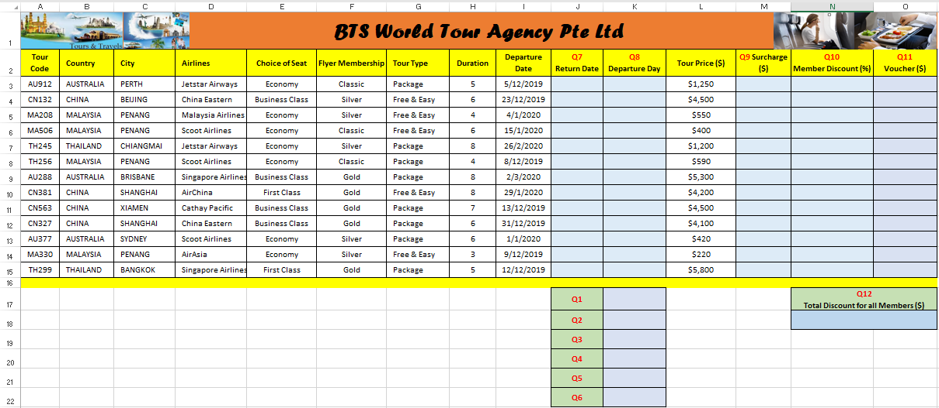

**Write down the Excel Functions or Formulas on the paper, NOT the values unless otherwise stated. E.g. Cell J17 =MODE(N3:N15)** **in the spaces provided.**

1. Write down the function/formula used in Cell K17 to compute the number of tours.

Cell K17: (2 marks)

1. Write down the function/formula used in Cell K18 to compute the total **Tour Price ($)** for all the tours flying by Scoot Airlines to Penang.

Cell K18: (3 marks)

1. Write down the function/formula used in Cell K19 to compute the average **Duration** for all the tours**.**

Cell K19: (2 marks)

1. Write down the function/formula used in K20 to compute the range of **Tour Price ($)** for all the tours.

Cell K20: (2 marks)

1. Write down the function/formula used in Cell K21 to compute the average **Tour Price ($)** for all the tours flying by China Eastern with Business Class.

Cell K21: (3 marks)

1. Write down the function/formula used in Cell K22 to compute the number of tours travelled by China Eastern and Jetstar Airways.

Cell K22: (4 marks)

1. Write down the function/formula used in Cell J3 to compute the **Return Date**.

Cell J3: (2 marks)

1. Write down the function/formula used in Cell K3 to compute the **Departure Day**

(E.g. Monday).

Cell K3: (2 marks)

1. Write down the function/formula used in Cell M3 to compute the **Surcharge ($)**.

If the **Departure Day** is Saturdayor the **Departure Day** is Sunday then

**Surcharge ($) =** $50

Otherwise

**Surcharge ($)** = $0

Cell M3: (4 marks)

1. Write down the function/formula used in Cell N3 to compute the **Member Discount (%)**.

If the **Flyer Membership** is Silverand the **Choice of Seat** is Economy then

**Member Discount (%)** = 10%

Otherwise

**Member Discount (%)** = 5%

Cell N3: (4 marks)

1. Write down the function/formula used in Cell O3 to compute the **Voucher ($)** given to eligible members.

If the **Flyer Membership** is Gold or **Tour Price ($)** is $3,500 or more,then

**Voucher ($)** = $100

Otherwise

**Voucher ($)** = $0

Cell O3: (4 marks)

1. Write down the function/formula used in Cell N18 to compute the **Total Discount of all Members ($).**

**Total Discount of all Members ($)** =

Sum of (**Tour Price ($)** by each member x **Member Discount (%)**)

Cell N18: (3 marks)

# SECTION B (40 Marks)

With your workbook remains open, select the worksheet named <**Section C**>, based on the data given in the worksheet, compute the following using **Excel functions or formulas** where appropriate. Failure to use appropriate Excel functions or formulas will result in marks deduction.

**Write down the Excel Functions or Formulas on the paper, NOT the values unless otherwise stated. E.g. Cell H16**  **in the spaces provided.**

**=SUM(H3:H14)**

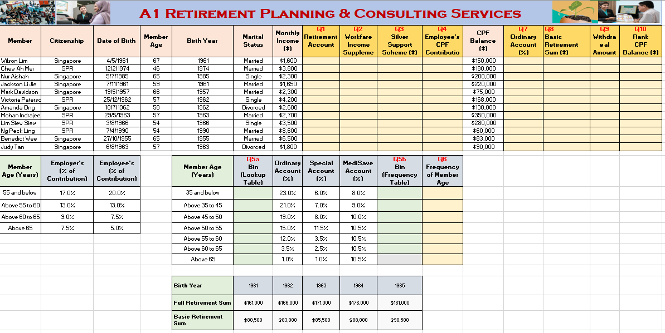

1. Write down the function/formula used in Cell H3 to determine the creation of **Retirement Account** based on **Member Age**.

If Member Age is 55 years and above

Set **Retirement Account** to Yes

Otherwise

Set **Retirement Account** to No.

Cell H3: (3 marks)

1. Write down the function/formula used in Cell I3 to compute the **Workfare Income Supplement ($)**. To qualify for Workfare Income Supplement if members:

* are a Singapore Citizen;
* are above 35 years old; and
* earn a monthly income of not more than $2,000

Member will receive $200 **Workfare Income Supplement ($)** if qualify

Otherwise **Workfare Income Supplement ($)** =$0

Cell I3: (4 marks)

1. Write down the function/formula used in Cell J3 to compute the **Silver Support Scheme ($).** To qualify for **Silver Support Scheme ($)** if members:

* are a Singapore Citizen;
* are aged 65 and above; and
* Single or Divorced.

Member will receive $500 **Silver Support Scheme ($)** if qualify

Otherwise **Silver Support Scheme ($)** = $0

Cell J3: (4 marks)

1. Write down the function/formula used in Cell K3 to determine the **Employee’s CPF Contribution ($)** in Cells A16:C20 based on the **Member Age (Years).** (Use IF function)

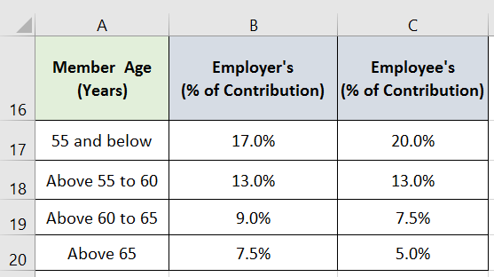

Cell K3: (5 marks)

1. Write down the **Bin** values for **Member Age (Years)** lookup in the Cells **F17:F23** and **Bin** values for **Frequency of Member Age** lookup in the Cells **J17:J23** provided in the table below. (4 marks)

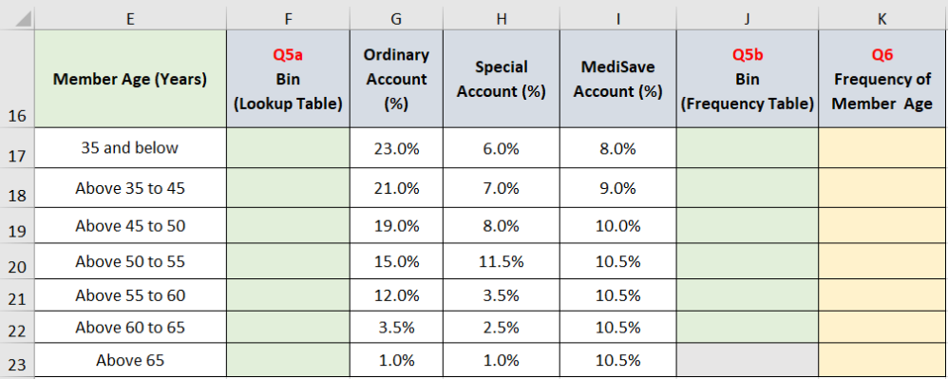

1. Find the distributionof the **Frequency** of **Member Age** in Cells K17:K23.
   1. Write down the **Frequency** values in the Cell K17:K23provided in the table in Question 5.

(2 marks)

* 1. Write down the formula used to find the distribution of **Frequency** of **Member Age.**

Cells K17:K23:  (3 marks)

1. Write down the function/formula used in Cell M3 to determine the **Ordinary Account (%)** based on **Member Age (Years)** with reference to Cells E16:G23 (use Lookup)

Cell M3: (4 marks)

1. Write down the function/formula used in Cell N3 to compute the **Basic**

**Retirement Sum ($)** based on **Birth Year** with reference to Cells E25:J27 (use Lookup).

You must use an **IS function** to test for any error value (#Value!) then determine the Basic Retirement Sum ($), otherwise display the text "N.A."

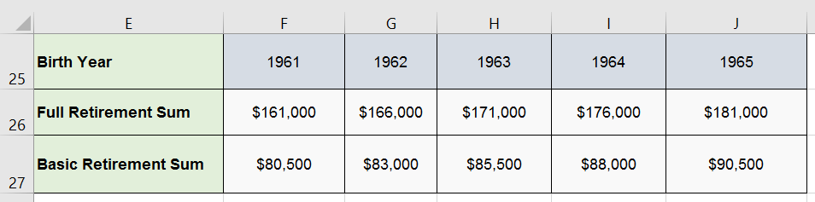

Cell N3:

(6 marks)

1. Write down the function/formula used in Cell O3 to compute the **Withdrawal Amount ($).**

If the Member Age is above 55 and the CPF Balance ($) is less than the Basic Retirement Sum ($) then

**Withdrawal Amount ($)** =$5000

Otherwise If the Member Age is above 55

**Withdrawal Amount ($) =** CPF Balance - Basic Retirement Sum + $5000

Otherwise display the text "N.A."

Cell O3: (6 marks)

1. Write down the function/formula used in Cell P3 to rank the **CPF Balance ($)** from lowest to highest for each member.

Cell P3: (3 marks)

# SECTION C (25 Marks)

With your workbook remains open, select the worksheet named <**Section B**>, based on the data given in the worksheet, compute the following using **Excel functions or formulas** where appropriate. Failure to use appropriate Excel functions or formulas will result in marks deduction.

**Write down the Excel Functions or Formulas on the paper, NOT the values unless otherwise stated. E.g. Cell B3 =LOWER(A3)**  **in the spaces provided.**

**The Final Output is as follows:**

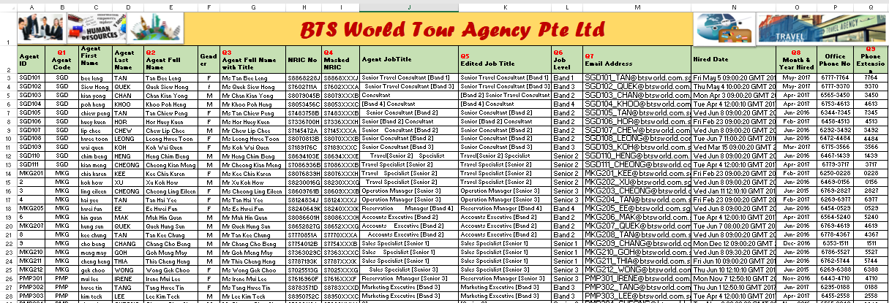

1. Write down the function/formula used in Cell B3 to display the first three characters from the **Agent ID** (in Cell A3).

Cell B3: (2 marks)

1. Write down the function/formula used in Cell E3 to combine the **Agent** **Last Name** (in Cell D3) and the **Agent** **First Name** (in Cell C3) and capitalize the first letter of each word for the combined text.

Cell E3: (3 marks)

1. Write down the function/formula used in Cell G3 to display a title (“Mdm” or “Mr”) including a space before the **Agent** **Full Name** (in Cell E3) based on the following:

If the Agent is Female then

Add a title “Mdm” including a space before the **Agent Full Name**

Otherwise

Add a title “Mr” including a space before the **Agent Full Name.**

Cell G3: (3 marks)

1. Write down the function/formula used in Cell I3 to mask the last three numbers from the **NRIC No** (in Cell H3) with “XXX”.

For Example: **S8868XXXJ**

Cell I3**:** (2 marks)

1. Write down the function/formula used in Cell K3 to remove all leading and trailing spaces except single space between words in the **Agent** **Job Title** (in Cell J3).

Cell K3: (2 marks)

1. Write down the function/formula used in Cell L3 to display the **Job Level** from **Edited Job Title** (in cell K3). The Job Level is enclosed by the left and right square brackets in the Edited Job Title for e.g. Band 1.

You must meaningfully use at least one **MID** function in your answer.

Cell L3: (5 marks)

1. Write down the function/formula used in Cell M3 to combine the **Agent ID** (in Cell A3), “_” and **Agent** **Last Name** (in Cell D3) and “@btsworld.com.sg”.

Eg: SGD101_TAN@btsworld.com.sg

Cell M3: (3 marks)

1. Write down the function/formula used in Cell O3 to display the month and year of the **Hired** **Date** (in Cell N3). The month and year is to be separated by a hyphen e.g. May-2017.

Cell O3**:** (3 marks)

1. Write down the function/formula used in Cell Q3 to display the last four numbers from the **Office Phone No** (in Cell P3).

Cell Q3**:** (2 marks)

**- End of MST Revision Paper Set 1** –