**Chore Change**

Company: Big Ike Inc.

Submitted By: Isaac Medlin

Submitted To: Gary Clark

Email: [Isaac.medlin@oit.edu](mailto:Isaac.medlin@oit.edu)

Date: Tuesday, October 14, 2020

Version: 1.0

# Signatory Page

This document was accepted by:

X_____________________________ _____________________

Signature (Gary Clark) Date

This document was submitted by:

X_____________________________ _____________________

Signature (Isaac Medlin) Date

# Revision History

|  |  |  |  |  |  |
| --- | --- | --- | --- | --- | --- |
| Author | Company | Version | Date | Filename | comments |
| Isaac Medlin | Big Ike Inc. | 1.0 | 10/14/2020 | Use Case Model | Initial Draft |
|  |  |  |  |  |  |

Table of Contents

Signatory Page ii

Revision History iii

Class Diagrams 1

Account UML’s 1

Main controller UML 2

Chores UML 2

Class Specifications 3

Account 3

Parent Account 4

Child Account 5

Main Controller 6

Chores 8

Appendix 9

CRUD Matrix 9

# Class Diagrams

# - Protected

+ - Public

- - Private

**Note: this is all I could think of for the time being, once I get further into the implementation process these will more than likely change**

## Account UML’s

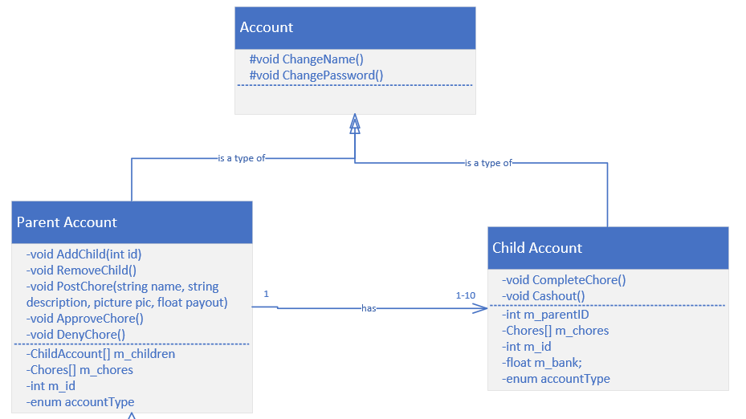

## Main controller UML

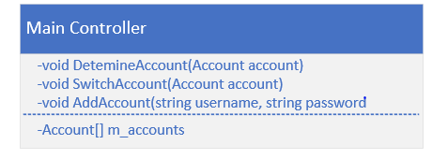

## Chores UML

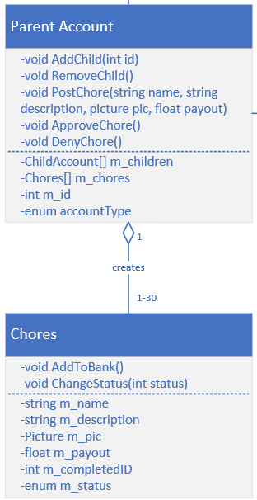

# Class Specifications

## Account

|  |
| --- |
| **Class Information** |
| **Class Name:** Account  Abstract Type: No Persistence: No |

|  |  |  |
| --- | --- | --- |
| **Trace-ability Information** | | |
| **Use Case ID** | **Use Case Name** | **Steps** |
| 900 | Account page | 5 |
|  |  |  |

|  |  |  |
| --- | --- | --- |
| **Public Methods** | | |
| **Signature** | **Preconditions** | **Post Condition** |
| N/A |  |  |
|  |  |  |

|  |  |  |
| --- | --- | --- |
| **Protected Methods** | | |
| **Signature** | **Preconditions** | **Post Conditions** |
| Void ChangeName() | Have an account | Account Name’s changed |
| Void ChangePassword() | Have an account | Account Passwords changed |

|  |  |  |
| --- | --- | --- |
| **Private Methods** | | |
| **Signature** | **Preconditions** | **Post Conditions** |
| N/A |  |  |

|  |  |  |  |  |  |
| --- | --- | --- | --- | --- | --- |
| **Attributes** | | | | | |
| **Name** | **Type** | **Object (y/n)** | **Instance/ Static** | **Visibility** | **Description** |
| **N/A** |  |  |  |  |  |

|  |  |
| --- | --- |
| **Concurrency** | |
| **Threading Issue** | **Description** |
| No threading in this function |  |

|  |  |  |
| --- | --- | --- |
| **Major Exceptions** | | |
| **Name** | **Trigger** | **Action** |
| Invalid name | Name change is invalid | Pop up box with an invalid name |
| Invalid password | Pop up saying invalid password | Pop up box with exception message |

|  |  |  |  |
| --- | --- | --- | --- |
| **Instance Information** | | | |
| **Minimum** | **Maximum** | **Mean** | **Fixed** |
|  |  |  |  |

|  |  |  |
| --- | --- | --- |
| **General Comments** | | |
| **Author** | **Date** | **Comment** |
|  |  |  |

## Parent Account

|  |
| --- |
| **Class Information** |
| **Class Name:** Parent Account  Abstract Type: No Persistence: No |

|  |  |  |
| --- | --- | --- |
| **Trace-ability Information** | | |
| **Use Case ID** | **Use Case Name** | **Steps** |
| 900 | Account Page | 5 |
| 100 | Registering | 2 |
| 300 | Add Chore | 3, 9, 8 |
| 400 | Adding a Child Account | 5.3 |
| 700 | Approving Chore | 7.3-7.4 |
|  |  |  |

|  |  |  |
| --- | --- | --- |
| **Public Methods** | | |
| **Signature** | **Preconditions** | **Post Condition** |
| N/A |  |  |
|  |  |  |

|  |  |  |
| --- | --- | --- |
| **Protected Methods** | | |
| **Signature** | **Preconditions** | **Post Conditions** |
| N/A |  |  |
|  |  |  |

|  |  |  |
| --- | --- | --- |
| **Private Methods** | | |
| **Signature** | **Preconditions** | **Post Conditions** |
| Void AddChild(int id) | Have a valid child id | Child is added to parents list |
| Void RemoveChild() | Have child under parent account | Child is removed from parents list |
| Void PostChore(string name, string description, picture pic, float payout) | N/A | Chore is posted |
| Void ApproveChore() | Chore is completed by child | Chore is approved, adding it to completed |
| Void DenyChore() | Chore is “completed” by child | Chore is denied, moving it back to in progress |

|  |  |  |  |  |  |
| --- | --- | --- | --- | --- | --- |
| **Attributes** | | | | | |
| **Name** | **Type** | **Object (y/n)** | **Instance/ Static** | **Visibility** | **Description** |
| ChildAccout[] m_children | Class Array | Y | Instance | Private | Array of child accounts under parent |
| Chores[] m_chores | Class Array | Y | Instance | Private | Array of chores added under parent account |
| Int m_id | Int | N | Instance | Private | Unique Id of parent account |
| Enum accountType | Enum | N | Instance | Private | Tells whether account is parent account or child account |

|  |  |
| --- | --- |
| **Concurrency** | |
| **Threading Issue** | **Description** |
| No threading |  |

|  |  |  |
| --- | --- | --- |
| **Major Exceptions** | | |
| **Name** | **Trigger** | **Action** |
| InvalidChildID | Entering in an invalid child id on add | Pop up box saying invalid id |
| MissingInformation | Forgetting to fill out a required field while posting a chore | Pop up asking to add required information |
|  |  |  |

|  |  |  |  |
| --- | --- | --- | --- |
| **Instance Information** | | | |
| **Minimum** | **Maximum** | **Mean** | **Fixed** |
|  |  |  |  |

|  |  |  |
| --- | --- | --- |
| **General Comments** | | |
| **Author** | **Date** | **Comment** |
|  |  |  |

## Child Account

|  |
| --- |
| **Class Information** |
| **Class Name:** Child Account  Abstract Type: No Persistence: No |

|  |  |  |
| --- | --- | --- |
| **Trace-ability Information** | | |
| **Use Case ID** | **Use Case Name** | **Steps** |
| 500 | Paying out child | 4 |
| 600 | Child Completing a chore | 7 |

|  |  |  |
| --- | --- | --- |
| **Public Methods** | | |
| **Signature** | **Preconditions** | **Post Condition** |
| N/A |  |  |
|  |  |  |

|  |  |  |
| --- | --- | --- |
| **Protected Methods** | | |
| **Signature** | **Preconditions** | **Post Conditions** |
| N/A |  |  |
|  |  |  |

|  |  |  |
| --- | --- | --- |
| **Private Methods** | | |
| **Signature** | **Preconditions** | **Post Conditions** |
| Void CompleteChore() | Chore is accepted by child | Chore moves sections to awaiting parents approval |
| Void Cashout() | Have money in their bank | Bank amount gets reset and parents are notified |

|  |  |  |  |  |  |
| --- | --- | --- | --- | --- | --- |
| **Attributes** | | | | | |
| **Name** | **Type** | **Object (y/n)** | **Instance/ Static** | **Visibility** | **Description** |
| Int m_parentID | Int | N | instance | Private | Has the parent ID their under |
| Chores[] m_chores | Chore array | Y | Instance | Private | An array of chores that the parent created |
| Int m_id | Int | N | Instance | Private | The unique ID of a child |
| Float m_bank | Float | N | Instance | Private | Holds the amount a child has earned |
| Enum accountType | Enum | N | Instance | Private | Specifies what kind of account it is |

|  |  |
| --- | --- |
| **Concurrency** | |
| **Threading Issue** | **Description** |
| N/A |  |

|  |  |  |
| --- | --- | --- |
| **Major Exceptions** | | |
| **Name** | **Trigger** | **Action** |
| N/A |  |  |

|  |  |  |  |
| --- | --- | --- | --- |
| **Instance Information** | | | |
| **Minimum** | **Maximum** | **Mean** | **Fixed** |
|  |  |  |  |

|  |  |  |
| --- | --- | --- |
| **General Comments** | | |
| **Author** | **Date** | **Comment** |
|  |  |  |

## Main Controller

|  |
| --- |
| **Class Information** |
| **Class Name:** Main Controller  Abstract Type: No Persistence: No |

|  |  |  |
| --- | --- | --- |
| **Trace-ability Information** | | |
| **Use Case ID** | **Use Case Name** | **Steps** |
| 800 | Switch Account | 6, 10 |
|  |  |  |

|  |  |  |
| --- | --- | --- |
| **Public Methods** | | |
| **Signature** | **Preconditions** | **Post Condition** |
| N/A |  |  |
|  |  |  |

|  |  |  |
| --- | --- | --- |
| **Protected Methods** | | |
| **Signature** | **Preconditions** | **Post Conditions** |
| N/A |  |  |
|  |  |  |

|  |  |  |
| --- | --- | --- |
| **Private Methods** | | |
| **Signature** | **Preconditions** | **Post Conditions** |
| Void DetermineAccount(Account account) | Have an account on the device or logged in | Switched GUIs based on account type |
| Void AddAccount(string username, string password) | Have an account registered | Add accounts to the list of existing account |
| Void SwitchAccount(Account account) | Have accounts added on the device. | Account is switched and GUI adapts to account type |

|  |  |  |  |  |  |
| --- | --- | --- | --- | --- | --- |
| **Attributes** | | | | | |
| **Name** | **Type** | **Object (y/n)** | **Instance/ Static** | **Visibility** | **Description** |
| Account[] m_accounts | Account Array | Y | Static | Private | An array of all the accounts added on the device |

|  |  |
| --- | --- |
| **Concurrency** | |
| **Threading Issue** | **Description** |
| No threading |  |

|  |  |  |
| --- | --- | --- |
| **Major Exceptions** | | |
| **Name** | **Trigger** | **Action** |
| InvalidAccount | Using the wrong sign in information to add an account | Account is added to the list of accounts |

|  |  |  |  |
| --- | --- | --- | --- |
| **Instance Information** | | | |
| **Minimum** | **Maximum** | **Mean** | **Fixed** |
|  |  |  |  |

|  |  |  |
| --- | --- | --- |
| **General Comments** | | |
| **Author** | **Date** | **Comment** |
|  |  |  |

## Chores

|  |
| --- |
| **Class Information** |
| **Class Name:** Chores  Abstract Type: No Persistence: No |

|  |  |  |
| --- | --- | --- |
| **Trace-ability Information** | | |
| **Use Case ID** | **Use Case Name** | **Steps** |
| 500 | Switch Account | 4 |
|  |  |  |

|  |  |  |
| --- | --- | --- |
| **Public Methods** | | |
| **Signature** | **Preconditions** | **Post Condition** |
| N/A |  |  |
|  |  |  |

|  |  |  |
| --- | --- | --- |
| **Protected Methods** | | |
| **Signature** | **Preconditions** | **Post Conditions** |
| N/A |  |  |
|  |  |  |

|  |  |  |
| --- | --- | --- |
| **Private Methods** | | |
| **Signature** | **Preconditions** | **Post Conditions** |
| Void AddToBank() | Have a child complete the chore | Amount of money is added to child bank |
| Void ChangeStatus(int status) | Have a chore go through one of its stages | The chore is added to its next stage. |

|  |  |  |  |  |  |
| --- | --- | --- | --- | --- | --- |
| **Attributes** | | | | | |
| **Name** | **Type** | **Object (y/n)** | **Instance/ Static** | **Visibility** | **Description** |
| String m_name | String | N | Static | Private | A name for the chore |
| String m_description | String | N | Static | Private | A description for the chore |
| Picture m_pic | Picture | N | Static | Private | A picture for the chore |
| Float m_payout | Float | N | Static | Private | The Payout for specific chore |
| Int m_completedID | Int | N | Static | Private | Id of the child that accepted/completed the chore |
| Enum m_status | Enum | N | Static | Private | Marks the chore status |

|  |  |
| --- | --- |
| **Concurrency** | |
| **Threading Issue** | **Description** |
| No threading |  |

|  |  |  |
| --- | --- | --- |
| **Major Exceptions** | | |
| **Name** | **Trigger** | **Action** |
| N/A |  |  |

|  |  |  |  |
| --- | --- | --- | --- |
| **Instance Information** | | | |
| **Minimum** | **Maximum** | **Mean** | **Fixed** |
|  |  |  |  |

|  |  |  |
| --- | --- | --- |
| **General Comments** | | |
| **Author** | **Date** | **Comment** |
|  |  |  |

# Appendix

## CRUD Matrix

|  |  |  |  |  |  |  |  |
| --- | --- | --- | --- | --- | --- | --- | --- |
| Use Case Id | Use Case Name | Type | Account | Parent | Child | Chores | Main Controller |
| 100 | Registering | Read | C |  |  |  |  |
| 200 | Logging In | Read | R |  |  |  | R |
| 300 | Add Chore | Write |  | C |  | C |  |
| 400 | Adding Child Account | Read | R | R |  |  |  |
| 500 | Paying Out child | Read/ Update |  | R | UR |  |  |
| 600 | Child completing chores | Read/ Update |  | R | RU | U |  |
| 700 | Approving a chore | Read/  Update |  | RU |  | U |  |
| 800 | Switch Account | Read | R |  |  |  | R |
| 900 | Account Page | Read/  Write/  Update | RU |  |  |  |  |