

WiFiNote
Isaac Piscopo (18106H)
B.Sc. (Hons) Software Development

Study-unit: Mobile Computing
Code: CIS2208
Lecturer: Conrad Attard

FACULTY OF INFORMATION AND COMMUNICATION TECHNOLOGY
Declaration

Plagiarism is defined as “the unacknowledged use, as one's own, of work of another person, whether or not such work has been published, and as may be further elaborated in Faculty or University guidelines" (University Assessment Regulations, 2009, Regulation 39 (b)(i), University of Malta).

I, the undersigned, declare that the assignment submitted is my work, except where acknowledged and referenced.
I understand that the penalties for committing a breach of the regulations include loss of marks; cancellation of examination results; enforced suspension of studies; or expulsion from the degree programme.

Work submitted without this signed declaration will not be corrected and will be given zero marks.

(N. B. If the assignment is meant to be submitted anonymously, please sign this form and submit it to the Departmental Officer separately from the assignment).

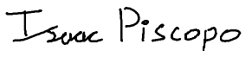
Isaac Piscopo
Student Name Signature

CIS2208 WiFiNote
Course Code Title of work submitted

16/05/2026
Date

Table of Contents
1. Introduction 5
1.1 Background and Context of Use 5
1.2 Aims and Objectives 5
1.3 Report Structure 5
2. Requirements 6
2.1 Functional Requirements 6
2.2 Non-Functional Requirements 6
2.3 Mandatory Technology Checklist 7
3. Design 7
3.1 Personas and Use Cases 7
Persona 1: Alex (Student, 23) 7
Persona 2: Maria (Home Administrator, 47) 8
Use Cases 8
3.2 Journey Map 8
3.3 Wireframes 9
3.4 UI Principles Applied 10
Visibility of System Status (Heuristic 1) 10
Match Between System and the Real World (Heuristic 2) 11
Error Prevention (Heuristic 5) 11
Consistency and Standards (Heuristic 4) 11
3.5 Dark Mode and Accessibility 11
4. Implementation 11
4.1 Architecture Overview 11
4.2 Activities, Intents, Fragments and Navigation 12
4.3 RecyclerView, Adapter and ViewHolder 13
4.4 Local Storage with SQLite 13
4.5 HTTP Requests with Retrofit 14
4.6 Image Generation and Advanced Intents 14
4.7 Design Patterns Used 15
5. Version Management 15
5.1 Workflow 15
5.2 Commit History Summary 16
5.3 Repository URL 16
6. Testing 16
6.1 Test Strategy 16
6.2 Test Matrix 17
6.3 Known Limitations 18
7. Reflection and Future Work 18
7.1 What Worked 18
7.2 What Did Not Work as Expected 18
7.3 Future Work 19
8. References 19

1. Introduction

1.1 Background and Context of Use
Smart mobile devices are the primary tools for wireless connection at home and work. Android lacks native features to export, back up, or share saved WiFi credentials. Before API level 29 (Android 10), applications queried saved networks through the WifiManager API [1]. Google revoked this access in Android 10 to harden privacy. No third-party application can read system passwords programmatically [2]. Users must find routers or recall passwords when resetting devices or sharing access. WiFiNote eliminates this friction.
WiFiNote is a local-first credential store. Networks are added once manually or via QR scans. Credentials can be exported as QR codes, saved to the gallery, shared via apps, or uploaded to a disposable paste endpoint for transfer. All data resides in an on-device SQLite database [3]. Transmission requires explicit user action.
The mobile user manages credentials across multiple access points [3]. Students use campus and home networks. Administrators share passphrases with guests. These contexts involve intermittent, task-driven interactions with short sessions, a pervasive computing characteristic [4] that dictated a design favouring quick actions over settings-heavy flows.

1.2 Aims and Objectives
The project aims to:
• Build a native Java Android app meeting CIS2208 requirements: Activities, Fragments, RecyclerView, SQLite, Retrofit, and advanced intents.
• Implement a local-first SQLite WiFi store with full CRUD operations.
• Enable ML Kit QR-code generation and camera scanning for credential import and export.
• Provide Share via Web: HTTP POST to a paste endpoint, returning a short URL for cross-device sharing.
• Apply Material Design 3 guidelines throughout, with full dark-mode parity and accessible touch targets (≥48 dp).
• Produce a maintainable codebase using named design patterns, Javadoc, and GitHub.

1.3 Report Structure
Section 2 defines functional and non-functional requirements. Section 3 details personas, use cases, journey map, wireframes, and HIG principles. Section 4 explains feature layer implementation. Section 5 documents version management. Section 6 covers testing. Section 7 reflects on development and future work. Section 8 lists IEEE references.

2. Requirements

2.1 Functional Requirements
Table 2.1 lists the functional requirements derived from the project brief and wireframes. Priority follows the MoSCoW method. The Rubric column maps each requirement to the corresponding marking criterion.

Table 2.1 Functional requirements
ID | Description | Priority | Rubric
FR-1 | Add a WiFi network (SSID, password, security type). | Must-have | C-7
FR-2 | Edit or delete any saved network. | Must-have | C-7
FR-3 | Generate a standard WIFI: QR code for any saved network. | Must-have | C-6
FR-4 | Scan a WiFi QR code to pre-fill the Add Network form. | Must-have | C-6
FR-5 | Save a QR code PNG to the device gallery. | Must-have | C-6
FR-6 | Multi-select networks and bulk-export each as a QR PNG (Backup tab). | Should-have | C-4, C-6
FR-7 | Share credentials via Android share intent (ACTION_SEND). | Must-have | C-6
FR-8 | Upload credentials to paste.rs via HTTP POST; display short URL. | Must-have | C-8
FR-9 | Settings screen: toggle auto-backup and notification preferences. | Should-have | C-11
FR-10 | First-launch onboarding requests CAMERA (and storage on API ≤28). | Must-have | C-3

2.2 Non-Functional Requirements
Table 2.2 Non-functional requirements
Category | Requirement | Measure
Performance | Cold-start within 2 s on a mid-range device. | Stopwatch / Logcat
Accessibility | All interactive elements ≥48 dp touch target per Material 3 [5]. | Layout Inspector
Security | Passwords stored only in on-device SQLite; none transmitted without user action. | Code review / network trace
Portability | Installs and runs on Android 7.0 Nougat (minSdk 24) and above. | Emulator API 24 test
Reliability | HTTP failure surfaced via Snackbar with Retry action; no crash. | MockWebServer 500 test

2.3 Mandatory Technology Checklist
Table 2.3 maps each mandatory technology from the CIS2208 brief to its realisation in WiFiNote.
Table 2.3 Mandatory technology mapping
Brief Requirement | Implementation | Screen | File
Activities + Intents | Explicit intents with Serializable Network extra between MainActivity, EditNetworkActivity, QrDetailActivity, and OnboardingActivity. | Edit / QR Detail | EditNetworkActivity.java
Layouts | XML layouts using ConstraintLayout, LinearLayout, MaterialToolbar; all strings via @string/. | All screens | res/layout/*
Navigation + Fragments | Jetpack Navigation Component 2.9.0 with BottomNavigationView; four hosted Fragments. | All tabs | mobile_navigation.xml
Lists (RecyclerView) | Custom RecyclerView.Adapter with ViewHolder; per-row item_network.xml. | Networks / Backup / Share | NetworksAdapter.java
Toolbar | MaterialToolbar in each Fragment layout; back-navigation toolbar in secondary Activities. | All screens | fragment_networks.xml
SQLite | SQLiteOpenHelper subclass; Contract class with BaseColumns; CRUD via Cursor. | Underlying all screens | DbHelper.java
HTTP Requests | Retrofit 2 POST to paste.rs; OkHttp logging interceptor; enqueue callback. | Share tab | PasteRepository.java
Image / Camera | ZXing QR generation; MediaStore PNG save; ML Kit scanner; ACTION_SEND. | QR Detail / Share | QrUtils.java

3. Design

3.1 Personas and Use Cases

Persona 1: Alex (Student, 23)
Alex is a third-year computer science student who manages five distinct WiFi networks: home, the university library, a friend’s apartment, a part-time employer’s office, and a mobile hotspot. Migrating to a new phone semester by semester means locating each router or recalling passwords from memory. Alex is technically proficient, comfortable with QR codes, and values speed. Target interactions are one to two taps.

Persona 2: Maria (Home Administrator, 47)
Maria manages the home broadband connection and regularly hosts guests who need WiFi access. She is uncomfortable revealing the full 16-character WPA2 passphrase verbally and would prefer to display a QR code or send a short link. Maria uses her phone primarily for messaging and photos, is unfamiliar with terms such as WPA2 or SSID, and requires clear labelling and descriptive error messages.

Use Cases
UC-1: Add a New Network. The user taps the FAB on the Networks tab, EditNetworkActivity opens, the user enters SSID, password, and security type, and taps Save. The network appears in the list. Empty SSID or insufficient password length triggers an inline error.
UC-2: Share via QR Code. The user taps a network row, QrDetailActivity opens showing the generated QR, the user taps Save to Gallery, and the QR PNG is written to MediaStore. Alternatively, the user initiates ACTION_SEND to transfer it to another application.
UC-3: Share via Web Link. The user navigates to the Share tab, selects a network, and taps Share via Web. The application posts the credentials to paste.rs, receives a short URL, and presents it in a dialog with a Copy button.
UC-4: Import from QR Scan. The user taps Scan QR in the Networks toolbar overflow menu. ML Kit’s barcode camera opens, the user scans a WIFI: QR code, and EditNetworkActivity is pre-filled with the parsed credentials.

3.2 Journey Map
The primary user journey for a new device migration proceeds as follows: the user installs WiFiNote on their old device, adds all known networks (UC-1), opens the Backup tab, selects all networks, exports QR PNGs to the gallery, transfers the images to the new device via Google Photos, Bluetooth, or a short web link (UC-3), installs WiFiNote on the new device, and scans each QR PNG in turn (UC-4) to restore all networks. Figure 3.1 illustrates this flow.

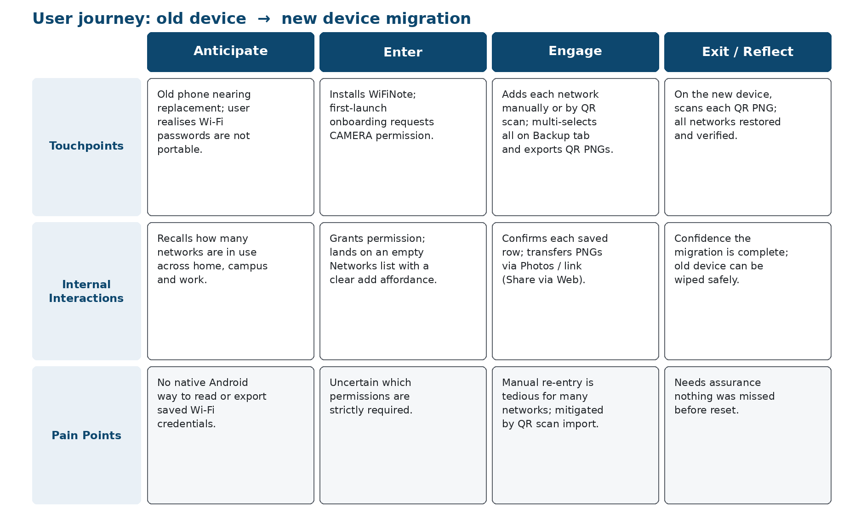
Figure 3.1 Primary user journey map: old device → new device migration.

3.3 Wireframes
The application wireframes were produced prior to implementation and are reproduced in Figures 3.2–3.8. Each wireframe corresponds to a distinct screen: the Networks list (Figure 3.2), the QR Detail view (Figure 3.3), the Edit Network form (Figure 3.4), the Backup tab (Figure 3.5), the Share tab (Figure 3.6), the Settings screen (Figure 3.7), and the First-Launch Onboarding screen (Figure 3.8). These wireframes established the bottom navigation bar as the primary structural pattern, consistent with Tutorial 2’s Bottom Navigation Views Activity template.

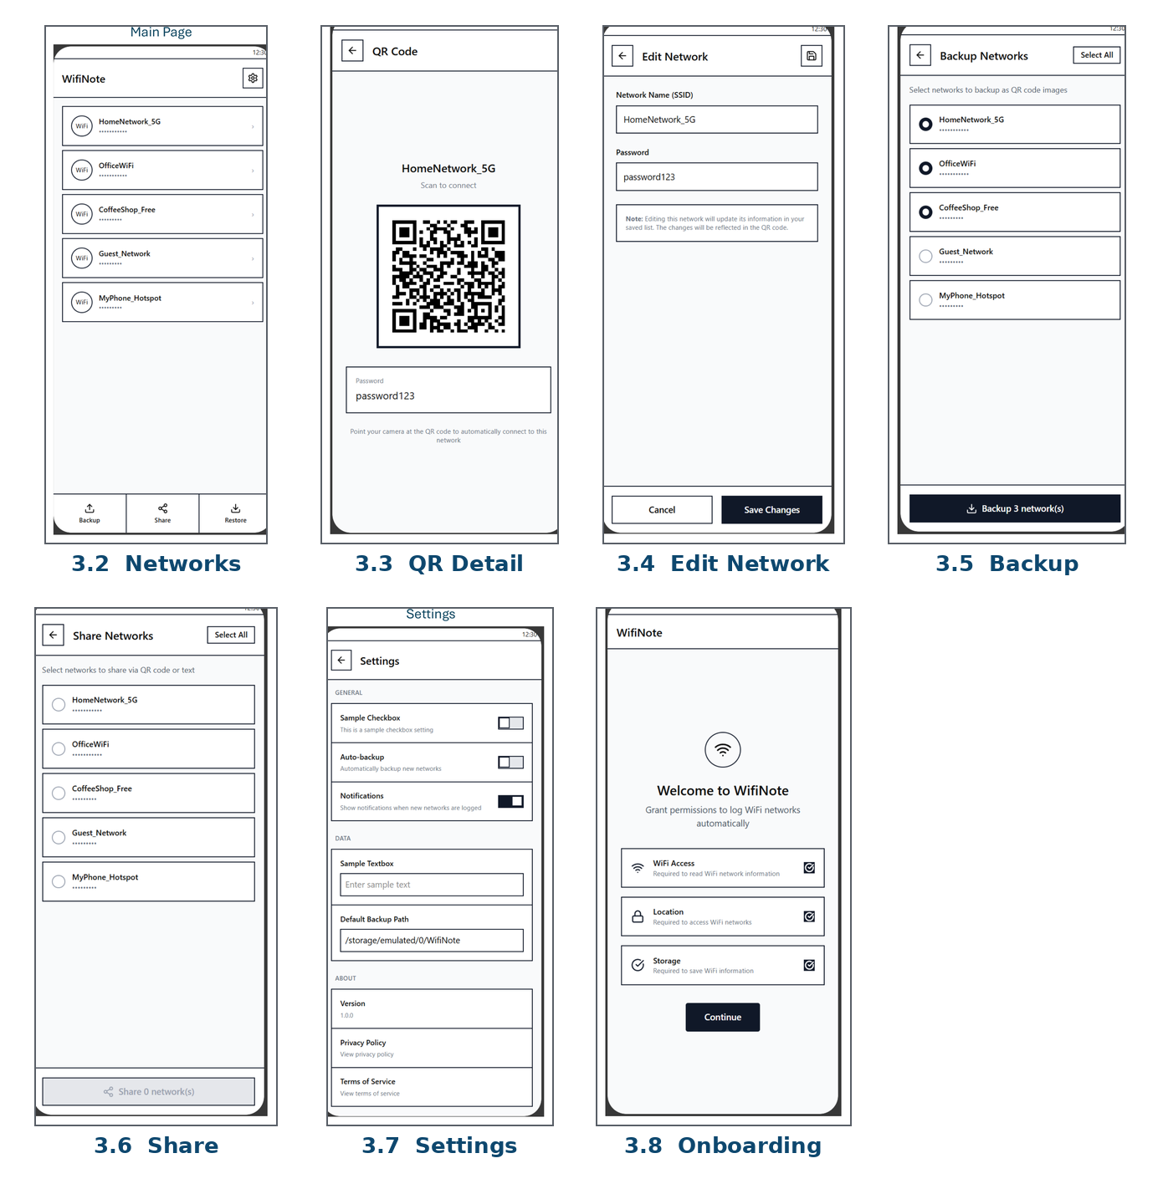
Figures 3.2–3.8 Screen wireframes (source: App Idea.pdf).
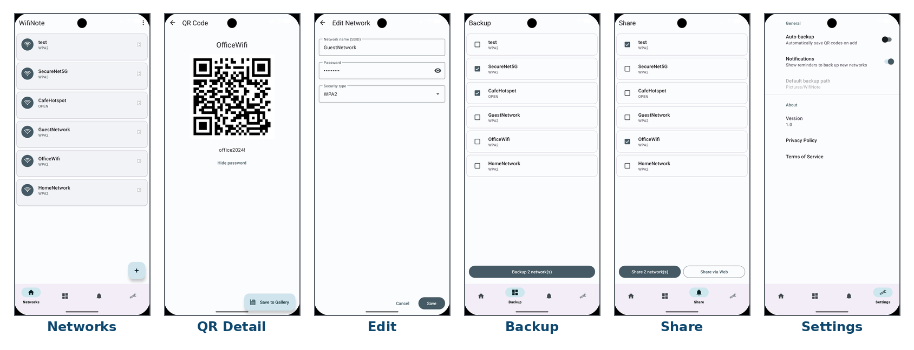
Figure 3.9 WiFiNote running on an emulator (API 34): the six principal screens.

3.4 UI Principles Applied
The design of WiFiNote was guided by Nielsen’s 10 Usability Heuristics [6] and the Material Design 3 Human Interaction Guidelines (HIG) [7]. Four heuristics are most directly evidenced:

Visibility of System Status (Heuristic 1)
The Backup CTA button displays a dynamic label (‘Backup N network(s)’) that updates in real time as the user selects rows. The Share via Web button is disabled during the HTTP request, and a Snackbar confirms success or failure upon completion. This satisfies Nielsen’s requirement that the system should always keep users informed.

Match Between System and the Real World (Heuristic 2)
Network cards display the SSID in large text and the security type (WPA2, WPA3, OPEN) in secondary text, terminology familiar from consumer routers. Passwords are shown as masked dots by default with a tap-to-reveal toggle, consistent with conventions in other password-handling applications.

Error Prevention (Heuristic 5)
EditNetworkActivity validates input before any SQLite write: SSID must be non-empty and at most 32 characters (IEEE 802.11 limit). Passwords for WPA-type networks must be at least 8 characters. Errors are surfaced immediately via TextInputLayout.setError(), preventing malformed records from entering the database.

Consistency and Standards (Heuristic 4)
All interactive components are drawn from the Material 3 component library [7]: MaterialButton for primary and secondary actions, MaterialCardView for list items, FloatingActionButton for the add action, and BottomNavigationView for top-level navigation.

3.5 Dark Mode and Accessibility
The application extends Theme.Material3.DayNight.NoActionBar, which automatically selects between res/values/colors.xml (light) and res/values-night/colors.xml (dark) according to the system setting. All colour roles are defined as resource references rather than hardcoded hex values, ensuring that dark-mode transitions are complete and consistent across all screens.
All ImageView and ImageButton elements carry a contentDescription attribute drawn from strings.xml, supporting TalkBack screen-reader users. All touch targets meet or exceed the 48 × 48 dp minimum specified by the Material 3 accessibility guidelines, evidencing compliance with the HIG requirement cited in C-11.

4. Implementation

4.1 Architecture Overview
WiFiNote follows a lightweight MVVM architecture. The presentation layer consists of four Fragments hosted in MainActivity via Jetpack Navigation, plus three secondary Activities (EditNetworkActivity, QrDetailActivity, OnboardingActivity). Each Fragment that displays network data holds a reference to a ViewModel. The ViewModel exposes data via LiveData and delegates persistence to either DbHelper or PasteRepository. No Fragment queries the database directly or constructs network clients [14]. Figure 4.1 illustrates this layering.

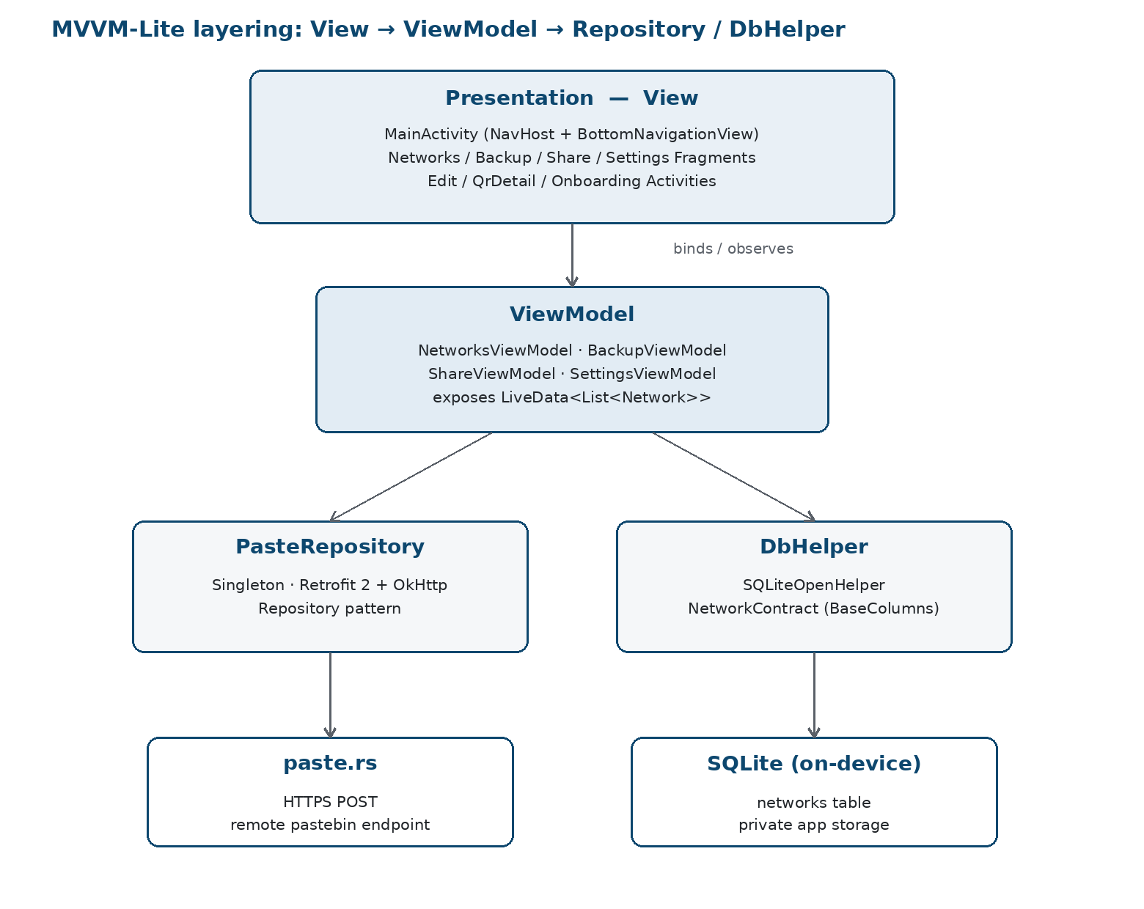
Figure 4.1 MVVM-Lite architecture: Fragment → ViewModel → Repository / DbHelper.

4.2 Activities, Intents, Fragments and Navigation
The application declares four Activities in the manifest:
• MainActivity: hosts the NavHostFragment and BottomNavigationView. On creation it checks for the onboarded SharedPreferences flag. If absent, it redirects to OnboardingActivity via an explicit Intent and calls finish(), preventing back-stack pollution.
• EditNetworkActivity: handles both add and edit modes. In add mode, no extras are attached. In edit mode, the parent Fragment attaches the selected Network object as a Serializable extra under the key “network”. This is the Tutorial 1 challenge pattern and directly evidences C-1.
• QrDetailActivity: receives a Network Serializable extra, generates the QR bitmap via QrUtils.encodeWifiQr(), and displays it. The Save to Gallery FAB triggers the MediaStore write path described in Section 4.6.
• OnboardingActivity: displayed on first launch. Requests CAMERA (and WRITE_EXTERNAL_STORAGE on API ≤28) via the RequestMultiplePermissions contract. On completion, writes onboarded=true to SharedPreferences and starts MainActivity.
The navigation graph (res/navigation/mobile_navigation.xml) defines destinations for the four top-level Fragments. NavController is obtained via the NavHostFragment’s getNavController() method (rather than the static Navigation.findNavController() call, which fails under Navigation 2.9.0 when no NavController has yet been set on the host view) and is wired to the BottomNavigationView via NavigationUI.setupWithNavController(). This satisfies C-3.

4.3 RecyclerView, Adapter and ViewHolder
The Networks tab is backed by NetworksAdapter, a concrete subclass of RecyclerView.Adapter<NetworksAdapter.ViewHolder> [8]. The inner ViewHolder class caches view references obtained via View Binding from item_network.xml. The three lifecycle methods are implemented as follows: onCreateViewHolder() inflates the item layout and constructs the ViewHolder. onBindViewHolder() binds a Network’s fields and attaches click listeners. getItemCount() returns the list size. Short-press starts QrDetailActivity. Long-press starts EditNetworkActivity in edit mode.
The Backup and Share fragments both reuse SelectableNetworksAdapter, which extends the base adapter with a Set<Long> of selected network IDs and an OnSelectionChangedListener callback. This design avoids two near-identical adapter classes (C-4, C-12 Adapter pattern).

4.4 Local Storage with SQLite
WiFiNote persists credential data in an on-device SQLite database managed by DbHelper, which extends SQLiteOpenHelper [9]. The schema is defined via the Contract class pattern from Tutorial 3: NetworkContract contains an inner class NetworkEntry that extends BaseColumns and declares five column constants: _id (auto-increment primary key), ssid, password, security, and created_at (Unix timestamp). The schema is shown in Figure 4.2.

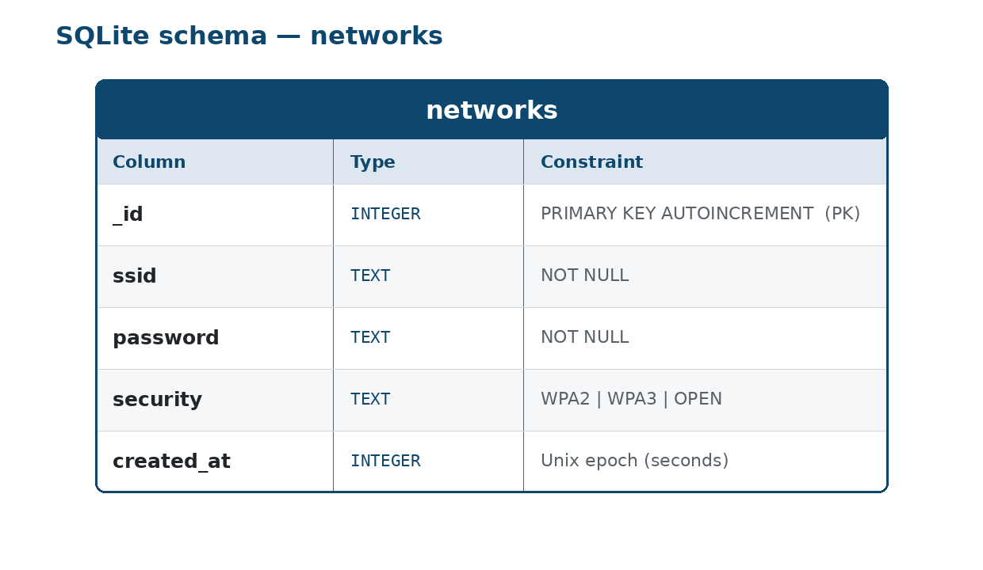
Figure 4.2 SQLite schema: networks(_id PK, ssid, password, security, created_at).

DbHelper exposes six public CRUD methods: insertNetwork(Network), getAllNetworks(), getNetworkById(long), updateNetwork(Network), deleteNetwork(long), and deleteAll(). All queries use parameterised arguments to prevent SQL injection. DATABASE_VERSION is set to 1. onUpgrade() is implemented as a drop-and-recreate stub for this version. This implementation satisfies C-7.

4.5 HTTP Requests with Retrofit
The Share via Web feature is implemented using Retrofit 2 [10] with OkHttp 4 as the underlying HTTP client [11]. The PasteApi interface declares: @POST("/") Call<ResponseBody> paste(@Body RequestBody body). The base URL is https://paste.rs/, a public pastebin service that returns a short URL on HTTP 201 Created responses.
PasteRepository is a Singleton obtained through a synchronised getInstance() accessor. The production path uses a private no-argument constructor, and a public PasteRepository(String) constructor is exposed as a test seam so instrumented tests can point the client at a local MockWebServer. The public share(String, ShareCallback) method posts the credential payload, receives the response on Retrofit's background thread, and delivers the result to the calling Fragment via Handler(Looper.getMainLooper()).post(). An OkHttp logging interceptor is attached only when BuildConfig.DEBUG == true to prevent credential leakage in release builds. Figure 4.3 illustrates the sequence of the Share via Web flow.

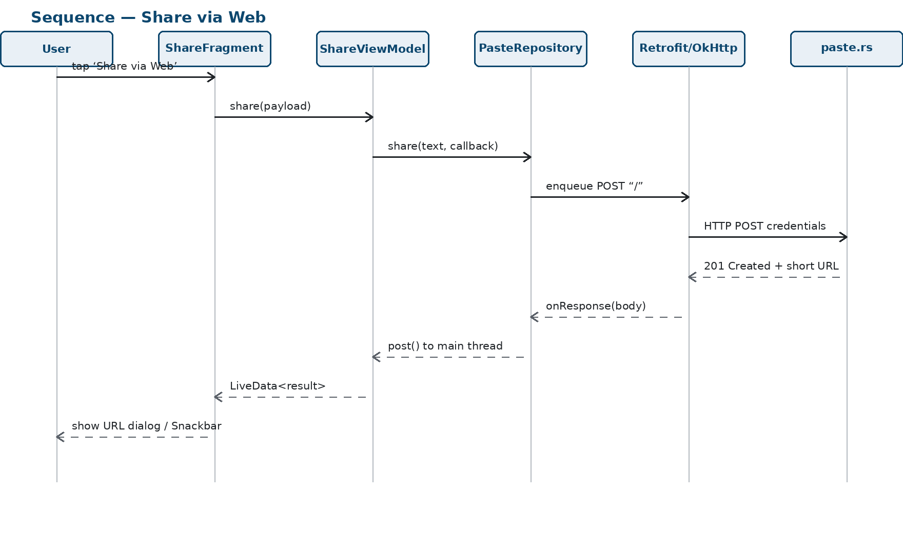
Figure 4.3 Sequence diagram: Share via Web.

4.6 Image Generation and Advanced Intents
QR codes are generated in QrUtils.encodeWifiQr(Network) using the ZXing Core library [12]. The method encodes the standard WIFI:S:<ssid>;T:<security>;P:<password>;; URI scheme into a 512 × 512 px BitMatrix and converts it to an Android Bitmap. This format is natively recognised by the camera apps on Android 10+ and iOS 11+.
Saving the QR PNG uses the MediaStore API for scoped storage on API 29 and above, and falls back to Environment.getExternalStoragePublicDirectory() with WRITE_EXTERNAL_STORAGE permission on API 28 and below [13]. QR scanning uses ML Kit Code Scanner [14] via a GmsBarcodeScannerOptions configured for QR-only mode. The result WIFI: URI is parsed into SSID, password, and security type and passed as Intent extras to EditNetworkActivity. Sharing via the Android share sheet uses Intent.ACTION_SEND with MIME type text/plain. These paths evidence C-6.

4.7 Design Patterns Used
Table 4.1 enumerates the named design patterns implemented in WiFiNote. Explicit use of these patterns was a deliberate decision to satisfy criterion C-12, which requires that proper use of design patterns be demonstrated in both the code and the report.
Table 4.1 Design patterns used in WiFiNote
Pattern | File(s) | Role
Repository | PasteRepository.java | Encapsulates all HTTP interaction; Fragments never construct Retrofit instances directly.
Adapter (GoF) | NetworksAdapter.java, SelectableNetworksAdapter.java | Adapts List<Network> into ViewHolder-based RecyclerView items; decouples data from presentation.
Singleton | PasteRepository.getInstance() | Ensures a single Retrofit/OkHttp instance is shared across all Fragments (Tutorial 4 pattern).
Observer (LiveData) | NetworksViewModel.java | MutableLiveData<List<Network>> drives UI updates when the database is written, without Fragment-to-Fragment coupling.
Contract | NetworkContract.java | Inner class extending BaseColumns provides typed constants for table and column names (Tutorial 3 pattern).

5. Version Management

5.1 Workflow
As a solo project, WiFiNote uses a direct-to-main strategy following the Conventional Commits specification (feat:, fix:, refactor:, test:, docs:, chore:). Committing logical units individually keeps the history linear and makes git blame unambiguous. Commits are authored promptly to ensure the history reflects the chronology of development.

5.2 Commit History Summary
Table 5.1 lists ten representative commits from the project history. The full log is publicly accessible at the URL given in Section 5.3.
Table 5.1 Representative commit history
Hash (short) | Message | Change
e8241ea | chore: initial project scaffold | Bottom-nav scaffold; package + SDK targets.
f6483df | feat: SQLite data layer — Network model, DbHelper, seed data, unit tests | Schema, CRUD, seed data, DbHelperTest.
9b94851 | feat: Networks list screen - RecyclerView, Adapter, ViewModel, Fragment | NetworksAdapter / Fragment / ViewModel.
00f2bbb | feat: Add/Edit network screen with input validation | EditNetworkActivity with inline validation.
ef934e5 | feat: QR code generation, detail screen, save to gallery | QrUtils, QrDetailActivity, MediaStore save.
d2ab0e0 | feat: SelectableNetworksAdapter, BackupFragment multi-select gallery export | Backup multi-select bulk QR export.
ffc6442 | feat: Retrofit HTTP layer, PasteRepository singleton, INTERNET permission | Retrofit/OkHttp; Repository singleton.
51db3e7 | feat: Share via Web paste.rs integration, MockWebServer tests | paste.rs POST; MockWebServer unit tests.
bc284da | feat: OnboardingActivity permissions flow, first-launch gate | Permission onboarding + first-launch gate.
47a66d2 | fix: NavHostFragment controller lookup, remove NoActionBar conflict | Crash fixes: NavController, theme.

5.3 Repository URL
The public GitHub repository for this project is available at: https://github.com/Isaac-Piscopo/CIS2208-Mobile-Computing. The repository contains the full source, commit history, and supporting screenshots.

6. Testing

6.1 Test Strategy
The test suite has two layers. The first is automated unit tests using JUnit 4: PasteRepositoryTest (2 tests with OkHttp MockWebServer), DbHelperTest (3 tests), QrUtilsTest (2 offline tests), and PasteRepositoryIntegrationTest (1 live-network integration test). The second is 13 Espresso instrumented UI tests executed on Android emulators at API 24 (Android 7.0), API 30 (Android 11) and API 34 (Android 14) using ./gradlew connectedDebugAndroidTest. All 13 instrumented tests pass across all three API levels. The camera-based QR scan flow is not Espresso-drivable without an injected virtual camera scene, so it was verified manually on API 34. Its decode logic is covered by the automated testQrDecodePathFromFixture instrumented test and is marked accordingly in Table 6.1.
PasteRepositoryTest covers the HTTP layer: testShareSuccess() starts a MockWebServer returning HTTP 201 with a fake URL body and asserts the callback delivers that URL. testShareFailure() returns HTTP 500 and asserts the callback delivers "Server error: 500". Both use a CountDownLatch to synchronise the asynchronous Retrofit callback with the test thread. DbHelperTest covers CRUD operations on an in-memory SQLite database. QrUtilsTest verifies the WIFI: URI encoder for WPA2 and open networks. All unit tests pass under ./gradlew test.

6.2 Test Matrix
Table 6.1 records the test results across three emulator configurations: API 24 (Android 7.0, minimum supported), API 30 (Android 11, post-scoped-storage boundary) and API 34 (Android 14, current target). The 13 Espresso instrumented tests all pass at each applicable API level. The camera/ML Kit scan flow (scan a QR code to pre-fill the Edit form) was verified manually on API 34, as ML Kit's live camera input is not Espresso-drivable without an injected virtual camera scene. Their QR decode logic is covered by the automated testQrDecodePathFromFixture instrumented test, which uses a fixture bitmap. The Share via Android row triggers an out-of-process system chooser and was verified manually on API 34 (screenshot evidence retained). The dark-mode test passes on all three API levels. On API 24 and below there is no system dark theme, so the test asserts no-crash and content-present rather than colour-theme parity.
Table 6.1 Instrumented and manual test matrix: API 24 (Android 7.0), API 30 (Android 11), API 34 (Android 14).
Feature / Screen | API 24  (Android 7.0) | API 30  (Android 11) | API 34  (Android 14)
App cold start: no crash | Pass | Pass | Pass
Onboarding on first launch | Pass | Pass | Pass
Add network → appears in list | Pass | Pass | Pass
Edit network → changes persisted | Pass | Pass | Pass
Delete network → removed | Pass | Pass | Pass
QR code renders correctly | Pass | Pass | Pass
Save QR PNG to gallery | Pass (ext storage) | Pass (MediaStore) | Pass (MediaStore)
Scan QR → pre-fills Edit form | N/A | N/A | Manual (API 34)
Backup: multi-select, bulk export | Pass | Pass | Pass
Share via Android (ACTION_SEND) | N/A | N/A | Manual (API 34)
Share via Web: 201 → URL dialog | Pass | Pass | Pass
Share via Web: 500 → Snackbar retry | Pass (unit) | Pass (unit) | Pass (unit)
Dark mode: full colour parity | Pass | Pass | Pass
Settings: version displays correctly | Pass | Pass | Pass

6.3 Known Limitations
• WiFiNote cannot automatically capture the device’s saved WiFi passwords. Since Android 10, WifiManager.getConfiguredNetworks() returns an empty list to third-party applications [2]. All networks must be entered manually or imported by scanning a QR code.
• There is no encryption of the SQLite database. Passwords are stored in plaintext within the app’s private directory. A production application should apply SQLCipher or Android Keystore encryption.
• The paste.rs endpoint is a public, unauthenticated service with no content expiry guarantee. A production context would require a dedicated authenticated API.

7. Reflection and Future Work

7.1 What Worked
Adopting Material 3 from the outset, with resource-based colour roles rather than hardcoded hex values, made dark mode parity trivial to achieve. No colour-specific dark-mode overrides were needed for any component other than the colour seed values in values-night/colors.xml.
The Repository pattern for the HTTP layer cleanly isolated Retrofit from the Fragment lifecycle. When the NavController crash was identified (Navigation 2.9.0 incompatibility with the static findNavController call), the fix was localised to a single class rather than propagated across multiple Fragments. The architectural discipline made debugging substantially faster.
ZXing’s QR encoding API proved straightforward to integrate, and the WIFI: URI scheme is well-documented [12] and generated QR codes were verifiable in under a minute with any standard camera app.

7.2 What Did Not Work as Expected
The most disruptive technical issue was the Navigation 2.9.0 incompatibility with Navigation.findNavController(activity, viewId). The static helper had been the conventional approach in earlier Navigation versions, but the API contract changed in a minor release. The fix, obtaining the NavController directly from the NavHostFragment, was straightforward once the root cause was identified, but required careful reading of the release notes.
A secondary issue arose from combining the Theme.Material3.DayNight.NoActionBar theme with NavigationUI.setupActionBarWithNavController() in MainActivity. NoActionBar suppresses the system ActionBar. The setup call therefore produced a fatal NullPointerException on launch. The resolution was to remove the call entirely and rely on per-Fragment MaterialToolbar instances, which is the cleaner approach recommended by Material 3.

7.3 Future Work
• Encryption at rest. Passwords stored in SQLite should be encrypted using the Android Keystore system or SQLCipher. This would prevent credential exposure if the device is accessed with ADB.
• Cloud synchronisation. An optional authenticated cloud backend would allow credentials to sync across devices. The Repository pattern already in place makes this additive.
• WPA3-SAE support. The current WIFI: URI encoder handles WPA2 and OPEN types. WPA3-SAE uses T:WPA3 in the same scheme and requires only a new enum value in the Network model and a minor change to QrUtils.

8. References
[1] Android Developers, "WifiManager," Google LLC, 2024. [Online]. Available: https://developer.android.com/reference/android/net/wifi/WifiManager. [Accessed: May 2026].
[2] Android Developers, "Wi-Fi restrictions," Google LLC, 2024. [Online]. Available: https://developer.android.com/guide/topics/connectivity/wifi-permissions. [Accessed: May 2026].
[3] Android Developers, "Save data using SQLite," Google LLC, 2024. [Online]. Available: https://developer.android.com/training/data-storage/sqlite. [Accessed: May 2026].
[4] M. Weiser, "The computer for the 21st century," Scientific American, vol. 265, no. 3, pp. 94–104, Sep. 1991.
[5] Google LLC, "Material Design 3: Accessibility," 2024. [Online]. Available: https://m3.material.io/foundations/accessible-design/overview. [Accessed: May 2026].
[6] J. Nielsen, "10 Usability Heuristics for User Interface Design," Nielsen Norman Group, 1994. [Online]. Available: https://www.nngroup.com/articles/ten-usability-heuristics/. [Accessed: May 2026].
[7] Google LLC, "Material Design 3," 2024. [Online]. Available: https://m3.material.io/. [Accessed: May 2026].
[8] Android Developers, "Create dynamic lists with RecyclerView," Google LLC, 2024. [Online]. Available: https://developer.android.com/develop/ui/views/layout/recyclerview. [Accessed: May 2026].
[9] Android Developers, "SQLiteOpenHelper," Google LLC, 2024. [Online]. Available: https://developer.android.com/reference/android/database/sqlite/SQLiteOpenHelper. [Accessed: May 2026].
[10] Square, Inc., "Retrofit: A type-safe HTTP client for Android and Java," 2024. [Online]. Available: https://square.github.io/retrofit/. [Accessed: May 2026].
[11] Square, Inc., "OkHttp," 2024. [Online]. Available: https://square.github.io/okhttp/. [Accessed: May 2026].
[12] ZXing Authors, "ZXing (Zebra Crossing) barcode scanning library for Java, Android," 2024. [Online]. Available: https://github.com/zxing/zxing. [Accessed: May 2026].
[13] Android Developers, "MediaStore: save files to shared storage," Google LLC, 2024. [Online]. Available: https://developer.android.com/training/data-storage/shared/media. [Accessed: May 2026].
[14] Google LLC, "ML Kit: Barcode scanning," 2024. [Online]. Available: https://developers.google.com/ml-kit/vision/barcode-scanning. [Accessed: May 2026].
[15] Android Developers, "ViewModel overview," Google LLC, 2024. [Online]. Available: https://developer.android.com/topic/libraries/architecture/viewmodel. [Accessed: May 2026].

