CSIT214 Group Assignment

Justification for project selection

Fly Dream Air aims to further its progress as a stellar service for travel both domestically, and worldwide. To achieve this, Fly Dream Air will work to digitize its business processes and operations. Three projects have been conceived to fit this vision:

• Project 1: develop an IT software system to manage customers and allow them to book flights, manage flight reservations, seat selections, purchasing in-flight services such as food and drinks.

• Project 2: develop an IT software system to manage loyalty programs (e.g., frequent flyer points and rewards including a wide range of ways to earn points, use points, status upgrade, etc.).

• Project 3: develop an IT software system to manage the airline’s lounges across the world (e.g., customer membership, pay-per-use, bookings, cancellations, occupancy management, search for lounges, etc.)

Each of these projects have their own intricate benefits and detriments. These are best judged by analyzing each of their abilities to satisfy the Fly Dream Air organizational needs, to be feasible as an IT project for the company and to be feasible and profitable financially.

Organizational Needs Analysis

Before we start delving into the specifics of how particular projects do or don’t satisfy Fly Dream Air’s organizational needs, we need to define those needs. Fly Dream Air as an organization has many needs. For this project, the following needs are relevant:

* To continue and improve operations in a more digital world
* To provide more avenues to use our service
* To continue to produce a profit for our stakeholders

Project 1 satisfies the organizational needs of Fly Dream Air very well. It involves providing another avenue into using our service, specifically through a website. This satisfies the need to continue and improve operations in a more digital world. Younger and more technology experienced customers may prefer to or exclusively book, manage and customize their flights through mediums such as websites or mobile apps.

By going forward with project 1, this gives that untapped market of customers the ability to use our service. This shows how the need to provide more avenues to use our service is also satisfied by project 1, as a website is yet another way to book flights with Fly Dream. Project 1 would also satisfy our need to continue to produce a profit for our stakeholders, as the market of paying customers who prefer to or exclusively book/customize flights is a new source of revenue.

Projects 2 and 3 do not satisfy organizational needs as well as project 1. The need to continue and improve operations in a more digital world is somewhat met by projects 2 and 3. One of the main problems with projects 2 and 3 is that they don’t satisfy the need to provide more avenues to use our service. They instead just expand/add to our services. This is how the two projects somewhat satisfy the need to improve operations, but not necessarily the need to provide more avenues to use our service. Because they don’t add any new avenues, projects 2 and 3 are reliant on our current customer base to potentially pay more or spend more time than they normally would using our service to engage with the new features brought by the projects.

Then there's satisfying the need to continue to produce a profit for our stakeholders. Project 2 could somewhat satisfy this need, as it has been seen with other airlines how loyalty programs can increase profit from the same customers, however project 1 is still superior as project 2 incurs a risk of Fly Dreams current customer base simply ignoring the new programs to continue to use our service how they have already been doing.

Weighted Scoring model Analysis

Having outlined the organizational needs of Fly Dream Air, a weighted scoring model was made to quantify not only how well each project meets the needs of Fly Dream, but also the feasibility, logistics and public reception of each project. This model includes the following factors, weighted in the following proportions:

* Supporting organizational needs (30%)
* Build Time (10%)
* Matching/Outperforming Competition (20%)
* Risk of Backlash (10%)
* Profitable (30%)

The weights went through multiple different iterations, but we decided the previous weights fit the best. Build time was weighted at only 10% because Fly Dream is currently profitable and as such, we can afford to spend time improving ourselves even further. Risk of backlash gets the same weight, as Fly Dream doesn’t have many negative perceptions at the moment and public rejections of company decisions are usually both a loud minority of the company’s customer base and don’t actually result in customers switching to an entirely different unfamiliar service.

Matching/outperforming competition is weighted at 20% because whilst it may not always align with Fly Dreams specific organizational needs, it may provide insights into how are competitors are doing well when we are not. Fly Dream’s organizational needs being met and the profitability of the project are weighted the highest as we always need to meet our needs as a company and continue to produce a profit for our stakeholders.

Here are the results of the weighted scoring model:

|  |  |  |  |  |
| --- | --- | --- | --- | --- |
|  | Weight | Project 1 | Project 2 | Project 3 |
| Supports Org Needs | 30% | 90 | 60 | 40 |
| Build Time | 10% | 90 | 70 | 80 |
| Matching/Outperforming Comp | 20% | 70 | 90 | 70 |
| Risk of Backlash | 10% | 90 | 65 | 80 |
| Profitable | 30% | 80 | 80 | 60 |
| TOTAL WEIGHTED | 100% | 83 | 72.5 | 60 |

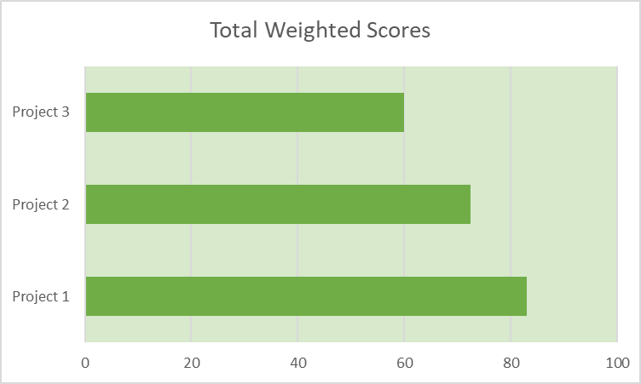

Threats Destroyed and Opportunities Provided by this Project

Most Competing airlines already have services similar to project 1 in place, and these services are always a benefit to them. Project 1 provides an opportunity to match our competitors and reap the same success they’ve found with their services. Not only can we reach the same standard as our competitors, but we can also rise above by looking at what does and doesn’t work well for our competitors services and choosing aspects that make our services preferable and profitable.

By not having the services detailed in project 1, it will be harder for Fly Dream Air to become a well-known/established airline, whilst our competitors with similar services to those proposed in project 1 either already are or are on their way to being known airlines amongst our customer base. This is a threat to Fly Dream, as without project 1’s services, customers could tend to stick with airlines they know or have heard of before, making us miss out on a nice portion of our potential customers.