Computer Graphics 2020

https://en.wikipedia.org/wiki/Computer_graphics
Computer graphics are pictures and movies created using computers – usually referring to image data created by a computer specifically with help from specialized graphical hardware and software. It is a vast and recent area in computer science. The phrase was coined by computer graphics researchers Verne Hudson and William Fetter of Boeing in 1960. It is often abbreviated as CG, though sometimes erroneously referred to as CGI.
Important topics in computer graphics include user interface design, sprite graphics, vector graphics, 3D modeling, shaders, GPU design, and computer vision, among others. The overall methodology depends heavily on the underlying sciences of geometry, optics, and physics. Computer graphics is responsible for displaying art and image data effectively and meaningfully to the user, and processing image data received from the physical world. The interaction and understanding of computers and interpretation of data has been made easier because of computer graphics. Computer graphic development has had a significant impact on many types of media and has revolutionized animation, movies, advertising, video games, and graphic design generally.
[3.18 10:00] Introduction to Graphics Programming
Geri's Game
https://www.youtube.com/watch?v=9IYRC7g2ICg

https://zoom.us/ download, make account, sign in

openChattingRoom@kakao https://open.kakao.com/o/ggC1Vc1b
10 minutes before class starts, the KakaoTalk open chat room will announce the meeting ID.

zoom meeting ID : ###-###-###

20185104 리쿤 20185106 푸루이 20185116 위히앙쉬 틴트림 데 아리
20195031 노룰로도프 올로비딘 20195032 니콜라우스 이삭 토마스
20195033 데이비드 이사악 코사시 20195037 수탄토 아리프 라치만
20195118 임마누엘인드라 20195119 친쯔지에
20195147 체리 도미니 카리스 20195149 알케코브세잇마메트

20205006 텐 에카테리나 20205054 김 엘레나

https://www.python.org/
Python Tutorial , A Byte of Python , Python GUI Programming
Cookbook
https://www.anaconda.com/


conda create -n yourenvname python=x.x anaconda
activate yourenvname
deactivate
conda env list
conda remove -n yourenvname --all
pip install pygame

https://www.pygame.org/news
https://www.slideshare.net/Felix11H/pygame-presentation
https://www.edureka.co/blog/pygame-tutorial
https://pythonprogramming.net/pygame-python-3-part-1-intro/
http://programarcadegames.com/


sample code
image.py
mouseMove.py
mouseKey.py
mouseMoveButton.py
curve_pattern.png
icon_speech.png

HW 1. Implement drawPolygon due to 3.25
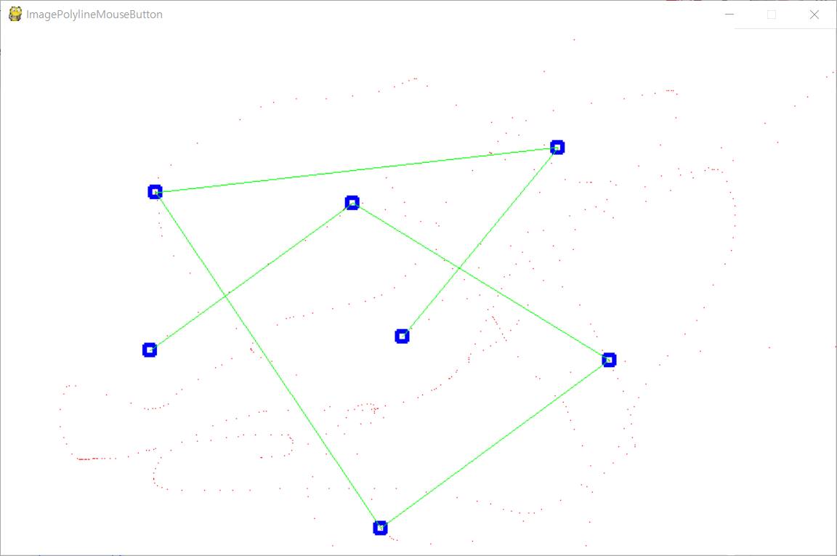
https://pypi.org/project/opencv-python/
https://readthedocs.org/projects/opencv-python-tutroals/
https://readthedocs.org/projects/opencv-python-tutroals/downloads/pdf/latest/
http://nummist.com/opencv/
https://techfort.github.io/pycv/


sample code
opencvMouse.py
opencvDrawing.py
opencvSubplot.py
opencvVideo.py
sku6710411.jpg

[3.25,4,1,8] Affine Combination (lab01, kmmcs, glut, ship)
Introduction to Curves and Surfaces SIGGRAPH 1996 Dr. Alyn P. Rockwood Organizer Peter Chambers Author & Presenter Dr. Hans Hagen Presenter Thomas McInerney Presenter
Handbook of Computer Aided Geometric Design Edited By G. Farin, Arizona State University, Tempe, USA, J. Hoschek, Technische Universitat, Darmstadt, Germany, M.-S. Kim, Seoul National University, South Korea
A History of Curves and Surfaces in CAGD By G. Farin, Arizona State University, USA
Spline Methods by Tom Lyche, Univ. of Oslo, Norway

JamBoard 200325 Note
HW 2. Implement drawLine function with drawPoint - initial code

[4.15,22] Subdivision Schemes
Center for Graphics and Geometric Computing, Technion, Dianne Hansford,
Joe Warren, Weiyin Ma, subdivision.org, Peter Schroder, KMMCS,
A Tutorial on CGAL Polyhedron for Subdivision Algorithms(zip)

[4.22] Self Introduction & Current Research Topics using Cloud Service
Registration

[4.29] CG&Geometry - Simplification
Surface simplification using a discrete curvature norm,
Fast and Memory Efficient Polygonal Simplification, bunnyLOD
http://doc.cgal.org/latest/Surface_mesh_simplification/
http://www.shapeways.com/tutorials/polygon_reduction_with_meshlab

Parametrization - Texture Mapping
Parameterization of Meshes and Its Applications
http://www.mn.uio.no/math/english/people/aca/michaelf/papers/papers.html
M. S. Floater, Parametrization and smooth approximation of surface triangulations,
Comp. Aided Geom. Design 14 (1997), 231-250.

[5.6] PhotoRealFaceAnimation

Image & Mesh Deformation
As-Rigid-As-Possible Shape Manipulation (Java, Windows)
http://www-ui.is.s.u-tokyo.ac.jp/~takeo/papers/rigid.pdf
http://www.dgp.toronto.edu/~rms/software/Deform2D/
http://www.youtube.com/watch?v=HKt8Qt4bLvI
Image Deformation using RBF (1)
https://drive.google.com/file/d/0BxzK5MFABzF1MHE1Z3lyMDNiODg/view?usp=sharing
http://faculty.cse.tamu.edu/schaefer/research/mls.pdf
https://drive.google.com/file/d/0BxzK5MFABzF1UlIzNG5mZkh6QTQ/view?usp=sharing
http://www.youtube.com/watch?v=g5l4IdtUCOo

Kinect Face Tracking + China Opera Mask
http://www.youtube.com/watch?v=C1JPUmq-X0w

Laplacian Surface Mesh Editing
http://www.cs.jhu.edu/~misha/Fall07/Papers/Sorkine04.pdf
http://www.cs.cmu.edu/afs/cs/academic/class/15462-s10/www/lec-slides/lec09.pdf
http://www.youtube.com/watch?v=38wF2Qnoc7A
Kinect - KinectFusion (1, 2, 3, 4, 5, 6)

[5,27] Topic Presentation using Cloud Service - Registration

01 http://research.microsoft.com/en-us/um/redmond/groups/ivm/ICE/
02 http://www.cs.bath.ac.uk/brown/autostitch/autostitch.html
03 http://photosynth.net/
04 http://phototour.cs.washington.edu/
05 https://www.cs.cornell.edu/~snavely/bundler/
06 http://www.leadtools.com/sdk/medical/3d.htm#3d_projection
07 http://opensourcephotogrammetry.blogspot.kr/
08 http://reconstructme.net/
09 http://visualsize.com/photomodel3d.php
10 https://threejs.org/
11 http://paperjs.org/

