Game Design Document

Fill up the following document

1. Write the title of your project.

C.P.S Test

1. What is the goal of the game?

Get the highest amount of clicks in a set amount of time

1. Write a brief story of your game.

When you load up the test you are greeted with a [ insert shape here ] on top of it are some timers like 5 sec, 10 sec, 15 sec, etc your goal is to click the most amount of times in the time you set and when the first click happens the timmer starts.

1. Which are the playing characters of this game?

* Playing characters are the ones who respond to the user based on the input from the user.
* Cars, monkeys, dinos, wizards, etc., are the playing characters in the game.

|  |  |  |
| --- | --- | --- |
| Number | Character Name | What can this character do? |
| 1 | mouse | click |
| 2 |  |  |
| 3 |  |  |
| 4 |  |  |
| 5 |  |  |
| 6 |  |  |
| 7 |  |  |
| 8 |  |  |

1. Which are the Non-Playing Characters of this game?

* Non-Playing characters are the ones that don't have an action or behavior when the user interacts with the game.
* Hurdles, stones, bananas, coins, etc., are non-playing characters in the game.

|  |  |  |
| --- | --- | --- |
| Number | Character Name | What can this character do? |
| 1 |  |  |
| 2 |  |  |
| 3 |  |  |
| 4 |  |  |
| 5 |  |  |
| 6 |  |  |
| 7 |  |  |
| 8 |  |  |

Draw your imagination of this game. What does this game look like?

* Draw the game either on your computer or on paper.
* Add images of the game scenes to show each of the playing and non-playing characters at least once.

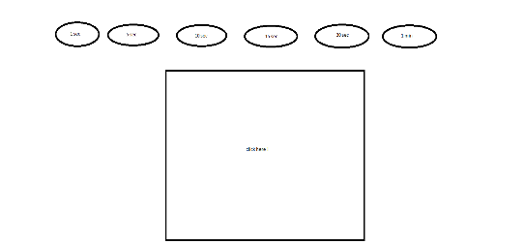

How do you plan to make your game engaging?

The competition between people will want to make them play more to get to #1