SecretsPay — Feature flowcharts
Web2.5 wallet on Stellar Testnet. One flowchart per feature, ready to copy into Word. This is not mainnet and not a bank: balances are test funds.

Feature index
1. Roles and navigation
2. Account registration
3. Sign in
4. Home — Customer
5. Home — Merchant
6. Send by public key
7. Pay with QR
8. Charge / invoice QR
9. Add funds
10. SEP-24 USDC deposit
11. SINPE Movil top-up (customer)
12. Virtual Visa
13. POS simulator
14. Map — Customer / Admin
15. Publish venue — Merchant
16. RWA — Learn
17. RWA — Tokenize asset
18. RWA — Marketplace
19. RWA — Portfolio and dividends
20. RWA — Structuring panel
21. Super admin / Distributor
22. Event cash desk
23. SINPE desk
24. Profile and sign out

1. Roles and navigation
Who reaches each screen. Event staff (cashier and SINPE desk) do not see Card, Map, or RWA.
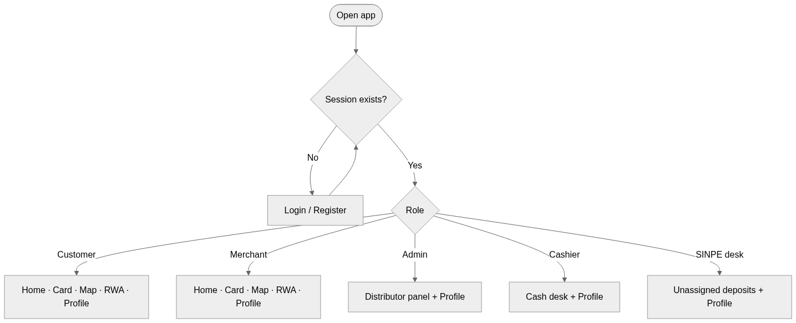

2. Account registration
The user picks Customer or Merchant. The server creates a keypair, funds it on Testnet, and stores the secret encrypted. The browser never sees the private key.
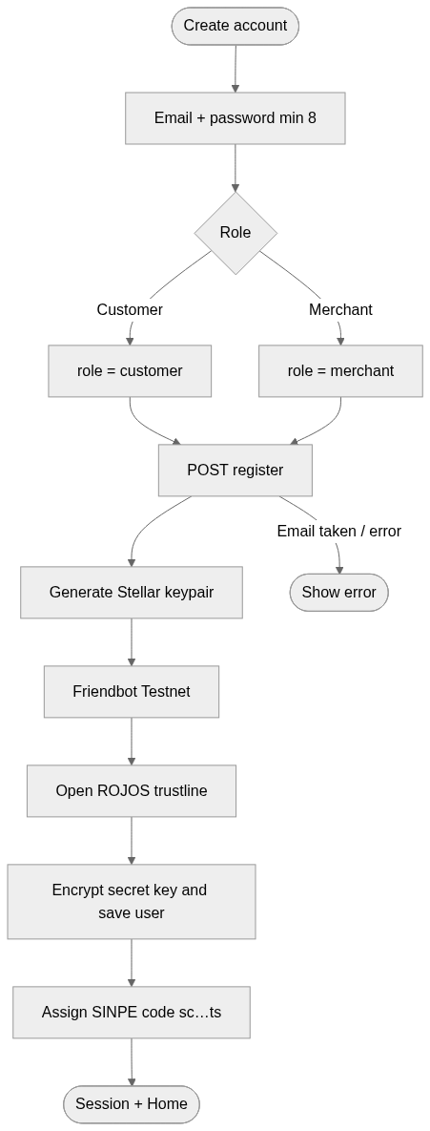

3. Sign in
Guests go to /login. If a session cookie already exists, they are redirected to Home.
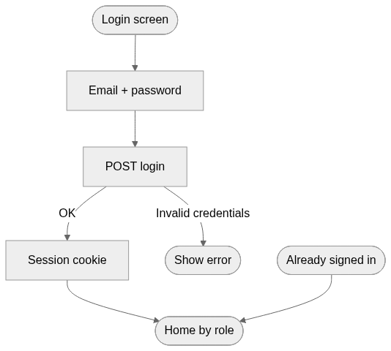

4. Home — Customer
Dashboard with ROJOS / XLM / USDC balances, SINPE top-ups, activity, and QR pay.
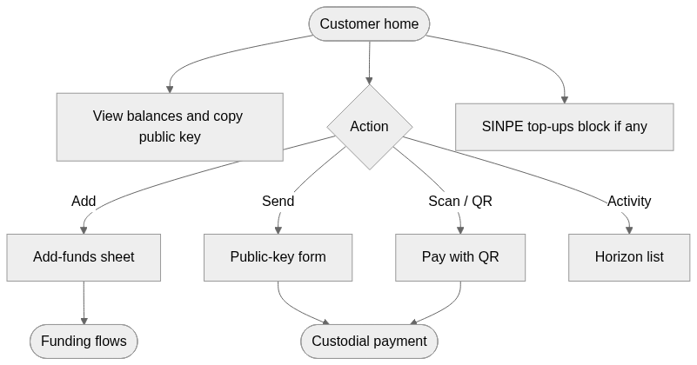

5. Home — Merchant
Same wallet as the customer, plus charge via invoice QR instead of scanning to pay.
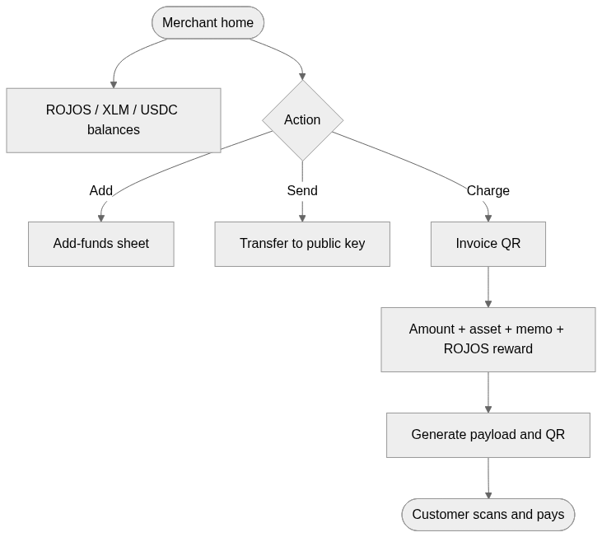

6. Send by public key
Custodial Testnet payment. The backend signs and may wrap a fee-bump. Default asset: ROJOS.
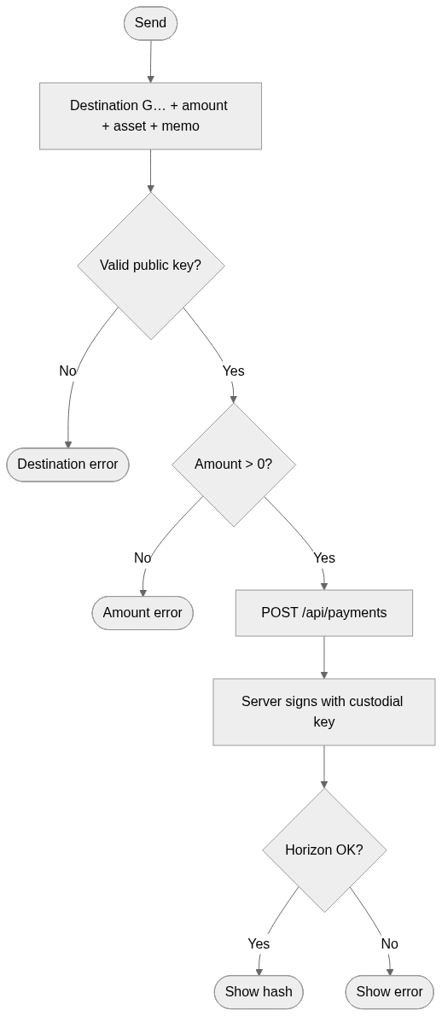

7. Pay with QR
The customer opens the camera or pastes SP1|… text. Confirms destination, amount, memo, and optional ROJOS reward.
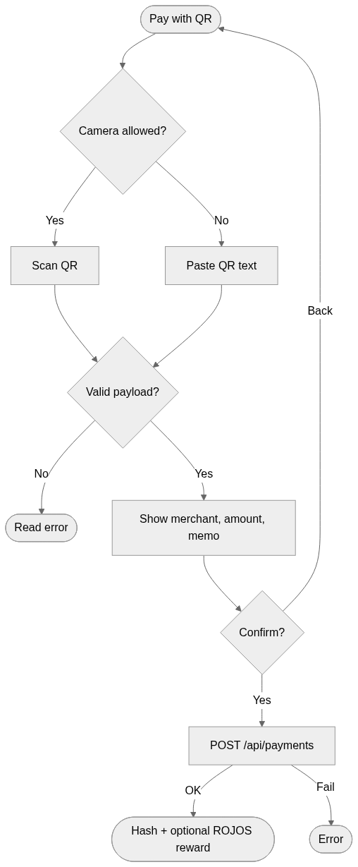

8. Charge / invoice QR
The merchant does not send the payment: they generate a QR that the customer settles on Testnet.
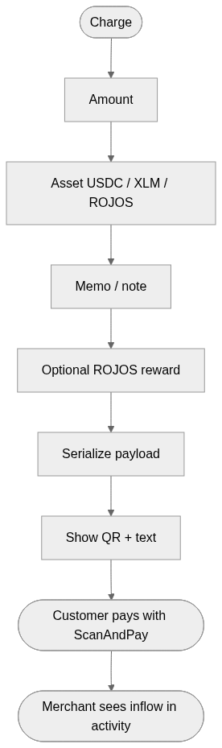

9. Add funds
Home → Add sheet. Four funding rails.
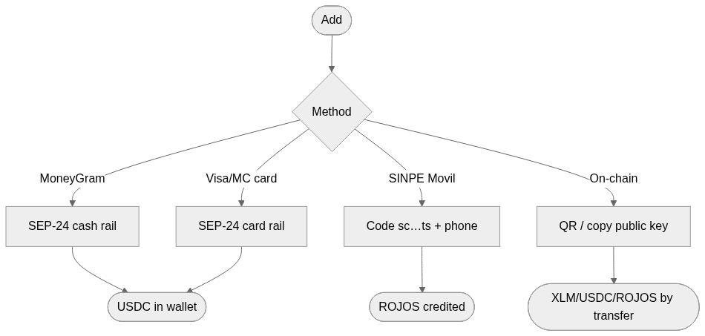

10. SEP-24 USDC deposit
MoneyGram cash or card. Requires a USDC trustline. The interactive anchor runs through server-side SEP-10/24.
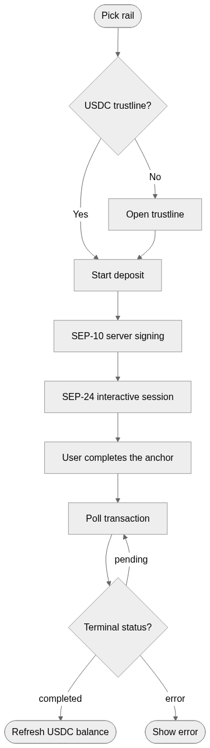

11. SINPE Movil top-up (customer)
Parity CRC 1,000 = 1 ROJO. Promo CRC 9,000 = 10 ROJOS. If the SMS has no account code, the deposit waits for a manual match.
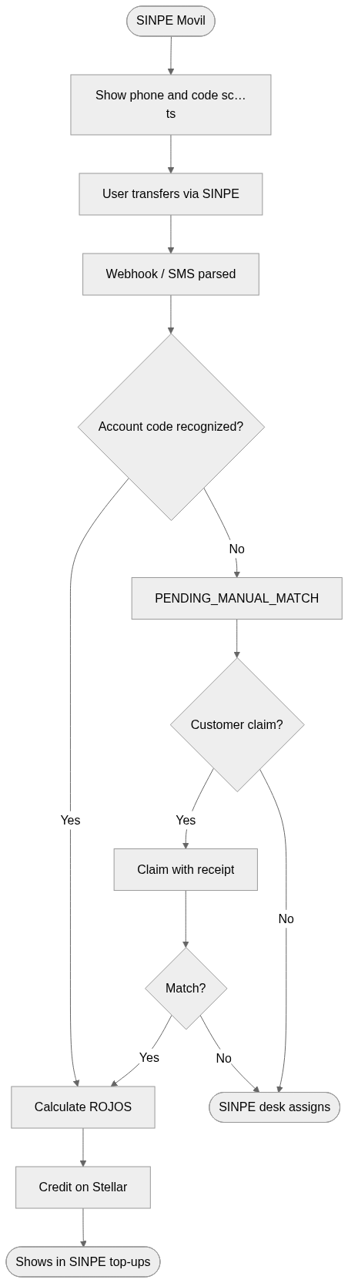

12. Virtual Visa
Rain Cards-style sandbox. Spendable balance is the Stellar account USDC. PAN/CVV only after Reveal details (20 s).
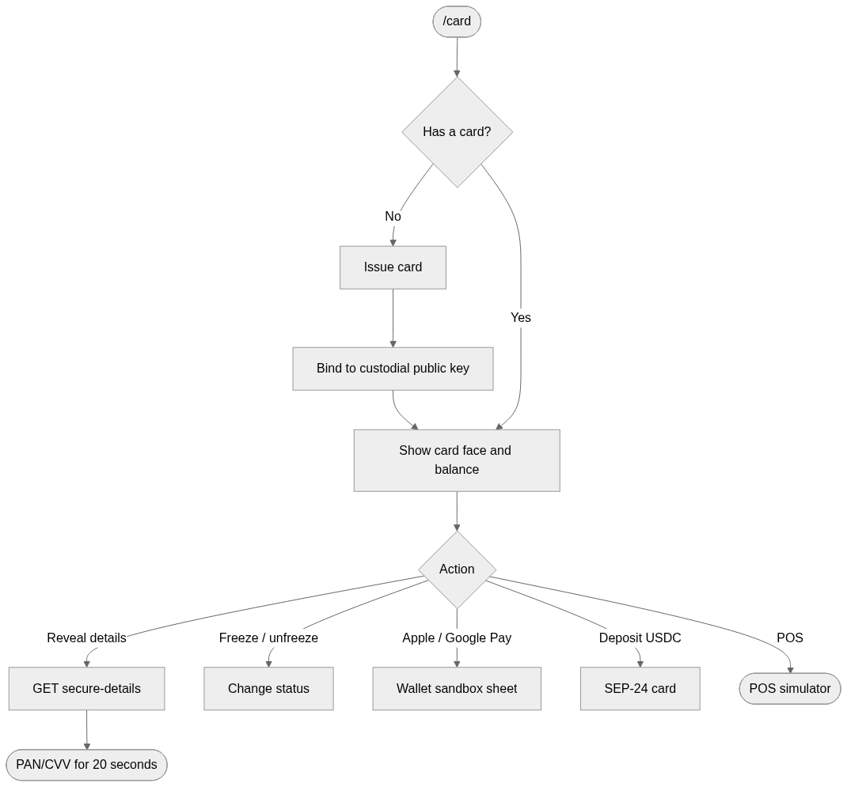

13. POS simulator
Sandbox Visa charge. If funds exist they are debited on Testnet to treasury. Frozen card or insufficient funds = declined.
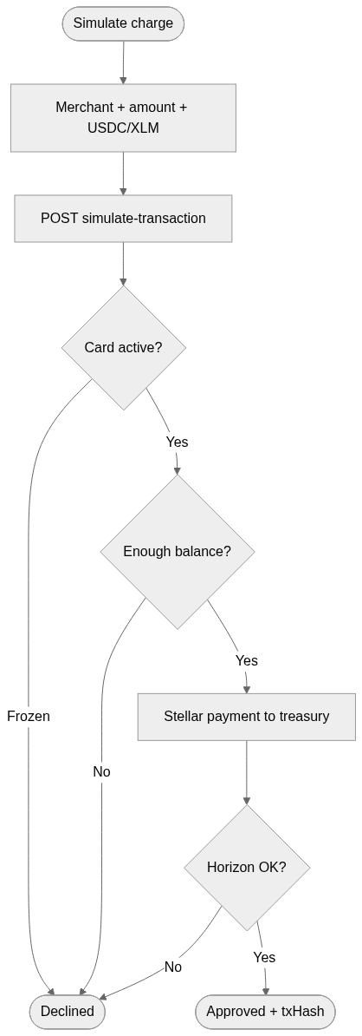

14. Map — Customer / Admin
Pins for published venues. Filter by category or ROJOS promo.
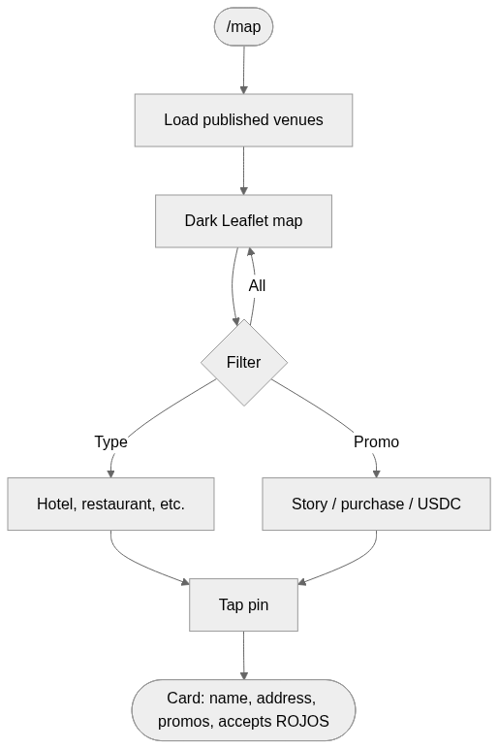

15. Publish venue — Merchant
Nominatim geocoding. ROJOS promos are visible to customers on the map.
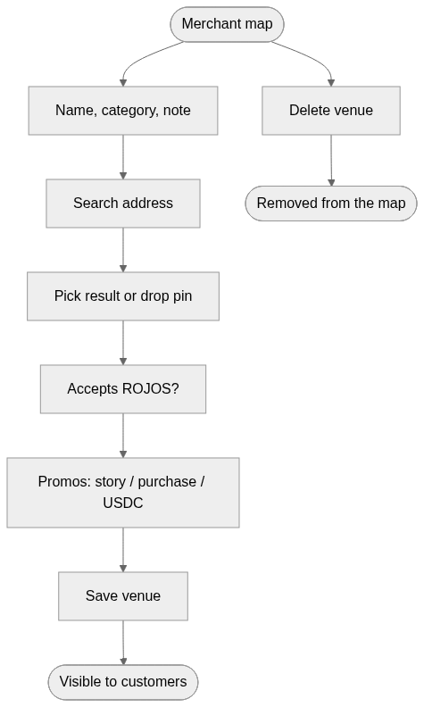

16. RWA — Learn
Education and FAQ. Tokenization is merchant/admin only. Customers go to the marketplace.
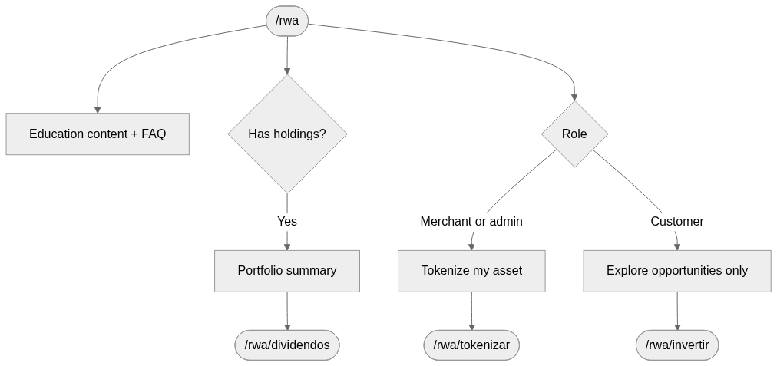

17. RWA — Tokenize asset
Five-step wizard. The file lands in audit for the structuring panel.
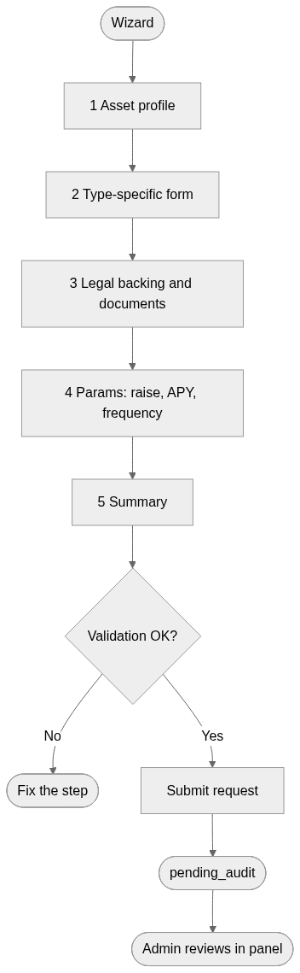

18. RWA — Marketplace
Buy with wallet USDC. Enforces minimum, remaining capacity, and the asset token trustline.
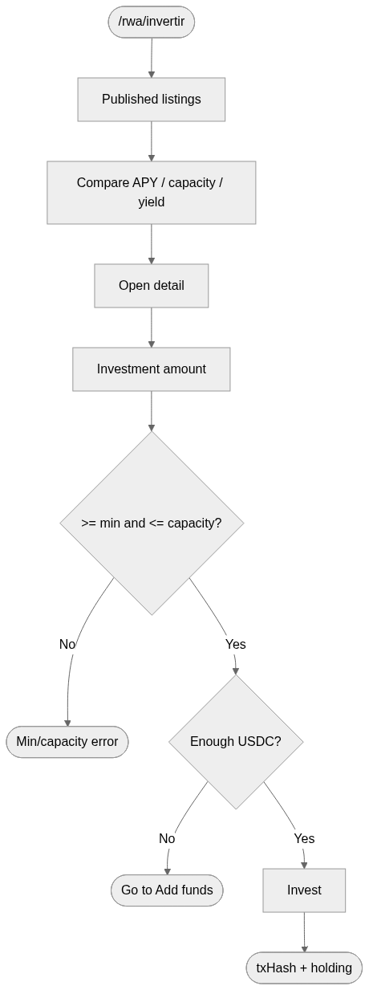

19. RWA — Portfolio and dividends
Invested capital, estimated yield, and claiming pending dividends.
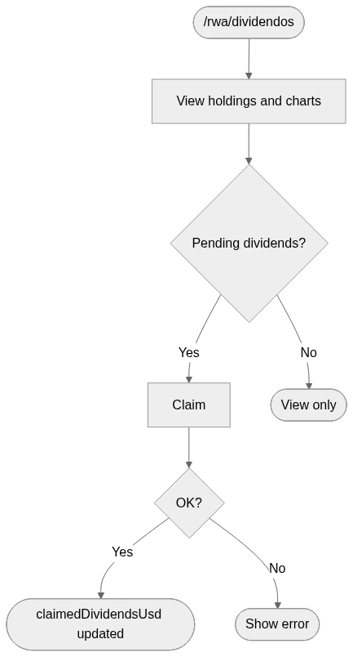

20. RWA — Structuring panel
Admin only. Audit → legal → approve (marketplace) or reject.
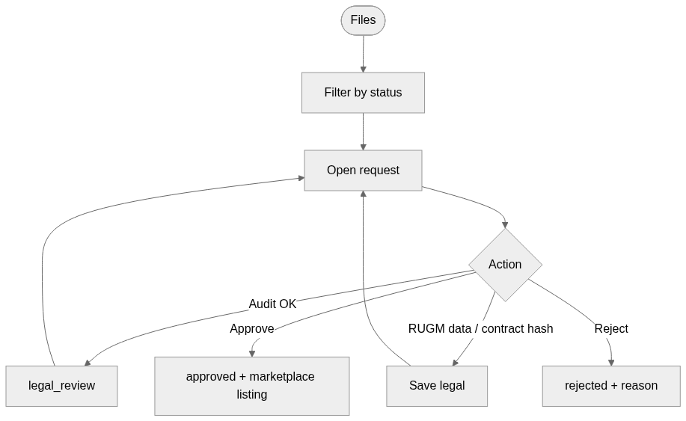

21. Super admin / Distributor
Admin home: finance, merchants, customers, RWA, and SINPE. Event staff do not use this panel.
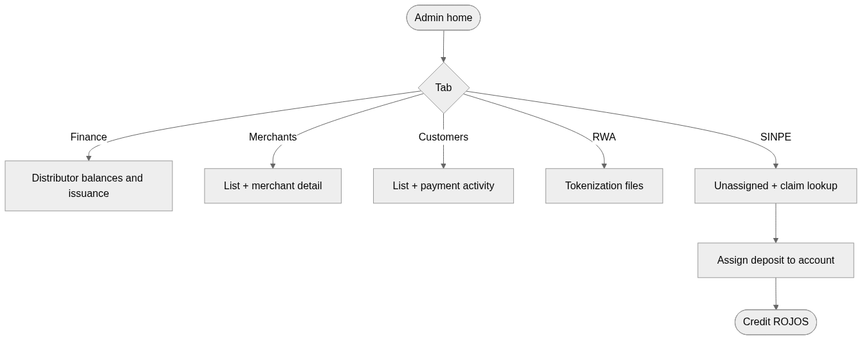

22. Event cash desk
Cashier role. Takes colones, finds the account, and credits ROJOS at the same SINPE parity.
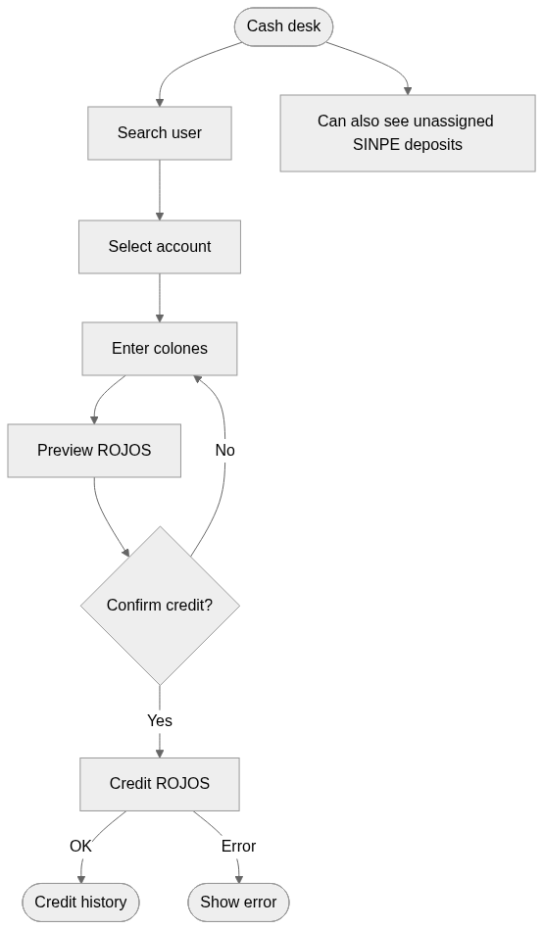

23. SINPE desk
sinpe_ops role. Same assignment tool as admin, without the rest of the panel.
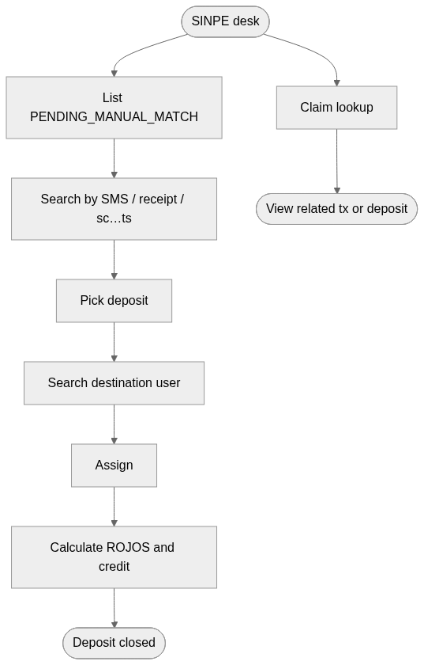

24. Profile and sign out
Account details, SINPE code when applicable, public key, and logout.
