Quick Testrecord documentation

Content
History 1
BETA Release V 1.2.2 1
Notes and Tips 1
Step by step example 2
GUI layout 2
Performing a search 3
Generating a record 3
Problem solving 4
“Wrong Datafinder” Problem 4
“Cannot open data store” Problem 5
“The index *** does not correspond to a member of the collection” Problem 5
Error Reporting 5

History

BETA Release V 1.2.2

Notes and Tips
All Notes and Tips written in this Document are also here for a quick overview.

ATTENTION: if it says “Matches found: > 999”, then there may be more shots, but the list can not show them all.

Note: If you specified an oscillogram number (1) and a Shot range (4), the program automatically selects all found shots.

Tip: When you for example selected a year, only available “Kinds of test objects” appear. If you are not sure about a property, fill in the others first.

Note: If you cancel the “Save PDF” Dialog, you do not generate this record.

Note: If the shots you selected are in different testshifts, the TestRecord Program will save it in a different PDF.

Step by step example

GUI layout
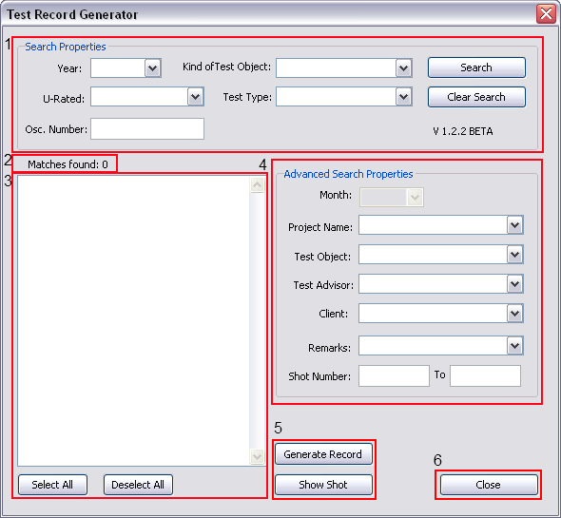

- “Search Properties” area. This is meant to eliminate as many shots as possible, so the first search doesn’t produce too many results.
- Shows the number of shots found. ATTENTION: if it says “Matches found: > 999”, then there may be more shots, but the list can not show them all.
- Lists found shots. Here you can select the shots you want to create a record of. You can select and deselect all shots with the two buttons.
- “Advanced Search Properties” Area. This appears after the first search. Here you can look for specific shots if needed
- “Show Shot” Button: Shows a shot in the Dataportal you selected in the list (3). Note: If you selected some shots, it takes the first one.
“Generate Record” Button: Generates a PDF for the shots you selected in the List (3). Note: If you specified an oscillogram number (1) and a Shot range (4), the program automatically selects all found shots.
- Closes Window

Performing a search
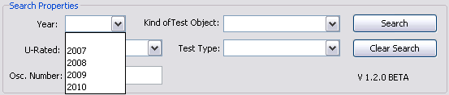
Step 1: Enter Search Properties

Tip: When you for example selected a year, only available “Kinds of test objects” appear. If you are not sure about a property, fill in the others first.

Step 2: Klick on “Search” Button.
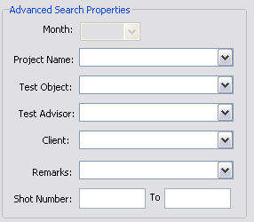
Step 3: If there are too many shots in the list, use the “Advanced search Properties” to get more precise results. Note: The month property is only available when you selected a year.

Generating a record
Step 1: Select Shots in the List

Step 2: Klick the “Generate Report” Button.

Step 3: A “Save PDF” Dialog appears, select the folder you want to put the record in.
Note: If you cancel the “Save PDF” Dialog, you do not generate this record.

Step 4: A window appears, if you want to add a picture of the Test Setup to the Record.

Note: If the shots you selected are in different testshifts, the TestRecord Program will save it in a different PDF. You will have to repeat Step 3 and 4.

HowTo

How to Add/Change/Remove S
Open file “C:\DIAdem\abbext\TestRecord\TableStandards.txt”. In this file, all the Datapages standard layouts are defined.

Current defined Standards:
- STD
- Bustransfer
- Internal arc
- Synthetik

Problem solving

“Wrong Datafinder” Problem

Solution:
Step 1: click on an empty Gear, usually number 2 is empty.
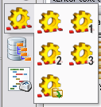

Step 2: A Message box appears with:“The Button has no Datafinder. Do you want to select a Datafinder?”
Klick “Yes”

Step 3: Select the acqui@CH-W-0014698 and click OK.
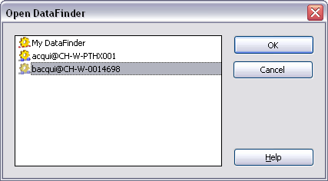

Step 4: Select the Gear with the acqui Datafinder
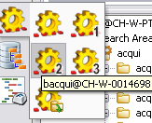

“Cannot open data store” Problem
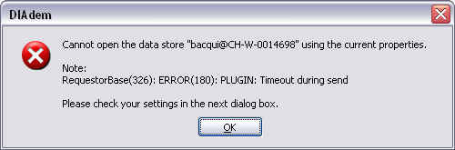

acqui Datafinder is currently offline or you may have no network connection.

“The index *** does not correspond to a member of the collection” Problem
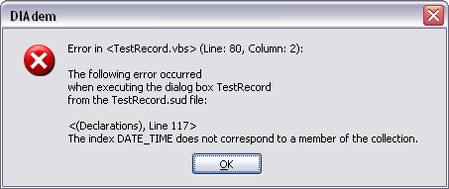

Solution:
Step 1: Make sure you have the acqui Datafinder selected.

Step 2: If the Problem persists, then you are not able to connect to acqui. Either the Datafinder is offline or you have no connection.

Error Reporting
Write an Email to: Jonas.Schwammberger@ch.abb.com (Valid until February 2011)
Append a Screenshot of the Error-Message.
If possible, append a screenshot of the GUI with the search values and Shots too, or write them in the Email.

