Visual Exploratory Data Analysis (VisEDA): PART D
Point Cloud Exploratory Data Analysis
A Guide to 3D Point Cloud Dataset Analysis

Isaac Osei Agyemang
Version 1.0.0
2026

Preface
VisEDA was created to bring the discipline and convenience of exploratory data analysis to visual and spatial datasets. Point clouds require a specialised form of EDA because every sample is an unordered set of three-dimensional coordinates, often augmented with intensity, colour, or sensor-specific attributes. Dataset quality cannot be assessed reliably from a single 3D preview: density, scale, coordinate extent, duplication, missing values, outliers, point spacing, height structure, and geometric shape must all be examined quantitatively.
PointCloudEDA provides one unified interface for a single cloud, a list of clouds, a directory of point-cloud files, or in-memory NumPy arrays. It computes per-cloud geometry, height statistics, nearest-neighbour spacing, data-quality indicators, PCA-based shape descriptors, attribute summaries, and dataset-level distances. It also produces a comprehensive dashboard, single-cloud projections, cloud preview grids, height-distribution overlays, pairwise-distance heatmaps, and a self-contained HTML report.
Isaac Osei Agyemang
August 2026

Table of Contents
Preface 2
Table of Contents 3
Chapter 1 — Introduction 6
1.1 What is PointCloudEDA? 6
1.2 Why Point Cloud EDA Matters 6
1.3 The Point Cloud Data Model 6
1.4 Design Philosophy 6
1.5 Installation 7
1.6 Supported Data Formats 7
1.7 Coordinate and Attribute Conventions 7
Chapter 2 — Quick Start 8
2.1 Analyse a Directory 8
2.2 Analyse a Single File 8
2.3 Load NumPy Arrays Directly 8
2.4 Obtain the Summary 9
2.5 Generate All Visualisations 9
2.6 Generate an HTML Report 9
2.7 Command-Line Interface 9
2.8 Run the Complete Test Script 9
Chapter 3 — The PointCloudEDA Class 10
3.1 Constructor 10
3.2 load() — Files and Directories 10
3.3 load_arrays() — In-Memory Clouds 10
3.4 summary() — Nested Dataset Statistics 10
3.5 get_record() and get_cloud() 11
3.6 pairwise_cloud_distances() 11
3.7 report() 12
Chapter 4 — The PointCloudRecord Object 13
4.1 Identity and Status Fields 13
4.2 Coordinate and Extent Fields 13
4.3 Height and Radial Fields 13
4.4 Quality Fields 13
4.5 PCA Shape Descriptors 14
4.6 Attribute and Preview Fields 14
Chapter 5 — What Is Analysed 15
5.1 Input Validation and Finite Filtering 15
5.2 Reproducible Downsampling 15
5.3 Coordinate Statistics and Centroid 15
5.4 Bounding Box, Volume, and Density 15
5.5 Height Structure 15
5.6 Radial Spread and Outlier Fraction 15
5.7 Duplicate Fraction 16
5.8 Nearest-Neighbour Spacing 16
5.9 PCA-Based Global Shape 16
5.10 Intensity and RGB Attributes 16
5.11 Descriptor-Space Dataset Distance 16
Chapter 6 — Visualisations 17
6.1 plot_dataset() — Dataset Dashboard 17
Row 1: Dataset Overview and Label Distribution 18
Row 2: Point Count, Volume, Density, and Height Variation 18
Row 3: XYZ Spans and Quality Metrics 18
Row 4: PCA Shape Descriptors and Distance Heatmap 18
6.2 plot() — Single-Cloud Dashboard 18
Cloud Overview Card 19
3D Scatter and Orthographic Projections 19
Height Histogram and XY Density Map 19
Nearest-Neighbour Spacing 19
6.3 plot_clouds_grid() — Preview Grid 19
6.4 plot_height_distribution() — Z Distribution Overlay 19
6.5 plot_pairwise_cloud_distances() — Distance Heatmap 20
Chapter 7 — Interpreting Results and Common Findings 22
7.1 Red Flags to Review 22
7.2 Reading Shape Descriptors Together 22
7.3 Interpreting Density Carefully 22
7.4 Example Findings from the Attached Outputs 22
7.5 Thresholds Are Dataset-Dependent 23
Chapter 8 — Advanced Usage 24
8.1 Working with Large Datasets 24
8.2 Access and Filter Records 24
8.3 Export Records to pandas 24
8.4 Use PointCloudEDA Before Model Training 25
8.5 Prevent Similarity Leakage 25
8.6 Compare Two Datasets 25
8.7 Reproducibility Considerations 25
Chapter 9 — HTML Report, CLI, and Testing 26
9.1 HTML Report Structure 26
9.2 Command-Line Options 26
9.3 Test Coverage 26
9.4 Common Errors 26
Chapter 10 — API Reference 27
10.1 Return and Failure Behaviour 27
Chapter 11 —Roadmap 28
Version 1.0.0 28
Roadmap 28
Appendix A — PointCloudRecord Fields 29
Appendix B — summary() Schema 30
Appendix C — Mathematical Reference 31
Appendix D — Glossary 32
Appendix E — Acknowledgements 33

Chapter 1 — Introduction

1.1 What is PointCloudEDA?
PointCloudEDA is the 3D point-cloud analysis module of VisEDA. It analyses individual point clouds and complete point-cloud datasets using the same PointCloudEDA class. The first three columns of every input array are interpreted as X, Y, and Z coordinates. Additional columns are retained as attributes and may represent intensity or RGB information.
At the individual-cloud level, PointCloudEDA computes coordinate ranges, centroid, bounding-box dimensions, volume, density, height statistics, radial spread, duplicate fraction, finite fraction, outlier fraction, nearest-neighbour spacing, PCA shape descriptors, intensity statistics, and colour statistics. At the dataset level, it aggregates these records into distributions, class counts, quality summaries, geometric comparisons, and pairwise descriptor-space distances.

1.2 Why Point Cloud EDA Matters
- Coordinate validity: NaN and infinite XYZ rows can silently break registration, voxelisation, meshing, and neural-network pipelines.
- Point-count variation: Clouds with a few hundred points and clouds with millions of points require different sampling and batching strategies.
- Scale and units: Metres, centimetres, millimetres, and arbitrary normalised coordinates can coexist unless explicitly audited.
- Density inconsistency: Two clouds may describe the same object but use very different sampling densities, biasing local geometric features.
- Duplicate points: Repeated XYZ coordinates inflate point counts without adding information and can distort neighbour statistics.
- Outliers: Isolated points far from the main cloud can expand the bounding box and destabilise normalisation.
- Shape imbalance: A dataset may contain mostly planar, linear, or volumetric structures even when class labels appear balanced.
- Attribute inconsistency: Some files may contain intensity or RGB columns while others contain only XYZ.
- Data leakage: Near-identical clouds can appear in both training and validation sets unless descriptor similarity is checked.
- Corrupt formats: Malformed PLY headers, missing LAS dependencies, or inconsistent text delimiters can leave unreadable samples.

1.3 The Point Cloud Data Model
A point cloud is represented as an N × D matrix. N is the number of points and D is the number of columns. PointCloudEDA requires D ≥ 3, with columns 0, 1, and 2 corresponding to X, Y, and Z. A one-dimensional input containing at least three values is reshaped to a single-point cloud.
P ∈ ℝ^(N × D), D ≥ 3
Columns 0–2 are XYZ; later columns are optional attributes.
The implementation converts arrays to float32 and removes rows whose XYZ coordinates are not all finite. The fraction retained is recorded as finite_fraction. If no finite XYZ rows remain, the cloud is marked corrupt.

1.4 Design Philosophy
- One interface for files and arrays. load() handles files and directories; load_arrays() handles in-memory arrays.
- Dataset-first EDA. The implementation emphasises distributions and comparisons across clouds, not only attractive 3D previews.
- Reproducible downsampling. Large clouds are sampled with a fixed random seed and sorted selected indices.
- Optional expensive analyses. Nearest-neighbour and PCA geometry calculations can be disabled for quick runs.
- Lazy dependencies. scikit-learn and laspy are imported only when the corresponding features or formats are used.
- Transparent records. Every analysed cloud is represented by a PointCloudRecord containing the computed values.
- Graceful degradation. Missing optional dependencies produce unavailable metrics rather than preventing the remainder of the analysis.

1.5 Installation
# Core package
pip install viseda numpy matplotlib
# Nearest-neighbour calculations
pip install scikit-learn
# LAS / LAZ point clouds
pip install laspy
pip install "laspy[lazrs]"
# Editable Word documentation generator
pip install python-docx pillow
Note: LAS files can be read with laspy. LAZ decompression normally requires an additional backend such as lazrs. When compute_neighbors=False, scikit-learn is not required for nearest-neighbour spacing.

1.6 Supported Data Formats
Table 1. Supported PointCloudEDA input formats.
Extension | Reader | Expected layout | Notes
.npy | numpy.load | N × D, D ≥ 3 | Direct NumPy array.
.npz | numpy.load | First array in archive | The first key is used.
.txt | numpy.loadtxt | Whitespace-delimited columns | XYZ followed by optional attributes.
.csv | numpy.loadtxt | Comma-delimited columns | Headerless numeric CSV expected.
.xyz | numpy.loadtxt | Whitespace-delimited XYZ | Additional columns are accepted.
.pts | numpy.loadtxt | Whitespace-delimited points | Additional columns are accepted.
.ply | Internal ASCII parser | ASCII vertex properties | Binary PLY is not handled by the current parser.
.las/.laz | laspy.read | LAS coordinates and attributes | Requires laspy; LAZ may require lazrs.

1.7 Coordinate and Attribute Conventions
PointCloudEDA does not assume a particular coordinate reference system or physical unit. X, Y, and Z are analysed exactly as supplied. Consequently, bounding-box volume and density are only comparable when clouds use compatible units and coordinate conventions.
A fourth column is treated as intensity when present. Colour detection requires at least six columns; the final three columns are interpreted as RGB and normalised to [0,1]. If RGB values exceed 1, they are divided by max(255, observed maximum).
Note: The current colour detector classifies every cloud with at least six columns as colour-bearing. Ensure the last three columns genuinely represent RGB.

Chapter 2 — Quick Start

2.1 Analyse a Directory
from viseda import PointCloudEDA
# Example structure
# pointcloud_dataset/
# plane/
# plane.laz
# vegetation/
# vegetation_1_3.las
eda = PointCloudEDA(
verbose=True,
max_points_per_cloud=200_000,
compute_neighbors=True,
compute_geometry=True,
)
eda.load(
"pointcloud_dataset/",
label_from_parent=True,
recursive=True,
)
summary = eda.summary()
print(summary["inventory"])
print(summary["geometry"])
print(summary["quality"])
eda.plot_dataset(
save_path="outputs_pointcloud/plot_dataset.png"
)

2.2 Analyse a Single File
from viseda import PointCloudEDA
eda = PointCloudEDA()
eda.load("plane.laz")
rec = eda.get_record(0)
print(rec.n_points)
print(rec.bbox_size)
print(rec.planarity)
eda.plot(
cloud_index=0,
save_path="outputs_pointcloud/plot.png",
)

2.3 Load NumPy Arrays Directly
import numpy as np
from viseda import PointCloudEDA
cloud_a = np.load("bridge.npy") # shape (N, D)
cloud_b = np.load("road.npy")
eda = PointCloudEDA(
max_points_per_cloud=100_000,
compute_neighbors=True,
compute_geometry=True,
)
eda.load_arrays(
[cloud_a, cloud_b],
labels=["bridge", "road"],
names=["bridge_001", "road_001"],
)
eda.plot_clouds_grid(n=2, cols=2)

2.4 Obtain the Summary
stats = eda.summary()
print(stats["inventory"])
print(stats["geometry"])
print(stats["height"])
print(stats["quality"])
print(stats["shape_descriptors"])
print(stats["attributes"])

2.5 Generate All Visualisations
eda.plot_dataset() # dataset dashboard
eda.plot(cloud_index=0) # single-cloud dashboard
eda.plot_clouds_grid(n=12, cols=4) # 3D preview grid
eda.plot_height_distribution() # overlaid Z distributions
eda.plot_pairwise_cloud_distances() # descriptor-distance heatmap
# Save instead of displaying
eda.plot_dataset(
save_path="outputs_pointcloud/plot_dataset.png",
dpi=150,
)

2.6 Generate an HTML Report
report_path = eda.report(
"outputs_pointcloud/viseda_pointcloud_report.html"
)
print(report_path)

2.7 Command-Line Interface
# Full dataset analysis and report
viseda cloud pointcloud_dataset/ -- label-from-parent --report outputs_pointcloud/report.html --plot --save-plot outputs_pointcloud/plot_dataset.png
# Limit clouds and per-cloud points
viseda cloud pointcloud_dataset/ --max-clouds 100 --max-points 200000 --label-from-parent
Note: The current CLI exposes max_clouds and max_points_per_cloud. More specialised constructor options such as compute_neighbors, compute_geometry, neighbor_sample_size, and duplicate_decimals are available through the Python API.

2.8 Run the Complete Test Script
# Synthetic data only
python testpointcloud.py
# Analyse a directory and save plots
python testpointcloud.py --dir "C:/path/to/pointclouds" --save-plots --quick
# Analyse one file
python testpointcloud.py --file "C:/path/to/cloud.laz" --save-plots

Chapter 3 — The PointCloudEDA Class

3.1 Constructor
from viseda import PointCloudEDA
eda = PointCloudEDA(
verbose=True,
max_clouds=None,
max_points_per_cloud=200_000,
sample_seed=0,
compute_neighbors=True,
compute_geometry=True,
neighbor_sample_size=10_000,
duplicate_decimals=5,
)
Table 2. PointCloudEDA constructor parameters.
Parameter | Type/default | Meaning and practical effect
verbose | bool = True | Print loading progress and error messages.
max_clouds | int | None = None | Limit the number of clouds analysed.
max_points_per_cloud | int | None = 200000 | Randomly downsample clouds above this count; None retains all points.
sample_seed | int = 0 | Seed used for reproducible downsampling and sampling.
compute_neighbors | bool = True | Compute nearest-neighbour spacing with scikit-learn.
compute_geometry | bool = True | Compute covariance-eigenvalue shape descriptors.
neighbor_sample_size | int = 10000 | Maximum points used for nearest-neighbour calculations.
duplicate_decimals | int = 5 | XYZ rounding precision used to estimate duplicate points.

3.2 load() — Files and Directories
def load( self, source: Union[str, Path, Sequence[Union[str, Path]]], labels: Optional[Dict[str, str]] = None, label_from_parent: bool = False, recursive: bool = True, ) -> "PointCloudEDA":
load() resolves a single file, a sequence of files, or a directory. Directory discovery uses the supported extension set and can recurse into subdirectories. If max_clouds is configured, the resolved path list is truncated before analysis.
labels accepts a mapping from path to label. With label_from_parent=True, the immediate parent directory name becomes the label. Each file is read, downsampled if necessary, stored in the internal array cache, and converted into a PointCloudRecord.

3.3 load_arrays() — In-Memory Clouds
def load_arrays( self, arrays: Sequence[np.ndarray], labels: Optional[Sequence[str]] = None, names: Optional[Sequence[str]] = None, ) -> "PointCloudEDA":
load_arrays() accepts any sequence of N × D arrays. The optional labels and names sequences are truncated consistently when max_clouds is set. Names default to <array_0>, <array_1>, and so forth. Invalid arrays are retained as corrupt records with their error messages.

3.4 summary() — Nested Dataset Statistics
def summary(self) -> Dict[str, Any]:
summary() returns inventory, geometry, height, quality, shape_descriptors, and attributes sections. Each scalar distribution uses the same statistics schema: count, mean, standard deviation, minimum, 25th percentile, median, 75th percentile, and maximum.
{
"inventory": {
"total_clouds", "valid_clouds", "corrupt_clouds",
"corrupt_paths", "format_distribution",
"label_distribution", "point_count",
"dimension_count", "has_color_count",
"has_intensity_count"
},
"geometry": {
"bbox_volume", "density",
"span_x", "span_y", "span_z",
"bbox_size_mean", "xyz_mean_mean", "xyz_std_mean"
},
"height": {
"height_min", "height_max",
"height_mean", "height_std"
},
"quality": {
"finite_fraction", "duplicate_fraction",
"outlier_fraction", "nearest_neighbor_mean",
"nearest_neighbor_median", "nearest_neighbor_std"
},
"shape_descriptors": {
"linearity", "planarity",
"scattering", "curvature"
},
"attributes": {
"intensity_mean", "intensity_std",
"rgb_mean_mean", "rgb_std_mean"
}
}

3.5 get_record() and get_cloud()
record = eda.get_record(index=0)
cloud = eda.get_cloud(index=0)
print(record.path)
print(record.n_points)
print(cloud.shape)
get_record() returns the PointCloudRecord object. get_cloud() returns the loaded and potentially downsampled array associated with the record. For file-backed records, the array is normally served from the internal cache created during loading.

3.6 pairwise_cloud_distances()
def pairwise_cloud_distances(self, max_clouds: int = 50) -> Tuple[np.ndarray, List[str]]:
This method compares clouds using 15 summary descriptors rather than raw point-to-point Chamfer distance. The feature vector contains point count; X, Y, and Z spans; bounding-box volume; density; height mean and standard deviation; nearest-neighbour mean; duplicate and outlier fractions; and the four PCA shape descriptors.
Every feature is z-score normalised across the selected clouds. Zero standard deviations are replaced by 1, missing or infinite values are converted to 0, and Euclidean distances are calculated in the normalised descriptor space.
$$Dᵢⱼ = √Σₖ (Zᵢₖ - Zⱼₖ)²$$
Z is the z-score-normalised 15-feature cloud descriptor.
Note: The result is not a Chamfer, Hausdorff, Earth Mover's, or ICP alignment distance. It compares global descriptors and is designed for fast dataset-level EDA.

3.7 report()
def report(self, output_path: str = "viseda_pointcloud_report.html") -> str:
report() writes a self-contained HTML document using light-theme cards and statistic rows. It includes inventory, geometry, height, quality, shape descriptors, and attribute summaries.

Chapter 4 — The PointCloudRecord Object
Every loaded sample produces one PointCloudRecord. The object is intentionally lightweight and uses __slots__ to define all fields. Fields that cannot be computed because an optional analysis is disabled or a dependency is unavailable are set to None.

4.1 Identity and Status Fields
Field | Meaning
path | File path, supplied name, or <array_N> identifier.
label | Class label from the mapping or parent folder.
file_ext | Input extension or 'array'.
file_size_kb | File size in kilobytes for file-backed clouds.
n_points | Number of finite points after downsampling and filtering.
n_dims | Number of columns in the normalised array.
dtype | Internal array dtype.
has_color | Whether the cloud has at least six columns and final RGB-like columns.
has_intensity | True when at least four columns are present.
is_corrupt | Whether loading or analysis failed.
error | Stored exception message for a corrupt record.

4.2 Coordinate and Extent Fields
Field | Shape / type | Meaning
xyz_min | 3-vector | Minimum X, Y, Z.
xyz_max | 3-vector | Maximum X, Y, Z.
xyz_mean | 3-vector | Coordinate mean.
xyz_std | 3-vector | Coordinate standard deviation.
centroid | 3-vector | Copy of xyz_mean.
bbox_size | 3-vector | xyz_max − xyz_min.
span_x/y/z | scalar | Individual bounding-box dimensions.
bbox_volume | scalar | Product of spans with a 1e−12 floor per dimension.
density | scalar | n_points divided by bounding-box volume.

4.3 Height and Radial Fields
Field | Meaning
height_min / max | Minimum and maximum Z.
height_mean / std | Mean and standard deviation of Z.
z_percentiles | Z percentiles at 0, 5, 25, 50, 75, 95, and 100.
radial_distance_mean | Mean Euclidean distance from the centroid.
radial_distance_std | Standard deviation of centroid distances.

4.4 Quality Fields
Field | Meaning
finite_fraction | Fraction of original rows whose XYZ values are all finite.
duplicate_fraction | Fraction lost when rounded XYZ rows are reduced to unique coordinates.
outlier_fraction | Fraction whose centroid distance exceeds mean + 3 standard deviations.
nearest_neighbor_mean | Mean nearest-other-point distance.
nearest_neighbor_median | Median nearest-other-point distance.
nearest_neighbor_std | Variability of nearest-neighbour spacing.

4.5 PCA Shape Descriptors
Field | Formula | Interpretation
linearity | (λ₁−λ₂)/λ₁ | High when one principal direction dominates.
planarity | (λ₂−λ₃)/λ₁ | High for broad, thin surfaces.
scattering | λ₃/λ₁ | High for volumetric, isotropic point distributions.
curvature | λ₃/(λ₁+λ₂+λ₃) | Smallest-eigenvalue contribution to total variance.
normal_entropy | −Σ pᵢ log(pᵢ) | Entropy of the normalised eigenvalue spectrum.

Note: The implementation computes one global covariance matrix per cloud, not local neighbourhood descriptors at every point. The resulting values summarise overall cloud shape.

4.6 Attribute and Preview Fields
Field | Meaning
intensity_mean / std | Mean and standard deviation of column 3 when present.
rgb_mean / std | Mean and standard deviation of the final three columns after RGB normalisation.
sample_points | Up to 5,000 XYZ points retained for quick plotting.

Chapter 5 — What Is Analysed

5.1 Input Validation and Finite Filtering
The normaliser requires a two-dimensional array with at least three columns. A one-dimensional vector of length at least three is treated as one point. The first quality calculation is finite_fraction: the mean of a mask that requires all three XYZ values to be finite.
finite_fraction = N_finite / N_original
Rows with invalid XYZ values are removed before all subsequent calculations. Attributes in remaining rows are not required to be finite for the XYZ geometry, although intensity and RGB summaries explicitly filter non-finite attribute values.

5.2 Reproducible Downsampling
When a cloud contains more than max_points_per_cloud points, the implementation selects a random subset without replacement using NumPy's default_rng(sample_seed). The chosen indices are sorted before indexing so that the output remains in original row order.
Note: n_points refers to the analysed/downsampled cloud, not necessarily the original file point count. Set max_points_per_cloud=None to retain all points when memory permits.

5.3 Coordinate Statistics and Centroid
PointCloudEDA calculates minimum, maximum, mean, and standard deviation independently for X, Y, and Z. The centroid equals the arithmetic coordinate mean.
$$c = (1/N) Σᵢ pᵢ$$
pᵢ is the XYZ coordinate of point i.

5.4 Bounding Box, Volume, and Density
bbox_size = xyz_max − xyz_min
bbox_volume = $∏ₐ$ max($bbox_sizeₐ$, $10⁻¹²$)
density = N / bbox_volume
Density is therefore an axis-aligned bounding-box density, not surface density or neighbourhood density. It is highly sensitive to coordinate units and outliers. A single remote point can enlarge the bounding box and reduce the reported density.

5.5 Height Structure
The Z column is treated as height. PointCloudEDA stores minimum, maximum, mean, standard deviation, and seven percentiles. These summaries are useful for comparing terrain, vegetation, road, object, and building clouds.
Note: If the dataset uses a coordinate system where another axis is vertical, rotate or reorder the coordinates before loading.

5.6 Radial Spread and Outlier Fraction
For each point, PointCloudEDA calculates its Euclidean distance from the centroid. Points whose distance exceeds the mean radial distance plus three radial standard deviations are counted as outliers.
outlier = [$rᵢ >$ mean(r) + $3·std(r)$]
outlier_fraction = N_outlier / N
This is a global radial heuristic. It is effective for isolated far-away points but can classify legitimate distant structures as outliers in elongated or multi-component clouds.

5.7 Duplicate Fraction
XYZ coordinates are rounded to duplicate_decimals places. The number of unique rounded rows is compared with the analysed point count.
duplicate_fraction = 1 − N_unique(round(XYZ, d)) / N
The decimal precision determines the spatial tolerance. With duplicate_decimals=5, points that differ only beyond five decimal places are treated as duplicates.

5.8 Nearest-Neighbour Spacing
When compute_neighbors=True, up to neighbor_sample_size points are sampled. scikit-learn NearestNeighbors is fitted with n_neighbors=2. The first returned neighbour is the point itself; the second distance is the nearest other point.
The mean, median, and standard deviation describe local spacing. Low mean spacing indicates dense sampling. High spacing variability may indicate holes, mixed densities, or multiple spatial components.

5.9 PCA-Based Global Shape
Up to 50,000 sampled XYZ points are centred and used to form a 3 × 3 covariance matrix. Its eigenvalues are sorted λ₁ ≥ λ₂ ≥ λ₃ ≥ 0. The four descriptors capture whether the global point distribution is line-like, plane-like, or volumetric.
linearity = (λ₁ − λ₂) / λ₁
planarity = (λ₂ − λ₃) / λ₁
scattering = λ₃ / λ₁
curvature = λ₃ / (λ₁ + λ₂ + λ₃)
A linear cable, rail, or elongated object tends to have high linearity. A road surface or wall tends to have high planarity. A sphere, foliage cluster, or volumetric object tends to have higher scattering.

5.10 Intensity and RGB Attributes
When D ≥ 4, column 3 is summarised as intensity. When D ≥ 6, the final three columns are interpreted as RGB. RGB is normalised to [0,1], and per-channel mean and standard deviation are stored.

5.11 Descriptor-Space Dataset Distance
The pairwise distance matrix compares global cloud summaries rather than raw geometry. This makes it computationally inexpensive and appropriate for broad EDA, but it does not detect rigidly transformed copies or detailed local-shape differences as accurately as point-set distances.

Chapter 6 — Visualisations

6.1 plot_dataset() — Dataset Dashboard
def plot_dataset( self, figsize: Tuple[int, int] = (22, 18), save_path: Optional[str] = None, dpi: int = 150, ) -> None:

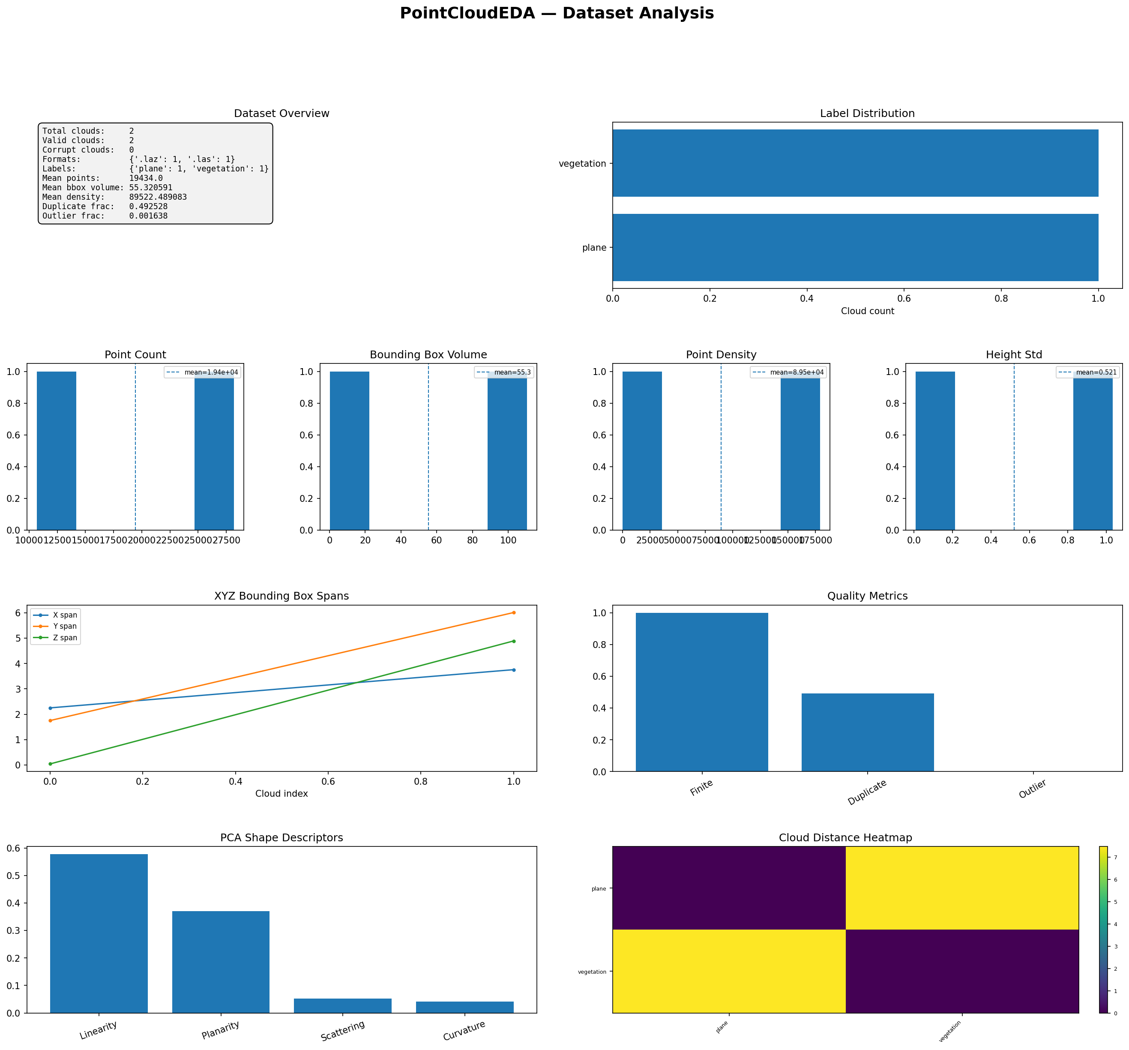
Figure 6-1. PointCloudEDA Dataset Dashboard
The dataset dashboard combines inventory, class balance, point counts, bounding-box volume, density, height variation, XYZ spans, quality indicators, shape descriptors, and pairwise cloud distances.

Row 1: Dataset Overview and Label Distribution
The overview card reports total, valid, and corrupt clouds; format and label counts; mean point count; mean bounding-box volume; mean density; duplicate fraction; and outlier fraction. The label bar chart reveals class balance.

Row 2: Point Count, Volume, Density, and Height Variation
Four histograms show the distributions of analysed point count, axis-aligned bounding-box volume, point density, and Z standard deviation. Dashed vertical lines mark the dataset mean.

Row 3: XYZ Spans and Quality Metrics
The XYZ span plot shows how X, Y, and Z extents change across cloud index. The quality panel reports mean finite fraction, duplicate fraction, outlier fraction, and nearest-neighbour mean when available.

Row 4: PCA Shape Descriptors and Distance Heatmap
The descriptor bars summarise mean linearity, planarity, scattering, and curvature. The heatmap compares up to 30 clouds using the normalised global feature vector.

6.2 plot() — Single-Cloud Dashboard
def plot( self, cloud_index: int = 0, max_points: int = 20_000, figsize: Tuple[int, int] = (18, 14), save_path: Optional[str] = None, dpi: int = 150, ) -> None:
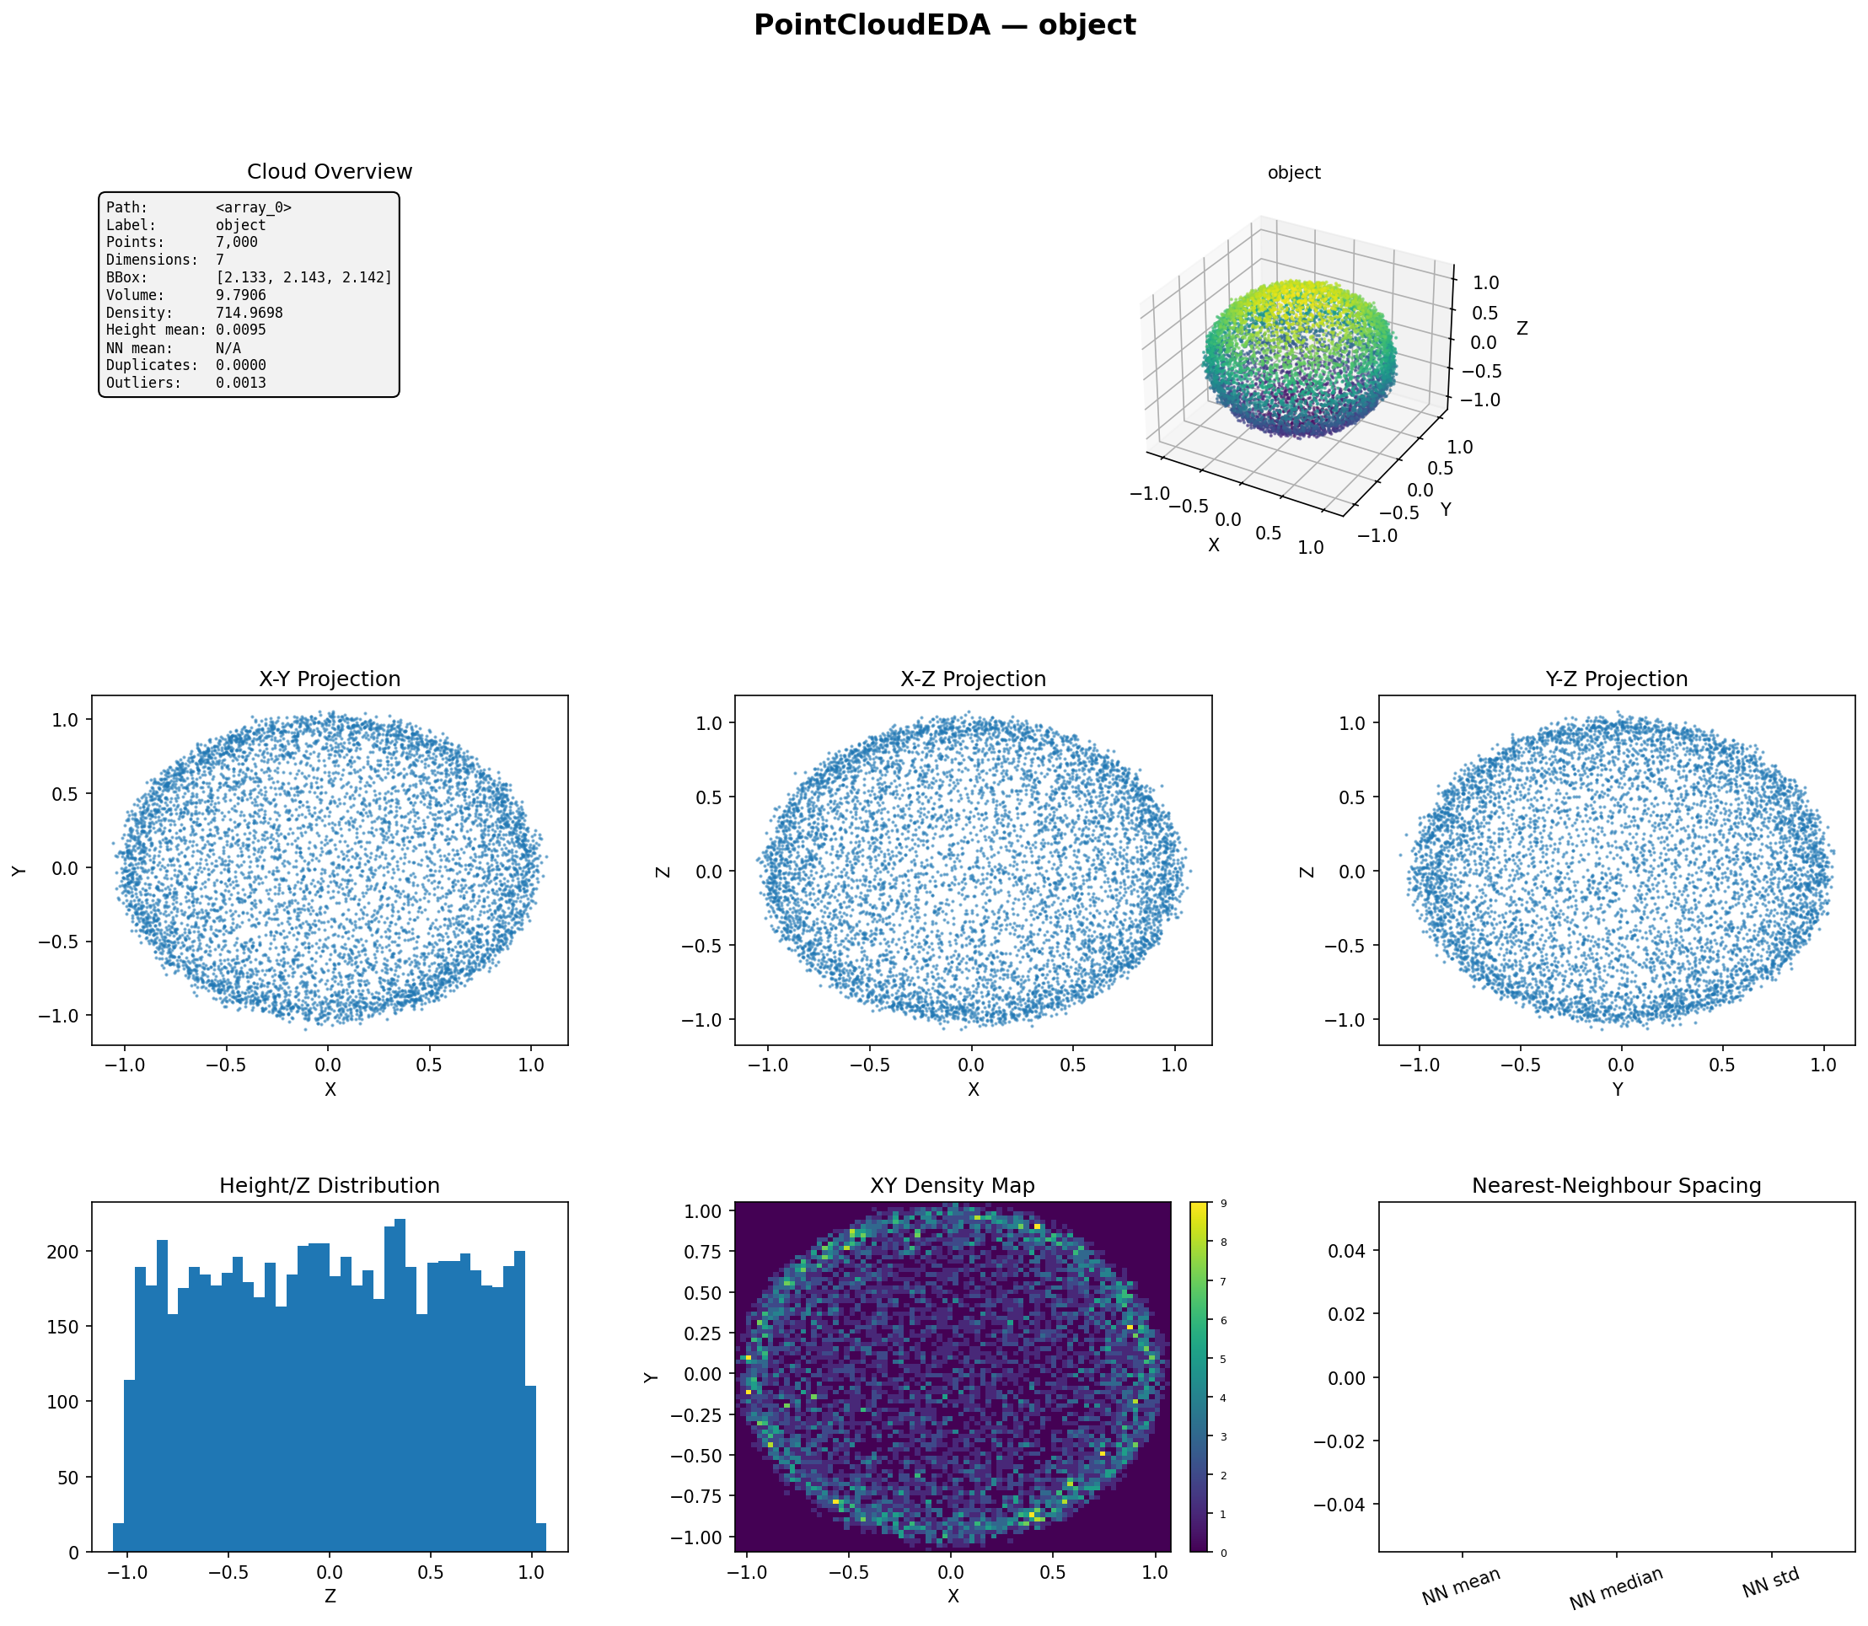
Figure 6-2. Single-Cloud Dashboard
A selected cloud is shown through a metadata card, a 3D scatter plot, XY/XZ/YZ projections, a Z histogram, an XY density map, and nearest-neighbour spacing bars.

Cloud Overview Card
The card displays path, label, point count, dimensionality, bounding-box size, volume, density, mean height, nearest-neighbour mean, duplicate fraction, and outlier fraction.

3D Scatter and Orthographic Projections
The 3D panel colours points by Z. The XY, XZ, and YZ projections reveal planarity, vertical structure, elongation, and hidden overlap that may be difficult to assess in a perspective view.

Height Histogram and XY Density Map
The Z histogram exposes layers and height modes. The XY density map uses a two-dimensional histogram and is especially useful for detecting coverage gaps and uneven sampling.

Nearest-Neighbour Spacing
The final panel compares the mean, median, and standard deviation of nearest-neighbour distances. When neighbour computation is disabled or unavailable, values are displayed as zero in this plotting helper.

6.3 plot_clouds_grid() — Preview Grid
def plot_clouds_grid( self, n: int = 12, cols: int = 4, max_points: int = 8_000, figsize: Optional[Tuple[int, int]] = None, save_path: Optional[str] = None, dpi: int = 150, ) -> None:

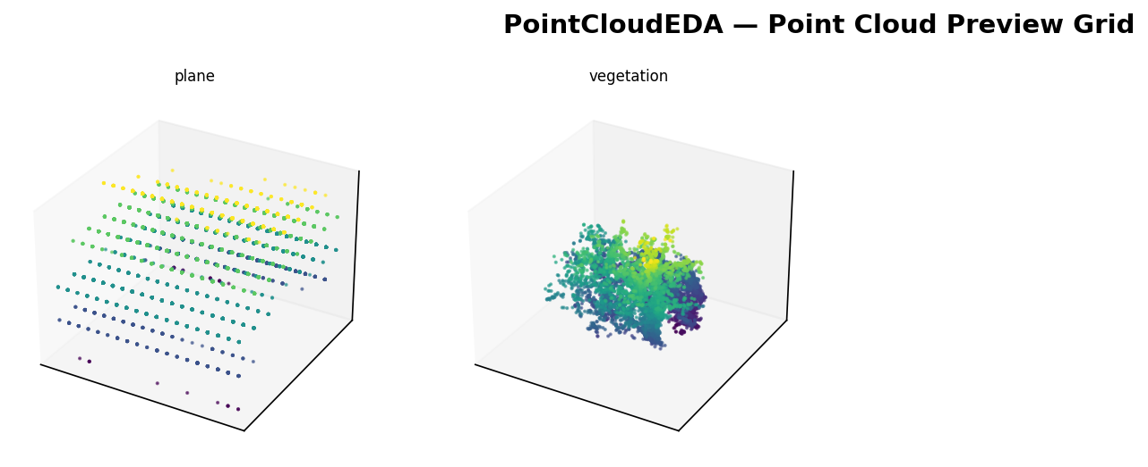
Figure 6-3. Point Cloud Preview Grid
Middle-level visual inspection across several clouds. Each panel uses a sampled 3D scatter coloured by Z and titled with the cloud label or filename.

Use this grid as a sanity check for orientation, scale, content, and label correctness. Large differences in axis scale may make some clouds appear compressed; compare the numeric spans in the dataset dashboard.

6.4 plot_height_distribution() — Z Distribution Overlay
def plot_height_distribution( self, figsize: Tuple[int, int] = (12, 6), save_path: Optional[str] = None, dpi: int = 150, ) -> None:

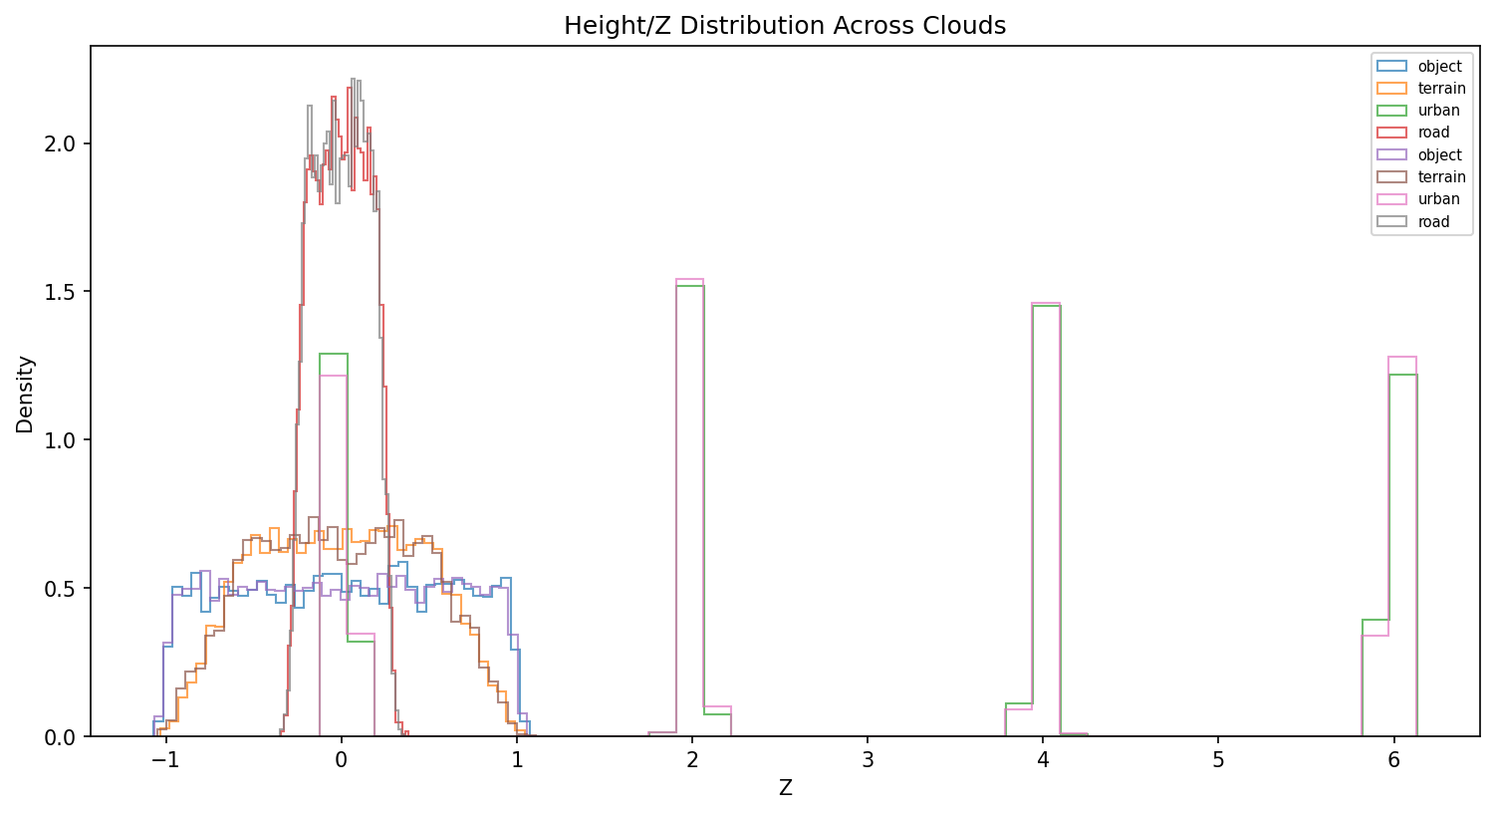
Figure 6-4. Height/Z Distributions Across Clouds
Overlaid density-normalised Z histograms for up to 30 valid clouds. The plot reveals layers, terrain profiles, object heights, and between-class vertical differences.

Legends are displayed when there are at most ten valid clouds. Repeated labels in a synthetic test reflect multiple clouds per class; in large datasets the overlay is intended for pattern recognition rather than individual curve identification.

6.5 plot_pairwise_cloud_distances() — Distance Heatmap
def plot_pairwise_cloud_distances( self, max_clouds: int = 50, figsize: Tuple[int, int] = (10, 8), save_path: Optional[str] = None, dpi: int = 150, ) -> None:

Figure 5. Pairwise Cloud Distance Matrix
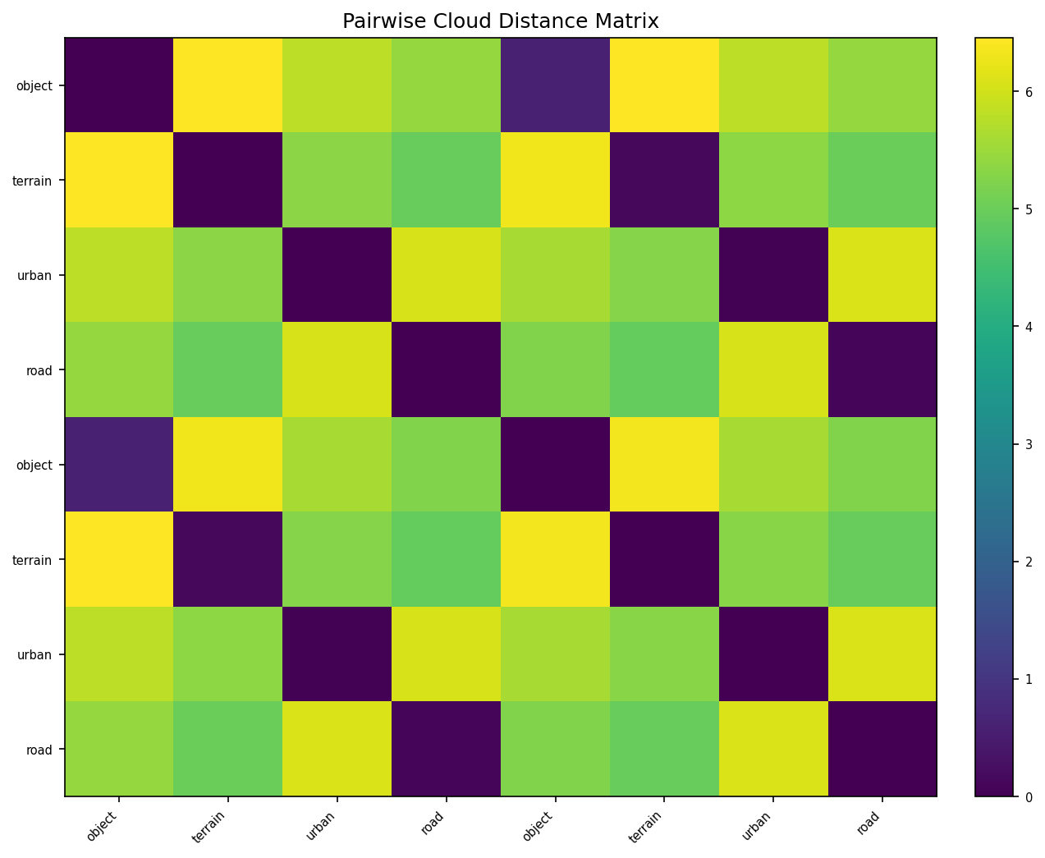
A symmetric matrix of Euclidean distances in the normalised 15-feature descriptor space. The diagonal is zero; darker off-diagonal cells indicate globally similar clouds.

Repeated block or checkerboard patterns often indicate that multiple clouds share the same synthetic scene type or class geometry. Use the matrix to identify redundancy before creating train/validation/test splits.

Chapter 7 — Interpreting Results and Common Findings

7.1 Red Flags to Review
Finding | Why it matters | Recommended investigation
finite_fraction < 1 | Rows contained NaN or infinite XYZ coordinates. | Identify the source file and quantify removed rows.
High duplicate_fraction | Point count is inflated without adding spatial information. | Inspect acquisition/export process and rounding precision.
High outlier_fraction | Isolated points may distort scale and density. | Visualise projections and consider robust filtering.
Very low density | Sparse sampling or an expanded bounding box. | Check coordinate units and remote outliers.
Very high density | Possible duplicate points or very small coordinate extent. | Compare duplicate fraction and units.
Large NN std | Strongly uneven local sampling. | Inspect density maps and acquisition overlap.
Mixed point counts | Batching and model input sizes may be inconsistent. | Downsample, voxelise, or use dynamic batching.
Mixed attribute counts | Some clouds include intensity/RGB while others do not. | Standardise the feature schema before training.
Distance heatmap dark clusters | Near-redundant clouds may cause leakage. | Group similar samples before splitting.
Unexpected shape descriptors | Labels may not match geometry. | Review cloud orientation and class assignment.

7.2 Reading Shape Descriptors Together
Typical global structure | Expected descriptor pattern
Line or elongated cable/rail | High linearity; low planarity and scattering.
Plane, wall, road, roof | High planarity; low scattering and curvature.
Sphere, foliage, volumetric object | Higher scattering; lower linearity and planarity.
Layered building cloud | Descriptor values depend on total extent; height histogram often shows multiple modes.
Noisy isotropic cluster | Moderate/high scattering and entropy; potentially high outlier fraction.

7.3 Interpreting Density Carefully
Because density uses the axis-aligned bounding-box volume, comparisons are meaningful only when coordinates use compatible units, and clouds cover comparable regions. A road corridor and a compact object can have very different density values even if their sensors have the same physical sampling resolution.

7.4 Example Findings from the Attached Outputs
The attached single-cloud object dashboard shows a roughly spherical structure: XY, XZ, and YZ projections are similarly rounded, and the 3D scatter has comparable extent on all axes. This visual pattern is consistent with a volumetric object rather than a plane or line.
The two-cloud dataset dashboard contrasts a plane and vegetation cloud. The span curves and point-density panels show that their geometric scale and sampling differ substantially. The pairwise heatmap has a large off-diagonal distance, confirming that their global descriptors are distinct.
The eight-cloud distance matrix exhibits repeated dark cells for same-type synthetic clouds and bright cells between structurally different types. This demonstrates the intended use of descriptor-space distance for rapid dataset similarity screening.

7.5 Thresholds Are Dataset-Dependent
Note: PointCloudEDA does not enforce universal quality thresholds. A nearest-neighbour distance of 0.05 may be dense in metres and sparse in millimetres. Interpret distributions relative to the dataset, acquisition system, coordinate units, and downstream task.

Chapter 8 — Advanced Usage

8.1 Working with Large Datasets
eda = PointCloudEDA(
max_clouds=500,
max_points_per_cloud=100_000,
compute_neighbors=False, # fastest quick overview
compute_geometry=True,
)
eda.load("large_dataset/", label_from_parent=True)
For a first audit, limit clouds and disable neighbour calculations. Geometry descriptors use at most 50,000 points internally. After identifying suspicious classes or files, rerun those subsets with compute_neighbors=True and a larger point cap.

8.2 Access and Filter Records
valid = [r for r in eda._records if not r.is_corrupt]
# Highest duplicate fractions
duplicates = sorted(
valid,
key=lambda r: r.duplicate_fraction or 0.0,
reverse=True,
)[:10]
# Most planar clouds
planar = sorted(
valid,
key=lambda r: r.planarity or 0.0,
reverse=True,
)[:10]
for rec in planar:
print(rec.path, rec.planarity, rec.n_points)

8.3 Export Records to pandas
import pandas as pd
rows = []
for r in eda._records:
if r.is_corrupt:
continue
rows.append({
"path": r.path,
"label": r.label,
"n_points": r.n_points,
"bbox_volume": r.bbox_volume,
"density": r.density,
"height_std": r.height_std,
"duplicate_fraction": r.duplicate_fraction,
"outlier_fraction": r.outlier_fraction,
"nn_mean": r.nearest_neighbor_mean,
"linearity": r.linearity,
"planarity": r.planarity,
"scattering": r.scattering,
"curvature": r.curvature,
})
df = pd.DataFrame(rows)
df.to_csv("pointcloud_eda_records.csv", index=False)

8.4 Use PointCloudEDA Before Model Training
# Example preprocessing decisions driven by EDA
stats = eda.summary()
# Choose a common point budget from the median analysed count
median_points = int(
stats["inventory"]["point_count"]["median"]
)
# Flag clouds for review
review = [
r.path for r in eda._records
if not r.is_corrupt and (
(r.finite_fraction or 0) < 1.0
or (r.duplicate_fraction or 0) > 0.20
or (r.outlier_fraction or 0) > 0.05
)
]
Note: The numerical cut-offs in this example are illustrative workflow choices, not thresholds implemented or recommended universally by PointCloudEDA.

8.5 Prevent Similarity Leakage
Use pairwise_cloud_distances() before assigning random splits. Build groups of clouds with very small descriptor distances, then ensure every group is assigned wholly to one split. For high-stakes duplicate detection, supplement the descriptor matrix with registration-aware metrics such as Chamfer distance after alignment.

8.6 Compare Two Datasets
train = PointCloudEDA(compute_neighbors=False)
train.load("train/", label_from_parent=True)
test = PointCloudEDA(compute_neighbors=False)
test.load("test/", label_from_parent=True)
train_stats = train.summary()
test_stats = test.summary()
print("Train density:",
train_stats["geometry"]["density"]["mean"])
print("Test density:",
test_stats["geometry"]["density"]["mean"])
print("Train planarity:",
train_stats["shape_descriptors"]["planarity"]["mean"])
print("Test planarity:",
test_stats["shape_descriptors"]["planarity"]["mean"])

8.7 Reproducibility Considerations
Keep sample_seed constant when comparing runs. Record max_points_per_cloud, neighbor_sample_size, compute_neighbors, compute_geometry, and duplicate_decimals with experimental metadata. Changing these values can alter record statistics and pairwise distances.

Chapter 9 — HTML Report, CLI, and Testing

9.1 HTML Report Structure
The self-contained HTML report uses responsive cards, badges, bars, and statistic rows. It contains inventory counts; label and format distributions; point and dimension counts; geometry; height; quality; shape descriptors; and intensity/RGB attribute summaries. No external JavaScript or CSS files are required.

9.2 Command-Line Options
Option | Meaning
path | Point-cloud file or dataset directory.
--max-clouds | Maximum number of clouds to analyse.
--max-points | Maximum analysed points per cloud; CLI default is 1,000,000.
--label-from-parent | Use parent directory as class label.
--report | Write the HTML report.
--plot | Generate the dataset dashboard.
--save-plot | Save the dashboard to a specified path.

9.3 Test Coverage
The supplied testpointcloud.py validates array loading, directory loading, NPY/NPZ/TXT/XYZ/PLY formats, summary fields, PointCloudRecord completeness, get_record(), get_cloud(), pairwise distances, all five visualisations, HTML reporting, max_clouds, all-nonfinite inputs, and single-point clouds.
python testpointcloud.py --save-plots
# Quick mode skips slower nearest-neighbour calculations
python testpointcloud.py --save-plots --quick
# Real LAS/LAZ directory
python testpointcloud.py --dir "C:/Users/Desktop/testptcloud" --save-plots --quick

9.4 Common Errors
Error / symptom | Cause | Resolution
No valid point clouds loaded | Unsupported files, corrupt arrays, or missing LAS reader. | Check extensions and install laspy/lazrs.
Point cloud array must have shape (N,D) | Input is not two-dimensional or has fewer than three columns. | Reshape and ensure XYZ are first.
Nearest-neighbour panel empty | compute_neighbors=False, one point, or scikit-learn unavailable. | Enable neighbours and install scikit-learn.
Binary PLY fails | Current internal PLY reader expects ASCII. | Convert to ASCII PLY, NPY, LAS, or extend the reader.
Density values appear extreme | Units differ, or bounding box is affected by outliers. | Standardise coordinates and inspect projections.
Output DOCX/PDF permission denied | The output file is open in Word or a PDF viewer. | Close it or allow the generator to use its timestamped fallback.

Chapter 10 — API Reference
Method | Current signature | Purpose
__init__ | PointCloudEDA(verbose=True, max_clouds=None, max_points_per_cloud=200000, sample_seed=0, compute_neighbors=True, compute_geometry=True, neighbor_sample_size=10000, duplicate_decimals=5) | Create an analysis session.
load | def load( self, source: Union[str, Path, Sequence[Union[str, Path]]], labels: Optional[Dict[str, str]] = None, label_from_parent: bool = False, recursive: bool = True, ) -> "PointCloudEDA": | Load one file, a list, or a directory.
load_arrays | def load_arrays( self, arrays: Sequence[np.ndarray], labels: Optional[Sequence[str]] = None, names: Optional[Sequence[str]] = None, ) -> "PointCloudEDA": | Load N × D arrays.
summary | def summary(self) -> Dict[str, Any]: | Return nested aggregate statistics.
get_record | def get_record(self, index: int = 0) -> PointCloudRecord: | Return one PointCloudRecord.
get_cloud | def get_cloud(self, index: int = 0) -> np.ndarray: | Return one analysed/downsampled array.
pairwise_cloud_distances | def pairwise_cloud_distances(self, max_clouds: int = 50) -> Tuple[np.ndarray, List[str]]: | Return descriptor distance matrix and names.
plot_dataset | def plot_dataset( self, figsize: Tuple[int, int] = (22, 18), save_path: Optional[str] = None, dpi: int = 150, ) -> None: | Generate dataset dashboard.
plot | def plot( self, cloud_index: int = 0, max_points: int = 20_000, figsize: Tuple[int, int] = (18, 14), save_path: Optional[str] = None, dpi: int = 150, ) -> None: | Generate single-cloud dashboard.
plot_clouds_grid | def plot_clouds_grid( self, n: int = 12, cols: int = 4, max_points: int = 8_000, figsize: Optional[Tuple[int, int]] = None, save_path: Optional[str] = None, dpi: int = 150, ) -> None: | Generate multi-cloud preview grid.
plot_height_distribution | def plot_height_distribution( self, figsize: Tuple[int, int] = (12, 6), save_path: Optional[str] = None, dpi: int = 150, ) -> None: | Overlay Z distributions.
plot_pairwise_cloud_distances | def plot_pairwise_cloud_distances( self, max_clouds: int = 50, figsize: Tuple[int, int] = (10, 8), save_path: Optional[str] = None, dpi: int = 150, ) -> None: | Plot descriptor-distance matrix.
report | def report(self, output_path: str = "viseda_pointcloud_report.html") -> str: | Write HTML report and return its path.

10.1 Return and Failure Behaviour
load() and load_arrays() return self, allowing method chaining. summary() returns a dictionary. get_record() returns a PointCloudRecord. get_cloud() returns a NumPy array. pairwise_cloud_distances() returns (distance_matrix, names). Plotting methods return None. report() returns the output path string.
summary(), plotting methods, record access, and report() require a loaded object and raise RuntimeError before load(). Pairwise distance analysis requires at least two valid clouds and raises ValueError otherwise.

Chapter 11 —Roadmap

Version 1.0.0
- Unified PointCloudEDA class for file and array inputs.
- Dataset summary with inventory, geometry, height, quality, shape, and attribute sections.
- Support for NPY, NPZ, text, XYZ, PTS, ASCII PLY, LAS, and LAZ.
- Reproducible per-cloud downsampling.
- Nearest-neighbour spacing and PCA shape descriptors.
- Dataset dashboard, single-cloud dashboard, preview grid, height overlay, and distance heatmap.
- Styled self-contained HTML report.
- Complete synthetic and file-format test suite.

Roadmap
- Binary PLY and richer PLY property support.
- Coordinate reference system and unit metadata.
- Voxel-density and local neighbourhood density analysis.
- Local surface normals and per-point curvature distributions.
- Ground/non-ground separation and canopy metrics for LiDAR.
- Chamfer, Hausdorff, and Earth Mover's distance options.
- Rigid registration and duplicate detection invariant to translation and rotation.
- Class-conditional dashboards and per-class descriptor comparison.
- Interactive 3D HTML previews.
- Octree, voxel, and occupancy-grid summaries.
- Additional LAS dimensions and waveform metadata.
- Streaming analysis for extremely large LAS/LAZ files.

Appendix A — PointCloudRecord Fields
Field | Group | Meaning
path | Identity | Path/name identifier.
label | Identity | Class label.
file_ext | Identity | Input extension or array.
file_size_kb | Identity | File size in KB.
n_points | Inventory | Analysed finite point count.
n_dims | Inventory | Array column count.
dtype | Inventory | Internal dtype.
has_color | Attributes | RGB-like final columns detected.
has_intensity | Attributes | At least four columns.
is_corrupt | Status | Whether analysis failed.
error | Status | Failure message.
xyz_min | Geometry | Minimum XYZ.
xyz_max | Geometry | Maximum XYZ.
xyz_mean | Geometry | Mean XYZ.
xyz_std | Geometry | XYZ standard deviations.
bbox_size | Geometry | Axis-aligned spans.
bbox_volume | Geometry | Product of spans.
centroid | Geometry | Mean XYZ.
span_x/y/z | Geometry | Individual extents.
density | Geometry | Points per bounding-box volume.
height_min/max | Height | Z extrema.
height_mean/std | Height | Z mean and spread.
z_percentiles | Height | 0/5/25/50/75/95/100 percentiles.
radial_distance_mean/std | Quality | Centroid-distance statistics.
nearest_neighbor_mean | Quality | Mean nearest-other-point spacing.
nearest_neighbor_median | Quality | Median nearest spacing.
nearest_neighbor_std | Quality | Spacing variability.
outlier_fraction | Quality | Radial 3-sigma fraction.
duplicate_fraction | Quality | Rounded duplicate estimate.
finite_fraction | Quality | Fraction with finite XYZ.
planarity | Shape | Global PCA planarity.
linearity | Shape | Global PCA linearity.
scattering | Shape | Global PCA scattering.
curvature | Shape | Global PCA curvature.
normal_entropy | Shape | Eigenvalue entropy.
intensity_mean/std | Attributes | Column-3 statistics.
rgb_mean/std | Attributes | Normalised RGB statistics.
sample_points | Preview | Up to 5,000 sampled XYZ points.

Appendix B — summary() Schema
{
"inventory": {
"total_clouds", "valid_clouds", "corrupt_clouds",
"corrupt_paths", "format_distribution",
"label_distribution", "point_count",
"dimension_count", "has_color_count",
"has_intensity_count"
},
"geometry": {
"bbox_volume", "density",
"span_x", "span_y", "span_z",
"bbox_size_mean", "xyz_mean_mean", "xyz_std_mean"
},
"height": {
"height_min", "height_max",
"height_mean", "height_std"
},
"quality": {
"finite_fraction", "duplicate_fraction",
"outlier_fraction",
"nearest_neighbor_mean",
"nearest_neighbor_median",
"nearest_neighbor_std"
},
"shape_descriptors": {
"linearity", "planarity",
"scattering", "curvature"
},
"attributes": {
"intensity_mean", "intensity_std",
"rgb_mean_mean", "rgb_std_mean"
}
}

Appendix C — Mathematical Reference
Metric | Definition used by PointCloudEDA
Centroid | c = (1/N) Σ pᵢ
Bounding-box size | max(XYZ) − min(XYZ)
Bounding-box volume | ∏ max(span, 10⁻¹²)
Density | N / bounding-box volume
Radial outlier rule | rᵢ > mean(r) + 3·std(r)
Duplicate fraction | 1 − N_unique(round(XYZ,d))/N
Linearity | (λ₁−λ₂)/λ₁
Planarity | (λ₂−λ₃)/λ₁
Scattering | λ₃/λ₁
Curvature | λ₃/(λ₁+λ₂+λ₃)
Eigenvalue entropy | −Σ pᵢ log(pᵢ)
Descriptor distance | Euclidean distance after feature z-score normalisation

Appendix D — Glossary
Term | Definition
Axis-aligned bounding box | Smallest XYZ-aligned box containing the cloud.
Centroid | Arithmetic mean of all XYZ coordinates.
Chamfer distance | Point-set distance not used by the current pairwise method.
Density | Number of points divided by bounding-box volume in this implementation.
Duplicate point | A rounded XYZ coordinate that appears more than once.
Finite point | A point whose X, Y, and Z are not NaN or infinite.
Intensity | Scalar return-strength or sensor attribute, treated as column 3.
LAS/LAZ | Common LiDAR formats; LAZ is compressed LAS.
Nearest neighbour | Closest other sampled point in Euclidean XYZ space.
Outlier | Point beyond the global radial mean plus three standard deviations.
Planarity | PCA eigenvalue descriptor for plane-like structure.
Point cloud | Unordered set of spatial points with optional attributes.
Scattering | PCA descriptor indicating volumetric spread.
Voxelisation | Discretising 3D space into regular cells.

Appendix E — Acknowledgements
PointCloudEDA builds on NumPy, Matplotlib, scikit-learn, laspy, and python-docx. The module is intended for researchers and practitioners working with LiDAR, photogrammetry, robotics, autonomous systems, structural inspection, terrain modelling, urban mapping, forestry, and 3D object recognition.

