Visual Exploratory Data Analysis (VisEDA): PART E
Text and NLP Exploratory Data Analysis
A Guide to Text and Natural Language Dataset Analysis

Isaac Osei Agyemang
Version 1.0.0
2026

Preface
Exploratory Data Analysis is as important for natural-language data as it is for images, videos, hyperspectral cubes, and point clouds. Text datasets can contain class imbalance, empty records, inconsistent encodings, unusually short or long documents, duplicate content, repeated boilerplate, mixed writing scripts, URLs, email addresses, hashtags, mentions, numerical artefacts, and large differences in vocabulary or readability. These properties can change model behaviour before any tokeniser, embedding model, recurrent network, or transformer is trained.
TextEDA extends VisEDA to text and NLP datasets using the same progressive workflow used elsewhere in the library: load the dataset, obtain a structured numerical summary, inspect visual diagnostics, and export a shareable HTML report. It supports plain-text documents, web text, delimited datasets, JSON/JSONL corpora, and in-memory strings. The default implementation deliberately uses lightweight regular-expression tokenisation rather than silently requiring NLTK, spaCy, or transformer packages.
This manual documents the current TextEDA implementation. It explains both the public API and the calculations behind the reported metrics so that results can be interpreted correctly and reproduced in downstream NLP workflows.
Isaac Osei Agyemang
August 2026

Table of Contents
Preface 2
Table of Contents 3
Chapter 1 — Introduction 6
1.1 What is VisEDA TextEDA? 6
1.2 Why Text EDA Matters 6
1.3 Design Philosophy 6
1.4 Installation 6
1.5 Supported Data Formats 7
1.6 Tokenisation and Language Scope 7
Chapter 2 — Quick Start 8
2.1 Directory Dataset with Parent-Folder Labels 8
2.2 CSV, TSV, JSON, and JSONL Datasets 8
2.3 In-Memory Text 8
2.4 Getting a Summary 8
2.5 Vocabulary and N-gram Analysis 9
2.6 Document Similarity and Near-Duplicates 9
2.7 Generate Visualisations 9
2.8 Generate an HTML Report 9
2.9 Command-Line Interface 9
2.10 User-Dataset-Only Test Script 10
Chapter 3 — The TextEDA Class 11
3.1 Constructor 11
3.2 load() — Files, Lists, and Directories 11
3.3 load_texts() — In-Memory Strings 11
3.4 get_record() and get_text() 11
3.5 vocabulary() — Corpus Token Frequencies 12
3.6 summary() — Full Dataset Statistics 12
3.7 pairwise_document_distances() 12
3.8 near_duplicate_pairs() 12
3.9 report() — Self-Contained HTML 12
Chapter 4 — Input Parsing and Dataset Organisation 13
4.1 Path Resolution 13
4.2 Encoding Detection 13
4.3 Plain Text and Markup Files 13
4.4 CSV and TSV Field Selection 13
4.5 JSON and JSONL Expansion 13
4.6 Labels and Source Indices 13
Chapter 5 — What Is Analysed 14
5.1 Dataset Inventory 14
5.2 Character and Byte Counts 14
5.3 Token and Word Counts 14
5.4 Sentence, Paragraph, and Line Counts 14
5.5 Word-Length Statistics 14
5.6 Sentence-Length and Paragraph Statistics 14
5.7 Lexical Diversity and Type-Token Ratio 14
5.8 Hapax Legomena 14
5.9 Stopword Statistics 15
5.10 Top Tokens, Bigrams, and Trigrams 15
5.11 Punctuation, Digits, Uppercase, and Whitespace 15
5.12 Non-ASCII, Emoji, URLs, Email, Hashtags, and Mentions 15
5.13 Repeated-Line Fraction 15
5.14 Empty, Very-Short, and Very-Long Flags 15
5.15 Readability Estimates 15
5.16 Writing-Script Detection 16
5.17 Exact Duplicate Detection 16
5.18 TF-IDF Pairwise Distance 16
Chapter 6 — Visualisations 17
6.1 plot_dataset() — Comprehensive Dataset Dashboard 17
Row 1: Dataset Overview and Label Distribution 17
Row 2: Basic Length and Lexical Diversity 17
Row 3: Sentence/Word Length, Stopwords, and Readability 17
Row 4: Symbol and Repetition Rates 17
Row 5: Top Words and Bigrams 17
Row 6: Scripts, Formats, and Scatter Diagnostics 17
Row 7: Pairwise Distances and Quality Flags 17
6.2 plot() — Single-Document Deep Dive 19
Document Overview and Text Preview 19
Top Tokens and Top Bigrams 19
Token and Sentence Length 19
Character Composition and Token Coverage 20
Script, Quality, and Sentence Sequence 20
6.3 plot_word_frequency() — Dataset Word Frequency 20
6.4 plot_ngram_frequency() — N-gram Frequency 20
6.5 plot_length_distribution() — Length Dashboard 21
6.6 plot_label_comparison() — Metric by Class 22
6.7 plot_pairwise_document_distances() — Similarity Heatmap 22
6.8 plot_text_samples() — Text Sample Grid 23
Chapter 7 — The TextRecord Object 25
7.1 Identity and Status Fields 25
7.2 Count Fields 25
7.3 Length and Distribution Fields 25
7.4 Lexical Fields 25
7.5 Character and Symbol Fields 26
7.6 Quality and Style Fields 26
Chapter 8 — HTML Report, CLI, and Testing 27
8.1 HTML Report Structure 27
8.2 CLI Options 27
8.3 User-Dataset Test Workflow 27
8.4 Common Errors 27
Chapter 9 — Advanced Usage 29
9.1 Custom Stopwords 29
9.2 Preserve Case 29
9.3 Minimum Token Length 29
9.4 Thresholds for Short and Long Documents 29
9.5 Access Records as a pandas DataFrame 29
9.6 Dataset Split Hygiene 30
9.7 Compare Two Corpora 30
9.8 Large Corpora 30
Chapter 10 — Interpreting Results and Common Findings 31
10.1 Red Flags to Watch For 31
10.2 Interpreting the Attached Example Dataset 31
10.3 Readability Is Not Model Quality 31
10.4 Token Counts Are Not Transformer Tokens 31
Chapter 11 — API Reference 32
11.1 Return and Failure Behaviour 33
Chapter 12 —Roadmap 34
Version 1.0.0 — TextEDA Integration 34
Roadmap 34
Appendix A — Complete TextRecord Field Reference 35
Appendix B — summary() Schema 37
Appendix C — Mathematical and Heuristic Reference 38
Appendix D — Writing Scripts Recognised 39
Appendix E — Glossary 40
Appendix F — Acknowledgements 41

Chapter 1 — Introduction

1.1 What is VisEDA TextEDA?
TextEDA is the text and natural-language exploratory analysis module of VisEDA. One TextEDA object can analyse a single document, a directory of text files, a list of file paths, structured CSV/TSV/JSON/JSONL records, or a sequence of in-memory strings. Every document is converted into a TextRecord containing counts, lexical statistics, symbol rates, readability estimates, writing-script information, quality flags, and a short preview. Dataset-level methods aggregate these records and analyse corpus vocabulary and document similarity.

1.2 Why Text EDA Matters
- Class balance: sentiment, intent, topic, toxicity, or other labels can be heavily imbalanced even when the corpus looks large.
- Length distribution: short messages and long articles have very different truncation, padding, batching, and memory requirements.
- Vocabulary coverage: a corpus with many singleton tokens, identifiers, spelling variants, or domain terms may require different tokenisation and normalisation choices.
- Duplicates and near-duplicates: repeated documents can leak across train/validation/test splits and inflate evaluation scores.
- Encoding and script variation: UTF-8, UTF-16, legacy encodings, and multilingual scripts can create silent parsing failures or unintended language mixtures.
- Markup and symbols: URLs, email addresses, hashtags, mentions, emoji, punctuation, and numbers may be informative features or preprocessing noise depending on the task.
- Stopword dominance: very common function words can obscure content-word patterns in frequency analyses.
- Readability and sentence structure: large variation in syntactic length or reading difficulty can reveal domain shift between classes or data sources.
- Repeated boilerplate: templates, disclaimers, headers, and repeated lines can dominate document similarity without representing the target task.
- Corrupt or empty records: empty fields and parsing errors can propagate to tokenisers and model training unless detected early.

1.3 Design Philosophy
- Lightweight by default. Tokenisation, sentence splitting, script analysis, readability, duplicate hashing, and most plots work without large NLP frameworks.
- Structured and unstructured inputs. The same class accepts individual files, class-folder datasets, CSV/TSV tables, JSON/JSONL corpora, and Python strings.
- Progressive disclosure. summary() provides statistics; plot_dataset() and plot() provide visual interpretation; report() provides a shareable HTML document.
- Transparent heuristics. Readability, sentence splitting, stopwords, and near-duplicate thresholds are explicitly documented rather than hidden behind a model.
- Optional scikit-learn acceleration. TF-IDF cosine distances use scikit-learn when available and fall back to a NumPy implementation when it is not.
- User-controlled vocabulary behaviour. Case folding, minimum token length, and the stopword set are constructor options.
- Dataset integrity first. Empty, very-short, very-long, duplicate, encoding, and script anomalies are treated as EDA findings rather than silently discarded.

1.4 Installation
# Core VisEDA/TextEDA requirements
pip install viseda numpy matplotlib
# Recommended for TF-IDF cosine distances
pip install scikit-learn
# Required only to run this Word documentation generator
pip install python-docx pillow
Note: TextEDA does not require NLTK, spaCy, or transformer libraries for its built-in analysis. If scikit-learn is unavailable, pairwise_document_distances() uses the included NumPy TF-IDF fallback.

1.5 Supported Data Formats
Table 1. Supported TextEDA input formats.
Extension | Interpretation | Document expansion behaviour
.txt / .text | Plain text | One file becomes one document.
.md / .rst / .log | Plain textual content | One file becomes one document; markup is not stripped.
.html / .htm | Web text | HTML tags are removed; script/style/noscript/SVG content is ignored.
.csv | Comma-delimited structured data | Each data row becomes a document using a selected text field.
.tsv | Tab-delimited structured data | Each data row becomes a document using a selected text field.
.json | JSON string, object, list, or wrapper object | Objects/lists can expand into multiple documents.
.jsonl / .ndjson | One JSON value per line | Each non-empty line is parsed and expanded.
Python strings | In-memory documents | Use load_texts() with optional labels and names.

1.6 Tokenisation and Language Scope
The default tokenizer is Unicode-aware and is implemented with a regular expression. It recognises alphabetic words, including internal apostrophes and hyphens, and numeric tokens that may contain commas or decimal points. When lowercase=True, tokens are case-folded. min_token_length removes short tokens except numeric tokens.
The built-in stopword list and Flesch readability heuristic are English-oriented. Writing-script analysis is multilingual, but TextEDA does not perform language identification, stemming, lemmatisation, POS tagging, named-entity recognition, sentiment classification, or transformer tokenisation.

Chapter 2 — Quick Start

2.1 Directory Dataset with Parent-Folder Labels
# Example structure
# text_dataset/
# positive/
# review_001.txt
# review_002.txt
# negative/
# review_003.txt
# neutral/
# review_004.txt
from viseda import TextEDA
eda = TextEDA(verbose=True)
eda.load(
"text_dataset/",
label_from_parent=True,
recursive=True,
)
stats = eda.summary()
print(stats["inventory"])
print(stats["lexical"])

2.2 CSV, TSV, JSON, and JSONL Datasets
from viseda import TextEDA
eda = TextEDA()
eda.load(
"reviews.csv",
text_field="text",
label_field="label",
)
# The same arguments apply to .tsv, .json, .jsonl, and .ndjson
print(eda.summary()["labels"])
Note: When text_field or label_field is omitted, TextEDA attempts to identify common field names automatically. If a text field cannot be determined, it raises a KeyError listing the available fields.

2.3 In-Memory Text
from viseda import TextEDA
texts = [
"The bridge inspection report describes surface cracking.",
"Traffic congestion increased during the evening period.",
]
labels = ["infrastructure", "traffic"]
eda = TextEDA()
eda.load_texts(texts, labels=labels)

2.4 Getting a Summary
summary = eda.summary()
print(summary["inventory"])
print(summary["length"])
print(summary["lexical"])
print(summary["symbols"])
print(summary["readability"])
print(summary["quality"])
print(summary["labels"])

2.5 Vocabulary and N-gram Analysis
# Ordered token -> frequency dictionary
top_words = eda.vocabulary(top_n=30)
# Exclude the configured stopword list
content_words = eda.vocabulary(
top_n=30,
exclude_stopwords=True,
)
print(top_words)

2.6 Document Similarity and Near-Duplicates
distances, names = eda.pairwise_document_distances(
max_documents=50,
max_features=5000,
exclude_stopwords=True,
)
similar_pairs = eda.near_duplicate_pairs(
threshold=0.15,
max_documents=100,
)

2.7 Generate Visualisations
eda.plot_dataset() # comprehensive corpus dashboard
eda.plot(document_index=0) # one-document deep dive
eda.plot_word_frequency() # unigram frequency
eda.plot_ngram_frequency(n=2) # bigram frequency
eda.plot_length_distribution() # length-focused dashboard
eda.plot_label_comparison("word_count") # per-label box plot
eda.plot_pairwise_document_distances() # TF-IDF distance heatmap
eda.plot_text_samples(n=12, cols=3) # text preview grid
# Save instead of display
eda.plot_dataset(
save_path="outputs_text/plot_dataset.png",
dpi=160,
)

2.8 Generate an HTML Report
report_path = eda.report(
"outputs_text/viseda_text_report.html"
)
print(report_path)

2.9 Command-Line Interface
# Directory dataset
viseda text "C:/data/text_dataset" --label-from-parent --plot --save-plot outputs_text/plot_dataset.png --report outputs_text/report.html
# Structured CSV
viseda text "C:/data/reviews.csv" --text-field text --label-field label --plot

2.10 User-Dataset-Only Test Script
# Directory
python testtext.py --dir "C:/Users/Ike/Desktop/test_dataset/folder_dataset" --save-plots
# CSV
python testtext.py --file "C:/data/reviews.csv" --text-field text --label-field label --save-plots
Note: The supplied testtext.py is intentionally user-dataset-only. It does not generate or analyse a synthetic corpus. The HTML report and plots therefore correspond to the dataset passed with --dir or --file.

Chapter 3 — The TextEDA Class

3.1 Constructor
def __init__(self, verbose=True, max_documents=None, lowercase=True, min_token_length=1, stopwords=None, short_document_words=5, long_document_words=1000, top_n=30, encoding=None, random_seed=0) -> None:
Table 2. TextEDA constructor parameters.
Parameter | Default | Purpose
verbose | True | Print loading and reporting progress.
max_documents | None | Cap the number of expanded documents analysed.
lowercase | True | Case-fold tokens for vocabulary/frequency analyses.
min_token_length | 1 | Minimum token length; numeric tokens are retained even when short.
stopwords | None | Optional iterable replacing the built-in English stopword set.
short_document_words | 5 | Documents with fewer tokens are flagged very_short.
long_document_words | 1000 | Documents with more tokens are flagged very_long.
top_n | 30 | Number of top unigrams, bigrams, and trigrams retained per TextRecord.
encoding | None | Preferred input encoding tried before automatic fallbacks.
random_seed | 0 | Seed used by reproducible sampling in internal fallback workflows.

3.2 load() — Files, Lists, and Directories
def load( self, source: Union[str, Path, Sequence[Union[str, Path]]], labels: Optional[Mapping[str, str]] = None, label_from_parent: bool = False, recursive: bool = True, text_field: Optional[str] = None, label_field: Optional[str] = None, ) -> "TextEDA":
load() resolves a file, a list of files, or a directory. Only files whose extensions appear in SUPPORTED_EXTS are accepted. Directories are searched recursively by default. A path-to-label mapping can be supplied through labels; otherwise label_from_parent=True uses each file's immediate parent directory.
Structured files can expand one physical file into many TextRecord objects. In those cases, source_index identifies the row or JSON item and the record name is written as filename#source_index. max_documents applies after expansion.

3.3 load_texts() — In-Memory Strings
def load_texts( self, texts: Sequence[str], labels: Optional[Sequence[str]] = None, names: Optional[Sequence[str]] = None, ) -> "TextEDA":
load_texts() is useful for data already held in pandas, databases, APIs, notebooks, or preprocessing pipelines. Each string becomes a TextRecord with file_ext='text' and encoding='unicode'.

3.4 get_record() and get_text()
rec = eda.get_record(0)
text = eda.get_text(0)
print(rec.word_count)
print(rec.lexical_diversity)
print(text)
get_record() exposes the computed TextRecord. get_text() retrieves the original string stored by the TextEDA object. Both methods require a completed load() or load_texts() call.

3.5 vocabulary() — Corpus Token Frequencies
def vocabulary( self, min_frequency: int = 1, top_n: Optional[int] = None, exclude_stopwords: bool = False, ) -> Dict[str, int]:
vocabulary() aggregates the same tokens used by TextEDA's record-level analysis. Items are sorted first by descending frequency and then alphabetically for equal counts. min_frequency removes rare tokens, top_n truncates the output, and exclude_stopwords uses the configured stopword set.

3.6 summary() — Full Dataset Statistics
def summary(self) -> Dict[str, Any]:
summary() returns seven top-level sections: inventory, length, lexical, symbols, readability, quality, and labels. Numeric document-level metrics are aggregated with count, mean, standard deviation, minimum, 25th percentile, median, 75th percentile, and maximum.
summary = eda.summary()
summary["inventory"]
summary["length"]
summary["lexical"]
summary["symbols"]
summary["readability"]
summary["quality"]
summary["labels"]

3.7 pairwise_document_distances()
def pairwise_document_distances( self, max_documents: int = 50, max_features: int = 5_000, exclude_stopwords: bool = True, ) -> Tuple[np.ndarray, List[str]]:
The preferred implementation uses scikit-learn TfidfVectorizer followed by cosine_distances. If scikit-learn is unavailable or the vectorisation step raises an exception, TextEDA builds TF-IDF vectors with NumPy and computes 1 - cosine similarity.
$$distance(i,j) = 1 - cosine({TFIDF}_{i}, {TFIDF}_{j})$$
Note: The matrix describes lexical similarity, not semantic embedding similarity. Two paraphrases with different vocabulary may remain far apart, while templated documents can appear very close.

3.8 near_duplicate_pairs()
def near_duplicate_pairs( self, threshold: float = 0.15, max_documents: int = 100, ) -> List[Tuple[str, str, float]]:
Every upper-triangular document pair whose TF-IDF cosine distance is less than or equal to threshold is returned. The default 0.15 threshold corresponds to a cosine similarity of at least 0.85.

3.9 report() — Self-Contained HTML
def report(self, output_path: str = "viseda_text_report.html") -> str:
report() writes a single HTML file with embedded CSS and no external assets. It includes corpus inventory, label/format/script distributions, length statistics, symbol and markup statistics, readability, quality, vocabulary statistics, top words, and top bigrams.

Chapter 4 — Input Parsing and Dataset Organisation

4.1 Path Resolution
For a directory, TextEDA uses rglob('*') when recursive=True and glob('*') otherwise, then keeps only files with supported extensions. A single unsupported file raises ValueError. A missing path raises FileNotFoundError.

4.2 Encoding Detection
TextEDA attempts the user-specified encoding first when provided, then tries UTF-8, UTF-8 with BOM, UTF-16, UTF-16 little-endian, UTF-16 big-endian, Windows CP1252, and Latin-1. The first successful decoding is stored in TextRecord.encoding.
# Force an encoding preference when known
eda = TextEDA(encoding="utf-8")
eda.load("corpus/")

4.3 Plain Text and Markup Files
.txt, .text, .md, .rst, and .log are read as raw text. Markdown and reStructuredText syntax is therefore included in punctuation and token statistics. HTML/HTM is treated differently: tags are removed and script, style, noscript, and SVG content is ignored by the built-in HTML parser.

4.4 CSV and TSV Field Selection
Delimited files are read with csv.DictReader. If text_field is given, it must match an existing column exactly. Otherwise TextEDA searches the following candidates case-insensitively.
Table 3. Automatic structured-data field detection.
Purpose | Automatically recognised field names
Text | text, content, document, sentence, review, comment, body, description, message, abstract, article, question
Label | label, class, category, target, sentiment, topic, intent

Note: If a structured dataset contains only one column and no text_field is specified, that sole column is used as text. Label detection is optional; if no candidate label field exists, documents remain unlabelled.

4.5 JSON and JSONL Expansion
A JSON string is treated as one document. A JSON list is iterated. A JSON object is first checked for list-valued wrapper keys data, records, items, documents, or examples; otherwise the object itself is treated as one item. JSONL/NDJSON parses each non-empty line independently and records its line number as source_index.

4.6 Labels and Source Indices
Structured labels extracted from label_field take precedence over a base label supplied by labels or label_from_parent. For plain files, the base label is retained. This makes folder labels and row-level labels composable without changing the public loading interface.

Chapter 5 — What Is Analysed

5.1 Dataset Inventory
Inventory statistics include total, valid, and corrupt document counts; corrupt paths; file-format distribution; detected encoding distribution; label distribution; and dominant writing-script distribution.

5.2 Character and Byte Counts
char_count is Python's Unicode string length. byte_count is the length after UTF-8 encoding with replacement for encoding errors. For ASCII-only text these values are typically equal; multilingual or emoji-rich text can require multiple UTF-8 bytes per character.

5.3 Token and Word Counts
word_count stores the total number of regex tokens, including numeric tokens. alpha_word_count counts tokens that fully match the alphabetic WORD_RE pattern. numeric_token_count counts tokens containing at least one digit. unique_word_count counts distinct analysed tokens after case folding and minimum-length filtering.

5.4 Sentence, Paragraph, and Line Counts
Sentence splitting is heuristic: sentence boundaries occur after '.', '!', or '?' followed by whitespace, or at newline boundaries. Paragraphs are separated by one or more blank lines. line_count uses the original line structure, while nonempty_line_count ignores whitespace-only lines.
Note: Sentence segmentation is intentionally lightweight. Abbreviations, quotations, ellipses, URLs, and language-specific punctuation can produce different boundaries from a trained sentence segmenter.

5.5 Word-Length Statistics
For every record TextEDA stores average, median, and standard deviation of token lengths. Dataset summary() aggregates avg_word_length across documents. These metrics can reveal identifiers, codes, URLs fragmented into tokens, or domain-specific long terminology.

5.6 Sentence-Length and Paragraph Statistics
Sentence lengths are measured in analysed tokens. The record stores average, median, standard deviation, and maximum sentence length. avg_paragraph_words is the mean token count of detected paragraphs.

5.7 Lexical Diversity and Type-Token Ratio
$$lexical_diversity = unique_tokens / total_tokens$$
The same ratio is calculated per document and at corpus level. Values close to 1 indicate that most tokens occur only once; lower values indicate heavier reuse. The measure is strongly length-dependent, so comparisons should account for document size.

5.8 Hapax Legomena
$$hapax_ratio = tokens_with_frequency_1 / unique_tokens$$
A hapax token appears exactly once. High hapax ratios can indicate rich vocabulary, many identifiers, spelling noise, proper names, OCR artefacts, or a very small corpus. TextEDA reports document-level hapax counts/ratios and corpus-level hapax statistics.

5.9 Stopword Statistics
$$stopword_ratio = stopword_tokens / total_tokens$$
The default stopword set is a compact built-in English list. It can be completely replaced through the stopwords constructor parameter. Stopword ratios are diagnostic rather than prescriptive: some NLP tasks benefit from retaining stopwords.

5.10 Top Tokens, Bigrams, and Trigrams
Each TextRecord retains its top_n unigrams, bigrams, and trigrams. Dataset summary() additionally returns the top 50 words, content words, bigrams, and trigrams. N-grams are contiguous token sequences without smoothing or linguistic filtering.

5.11 Punctuation, Digits, Uppercase, and Whitespace
$$punctuation_rate = punctuation_characters / characters$$
$$digit_rate = digit_characters / characters$$
$$uppercase_rate = uppercase_letters / alphabetic_characters$$
$$whitespace_rate = whitespace_characters / characters$$
Punctuation is defined as a character that is neither alphanumeric nor whitespace. These rates can reveal code-like data, templated messages, unusual capitalisation, or numeric-heavy records.

5.12 Non-ASCII, Emoji, URLs, Email, Hashtags, and Mentions
non_ascii_rate measures the fraction of characters whose code point exceeds 127. Regex counters separately identify emoji, HTTP/WWW URLs, email addresses, hashtags, and @mentions. These are simple counts and do not redact or transform the underlying text.

5.13 Repeated-Line Fraction
Non-empty lines are whitespace-normalised and case-folded before comparison. repeated_line_fraction is one minus the fraction of unique normalised lines. It is designed to identify repeated boilerplate, logs, templated content, or accidental line duplication.
$$repeated_line_fraction = \frac{1 - unique_normalised_lines}{nonempty_lines}$$

5.14 Empty, Very-Short, and Very-Long Flags
empty is true when text.strip() is empty. very_short is true when word_count is below short_document_words. very_long is true when word_count exceeds long_document_words. The defaults are 5 and 1000 tokens respectively and are configurable.

5.15 Readability Estimates
TextEDA uses a lightweight English syllable heuristic and computes two familiar readability estimates. Only alphabetic tokens are used in the syllable calculation. Documents without alphabetic words or detected sentences receive None for readability.
$$Flesch = 206.835 - 1.015(W/S) - 84.6(Y/W)$$
W = alphabetic words, S = sentences, Y = estimated syllables.
$$FK_grade = 0.39(W/S) + 11.8(Y/W) - 15.59$$
Note: These formulas and the included syllable heuristic are English-oriented. For multilingual corpora, use readability as an exploratory flag rather than a universal linguistic score.

5.16 Writing-Script Detection
Alphabetic characters are assigned to Unicode ranges. The implementation recognises Latin, Cyrillic, Greek, Arabic, Hebrew, Devanagari, Bengali, Thai, CJK, Hiragana, Katakana, Hangul, and Other. script_distribution gives per-document fractions and dominant_script records the largest group.

5.17 Exact Duplicate Detection
Before hashing, all whitespace is normalised to single spaces, and the text is case-folded. TextEDA then calculates a SHA-256 hash. Documents sharing the same hash form an exact-duplicate group even if their original spacing or letter case differs.
Note: Because normalisation ignores whitespace and case, 'Exact duplicate' here means exact after TextEDA's normalisation, not byte-for-byte identical files.

5.18 TF-IDF Pairwise Distance
The scikit-learn path uses TfidfVectorizer with min_df=1, a Unicode word token pattern, the configured lowercase setting, optional stopword removal, and max_features. The NumPy fallback computes term frequency, smoothed inverse document frequency, L2 normalisation, cosine similarity, and finally distance = 1 - similarity.
$$idf(t) = log((1 + N) / (1 + df(t))) + 1$$

Chapter 6 — Visualisations

6.1 plot_dataset() — Comprehensive Dataset Dashboard
def plot_dataset( self, figsize: Tuple[int, int] = (22, 28), save_path: Optional[str] = None, dpi: int = 160, top_n: int = 20, ) -> None:

Row 1: Dataset Overview and Label Distribution
The overview card reports total and valid documents, corrupt count, unique labels, mean word count, vocabulary size, type-token ratio, and exact-duplicate fraction. The adjacent horizontal bar chart visualises class balance.

Row 2: Basic Length and Lexical Diversity
Histograms show word count, character count, sentence count, and document lexical diversity. Dashed vertical lines indicate the dataset mean when data are available.

Row 3: Sentence/Word Length, Stopwords, and Readability
The third row shows average sentence length, average word length, stopword ratio, and Flesch Reading Ease. These panels make it easier to identify stylistic or preprocessing differences between documents.

Row 4: Symbol and Repetition Rates
Punctuation rate, digit rate, non-ASCII rate, and repeated-line fraction highlight code-like, numeric, multilingual, or templated records.

Row 5: Top Words and Bigrams
Corpus-level unigrams and bigrams are presented as horizontal frequency bars. By default stopwords are retained, which allows the plot to reveal how dominant function words are; use dedicated frequency methods with exclude_stopwords=True for content-word analysis.

Row 6: Scripts, Formats, and Scatter Diagnostics
The writing-script and file-format distributions are accompanied by Words vs Unique Words and Average Sentence Length vs Readability scatter plots. These expose document-level relationships that histograms may hide.

Row 7: Pairwise Distances and Quality Flags
The final row displays a TF-IDF cosine-distance matrix for up to 30 documents and fractions of empty, very-short, very-long, and exact-duplicate documents.

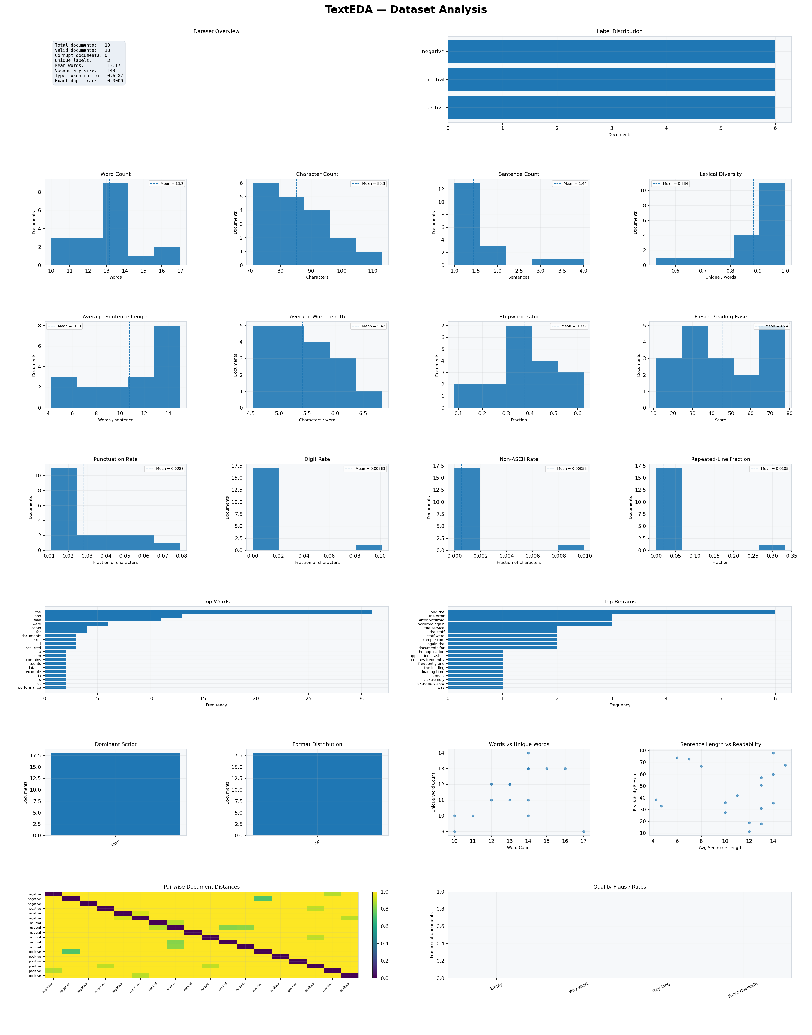
Figure 6-1. TextEDA Dataset Analysis Dashboard
A seven-row corpus dashboard combining inventory, label distribution, document lengths, lexical diversity, readability, character composition, top words and bigrams, scripts, formats, scatter diagnostics, pairwise distances, and quality flags.

6.2 plot() — Single-Document Deep Dive
def plot( self, document_index: int = 0, figsize: Tuple[int, int] = (18, 15), save_path: Optional[str] = None, dpi: int = 160, top_n: int = 20, ) -> None:

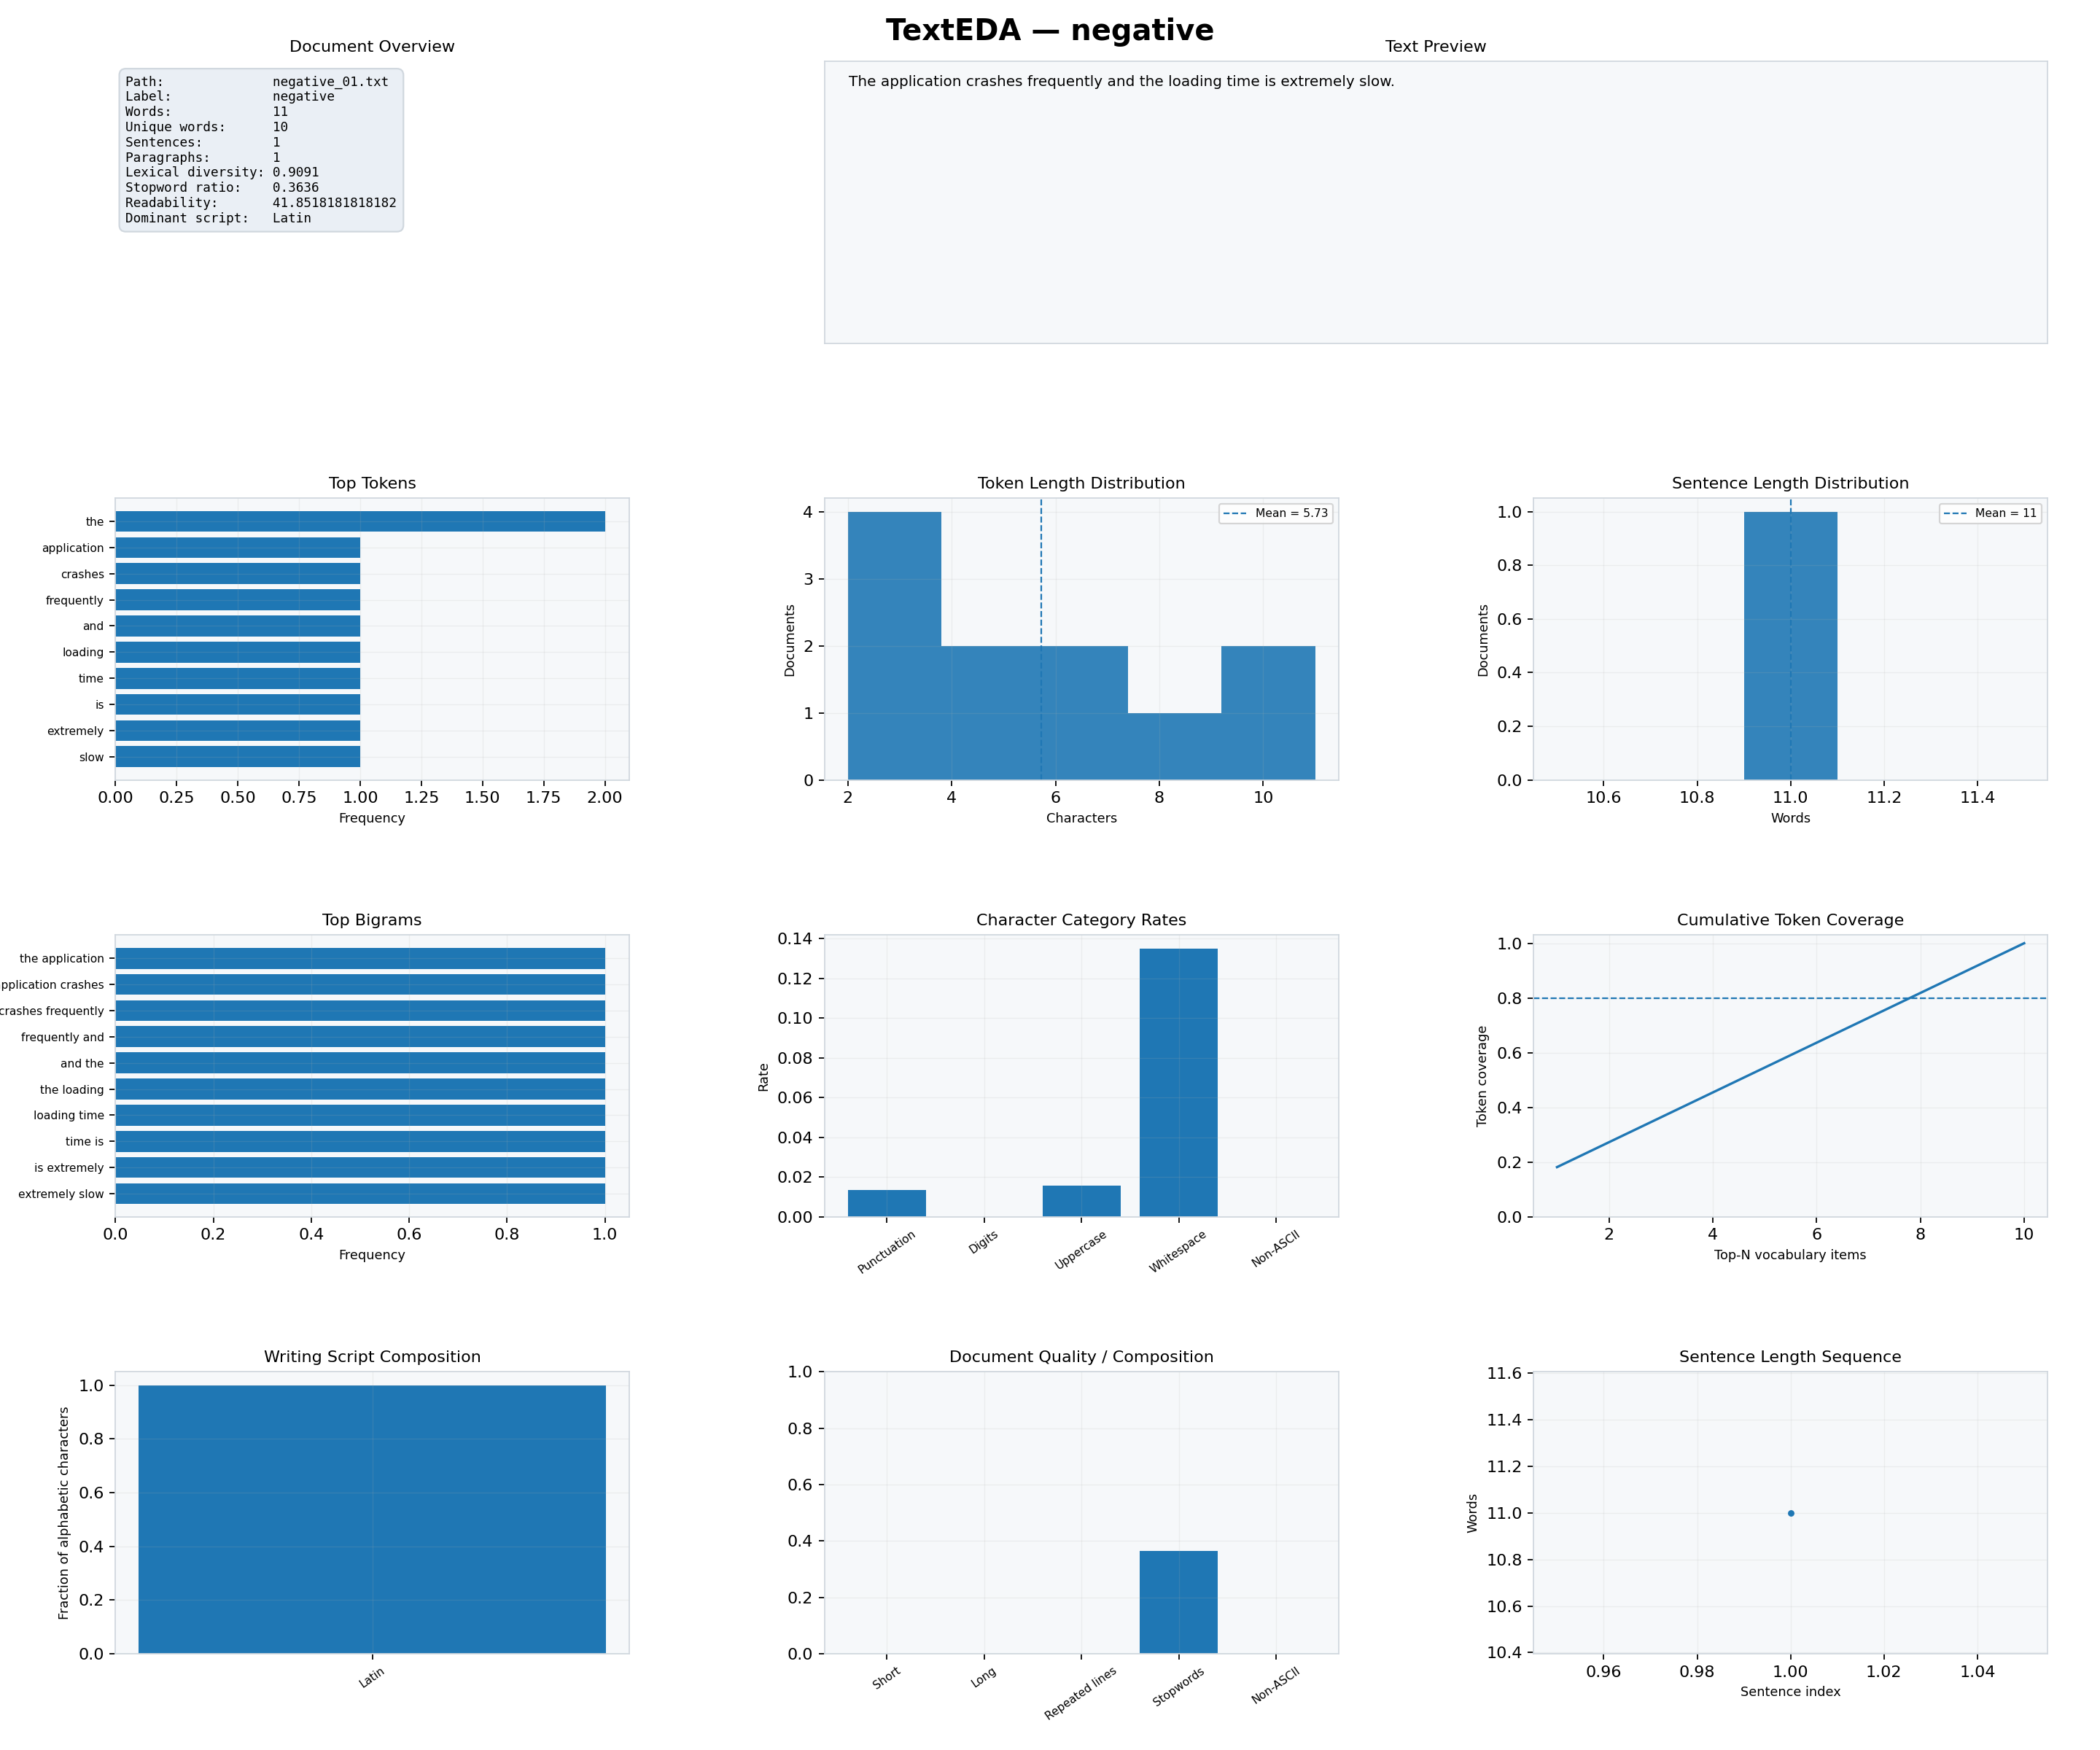
Figure 6-2. TextEDA Single-Document Dashboard
A deep dive into one document: overview card, text preview, top tokens, token and sentence-length distributions, bigrams, character-category rates, cumulative token coverage, script composition, quality/composition flags, and sentence-length sequence.

Document Overview and Text Preview
The overview card includes path/name, label, word count, unique words, sentence and paragraph counts, lexical diversity, stopword ratio, readability, and dominant script. The text preview shows the original document within a bounded panel.

Top Tokens and Top Bigrams
Frequency bars show the dominant token vocabulary and contiguous two-token phrases in the selected document.

Token and Sentence Length
Token-length and sentence-length histograms reveal unusually long tokens, terse statements, or long sentences within the selected record.

Character Composition and Token Coverage
Character rates summarise punctuation, digits, uppercase, whitespace, and non-ASCII content. The cumulative token-coverage curve shows how quickly the most frequent vocabulary items account for the document's token mass.

Script, Quality, and Sentence Sequence
The final row displays the document's writing-script proportions, short/long/repeated-line/stopword/non-ASCII composition, and a sentence-by-sentence word-count sequence.

6.3 plot_word_frequency() — Dataset Word Frequency
def plot_word_frequency( self, top_n: int = 30, exclude_stopwords: bool = False, figsize: Tuple[int, int] = (12, 8), save_path: Optional[str] = None, dpi: int = 160, ) -> None:
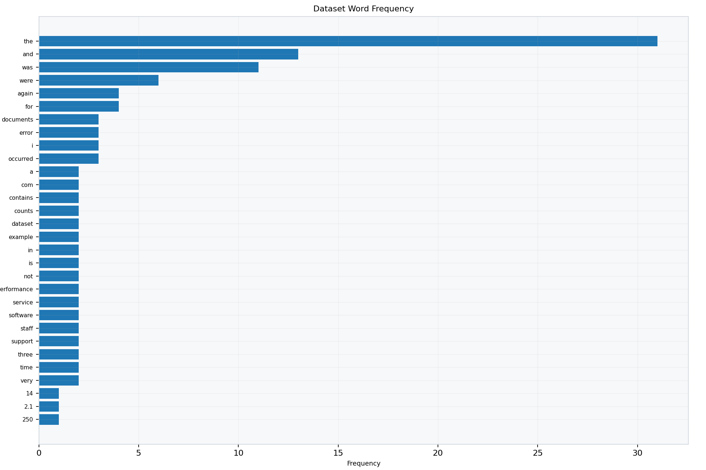
Figure 6-3. Dataset Word Frequency
A horizontal bar chart of the most frequent corpus tokens. The supplied example retains stopwords, so common function words appear prominently.
For topic-oriented interpretation, rerun with exclude_stopwords=True. For preprocessing audits, keeping stopwords can be more informative because it shows the raw lexical composition.

6.4 plot_ngram_frequency() — N-gram Frequency
def plot_ngram_frequency( self, n: int = 2, top_n: int = 30, exclude_stopwords: bool = False, figsize: Tuple[int, int] = (12, 8), save_path: Optional[str] = None, dpi: int = 160, ) -> None:

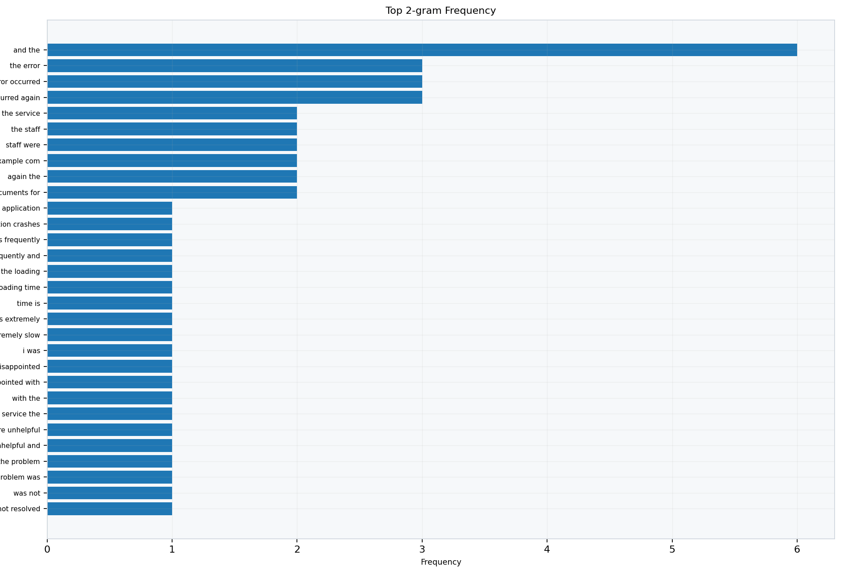
Figure 6-4. Top N-gram Frequency
Frequency of the most common contiguous n-token sequences. The attached example uses n=2 and therefore shows bigrams.

6.5 plot_length_distribution() — Length Dashboard
def plot_length_distribution( self, figsize: Tuple[int, int] = (16, 10), save_path: Optional[str] = None, dpi: int = 160, ) -> None:
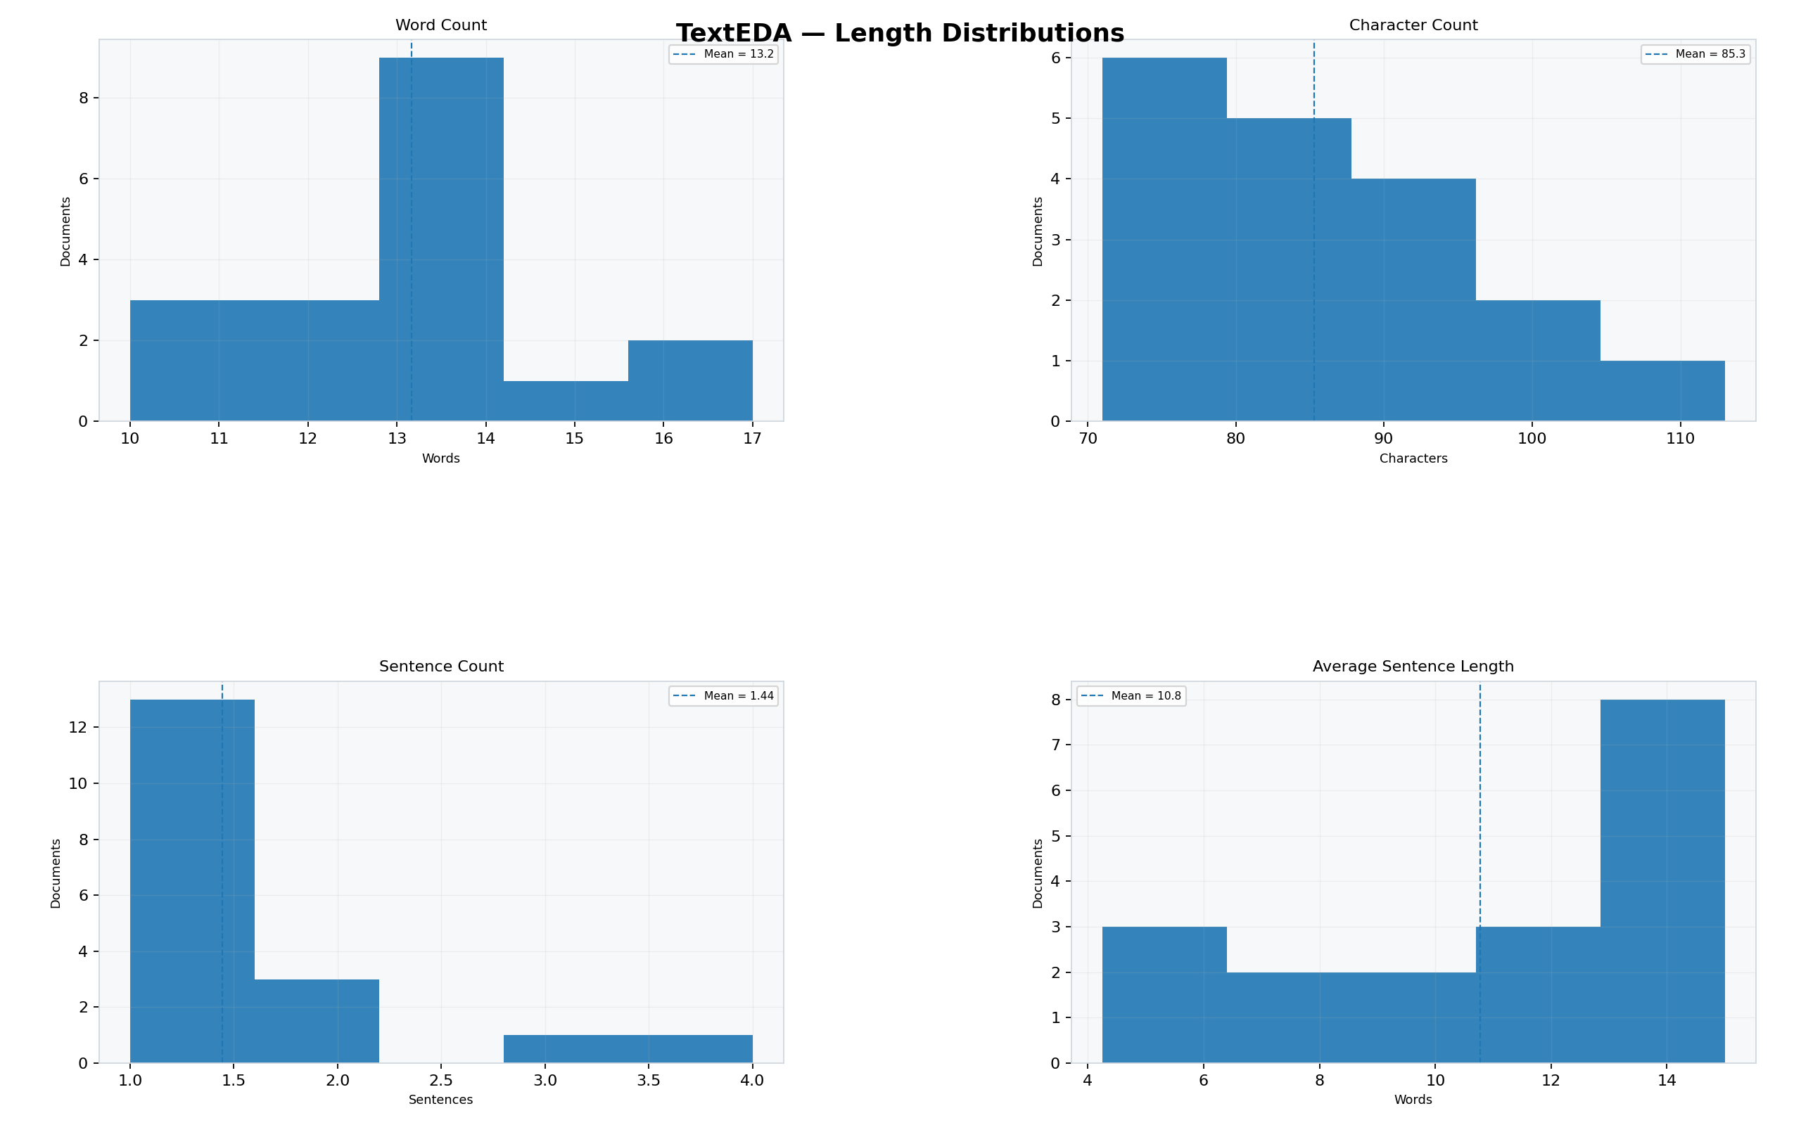
Figure 6-5. Text Length Distributions
Four histograms summarising word count, character count, sentence count, and average sentence length across documents.

6.6 plot_label_comparison() — Metric by Class
def plot_label_comparison( self, metric: str = "word_count", figsize: Tuple[int, int] = (12, 7), save_path: Optional[str] = None, dpi: int = 160, ) -> None:
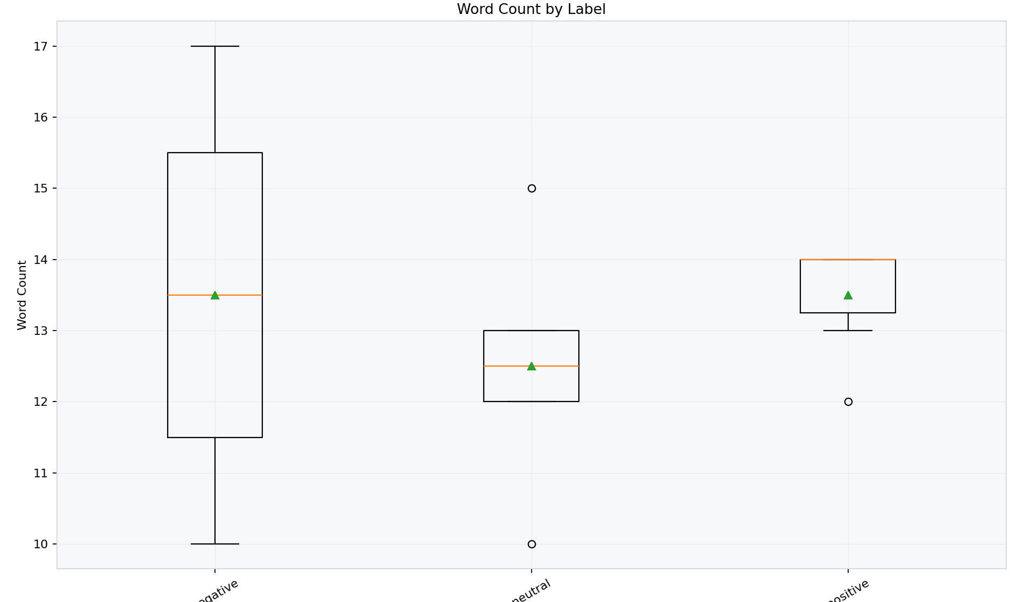
Figure 6-6. Word Count by Label
A box plot comparing a numeric TextRecord metric across labels. The mean is shown in addition to standard box-plot statistics.
metric can be any existing numeric TextRecord attribute, for example word_count, lexical_diversity, avg_sentence_length, stopword_ratio, punctuation_rate, or readability_flesch. Unknown attributes raise ValueError.

6.7 plot_pairwise_document_distances() — Similarity Heatmap
def plot_pairwise_document_distances( self, max_documents: int = 50, figsize: Tuple[int, int] = (11, 9), save_path: Optional[str] = None, dpi: int = 160, ) -> None:

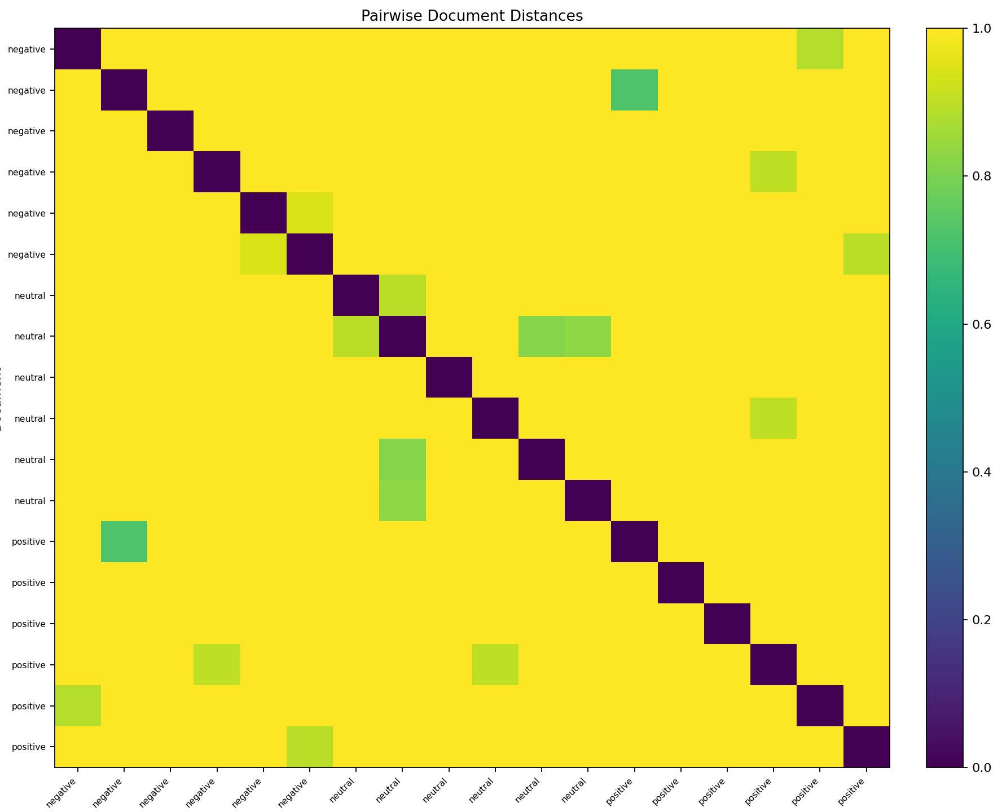
Figure 6-7. Pairwise Document Distances
A heatmap of TF-IDF cosine distances. Zero-valued diagonal cells represent each document compared with itself; smaller off-diagonal values indicate stronger lexical similarity.

Note: If multiple records share the same label, axis labels can repeat. The matrix order follows the loaded record order; use get_record() or custom names with load_texts() when unique display names are needed.

6.8 plot_text_samples() — Text Sample Grid
def plot_text_samples( self, n: int = 12, cols: int = 3, chars: int = 450, figsize: Optional[Tuple[int, int]] = None, save_path: Optional[str] = None, dpi: int = 160, ) -> None:

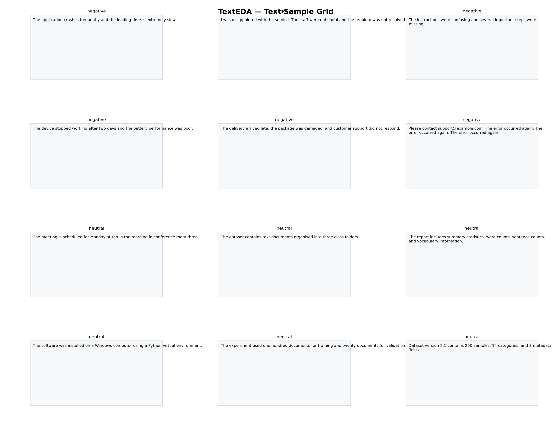
Figure 6-8. TextEDA Text Sample Grid
A compact visual audit of up to n valid documents. Each panel displays a normalised preview and the document label or name.

The grid is useful for detecting incorrect labels, repeated templates, unexpected languages, formatting artefacts, and content that numerical statistics alone may not reveal.

Chapter 7 — The TextRecord Object
Every loaded or expanded document produces one TextRecord. The class uses __slots__ to define the complete field schema. Fields are grouped below by function.

7.1 Identity and Status Fields
Field | Meaning
path | Source path or in-memory name.
name | Display name; structured rows use filename#source_index.
label | Structured label, mapped label, parent-folder label, or None.
file_ext | Input extension or 'text' for load_texts().
source_index | Row/item/line index for expanded structured inputs.
file_size_kb | Physical file size in kilobytes when file-backed.
encoding | Successful decoding used for the source file.
is_corrupt | True when reading or record analysis failed.
error | Stored error message for corrupt records.
normalised_hash | SHA-256 hash after whitespace normalisation and case folding.

7.2 Count Fields
Field | Meaning
char_count | Unicode character count.
byte_count | UTF-8 encoded byte count.
word_count | Total analysed tokens, including numeric tokens.
alpha_word_count | Alphabetic word tokens.
numeric_token_count | Tokens containing at least one digit.
unique_word_count | Distinct analysed tokens.
sentence_count | Heuristically detected sentences.
paragraph_count | Blank-line separated paragraphs.
line_count | Number of source lines.
nonempty_line_count | Source lines containing non-whitespace content.

7.3 Length and Distribution Fields
Field | Meaning
avg_word_length | Mean analysed token length.
median_word_length | Median token length.
word_length_std | Token-length standard deviation.
avg_sentence_length | Mean tokens per detected sentence.
median_sentence_length | Median tokens per sentence.
sentence_length_std | Sentence-length standard deviation.
avg_paragraph_words | Mean tokens per detected paragraph.
max_sentence_words | Largest detected sentence token count.

7.4 Lexical Fields
Field | Meaning
lexical_diversity | unique_word_count / word_count.
hapax_count | Number of token types occurring once in the document.
hapax_ratio | hapax_count / unique_word_count.
stopword_count | Configured stopword occurrences.
stopword_ratio | stopword_count / word_count.
top_tokens | Most common unigrams retained up to top_n.
top_bigrams | Most common contiguous 2-grams.
top_trigrams | Most common contiguous 3-grams.

7.5 Character and Symbol Fields
Field | Meaning
punctuation_count / rate | Non-alphanumeric, non-whitespace characters and their character fraction.
digit_count / rate | Digit characters and their character fraction.
uppercase_count / rate | Uppercase letters and fraction of alphabetic characters.
whitespace_count / rate | Whitespace characters and their character fraction.
non_ascii_count / rate | Characters with code point > 127 and their fraction.
emoji_count | Matches from the built-in emoji Unicode ranges.
url_count | HTTP/HTTPS/WWW URL matches.
email_count | Email-address regex matches.
hashtag_count | #token matches.
mention_count | @token matches.

7.6 Quality and Style Fields
Field | Meaning
repeated_line_fraction | Fraction of non-empty lines duplicated after normalisation.
empty | Whether stripped text is empty.
very_short | Whether word_count is below short_document_words.
very_long | Whether word_count exceeds long_document_words.
readability_flesch | Flesch Reading Ease estimate or None.
readability_grade | Flesch-Kincaid grade estimate or None.
script_distribution | Fractions of alphabetic characters by recognised Unicode script.
dominant_script | Script with the largest alphabetic-character count.
preview | Whitespace-normalised first 500 characters.

Chapter 8 — HTML Report, CLI, and Testing

8.1 HTML Report Structure
The generated HTML uses a responsive light-theme card layout. Inventory cards show total/valid/corrupt documents together with label, format, and dominant-script distributions. Subsequent sections summarise length, symbols and markup, readability, quality, and vocabulary.
The attached report was generated from an 18-document example corpus and correctly reports 18 total/valid documents with six negative, six neutral, and six positive labels. It demonstrates that report() reflects the currently loaded user dataset rather than a built-in fixture.

8.2 CLI Options
CLI option | Meaning
path | Text file or dataset directory.
--max | Maximum documents to analyse.
--text-field | Text column/key for CSV/TSV/JSON.
--label-field | Label column/key for CSV/TSV/JSON.
--label-from-parent | Use the parent folder as label.
--encoding | Preferred input encoding.
--preserve-case | Disable token case folding.
--min-token-length | Minimum token length.
--short-words | Very-short document threshold.
--long-words | Very-long document threshold.
--report | Write an HTML report.
--plot | Generate a dataset or single-document dashboard.
--single-plot | Plot one document rather than the dataset.
--document-index | Document index for --single-plot.
--save-plot | Save the selected dashboard image.

8.3 User-Dataset Test Workflow
The supplied testtext.py requires either --dir or --file. It validates loading, summary output, required TextRecord fields, vocabulary, document distances, all applicable visualisations, and HTML report generation. No synthetic dataset is generated or analysed.
python testtext.py --dir "C:/Users/Ike/Desktop/test_dataset/folder_dataset" --save-plots
# Optional output controls
python testtext.py --file "C:/data/reviews.jsonl" --text-field text --label-field label --save-plots --output-dir outputs_text --report viseda_text_report.html

8.4 Common Errors
Error / symptom | Likely cause | Resolution
Unsupported text format | File extension not in SUPPORTED_EXTS. | Convert the file or extend TextEDA's loader.
Could not identify a text field | Structured file has no recognised text column/key. | Pass text_field/--text-field explicitly.
Requested label_field not found | Specified label column/key is absent. | Check field spelling or omit the label field.
Unable to decode | None of the encoding fallbacks succeeded. | Pass encoding explicitly or convert the file to Unicode.
Need at least two valid documents | Distance analysis was requested on one valid document. | Load at least two documents or skip pairwise analysis.
No labelled documents are available | plot_label_comparison() has no labels. | Provide labels via folders, mappings, or structured label_field.
Unknown TextRecord metric | Invalid metric name in plot_label_comparison(). | Use a numeric TextRecord attribute.
Readability is None | No alphabetic words/sentences were available. | Treat as unavailable rather than zero.
DOCX PermissionError | Generated Word file is open/locked. | Close it; the documentation generator also supports timestamp fallback.

Chapter 9 — Advanced Usage

9.1 Custom Stopwords
domain_stopwords = {
"the", "and", "of",
"report", "document", "section",
}
eda = TextEDA(stopwords=domain_stopwords)
eda.load("corpus/")
content_vocab = eda.vocabulary(
top_n=50,
exclude_stopwords=True,
)
Note: Passing stopwords replaces the built-in set; it does not extend it automatically. Combine sets explicitly when you want both general and domain-specific stopwords.

9.2 Preserve Case
eda = TextEDA(lowercase=False)
eda.load("named_entities/")
# 'Apple' and 'apple' remain separate vocabulary entries.
print(eda.vocabulary(top_n=30))

9.3 Minimum Token Length
eda = TextEDA(min_token_length=3)
eda.load("corpus/")
Short alphabetic tokens below the threshold are removed from vocabulary and length analyses. Numeric tokens remain eligible even when their string length is shorter than the threshold.

9.4 Thresholds for Short and Long Documents
eda = TextEDA(
short_document_words=20,
long_document_words=512,
)
eda.load("documents/")
Choose these thresholds to match the modelling pipeline. For example, a transformer with a 512-token context does not map exactly to 512 TextEDA regex tokens, but TextEDA can still flag obviously long records for closer inspection.

9.5 Access Records as a pandas DataFrame
import pandas as pd
rows = []
for rec in eda._records:
if rec.is_corrupt:
continue
rows.append({
"path": rec.path,
"label": rec.label,
"words": rec.word_count,
"sentences": rec.sentence_count,
"lexical_diversity": rec.lexical_diversity,
"stopword_ratio": rec.stopword_ratio,
"readability": rec.readability_flesch,
"script": rec.dominant_script,
})
df = pd.DataFrame(rows)
df.to_csv("texteda_records.csv", index=False)

9.6 Dataset Split Hygiene
Before random train/validation/test splitting, inspect exact_duplicate_groups and near_duplicate_pairs(). Documents from the same template, source article, conversation, or duplicated record should generally remain in one split when leakage would invalidate evaluation.

9.7 Compare Two Corpora
train = TextEDA()
train.load("train/", label_from_parent=True)
test = TextEDA()
test.load("test/", label_from_parent=True)
a = train.summary()
b = test.summary()
print("Train mean words:", a["length"]["words"]["mean"])
print("Test mean words:", b["length"]["words"]["mean"])
print("Train vocab:", a["lexical"]["dataset_unique_tokens"])
print("Test vocab:", b["lexical"]["dataset_unique_tokens"])
print("Train scripts:", a["inventory"]["dominant_script_distribution"])
print("Test scripts:", b["inventory"]["dominant_script_distribution"])

9.8 Large Corpora
max_documents limits the expanded corpus. Pairwise distances independently cap analysis with max_documents because the distance matrix grows quadratically in document count. For very large corpora, use summary() on a representative sample and run similarity analysis on stratified subsets.
$$pairwise matrix storage grows as O(N²)$$

Chapter 10 — Interpreting Results and Common Findings

10.1 Red Flags to Watch For
Finding | Possible implication | Next action
High corrupt count | Unsupported encoding or malformed structured data. | Inspect corrupt_paths and source-file errors.
Many empty documents | Missing fields or failed upstream extraction. | Remove/fix empty records before tokenisation.
Many very-short documents | Labels may be inferred from insufficient context. | Review thresholds and task requirements.
Many very-long documents | Truncation or memory pressure likely. | Plan chunking, summarisation, or long-context models.
High exact-duplicate fraction | Train/test leakage and corpus redundancy risk. | Deduplicate or group before splitting.
Small pairwise distances | Near-duplicate or templated records. | Inspect text pairs and source provenance.
Very high type-token ratio | Tiny corpus, many rare terms, IDs, spelling/OCR noise. | Inspect hapax and top content words.
High repeated-line fraction | Boilerplate, logs, headers, or accidental duplication. | Strip templates or repeated metadata if irrelevant.
Unexpected dominant scripts | Mixed language or encoding content. | Stratify by language/script or audit source files.
Large class differences in length | Length may become a shortcut feature. | Use plot_label_comparison and inspect sampling/preprocessing.
Readability differs by label | Classes may be confounded with writing style/source. | Audit source/domain distribution.
High URL/email/mention rates | Social/web metadata may dominate vocabulary. | Decide whether to normalise, mask, or preserve these tokens.

10.2 Interpreting the Attached Example Dataset
The attached example report contains 18 valid .txt documents divided evenly among negative, neutral, and positive labels. The balanced label bars therefore do not indicate class imbalance, while the length and lexical plots demonstrate how TextEDA can still reveal within-class variation even when counts are balanced.
The pairwise distance heatmap is predominantly high-distance away from the diagonal, with a small number of lower-distance pairs. This suggests most documents have distinct lexical content while some share wording. The quality-flags panel shows no empty, very-short, very-long, or exact-duplicate records under the configured thresholds.
Note: Findings from the demonstration corpus illustrate how to read the plots; they are not universal quality targets. Thresholds and distributions must be interpreted relative to the NLP task and data source.

10.3 Readability Is Not Model Quality
Flesch scores describe surface-level English reading difficulty, not semantic correctness, sentiment, toxicity, factuality, or usefulness for a language model. Treat readability as a dataset-characterisation metric.

10.4 Token Counts Are Not Transformer Tokens
TextEDA's regex tokens do not correspond to BPE, WordPiece, SentencePiece, or other subword tokenisers. Use TextEDA for broad corpus EDA, then measure the exact production tokenizer when context-window utilisation is critical.

Chapter 11 — API Reference
Method | Current signature | Purpose
__init__ | TextEDA(verbose=True, max_documents=None, lowercase=True, min_token_length=1, stopwords=None, short_document_words=5, long_document_words=1000, top_n=30, encoding=None, random_seed=0) | Create a text-analysis session.
load | def load( self, source: Union[str, Path, Sequence[Union[str, Path]]], labels: Optional[Mapping[str, str]] = None, label_from_parent: bool = False, recursive: bool = True, text_field: Optional[str] = None, label_field: Optional[str] = None, ) -> "TextEDA": | Load supported files/directories.
load_texts | def load_texts( self, texts: Sequence[str], labels: Optional[Sequence[str]] = None, names: Optional[Sequence[str]] = None, ) -> "TextEDA": | Load in-memory strings.
get_record | def get_record(self, index: int = 0) -> TextRecord: | Return one TextRecord.
get_text | def get_text(self, index: int = 0) -> str: | Return stored source text.
vocabulary | def vocabulary( self, min_frequency: int = 1, top_n: Optional[int] = None, exclude_stopwords: bool = False, ) -> Dict[str, int]: | Return sorted token frequencies.
summary | def summary(self) -> Dict[str, Any]: | Return nested corpus statistics.
pairwise_document_distances | def pairwise_document_distances( self, max_documents: int = 50, max_features: int = 5_000, exclude_stopwords: bool = True, ) -> Tuple[np.ndarray, List[str]]: | Return TF-IDF cosine distances and names.
near_duplicate_pairs | def near_duplicate_pairs( self, threshold: float = 0.15, max_documents: int = 100, ) -> List[Tuple[str, str, float]]: | Return close document pairs.
plot_dataset | def plot_dataset( self, figsize: Tuple[int, int] = (22, 28), save_path: Optional[str] = None, dpi: int = 160, top_n: int = 20, ) -> None: | Comprehensive dataset dashboard.
plot | def plot( self, document_index: int = 0, figsize: Tuple[int, int] = (18, 15), save_path: Optional[str] = None, dpi: int = 160, top_n: int = 20, ) -> None: | Single-document dashboard.
plot_word_frequency | def plot_word_frequency( self, top_n: int = 30, exclude_stopwords: bool = False, figsize: Tuple[int, int] = (12, 8), save_path: Optional[str] = None, dpi: int = 160, ) -> None: | Corpus unigram plot.
plot_ngram_frequency | def plot_ngram_frequency( self, n: int = 2, top_n: int = 30, exclude_stopwords: bool = False, figsize: Tuple[int, int] = (12, 8), save_path: Optional[str] = None, dpi: int = 160, ) -> None: | Corpus n-gram plot.
plot_length_distribution | def plot_length_distribution( self, figsize: Tuple[int, int] = (16, 10), save_path: Optional[str] = None, dpi: int = 160, ) -> None: | Length dashboard.
plot_label_comparison | def plot_label_comparison( self, metric: str = "word_count", figsize: Tuple[int, int] = (12, 7), save_path: Optional[str] = None, dpi: int = 160, ) -> None: | Compare a metric by label.
plot_pairwise_document_distances | def plot_pairwise_document_distances( self, max_documents: int = 50, figsize: Tuple[int, int] = (11, 9), save_path: Optional[str] = None, dpi: int = 160, ) -> None: | Distance heatmap.
plot_text_samples | def plot_text_samples( self, n: int = 12, cols: int = 3, chars: int = 450, figsize: Optional[Tuple[int, int]] = None, save_path: Optional[str] = None, dpi: int = 160, ) -> None: | Document preview grid.
report | def report(self, output_path: str = "viseda_text_report.html") -> str: | Write HTML report and return path.

11.1 Return and Failure Behaviour
load() and load_texts() return self. get_record() returns TextRecord; get_text() returns str; vocabulary() and summary() return dictionaries; pairwise_document_distances() returns a NumPy matrix plus display names; near_duplicate_pairs() returns a list of tuples; plotting methods return None; report() returns the saved path string.
Analysis methods require a loaded object and raise RuntimeError if called before load()/load_texts(). Pairwise distance requires at least two valid documents. Invalid field names, unsupported formats, and missing paths raise explicit exceptions.

Chapter 12 —Roadmap

Version 1.0.0 — TextEDA Integration
- Unified TextEDA class for files, directories, structured corpora, and in-memory strings.
- TextRecord schema covering length, lexical, symbol, readability, script, and quality metrics.
- Plain text, HTML, CSV, TSV, JSON, JSONL, and NDJSON loading.
- Automatic structured text/label field detection.
- Encoding fallback chain and corrupt-record tracking.
- Corpus vocabulary, n-grams, exact duplicates, TF-IDF distances, and near-duplicate pairs.
- Comprehensive dataset dashboard and single-document dashboard.
- Dedicated frequency, length, label-comparison, distance, and sample-grid plots.
- Self-contained HTML report.
- User-dataset-only test workflow without synthetic-corpus reporting.

Roadmap
- Language identification and language-conditioned summaries.
- Pluggable spaCy/NLTK sentence and word tokenisers while retaining the lightweight default.
- Transformer-token length profiling for selected Hugging Face tokenisers.
- Embedding-based semantic similarity and duplicate detection.
- Named-entity, POS, dependency, and phrase-distribution analysis as optional extensions.
- Unicode normalisation diagnostics (NFC/NFD/NFKC/NFKD).
- PII-pattern auditing with privacy-preserving reporting.
- Topic-modelling and clustering visualisations.
- Class-conditional vocabulary and distinctive-term analysis.
- Train/validation/test corpus comparison utilities.
- Streaming/iterator interfaces for corpora too large to retain in memory.
- Document source/provenance metadata support.
- Interactive HTML dashboards and searchable text-sample tables.

Appendix A — Complete TextRecord Field Reference
Field | Group | Meaning
path | Identity | Source path or in-memory identifier.
name | Identity | Display name for the record.
label | Identity | Optional class/target label.
file_ext | Identity | Source extension or text.
source_index | Identity | Expanded structured-data index.
file_size_kb | Identity | Source-file size in KB.
encoding | Identity | Successful text decoding.
is_corrupt | Status | Whether reading/analysis failed.
error | Status | Stored failure text.
normalised_hash | Quality | Whitespace/case-normalised SHA-256.
char_count | Counts | Unicode characters.
byte_count | Counts | UTF-8 bytes.
word_count | Counts | Analysed tokens.
alpha_word_count | Counts | Alphabetic word tokens.
numeric_token_count | Counts | Tokens containing digits.
unique_word_count | Counts | Distinct analysed tokens.
sentence_count | Counts | Detected sentences.
paragraph_count | Counts | Detected paragraphs.
line_count | Counts | All source lines.
nonempty_line_count | Counts | Non-empty source lines.
avg_word_length | Length | Mean token characters.
median_word_length | Length | Median token characters.
word_length_std | Length | Token-length standard deviation.
avg_sentence_length | Length | Mean tokens/sentence.
median_sentence_length | Length | Median tokens/sentence.
sentence_length_std | Length | Sentence-length standard deviation.
avg_paragraph_words | Length | Mean tokens/paragraph.
max_sentence_words | Length | Maximum tokens in a sentence.
lexical_diversity | Lexical | Unique/total token ratio.
hapax_count | Lexical | Token types occurring once.
hapax_ratio | Lexical | Hapax/unique ratio.
stopword_count | Lexical | Configured stopword occurrences.
stopword_ratio | Lexical | Stopwords/total tokens.
top_tokens | Lexical | Top unigrams.
top_bigrams | Lexical | Top contiguous bigrams.
top_trigrams | Lexical | Top contiguous trigrams.
punctuation_count/rate | Symbols | Punctuation count and character fraction.
digit_count/rate | Symbols | Digit count and character fraction.
uppercase_count/rate | Symbols | Uppercase count and alphabetic fraction.
whitespace_count/rate | Symbols | Whitespace count and character fraction.
non_ascii_count/rate | Symbols | Non-ASCII count and character fraction.
emoji_count | Symbols | Emoji regex matches.
url_count | Symbols | URL regex matches.
email_count | Symbols | Email regex matches.
hashtag_count | Symbols | Hashtag matches.
mention_count | Symbols | Mention matches.
repeated_line_fraction | Quality | Repeated normalised non-empty line fraction.
empty | Quality | Empty-document flag.
very_short | Quality | Very-short threshold flag.
very_long | Quality | Very-long threshold flag.
readability_flesch | Readability | Flesch Reading Ease estimate.
readability_grade | Readability | Flesch-Kincaid grade estimate.
script_distribution | Script | Alphabetic-character fractions by script.
dominant_script | Script | Most frequent recognised script.
preview | Preview | Normalised first 500 characters.

Appendix B — summary() Schema
{
"inventory": {
"total_documents", "valid_documents",
"corrupt_documents", "corrupt_paths",
"format_distribution", "encoding_distribution",
"label_distribution", "dominant_script_distribution"
},
"length": {
"characters", "bytes", "words", "sentences",
"paragraphs", "lines", "avg_word_length",
"avg_sentence_length", "sentence_length_std"
},
"lexical": {
"dataset_total_tokens", "dataset_unique_tokens",
"dataset_type_token_ratio", "dataset_hapax_count",
"dataset_hapax_ratio", "document_lexical_diversity",
"document_hapax_ratio", "stopword_ratio",
"top_words", "top_content_words",
"top_bigrams", "top_trigrams"
},
"symbols": {
"punctuation_rate", "digit_rate", "uppercase_rate",
"whitespace_rate", "non_ascii_rate", "emoji_count",
"url_count", "email_count", "hashtag_count",
"mention_count"
},
"readability": {
"flesch_reading_ease", "flesch_kincaid_grade"
},
"quality": {
"empty_documents", "very_short_documents",
"very_long_documents", "repeated_line_fraction",
"exact_duplicate_groups", "documents_in_duplicate_groups",
"exact_duplicate_fraction"
},
"labels": {
"label_distribution", "class_imbalance_ratio"
}
}

Appendix C — Mathematical and Heuristic Reference
Metric / operation | Definition used by TextEDA
Lexical diversity | unique tokens / total tokens
Hapax ratio | token types occurring once / unique tokens
Stopword ratio | stopword tokens / total tokens
Punctuation rate | punctuation characters / characters
Digit rate | digit characters / characters
Uppercase rate | uppercase letters / alphabetic characters
Whitespace rate | whitespace characters / characters
Non-ASCII rate | characters with ord(ch)>127 / characters
Repeated-line fraction | 1 - unique normalised non-empty lines / non-empty lines
Flesch Reading Ease | 206.835 - 1.015(W/S) - 84.6(Y/W)
Flesch-Kincaid grade | 0.39(W/S) + 11.8(Y/W) - 15.59
Fallback TF | token frequency / total document tokens
Fallback IDF | log((1+N)/(1+df)) + 1
Pairwise distance | 1 - cosine similarity of TF-IDF vectors
Exact duplicate hash | SHA-256 of whitespace-normalised, case-folded text

Appendix D — Writing Scripts Recognised
Script | Unicode coverage in the current implementation
Latin | Basic/Extended Latin ranges 0041-024F and 1E00-1EFF
Cyrillic | 0400-052F
Greek | 0370-03FF
Arabic | 0600-06FF, 0750-077F, 08A0-08FF
Hebrew | 0590-05FF
Devanagari | 0900-097F
Bengali | 0980-09FF
Thai | 0E00-0E7F
CJK | 3400-4DBF, 4E00-9FFF, F900-FAFF
Hiragana | 3040-309F
Katakana | 30A0-30FF
Hangul | AC00-D7AF and 1100-11FF
Other | Alphabetic characters outside the listed ranges

Appendix E — Glossary
Term | Definition
Corpus | A collection of text documents analysed as one dataset.
Token | A unit returned by TextEDA's regular-expression tokenizer.
Type | A unique token value in a vocabulary.
Type-token ratio | Number of unique token types divided by total tokens.
Hapax legomenon | A token type occurring exactly once.
Stopword | A common function word included in the configured exclusion set.
N-gram | A contiguous sequence of n tokens.
TF-IDF | Term-frequency inverse-document-frequency weighting.
Cosine distance | One minus cosine similarity between vector representations.
Near-duplicate | Documents whose TF-IDF distance is below a selected threshold.
Exact duplicate | Documents sharing TextEDA's normalised SHA-256 hash.
Readability | Surface-level estimate of reading difficulty; not a semantic quality measure.
Writing script | Unicode character system such as Latin, Arabic, CJK, or Hangul.
Encoding | Mapping used to decode bytes into Unicode text.
Boilerplate | Repeated template text such as headers, disclaimers, or signatures.
Structured text dataset | Rows/items where text and labels are stored in named fields.

Appendix F — Acknowledgements
TextEDA is implemented with Python's standard text-processing libraries, NumPy, Matplotlib, and optional scikit-learn. The module is intended to support researchers and practitioners working in NLP, text classification, sentiment analysis, information retrieval, document analysis, social-media analytics, and language-model dataset preparation.

