Visual Exploratory Data Analysis (VisEDA): PART C
Hyperspectral Exploratory Data Analysis
A Guide to Hyperspectral and Multispectral Dataset Analysis

Isaac Osei Agyemang
Version 1.0.0
2026

Preface
VisEDA was created to bring the discipline and convenience of tabular exploratory data analysis to visual datasets. Hyperspectral data requires especially careful EDA because every sample contains both spatial structure and a dense spectral signature. A dataset can appear visually plausible while still containing defective bands, incompatible wavelength definitions, inconsistent radiometric scales, class imbalance, spectral redundancy, or corrupt files.
HyperspectralEDA addresses these issues through one unified interface for individual cubes and multi-cube datasets. It analyses spatial dimensions, per-band statistics, signal-to-noise ratio, robust noise, spectral smoothness, inter-band correlation, dropout bands, vegetation and water indices, principal components, texture, and cross-cube spectral diversity. The module also produces detailed dashboards, dedicated spectral plots, a self-contained HTML report, and programmatic access to all computed fields.
This manual is generated from the current HyperspectralEDA implementation, its test suite, command-line interface, HTML report, and visual outputs. The Word format is intentionally editable so that descriptions, screenshots, institutional branding, examples, and future API changes can be revised directly.
Isaac Osei Agyemang
May 2026

Table of Contents
Preface 2
Table of Contents 3
Chapter 1 — Introduction 7
1.1 What is HyperspectralEDA? 7
1.2 Why Hyperspectral EDA Matters 7
1.3 The Hyperspectral Cube 7
1.4 Design Philosophy 7
1.5 Installation 7
1.6 Supported Data Formats 8
1.7 Wavelength Conventions 8
Chapter 2 — Quick Start 9
2.1 Analyse a Single Cube 9
2.2 Analyse a Directory of Cubes 9
2.3 Load NumPy Arrays Directly 9
2.4 Get the Summary Dictionary 10
2.5 Generate All Visualisations 10
2.6 Extract a Pixel Spectral Signature 10
2.7 Compute Spectral Index Maps 10
2.8 Obtain PCA Scores 10
2.9 Generate the HTML Report 11
2.10 Command-Line Interface 11
Chapter 3 — The HyperspectralEDA Class 12
3.1 Constructor 12
3.2 load() — Load Cubes from Files 12
3.3 load_arrays() — Load In-Memory Cubes 12
3.4 summary() — Aggregate Statistics 12
3.5 get_record() — Access a CubeRecord 13
3.6 spectral_signature() — Read One Pixel Spectrum 13
3.7 compute_index() — Create an Index Map 13
3.8 pca_scores() — Obtain Pixel-Level Components 13
3.9 report() — Generate HTML 13
3.10 Object State and Method Chaining 13
Chapter 4 — The CubeRecord Object 14
4.1 Identity and Shape Fields 14
4.2 Global and Per-Band Fields 14
4.3 Spectral Quality and Spatial Fields 14
4.4 Spectral Indices, PCA, and Texture 14
Chapter 5 — What Is Analysed 16
5.1 Dataset Inventory 16
5.2 Spatial Dimensions and File Size 16
5.3 Global Radiometric Statistics 16
5.4 Per-Band Mean, Standard Deviation, Minimum, and Maximum 16
5.5 Signal-to-Noise Ratio 16
5.6 Robust Noise Using Median Absolute Deviation ($MAD$) 16
5.7 Saturation Fraction 16
5.8 Spectral Smoothness 17
5.9 Inter-Band Correlation 17
5.10 Dropout Band Detection 17
5.11 Spatial Mean and Spatial Standard-Deviation Maps 17
5.12 Spectral Indices 17
5.13 Principal Component Analysis 17
5.14 GLCM Texture on the First Principal Component 17
5.15 Cross-Cube Mean Spectrum 18
5.16 Spectral Diversity 18
5.17 Corrupt-File Detection 18
Chapter 6 — Visualisations 19
6.1 plot() — Single-Cube Deep-Dive Dashboard 19
Cube Overview 20
False Colour 20
Spatial Mean Map 20
Mean Spectral Signature ± 1σ 20
SNR per Band 20
Per-Band Min / Mean / Max 20
NDVI, NDWI, and EVI maps 20
PCA Variance 20
Texture (GLCM) 20
Spectral Quality Metrics 20
6.2 plot_dataset() — Dataset Analysis Dashboard 20
6.3 plot_spectra() — Spectral Overlay 22
6.4 plot_false_colour() — False-Colour Previews 22
6.5 plot_ndvi() — NDVI Map Grid 23
6.6 plot_pca_components() — PCA Component Images 23
6.7 plot_band_stats() — Per-Band Diagnostics 24
6.8 plot_spectral_diversity() — Cosine Similarity 25
Chapter 7 — Interpreting Results and Common Findings 26
7.1 Red Flags to Review 26
7.2 Interpreting the Attached Example Outputs 26
7.3 Reflectance, Radiance, and Digital Numbers 26
7.4 Comparing Datasets Fairly 26
Chapter 8 — Advanced Usage 28
8.1 Working with Large Datasets 28
8.2 Accessing and Filtering CubeRecord Objects 28
8.3 Exporting Records to a DataFrame 28
8.4 Manual Band Overrides 29
8.5 Integrating with a Machine-Learning Pipeline 29
8.6 Comparing Two Datasets 29
Chapter 9 — HTML Report 30
Chapter 10 — Command-Line Reference 31
Chapter 11 — API Reference 32
HyperspectralEDA.__init__() 32
HyperspectralEDA.load() 32
HyperspectralEDA.load_arrays() 32
HyperspectralEDA.summary() 32
HyperspectralEDA.get_record() 32
HyperspectralEDA.spectral_signature() 32
HyperspectralEDA.compute_index() 32
HyperspectralEDA.pca_scores() 32
HyperspectralEDA.plot() 33
HyperspectralEDA.plot_dataset() 33
HyperspectralEDA.plot_spectra() 33
HyperspectralEDA.plot_false_colour() 33
HyperspectralEDA.plot_ndvi() 33
HyperspectralEDA.plot_pca_components() 33
HyperspectralEDA.plot_band_stats() 33
HyperspectralEDA.plot_spectral_diversity() 33
HyperspectralEDA.report() 33
Chapter 12 — Troubleshooting 35
No valid cubes found 35
Ground-truth masks are analysed as cubes 35
Wavelength length does not match band count 35
EVI is extremely large 35
GLCM is blank or unavailable 35
PCA is blank 35
Spectral diversity says at least two cubes are required 35
The .mat loader chooses the wrong array 35
ENVI or GeoTIFF loading fails 35
The Word TOC is blank 35
The Word output is permission denied 35
Chapter 13 —Roadmap 36
Version 1.0.0 — Current Documented Release 36
Roadmap 36
Appendix A — Complete CubeRecord Field Reference 37
Appendix B — summary() Schema 38
Appendix C — Glossary 39
Appendix D — Documentation Generator Usage 40
Appendix E — Acknowledgements 41

Chapter 1 — Introduction

1.1 What is HyperspectralEDA?
HyperspectralEDA is the hyperspectral and multispectral analysis module of VisEDA. It accepts a single data cube, a directory of cubes, an explicit file list, or in-memory NumPy arrays. Every cube is normalised to the convention (H, W, B): image height, image width, and spectral bands. At the individual-cube level, the module computes metadata, spatial maps, per-band statistics, spectral quality indicators, spectral indices, texture measures, and PCA variance. At the dataset level, it aggregates compatible cubes to reveal distributions, class balance, cross-cube spectra, and spectral diversity.

1.2 Why Hyperspectral EDA Matters
- Band integrity: A cube may contain bands with near-zero variance, saturation, severe noise, or sensor artefacts.
- Radiometric consistency: Cubes from different sensors or processing stages may use reflectance, radiance, or raw digital numbers on incompatible scales.
- Wavelength alignment: Spectral indices are only meaningful when band positions correspond to the intended wavelengths.
- Dimensionality: Hundreds of bands are often highly redundant; PCA shows how many components explain most variance.
- Spectral similarity: Near-identical cubes can produce data leakage or a misleadingly large training set.
- Spatial inconsistency: Different cube dimensions and resolutions require explicit preprocessing decisions.
- Class imbalance: Folder-based labels may be unevenly represented, biasing downstream classifiers.
- Corrupt or auxiliary files: Ground-truth masks and metadata arrays can be mistaken for cubes unless the dataset is organised correctly.

1.3 The Hyperspectral Cube
A hyperspectral cube combines two spatial dimensions with one spectral dimension. For a cube C with shape H × W × B, C[i, j, b] is the measured value at row i, column j, and band b. The implementation expects or converts every cube to this H-W-B layout. A two-dimensional array is treated as a single-band cube with shape H × W × 1.
C ∈ ℝ^(H × W × B)
H = height, W = width, B = spectral bands
Note: The loader does not automatically distinguish a ground-truth label mask from a one-band image. Store *_gt.mat masks outside the analysis directory, or filter them before loading.

1.4 Design Philosophy
- One class for single and multiple cubes. The same HyperspectralEDA object supports a deep dive into one cube and aggregate dataset analysis.
- Progressive disclosure. summary() provides structured statistics; plot() and plot_dataset() provide visual interpretation; report() creates a shareable HTML file.
- Lazy optional dependencies. GLCM, PCA, ENVI, GeoTIFF, and MATLAB support are imported only when required.
- Memory-aware computation. Inter-band correlation, PCA, and GLCM use deterministic pixel sampling when cubes are large.
- Reproducibility. Random sampling uses a fixed NumPy random generator seed of 0 in the current implementation.
- Transparent records. Every cube is represented by a CubeRecord object containing all computed fields.

1.5 Installation
Install the core package and the dependencies needed for the formats and analyses you intend to use:
pip install viseda numpy matplotlib
# MATLAB .mat files
pip install scipy
# PCA and GLCM texture
pip install scikit-learn scikit-image opencv-python
# ENVI .hdr / .bil / .bip / .bsq
pip install spectral
# Multi-band GeoTIFF
pip install rasterio
# Editable Word documentation generator
pip install python-docx pillow
Note: When compute_glcm=False or compute_pca=False, the corresponding optional analysis is skipped. The remainder of HyperspectralEDA continues to work.

1.6 Supported Data Formats
Table 1. Supported HyperspectralEDA input formats.
Extension | Reader | Expected behaviour | Dependency
.mat | scipy.io.loadmat | Selects the largest non-private array in the MATLAB file. | scipy
.npy | numpy.load | Loads one array and converts it to float32. | numpy
.npz | numpy.load | Uses the first key in the archive. | numpy
.hdr/.bil/.bip/.bsq/.envi | spectral.open_image | Reads ENVI-compatible data and normalises to H-W-B. | spectral
.tif/.tiff | rasterio.open | Reads B-H-W and transposes to H-W-B. | rasterio

1.7 Wavelength Conventions
The optional wavelengths array should contain one wavelength value in nanometres for each band. When supplied, spectral plots use a physical wavelength axis and spectral indices automatically select the nearest bands to approximately 490 nm (blue), 560 nm (green), 670 nm (red), and 850 nm (near infrared). When wavelengths are omitted, the module uses band indices 0…B−1 and the automatic spectral-index band selection becomes an index-space approximation.
Note: A wavelength array whose length differs from the current cube band count should be corrected before interpretation. Different datasets such as PaviaU, Indian Pines, and Salinas have different band counts; one global wavelength array may therefore be inappropriate for a mixed directory.

Chapter 2 — Quick Start

2.1 Analyse a Single Cube
import numpy as np
from viseda import HyperspectralEDA
# Example wavelength axis for a 103-band PaviaU cube
wavelengths = np.linspace(400, 1500, 103)
eda = HyperspectralEDA(
verbose=True,
wavelengths=wavelengths,
compute_glcm=True,
compute_pca=True,
)
eda.load("PaviaU.mat")
stats = eda.summary()
print(stats["inventory"])
print(stats["spectral_quality"])
eda.plot(cube_index=0, save_path="outputs_hyper/plot.png")
eda.plot_band_stats(cube_index=0,
save_path="outputs_hyper/plot_band_stats.png")

2.2 Analyse a Directory of Cubes
from viseda import HyperspectralEDA
# Recommended dataset structure
# hyperspectral_dataset/
# city/
# PaviaU.mat
# farmland/
# Indian_pines_corrected.mat
# forest/
# Salinas_corrected.mat
eda = HyperspectralEDA(verbose=True, compute_glcm=True, compute_pca=True)
eda.load(
"hyperspectral_dataset/",
label_from_parent=True,
recursive=True,
)
eda.plot_dataset(save_path="outputs_hyper/plot_dataset.png")
eda.plot_false_colour(save_path="outputs_hyper/plot_false_colour.png")
eda.plot_ndvi(save_path="outputs_hyper/plot_ndvi.png")
eda.plot_spectra(save_path="outputs_hyper/plot_spectra.png")
eda.report("outputs_hyper/viseda_hyper_report.html")

2.3 Load NumPy Arrays Directly
import numpy as np
from viseda import HyperspectralEDA
cube_a = np.load("cube_a.npy") # shape: (H, W, B)
cube_b = np.load("cube_b.npy")
eda = HyperspectralEDA(
wavelengths=np.linspace(400, 2500, cube_a.shape[2]),
compute_glcm=False,
compute_pca=True,
)
eda.load_arrays(
[cube_a, cube_b],
labels=["farmland", "urban"],
)
eda.plot_dataset()

2.4 Get the Summary Dictionary
summary = eda.summary()
print(summary["inventory"])
print(summary["spatial"])
print(summary["spectral_stats"])
print(summary["spectral_quality"])
print(summary["spectral_indices"])
print(summary["texture"])
print(summary["pca"])
print(summary["labels"])

2.5 Generate All Visualisations
eda.plot(cube_index=0) # single-cube dashboard
eda.plot_dataset() # full dataset dashboard
eda.plot_spectra(max_cubes=20) # spectral overlay
eda.plot_false_colour(n=12, cols=4) # false-colour grid
eda.plot_ndvi(n=12, cols=4) # NDVI maps
eda.plot_pca_components(cube_index=0,
n_components=6) # PCA images
eda.plot_band_stats(cube_index=0) # six per-band curves
eda.plot_spectral_diversity() # cosine similarity heatmap

2.6 Extract a Pixel Spectral Signature
wavelengths, signature = eda.spectral_signature(
cube_index=0,
row=100,
col=120,
)
print(wavelengths.shape)
print(signature.shape)

2.7 Compute Spectral Index Maps
ndvi = eda.compute_index(0, "ndvi")
ndwi = eda.compute_index(0, "ndwi")
evi = eda.compute_index(0, "evi")
savi = eda.compute_index(0, "savi")
print(ndvi.shape) # (height, width)

2.8 Obtain PCA Scores
scores, variance_ratio = eda.pca_scores(
cube_index=0,
n_components=10,
)
print(scores.shape) # (H*W, 10)
print(variance_ratio) # explained variance per component
print(variance_ratio.cumsum())

2.9 Generate the HTML Report
report_path = eda.report("outputs_hyper/viseda_hyper_report.html")
print(report_path)

2.10 Command-Line Interface
# Basic summary
viseda hyper path/to/cubes/
# Infer labels from parent folders and save an HTML report
viseda hyper path/to/cubes/ --label-from-parent --report outputs_hyper/report.html
# Provide wavelengths saved as a NumPy array
viseda hyper path/to/PaviaU.mat --wavelengths wavelengths.npy --plot --save-plot outputs_hyper/plot.png
# Dataset dashboard rather than the single-cube plot
viseda hyper path/to/cubes/ --label-from-parent --plot --dataset-plot --save-plot outputs_hyper/plot_dataset.png

Chapter 3 — The HyperspectralEDA Class

3.1 Constructor
eda = HyperspectralEDA(
verbose=True,
wavelengths=None,
max_cubes=None,
compute_glcm=True,
compute_pca=True,
dropout_threshold=0.01,
ndvi_nir_band=None,
ndvi_red_band=None,
ndwi_green_band=None,
ndwi_nir_band=None,
)
Table 2. HyperspectralEDA constructor parameters.
Parameter | Type | Default | Meaning
verbose | bool | True | Print loading and progress messages.
wavelengths | 1-D array or None | None | Band-centre wavelengths in nm. Enables physical-axis plots and automatic index bands.
max_cubes | int or None | None | Maximum cubes analysed during load().
compute_glcm | bool | True | Compute GLCM texture from the first principal component.
compute_pca | bool | True | Compute up to 20 PCA explained-variance components.
dropout_threshold | float | 0.01 | A band is flagged when its standard deviation is below this fraction of the standard deviation of band standard deviations.
ndvi_nir_band | int or None | None | Manual NIR band override for NDVI/EVI/SAVI.
ndvi_red_band | int or None | None | Manual red band override for NDVI/EVI/SAVI.
ndwi_green_band | int or None | None | Manual green band override for NDWI.
ndwi_nir_band | int or None | None | Manual NIR band override for NDWI.

3.2 load() — Load Cubes from Files
def load( self, source: Union[str, Path, List], labels: Optional[Dict[str, str]] = None, label_from_parent: bool = False, recursive: bool = True, ) -> "HyperspectralEDA":
Discovers supported cube files, applies max_cubes, determines labels, computes one CubeRecord per file, and marks unreadable inputs as corrupt rather than terminating the complete dataset analysis.

3.3 load_arrays() — Load In-Memory Cubes
def load_arrays( self, arrays: List[np.ndarray], labels: Optional[List[str]] = None, ) -> "HyperspectralEDA":
Accepts a list of H-W-B NumPy arrays. Each array is converted to float32 and analysed using the same statistics as file-backed cubes. Array-backed records use names such as <array_0>.

3.4 summary() — Aggregate Statistics
def summary(self) -> Dict[str, Any]:
Returns inventory, spatial, spectral_stats, spectral_quality, spectral_indices, texture, PCA, and label sections. Compatible band counts are grouped using the dominant band count for cross-cube spectral aggregation.

3.5 get_record() — Access a CubeRecord
def get_record(self, index: int = 0) -> CubeRecord:
Returns the record at the requested position. This is the primary route for filtering, sorting, exporting, or inspecting per-cube fields.

3.6 spectral_signature() — Read One Pixel Spectrum
def spectral_signature( self, cube_index: int = 0, row: int = 0, col: int = 0 ) -> Tuple[np.ndarray, np.ndarray]:
Re-reads the selected file-backed cube and returns the wavelength/index axis and spectral values for a single pixel. Coordinates are checked against cube dimensions.

3.7 compute_index() — Create an Index Map
def compute_index( self, cube_index: int = 0, index_name: str = "ndvi", ) -> np.ndarray:
Computes NDVI, NDWI, EVI, or SAVI for one cube. The result is a two-dimensional map with the cube height and width.

3.8 pca_scores() — Obtain Pixel-Level Components
def pca_scores( self, cube_index: int = 0, n_components: int = 10, ) -> Tuple[np.ndarray, np.ndarray]:
Reshapes the cube to H×W pixel spectra, runs randomized PCA, and returns component scores and explained-variance ratios.

3.9 report() — Generate HTML
def report(self, output_path: str = "viseda_hyperspectral_report.html") -> str:
Writes a self-contained HTML report based on summary(). The report contains inventory, spatial, and spectral statistics; spectral quality; indices; PCA; texture; labels; and dependency-free styling.

3.10 Object State and Method Chaining
load() and load_arrays() return self, allowing method chaining. summary(), plotting methods, report(), spectral_signature(), compute_index(), and pca_scores() require a loaded object. Calling them before loading raises a RuntimeError through the internal _check_loaded() guard.
eda = (
HyperspectralEDA(verbose=True)
.load("dataset/", label_from_parent=True)
)
summary = eda.summary()

Chapter 4 — The CubeRecord Object
Each analysed cube is represented by a lightweight CubeRecord. The object uses __slots__, so its supported fields are explicit and memory overhead is reduced. Fields are initialised to None and populated when the corresponding analysis succeeds.

4.1 Identity and Shape Fields
Field | Type | Meaning
path | str | File path or <array_i>.
label | str or None | Class label from a mapping or parent directory.
file_ext | str | Extension such as .mat, .npy, .tif, or array.
file_size_kb | float or None | File size for file-backed cubes.
height | int | Spatial height H.
width | int | Spatial width W.
bands | int | Spectral band count B.
dtype | str | Internal cube dtype after conversion, normally float32.
is_corrupt | bool | True when reading or analysis failed.

4.2 Global and Per-Band Fields
Field | Type | Meaning
global_mean/global_std | float | Overall cube mean and standard deviation.
global_min/global_max | float | Overall minimum and maximum.
dynamic_range | float | global_max − global_min.
band_means | array (B,) | Mean of every spectral band.
band_stds | array (B,) | Standard deviation of every band.
band_mins/band_maxs | array (B,) | Per-band extrema.
band_snr | array (B,) | Per-band mean divided by standard deviation.
band_noise_mad | array (B,) | Per-band median absolute deviation.
band_saturation_frac | array (B,) | Fraction of pixels equal to the cube global maximum.

4.3 Spectral Quality and Spatial Fields
Field | Type | Meaning
spectral_smoothness | float | Mean absolute difference between adjacent band means.
inter_band_corr | float | Mean off-diagonal correlation between bands.
n_dropout_bands | int | Bands below the configured variability threshold.
snr_mean | float | Mean of band_snr.
spatial_mean_map | array (H,W) | Mean across bands for each pixel.
spatial_std_map | array (H,W) | Standard deviation across bands for each pixel.

4.4 Spectral Indices, PCA, and Texture
Field | Type | Meaning
ndvi_mean/ndvi_std | float | Summary of the NDVI map.
ndwi_mean/ndwi_std | float | Summary of the NDWI map.
evi_mean/evi_std | float | Summary of the EVI map.
savi_mean/savi_std | float | Summary of the SAVI map.
pca_variance_ratio | array | Explained variance for up to 20 components.
glcm_contrast | float | Texture contrast on PC1.
glcm_dissimilarity | float | Texture dissimilarity on PC1.
glcm_homogeneity | float | Texture homogeneity on PC1.
glcm_energy | float | GLCM energy on PC1.
glcm_correlation | float | GLCM correlation on PC1.
glcm_asm | float | Angular second moment on PC1.

Chapter 5 — What Is Analysed

5.1 Dataset Inventory
The inventory section records total, valid, and corrupt cube counts; corrupt paths; distributions of band counts and file formats; and labels. A mixed band-count distribution is not automatically an error, but only cubes sharing the dominant band count contribute to cross-cube spectra and spectral-diversity analysis.

5.2 Spatial Dimensions and File Size
HyperspectralEDA summarises cube heights, widths, band counts, and file sizes using count, mean, standard deviation, minimum, quartiles, median, and maximum. These statistics identify mixed spatial resolutions, inconsistent scene extents, and unexpectedly small files.

5.3 Global Radiometric Statistics
global_mean and global_std describe the overall radiometric scale of each cube. global_min and global_max identify the observed range, while dynamic_range is the difference between the extrema. These values should not be compared blindly across reflectance, radiance, and raw digital-number datasets.
Dynamic range = max(C) − min(C)

5.4 Per-Band Mean, Standard Deviation, Minimum, and Maximum
For every band b, HyperspectralEDA computes mean, standard deviation, minimum, and maximum over the H×W spatial plane. The band-mean curve is the cube's average spectral signature. Band-standard-deviation peaks indicate wavelengths with strong spatial variability, while minima may reveal low-information or defective bands.

5.5 Signal-to-Noise Ratio
$${SNR}_{b} = μ_{b} / (σ_{b} + ε)$$
$μ_{b}$ and $σ_{b}$ are the spatial mean and standard deviation of band b; ε = 10⁻⁹.
The implementation uses a simple mean-to-standard-deviation ratio. snr_mean is the average across bands. This is a descriptive signal-consistency measure rather than a calibrated instrument SNR. Low values can indicate weak signal, high spatial variation, noise, or a mean near zero.

5.6 Robust Noise Using Median Absolute Deviation ($MAD$)
${MAD}_{b}$ = median(|$C_{b}$ − median($C_{b}$)|)
Median absolute deviation is more robust to isolated extreme pixels than standard deviation. The plot_band_stats() dashboard exposes the full per-band $MAD$ curve, helping identify noisy wavelength regions.

5.7 Saturation Fraction
${Saturation fraction}_{b}$ = count($C_{b}$ = global max) / (H×W)
The current implementation defines saturation relative to the cube's global maximum. A high value means many pixels in a band are pinned at that maximum. Because the maximum is cube-dependent, interpretation should consider sensor bit depth and preprocessing.

5.8 Spectral Smoothness
Smoothness = mean(| $μ_{(b+1)}$ − $μ_{b}$ |)
This scalar measures the average step between adjacent band means. A low value indicates a smooth mean spectrum; a high value indicates rapid changes, strong absorption features, calibration discontinuities, or mismatched band ordering. Absolute values depend on radiometric scale.

5.9 Inter-Band Correlation
Pixel spectra are reshaped to an N×B matrix. When N exceeds 5,000 pixels, a deterministic 5,000-pixel sample is used. The B×B correlation matrix is calculated, and the mean of all off-diagonal entries becomes inter_band_corr. High correlation suggests spectral redundancy; low or negative values indicate more independent band behaviour or potential artefacts.

5.10 Dropout Band Detection
Dropout if $σ_{b}$ < dropout_threshold × std({$σ_{1}$,…,$σ_{b}$})
The default threshold is 0.01. A dropout band has exceptionally low spatial variability relative to the spread of band standard deviations. The count is stored as n_dropout_bands. Constant or almost constant bands are strong candidates for removal.
Note: This implementation uses the standard deviation of the per-band standard deviations, not the overall cube standard deviation. Interpret the threshold accordingly when customising dropout_threshold.

5.11 Spatial Mean and Spatial Standard-Deviation Maps
spatial_mean_map averages all bands at every pixel. It gives a panchromatic-like structural view. spatial_std_map measures how strongly each pixel varies over wavelengths, highlighting spectrally distinctive materials or boundaries.

5.12 Spectral Indices
When appropriate bands can be selected, the module computes four common indices. Band positions are chosen by the nearest wavelength or by explicit constructor overrides.
NDVI = (NIR − Red) / (NIR + Red + ε)
NDWI = (Green − NIR) / (Green + NIR + ε)
EVI = 2.5(NIR − Red) / (NIR + 6Red − 7.5Blue + 1 + ε)
SAVI = 1.5(NIR − Red) / (NIR + Red + 0.5 + ε)
Note: NDVI and related thresholds assume reflectance-like inputs. Raw digital numbers or radiance can produce unusual values, especially EVI when the denominator approaches zero. The test suite therefore checks finiteness rather than forcing synthetic reflectance ranges for real .mat datasets.

5.13 Principal Component Analysis
PCA reshapes the cube to H×W pixel spectra and fits up to min(20, B, number of pixels) components. If a cube exceeds 10,000 pixels, a fixed 10,000-pixel sample is used for fitting. pca_variance_ratio stores the explained variance. The summary reports the mean component profile across cubes and the mean number of components needed to reach 95% cumulative variance.

5.14 GLCM Texture on the First Principal Component
Texture is computed on a first-principal-component image because PC1 condenses the dominant spatial-spectral information into one greyscale plane. The PC1 image is resized to 128×128, quantised to 64 grey levels, and analysed at distance 1 and angles 0°, 45°, 90°, and 135°. The resulting properties are averaged over angles.
GLCM feature | Interpretation
Contrast | Emphasises strong local intensity differences.
Dissimilarity | Measures average absolute grey-level difference.
Homogeneity | High when co-occurrences concentrate near the diagonal.
Energy | Square root of angular second moment; high for regular texture.
Correlation | Measures linear dependency between neighbouring grey levels.
ASM | Sum of squared GLCM probabilities.

5.15 Cross-Cube Mean Spectrum
The dominant band count is the most frequent B value in the dataset. Cubes with that band count are stacked by band_means to calculate a dataset mean spectrum and standard-deviation envelope. This avoids invalid stacking of incompatible spectral dimensions.

5.16 Spectral Diversity
cosine similarity(i,j) = ($s_{i}$ · $s_{j}$) / (||$s_{i}$|| ||$s_{j}$||)
Mean spectra from up to 50 cubes sharing the dominant band count are normalised and compared by cosine similarity. Values close to 1 indicate very similar spectral shapes. The heatmap is especially useful for detecting redundant scenes, repeated samples, or class clusters.

5.17 Corrupt-File Detection
Read or analysis failures are caught per cube. The corresponding CubeRecord is marked is_corrupt=True and remains in the inventory, allowing the dataset analysis to complete. The summary records corrupt_paths for follow-up.

Chapter 6 — Visualisations

6.1 plot() — Single-Cube Deep-Dive Dashboard
eda.plot(
cube_index=0,
figsize=(22, 20),
save_path="outputs_hyper/plot.png",
dpi=150,
rgb_bands=None,
)

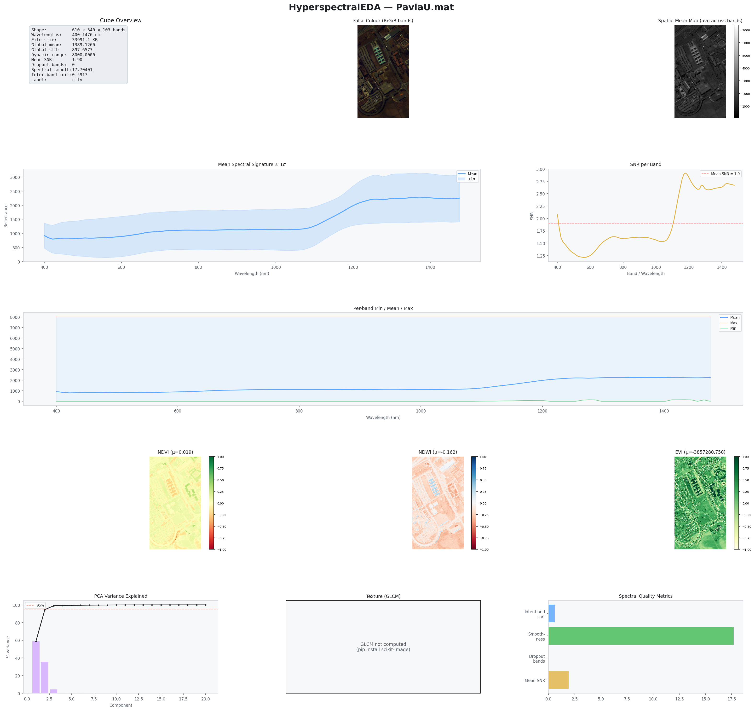
Figure 6-1. HyperspectralEDA single-cube dashboard
The dashboard combines cube metadata, false colour, a spatial mean map, spectral curves, indices, PCA, texture, and quality indicators for one cube.

Cube Overview
Shows shape, wavelength range, file size, global mean and standard deviation, dynamic range, mean SNR, dropout bands, spectral smoothness, inter-band correlation, and label.

False Colour
Uses three selected bands as red, green, and blue channels after percentile-style normalisation. rgb_bands can override automatic selection.

Spatial Mean Map
Displays the mean across all bands for every pixel, providing a panchromatic structural overview.

Mean Spectral Signature ± 1σ
Plots band_means and an envelope based on band standard deviations.

SNR per Band
Shows band_snr and a horizontal line at the cube mean SNR.

Per-Band Min / Mean / Max
Compares extrema and mean across the full wavelength axis.

NDVI, NDWI, and EVI maps
Displays spatial index patterns. The figure title includes each map's mean value.

PCA Variance
Shows individual component variance and cumulative explained variance with a 95% reference line.

Texture (GLCM)
A radar plot of available GLCM properties; a message appears when GLCM is unavailable.

Spectral Quality Metrics
Summarises inter-band correlation, smoothness, dropout bands, and mean SNR in one bar chart.

6.2 plot_dataset() — Dataset Analysis Dashboard
eda.plot_dataset(
figsize=(24, 24),
save_path="outputs_hyper/plot_dataset.png",
dpi=150,
)

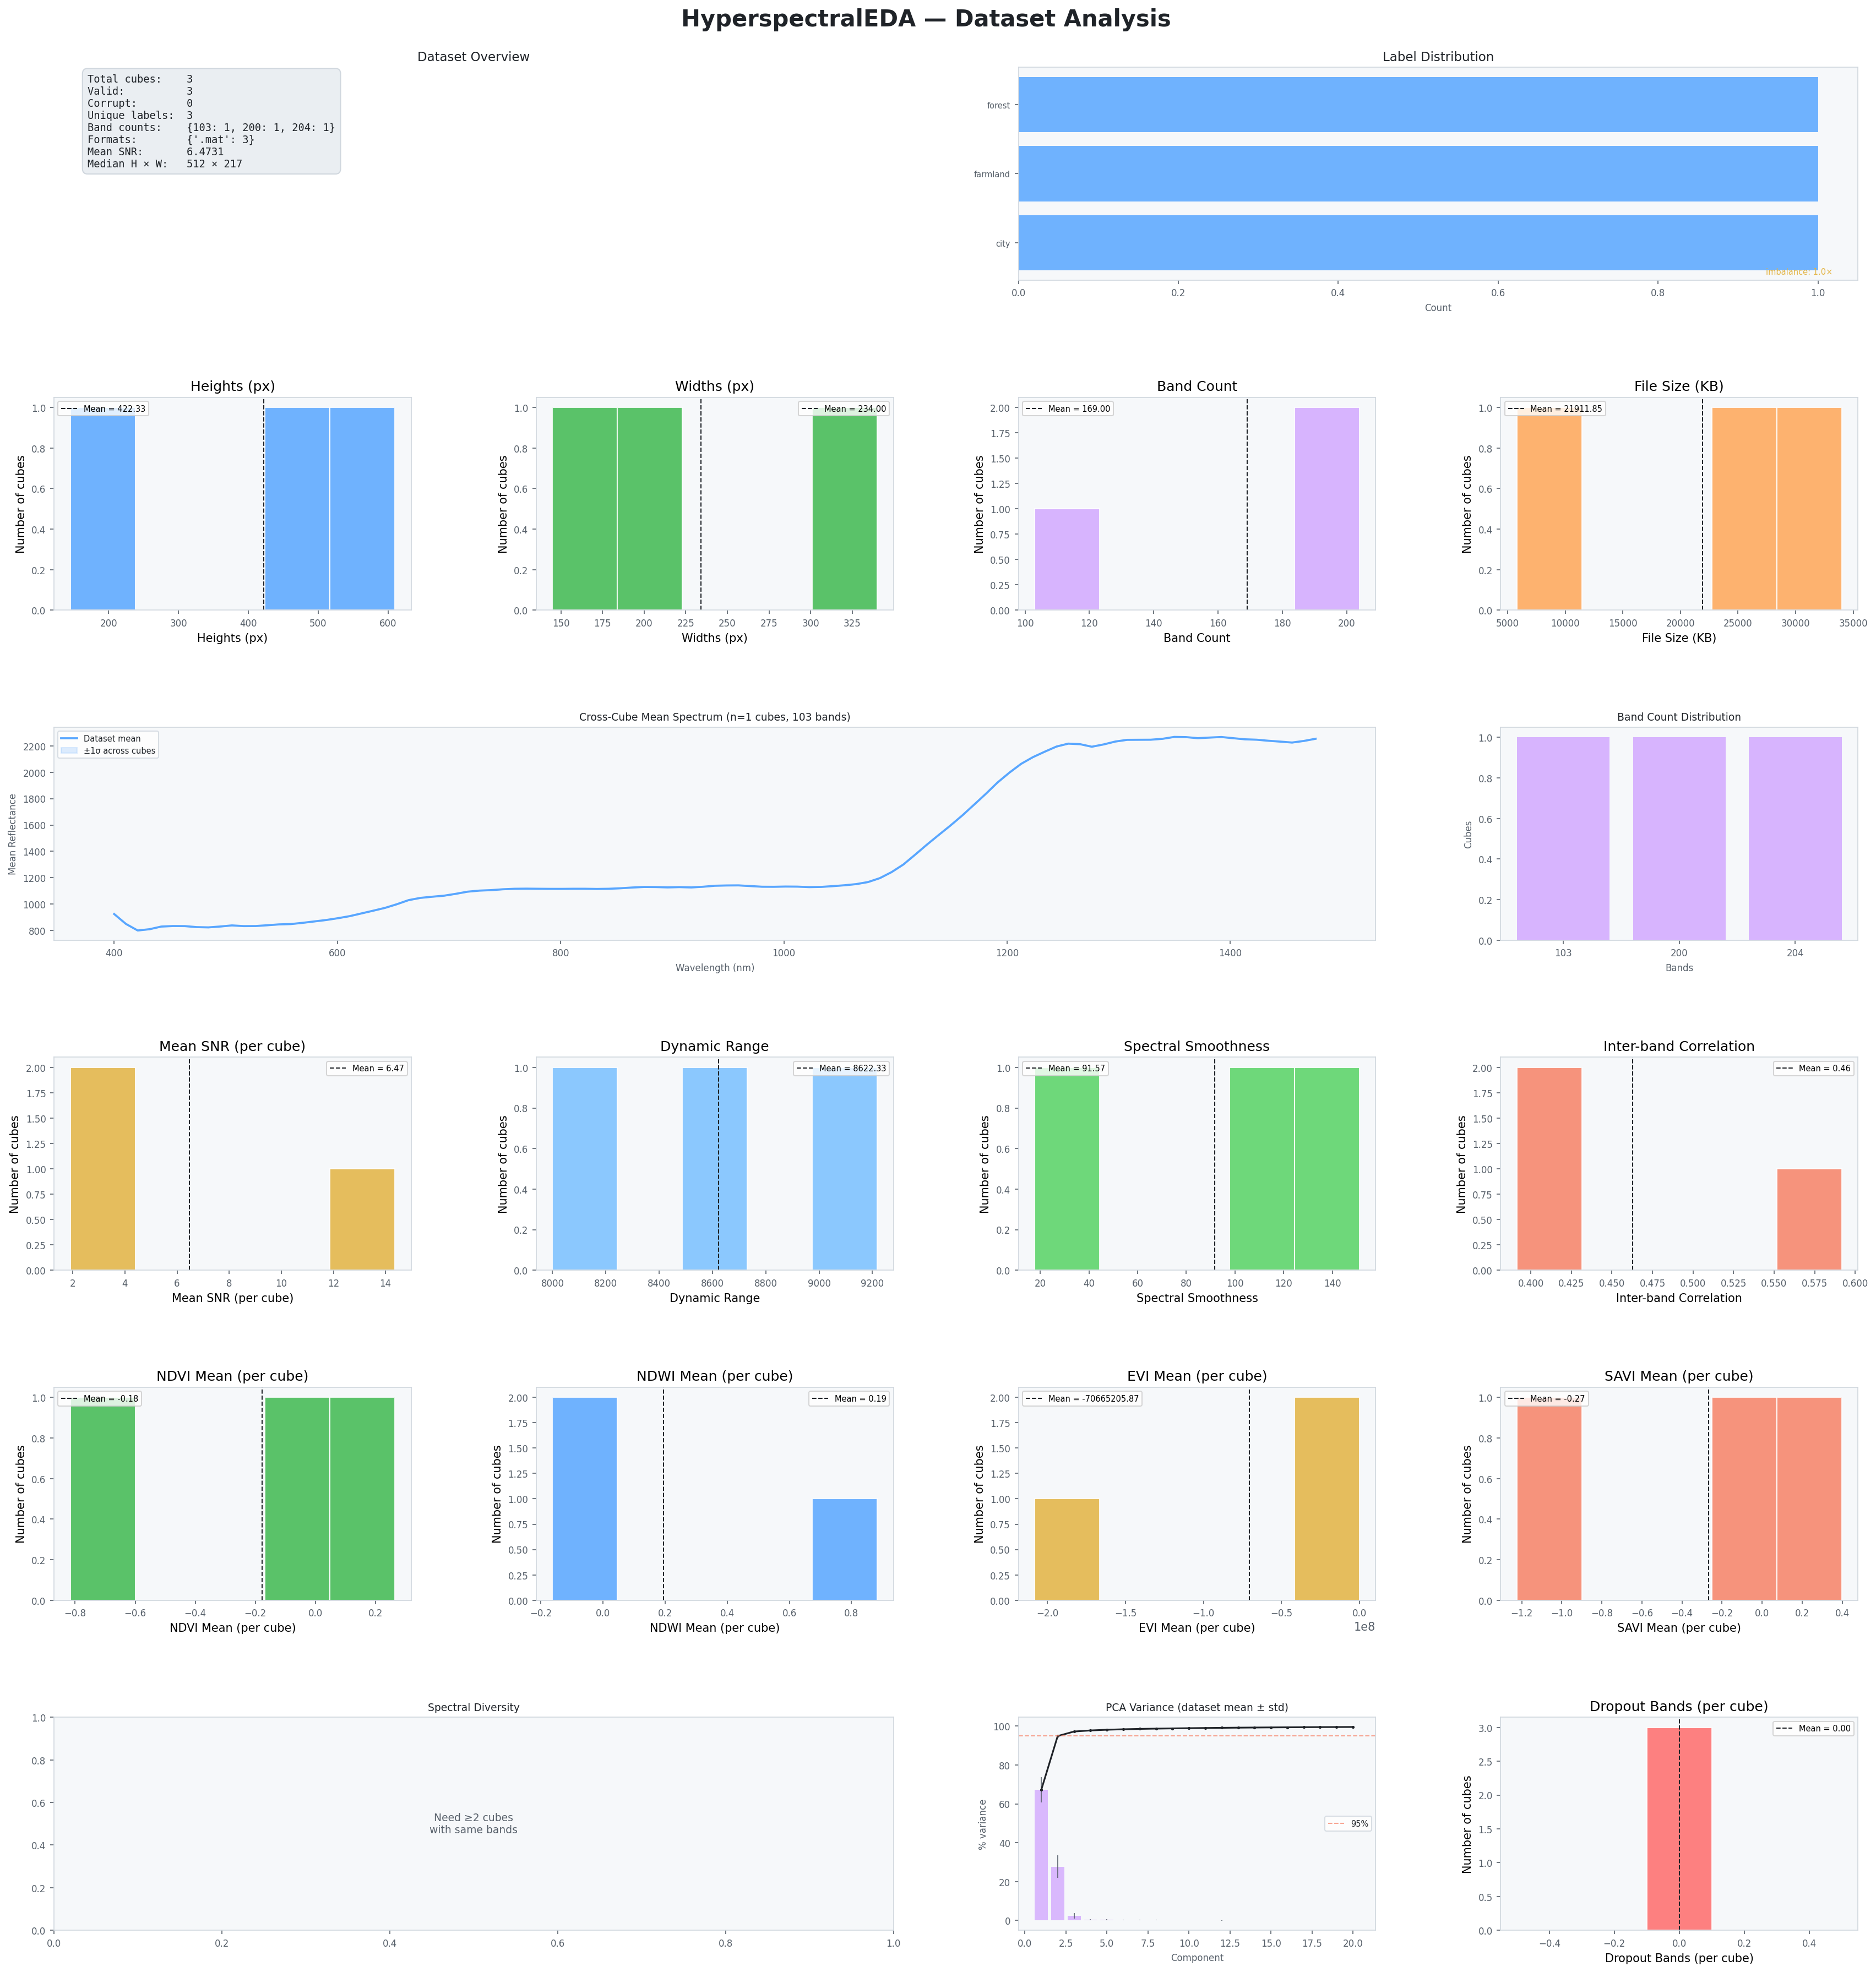
Figure 6-2. HyperspectralEDA dataset dashboard
The six-row dashboard summarises inventory, labels, spatial dimensions, band counts, cross-cube spectra, spectral quality, indices, PCA, dropout bands, and spectral diversity.

Dashboard row | Content
Row 0 | Dataset overview card and label distribution.
Row 1 | Height, width, band-count, and file-size distributions.
Row 2 | Cross-cube mean spectrum with standard-deviation envelope and band-count distribution.
Row 3 | Mean SNR, dynamic range, spectral smoothness, and inter-band correlation distributions.
Row 4 | NDVI, NDWI, EVI, and SAVI per-cube mean distributions.
Row 5 | Spectral diversity, dataset PCA variance, and dropout-band distribution.

6.3 plot_spectra() — Spectral Overlay
eda.plot_spectra(
max_cubes=20,
figsize=(14, 6),
save_path="outputs_hyper/plot_spectra.png",
dpi=150,
)
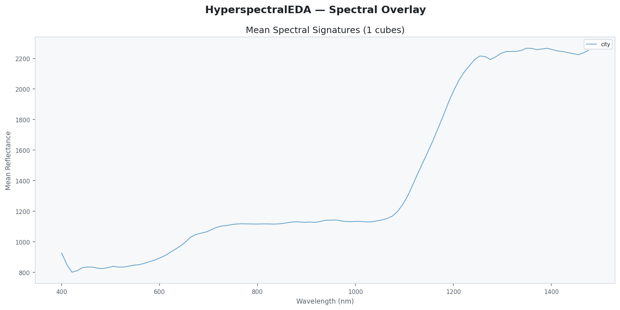
Figure 6-3. Mean spectral signatures
Each curve is the per-band mean of one compatible cube. Labels are used in the legend when available. The plot is limited to cubes sharing the dominant band count.
Parallel curves with similar shape but different magnitude indicate comparable spectral behaviour on different radiometric scales. Divergent shapes can reveal different land-cover classes, sensors, preprocessing, or defective cubes.

6.4 plot_false_colour() — False-Colour Previews
eda.plot_false_colour(
n=12,
cols=4,
rgb_bands=None,
save_path="outputs_hyper/plot_false_colour.png",
)

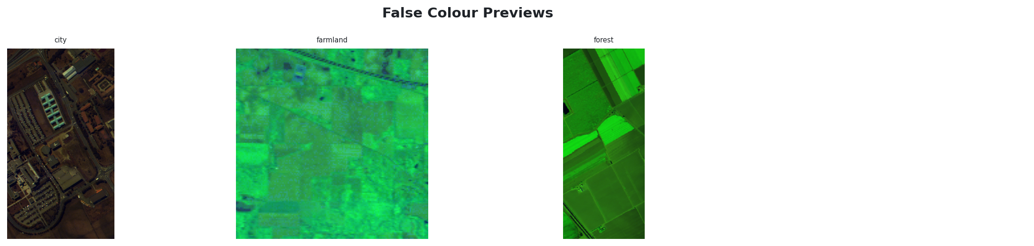
Figure 6-4. False-colour preview grid
Representative false-colour composites for multiple cubes. Parent-folder labels or file names identify each panel.
False-colour images are qualitative. The displayed colours depend on band selection and normalisation; they should not be interpreted as calibrated true-colour imagery unless the chosen bands correspond to visible red, green, and blue wavelengths.

6.5 plot_ndvi() — NDVI Map Grid
eda.plot_ndvi(
n=12,
cols=4,
save_path="outputs_hyper/plot_ndvi.png",
)
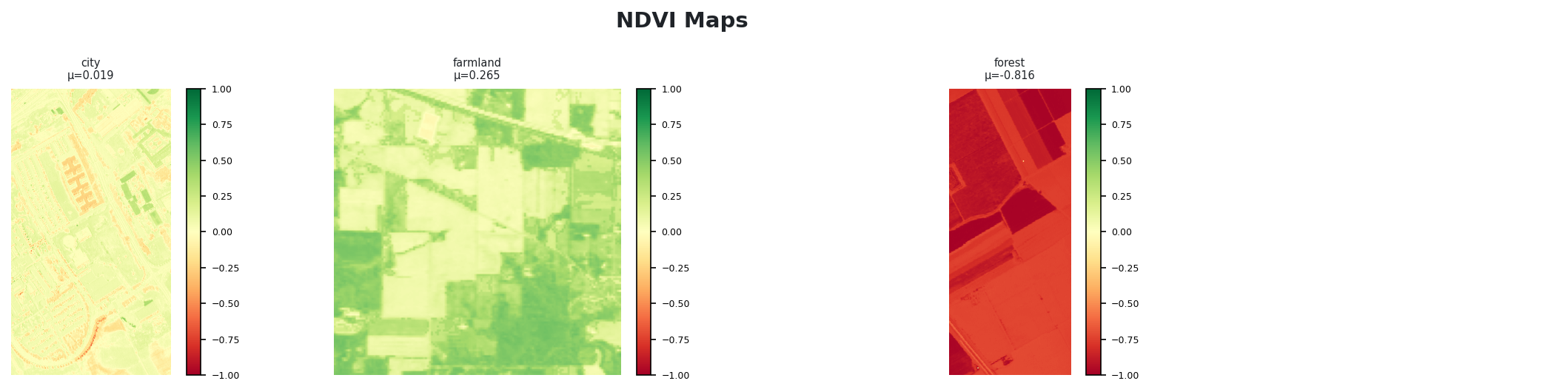
Figure 6-5. NDVI maps
NDVI maps for several cubes, each displayed on a fixed -1 to 1 colour scale with the cube-level mean shown in the title.
Note: Negative or extreme NDVI values can be valid for non-vegetated surfaces, but incorrect wavelength mapping or raw digital numbers can also distort the index.

6.6 plot_pca_components() — PCA Component Images
eda.plot_pca_components(
cube_index=0,
n_components=6,
save_path="outputs_hyper/plot_pca_components.png",
)

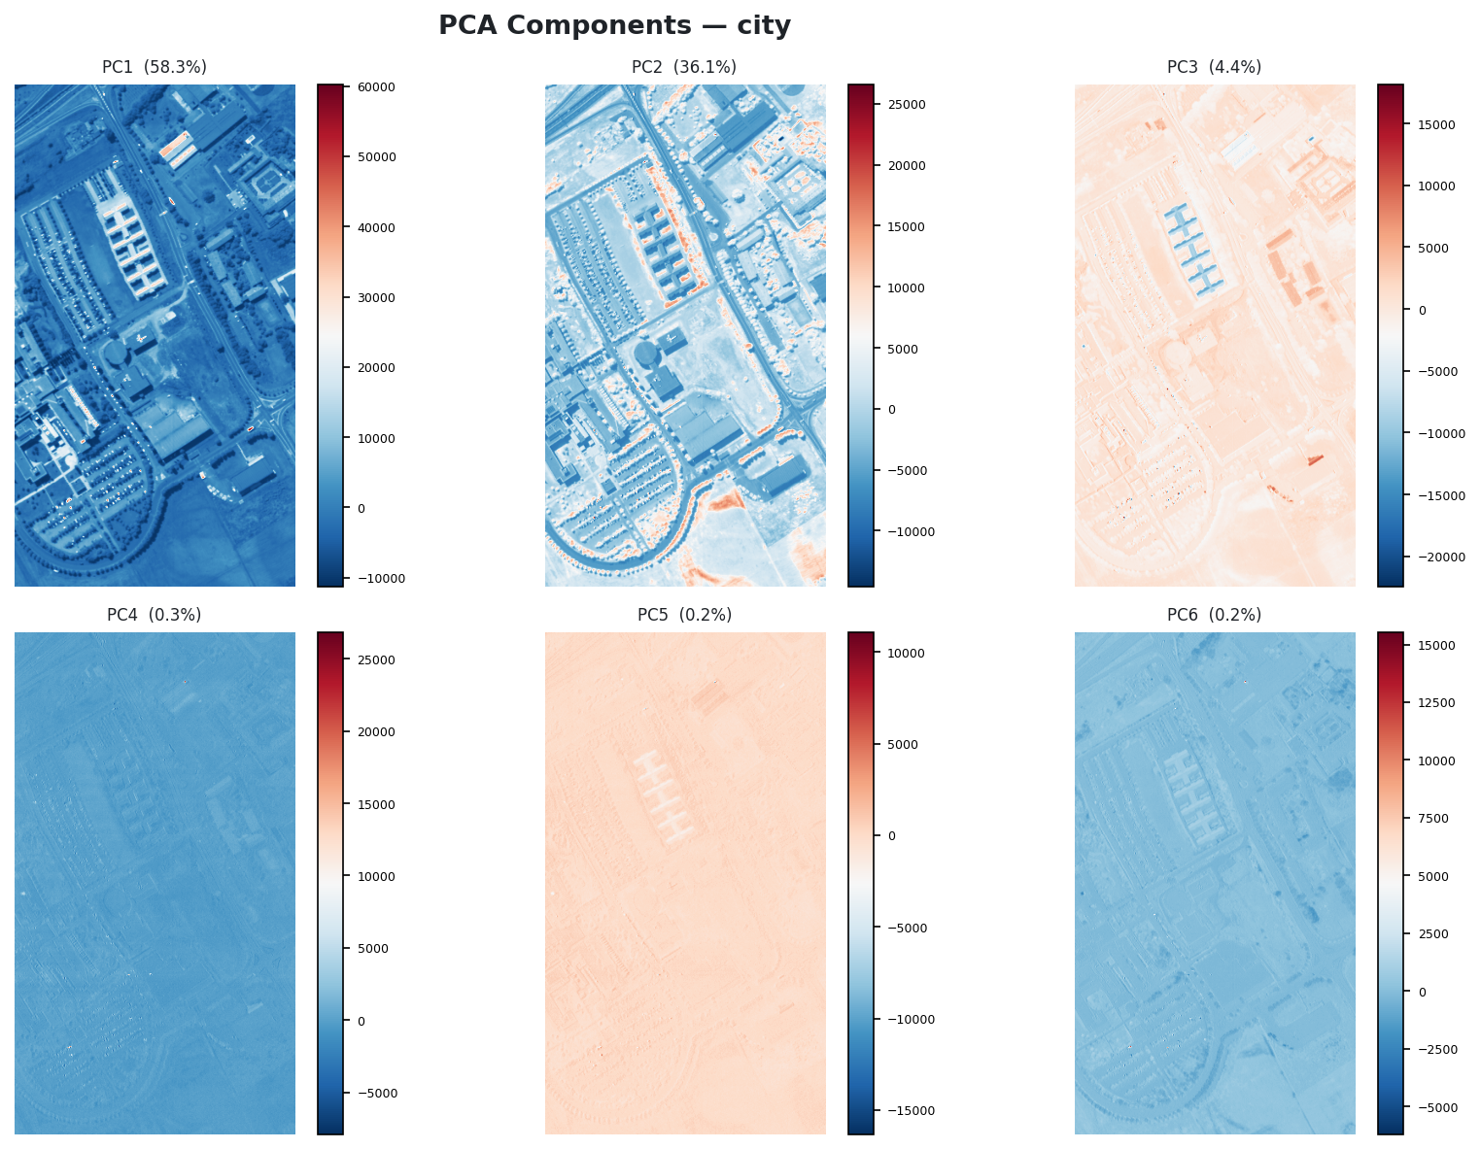
Figure 6-6. Principal component images
The first six PCA score images. Each title reports the percentage of spectral variance explained by the component.
PC1 normally captures overall brightness and major material differences. Later components contain progressively subtler spectral contrasts and may reveal boundaries, rare materials, noise, or striping. Component signs are arbitrary; blue versus red does not imply a universal physical meaning.

6.7 plot_band_stats() — Per-Band Diagnostics
eda.plot_band_stats(
cube_index=0,
figsize=(16, 10),
save_path="outputs_hyper/plot_band_stats.png",
)

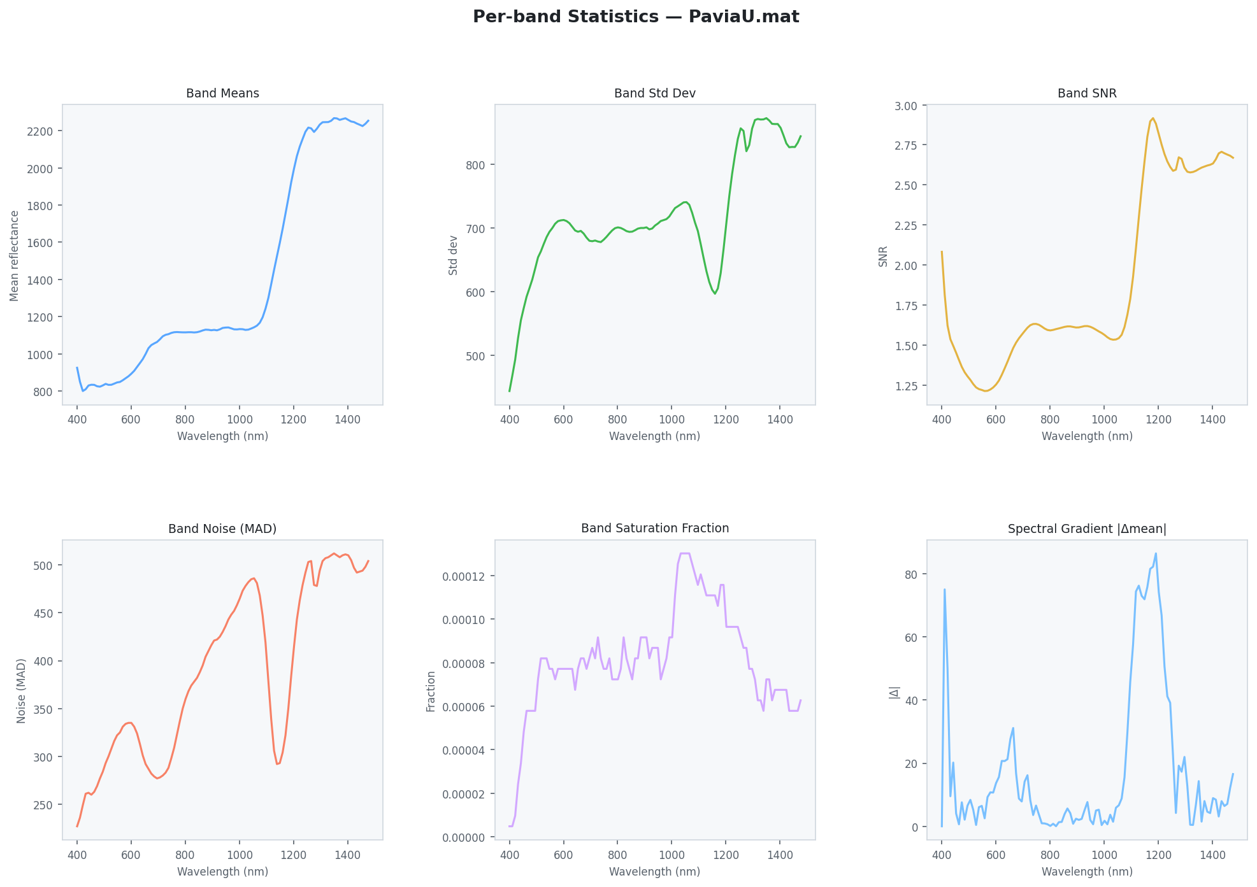
Figure 6-7. Per-band statistics
Six line charts show band mean, band standard deviation, band SNR, robust noise MAD, saturation fraction, and the absolute gradient of adjacent band means.
Panel | Diagnostic value
Band Means | Average spectral signature and broad absorption or response patterns.
Band Std Dev | Spatial variability by wavelength.
Band SNR | Bands with weak mean relative to spatial variation.
Band Noise (MAD) | Robust estimate of within-band spread/noise.
Band Saturation Fraction | Bands with many pixels pinned at the cube maximum.
Spectral Gradient |Δmean| | Abrupt changes between neighbouring band means.

6.8 plot_spectral_diversity() — Cosine Similarity
eda.plot_spectral_diversity(
figsize=(10, 8),
save_path="outputs_hyper/plot_spectral_diversity.png",
)
Figure omitted: Figure file for 'plot_spectral_diversity' was not found. Generate the plot first or pass --image-dir. Expected one of: plot_spectral_diversity.png, plot_spectral_diversity(1).png.

Chapter 7 — Interpreting Results and Common Findings

7.1 Red Flags to Review
Table 3. Common HyperspectralEDA findings and responses.
Finding | Possible meaning | Recommended action
Corrupt cubes | Unreadable file, unsupported structure, missing dependency, or auxiliary data rather than a cube. | Inspect corrupt_paths; verify dependencies and folder contents.
Mixed band counts | Different sensors, preprocessed variants, or accidental masks. | Analyse compatible groups separately or resample to a common wavelength grid.
n_dropout_bands > 0 | Constant or near-constant bands. | Inspect band indices and consider removing them.
Low mean SNR | Weak signal, strong spatial variability, noise, or scale near zero. | Review band curves; compare only within similar radiometric scales.
High spectral smoothness | Abrupt spectral changes, band-order problems, or real absorption features. | Inspect spectral gradient and wavelength metadata.
Very high inter-band correlation | Substantial spectral redundancy. | Use PCA or band-selection methods.
Very low/negative inter-band correlation | Independent spectral structure, noise, or calibration problems. | Inspect correlation and per-band statistics.
Extreme EVI | Denominator close to zero or non-reflectance data. | Check wavelength mapping and radiometric preprocessing.
PCA reaches 95% in 1–2 components | Strong redundancy or brightness-dominated variation. | Inspect later components before aggressive reduction.
Large low-similarity blocks | Distinct classes/sensors or inconsistent preprocessing. | Verify labels and acquisition conditions.

7.2 Interpreting the Attached Example Outputs
The supplied example dataset contains city, farmland, and forest cubes with different spatial dimensions and band counts. The dataset dashboard correctly reports three valid cubes and separate band-count categories. Because only one cube has the dominant 103-band configuration, the cross-cube mean spectrum and spectral-diversity panels cannot represent all three cubes simultaneously. This illustrates why wavelength-compatible grouping is essential.
The PaviaU single-cube output shows a 610×340×103 cube. Its mean spectrum changes strongly across the wavelength axis, while the PCA panel indicates that the first two components explain most variance. The GLCM panel reports that texture was not computed in that run, which can occur when compute_glcm=False or an optional dependency is unavailable.
The example EVI mean is numerically extreme. This is not automatically a software error: EVI contains a denominator that can approach zero, and public MATLAB datasets are frequently stored as digital numbers rather than atmospherically corrected reflectance. Index maps should therefore be interpreted only after confirming the radiometric scale and wavelength assignments.

7.3 Reflectance, Radiance, and Digital Numbers
Thresholds commonly quoted for vegetation indices assume surface reflectance. Radiance retains illumination and atmospheric effects, while raw digital numbers are sensor-scaled integers. HyperspectralEDA does not automatically convert among these physical quantities. The user must supply appropriately calibrated data for physically meaningful index interpretation.

7.4 Comparing Datasets Fairly
- Compare cubes only after confirming consistent units and preprocessing.
- Use the same wavelength grid or resample spectra before distance calculations.
- Separate sensors with different spectral response functions.
- Compare SNR and smoothness within a sensor/acquisition group rather than across arbitrary scales.
- Use class-aware spectral overlays to check whether between-class differences exceed within-class variation.

Chapter 8 — Advanced Usage

8.1 Working with Large Datasets
# Quick overview of the first 100 cubes
eda = HyperspectralEDA(
max_cubes=100,
compute_glcm=False,
compute_pca=False,
)
eda.load("large_dataset/", label_from_parent=True)
# Re-enable expensive analyses for a representative subset
detailed = HyperspectralEDA(
max_cubes=12,
compute_glcm=True,
compute_pca=True,
).load("large_dataset/", label_from_parent=True)
GLCM and PCA are the most computationally expensive analyses. The implementation already samples pixels for correlation, GLCM fitting, and PCA fitting, but max_cubes and the compute flags provide the largest speed gains.

8.2 Accessing and Filtering CubeRecord Objects
records = [r for r in eda._records if not r.is_corrupt]
# Lowest-SNR cubes
low_snr = sorted(records, key=lambda r: r.snr_mean or float("inf"))[:10]
for rec in low_snr:
print(rec.path, rec.snr_mean)
# Cubes containing dropout bands
dropout = [r for r in records if (r.n_dropout_bands or 0) > 0]
# Spectrally rough cubes
rough = sorted(
records,
key=lambda r: r.spectral_smoothness or 0,
reverse=True,
)[:10]

8.3 Exporting Records to a DataFrame
import pandas as pd
rows = []
for r in eda._records:
rows.append({
"path": r.path,
"label": r.label,
"height": r.height,
"width": r.width,
"bands": r.bands,
"global_mean": r.global_mean,
"global_std": r.global_std,
"snr_mean": r.snr_mean,
"spectral_smoothness": r.spectral_smoothness,
"inter_band_corr": r.inter_band_corr,
"n_dropout_bands": r.n_dropout_bands,
"ndvi_mean": r.ndvi_mean,
"is_corrupt": r.is_corrupt,
})
df = pd.DataFrame(rows)
df.to_csv("outputs_hyper/hyperspectral_inventory.csv", index=False)

8.4 Manual Band Overrides
# Use known sensor band indices instead of wavelength auto-selection
eda = HyperspectralEDA(
ndvi_nir_band=80,
ndvi_red_band=55,
ndwi_green_band=30,
ndwi_nir_band=80,
)
eda.load("cube.npy")
Note: The implementation uses expressions such as self._ndvi_nir or auto_band. Therefore, an override value of 0 is treated as false and falls back to automatic selection. Avoid using band index 0 as an override without updating that implementation to test against None explicitly.

8.5 Integrating with a Machine-Learning Pipeline
summary = eda.summary()
# Example quality gate
if summary["inventory"]["corrupt_cubes"] > 0:
raise RuntimeError("Remove or repair corrupt cubes before training")
if summary["spectral_quality"]["n_dropout_bands"]["max"] > 0:
print("Review dropout bands before model development")
# PCA-based dimensionality decision
n95 = summary["pca"].get("n_components_95pct_mean")
print("Mean components needed for 95% variance:", n95)

8.6 Comparing Two Datasets
train = HyperspectralEDA(wavelengths=wl).load("train/", label_from_parent=True)
test = HyperspectralEDA(wavelengths=wl).load("test/", label_from_parent=True)
s_train = train.summary()
s_test = test.summary()
print("Train SNR:", s_train["spectral_quality"]["snr_mean"]["mean"])
print("Test SNR:", s_test["spectral_quality"]["snr_mean"]["mean"])
print("Train smoothness:", s_train["spectral_quality"]["spectral_smoothness"]["mean"])
print("Test smoothness:", s_test["spectral_quality"]["spectral_smoothness"]["mean"])

Chapter 9 — HTML Report
report() generates a self-contained HTML document. The attached implementation uses a light VisEDA theme and card-based responsive layout. It can be viewed locally without an internet connection and safely shared as one file.
Table 4. Sections in the HyperspectralEDA HTML report.
Report section | Contents
Inventory | Total, valid, corrupt counts; label, band-count, and format distributions.
Spatial | Height, width, bands, and file-size descriptive statistics.
Spectral Statistics | Global mean, global standard deviation, and dynamic range.
Spectral Quality | Mean SNR, spectral smoothness, inter-band correlation, and dropout bands.
Spectral Indices | NDVI, NDWI, EVI, and SAVI per-cube summaries when available.
PCA | Mean variance profile and number of components required for 95% variance.
Texture | GLCM summaries when computed.

eda.report("outputs_hyper/viseda_hyper_report.html")

Chapter 10 — Command-Line Reference
The current VisEDA CLI exposes one hyper subcommand. It loads a single cube or directory, prints the summary as JSON, optionally saves the HTML report, and renders either the single-cube or dataset dashboard.
usage: viseda hyper PATH [--wavelengths FILE]
[--label-from-parent]
[--report FILE]
[--plot]
[--dataset-plot]
[--save-plot FILE]
Argument | Meaning
PATH | Single file or directory of hyperspectral cubes.
--wavelengths FILE | Path to a .npy array containing wavelength values.
--label-from-parent | Infer each label from its parent folder.
--report FILE | Write the self-contained HTML report.
--plot | Generate a visualisation.
--dataset-plot | Use plot_dataset() rather than plot().
--save-plot FILE | Save the selected plot to disk.

Note: The current CLI does not expose max_cubes, compute_glcm, compute_pca, dropout_threshold, individual plot methods, or manual band overrides. Use the Python API for those options or extend cli.py.

Chapter 11 — API Reference

HyperspectralEDA.__init__()
HyperspectralEDA(verbose=True, wavelengths=None, max_cubes=None, compute_glcm=True, compute_pca=True, dropout_threshold=0.01, ndvi_nir_band=None, ndvi_red_band=None, ndwi_green_band=None, ndwi_nir_band=None)
Initialise analysis configuration; does not load data.

HyperspectralEDA.load()
def load( self, source: Union[str, Path, List], labels: Optional[Dict[str, str]] = None, label_from_parent: bool = False, recursive: bool = True, ) -> "HyperspectralEDA":
Load files from a path, directory, or explicit list.

HyperspectralEDA.load_arrays()
def load_arrays( self, arrays: List[np.ndarray], labels: Optional[List[str]] = None, ) -> "HyperspectralEDA":
Load H-W-B NumPy arrays.

HyperspectralEDA.summary()
def summary(self) -> Dict[str, Any]:
Return the nested aggregate statistics dictionary.

HyperspectralEDA.get_record()
def get_record(self, index: int = 0) -> CubeRecord:
Return one CubeRecord.

HyperspectralEDA.spectral_signature()
def spectral_signature( self, cube_index: int = 0, row: int = 0, col: int = 0 ) -> Tuple[np.ndarray, np.ndarray]:
Return wavelength/index axis and one pixel spectrum.

HyperspectralEDA.compute_index()
def compute_index( self, cube_index: int = 0, index_name: str = "ndvi", ) -> np.ndarray:
Compute NDVI, NDWI, EVI, or SAVI map.

HyperspectralEDA.pca_scores()
def pca_scores( self, cube_index: int = 0, n_components: int = 10, ) -> Tuple[np.ndarray, np.ndarray]:
Return pixel-level PCA scores and explained variance.

HyperspectralEDA.plot()
def plot( self, cube_index: int = 0, figsize: Tuple[int, int] = (22, 20), save_path: Optional[str] = None, dpi: int = 150, rgb_bands: Optional[Tuple[int, int, int]] = None, ) -> None:
Render the single-cube dashboard.

HyperspectralEDA.plot_dataset()
def plot_dataset( self, figsize: Tuple[int, int] = (24, 24), save_path: Optional[str] = None, dpi: int = 150, ) -> None:
Render the dataset dashboard.

HyperspectralEDA.plot_spectra()
def plot_spectra( self, max_cubes: int = 20, figsize: Tuple[int, int] = (14, 6), save_path: Optional[str] = None, dpi: int = 150, ) -> None:
Overlay compatible mean spectra.

HyperspectralEDA.plot_false_colour()
def plot_false_colour( self, n: int = 12, cols: int = 4, rgb_bands: Optional[Tuple[int, int, int]] = None, figsize: Optional[Tuple] = None, save_path: Optional[str] = None, dpi: int = 150, ) -> None:
Render a false-colour cube grid.

HyperspectralEDA.plot_ndvi()
def plot_ndvi( self, n: int = 12, cols: int = 4, figsize: Optional[Tuple] = None, save_path: Optional[str] = None, dpi: int = 150, ) -> None:
Render NDVI maps.

HyperspectralEDA.plot_pca_components()
def plot_pca_components( self, cube_index: int = 0, n_components: int = 6, figsize: Optional[Tuple] = None, save_path: Optional[str] = None, dpi: int = 150, ) -> None:
Render PCA score images.

HyperspectralEDA.plot_band_stats()
def plot_band_stats( self, cube_index: int = 0, figsize: Tuple[int, int] = (16, 10), save_path: Optional[str] = None, dpi: int = 150, ) -> None:
Render six per-band diagnostic curves.

HyperspectralEDA.plot_spectral_diversity()
def plot_spectral_diversity( self, figsize: Tuple[int, int] = (10, 8), save_path: Optional[str] = None, dpi: int = 150, ) -> None:
Render cosine-similarity heatmap.

HyperspectralEDA.report()
def report(self, output_path: str = "viseda_hyperspectral_report.html") -> str:
Write the HTML report and return its path.

Chapter 12 — Troubleshooting

No valid cubes found
Check that the path contains supported files, optional dependencies are installed, and the arrays have two or three dimensions. Inspect verbose messages and summary()['inventory']['corrupt_paths'].

Ground-truth masks are analysed as cubes
Move *_gt.mat files outside the analysis directory or build an explicit file list containing only image cubes.

Wavelength length does not match band count
Supply a wavelength array for the specific sensor/cube or analyse different band-count groups separately.

EVI is extremely large
Confirm reflectance scaling and wavelength mapping. Raw digital numbers can make the EVI denominator close to zero.

GLCM is blank or unavailable
Install scikit-image, scikit-learn, and OpenCV; set compute_glcm=True. The implementation catches failures and leaves texture fields as None.

PCA is blank
Install scikit-learn and set compute_pca=True. Single-band cubes cannot produce a spectral PCA profile.

Spectral diversity says at least two cubes are required
At least two valid cubes must share the same dominant band count.

The .mat loader chooses the wrong array
The current loader selects the largest non-private MATLAB array. Keep ground truth and auxiliary arrays in separate files or customise _read_cube().

ENVI or GeoTIFF loading fails
Install spectral for ENVI formats and rasterio for GeoTIFF. Verify that sidecar files are available.

The Word TOC is blank
Open the document in Microsoft Word, press Ctrl+A then F9, or right-click the TOC and choose Update Field.

The Word output is permission denied
Close the existing DOCX if it is open. The generator also creates a timestamped filename when the target is locked.

Chapter 13 —Roadmap

Version 1.0.0 — Current Documented Release
- Unified analysis for single cubes and directories.
- MATLAB, NumPy, ENVI, and GeoTIFF support.
- Per-band statistics, SNR, MAD noise, saturation, and quality checks.
- NDVI, NDWI, EVI, and SAVI maps.
- PCA variance and component images.
- GLCM texture from the first principal component.
- Dataset dashboard, spectral overlay, false colour, NDVI, PCA, band-statistics, and diversity plots.
- Self-contained HTML report and VisEDA CLI integration.

Roadmap
- Explicit sensor profiles and wavelength validation.
- Automatic exclusion of ground-truth masks and metadata arrays.
- Radiometric calibration helpers for digital numbers, radiance, and reflectance.
- Spectral resampling to a common wavelength grid.
- Bad-band recommendations based on combined SNR, noise, smoothness, and saturation.
- Additional indices and user-defined index expressions.
- Endmember extraction and spectral-angle mapping.
- Interactive dashboards and exportable per-cube tables.
- Chunked or memory-mapped processing for very large cubes.

Appendix A — Complete CubeRecord Field Reference
Field | Group | Meaning
path | Identity | Source path or array placeholder.
label | Identity | Optional class label.
file_ext | Identity | File extension or array.
file_size_kb | Identity | File size in kilobytes.
height | Shape | Spatial height.
width | Shape | Spatial width.
bands | Shape | Spectral band count.
dtype | Shape | Internal dtype.
global_mean | Global | Overall cube mean.
global_std | Global | Overall cube standard deviation.
global_min | Global | Overall minimum.
global_max | Global | Overall maximum.
dynamic_range | Global | global_max − global_min.
band_means | Per-band | Spatial mean for each band.
band_stds | Per-band | Spatial standard deviation for each band.
band_mins | Per-band | Spatial minimum for each band.
band_maxs | Per-band | Spatial maximum for each band.
band_snr | Per-band | Mean/std for each band.
band_noise_mad | Per-band | Median absolute deviation for each band.
band_saturation_frac | Per-band | Fraction at the cube maximum.
spectral_smoothness | Quality | Mean adjacent band-mean difference.
inter_band_corr | Quality | Mean off-diagonal band correlation.
n_dropout_bands | Quality | Low-variance band count.
snr_mean | Quality | Mean band SNR.
spatial_mean_map | Spatial map | Mean across bands.
spatial_std_map | Spatial map | Std across bands.
ndvi_mean/std | Index | NDVI map summary.
ndwi_mean/std | Index | NDWI map summary.
evi_mean/std | Index | EVI map summary.
savi_mean/std | Index | SAVI map summary.
pca_variance_ratio | PCA | Explained-variance array.
glcm_contrast | Texture | GLCM contrast.
glcm_dissimilarity | Texture | GLCM dissimilarity.
glcm_homogeneity | Texture | GLCM homogeneity.
glcm_energy | Texture | GLCM energy.
glcm_correlation | Texture | GLCM correlation.
glcm_asm | Texture | Angular second moment.
is_corrupt | Status | Whether analysis failed.

Appendix B — summary() Schema
{
"inventory": {
"total_cubes", "valid_cubes", "corrupt_cubes",
"corrupt_paths", "band_distribution",
"format_distribution", "label_distribution"
},
"spatial": {
"height", "width", "bands", "file_size_kb"
},
"spectral_stats": {
"global_mean", "global_std", "dynamic_range",
"cross_cube_mean_spectrum",
"cross_cube_std_spectrum",
"dataset_mean_snr_per_band",
"dataset_mean_noise_per_band",
"dominant_band_count", "n_matching_cubes"
},
"spectral_quality": {
"snr_mean", "spectral_smoothness",
"inter_band_corr", "n_dropout_bands"
},
"spectral_indices": {
"ndvi", "ndwi", "evi", "savi"
},
"texture": {
"glcm_contrast", "glcm_dissimilarity",
"glcm_homogeneity", "glcm_energy",
"glcm_correlation", "glcm_asm"
},
"pca": {
"mean_variance_ratio", "n_components_95pct_mean"
},
"labels": {
"label_distribution", "class_imbalance_ratio"
}
}

Appendix C — Glossary
Term | Definition
Band | One wavelength channel in the cube.
Cube | A three-dimensional H-W-B hyperspectral array.
Digital number | Sensor-scaled integer before physical calibration.
Radiance | Radiant energy measured by the sensor.
Reflectance | Ratio of reflected to incident radiation; common basis for vegetation indices.
SNR | Signal-to-noise ratio; here mean divided by spatial standard deviation.
MAD | Median absolute deviation, a robust dispersion measure.
Dropout band | A band with exceptionally low spatial variability.
PCA | Principal component analysis, a linear dimensionality-reduction method.
GLCM | Grey-level co-occurrence matrix used for texture analysis.
NDVI | Normalised Difference Vegetation Index.
NDWI | Normalised Difference Water Index in the green-NIR formulation used here.
EVI | Enhanced Vegetation Index.
SAVI | Soil-Adjusted Vegetation Index.
Cosine similarity | Similarity of spectral shape independent of vector magnitude.

Appendix D — Documentation Generator Usage
# Install documentation dependencies
pip install python-docx pillow
# Run from the VisionEDA project root
python generate_hyperspectraleda_documentation.py
# Specify paths explicitly
python generate_hyperspectraleda_documentation.py --project-root "C:/Users/Ike/PycharmProjects/VisionEDA" --image-dir "C:/Users/Ike/PycharmProjects/VisionEDA/outputs_hyper" --output "C:/Users/Ike/PycharmProjects/VisionEDA/outputs_hyper/VisEDA_HyperspectralEDA_Documentation.docx"
Note: The generator embeds images when the expected PNG files exist. Missing figures are replaced by an explanatory note rather than causing the script to fail.

Appendix E — Acknowledgements
VisEDA HyperspectralEDA builds on NumPy, Matplotlib, SciPy, scikit-learn, scikit-image, OpenCV, Spectral Python, Rasterio, and python-docx. Public hyperspectral datasets such as Pavia University, Indian Pines, and Salinas provide useful benchmarks for testing spatial-spectral analysis workflows.

