Visual Exploratory Data Analysis (VisEDA): PART B
Video Exploratory Data Analysis
A Guide to Temporal & Visual Video Analysis
Isaac Osei Agyemang
Version 1.0.0
2026

Preface
VisEDA (Visual Exploratory Data Analysis) was built to bring the rigour of tabular EDA tools to visual datasets. The library's first module — ImageEDA — established a comprehensive framework for understanding image datasets. VideoEDA extends this framework into the temporal dimension, treating videos not merely as sequences of images but as rich, dynamic signals with properties that cannot be captured by analysing individual frames in isolation.
Video datasets present unique challenges. A dataset of 10,000 videos may contain 5 million frames — far too many to inspect manually. Quality issues manifest differently: a sharp first frame may be followed by a blurry middle section caused by camera motion. Scene changes create abrupt discontinuities. Lighting flicker introduces temporal instability invisible in per-frame statistics. VideoEDA is designed to surface all of these issues automatically.
This documentation covers VideoEDA version 1.0.0 in complete detail: every parameter, every metric, every visualisation, and every practical usage pattern. The source code, tests, and CLI examples are all reflected here.
Isaac Osei Agyemang
May 2026

Table of Contents
Preface 2
Table of Contents 3
Chapter 1 — Introduction 6
1.1 What is VideoEDA? 6
1.2 Why Video EDA Matters 6
1.3 Design Philosophy 6
1.4 Installation 6
1.5 Supported Video Formats 7
Chapter 2 — Quick Start 8
2.1 Single Video 8
2.2 Video Dataset from Directory 8
2.3 NumPy Array Videos 9
2.4 CLI Usage 9
Chapter 3 — The VideoEDA Class 10
3.1 Constructor Parameters 10
3.2 load() — File Loading 10
3.3 load_arrays() — Array Loading 11
3.4 summary() — Statistics Dictionary 11
3.5 get_record() and get_frames() 12
3.6 temporal_profile() 12
3.7 pairwise_video_distances() 12
3.8 report() 13
Chapter 4 — The VideoRecord Object 14
4.1 Identity Fields 14
4.2 Spatial Fields 14
4.3 Temporal Fields 14
4.4 Quality Fields 14
4.5 Motion Fields 15
4.6 Colour Fields 15
Chapter 5 — What Is Analysed 16
5.1 Frame Sampling Strategy 16
5.2 Spatial Properties 16
5.3 Brightness 16
5.4 Contrast 17
5.5 Sharpness and Blur Detection 17
5.6 Noise and Compression 17
5.7 Frame Difference and Motion Intensity 17
5.8 Motion Blur Detection 18
5.9 Scene Change Detection 18
5.10 Temporal Consistency 18
5.11 Colour Analysis 19
Chapter 6 — Visualisations 20
6.1 plot_dataset() — Dataset Dashboard 20
Row 0: Dataset Overview and Label Distribution 21
Row 1: Spatial and Temporal Inventory 21
Row 2: Quality Metrics 21
Row 3: Motion and Temporal Consistency 21
Row 4: Relationships and Colour 22
Row 5: Previews, Diversity, Resolution, Quality Flags 22
6.2 plot() — Single Video Dashboard 22
6.3 plot_motion_profile() — Motion/Sharpness Profile 23
6.4 plot_pairwise_video_distances() — Diversity Heatmap 24
6.5 plot_videos_grid() — Video Thumbnail Grid 25
6.6 plot_temporal_statistics() — Temporal Deep Dive 26
6.7 plot_quality_summary() — Quality Summary 26
6.8 plot_frame_samples() — Frame Sample Grid 26
Chapter 7 — Interpreting Results and Common Findings 27
7.1 Red Flags to Watch For 27
7.2 Common Dataset Patterns 27
Chapter 8 — Advanced Usage 28
8.1 Working with Large Datasets 28
8.2 Accessing VideoRecord Objects 28
8.3 Integrating with ML Pipelines 29
8.4 Comparing Two Datasets 29
Chapter 9 — API Reference 31
VideoEDA.__init__() 31
VideoEDA.load() 31
VideoEDA.load_arrays() 31
VideoEDA.summary() 31
VideoEDA.get_record(index) 32
VideoEDA.get_frames(index) 32
VideoEDA.temporal_profile(index) 32
VideoEDA.pairwise_video_distances(max_videos) 32
VideoEDA.plot_dataset() 32
VideoEDA.plot() 32
VideoEDA.plot_motion_profile() 33
VideoEDA.plot_pairwise_video_distances() 33
VideoEDA.plot_videos_grid() 33
VideoEDA.plot_temporal_statistics() 33
VideoEDA.plot_quality_summary() 33
VideoEDA.plot_frame_samples() 33
VideoEDA.report() 34
Chapter 10 —Roadmap 35
Version 1.0.0 (May 2026) — Initial Release 35
Roadmap 35
Appendix A — VideoRecord Fields 36
Appendix B — Glossary 37
Appendix C — Acknowledgements 38

Chapter 1 — Introduction

1.1 What is VideoEDA?
VideoEDA is the video analysis module of VisEDA. It performs comprehensive exploratory data analysis on a single video file, a directory of videos, or a collection of in-memory NumPy video arrays. The analysis operates at two levels simultaneously: at the per-video level, it extracts spatial, temporal, quality, motion, and colour statistics from sampled frames; at the dataset level, it aggregates these statistics across all videos to reveal distributions, anomalies, and dataset-wide patterns.
Unlike image EDA, which treats each image independently, VideoEDA understands the temporal dimension. It tracks how brightness, contrast, and sharpness evolve across a video's duration, detects moments of high motion and motion blur, identifies scene transitions, and quantifies the lighting stability of the entire recording.

1.2 Why Video EDA Matters
Before training any video understanding model — action recognition, activity detection, anomaly detection, or video captioning — understanding the dataset is not optional. The following questions should be answered before training begins:
- What is the distribution of video durations and frame counts? Very short or very long videos may need to be excluded or segmented.
- What fraction of frames are blurry? Motion blur and defocus blur degrade training signal differently and should be quantified separately.
- Are there scene changes? A video with many scene cuts is structurally different from one with a continuous scene, and this affects temporal modelling assumptions.
- Is the lighting stable? Flicker and inconsistent illumination introduce spurious temporal signals that confuse models.
- How diverse are the videos in the dataset? Pairwise distance analysis reveals clusters of similar videos that may cause imbalanced training.
- Are there corrupt or unreadable files that would cause training to crash silently?
VideoEDA answers all of these questions automatically, producing both numeric summaries and visualisations.

1.3 Design Philosophy
VideoEDA follows the same four principles as the rest of the VisEDA library:
- Zero required configuration. Point VideoEDA at a directory and it works. Every parameter has a sensible default.
- Progressive disclosure. summary() gives you the numbers; plot_dataset() gives you the pictures; report() gives you a shareable HTML document.
- Memory safety. Videos are not loaded entirely into RAM. VideoEDA samples frames at a configurable rate (frame_sample_rate) and enforces a per-video frame cap (max_frames_per_video), so even large datasets of long videos are processed safely.
- Lazy OpenCV import. OpenCV is only imported when processing video files. NumPy array inputs bypass OpenCV entirely, making VideoEDA usable in environments where OpenCV is difficult to install.

1.4 Installation
Install the core library:
pip install viseda
VideoEDA requires OpenCV for reading video files from disk:
pip install opencv-python
For headless server environments (no display):
pip install opencv-python-headless
Note: OpenCV is only required for file-based loading. If you are working with NumPy arrays directly via load_arrays(), OpenCV is not needed.

1.5 Supported Video Formats
VideoEDA supports the following file extensions via OpenCV's VideoCapture:
Extension | Format | Notes
.mp4 | MPEG-4 Part 14 | Most common; H.264/H.265 codec support depends on OS
.avi | Audio Video Interleave | Microsoft container; widely supported
.mov | QuickTime Movie | Apple container; H.264 usually supported
.mkv | Matroska | Open container; broad codec support
.webm | WebM | Web-optimised; VP8/VP9 codecs
.mpeg / .mpg | MPEG-1/2 | Legacy broadcast formats
.m4v | iTunes Video | Apple variant of MP4

Note: Codec support is determined by the OpenCV build and operating system. If a video file produces zero frames, the codec may not be installed. Use ffmpeg -i to inspect codec information.

Chapter 2 — Quick Start

2.1 Single Video
from viseda import VideoEDA
eda = VideoEDA()
eda.load("video.mp4")
# Get statistics
summary = eda.summary()
print(summary["quality"]["sharpness_mean"])
print(summary["motion"]["motion_blur_fraction"])
# Single video dashboard
eda.plot(video_index=0)
# Temporal deep dive
eda.plot_temporal_statistics(video_index=0)
# Motion/sharpness profile
eda.plot_motion_profile(video_index=0)
# Grid of sampled frames
eda.plot_frame_samples(video_index=0, n=12, cols=4)
# HTML report
eda.report("my_video_report.html"

2.2 Video Dataset from Directory
The most common pattern for ML datasets is a directory where sub-folders represent class labels:
# Dataset structure:
# UCF-101/
# ApplyEyeMakeup/
# v_ApplyEyeMakeup_g01_c01.avi
# ...
# Archery/
# v_Archery_g01_c01.avi
# ...
from viseda import VideoEDA
eda = VideoEDA(
verbose=True,
frame_sample_rate=5, # sample every 5th frame
max_frames_per_video=300, # cap at 300 frames per video
blur_threshold=80.0, # Laplacian threshold for blur
motion_blur_threshold=80.0, # sharpness threshold for motion blur
)
eda.load("UCF-101/", label_from_parent=True)
summary = eda.summary()
print(f"Total videos: {summary['inventory']['total_videos']}")
print(f"Label distribution: {summary['inventory']['label_distribution']}")
print(f"Mean duration: {summary['temporal']['duration_sec']['mean']:.2f}s")
print(f"Mean motion blur fraction: {summary['motion']['motion_blur_fraction']['mean']:.4f}")
eda.plot_dataset() # full dataset dashboard
eda.plot_pairwise_video_distances() # diversity heatmap
eda.plot_videos_grid(n=16) # thumbnail grid
eda.report("dataset_report.html") # HTML report

2.3 NumPy Array Videos
Use load_arrays() when videos are already in memory as NumPy arrays:
import numpy as np
from viseda import VideoEDA
# Each array: (T, H, W, 3) — uint8 [0,255] or float32 [0,1]
# T = frames, H = height, W = width
videos = [
np.random.randint(0, 255, (60, 96, 128, 3), dtype=np.uint8),
np.random.randint(0, 255, (90, 96, 128, 3), dtype=np.uint8),
]
labels = ["traffic", "sports"]
eda = VideoEDA(verbose=True, frame_sample_rate=3)
eda.load_arrays(videos, labels=labels, fps=30.0)
summary = eda.summary()
eda.plot_dataset()

2.4 CLI Usage
VideoEDA is also accessible via the viseda command-line tool:
# Analyse a dataset directory
viseda video path/to/dataset/ --label-from-parent
# Save an HTML report
viseda video path/to/dataset/ --report report.html
# Show the dataset dashboard
viseda video path/to/dataset/ --plot
# Show a single video's dashboard
viseda video path/to/video.mp4 --plot --single-plot
# Fast analysis: sample every 10th frame, cap at 100 frames
viseda video path/to/dataset/ \
--frame-sample-rate 10 \
--max-frames-per-video 100
# Full options
viseda video path/to/dataset/ \
--frame-sample-rate 5 \
--max-frames-per-video 300 \
--blur-threshold 80.0 \
--motion-blur-threshold 80.0 \
--label-from-parent \
--report report.html \
--plot \
--save-plot dashboard.png

Chapter 3 — The VideoEDA Class

3.1 Constructor Parameters
All configuration is set at construction time:
from viseda import VideoEDA
eda = VideoEDA(
verbose = True, # print progress messages
max_videos = None, # analyse all videos (or set a limit)
frame_sample_rate = 5, # sample every Nth frame
max_frames_per_video = 300, # cap sampled frames per video
blur_threshold = 80.0, # Laplacian var below = blurry frame
motion_blur_threshold = 80.0, # sharpness threshold for motion blur
scene_change_threshold = 35.0, # frame diff threshold for scene cuts
resize_width = 320, # resize frames to this width (speed)
)
Parameter | Type | Default | Description
verbose | bool | True | Print progress messages during loading. Shows per-video progress.
max_videos | int | None | None | Cap the number of videos analysed. Useful for quick exploratory runs.
frame_sample_rate | int | 5 | Sample every Nth frame. A value of 5 samples 20% of frames. Higher = faster but less accurate temporal statistics.
max_frames_per_video | int | 300 | Maximum sampled frames per video. Prevents memory issues with very long videos. At 30 fps with rate=5, this covers 50 seconds of video.
blur_threshold | float | 80.0 | Laplacian variance below this value flags a frame as blurry. The blur_fraction metric counts the fraction of blurry frames.
motion_blur_threshold | float | 80.0 | Sharpness threshold used together with high frame difference to detect motion-blurred frames. A frame is motion-blurred if its frame diff is in the top 25% AND its sharpness is below this threshold.
scene_change_threshold | float | 35.0 | Mean absolute pixel difference between consecutive frames above this value triggers a scene change count. Typical natural motion is 5-20; cuts are usually 30-100.
resize_width | int | None | 320 | Resize frames to this width for processing. Reduces memory and speeds up computation significantly. None = no resize (use original resolution).

3.2 load() — File Loading
eda.load(
source = "path/to/dataset/",
labels = None, # optional {path: label} dict
label_from_parent = False, # infer label from parent folder name
recursive = True, # recurse into sub-directories
)
The load() method walks the source path, discovers supported video files, reads each video using OpenCV, samples frames at the configured rate, and computes all statistics. Corrupt or unreadable files are marked with is_corrupt=True and their error message is stored in record.error.
Usage patterns:
# Pattern 1: class sub-folders (most common for ML datasets)
eda.load("UCF-101/", label_from_parent=True)
# Pattern 2: flat directory, no labels
eda.load("raw_videos/")
# Pattern 3: manual label mapping
labels = {"clip001.mp4": "running", "clip002.mp4": "jumping"}
eda.load("videos/", labels=labels)
# Pattern 4: explicit list of paths
from pathlib import Path
paths = list(Path("videos").glob("**/*.mp4"))[:100]
eda.load(paths)
# Pattern 5: single file
eda.load("video.mp4")

3.3 load_arrays() — Array Loading
eda.load_arrays(
videos = [...], # list of (T, H, W, 3) arrays
labels = None, # optional list of label strings
names = None, # optional list of name strings
fps = 30.0, # scalar or list of per-video fps values
)
Accepts float32 in [0,1] or uint8 in [0,255]. Single-channel arrays are broadcast to 3-channel. Arrays containing NaN or infinite values are marked corrupt.
Note: load_arrays() does not require OpenCV. The _cv2() import is skipped entirely when using array inputs.

3.4 summary() — Statistics Dictionary
Returns a nested dictionary with six top-level sections:
s = eda.summary()
# s["inventory"] — counts, formats, label distribution
# s["spatial"] — height, width, aspect ratio, megapixels
# s["temporal"] — frame count, fps, duration, temporal consistency
# s["quality"] — brightness, contrast, sharpness, blur fraction
# s["motion"] — frame diff, motion intensity, motion blur, scene changes
# s["colour"] — per-channel RGB mean and std
# s["labels"] — label distribution, class imbalance ratio
Every numeric field is a statistics dict with the same structure:
# Example: s["temporal"]["duration_sec"]
{
"count": 373,
"mean": 6.63,
"std": 3.12,
"min": 1.00,
"p25": 4.00,
"median": 6.00,
"p75": 8.00,
"max": 22.60
}

3.5 get_record() and get_frames()
# Access the VideoRecord for a specific video
rec = eda.get_record(index=0)
print(rec.path, rec.n_frames, rec.sharpness_mean)
# Access the sampled frames array (T, H, W, 3) uint8
frames = eda.get_frames(index=0)
print(frames.shape) # e.g. (60, 96, 128, 3)
# Iterate over all records
for rec in eda._records:
if not rec.is_corrupt:
print(rec.path, rec.blur_fraction)

3.6 temporal_profile()
Returns per-frame statistics for a single video — the raw time series behind the temporal plots. Useful for custom analysis beyond the built-in visualisations.
profile = eda.temporal_profile(index=0)
# Keys:
# profile["brightness"] — ndarray shape (T,), mean luminance per frame
# profile["contrast"] — ndarray shape (T,), std of luminance per frame
# profile["sharpness"] — ndarray shape (T,), Laplacian variance per frame
# profile["frame_diff"] — ndarray shape (T-1,), mean abs diff to prev frame
import matplotlib.pyplot as plt
plt.plot(profile["brightness"], label="Brightness")
plt.plot(profile["sharpness"], label="Sharpness")
plt.legend()
plt.title("Temporal Profile")
plt.show()

3.7 pairwise_video_distances()
Computes a pairwise Euclidean distance matrix between all loaded videos in a normalised feature space. The feature vector used for each video includes: n_frames, fps, duration_sec, height, width, brightness_mean, contrast_mean, sharpness_mean, blur_fraction, motion_blur_fraction, motion_intensity_mean, scene_change_rate. All features are z-score normalised before distance computation, so no single feature dominates.
D, names = eda.pairwise_video_distances(max_videos=50)
# D is a symmetric matrix shape (N, N) of Euclidean distances
# names is a list of N label/stem strings
# Find the most similar pair
import numpy as np
np.fill_diagonal(D, np.inf)
i, j = np.unravel_index(D.argmin(), D.shape)
print(f"Most similar: {names[i]} and {names[j]} (distance={D[i,j]:.3f})")

3.8 report()
# Generate a self-contained HTML report
eda.report("viseda_video_report.html")
The HTML report includes all summary() sections formatted in a card layout. No internet connection is required to view it. The file is safe to share via email or upload to a server.

Chapter 4 — The VideoRecord Object
Every analysed video produces one VideoRecord object. These are stored in eda._records and are accessible via eda.get_record(index). The record is a lightweight container for all per-video statistics computed during loading.

4.1 Identity Fields
Field | Type | Description
path | str | File path or '' for array-loaded videos
label | str|None | Class label (from folder name or label dict)
file_ext | str | File extension e.g. '.mp4', '.avi', or 'array'
file_size_kb | float|None | File size in kilobytes (None for array inputs)
is_corrupt | bool | True if the video could not be read or processed
error | str|None | Error message if is_corrupt is True

4.2 Spatial Fields
Field | Type | Description
height | int | Frame height in pixels (after optional resize)
width | int | Frame width in pixels (after optional resize)
channels | int | Number of colour channels (always 3 after normalisation)
aspect_ratio | float | width/height
megapixels | float | height × width / 1,000,000

4.3 Temporal Fields
Field | Type | Description
n_frames | int | Total frame count reported by the video container
sampled_frames | int | Number of frames actually sampled and analysed
fps | float | Frames per second reported by the container
duration_sec | float | n_frames / fps — total video duration
temporal_brightness_std | float | Std of per-frame mean brightness across sampled frames. High = flickering or lighting changes.
temporal_contrast_std | float | Std of per-frame contrast across sampled frames.

4.4 Quality Fields
Field | Type | Description
brightness_mean | float | Mean of per-frame mean luminance across all sampled frames
brightness_std | float | Std of per-frame mean luminance (inter-frame variation)
contrast_mean | float | Mean of per-frame contrast (std of pixel luminance)
contrast_std | float | Std of per-frame contrast across frames
sharpness_mean | float | Mean Laplacian variance across all sampled frames
sharpness_std | float | Std of per-frame sharpness
sharpness_min | float | Minimum per-frame sharpness (worst frame in the video)
blur_fraction | float | Fraction of sampled frames with sharpness < blur_threshold

4.5 Motion Fields
Field | Type | Description
frame_diff_mean | float | Mean absolute pixel difference between consecutive frames. Primary motion intensity measure.
frame_diff_std | float | Std of frame differences. High = inconsistent motion.
motion_intensity_mean | float | Same as frame_diff_mean (retained for API clarity)
motion_intensity_std | float | Same as frame_diff_std
motion_blur_fraction | float | Fraction of frames that are simultaneously high-motion (diff in top 25%) AND low-sharpness (< motion_blur_threshold)
scene_change_count | int | Number of frame transitions where diff > scene_change_threshold
scene_change_rate | float | scene_change_count / (sampled_frames - 1)

4.6 Colour Fields
Field | Type | Description
rgb_mean | ndarray (3,) | Per-channel mean pixel values across all sampled frames, normalised to [0,1]. Order: R, G, B.
rgb_std | ndarray (3,) | Per-channel std of pixel values across all sampled frames.
sample_frames | ndarray | Up to 6 evenly-spaced sampled frames for thumbnail previews. Shape: (min(T,6), H, W, 3), dtype uint8.

Chapter 5 — What Is Analysed

5.1 Frame Sampling Strategy
VideoEDA does not analyse every frame. Doing so would be prohibitively slow for large datasets — a 10-minute video at 30 fps contains 18,000 frames. Instead, frames are sampled at a fixed interval controlled by frame_sample_rate (default: every 5th frame) and capped at max_frames_per_video (default: 300 frames).
The sampling starts from frame 0 and takes every Nth frame until the cap is reached or the video ends. This gives uniform temporal coverage across the video. For a 60-second video at 30 fps with frame_sample_rate=5 and max_frames_per_video=300, all frames are sampled (60s × 30fps / 5 = 360 but capped at 300, covering ~50 seconds).
For array inputs via load_arrays(), the same logic applies: frames at indices 0, N, 2N, ... are selected up to the configured cap.
Note: Increasing frame_sample_rate reduces analysis time but makes temporal statistics coarser. For motion analysis, a rate of 1-3 is recommended. For quality statistics like brightness and sharpness, a rate of 5-10 is usually sufficient.

5.2 Spatial Properties
Spatial properties are measured once per video from the first sampled frame:
- Height and Width: Frame dimensions in pixels, measured after optional resizing. If resize_width is set, frames are resized proportionally.
- Aspect Ratio: Width divided by height. Values above 1.0 are landscape; below 1.0 are portrait; 1.0 is square. The standard 16:9 widescreen ratio is 1.778.
- Megapixels: Height × width / 1,000,000. A 320×180 frame is 0.0576 MP.
At the dataset level, the spatial distribution reveals resolution inconsistencies. The resolution scatter plot in plot_dataset() shows each video as a point at (width, height), making it easy to spot mixed-resolution datasets.

5.3 Brightness
Brightness is computed for each sampled frame as the mean luminance using the ITU-R BT.601 formula:
L = 0.299 × R + 0.587 × G + 0.114 × B
The weights reflect human visual sensitivity: the eye is most sensitive to green, least to blue. Range is 0 (pure black) to 255 (pure white).
Two brightness statistics are stored per video:
- brightness_mean: Average brightness across all sampled frames. A consistently dark video will have a low value regardless of frame-to-frame variation.
- temporal_brightness_std: Standard deviation of per-frame brightness across the video. This is the key temporal consistency metric. A stable video has low temporal_brightness_std; a flickering video has high values.
temporal_brightness_std | Interpretation
< 1.0 | Very stable lighting — ideal for most applications
1–5 | Normal variation — typical of moving subjects or slight lighting change
5–15 | Noticeable flicker or lighting transitions
> 15 | Strong flicker, rapid lighting changes, or strobe effects

5.4 Contrast
Contrast is computed per frame as the standard deviation of pixel luminance values across the frame. A frame where all pixels have similar brightness has low contrast (near 0); a frame with bright highlights and dark shadows has high contrast.
contrast_mean is the average across sampled frames. Low contrast_mean may indicate foggy, hazy, or poorly lit footage. For a typical outdoor sports dataset, values between 30–70 are expected.

5.5 Sharpness and Blur Detection
Sharpness is computed per frame using the variance of the Laplacian operator:
sharpness = Var(Laplacian(frame))
The Laplacian is a second-derivative edge detector. Sharp frames have many strong edges and produce high Laplacian variance. Blurry frames have few edges and produce low variance. This measure is robust to image brightness and content.
Three sharpness statistics are stored:
- sharpness_mean: Mean sharpness across all sampled frames. A sharp, clear video like a broadcast news programme might score 500–2000. A hand-held footage video might score 50–300.
- sharpness_std: Variation in sharpness across frames. High std indicates that some frames are sharp and some are blurry — typical of action footage.
- sharpness_min: The sharpness of the worst (most blurry) frame. Useful for detecting videos that contain at least one severely blurry frame.
Blur Detection (blur_fraction): A frame is flagged as blurry if its Laplacian variance is below blur_threshold (default 80). The blur_fraction is the proportion of sampled frames that are blurry.
blur_fraction | Interpretation | Recommended Action
0.00 | No blurry frames | No action needed
0.01–0.05 | Minor blur (~1–5% of frames) | Review; likely acceptable
0.05–0.20 | Moderate blur | Investigate; may affect training
0.20–0.50 | Severe blur | Consider exclusion or filtering
> 0.50 | Majority of frames blurry | Likely a defocused or motion-heavy video

5.6 Noise and Compression
VideoEDA does not currently compute a standalone noise estimate metric (unlike ImageEDA, which subtracts a Gaussian-blurred version). However, sensor noise is implicitly captured in the frame_diff_mean when motion is low: a static scene with high frame difference indicates sensor noise or compression artefacts between frames.
Note: A future release will add explicit noise and JPEG blockiness estimation for compressed video frames.

5.7 Frame Difference and Motion Intensity
Frame difference is the primary motion measure in VideoEDA. It is computed as the mean absolute pixel difference between consecutive sampled frames:
frame_diff[t] = mean(|frame[t] - frame[t-1]|)
This produces an array of length T-1 (one value per consecutive pair). Two aggregate statistics are computed:
- frame_diff_mean / motion_intensity_mean: Mean across all consecutive pairs. A low value means the video is static or slow-moving; a high value means fast or frequent motion.
- frame_diff_std / motion_intensity_std: Std across pairs. Low std means consistently smooth or consistently fast motion; high std means irregular motion — periods of stillness alternating with bursts of movement.
motion_intensity_mean | Interpretation
< 2 | Nearly static — surveillance footage, fixed camera
2–10 | Slow motion — walking, gentle panning
10–25 | Moderate motion — normal activity, typical action videos
> 25 | Fast motion — sports, rapid camera movements, scene cuts

5.8 Motion Blur Detection
Motion blur is a specific combination of high motion and low sharpness in the same frame. A frame is classified as motion-blurred when both conditions hold simultaneously:
motion_blurred = (frame_diff > 75th_percentile_of_diffs)
AND (sharpness < motion_blur_threshold)
The 75th percentile threshold adapts to the video's own motion range, so a static video with minor sensor jitter is not flagged. The motion_blur_fraction is the proportion of consecutive frame pairs satisfying both conditions.
This metric is uniquely valuable for datasets used in action recognition or autonomous driving, where motion blur is a systematic data quality issue rather than an occasional artefact.
Note: motion_blur_fraction = 0.0 for videos with only one sampled frame, since no frame differences can be computed.

5.9 Scene Change Detection
A scene change (cut) is detected when the frame difference exceeds scene_change_threshold (default: 35.0). Two statistics are computed:
- scene_change_count: Number of detected scene cuts in the video.
- scene_change_rate: scene_change_count / (sampled_frames - 1). Normalises by the number of frame transitions to allow comparison across videos of different lengths.
Scene change detection is relevant for:
- Action recognition: Videos with many cuts may have unreliable temporal context for models that assume temporal continuity.
- Surveillance: Continuous footage should have zero scene changes. Non-zero counts may indicate recording interruptions.
- Editing analysis: The scene change rate directly measures editing pace.
Note: The threshold of 35.0 works well for typical camera footage. For highly compressed videos, lower the threshold. For fast-motion sports, increase it to avoid false positives from rapid but continuous motion.

5.10 Temporal Consistency
Temporal consistency measures how stable a video's visual properties are across its duration. Two metrics are computed:
- temporal_brightness_std: Standard deviation of per-frame mean brightness. Measures lighting stability. Low = stable illumination; high = flicker, lighting changes, or day/night transitions.
- temporal_contrast_std: Standard deviation of per-frame contrast. Measures whether the visual complexity of scenes changes over time.
These metrics are especially important for:
- Surveillance systems: High temporal_brightness_std may indicate automatic exposure adjustment (AGC) or IR cut-filter switching.
- Indoor sports: Fluorescent lighting flicker at 50/60 Hz can produce sinusoidal brightness oscillations detectable with high temporal_brightness_std.
- Autonomous driving: Driving from tunnel to open road produces a sharp brightness transition visible as high temporal_brightness_std.

5.11 Colour Analysis
Colour statistics are computed by averaging across all pixels in all sampled frames:
- rgb_mean: Per-channel (R, G, B) mean pixel value in [0, 1]. Reveals colour cast: a dataset with consistently high R and low B is warm-toned.
- rgb_std: Per-channel std of pixel values across all sampled frames. Low std means the video is colour-consistent; high std means significant colour variation.
The RGB Mean Distribution plot in plot_dataset() overlays the R, G, B histograms across all videos, revealing systematic colour biases in the dataset.

Chapter 6 — Visualisations

6.1 plot_dataset() — Dataset Dashboard
The dataset dashboard as shown in Figure 6-1 is a six-row, four-column grid that provides a complete overview of the entire video dataset in one figure. It is the primary starting point for any new dataset and is equivalent to the main dashboard in ImageEDA. Call it as:
eda.plot_dataset(
figsize = (24, 24), # figure size in inches
save_path = "dashboard.png", # or None to show interactively
dpi = 150,
)
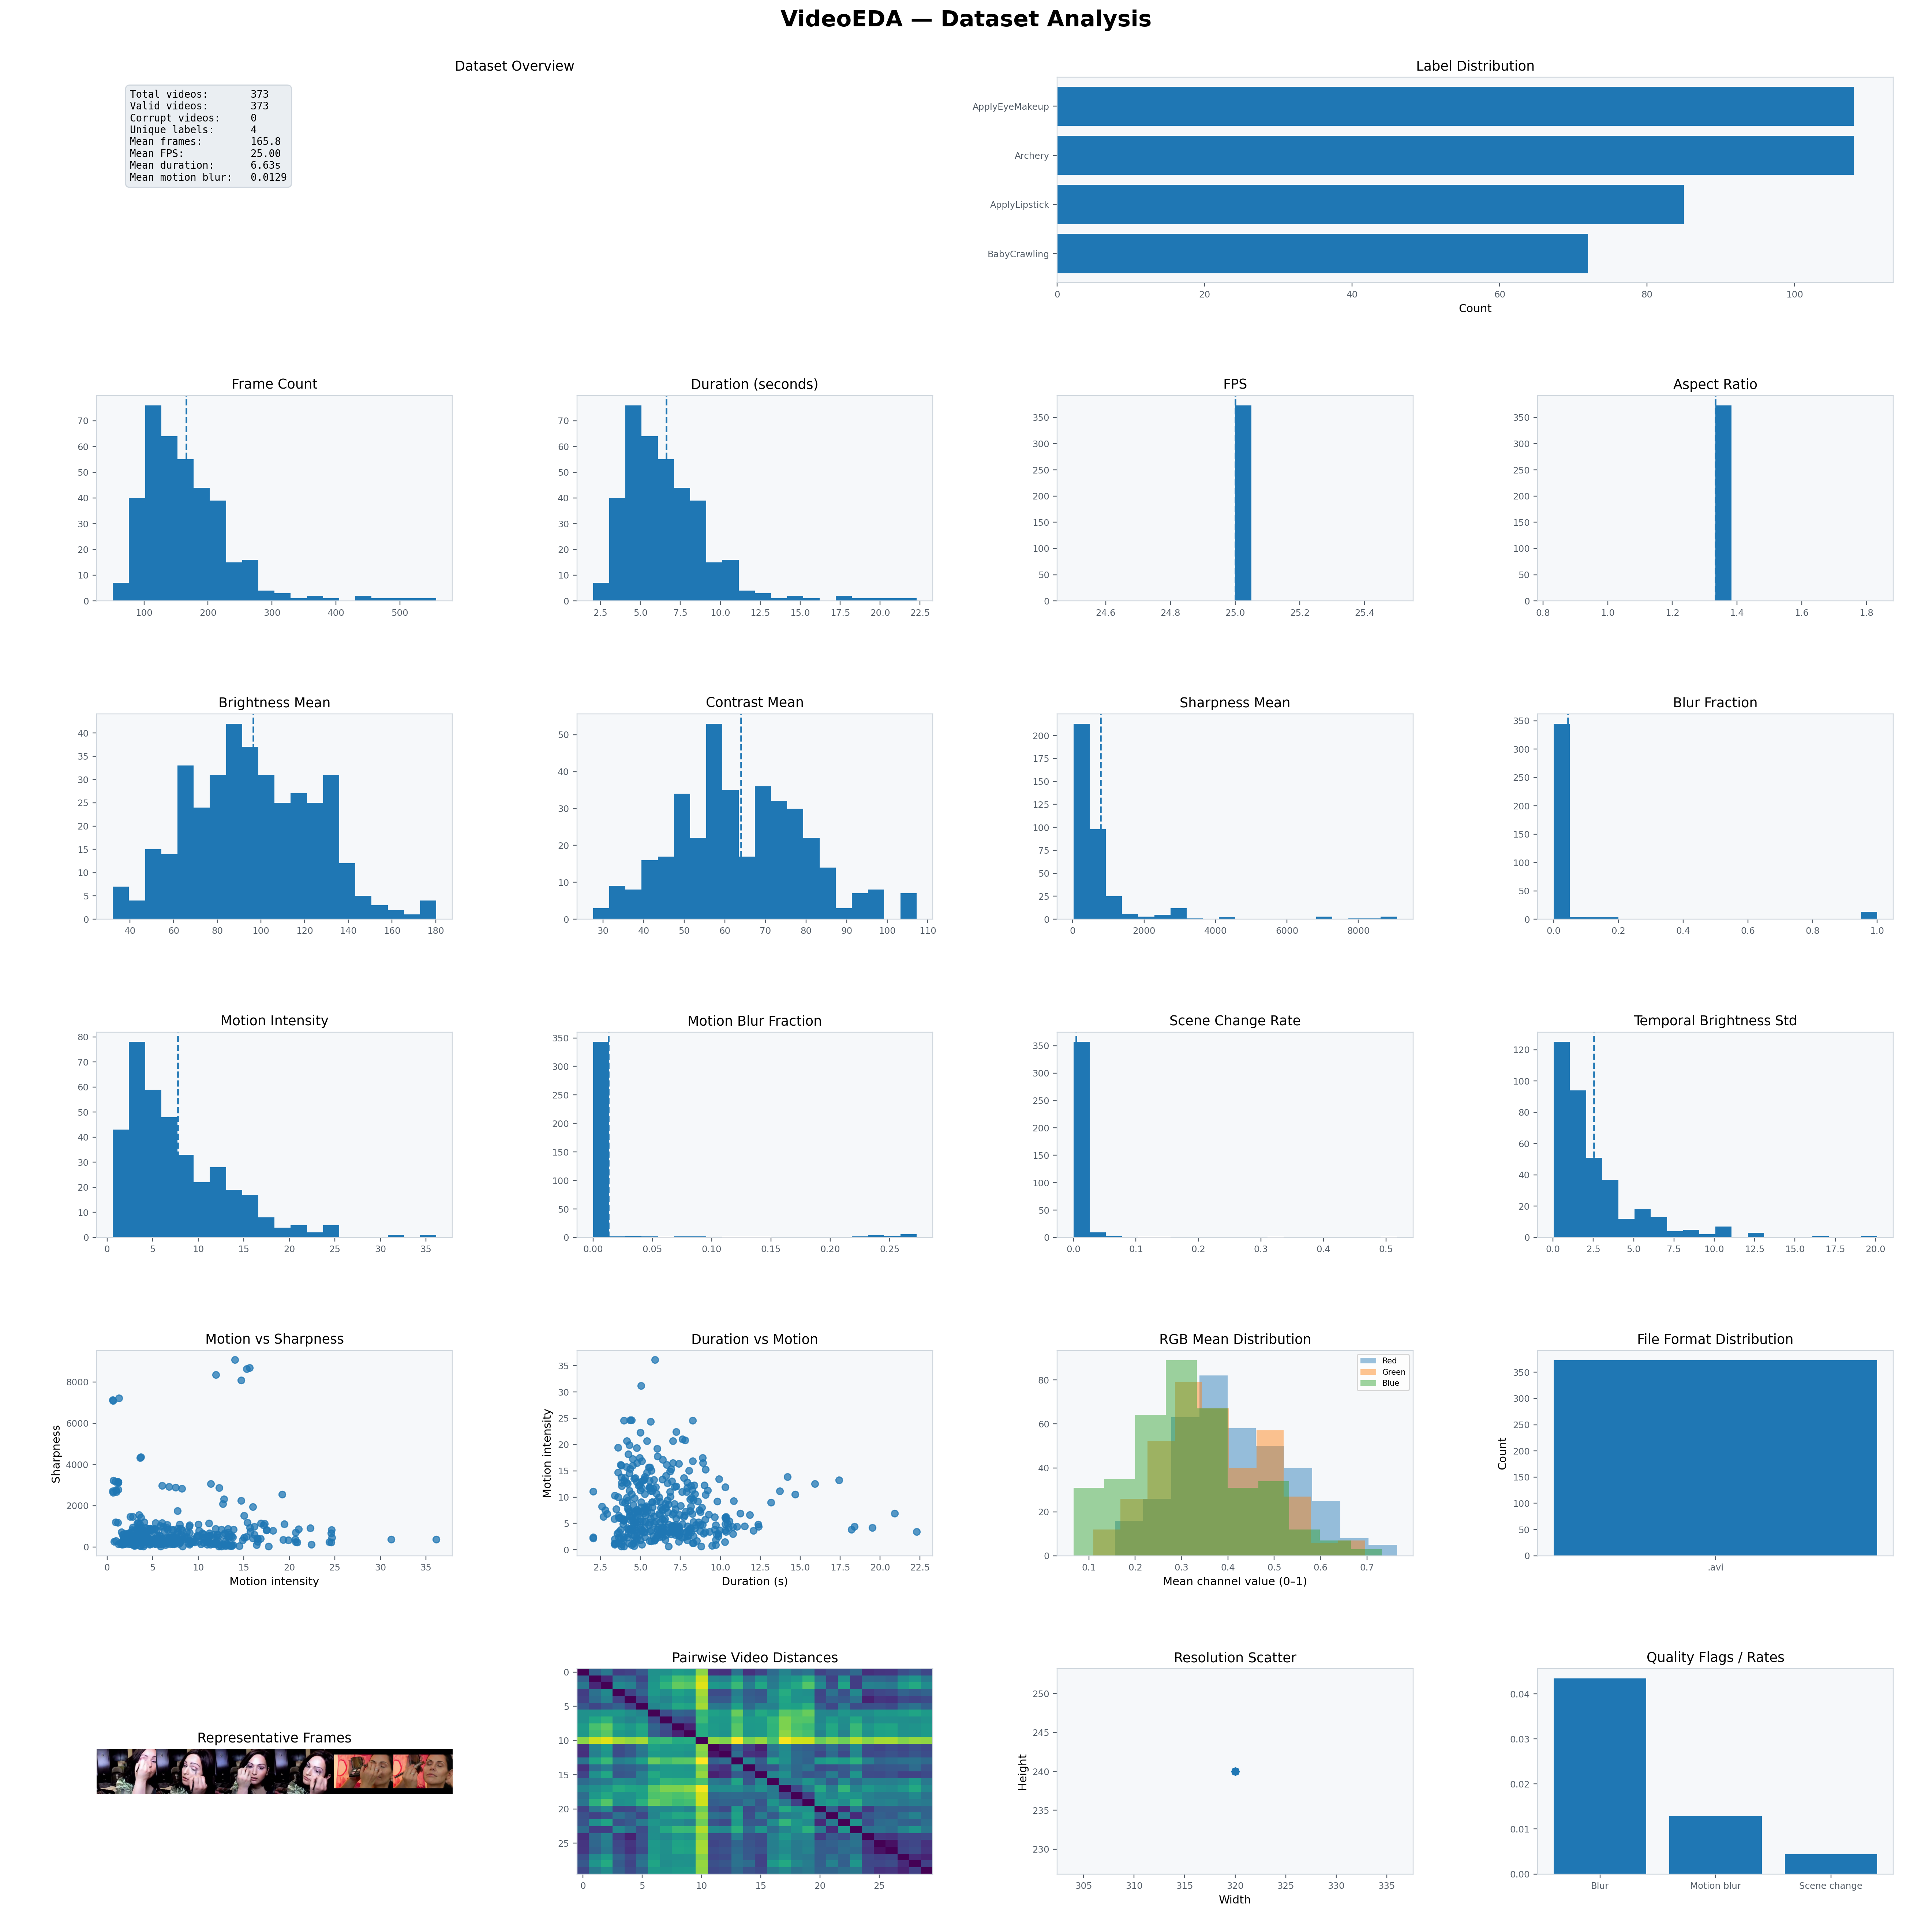
Figure 6.1 — VideoEDA Dataset Dashboard
The complete dataset-level dashboard. It combines inventory, temporal, quality, motion, colour, representative-frame and diversity analyses in a single figure.

Row 0: Dataset Overview and Label Distribution
Dataset Overview card (columns 0–1): A monospaced text card showing the eight most important dataset facts at a glance:
- Total, valid, and corrupt video counts
- Number of unique class labels
- Mean frame count across all videos
- Mean FPS across all videos
- Mean duration in seconds
- Mean motion blur fraction — a key quality indicator
Label Distribution (columns 2–3): A horizontal bar chart showing how many videos belong to each class label. Class labels are sorted by count descending, showing up to 20 classes. This is the first diagnostic to check — a class imbalance ratio above 5:1 is a red flag for ML training.

Row 1: Spatial and Temporal Inventory
Four histograms characterising the temporal structure of the dataset:
- Frame Count: Distribution of total frame counts. The dashed vertical line marks the mean. A wide distribution means the dataset has very short and very long videos — which requires handling in temporal models (padding/truncation).
- Duration (seconds): Distribution of video durations. For a typical action recognition dataset like UCF-101, this peaks at 4–10 seconds.
- FPS: Frames-per-second distribution. Most cameras record at 24, 25, or 30 fps. A spike at a single value (e.g., 25.0) indicates a homogeneous dataset.
- Aspect Ratio: Distribution of width/height ratios. A spike at 1.78 means all videos are 16:9. A wide distribution indicates mixed sources.

Row 2: Quality Metrics
Four histograms characterising per-video quality:
- Brightness Mean: Distribution of average brightness across videos. A bimodal distribution may indicate two distinct scene types (indoor/outdoor, day/night).
- Contrast Mean: Distribution of average contrast. Low-contrast videos from foggy or uniformly-lit scenes will cluster at the low end.
- Sharpness Mean: Distribution of average Laplacian variance. Right-skewed distribution is typical — most videos are moderately sharp, a small fraction are very sharp.
- Blur Fraction: Distribution of the proportion of blurry frames. Ideally a spike near 0 for most videos, with a long tail. Videos with blur_fraction > 0.5 should be reviewed.

Row 3: Motion and Temporal Consistency
- Motion Intensity: Distribution of mean frame difference. Action videos cluster at higher values; surveillance footage clusters near zero.
- Motion Blur Fraction: Distribution of the motion-blur metric. Most videos should have near-zero values. Consistently high values indicate fast-motion or poorly-exposed footage.
- Scene Change Rate: Distribution of cut frequency. Continuous footage has zero; edited content has non-zero rates.
- Temporal Brightness Std: Distribution of lighting stability. Values above 5 indicate significant flickering or lighting transitions.

Row 4: Relationships and Colour
- Motion vs Sharpness scatter: Each video is a point at (motion_intensity_mean, sharpness_mean). The inverse relationship — high motion tends to correlate with low sharpness — is the signature of motion blur. Videos in the high-motion, high-sharpness quadrant are well-exposed fast-motion videos; those in high-motion, low-sharpness are motion-blurred.
- Duration vs Motion scatter: Each video at (duration_sec, motion_intensity_mean). Reveals whether longer videos tend to be more or less active. No correlation is typical for well-curated datasets.
- RGB Mean Distribution: Overlapping histograms of per-video mean R, G, and B channel values. A rightward shift of the Red histogram vs Blue confirms a warm colour bias, as seen in outdoor or skin-tone-dominant datasets.
- File Format Distribution: Bar chart showing how many videos are in each format. A purely homogeneous format dataset (.avi only, or .mp4 only) is ideal.

Row 5: Previews, Diversity, Resolution, Quality Flags
- Representative Frames: A horizontal strip of middle frames from the first six valid videos. Provides a quick visual sanity check — confirming that the videos contain what is expected.
- Pairwise Video Distances: A heatmap of Euclidean distances between all videos in the normalised feature space (up to 30 videos). Dark cells = similar videos; bright/yellow cells = dissimilar videos. Clusters of dark cells reveal groups of nearly identical videos that may indicate dataset redundancy.
- Resolution Scatter: Each video as a point at (width, height). A tight cluster indicates a homogeneous dataset; spread points indicate mixed resolutions requiring normalisation.
- Quality Flags / Rates: A bar chart showing three mean rates across the dataset: blur fraction, motion blur fraction, and scene change rate. These three metrics summarise the overall quality at a glance.

6.2 plot() — Single Video Dashboard
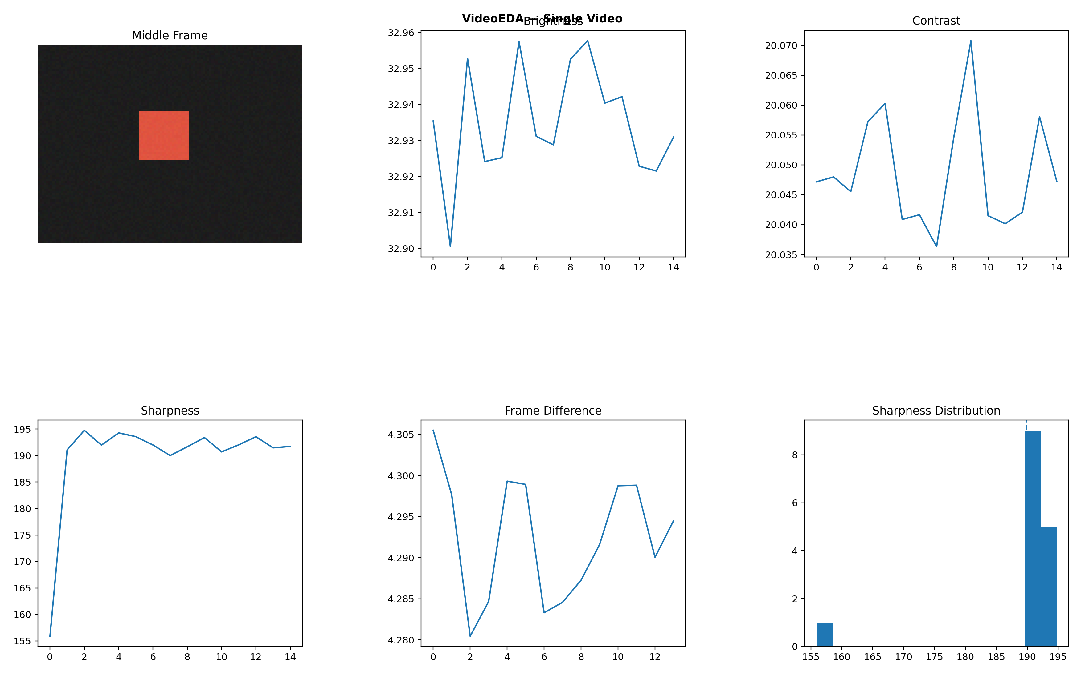
Figure 6.2 — Single Video Dashboard
The single-video dashboard showing a representative frame and temporal brightness, contrast, sharpness and frame-difference behaviour.
eda.plot(
video_index = 0,
figsize = (16, 10),
save_path = None,
dpi = 150,
)
The single video dashboard is a 2×3 grid showing six panels for one video:
Panel | Position | Content
Middle Frame | Row 0, Col 0 | The frame at the midpoint of the video. Provides a representative visual preview.
Brightness | Row 0, Col 1 | Per-frame mean brightness over sampled frames. Shows lighting evolution across the video.
Contrast | Row 0, Col 2 | Per-frame contrast (luminance std) over frames.
Sharpness | Row 1, Col 0 | Per-frame Laplacian variance. Dips indicate blurry sections; peaks indicate sharp sections.
Frame Difference | Row 1, Col 1 | Motion signal: mean abs pixel diff between consecutive frames. Spikes = motion bursts or cuts.
Sharpness Distribution | Row 1, Col 2 | Histogram of per-frame sharpness values. The dashed line marks the blur threshold.
Interpretation: In the single video dashboard from the UCF-101 dataset, the brightness panel shows a gradual increase (subject moving from shadow to light), the frame difference panel spikes at a scene transition, and the sharpness distribution is bimodal — most frames are sharp (right peak) with a smaller cluster of motion-blurred frames (left peak).

6.3 plot_motion_profile() — Motion/Sharpness Profile
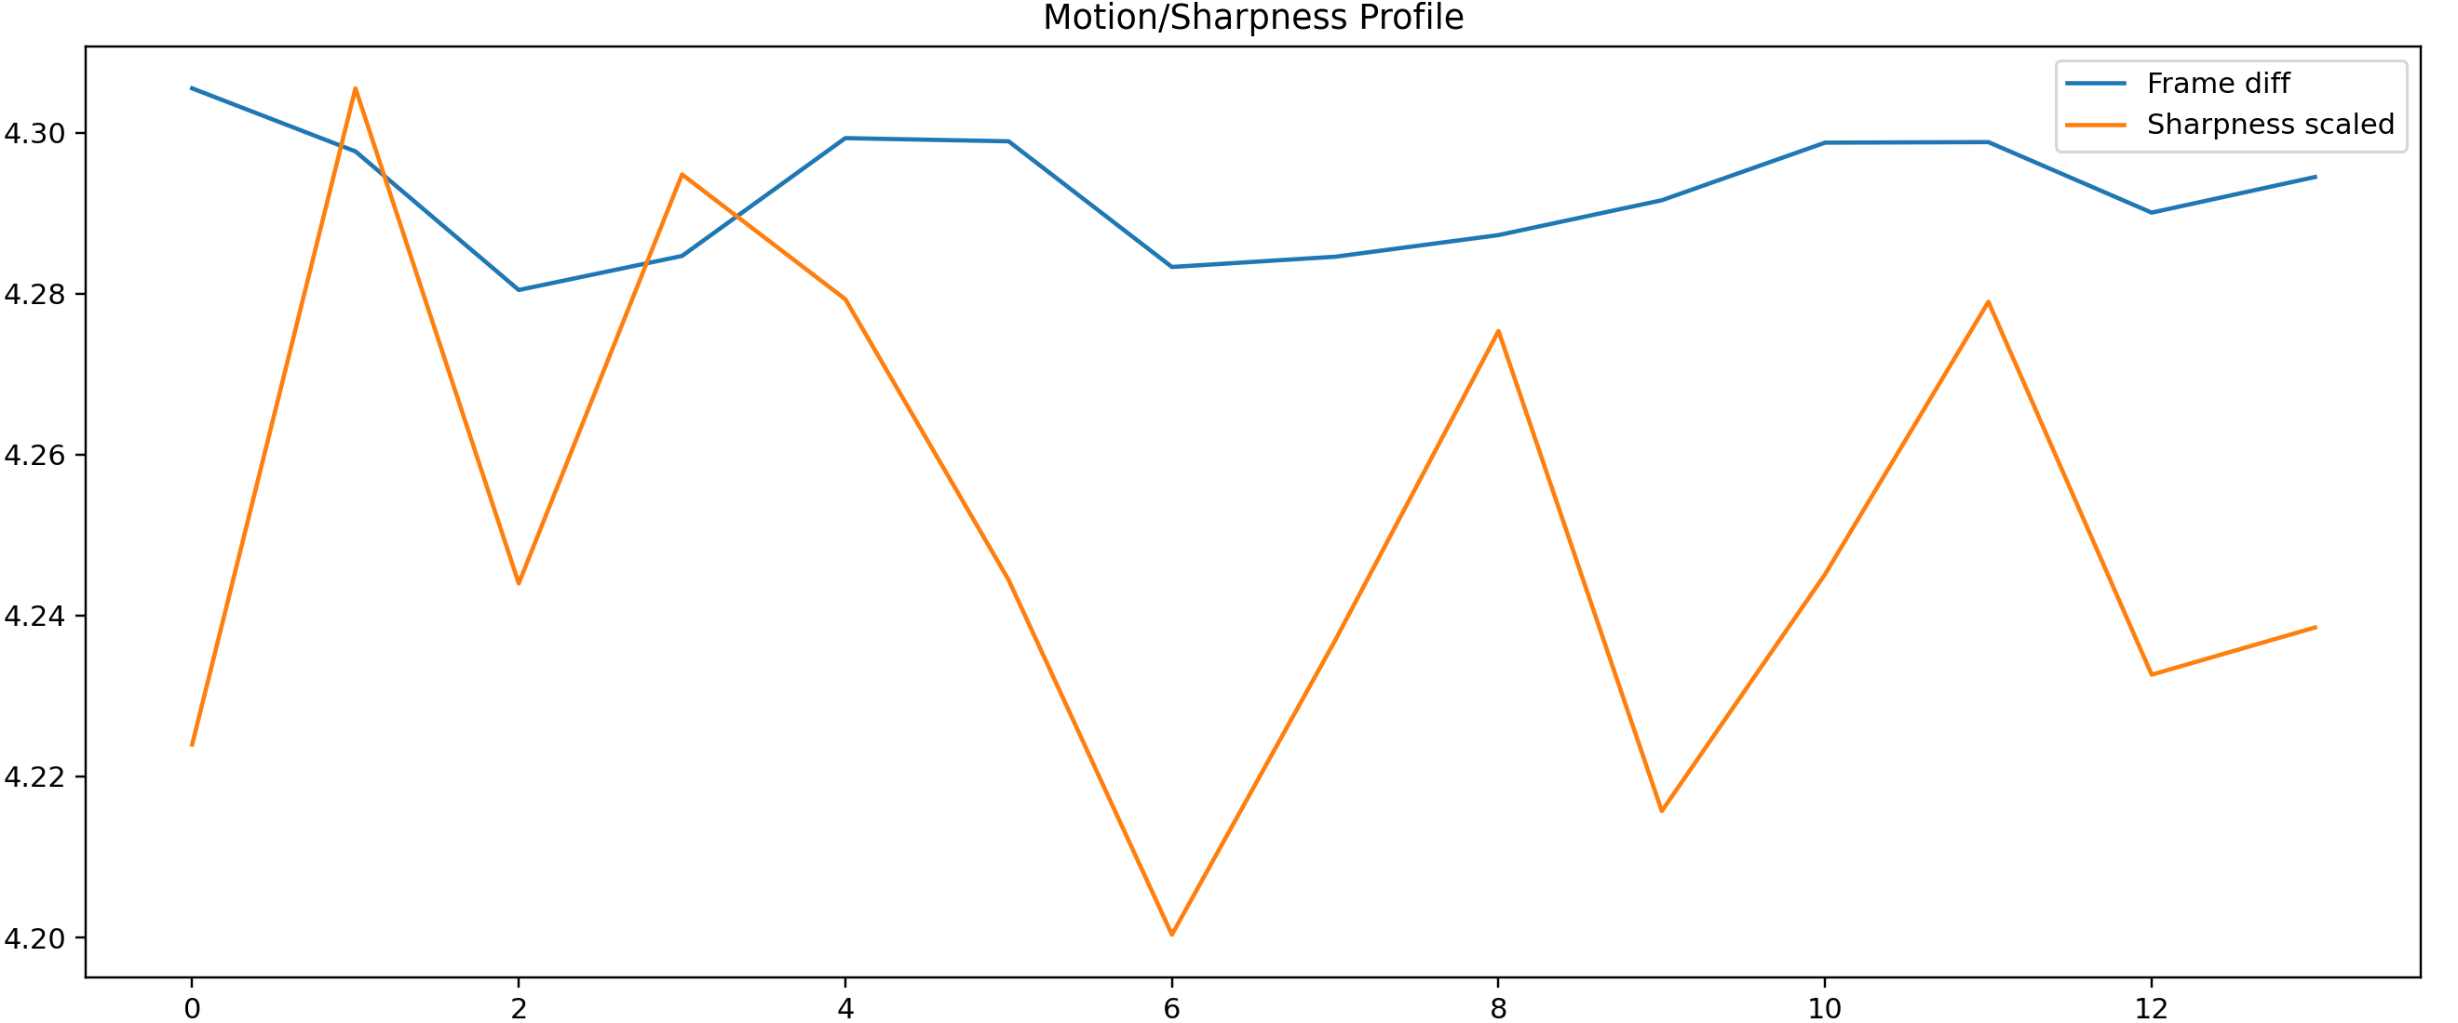
Figure 6.3 — Motion/Sharpness Profile
Frame difference and scaled sharpness plotted together to show whether high-motion sections coincide with sharpness drops.
eda.plot_motion_profile(
video_index = 0,
save_path = None,
dpi = 150,
)
Plots two overlaid time series for a single video on the same axis:
- Frame difference (blue): The raw motion signal — mean absolute pixel difference between consecutive sampled frames.
- Sharpness scaled (orange): Per-frame Laplacian variance, normalised to the same scale as the frame difference for visual comparison.
The key insight from this plot is the inverse correlation between motion and sharpness. When the frame difference spikes (fast motion), the sharpness typically drops (motion blur). When they move in sync, it suggests a scene cut rather than motion blur — cuts reset both signals abruptly.
This plot is particularly useful for:
- Drone footage: identifying when the drone is accelerating vs hovering
- Sports: identifying plays vs stoppage time
- Surveillance: identifying events (motion spikes) in otherwise static footage

6.4 plot_pairwise_video_distances() — Diversity Heatmap
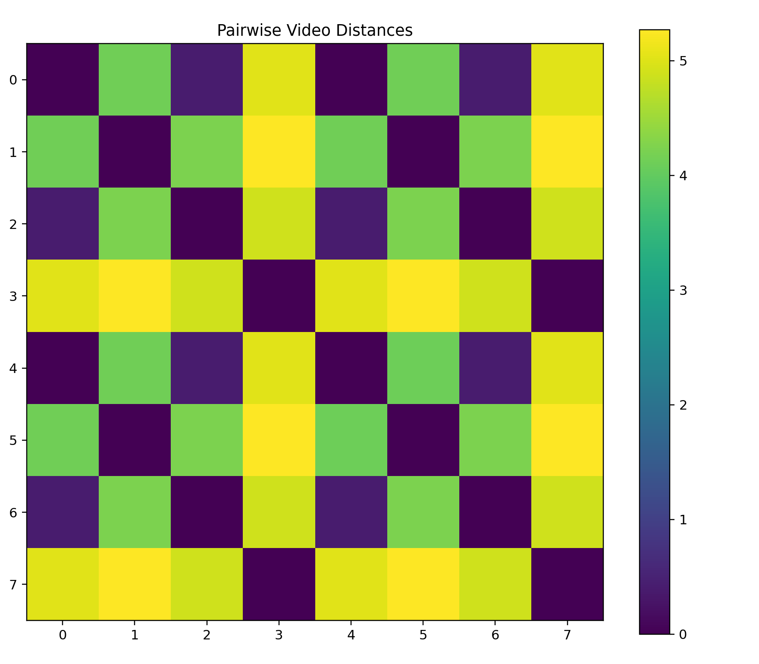
Figure 6.4 — Pairwise Video Distance Heatmap
A heatmap of normalised feature-space distances between videos. Dark cells represent similarity; brighter cells represent diversity.
eda.plot_pairwise_video_distances(
save_path = None,
dpi = 150,
)
Displays the full pairwise distance matrix as a colour heatmap. Each cell (i, j) shows the Euclidean distance between videos i and j in the normalised 12-dimensional feature space. The diagonal is always zero (a video is identical to itself).
Reading the heatmap:
- Dark cells (distance ≈ 0): Nearly identical videos. In the test output from synthetic data with alternating scenes, the checkerboard pattern shows that every other video is similar — videos of the same scene type cluster together.
- Yellow cells (high distance): Very different videos. High distance between all pairs indicates a diverse dataset — good for training.
- Block structure: Clusters of similar videos. In a well-organised dataset, videos of the same class should form blocks of low distance.
This analysis is unique to VideoEDA among common EDA tools. It enables:
- Redundancy detection: Identifying videos so similar they add no new information to the training set.
- Active learning: Selecting the most diverse subset of videos for annotation by choosing the minimum-distance spanning set.
- Train/val split validation: Ensuring that train and val splits are not dominated by similar videos.

6.5 plot_videos_grid() — Video Thumbnail Grid
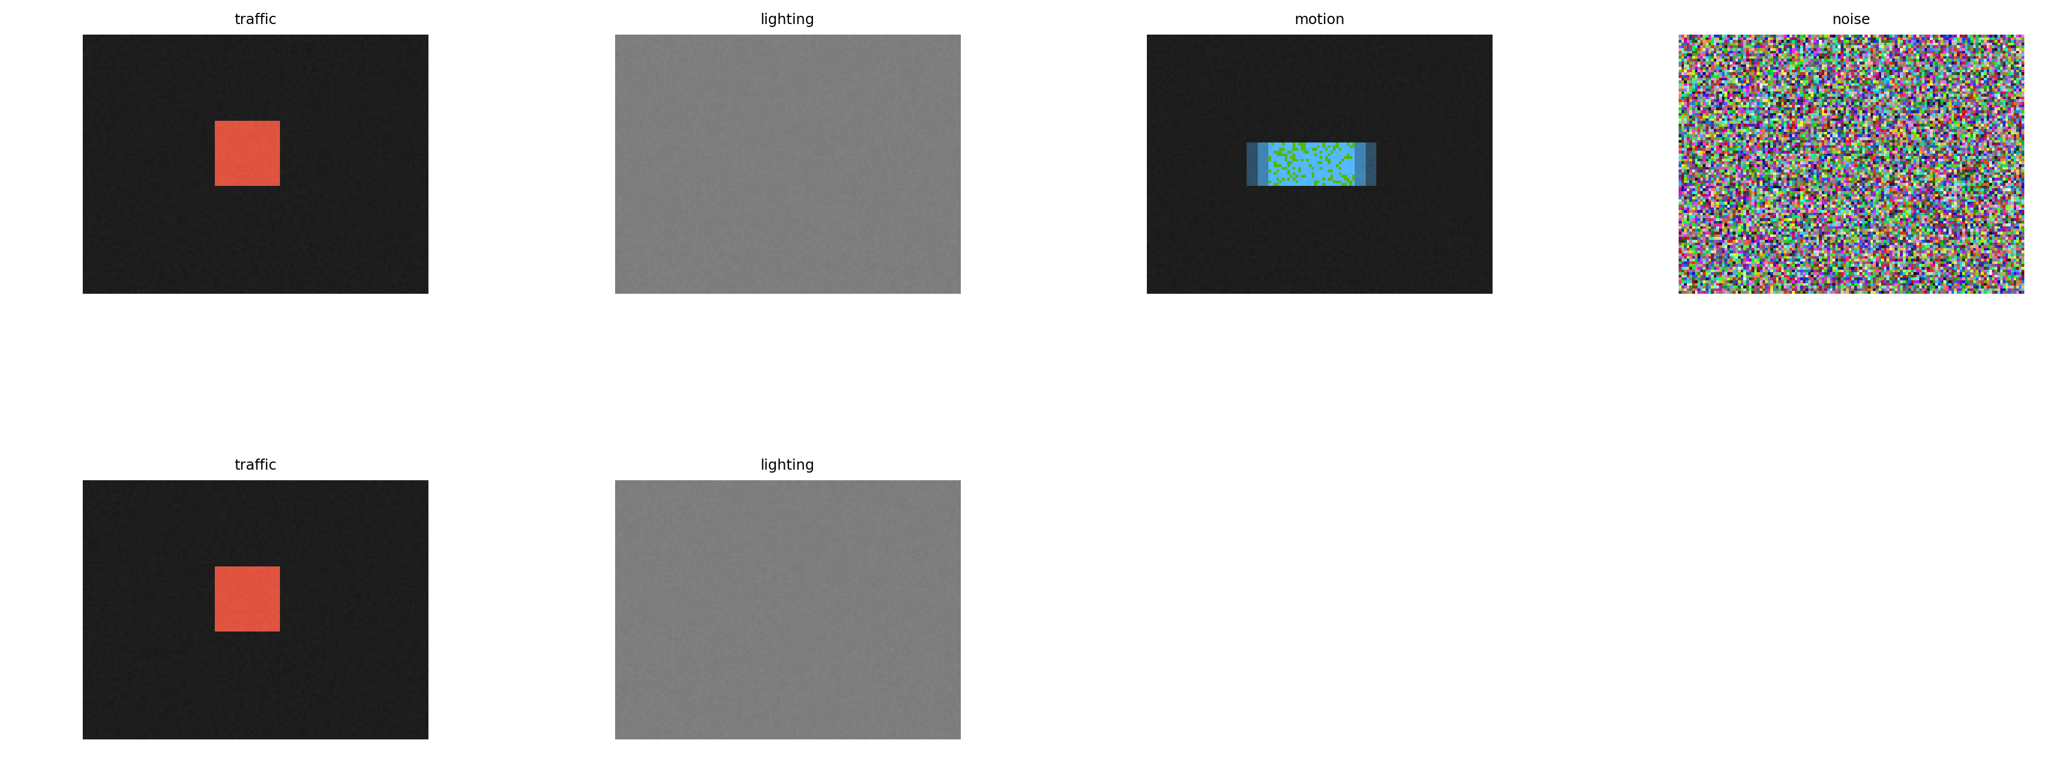
Figure 6.5 — Video Thumbnail Grid
A grid of representative middle frames from sampled videos, useful for visual sanity checking.
eda.plot_videos_grid(
n = 12, # max videos to display
cols = 4, # columns in grid
save_path = None,
dpi = 150,
)
Displays a grid of middle frames from up to n videos. Each thumbnail is labelled with the video's class label or filename stem. This is the visual equivalent of plot_samples() in ImageEDA — the first sanity check that the dataset actually contains what is expected.
For the UCF-101 dataset, this reveals the visual diversity of different action classes: ApplyEyeMakeup (close-up face, bright lighting), Archery (outdoor, green background), BabyCrawling (floor-level, soft lighting).

6.6 plot_temporal_statistics() — Temporal Deep Dive
eda.plot_temporal_statistics(
video_index = 0,
save_path = None,
dpi = 150,
)
A 2×2 detailed temporal analysis for one video, showing brightness, contrast, sharpness, and frame difference each in their own panel with proper axis labels and full resolution. Compared to plot(), this provides larger, higher-resolution temporal views for detailed inspection of a single video.

6.7 plot_quality_summary() — Quality Summary
eda.plot_quality_summary(
save_path = None,
dpi = 150,
)
A 2×3 quality-focused dashboard for the dataset showing: brightness mean distribution, contrast mean distribution, sharpness mean distribution, blur fraction distribution, motion blur fraction distribution, and a motion vs sharpness scatter. More focused than plot_dataset() when quality is the primary concern.

6.8 plot_frame_samples() — Frame Sample Grid
eda.plot_frame_samples(
video_index = 0,
n = 12, # number of frames to show
cols = 4,
save_path = None,
dpi = 150,
)
Displays n evenly-spaced sampled frames from a single video in a grid layout. Each frame is labelled with its index in the sampled frame array. This is the most direct way to inspect what VideoEDA actually saw when analysing a video — confirming that the frame_sample_rate and resize_width settings produced reasonable results.

Chapter 7 — Interpreting Results and Common Findings

7.1 Red Flags to Watch For
The following findings should prompt action before training:
Finding | Threshold | Recommended Action
blur_fraction mean > 0.20 | > 20% blurry frames on average | Review the blurriest videos. Consider excluding videos with blur_fraction > 0.5 from training.
motion_blur_fraction mean > 0.10 | > 10% motion-blurred frames | Increase blur_threshold or motion_blur_threshold, or use data augmentation for blur robustness.
temporal_brightness_std mean > 5 | High lighting instability | Investigate the source. Flicker may require video stabilisation preprocessing.
scene_change_rate mean > 0.20 | Many scene cuts | Consider whether multi-shot videos suit the task. Some models require continuous-scene input.
Class imbalance ratio > 5 | One class is 5× larger than another | Oversample minority classes, or use a class-weighted loss function.
Corrupt video count > 1% | More than 1% unreadable files | Investigate the source. Re-download or re-encode the corrupt files.
Pairwise heatmap shows large dark clusters | Many near-identical videos | Remove duplicates or near-duplicates before creating train/val splits.
Resolution scatter shows widespread | Mixed resolutions | Standardise all videos to the same resolution in preprocessing.

7.2 Common Dataset Patterns
UCF-101 (Action Recognition): In the dashboard shown in this documentation, 373 videos from 4 classes were analysed. Key findings:
- Mean duration 6.6s, mean FPS 25 — consistent short clips suitable for temporal modelling with fixed-length inputs.
- Mean motion intensity ~5–15 — typical for human activity videos.
- Low motion blur fraction (~0.013) — well-shot, mostly sharp footage.
- Scene change rate near zero — clips are single continuous shots.
- Temporal brightness std ~2–5 — stable lighting with minor variations.
Surveillance datasets: Typically show:
- Very low motion_intensity_mean (< 2) for static camera footage
- scene_change_count = 0 for continuous recordings
- High temporal_brightness_std if AGC (auto gain control) is active
Dashcam/autonomous driving datasets: Typically show:
- Moderate motion_intensity_mean (5–20) for normal driving speed
- Sharp bimodal brightness distribution (day vs night driving)
- Higher motion_blur_fraction during rapid lane changes or braking

Chapter 8 — Advanced Usage

8.1 Working with Large Datasets
# Strategy 1: limit the number of videos
eda = VideoEDA(max_videos=500)
eda.load("large_dataset/")
# Strategy 2: coarser frame sampling
eda = VideoEDA(frame_sample_rate=10, max_frames_per_video=100)
eda.load("large_dataset/")
# Strategy 3: smaller frame size
eda = VideoEDA(resize_width=160) # 160px wide instead of 320px
eda.load("large_dataset/")
# Strategy 4: combine all three for maximum speed
eda = VideoEDA(
max_videos = 1000,
frame_sample_rate = 10,
max_frames_per_video = 50,
resize_width = 160,
verbose = True,
)
eda.load("large_dataset/")
Note: On a typical laptop, VideoEDA processes approximately 30–60 videos per minute with the default settings (frame_sample_rate=5, max_frames_per_video=300, resize_width=320). Halving resize_width roughly quadruples processing speed.

8.2 Accessing VideoRecord Objects
# Find the 10 most blurry videos
blurry = sorted(
[r for r in eda._records if not r.is_corrupt],
key=lambda r: r.blur_fraction or 0,
reverse=True
)[:10]
for r in blurry:
print(f"{r.path}: blur={r.blur_fraction:.3f}, "
f"sharpness={r.sharpness_mean:.1f}")
# Find high-motion videos
action = [
r for r in eda._records
if not r.is_corrupt
and r.motion_intensity_mean is not None
and r.motion_intensity_mean > 20
]
print(f"{len(action)} high-motion videos")
# Export all stats to a DataFrame
import pandas as pd
data = []
for r in eda._records:
if not r.is_corrupt:
data.append({
"path": r.path,
"label": r.label,
"duration": r.duration_sec,
"fps": r.fps,
"n_frames": r.n_frames,
"brightness": r.brightness_mean,
"contrast": r.contrast_mean,
"sharpness": r.sharpness_mean,
"blur_fraction": r.blur_fraction,
"motion": r.motion_intensity_mean,
"motion_blur": r.motion_blur_fraction,
"scene_changes": r.scene_change_count,
"temporal_bri_std": r.temporal_brightness_std,
})
df = pd.DataFrame(data)
df.to_csv("video_stats.csv", index=False)

8.3 Integrating with ML Pipelines
from viseda import VideoEDA
import torch
from torch.utils.data import DataLoader
# Step 1: Analyse the dataset
eda = VideoEDA(verbose=True)
eda.load("dataset/train/", label_from_parent=True)
s = eda.summary()
# Step 2: Check for data quality issues before training
print(f"Corrupt videos: {s['inventory']['corrupt_videos']}")
print(f"Mean blur fraction: {s['quality']['blur_fraction']['mean']:.3f}")
print(f"Class imbalance: {s['labels']['class_imbalance_ratio']}")
print(f"Mean motion blur: {s['motion']['motion_blur_fraction']['mean']:.3f}")
# Step 3: Get per-video stats for sampling weights
blur_fractions = [r.blur_fraction or 0 for r in eda._records]
# Use inverse blur as quality weight: high blur = low weight
weights = [1.0 / (bf + 0.01) for bf in blur_fractions]
# Step 4: Get corrupt paths to exclude
corrupt_paths = s['inventory']['corrupt_paths']
print(f"Exclude from training: {corrupt_paths}")
# Step 5: Get mean RGB for normalisation
rgb_mean = s['colour']['rgb_mean_mean']
rgb_std = s['colour']['rgb_std_mean']
print(f"Dataset mean RGB: {rgb_mean}")
print(f"Dataset std RGB: {rgb_std}")

8.4 Comparing Two Datasets
eda_train = VideoEDA(verbose=False)
eda_val = VideoEDA(verbose=False)
eda_train.load("dataset/train/", label_from_parent=True)
eda_val.load("dataset/val/", label_from_parent=True)
s_tr = eda_train.summary()
s_va = eda_val.summary()
# Compare quality metrics
metrics = [
("Brightness mean", "quality", "brightness_mean"),
("Contrast mean", "quality", "contrast_mean"),
("Sharpness mean", "quality", "sharpness_mean"),
("Blur fraction", "quality", "blur_fraction"),
("Motion intensity", "motion", "motion_intensity_mean"),
("Motion blur frac", "motion", "motion_blur_fraction"),
("Scene change rate", "motion", "scene_change_rate"),
("Duration", "temporal","duration_sec"),
]
print(f"{'Metric':10} {'Val':>10} {'Diff%':>8}")
print("-" * 54)
for label, section, key in metrics:
tr = s_tr[section][key]["mean"]
va = s_va[section][key]["mean"]
if tr and va and tr != 0:
diff_pct = abs(tr - va) / abs(tr) * 100
flag = " ← !" if diff_pct > 20 else ""
print(f"{label:10.3f} {va:>10.3f} {diff_pct:>7.1f}%{flag}")
# Large differences (> 20%) in brightness, contrast, or motion
# indicate train/val distribution mismatch

Chapter 9 — API Reference
Complete reference for all public methods of the VideoEDA class.

VideoEDA.__init__()
Parameter | Type | Default | Description
verbose | bool | True | Print progress messages
max_videos | int|None | None | Max videos to analyse
frame_sample_rate | int | 5 | Sample every Nth frame
max_frames_per_video | int | 300 | Cap on sampled frames per video
blur_threshold | float | 80.0 | Laplacian var below = blurry frame
motion_blur_threshold | float | 80.0 | Sharpness threshold for motion blur
scene_change_threshold | float | 35.0 | Frame diff threshold for scene cuts
resize_width | int|None | 320 | Resize width for processing speed

VideoEDA.load()
Parameter | Type | Default | Description
source | str|Path|List | — | Directory, file, or list of paths
labels | dict|None | None | Optional {path: label} mapping
label_from_parent | bool | False | Infer label from parent folder name
recursive | bool | True | Recurse into sub-directories

VideoEDA.load_arrays()
Parameter | Type | Default | Description
videos | List[ndarray] | — | (T,H,W,3) arrays, uint8 or float32 [0,1]
labels | List[str]|None | None | Optional label per video
names | List[str]|None | None | Optional name per video (shown in plots)
fps | float|List | 30.0 | Frames per second: scalar or per-video list

VideoEDA.summary()
Returns a nested dict. Top-level keys:
Key | Contents
inventory | total_videos, valid_videos, corrupt_videos, corrupt_paths, format_distribution, label_distribution, file_size_kb
spatial | height, width, aspect_ratio, megapixels — each a stat dict
temporal | frame_count, sampled_frames, fps, duration_sec, temporal_brightness_std, temporal_contrast_std
quality | brightness_mean, brightness_std, contrast_mean, sharpness_mean, sharpness_min, blur_fraction
motion | frame_diff_mean, motion_intensity_mean, motion_blur_fraction, scene_change_count, scene_change_rate
colour | rgb_mean_mean [R,G,B] in [0,1], rgb_std_mean [R,G,B]
labels | label_distribution dict, class_imbalance_ratio

VideoEDA.get_record(index)
Parameter | Type | Default | Description
index | int | 0 | Index into eda._records (order of loading)
Returns: VideoRecord object.

VideoEDA.get_frames(index)
Parameter | Type | Default | Description
index | int | 0 | Index into eda._records
Returns: ndarray shape (T, H, W, 3), dtype uint8 — sampled frames.

VideoEDA.temporal_profile(index)
Parameter | Type | Default | Description
index | int | 0 | Index into eda._records
Returns: dict with keys brightness, contrast, sharpness (each ndarray of length T), and frame_diff (ndarray of length T-1).

VideoEDA.pairwise_video_distances(max_videos)
Parameter | Type | Default | Description
max_videos | int | 50 | Maximum videos to include in the distance matrix
Returns: (D, names) where D is a symmetric float ndarray of shape (N, N) and names is a list of N label/stem strings.

VideoEDA.plot_dataset()
Parameter | Type | Default | Description
figsize | tuple | (24,24) | Figure dimensions in inches
save_path | str|None | None | Path to save the figure; None = show interactively
dpi | int | 150 | Resolution for saved figures

VideoEDA.plot()
Parameter | Type | Default | Description
video_index | int | 0 | Which video to display
figsize | tuple | (16,10) | Figure dimensions
save_path | str|None | None | Save path or None
dpi | int | 150 | Resolution

VideoEDA.plot_motion_profile()
Parameter | Type | Default | Description
video_index | int | 0 | Which video to plot
save_path | str|None | None | Save path or None
dpi | int | 150 | Resolution

VideoEDA.plot_pairwise_video_distances()
Parameter | Type | Default | Description
save_path | str|None | None | Save path or None
dpi | int | 150 | Resolution

VideoEDA.plot_videos_grid()
Parameter | Type | Default | Description
n | int | 12 | Max videos to show
cols | int | 4 | Grid columns
save_path | str|None | None | Save path or None
dpi | int | 150 | Resolution

VideoEDA.plot_temporal_statistics()
Parameter | Type | Default | Description
video_index | int | 0 | Which video to analyse
save_path | str|None | None | Save path or None
dpi | int | 150 | Resolution

VideoEDA.plot_quality_summary()
Parameter | Type | Default | Description
save_path | str|None | None | Save path or None
dpi | int | 150 | Resolution

VideoEDA.plot_frame_samples()
Parameter | Type | Default | Description
video_index | int | 0 | Which video to sample from
n | int | 12 | Number of frames to display
cols | int | 4 | Grid columns
save_path | str|None | None | Save path or None
dpi | int | 150 | Resolution

VideoEDA.report()
Parameter | Type | Default | Description
output_path | str | viseda_video_report.html | Path for the HTML output file

Chapter 10 —Roadmap

Version 1.0.0 (May 2026) — Initial Release
- VideoEDA class with full per-video statistical analysis.
- load() for file-based loading (mp4, avi, mov, mkv, webm, mpeg, m4v).
- load_arrays() for NumPy array inputs without requiring OpenCV.
- All quality metrics: brightness, contrast, sharpness, blur_fraction.
- All motion metrics: frame_diff, motion_intensity, motion_blur_fraction, scene_change_count/rate.
- Temporal consistency metrics: temporal_brightness_std, temporal_contrast_std.
- Pairwise video distance computation and heatmap visualisation.
- Eight plot methods: plot_dataset, plot, plot_motion_profile, plot_pairwise_video_distances, plot_videos_grid, plot_temporal_statistics, plot_quality_summary, plot_frame_samples.
- HTML report generation via report().
- CLI integration via viseda video sub-command.

Roadmap
Version | Planned Feature
v1.2.0 | Optical flow-based motion estimation (more accurate than frame difference)
v1.2.0 | Audio analysis module (silence detection, audio quality metrics)
v1.2.0 | Perceptual hash-based near-duplicate detection across videos
v1.3.0 | Interactive Plotly dashboards as alternative to Matplotlib
v1.3.0 | Per-frame object detection counts (using lightweight detector)
v1.3.0 | Temporal FFT analysis (flicker frequency detection)
v1.4.0 | GPU-accelerated frame processing via CuPy or PyTorch
v1.4.0 | Video embedding and UMAP/t-SNE visualisation of dataset clusters
v1.5.0 | Depth video / RGB-D EDA module

Appendix A — VideoRecord Fields
Complete field reference for the VideoRecord object:
Field | Type | Description
path | str | File path or '' for array inputs
label | str|None | Class label if provided
file_ext | str | File extension or 'array'
file_size_kb | float|None | File size in KB
is_corrupt | bool | True if the video could not be processed
error | str|None | Error message string if is_corrupt=True
n_frames | int | Total frames in the video container
sampled_frames | int | Number of frames actually sampled
fps | float | Frames per second from container metadata
duration_sec | float | n_frames / fps
height | int | Frame height after optional resize
width | int | Frame width after optional resize
channels | int | Colour channels (always 3 after normalisation)
aspect_ratio | float | width / height
megapixels | float | height * width / 1,000,000
brightness_mean | float | Mean of per-frame mean luminance (0-255)
brightness_std | float | Std of per-frame brightness across frames
contrast_mean | float | Mean of per-frame luminance std
contrast_std | float | Std of per-frame contrast
sharpness_mean | float | Mean Laplacian variance across frames
sharpness_std | float | Std of per-frame sharpness
sharpness_min | float | Minimum per-frame sharpness (worst frame)
blur_fraction | float | Fraction of frames with sharpness < blur_threshold
frame_diff_mean | float | Mean absolute frame-to-frame pixel difference
frame_diff_std | float | Std of frame differences
motion_intensity_mean | float | Same as frame_diff_mean
motion_intensity_std | float | Same as frame_diff_std
motion_blur_fraction | float | Fraction of transitions with high diff + low sharpness
scene_change_count | int | Number of frame diffs above scene_change_threshold
scene_change_rate | float | scene_change_count / (sampled_frames - 1)
temporal_brightness_std | float | Std of per-frame mean brightness over the video
temporal_contrast_std | float | Std of per-frame contrast over the video
rgb_mean | ndarray(3) | Mean R,G,B pixel values in [0,1]
rgb_std | ndarray(3) | Std R,G,B pixel values
sample_frames | ndarray | Up to 6 preview frames, shape (N,H,W,3) uint8

Appendix B — Glossary
Laplacian
A second-order spatial derivative filter applied to grayscale image frames. Its variance (Laplacian variance) measures image sharpness — sharp images have many strong edges and high Laplacian variance; blurry images have few edges and low variance.
Frame difference
The mean absolute pixel difference between two consecutive sampled frames. The primary measure of motion intensity in VideoEDA.
Motion blur
Blur caused by camera or subject movement during frame exposure. In VideoEDA, a frame is classified as motion-blurred when frame difference is in the top 25% AND sharpness is below motion_blur_threshold.
Scene change
An abrupt transition between visually dissimilar frames, typically caused by a video cut, fade, or wipe. Detected when frame_diff > scene_change_threshold.
Temporal brightness std
Standard deviation of per-frame mean brightness across the sampled frames of a video. Measures lighting stability. High values indicate flicker, AGC activity, or scene transitions.
ITU-R BT.601
The standard formula for converting RGB to luminance: L = 0.299R + 0.587G + 0.114B, reflecting human visual sensitivity to each colour channel.
frame_sample_rate
The frame sampling interval. A value of N means every Nth frame is sampled. Controls the trade-off between analysis speed and temporal resolution.
Pairwise distance
The Euclidean distance between two videos in a normalised 12-dimensional feature space. Used to measure dataset diversity and detect near-duplicate videos.
Blur fraction
The proportion of a video's sampled frames that are classified as blurry (Laplacian variance below blur_threshold). Ranges from 0.0 (no blurry frames) to 1.0 (all blurry).
Data leakage
When information from the validation or test set influences training, typically through near-duplicate videos that appear in both splits. The pairwise distance heatmap helps detect this.

Appendix C — Acknowledgements
VideoEDA builds on the excellent work of the following open-source projects:
- OpenCV (cv2): Video file reading, frame decoding, colour conversion, Laplacian computation, and frame resizing. The backbone of all file-based video I/O in VideoEDA.
- NumPy: All numerical array operations, statistical computations, and the frame difference calculations.
- Matplotlib: All visualisations — dashboards, time series plots, heatmaps, histograms, and scatter plots.
- The UCF-101 Action Recognition dataset (Soomro et al., 2012) was used as the primary real-world test dataset for validating VideoEDA. Available at: https://www.crcv.ucf.edu/data/UCF101.php

