SAP IS-Retail (SAP S/4HANA Retail) Implementation Plan
Business requirements and processes, design, configuration, chart of accounts, integration, finance worked example, testing, Azure ETL data migration, cutover, go-live, hypercare and production
Isaac Detch – SAP Project Management Consultant (FICO)
Version 1.0 – October 2026
Table of Contents

1. Executive Summary
[CLIENT] Retail operates 50 stores, one distribution center and an online shop on a mix of legacy merchandising, POS back-office and finance systems. Prices and promotions are maintained in several places, store replenishment is largely manual, POS sales reach finance two to three days late, and vendor rebates are tracked in spreadsheets.
This plan implements SAP IS-Retail – delivered in S/4HANA as SAP S/4HANA Retail for merchandise management – as the single system for merchandise master data, buying, pricing and promotions, replenishment and allocation, store and DC inventory, POS sales integration, vendor rebates and finance. The plan covers every phase from business requirements to hypercare and steady-state production operations.

1.1 Objectives and success measures
Objective | Measure | Target
Single source of article, price and promotion data | Price discrepancies at POS | < 0.1% of scanned items
Automated store replenishment | Share of store orders generated automatically | ≥ 85%
Daily store P&L | POS sales posted to G/L | By 06:00 the next day
Inventory accuracy | Store stock accuracy (cycle counts) | ≥ 97%
Vendor rebate capture | Rebates accrued vs. contractually due | 100% accrued monthly
Faster close | Month-end close | WD+4

1.2 Scope
In scope | Out of scope (phase 2)
Merchandise category hierarchy, articles (generic & variants), sites, vendors | Fashion season & collection management (SAP S/4HANA for fashion)
Assortments, listing, sales price calculation, promotions | Customer loyalty and CRM
Purchasing, replenishment, allocation, stock transport orders | Unified demand forecasting & markdown optimisation
DC operations in EWM; store goods receipt, transfers and counts (Fiori) | Franchise and wholesale
POS outbound and inbound via CAR / POS DTA; sales audit | Store labour scheduling
Vendor rebates (condition contracts, Settlement Management)
Finance: AP, AR, cash & card settlement, inventory valuation, store P&L, financial statements

1.3 Document structure
Chapter | Content
2 | Business requirements
3 | Business processes and process flows
4 | Solution architecture and design
5 | Chart of accounts and account determination
6 | Configuration
7 | Integration
8 | Finance integration and worked example to the financial statements
9 | Testing
10 | Data migration – Azure ETL to SAP Migration Cockpit staging tables
11 | Cutover
12 | Go-live, hypercare and production operations
13 | Project plan, governance and risks
14 | Glossary of abbreviations and terms
App. A | Transaction code index

2. Business Requirements
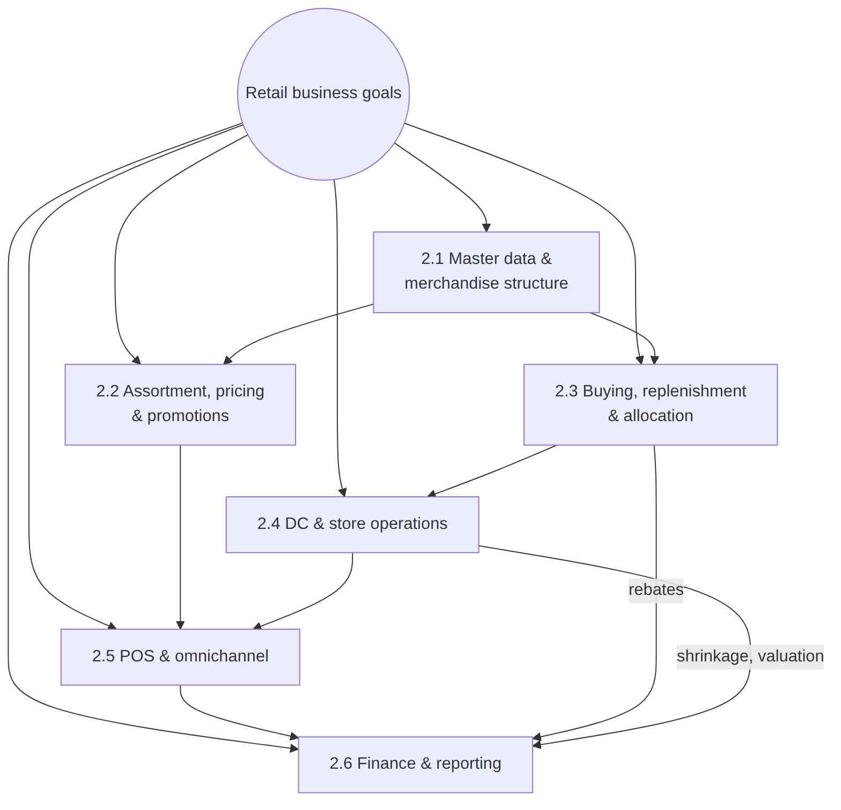
Figure 2-1. Requirement areas and their dependencies – every area ends in finance

2.1 Master data and merchandise structure
ID | Requirement | Priority | Acceptance criterion
BR-MD-01 | Four-level merchandise category hierarchy (division, department, merchandise category, article). | Must | Every article assigned to one merchandise category (MC); reports roll up by hierarchy.
BR-MD-02 | Fashion basics are maintained as generic articles with colour and size variants; each variant has its own EAN/UPC. | Must | Generic article TS-100 creates 3+ variants with EANs.
BR-MD-03 | Store, DC and online sites share a template (site profile) and are created in under 30 minutes. | Should | New site created by copy with listing and supply source.
BR-MD-04 | Vendors maintained as Business Partners with EDI settings and purchasing conditions. | Must | Vendor BP with purchasing org R100, info records, EDI partner profile.

2.2 Assortment, pricing and promotions
ID | Requirement | Priority | Acceptance criterion
BR-PR-01 | Articles are listed to stores by assortment (store cluster). | Must | Article sellable only in stores where listed.
BR-PR-02 | Retail prices are calculated from cost with margin targets and price-point rounding (e.g. .99). | Must | VKP5 proposes price; price points applied.
BR-PR-03 | Promotions with temporary prices by store group and date range are sent to POS automatically. | Must | Promo price active at POS on start date, removed after end date.
BR-PR-04 | Price changes reach all POS terminals before store opening. | Must | POS outbound complete by 05:00.

2.3 Buying, replenishment and allocation
ID | Requirement | Priority | Acceptance criterion
BR-BY-01 | DC replenishment from forecast with vendor lead times; POs sent by EDI. | Must | Replenishment run creates POs; EDI ORDERS transmitted.
BR-BY-02 | Store replenishment from DC based on POS consumption (min/max or forecast). | Must | Daily STOs DC01 → stores created automatically.
BR-BY-03 | New-season and promotional merchandise allocated to stores by allocation rules. | Should | Allocation table generates STOs / POs by store quantity.
BR-BY-04 | Vendor rebates accrued on every invoice and settled per contract. | Must | Condition contract accruals posted; settlement credit to vendor.

2.4 DC and store operations
ID | Requirement | Priority | Acceptance criterion
BR-OP-01 | DC inbound, putaway, picking and shipping run in EWM with RF devices. | Must | Inbound delivery → GR → putaway; outbound pick → GI.
BR-OP-02 | Stores receive DC deliveries on mobile Fiori apps by scanning. | Must | Store GR updates store stock same day.
BR-OP-03 | Stores perform cycle counts and annual inventory; differences post to shrinkage. | Must | Count approved; difference to 52300000 by store.
BR-OP-04 | Store-to-store transfers are possible. | Should | Transfer posted with in-transit stock.

2.5 Point of sale and omnichannel
ID | Requirement | Priority | Acceptance criterion
BR-POS-01 | POS sales, returns and tenders from all stores reach S/4HANA daily, audited. | Must | CAR sales audit approves; IDocs processed without errors by 06:00.
BR-POS-02 | POS sales reduce store stock and post revenue, tax, cost of sales and tenders. | Must | Postings as in §8.1.
BR-POS-03 | Online orders are fulfilled from the DC or ship-from-store with real-time stock. | Should | Stock availability API returns site stock.

2.6 Finance and reporting
ID | Requirement | Priority | Acceptance criterion
BR-FI-01 | Inventory valued at moving average cost by site; profit center per store and DC. | Must | Store P&L and inventory by profit center.
BR-FI-02 | Cash deposits and card settlements are reconciled automatically by store. | Must | Bank statement auto-match ≥ 95%.
BR-FI-03 | Gross margin by store, MC and article available daily. | Must | Margin Analysis and CAR reports.
BR-FI-04 | Shrinkage reported by store and MC. | Must | Inventory differences by profit center and MC.

2.7 Non-functional requirements
ID | Requirement
NFR-01 | POS inbound: 50 stores × [TICKETS_PER_DAY] tickets/day processed within the 01:00–05:00 window.
NFR-02 | Replenishment run for 50 stores × [ACTIVE_ARTICLES] articles completes in < 60 minutes.
NFR-03 | Store apps available 07:00–23:00 local time; 99.5% availability.
NFR-04 | Segregation of duties between price maintenance, vendor master, PO approval and payment.
NFR-05 | PCI DSS: no card numbers stored in S/4HANA or CAR; tokenised tenders only.

3. Business Processes

3.1 Process hierarchy
L1 | L2 | L3 processes
Merchandise management | Master data | MC hierarchy, article (generic/variant), site, vendor, EAN, characteristics
 | Assortment & listing | Assortment creation, store clustering, listing/de-listing
 | Pricing & promotions | Sales price calculation, price changes, promotion planning, POS download
Buy & move | Procure to DC | Replenishment, PO, EDI, ASN, GR, invoice, rebate accrual, payment
 | Replenish store | Store replenishment, allocation, STO, DC pick/ship, store GR
 | Inventory | Transfers, counts, adjustments, returns to vendor
Sell | Store sales | POS checkout, returns, end-of-day, sales audit, POS inbound
 | Online sales | Order capture, availability, fulfilment, returns
Finance | Record to report | Cash & card reconciliation, rebates settlement, valuation, store P&L, close, statements
The three core end-to-end flows are shown below as swimlanes (who does what, in which system).

3.2 Procure to distribution center
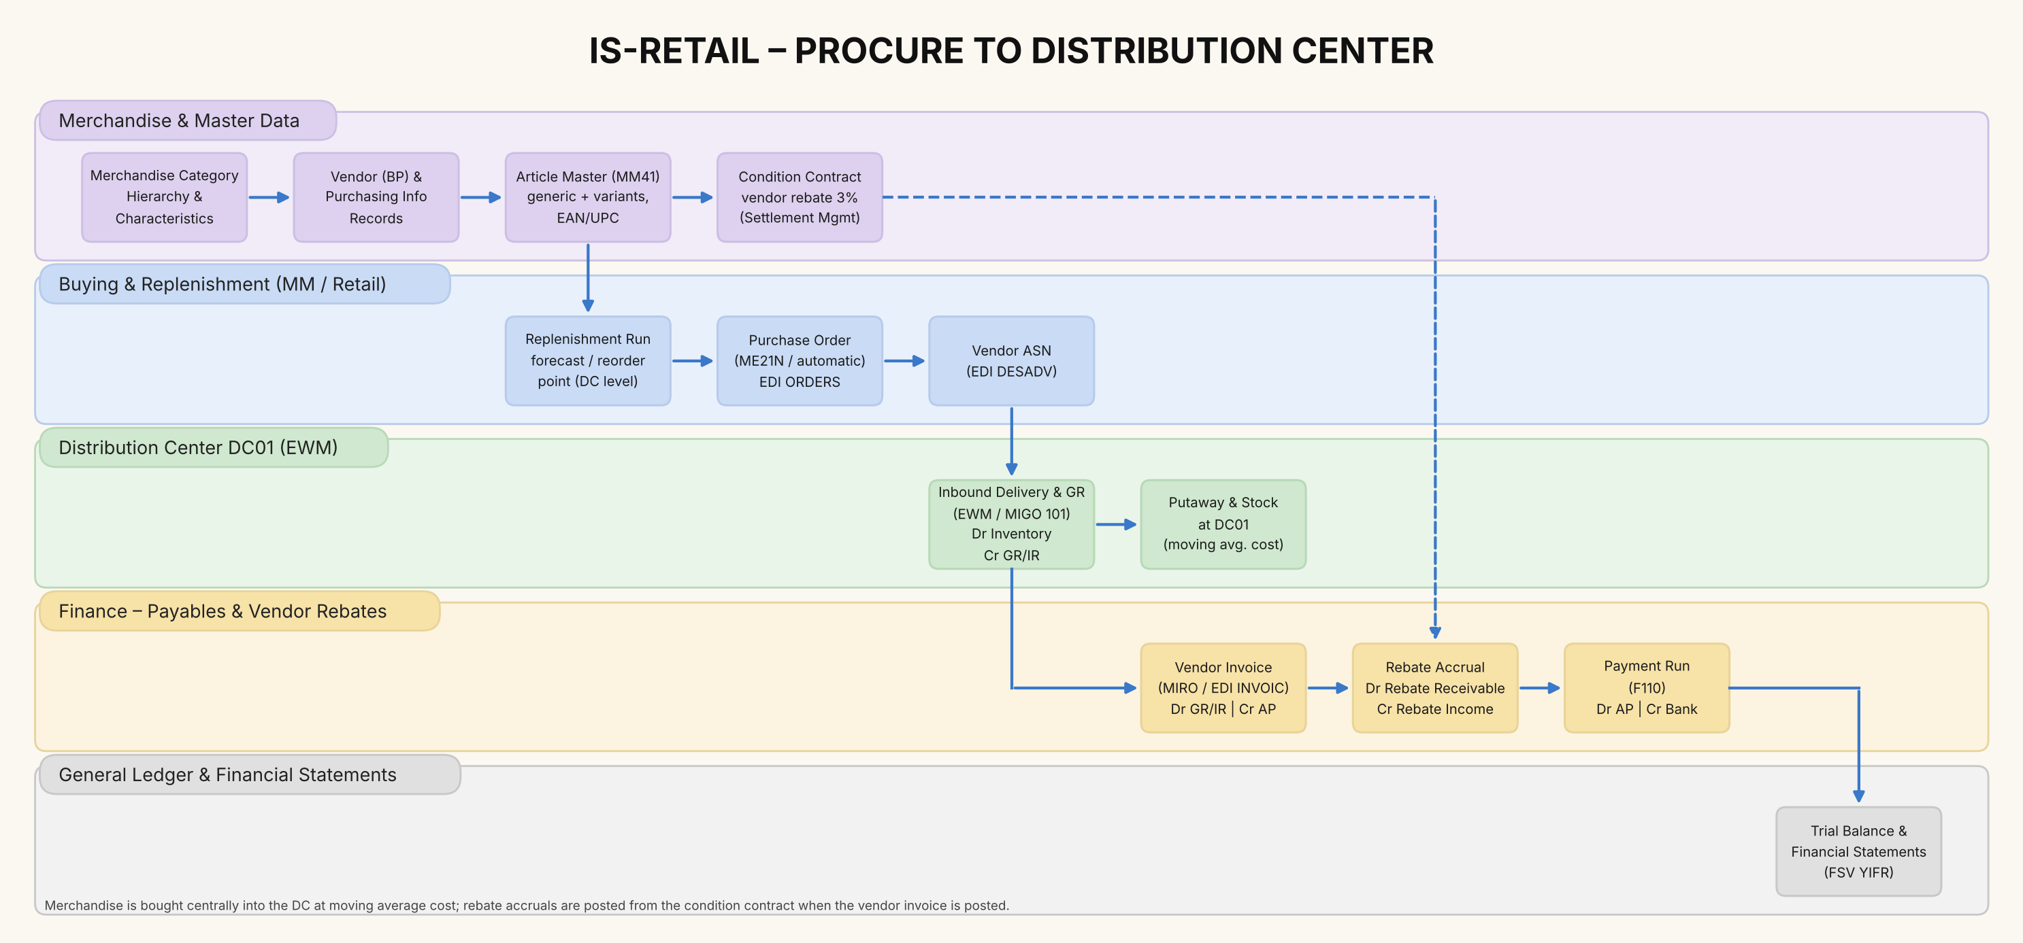
Figure 3-1. Procure to DC: master data, replenishment, EDI, goods receipt, invoice, rebate accrual, payment

3.3 Replenish store from DC
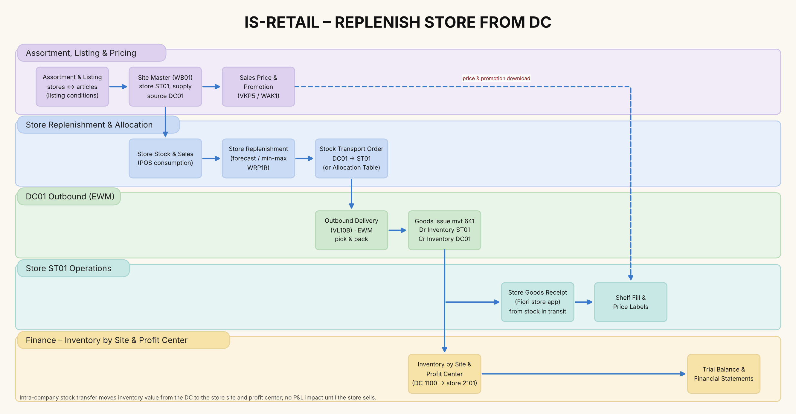
Figure 3-2. Store replenishment and stock transport from DC01 to store ST01

3.4 Point of sale to ledger
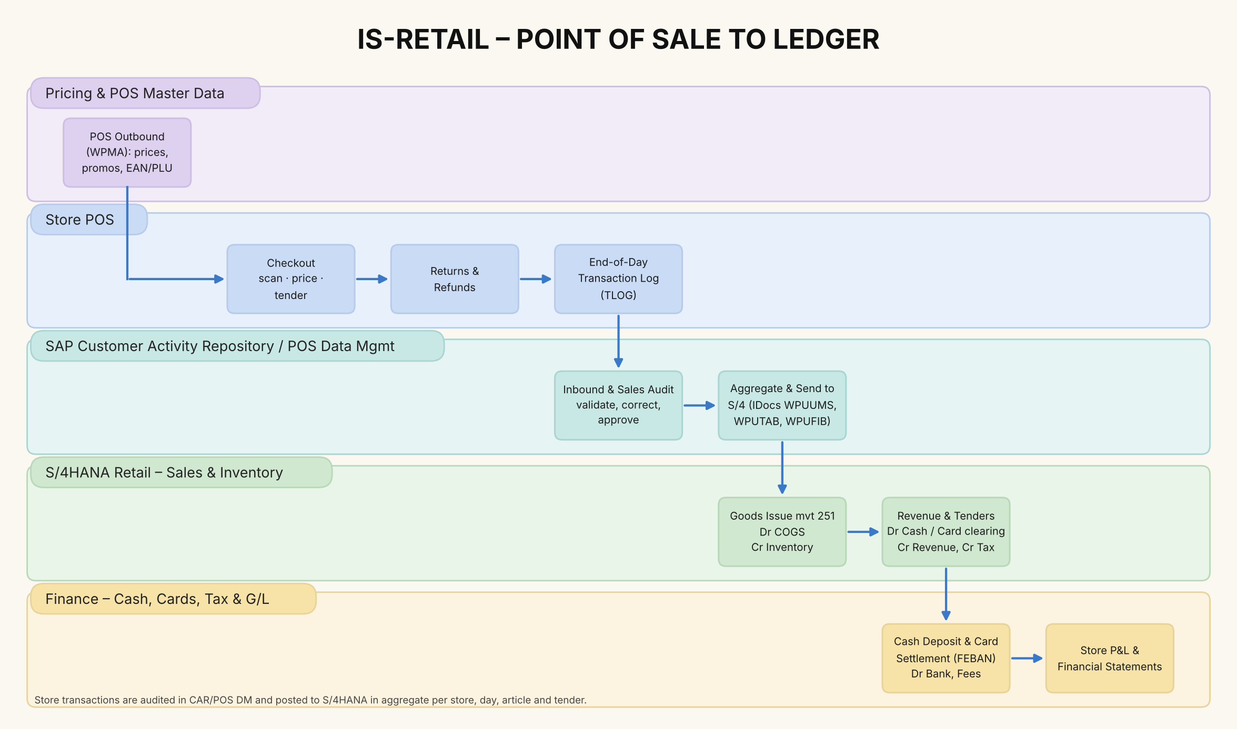
Figure 3-3. POS transactions through CAR sales audit to S/4HANA and finance

3.5 Pricing and promotions
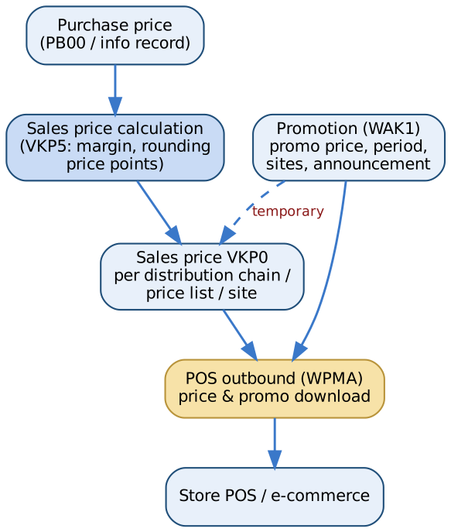
Figure 3-4. From purchase price to POS price

3.6 Vendor rebates
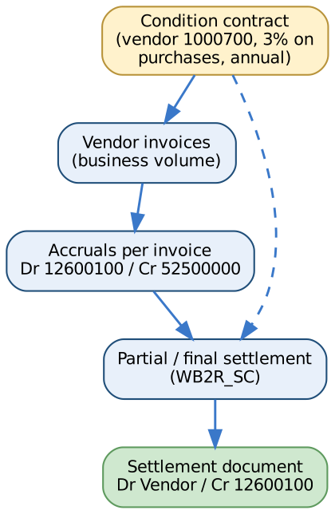
Figure 3-5. Condition contract accrual and settlement

4. Solution Architecture and Design

4.1 Solution landscape
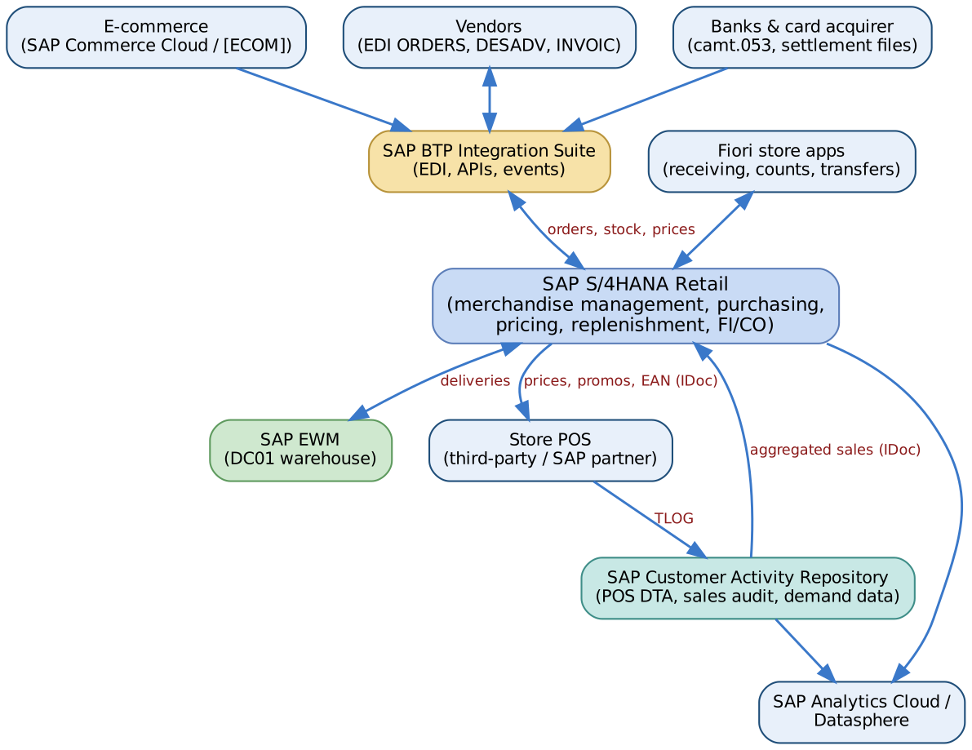
Figure 4-1. IS-Retail solution landscape
Tier | S/4HANA Retail | CAR / POS DTA | EWM
DEV | [S4D] / 100 | [CARD] | embedded / [EWMD]
QA | [S4Q] / 200 | [CARQ] | [EWMQ]
PRE-PROD | [S4R] / 300 | [CARR] | [EWMR]
PROD | [S4P] / 400 | [CARP] | [EWMP]

4.2 Organisational structure
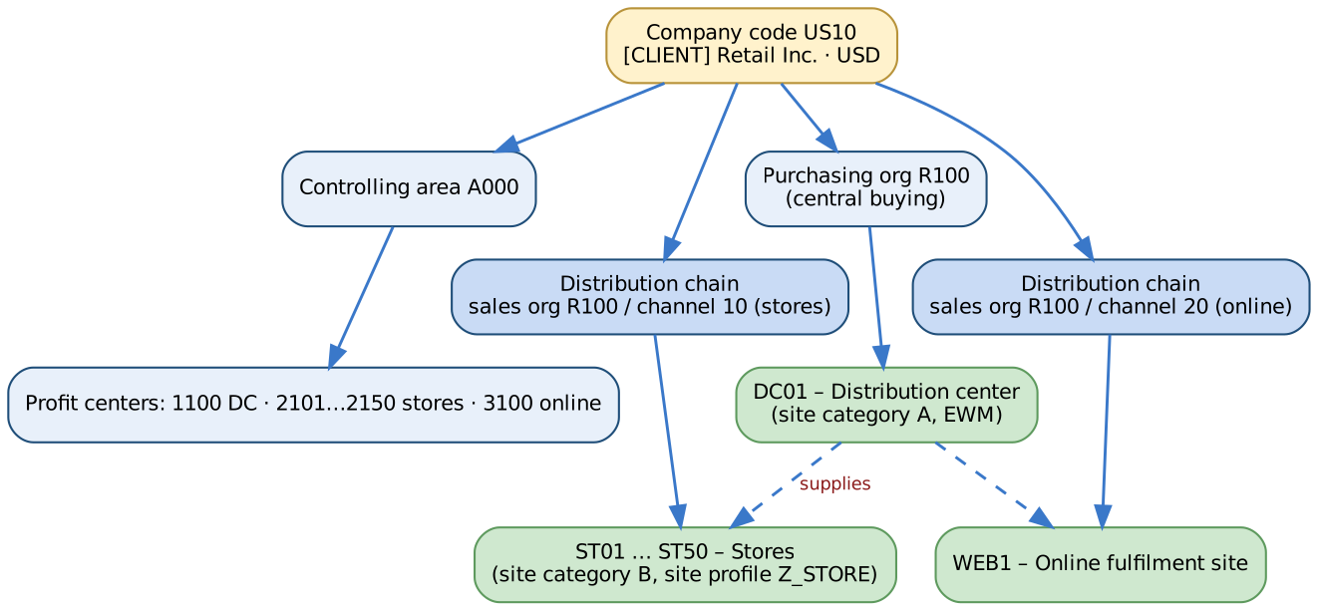
Figure 4-2. Retail organisational structure
Object | Value | Design note
Company code | US10 | Legal entity; YCOA; USD
Purchasing organisation | R100 | Central buying for all sites
Distribution chains | R100/10 stores · R100/20 online | Prices and assortments maintained per distribution chain
Sites | DC01 (DC), ST01–ST50 (stores), WEB1 (online) | Each site is a plant + customer; valuation at site level
Profit centers | 1100 DC, 2101–2150 stores, 3100 online | Store P&L and balance sheet by document splitting
Storage locations | DC01: 0001 (EWM-managed); stores: 0001 sales floor, 0002 back room | Store stock simple, no WM in stores

4.3 Merchandise category hierarchy and articles
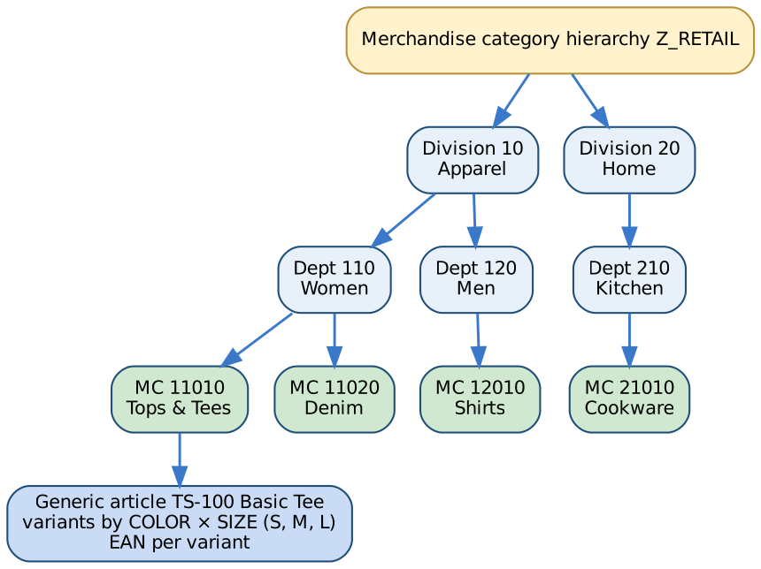
Figure 4-3. Merchandise category hierarchy and generic article
Design element | Decision
Article categories | 00 single article, 01 generic article (with 02 variants), 11 prepack, 10 sales set
Article types | HAWA trading goods for merchandise; NLAG non-stock for store supplies; display and prepack types as required [VERIFY]
Variant-creating characteristics | COLOR, SIZE assigned to merchandise categories via class type 026
EAN/UPC | Main EAN per variant and unit of measure; additional EANs allowed
Article numbering | Generic: external (TS-100); variants: generic + suffix (TS-100-BLK-M)
Inventory management | Article-based at site, valuated at moving average price [DECISION: retail method for stores?]

4.4 Key design decisions
ID | Decision | Rationale
DD-01 | Inventory valuation at moving average cost per site (not retail method) | Accurate COGS by store; simpler with S/4HANA; markdowns do not revalue stock
DD-02 | POS integration via CAR / POS DTA with sales audit; aggregated IDocs to S/4 | Volume reduction; audit before posting
DD-03 | DC on EWM; stores on Fiori store apps without warehouse management | Right-sized complexity
DD-04 | Vendor rebates in condition contracts (Settlement Management) | Replaces legacy subsequent settlement; accruals per invoice
DD-05 | One profit center per store | Store P&L and balance sheet
DD-06 | Store replenishment from DC only; direct-store-delivery for selected vendors [DECISION] | Supply chain control

5. Chart of Accounts
Company code US10 uses one operational chart of accounts based on the SAP Best Practices chart YCOA (8-digit accounts), extended with retail-specific accounts: POS tender clearing (cash, card, gift card, online payment provider), vendor rebate receivables and income from condition contracts, gift-card and store-credit liabilities, refund liability for expected returns, POS discounts, shrinkage, vendor markdown funding, store occupancy and card fees, and a data migration clearing account (39990000) that must be zero after the initial stock and G/L balance loads. The machine-readable source is finance/chart_of_accounts.csv (114 accounts).
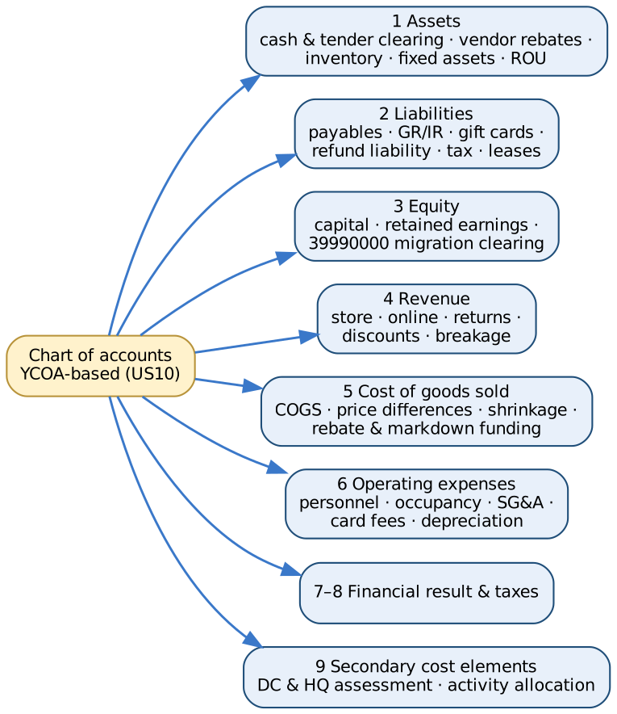

5.1 Design principles
- YCOA as the base, so SAP Best Practices content (account determination, financial statement version, reports) works with minimal change; retail accounts are added in free number ranges. Account numbers in this document are the client’s design – verify them against the YCOA delivered in your release before build [VERIFY].
- Inventory at moving average cost per site; one inventory account (13400000) for all merchandise, split by site and profit center through the material ledger and document splitting.
- Every POS tender has its own clearing account that must be zero once the bank deposit or acquirer settlement is matched – the daily control for 50 stores.
- Vendor rebates and vendor-funded markdowns reduce cost of goods sold (52500000, 52600000), not revenue.
- Returns and discounts are revenue deductions (41100000–41300000) so gross and net sales can be reported by store.
- Profit center per store and DC (2101–2150, 1100) with document splitting gives a store P&L and balance sheet.
- Migration clearing 39990000: initial stock (movement 561) and G/L balances are both posted against it; it must net to zero (reconciled automatically by the ETL).

5.2 Account groups
Group | Content | Number of accounts
CASH | Cash, bank and POS tender clearing | 8
RECV | Receivables, vendor rebates, prepaid, tax | 7
INV | Merchandise inventory | 4
FIXA | Fixed assets, right-of-use, intangibles, deferred tax | 17
PAYB | Payables, GR/IR, accruals, gift cards, refund liability, taxes | 16
DEBT | Leases and borrowings | 4
EQTY | Equity | 2
MIGR | Data migration clearing | 1
REVN | Revenue and sales deductions | 9
COGS | Cost of goods sold, shrinkage, rebates | 10
PERS | Personnel | 4
OCCU | Store occupancy | 5
SGA | Selling, general and administrative | 12
DEPR | Depreciation and amortisation | 5
FIN | Financial result | 4
TAX | Income taxes | 2
SECC | Secondary cost elements (CO only) | 4

5.3 Assets (1xxxxxxx)
Account | Description | FSV node | Statement line | Account determination | CO
11001000 | Bank 1 – Main Account | 1.1.1 | Cash and cash equivalents | House bank (FI12) | Balance sheet
11001010 | Bank 1 – Incoming Payments Clearing | 1.1.1 | Cash and cash equivalents | Bank statement posting rules (OT83) | Balance sheet
11001020 | Bank 1 – Outgoing Payments Clearing | 1.1.1 | Cash and cash equivalents | Payment program (F110) | Balance sheet
11009400 | Store Cash in Transit | 1.1.1 | Cash and cash equivalents | POS inbound tender mapping (cash) | Balance sheet
11009500 | Payment Card Clearing (acquirer) | 1.1.1 | Cash and cash equivalents | POS inbound tender mapping (card) | Balance sheet
11009600 | Online Payment Service Provider Clearing | 1.1.1 | Cash and cash equivalents | Commerce / PSP settlement | Balance sheet
11009700 | Gift Card Redemption Clearing | 1.1.1 | Cash and cash equivalents | POS inbound tender mapping (gift card) | Balance sheet
11009800 | Store Change Funds & Petty Cash | 1.1.1 | Cash and cash equivalents | Cash journal (FBCJ) | Balance sheet
12100000 | Trade Receivables – Domestic (B2B / franchise) | 1.1.2 | Trade receivables | Customer reconciliation account | Balance sheet
12190000 | Allowance for Doubtful Receivables | 1.1.2 | Trade receivables | Manual / valuation | Balance sheet
12600100 | Vendor Rebate Receivable (condition contract accruals) | 1.1.4 | Vendor receivables and rebates | Settlement Management accrual account | Balance sheet
12600200 | Vendor Receivables – Returns to Vendor & Debit Memos | 1.1.4 | Vendor receivables and rebates | MIRO subsequent debit / RTV | Balance sheet
12600300 | Vendor Down Payments | 1.1.4 | Vendor receivables and rebates | Special G/L A (OBYR) | Balance sheet
13400000 | Inventory – Merchandise (trading goods) | 1.1.5 | Inventories | OBYC BSX (valuation class 3100) | Balance sheet
13400100 | Inventory – Stock in Transit (cross-company STO) | 1.1.5 | Inventories | OBYC BSX / UMB | Balance sheet
13400300 | Inventory – Store Supplies & Packaging | 1.1.5 | Inventories | OBYC BSX (valuation class 3050) | Balance sheet
13400900 | Inventory Valuation Adjustment (LCM / NRV) | 1.1.5 | Inventories | Manual / valuation run | Balance sheet
14000000 | Prepaid Expenses (rent deposits, insurance) | 1.1.3 | Other current assets | Manual | Balance sheet
14100000 | Sales & Use Tax Receivable | 1.1.3 | Other current assets | Tax codes (FTXP) | Balance sheet
16100000 | Land | 1.2.1 | Property & equipment | AA account determination (AO90) | Balance sheet
16200000 | Buildings (owned DC) | 1.2.1 | Property & equipment | AO90 | Balance sheet
16300000 | Leasehold Improvements (store fit-out) | 1.2.1 | Property & equipment | AO90 | Balance sheet
16400000 | Store Fixtures & Equipment | 1.2.1 | Property & equipment | AO90 | Balance sheet
16500000 | POS Hardware & IT Equipment | 1.2.1 | Property & equipment | AO90 | Balance sheet
16600000 | DC Material Handling Equipment | 1.2.1 | Property & equipment | AO90 | Balance sheet
16700000 | Assets under Construction (new stores & remodels) | 1.2.1 | Property & equipment | AO90 (AuC settlement) | Balance sheet
16800000 | Right-of-Use Assets – Store & DC Leases | 1.2.2 | Right-of-use assets | Lease accounting (RE-FX / LAE) | Balance sheet
16900000 | Software & Intangible Assets | 1.2.3 | Intangible assets | AO90 | Balance sheet
17200000 | Accumulated Depreciation – Buildings | 1.2.1 | Property & equipment | AO90 | Balance sheet
17300000 | Accumulated Depreciation – Leasehold Improvements | 1.2.1 | Property & equipment | AO90 | Balance sheet
17400000 | Accumulated Depreciation – Store Fixtures | 1.2.1 | Property & equipment | AO90 | Balance sheet
17500000 | Accumulated Depreciation – POS & IT | 1.2.1 | Property & equipment | AO90 | Balance sheet
17600000 | Accumulated Depreciation – DC Equipment | 1.2.1 | Property & equipment | AO90 | Balance sheet
17800000 | Accumulated Amortisation – Right-of-Use Assets | 1.2.2 | Right-of-use assets | Lease accounting | Balance sheet
17900000 | Accumulated Amortisation – Software | 1.2.3 | Intangible assets | AO90 | Balance sheet
18000000 | Deferred Tax Assets | 1.2.4 | Deferred tax assets | Manual | Balance sheet

5.4 Liabilities (2xxxxxxx)
Account | Description | FSV node | Statement line | Account determination | CO
21100000 | Trade Payables – Domestic | 2.1.1 | Trade payables | Vendor reconciliation account | Balance sheet
21100100 | Trade Payables – Foreign (import) | 2.1.1 | Trade payables | Vendor reconciliation account | Balance sheet
21150000 | Payables – Landlords | 2.1.1 | Trade payables | Vendor reconciliation account | Balance sheet
21200000 | GR/IR Clearing – Merchandise | 2.1.2 | GR/IR clearing | OBYC WRX | Balance sheet
21200100 | GR/IR Clearing – Freight & Duties | 2.1.2 | GR/IR clearing | OBYC FR1 / FR3 | Balance sheet
21300000 | Accrued Expenses | 2.1.3 | Accrued and payroll liabilities | Accrual Engine / manual | Balance sheet
21400000 | Payroll Clearing | 2.1.3 | Accrued and payroll liabilities | Payroll posting | Balance sheet
21410000 | Payroll Withholdings & Benefits Payable | 2.1.3 | Accrued and payroll liabilities | Payroll posting | Balance sheet
21500000 | Gift Card Liability (unredeemed) | 2.1.4 | Gift card and customer liabilities | POS inbound (gift card sale) | Balance sheet
21510000 | Customer Deposits & Layaway | 2.1.4 | Gift card and customer liabilities | POS inbound / special G/L | Balance sheet
21520000 | Store Credit & Customer Credit Memos | 2.1.4 | Gift card and customer liabilities | POS inbound | Balance sheet
21530000 | Refund Liability – Expected Returns | 2.1.5 | Refund liabilities | Period-end estimate | Balance sheet
21540000 | Right-to-Recover Returned Goods (contra) | 2.1.5 | Refund liabilities | Period-end estimate | Balance sheet
22000000 | Sales Tax Payable | 2.1.7 | Taxes payable | Tax code MWS / jurisdiction codes | Balance sheet
22100000 | Use Tax Payable | 2.1.7 | Taxes payable | Tax codes | Balance sheet
22200000 | Income Tax Payable | 2.1.7 | Taxes payable | Manual | Balance sheet
23000000 | Lease Liabilities – Current | 2.1.6 | Lease liabilities – current | Lease accounting | Balance sheet
23100000 | Lease Liabilities – Non-current | 2.2.1 | Lease liabilities – non-current | Lease accounting | Balance sheet
23200000 | Revolving Credit Facility & Bank Loans | 2.2.2 | Borrowings | Treasury / manual | Balance sheet
24000000 | Deferred Tax Liabilities | 2.2.3 | Deferred tax liabilities | Manual | Balance sheet

5.5 Equity and migration clearing (3xxxxxxx)
Account | Description | FSV node | Statement line | Account determination | CO
31000000 | Share Capital | 3.1 | Share capital | — | Balance sheet
32000000 | Retained Earnings | 3.2 | Retained earnings | OB53 (balance carry-forward) | Balance sheet
39990000 | Data Migration Clearing (must be zero after go-live) | 3.9 | Migration clearing | OBYC GBB-BSA (mvt 561) / G/L balance load offset | Balance sheet

5.6 Revenue and sales deductions (4xxxxxxx)
Account | Description | FSV node | Statement line | Account determination | CO
41000000 | Revenue – Merchandise Sales (stores) | 4.1.1 | Gross sales | VKOA ERL (POS sales) | Primary – revenue (11)
41000100 | Revenue – Online Sales | 4.1.1 | Gross sales | VKOA ERL | Primary – revenue (11)
41000200 | Revenue – Wholesale & Franchise | 4.1.1 | Gross sales | VKOA ERL | Primary – revenue (11)
41100000 | Sales Returns (contra revenue) | 4.1.2 | Returns and discounts | POS inbound returns (mvt 252) | Primary – sales deduction (12)
41200000 | POS Discounts & Coupons | 4.1.2 | Returns and discounts | POS inbound (discount condition) | Primary – sales deduction (12)
41300000 | Employee Discounts | 4.1.2 | Returns and discounts | POS inbound (discount condition) | Primary – sales deduction (12)
41500000 | Gift Card Breakage Revenue | 4.1.3 | Other revenue | Period-end estimate | Primary – revenue (11)
41600000 | Delivery & Service Fee Revenue (online) | 4.1.3 | Other revenue | VKOA ERL | Primary – revenue (11)
41700000 | Other Operating Income (vendor marketing funds) | 4.1.3 | Other revenue | Settlement Management | Primary – revenue (11)

5.7 Cost of goods sold (5xxxxxxx)
Account | Description | FSV node | Statement line | Account determination | CO
50000000 | COGS – Merchandise (stores) | 5.1.1 | Cost of goods sold | OBYC GBB-VAX (mvt 251) | Primary cost (1)
50000100 | COGS – Merchandise (online) | 5.1.1 | Cost of goods sold | OBYC GBB-VAX | Primary cost (1)
50100000 | Inbound Freight & Duties (not capitalised) | 5.1.2 | Freight and duties | OBYC FRL / manual | Primary cost (1)
50200000 | Price Differences – Merchandise | 5.1.3 | Price differences | OBYC PRD | Primary cost (1)
52300000 | Inventory Differences / Shrinkage | 5.1.4 | Shrinkage rebates and markdowns | OBYC GBB-INV (mvt 701/702) | Primary cost (1)
52400000 | Damaged & Scrapped Merchandise | 5.1.4 | Shrinkage rebates and markdowns | OBYC GBB-VNG (mvt 551) | Primary cost (1)
52500000 | Vendor Rebate Income (COGS reduction) | 5.1.4 | Shrinkage rebates and markdowns | Settlement Management (condition contract) | Primary cost (1)
52600000 | Vendor Promotion & Markdown Funding (COGS reduction) | 5.1.4 | Shrinkage rebates and markdowns | Settlement Management | Primary cost (1)
52700000 | Inventory Write-down to NRV | 5.1.4 | Shrinkage rebates and markdowns | Manual / valuation run | Primary cost (1)
52800000 | Cash Discounts Received | 5.1.4 | Shrinkage rebates and markdowns | OBXU SKE | Primary cost (1)

5.8 Operating expenses (6xxxxxxx)
Account | Description | FSV node | Statement line | Account determination | CO
61000000 | Salaries & Wages – Stores | 6.1 | Personnel expenses | Payroll posting | Primary cost (1)
61000100 | Salaries & Wages – DC | 6.1 | Personnel expenses | Payroll posting | Primary cost (1)
61000200 | Salaries & Wages – Head Office | 6.1 | Personnel expenses | Payroll posting | Primary cost (1)
61100000 | Payroll Taxes & Benefits | 6.1 | Personnel expenses | Payroll posting | Primary cost (1)
62000000 | Rent & Occupancy – Stores (variable & short-term) | 6.2 | Occupancy expenses | FB60 / RE-FX | Primary cost (1)
62100000 | Common Area Maintenance | 6.2 | Occupancy expenses | FB60 | Primary cost (1)
62200000 | Utilities | 6.2 | Occupancy expenses | FB60 | Primary cost (1)
62300000 | Store Maintenance & Repairs | 6.2 | Occupancy expenses | FB60 / PM order | Primary cost (1)
62400000 | Security & Loss Prevention | 6.2 | Occupancy expenses | FB60 | Primary cost (1)
63000000 | Advertising & Marketing | 6.3 | Selling general and administrative | FB60 | Primary cost (1)
63100000 | Store Supplies & Shopping Bags | 6.3 | Selling general and administrative | OBYC GBB-VBR (cost center) | Primary cost (1)
63200000 | Outbound Freight & E-commerce Fulfilment | 6.3 | Selling general and administrative | Shipment cost settlement | Primary cost (1)
63300000 | IT & Software Subscriptions | 6.3 | Selling general and administrative | FB60 | Primary cost (1)
63400000 | Communication | 6.3 | Selling general and administrative | FB60 | Primary cost (1)
63500000 | Insurance | 6.3 | Selling general and administrative | FB60 | Primary cost (1)
63600000 | Bank & Payment Card Fees | 6.3 | Selling general and administrative | Bank statement posting rules (acquirer fee) | Primary cost (1)
63700000 | Cash Handling (armoured car) | 6.3 | Selling general and administrative | FB60 | Primary cost (1)
63800000 | Professional Fees | 6.3 | Selling general and administrative | FB60 | Primary cost (1)
63900000 | Travel | 6.3 | Selling general and administrative | FB60 | Primary cost (1)
64000000 | Depreciation – Leasehold Improvements & Fixtures | 6.4 | Depreciation and amortisation | AO90 / AFAB | Primary cost (1)
64100000 | Depreciation – POS & IT | 6.4 | Depreciation and amortisation | AO90 / AFAB | Primary cost (1)
64200000 | Depreciation – DC Equipment & Buildings | 6.4 | Depreciation and amortisation | AO90 / AFAB | Primary cost (1)
64300000 | Lease Cost / ROU Amortisation | 6.4 | Depreciation and amortisation | Lease accounting | Primary cost (1)
64400000 | Amortisation – Software | 6.4 | Depreciation and amortisation | AO90 / AFAB | Primary cost (1)
65000000 | Store Pre-opening Costs | 6.3 | Selling general and administrative | Project settlement | Primary cost (1)
65100000 | Gain / Loss on Disposal of Assets | 6.3 | Selling general and administrative | AO90 | Primary cost (1)

5.9 Financial result (7xxxxxxx)
Account | Description | FSV node | Statement line | Account determination | CO
70000000 | Interest Income | 7.1 | Financial result | Manual / treasury | P&L (not CO-relevant)
70100000 | Interest Expense | 7.1 | Financial result | Manual / treasury | P&L (not CO-relevant)
70200000 | Interest on Lease Liabilities | 7.1 | Financial result | Lease accounting | P&L (not CO-relevant)
70300000 | Exchange Rate Differences (import purchases) | 7.1 | Financial result | OBA1 KDF / KDB | P&L (not CO-relevant)
79000000 | Income Tax Expense – Current | 8.1 | Income taxes | Manual | P&L (not CO-relevant)
79100000 | Income Tax Expense – Deferred | 8.1 | Income taxes | Manual | P&L (not CO-relevant)

5.11 Secondary cost elements (CO) (9xxxxxxx)
Account | Description | FSV node | Statement line | Account determination | CO
94000000 | Assessment – DC Costs to Stores | 9.0 | — (secondary; nets to zero) | Assessment cycle (KSU1) | Secondary – assessment (42)
94100000 | Assessment – Head Office Costs to Stores | 9.0 | — (secondary; nets to zero) | Assessment cycle (KSU1) | Secondary – assessment (42)
94200000 | Activity Allocation – DC Handling (cases picked) | 9.0 | — (secondary; nets to zero) | Activity type CASE (KP26) | Secondary – activity allocation (43)
96000000 | Settlement – Store Opening & Remodel Projects | 9.0 | — (secondary; nets to zero) | Settlement profile (WBS → AuC) | Secondary – internal settlement (21)

5.12 Automatic account determination
Area | Key | Business event | Debit | Credit
MM (OBYC) | BSX | Inventory posting – all merchandise movements (valuation class 3100) | 13400000 | 13400000
MM (OBYC) | WRX | GR/IR clearing – vendor goods receipt vs invoice | 21200000 | 21200000
MM (OBYC) | PRD | Price differences when stock is insufficient to absorb invoice variance | 50200000 | 50200000
MM (OBYC) | GBB-VAX | POS sale / delivery goods issue (mvt 251 / 601) – cost of goods sold | 50000000
MM (OBYC) | GBB-INV | Physical inventory differences (mvt 701 / 702) | 52300000 | 52300000
MM (OBYC) | GBB-VNG | Scrapping damaged merchandise (mvt 551) | 52400000
MM (OBYC) | GBB-VBR | Store supplies consumed to cost center | 63100000
MM (OBYC) | GBB-BSA | Initial stock entry at migration (mvt 561) | 13400000 (via BSX) | 39990000
MM (OBYC) | FR1 / FR3 | Freight and duty clearing (planned delivery costs) | 21200100 | 21200100
SD (VKOA) | ERL | POS and online revenue by account assignment group |  | 41000000 / 41000100
SD (VKOA) | ERS | Sales deductions – discounts and coupons | 41200000
Tax | MWS | Output sales tax by jurisdiction |  | 22000000
POS inbound | Tender – cash | Store cash takings | 11009400
POS inbound | Tender – card | Card takings (acquirer) | 11009500
POS inbound | Tender – gift card redemption | Gift card used as tender | 21500000
POS inbound | Return (mvt 252) | Customer return – revenue and stock reversed | 41100000 / 13400000 | 11009400 / 50000000
Bank (OT83) | Store deposit | Cash deposited at bank | 11001000 | 11009400
Bank (OT83) | Acquirer settlement | Card settlement net of fees | 11001000 / 63600000 | 11009500
Settlement Mgmt | Condition contract accrual | Vendor rebate accrual per invoice | 12600100 | 52500000
Settlement Mgmt | Condition contract settlement | Rebate settled to vendor (credit memo) | 21100000 | 12600100
Asset Accounting (AO90) | Acquisition / depreciation | Store fit-out and POS hardware | 16300000-16500000 / 64000000-64100000 | 21100000 / 17300000-17500000

5.13 Financial statement version (FSV US10)
Node | Line
1.1.1 | Cash and cash equivalents
1.1.2 | Trade receivables
1.1.3 | Other current assets
1.1.4 | Vendor receivables and rebates
1.1.5 | Inventories
1.2.1 | Property & equipment
1.2.2 | Right-of-use assets
1.2.3 | Intangible assets
1.2.4 | Deferred tax assets
2.1.1 | Trade payables
2.1.2 | GR/IR clearing
2.1.3 | Accrued and payroll liabilities
2.1.4 | Gift card and customer liabilities
2.1.5 | Refund liabilities
2.1.6 | Lease liabilities – current
2.1.7 | Taxes payable
2.2.1 | Lease liabilities – non-current
2.2.2 | Borrowings
2.2.3 | Deferred tax liabilities
3.1 | Share capital
3.2 | Retained earnings
3.9 | Migration clearing
4.1.1 | Gross sales
4.1.2 | Returns and discounts
4.1.3 | Other revenue
5.1.1 | Cost of goods sold
5.1.2 | Freight and duties
5.1.3 | Price differences
5.1.4 | Shrinkage rebates and markdowns
6.1 | Personnel expenses
6.2 | Occupancy expenses
6.3 | Selling general and administrative
6.4 | Depreciation and amortisation
7.1 | Financial result
8.1 | Income taxes
Configuration of the chart (OB13, OB62, OBD4, FS00, OB53, OBYC, VKOA, AO90, OB58, document splitting) is in Chapter 6.

6. Configuration
Transaction codes and IMG paths are those of SAP S/4HANA Retail; confirm items marked [VERIFY] in your release before build.

6.1 Enterprise structure and sites
Setting | Transaction / IMG | Value
Company code, controlling area | OX02 / OKKP | US10 / A000 (shared with finance template)
Sales organisation & distribution channels | OVX5 / OVXI | R100; 10 stores, 20 online
Purchasing organisation | OX08 | R100
Site categories & profiles | SPRO → Logistics – General → Retailing → Site → Site Profiles [VERIFY] | Z_STORE (category A = store), Z_DC (category B = distribution center), Z_WEB
Number ranges for sites | SPRO → Site → Number Ranges [VERIFY] | External: DC01, ST01–ST99
Site master | WB01 / WB02 | Plant data, customer data, supply source, calendar, profit center
Plant ↔ company code / sales org | OX18 / OVX6 | All sites → US10; stores → R100/10

6.2 Merchandise categories and articles
Setting | Transaction / IMG | Value
Merchandise categories | WG21 / WG22 | 11010 Tops & Tees, 11020 Denim, 12010 Shirts, 21010 Cookware
Merchandise category hierarchy | SPRO → Merchandise Category → Hierarchy Levels; WMATGRP* [VERIFY] | Levels: division, department, MC
Characteristics & class type 026 | CT04 / CL02 | COLOR, SIZE variant-creating; assigned to MC 11010
Article types | OMS2 / MM41 defaults | HAWA, NLAG; field selection per type
Article master | MM41 / MM42 / MM43 | Basic, listing, purchasing, sales, logistics DC/store, POS, accounting
EAN number ranges & checks | SPRO → Logistics – General → EAN/UPC [VERIFY] | UPC-A / EAN-13 check digit

6.3 Assortment and listing
Setting | Transaction / IMG | Value
Assortment types & listing procedures | SPRO → Assortment → Listing [VERIFY] | Assortment per store cluster (A/B/C)
Assortments | WSOA1 / WSOA2 | Z_CLUSTER_A … C; stores assigned
Listing | WSP4 (listing conditions) [VERIFY] | Automatic listing by MC and assortment

6.4 Pricing and promotions
Setting | Transaction / IMG | Value
Sales price condition type | V/06 | VKP0 (retail sales price) per distribution chain / site
Price calculation schema | SPRO → Pricing → Sales Price Calculation [VERIFY] | Planned markup by MC; price points .99
Price point groups | SPRO → Price Point Groups [VERIFY] | Z_99: 0.99 / 4.99 / 9.99 endings
Sales price calculation | VKP5 / VKP2 | Mass calculation and release
Promotion types | SPRO → Promotion → Promotion Types [VERIFY] | Z_PROMO with promo price list
Promotions | WAK1 / WAK2 | PR-FALL: TS-100 at 15.00, store group A, 2 weeks

6.5 Purchasing, replenishment and allocation
Setting | Transaction / IMG | Value
Vendor BP roles & groupings | BP / BUCF | FLVN00, FLVN01; Y101
Purchasing info records & conditions | ME11 / MEK1 | PB00; vendor discounts
Document types | OMEC | NB (standard), UB (stock transport), Z-allocation [VERIFY]
Stock transport order setup | SPRO → MM → Purchasing → PO → Set up STO | Shipping data for sites; delivery type NL; mvt 641/101
Replenishment parameters | WR30 / WR60 [VERIFY] | Min/max per store; forecast-based at DC
Replenishment run | WRP1R | Daily 22:00 store; weekly DC
Allocation tables & rules | WA01 / WA21 [VERIFY] | Store quotas by cluster
EDI output | Output Management / NACE | ORDERS05 to vendors

6.6 Store and DC operations
Setting | Transaction / IMG | Value
EWM warehouse DC01 | /SCWM/LGNUM, /SCWM/MON | Inbound/outbound process types, storage types
Store apps | Fiori: receive products, transfer stock, count stock [VERIFY app names] | Roles for store manager/associate
Physical inventory | MI01 / MI04 / MI07 or Fiori | Cycle count by MC; tolerance per store
Movement types | OMJJ | 251/252 POS sales/returns, 641/101 STO, 701/702 inventory differences

6.7 POS interface
Setting | Transaction / IMG | Value
POS outbound profile | SPRO → POS Interface → Outbound → Profiles [VERIFY] | Z_STORE: prices, promotions, EAN, merchandise category
POS outbound processing | WPMA (manual), WPMI (initialisation) [VERIFY] | Change pointers daily 02:00
POS inbound profile | SPRO → POS Interface → Inbound → Profiles [VERIFY] | WPUUMS (sales aggregated), WPUTAB (tenders), WPUFIB (FI), WPUBON (receipts – optional)
POS inbound monitor | WPER | Error handling per store/day
CAR / POS DTA | CAR configuration (/POSDW/*) | Inbound TLOG, sales audit tasks, outbound to S/4

6.8 Vendor rebates
Setting | Transaction / IMG | Value
Condition contract types | SPRO → Settlement Management → Condition Contract [VERIFY] | Z_RBT: purchase rebate, accruals active
Condition contracts | WCOCO | CC-0001: vendor 1000700, 3% on purchases
Settlement | WB2R_SC | Monthly partial, annual final settlement

6.9 Chart of accounts and finance integration
The account design is in Chapter 5; the settings below create it and connect logistics to the ledger.
Setting | Transaction / IMG | Value
Chart of accounts | OB13 | YCOA – operational chart, 8-digit accounts, maintenance language EN
Assign chart to company code | OB62 | US10 → YCOA; country chart not used (US)
Account groups and number ranges | OBD4 | CASH 11000000–11999999 … SECC 94000000–96999999 (17 groups, see §5.2)
Field status variant / groups | OBC4 | Profit center required on P&L and inventory; tax code required on revenue
G/L accounts | FS00 / Fiori Manage G/L Account Master Data | 114 accounts from finance/chart_of_accounts.csv (mass load via Migration Cockpit G/L account [VERIFY])
Cost elements | FS00 (type 1 primary / 42 assessment / 43 activity) | P&L accounts as primary cost elements; 94000000–96000000 secondary
Retained earnings | OB53 | Key X → 32000000
Financial statement version | OB58 | FSV US10, nodes 1.1.1 … 8.0 as in §5.13
Ledgers and currencies | FINSC_LEDGER | 0L leading (US GAAP); company code currency USD; group currency USD
Document splitting | GSP_RD | Splitting characteristics profit center (zero-balance), segment; method 0000000012
Account determination (MM) | OBYC | BSX 13400000; WRX 21200000; PRD 50200000; GBB-VAX 50000000; GBB-INV 52300000; GBB-BSA 39990000
Revenue determination (POS sales) | VKOA | ERL 41000000 (stores), 41000100 (online); ERS 41200000 (POS discounts); MWS 22000000
Tender to G/L mapping | POS inbound FI settings [VERIFY] | Cash → 11009400; card → 11009500; gift card → 21500000
Bank statement rules | OT83 / Manage Bank Statement Reprocessing Rules | Store deposits; acquirer settlement with fee 63600000
Profit center derivation | Site master / document splitting | DC01 → 1100; ST01–ST50 → 2101–2150; WEB1 → 3100
Rebate accounts | Settlement Management account determination [VERIFY] | 12600100 / 52500000
Asset account determination | AO90 | Store fixtures 16400000; accumulated depreciation 17400000; POS & IT 16500000 / 17500000
Migration clearing | FS00 + OBYC GBB-BSA | 39990000 – post-migration balance 0 (blocked for manual posting after go-live)
Tip: Load the chart of accounts from the same CSV that drives the ETL G/L mapping (etl/config/mapping_rules.yaml) and the worked example – one source of truth for the account design, the migration mapping and the test expectations.

7. Integration
ID | Interface | Direction | Technology | Frequency
INT-R01 | Prices, promotions, EAN, MC to POS | S/4 → POS | IDoc (WP_PLU, WPDWGR, WP_EAN [VERIFY]) via BTP | Daily 02:00 + ad hoc
INT-R02 | TLOG from POS | POS → CAR | File / API | Near real time / end of day
INT-R03 | Aggregated sales, tenders, FI | CAR → S/4 | IDoc WPUUMS, WPUTAB, WPUFIB | Daily 01:00–05:00
INT-R04 | Purchase orders | S/4 → vendors | EDI ORDERS via BTP | On PO release
INT-R05 | Advance shipping notices | Vendors → S/4/EWM | EDI DESADV | On shipment
INT-R06 | Vendor invoices | Vendors → S/4 | EDI INVOIC | On invoice
INT-R07 | Bank statements & card settlements | Banks → S/4 | camt.053 / acquirer file | Daily
INT-R08 | Online orders & availability | Commerce ↔ S/4 | APIs via BTP | Real time
INT-R09 | Analytics | S/4, CAR → SAC/Datasphere | Live / replication | Hourly

8. Finance Integration and Worked Example
This chapter follows one article from purchase to the financial statements. Every amount below is produced and checked by finance/worked_example.py (run in CI): each entry balances, the trial balance balances, the balance sheet balances, all clearing accounts are zero and inventory equals units on hand × moving average cost. All accounts come from the chart of accounts in Chapter 5.

8.1 Retail events and their postings
Event | Movement / document | Debit | Credit
Vendor goods receipt at DC | 101 / WE | 13400000 Inventory (DC01) | 21200000 GR/IR
Vendor invoice | MIRO / RE | 21200000 GR/IR | 21100000 Vendor
Rebate accrual | Condition contract | 12600100 Rebate receivable | 52500000 Rebate income
Stock transfer DC → store | 641 / 101 | 13400000 (ST01, PC 2101) | 13400000 (DC01, PC 1100)
POS sale – stock | 251 | 50000000 COGS | 13400000 Inventory (store)
POS sale – revenue & tenders | POS inbound | 11009400 cash, 11009500 card | 41000000 revenue, 22000000 tax
POS return | 252 | 41100000 returns, 22000000 tax, 13400000 | 11009400 cash, 50000000 COGS
Cash deposit / card settlement | FEBAN | 11001000 bank, 63600000 card fees | 11009400 / 11009500
Inventory difference | 701 / 702 | 52300000 Shrinkage | 13400000 Inventory
Initial stock at migration | 561 | 13400000 Inventory | 39990000 Migration clearing

8.2 Scenario
Company code US10 starts with USD 100,000 of capital. It buys 1,000 Basic Tees (generic article TS-100, variants S/M/L) at USD 8 into DC01, moves 600 to store ST01, sells 300 at the regular price of USD 20 and 200 at the promotion price of USD 15 (promotion PR-FALL), accepts 10 returns, counts 5 units of shrinkage, accrues a 3% vendor rebate and pays store payroll and rent. Sales tax is 8%; two thirds of tenders are card (2.5% acquirer fee).
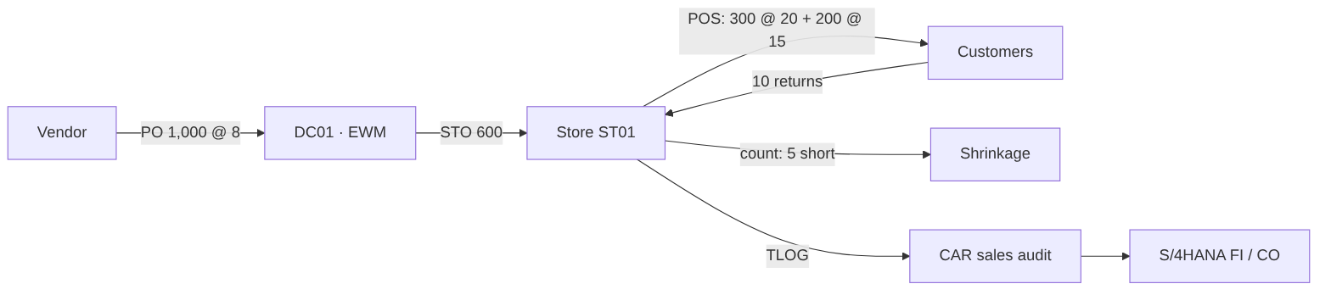

8.3 Journal entries
Step | Transaction | Doc | G/L | Account | Debit | Credit | Assignment
0 | Migration Cockpit – G/L balances | SA | 11001000 | Bank 1 – Main Account | 100,000.00
 |  |  | 31000000 | Share Capital |  | 100,000.00
R1 | WRP1R / ME21N | — | — | Replenishment proposal and PO: 1000 x TS-100 (variants S/M/L) @ 8 for DC01 – no posting
R2 | MIGO 101 / EWM inbound | WE | 13400000 | Inventory – Merchandise (trading goods) | 8,000.00 |  | BSX · site DC01 · PC 1100
 |  |  | 21200000 | GR/IR Clearing – Merchandise |  | 8,000.00 | WRX
R3 | MIRO | RE | 21200000 | GR/IR Clearing – Merchandise | 8,000.00 |  | WRX
 |  |  | 21100000 | Trade Payables – Domestic |  | 8,000.00 | Vendor 1000700
R4 | Condition contract accrual | SA | 12600100 | Vendor Rebate Receivable (condition contract accruals) | 240.00 |  | Condition contract CC-0001
 |  |  | 52500000 | Vendor Rebate Income (COGS reduction) |  | 240.00 | COGS reduction
R5 | F110 | ZP | 21100000 | Trade Payables – Domestic | 8,000.00
 |  |  | 11001000 | Bank 1 – Main Account |  | 8,000.00
D1 | STO · VL10B · VL02N (mvt 641) | WL | 13400000 | Inventory – Merchandise (trading goods) | 4,800.00 |  | Site ST01 · PC 2101
 |  |  | 13400000 | Inventory – Merchandise (trading goods) |  | 4,800.00 | Site DC01 · PC 1100
D2 | Store GR (Fiori, mvt 101) | — | — | Goods receipt in store from stock in transit – value already moved at goods issue
S1 | POS inbound WPUUMS (mvt 251) | WA | 50000000 | COGS – Merchandise (stores) | 4,000.00 |  | GBB-VAX · ST01
 |  |  | 13400000 | Inventory – Merchandise (trading goods) |  | 4,000.00 | BSX · ST01
S2 | POS inbound WPUUMS / WPUTAB | RV | 11009400 | Store Cash in Transit | 3,240.00 |  | Tender: cash
 |  |  | 11009500 | Payment Card Clearing (acquirer) | 6,480.00 |  | Tender: card
 |  |  | 41000000 | Revenue – Merchandise Sales (stores) |  | 9,000.00 | VKOA ERL · ST01
 |  |  | 22000000 | Sales Tax Payable |  | 720.00 | MWS
S3 | POS inbound return (mvt 252) | RV | 41100000 | Sales Returns (contra revenue) | 200.00 |  | Sales returns
 |  |  | 22000000 | Sales Tax Payable | 16.00
 |  |  | 11009400 | Store Cash in Transit |  | 216.00 | Cash refund
 |  |  | 13400000 | Inventory – Merchandise (trading goods) | 80.00 |  | Mvt 252 · ST01
 |  |  | 50000000 | COGS – Merchandise (stores) |  | 80.00
S4 | FEBAN – store deposit | ZB | 11001000 | Bank 1 – Main Account | 3,024.00
 |  |  | 11009400 | Store Cash in Transit |  | 3,024.00
S5 | FEBAN – acquirer settlement | ZB | 11001000 | Bank 1 – Main Account | 6,318.00
 |  |  | 63600000 | Bank & Payment Card Fees | 162.00 |  | CC store ST01
 |  |  | 11009500 | Payment Card Clearing (acquirer) |  | 6,480.00
S6 | Store physical inventory (mvt 702) | WI | 52300000 | Inventory Differences / Shrinkage | 40.00 |  | GBB-INV · ST01
 |  |  | 13400000 | Inventory – Merchandise (trading goods) |  | 40.00 | ST01
O1 | Payroll posting | Y2 | 61000000 | Salaries & Wages – Stores | 1,500.00 |  | CC store ST01
 |  |  | 21400000 | Payroll Clearing |  | 1,500.00
O2 | Bank transfer | ZP | 21400000 | Payroll Clearing | 1,500.00
 |  |  | 11001000 | Bank 1 – Main Account |  | 1,500.00
O3 | FB60 | KR | 62000000 | Rent & Occupancy – Stores (variable & short-term) | 1,200.00 |  | CC store ST01
 |  |  | 21150000 | Payables – Landlords |  | 1,200.00 | Landlord 1000800
C1 | FB50 | SA | 79000000 | Income Tax Expense – Current | 554.00 |  | 25% x 2,218
 |  |  | 22200000 | Income Tax Payable |  | 554.00
 |  |  |  | Total | 111,698.00 | 111,698.00

8.4 Inventory roll-forward
Movement | DC01 units | ST01 units | Value (USD)
Vendor GR | 1000 |  | 8,000.00
STO DC01 → ST01 | −600 | +600 | 0.00 (site transfer)
POS sales |  | −500 | (4,000.00)
POS returns |  | +10 | 80.00
Shrinkage |  | −5 | (40.00)
Closing | 400 | 105 | 4,040.00

8.5 Trial balance
G/L account | Description | FSV | Debit | Credit
11001000 | Bank 1 – Main Account | 1.1.1 | 99,842.00
12600100 | Vendor Rebate Receivable (condition contract accruals) | 1.1.4 | 240.00
13400000 | Inventory – Merchandise (trading goods) | 1.1.5 | 4,040.00
21150000 | Payables – Landlords | 2.1.1 |  | 1,200.00
22000000 | Sales Tax Payable | 2.1.7 |  | 704.00
22200000 | Income Tax Payable | 2.1.7 |  | 554.00
31000000 | Share Capital | 3.1 |  | 100,000.00
41000000 | Revenue – Merchandise Sales (stores) | 4.1.1 |  | 9,000.00
41100000 | Sales Returns (contra revenue) | 4.1.2 | 200.00
50000000 | COGS – Merchandise (stores) | 5.1.1 | 3,920.00
52300000 | Inventory Differences / Shrinkage | 5.1.4 | 40.00
52500000 | Vendor Rebate Income (COGS reduction) | 5.1.4 |  | 240.00
61000000 | Salaries & Wages – Stores | 6.1 | 1,500.00
62000000 | Rent & Occupancy – Stores (variable & short-term) | 6.2 | 1,200.00
63600000 | Bank & Payment Card Fees | 6.3 | 162.00
79000000 | Income Tax Expense – Current | 8.1 | 554.00
 | Total |  | 111,698.00 | 111,698.00

8.6 Income statement (store ST01 = company in this example)
Line | USD
Gross sales (41000000) | 9,000.00
Returns (41100000) | (200.00)
Net sales | 8,800.00
Cost of goods sold at moving average cost (50000000) | (3,920.00)
Vendor rebate income (52500000) | 240.00
Shrinkage (52300000) | (40.00)
Gross margin | 5,080.00
Store payroll (61000000) | (1,500.00)
Store rent (62000000) | (1,200.00)
Card fees (63600000) | (162.00)
Profit before tax | 2,218.00
Income tax 25% (79000000) | (554.00)
Net income | 1,664.00

8.7 Balance sheet
Line | USD
Cash and bank (11001000) | 99,842.00
Vendor rebate receivable (12600100) | 240.00
Inventory – DC01 400 + ST01 105 units × 8 (13400000) | 4,040.00
Total assets | 104,122.00
Payables – landlord (21150000) | 1,200.00
Sales tax payable (22000000) | 704.00
Income tax payable (22200000) | 554.00
Total liabilities | 2,458.00
Share capital (31000000) | 100,000.00
Net income for the period | 1,664.00
Total equity | 101,664.00
Total liabilities and equity | 104,122.00
Checks (automated): assets 104,122.00 = liabilities 2,458.00 + equity 101,664.00. GR/IR (21200000), store cash in transit (11009400) and card clearing (11009500) are zero because every receipt, deposit and settlement has been matched – the target daily state for every store.

8.8 Store KPIs from the example
KPI | Value
Net sales ST01 | 8,800.00
Gross margin % | 57.7%
Promotion share of units | 40%
Shrinkage % of net sales | 0.45%
Return rate (units) | 2.0%
Sell-through ST01 | 82%

8.9 Daily finance controls in production
Control | Account / report | Target
POS cash takings deposited | 11009400 Store cash in transit by store | 0 after bank statement
Card settlements received | 11009500 Payment card clearing | 0 after acquirer file
Goods received = invoiced | 21200000 GR/IR | Ageing < 30 days
Rebates accrued | 12600100 vs condition contract | Accrual = contract rate × invoiced value
Store stock accuracy | 52300000 Shrinkage by store and MC | < 1.5% of sales
Migration clearing | 39990000 | 0 from go-live onwards

9. Testing

9.1 Test strategy
Test phase | Scope | Environment | Entry / exit criteria | Owner
Unit test | Each configuration item & development object | DEV | Config complete / test evidence in ALM | Functional consultant
String test | Process segments (e.g. PO → GR → invoice) | DEV/QA | Unit tests passed / no sev-1 | Workstream lead
SIT 1 | End-to-end processes incl. interfaces with test POS and EDI | QA | Mock load 1 data / ≥ 95% pass, no sev-1 | Test lead
SIT 2 | Full scope incl. CAR, EWM, banks, month-end close | QA | Mock load 2 / 100% executed, no sev-1/2 | Test lead
Performance | POS inbound volume, replenishment run, POS outbound, EWM waves | PRE-PROD | Production-size data / NFR-01–03 met | Basis / test lead
UAT | Business acceptance per role, day-in-the-life of store & DC | QA | SIT exit / business sign-off | Business process owners
Store pilot rehearsal | Model store with real POS terminals, scanners, printers | QA + lab store | Devices certified / 3 trading days simulated | Store operations
Regression | Automated core scenarios after each transport wave | QA | Before each release | Test automation
Cutover rehearsal | Full cutover runbook incl. timings | PRE-PROD | Mock 3 / within cutover window | Cutover manager

9.2 Integration test scenarios
ID | Scenario | Expected result
SIT-R01 | Create generic article with variants, list to cluster A, calculate price, download to POS | Variants & EANs created; listed in 20 stores; price 19.99 rounded; POS file contains article
SIT-R02 | DC replenishment → PO → EDI ORDERS → DESADV → EWM GR → EDI INVOIC → MIRO | GR value 8,000.00; invoice matched; rebate accrual 240.00
SIT-R03 | Store replenishment → STO → EWM pick → GI 641 → store GR (Fiori) | Inventory value 4,800.00 moves to ST01 / PC 2101
SIT-R04 | Promotion PR-FALL created and active at POS on start date | POS sells at 15.00 in cluster A only
SIT-R05 | POS day with sales, return, cash and card tenders → CAR audit → S/4 | Revenue 8,800.00; COGS 3,920.00; tenders cleared
SIT-R06 | POS IDoc error (unknown EAN) → correction in CAR → reprocess | Error visible in WPER/CAR; reprocessed successfully
SIT-R07 | Store cycle count with difference | Shrinkage 40.00 posted to 52300000 / store
SIT-R08 | Card acquirer settlement & cash deposit bank statement | Auto-matched; fee to 63600000
SIT-R09 | Allocation of new season article to stores by cluster quota | STOs per store as per allocation table
SIT-R10 | Online order fulfilled from DC; customer return to store | Stock & revenue posted in correct sites
SIT-R11 | Condition contract settlement | Settlement document credits vendor; receivable cleared
SIT-FIN-01 | Month-end close and store P&L | Net income 1,664.00; balance sheet balances (§8.7)

9.3 Defect management
Severity | Definition | Resolution target
1 – Critical | Blocks trading, POS posting or payments; no workaround | 4 hours, fix before next test day
2 – High | Major function impaired; workaround hard | 2 days
3 – Medium | Function impaired; workaround exists | Before UAT exit
4 – Low | Cosmetic | Backlog

10. Data Migration – Azure ETL to the SAP Migration Cockpit
Legacy merchandising, POS back-office and finance data is extracted, cleansed and transformed in Microsoft Azure and loaded into the staging tables of the SAP S/4HANA Migration Cockpit in the SAP HANA database. The Migration Cockpit then performs the final, validated transfer into S/4HANA through its standard migration objects and APIs. Azure does the heavy lifting (profiling, mapping, de-duplication, GS1 checks, reconciliation and repeatable mock runs); SAP keeps control of the business-logic checks and the posting into the application.
A working reference implementation is in etl/: Bicep infrastructure, Data Factory pipelines, Databricks notebooks, a tested Python transformation library, control-database SQL and a sample run with deliberate data defects.
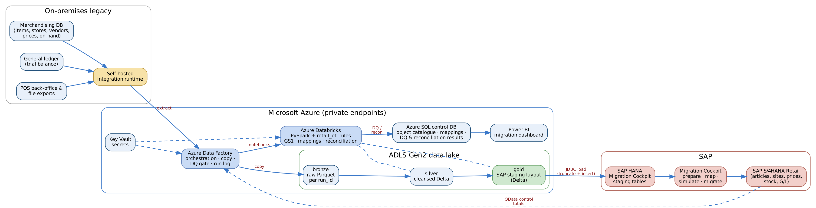
Figure 10-1. Azure ETL architecture – legacy → ADF → ADLS bronze/silver/gold (Databricks) → HANA staging → Migration Cockpit → S/4HANA

10.1 Migration approach
Decision | Choice | Rationale
Migration approach | New implementation (greenfield) of S/4HANA Retail; legacy is non-SAP | Clean master data and new merchandise category design
Transfer method | Migration Cockpit – Migrate Data Using Staging Tables | Volume (articles × variants × sites), repeatable loads, DB-level population from an external ETL
ETL platform | Azure Data Factory + Azure Databricks + ADLS Gen2 | Client standard cloud; scales for POS history; Git-versioned, testable code
Staging connection | Databricks → SAP HANA JDBC (ngdbc) into the staging schema; alternative: ADF copy via ODBC on the self-hosted IR | Staging tables are plain HANA tables; truncate + insert per object per run
Data quality | Rules in code (retail_etl) with results in Azure SQL and Power BI | DQ worklist for data owners; objective load gate
Reconciliation | Source → gold (Azure) and gold → S/4HANA (OData / CDS) | Two-stage proof: nothing lost in transformation, nothing lost in the load
What is not migrated | Closed POs, POS transactions (24 months of sales history loaded to CAR/forecasting separately), history of prices | Keeps cutover window to one night

10.2 End-to-end flow
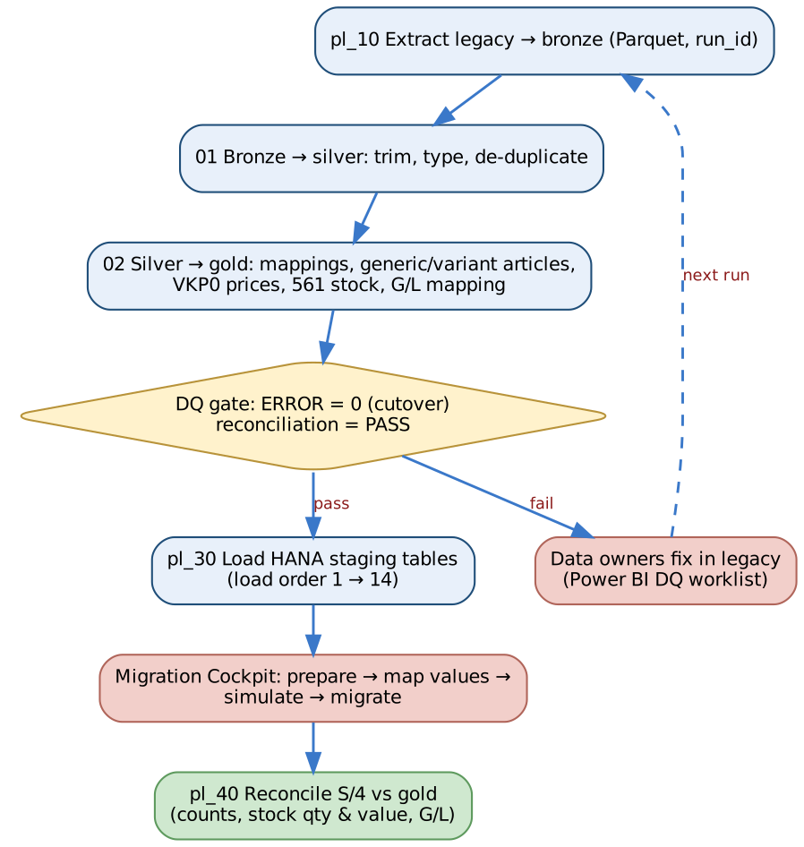
Figure 10-2. Pipeline sequence with the data-quality gate
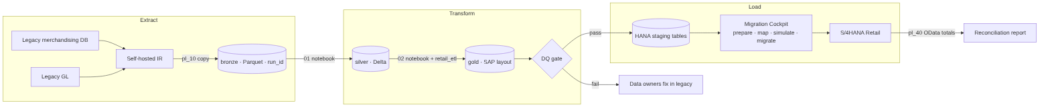

10.3 Azure components
Component | Purpose | Implementation
Self-hosted integration runtime | Secure access from Azure to on-premises legacy SQL Server and file shares | shir-onprem, registered in ADF
Azure Data Factory | Orchestration, extract copy, DQ gate, logging, retries | etl/adf/pipeline – pl_00_master_migration runs pl_10 → pl_20 → pl_30 → pl_40
ADLS Gen2 | Medallion lake: bronze raw Parquet per run_id, silver cleansed Delta, gold SAP staging layout, archive | HNS enabled, ZRS, public access disabled, private endpoints
Azure Databricks | PySpark transformations calling the shared retail_etl library; HANA JDBC load | etl/databricks notebooks 01–04
Azure SQL (control DB) | Object catalogue and load order, value mappings, run log, DQ results, reconciliation, readiness view | etl/sql/azure_sql
Key Vault | Legacy, HANA and S/4 credentials; accessed by managed identity | Secret scope kv-migration
Log Analytics | ADF / Databricks diagnostics and alerts | Diagnostic settings in Bicep
Power BI | Migration dashboard: DQ worklist per data owner, load readiness, reconciliation | Reads etl.v_load_readiness, etl.dq_result, etl.recon_result
Infrastructure as code | Repeatable environments (dev / test / prod migration) | etl/infra/main.bicep

10.4 Medallion layers
Layer | Content | Rules
Bronze | Exact copy of the legacy extract, partitioned by run_id (MOCK1, MOCK2, MOCK3, CUTOVER) | Immutable; kept for audit
Silver | Typed, trimmed, de-duplicated legacy data in legacy structure | Technical cleansing only – no business mapping
Gold | One table per migration object, SAP technical field names, values mapped to S/4HANA | Business mapping, GS1 checks, generic/variant build, 561 stock, G/L mapping; rejected rows go to DQ, never silently dropped

10.5 Transformation rules (silver → gold)
Object | Key transformation | Code
Site | Store / DC / web → site category VLFKZ A (store) / B (DC), site profile Z_STORE / Z_DC / Z_WEB; profit center DC01 → 1100, STnn → 21nn, WEB1 → 3100; ZIP zero-padded | transform.sites
Supplier | Vendor → Business Partner (grouping Y101), reconciliation account 21100000, purchasing org R100; duplicate tax ID = ERROR, missing bank = WARNING + payment block | transform.suppliers
Article | Legacy style → generic article (ATTYP 01), each colour/size SKU → variant (ATTYP 02); department/class → merchandise category (e.g. 10-100 → 11010); UPC checked with the GS1 check digit; EAN category UC (12-digit) / HE | transform.articles, quality.gtin_check_digit
Sales price | Retail price → VKP0 condition per sales org R100 / channel 10, valid from go-live; WARNING for price points not ending .99/.00 and price below cost | transform.sales_prices
Inventory balance | Post-count on-hand → movement type 561 per site / storage location 0001, value = quantity × moving average cost; ERROR for unknown site/article and negative stock | transform.inventory_balances
G/L balance | Legacy account → YCOA account via mapping_rules.yaml; legacy inventory account re-pointed to 39990000 because the 561 stock load already posts inventory; trial balance must balance | transform.gl_balances
All mappings are configuration, not code: etl/config/mapping_rules.yaml and the map.value_mapping table in the control database (approved by the data owner for each object).

10.6 Data quality gate
Severity | Meaning | Effect
ERROR | The record would fail or corrupt S/4HANA (invalid / duplicate GTIN, unmapped merchandise category, unknown site, negative stock, duplicate supplier) | Excluded from gold, reported to the data owner. Cutover run requires zero open ERRORs
WARNING | Loadable but needs business attention (price point, missing bank details) | Loaded; on the worklist
Reconciliation FAIL | Totals do not agree (rows, stock value, migration clearing) | ADF Fail activity – nothing is loaded to HANA
pl_20_transform evaluates the gate. In mock runs the parameter allow_dq_errors = true lets valid records through so the Migration Cockpit can be tested while defects are fixed; for the cutover run it is false.
Sample run (fictitious legacy extract with deliberate defects – etl/sample_output):
Object | Severity | Findings | Examples
article | ERROR | 4 | UPC fails GS1 check digit; duplicate UPC; department 90-900 not mapped
inventory_balance | ERROR | 25 | Stock for rejected articles; negative on-hand
sales_price | WARNING | 2 | Price point not ending .99 / .00
supplier | ERROR | 2 | Two vendors share one tax ID – merge before load
supplier | WARNING | 1 | No bank details – payment block until four-eyes verification

Reconciliation check | Expected | Actual | Status
Site: source rows = gold + rejected | 7 | 7 | PASS
Supplier: source rows = gold + rejected | 5 | 5 | PASS
Article: source variants = gold variants + rejected | 13 | 13 | PASS
Stock value (561) = legacy G/L inventory | 15,520.00 | 15,520.00 | PASS
Migration clearing 39990000 nets to zero | 0.00 | 0.00 | PASS

10.7 Loading the Migration Cockpit staging tables
- Create the migration project in the Fiori app Migrate Your Data – Migration Cockpit, method Migrate Data Using Staging Tables, with a database connection to the staging schema (same HANA database or a remote one) [VERIFY] for your release.
- Select migration objects (Site, Supplier, Article, Condition record for pricing in sales, Material inventory balance, G/L account balance …). The cockpit generates one staging table per structure (names such as /1LT/DS_MGRxxx…).
- Record the generated table names in etl/config/staging_tables.yaml and compare each staging structure with the gold layout (download the staging template).
- Load staging: pl_30_load_hana_staging reads the object catalogue in load order and runs notebook 03_load_hana_staging per object – truncate, then batched insert over JDBC with the technical user MIG_LOADER (password from Key Vault).
- Prepare and map values in the cockpit (e.g. legacy UoM, country, merchandise category if not mapped in Azure) – most mapping is already done in gold, so the cockpit mapping tasks are confirmations.
- Simulate each object (no posting; full application checks) and fix errors at source → re-run the pipeline.
- Migrate in load order; the cockpit records status per staging record (processed, error).
- Reconcile: pl_40_reconcile runs notebook 04_reconcile_target, reading S/4HANA OData / CDS views (articles, sites, stock by site, G/L balances) and comparing them with the gold control totals.
Important: Staging table names, structures and the available migration objects differ by S/4HANA release and are generated per project. Never hard-code them – keep them in configuration and re-check after each upgrade or project copy.

10.8 Migration object sequence
Load | Object | Migration Cockpit object | Azure gold | Dependency | Validation
1 | Sites (DC, stores, web) | Site [VERIFY] | site | Org structure configured | Site count; profit center
2 | Merchandise categories & hierarchy | Configuration / upload [VERIFY] | (config) | — | Hierarchy compare
3 | Suppliers (BP, bank) | Supplier | supplier | — | Count; bank four-eyes check
4 | Articles (generic, variants, EANs) | Article [VERIFY] | article | 2, 3 | Count by MC; EAN uniqueness
5 | Purchasing info records | Purchasing info record | (phase 2 of ETL) | 3, 4 | Cost sample
6 | Listings / assortments | Upload [VERIFY] | (phase 2 of ETL) | 1, 4 | Article–site count
7 | Sales prices (VKP0) | Condition record for pricing in sales | sales_price | 4, 6 | Price compare vs legacy POS
8–11 | Promotions, replenishment parameters, condition contracts, POS initialisation | Manual / upload / WPMI | — | 7 | Business sign-off
12 | Stock balances DC & stores (from count) | Material inventory balance (561) | inventory_balance | 1, 4 | Qty & value = count × cost
13 | Open POs and STOs | Purchase order (only open) | (phase 2 of ETL) | 3, 4 | Open qty / value
14 | G/L balances, open AP/AR | G/L account balance; open items | gl_balance | 12 | TB = legacy; 39990000 = 0

10.9 Financial reconciliation of the migration
The initial stock load (561) posts Dr 13400000 Inventory / Cr 39990000 Migration clearing (OBYC GBB-BSA). The G/L balance load posts all other legacy balances and Dr 39990000 for the legacy inventory balance (the ETL re-points the legacy inventory account to 39990000). After both loads, 39990000 must be zero; any difference is a stock-vs-ledger difference that finance must explain before go/no-go.
Step | Dr | Cr | Amount (sample)
Stock load 561 | 13400000 Inventory | 39990000 Migration clearing | 15,520.00
G/L balance – inventory line | 39990000 Migration clearing | (offset in balance load) | 15,520.00
39990000 balance |  |  | 0.00

10.10 Mock loads
Mock | Environment | Data | Run parameters | Exit criteria
Mock 1 | QA | Pilot stores + DC, 20% of articles | run_id=MOCK1, allow_dq_errors=true | ≥ 90% load success; DQ worklist issued
Mock 2 | QA | All stores, all articles | MOCK2, allow_dq_errors=true | ≥ 98%; price and stock reconcile
Mock 3 / dress rehearsal | PRE-PROD | Full volume, cutover timings | MOCK3, allow_dq_errors=false | ≥ 99.5%; zero ERRORs; within cutover window
Cutover | PROD | Full volume after physical count | CUTOVER, allow_dq_errors=false | Reconciliation PASS; sign-off by data owners and finance
Important: Article and EAN quality is the biggest migration risk in retail. The GS1, duplicate-EAN and unmapped-MC checks run in every mock; no article may go live without an EAN, merchandise category, listing and price.

10.11 Roles and security
Topic | Design
Data ownership | Each object has a business data owner in etl.migration_object who signs off the DQ worklist and reconciliation
Credentials | Only in Key Vault; ADF and Databricks use managed identities
Network | Private endpoints for ADLS, SQL, Key Vault, Databricks; SHIR outbound only
Personal data | Supplier bank details encrypted at rest; lake access by Entra ID groups; bronze retention ends 90 days after go-live
HANA user | MIG_LOADER with write access only to the staging schema
Audit | Every run logged in etl.run_log with run_id, row counts and user

11. Cutover
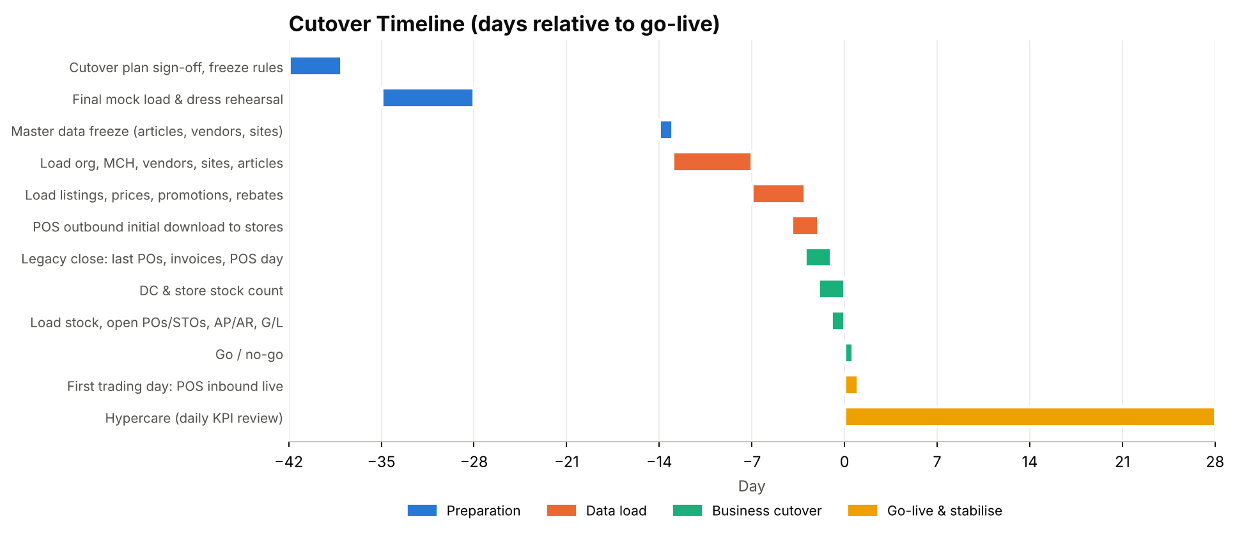
Figure 11-1. Cutover timeline

11.1 Cutover strategy
- Pilot then waves: DC01 and 5 pilot stores go live first; remaining 45 stores in waves of 10–15 stores per week. Until a store migrates, its POS continues on legacy; DC01 supplies both.
- Go-live on a Sunday night after store close, before the lowest-volume trading day.
- Stock baseline by physical count in DC and stores, loaded at count cost.
- Freeze periods: master data freeze T-14; price and promotion freeze T-7 (only emergency changes); no new POs in legacy from T-3.

11.2 Cutover runbook (excerpt)
# | Time | Task | Owner | Dependency
1 | T-14 | Freeze article, vendor and site changes in legacy | Master data lead | —
2 | T-13 … T-8 | Load sites, MCs, vendors, articles, info records, listings (objects 1–6) | Data migration lead | 1
3 | T-7 | Load prices, promotions, replenishment parameters, rebates (7–10) | Pricing / buying | 2
4 | T-4 | POS outbound initialisation; verify price files on pilot terminals | POS lead | 3
5 | T-3 | Last legacy POs; legacy invoice cut-off | Buying / AP | —
6 | T-2 (after close) | Physical count DC01 and pilot stores | Store & DC managers | 5
7 | T-1 | Load stock, open POs/STOs, AP/AR, G/L balances; reconcile | Data migration / finance | 6
8 | T-1 20:00 | Go / no-go meeting | Steering committee | 7
9 | T-0 06:00 | Open stores on S/4 prices; POS sends TLOG to CAR | Store operations | 8
10 | T+1 01:00 | First POS inbound run; first replenishment run | Hypercare team | 9

11.3 Go / no-go criteria
Criterion | Threshold
Stock load reconciled to count | 100% of sites; value difference < 0.1%
Article, EAN, price completeness | 100% of listed articles have EAN, price and listing
POS outbound verified on pilot terminals | Sample of 200 articles per store scanned correctly
Open sev-1 / sev-2 defects | 0 / ≤ 3 with workaround
Users trained & authorised | ≥ 95% of store and DC users
Hypercare staffed | War room, service desk and store champions confirmed
Rollback plan | Legacy POS and merchandising available for 2 weeks

12. Go-Live, Hypercare and Production

12.1 First-week checklist
Day | Checkpoint | Owner
Day 1 morning | All pilot stores open; POS prices correct; first sales scanned | Store ops / POS lead
Day 1 evening | End-of-day TLOG received in CAR for every store | CAR lead
Day 2 06:00 | POS inbound processed; store sales posted; no WPER errors outstanding | Hypercare
Day 2 | Replenishment run created STOs; DC wave picked and shipped | Supply chain
Day 3 | Store GR of first DC deliveries; in-transit stock clears | Stores
Day 3–5 | Bank statements matched for cash & card | Finance
Day 5 | First weekly store P&L reviewed | Finance / merchandising
Day 7 | Wave 2 readiness review | PMO

12.2 Rollout waves
Wave | Sites | Timing | Entry criteria
Pilot | DC01 + ST01–ST05 | Week 52 | Go/no-go passed
Wave 1 | ST06–ST20 | Week 55 | Pilot stable 2 weeks; KPIs green
Wave 2 | ST21–ST35 | Week 58 | Wave 1 stable
Wave 3 | ST36–ST50 + WEB1 | Week 61 | Wave 2 stable

12.3 Hypercare organisation
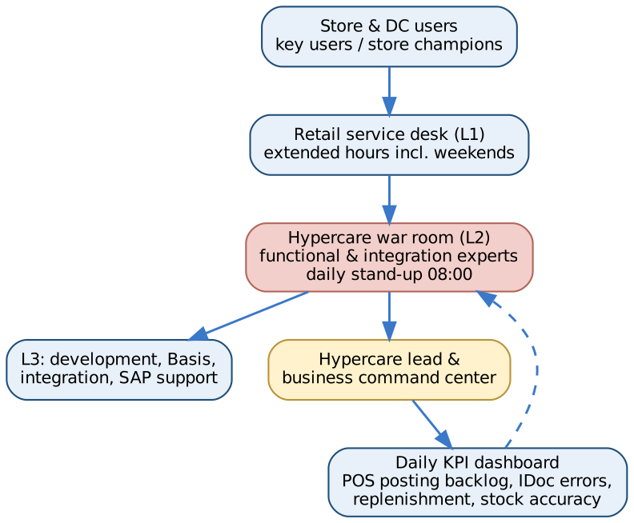
Figure 12-2. Hypercare organisation

12.4 Hypercare model
Element | Design
Duration | 4 weeks after pilot; 2 weeks after each wave (overlapping)
War room | Daily 08:00 stand-up; functional, integration, Basis, CAR, EWM and business leads
Store support | Store champions in every store; floor-walkers in pilot stores for first 3 days
Service desk | Extended hours 06:00–23:00 incl. weekends; retail ticket categories
Escalation | Sev-1 to hypercare lead within 15 minutes; SAP incident for product defects

12.5 Hypercare KPIs
KPI | Target | Source
POS inbound IDocs in error at 06:00 | 0 | WPER / CAR
Stores with missing TLOG | 0 | CAR monitor
Price discrepancies reported by stores | < 5 per day (pilot) | Service desk
Replenishment run completed by 23:30 | 100% | Job monitor
Store GR within 24 h of DC GI | ≥ 95% | In-transit stock report
Bank statement auto-match | ≥ 95% | FEBAN
Open sev-1 / sev-2 tickets | 0 / < 5 | ITSM

12.6 Exit criteria
- Two consecutive weeks with all hypercare KPIs green.
- No open sev-1 tickets; sev-2 tickets have agreed fix dates.
- First month-end close completed by WD+4 with store P&Ls.
- Knowledge transfer to the support organisation signed off; runbooks and job schedule handed over.

12.7 Daily batch schedule
Time | Job | Purpose | Owner
01:00 | CAR outbound to S/4 (aggregated sales) | Post store sales | CAR / Basis
01:30–05:00 | POS inbound processing (WPUUMS, WPUTAB, WPUFIB) | Stock, revenue, tenders | Basis
02:00 | POS outbound change pointers (WPMA job) | Prices & promotions to POS | Basis
05:00 | POS error check (WPER) & alert | Ensure completeness | Hypercare / AMS
06:00 | Bank statement import | Cash & card reconciliation | Finance
22:00 | Store replenishment run (WRP1R) | Create STOs | Supply chain
22:30 | STO → delivery creation (VL10B job) | DC waves | Supply chain
Weekly | DC replenishment / forecast | Vendor POs | Buying
Monthly | Rebate partial settlement (WB2R_SC); close tasks | Rebates & close | Finance

12.8 Support model
Tier | Scope | Provider
L0 | Store champions, knowledge base | Business
L1 | Service desk, password/role, triage | [SERVICE_DESK]
L2 | Retail functional (merchandising, POS, replenishment, finance) | Retail CoE / [AMS_PROVIDER]
L3 | Development, integration, Basis | [AMS_PROVIDER]
L4 | SAP product support | SAP

12.9 Continuous improvement
- Monthly review of POS errors, price discrepancies and replenishment accuracy by store.
- Quarterly release for enhancements and SAP Feature Pack adoption.
- Phase 2 backlog: fashion seasons, unified demand forecast, markdown optimisation, loyalty.

13. Project Plan, Governance and Risks
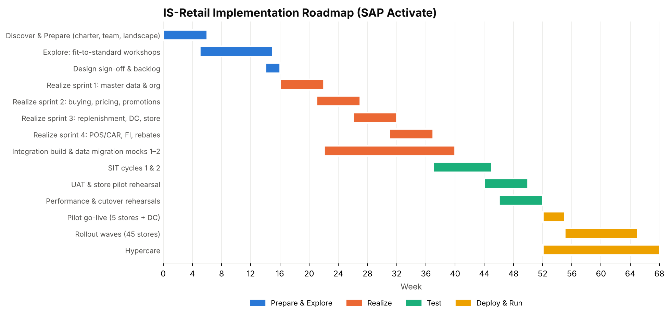
Figure 13-1. Implementation roadmap

13.0 Timeline (SAP Activate)
Illustrative start date 4 January 2027 – shift to the actual project start.
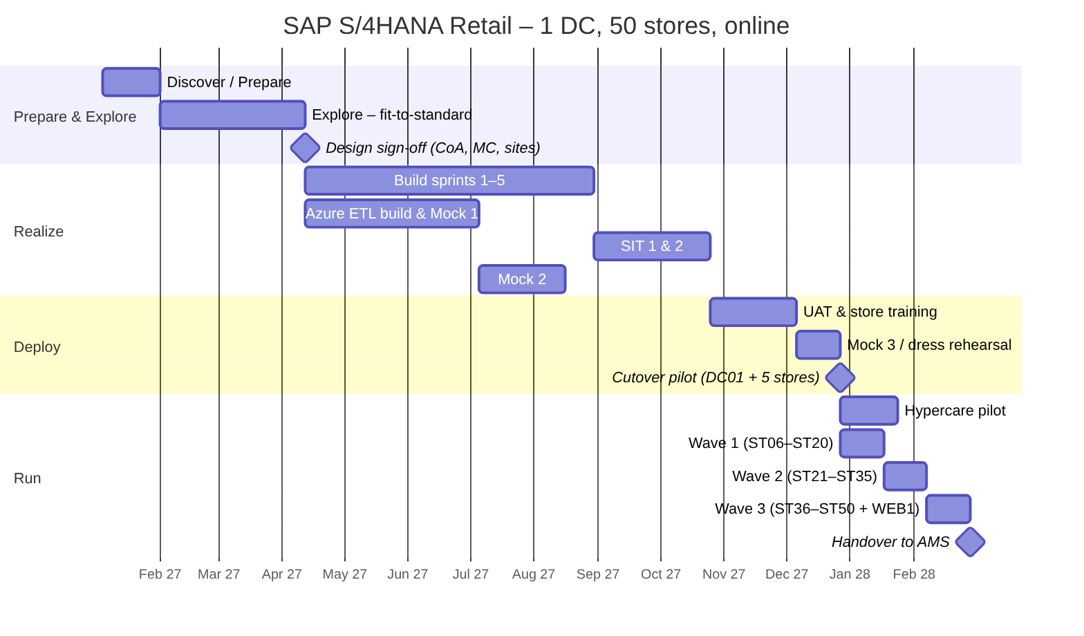

13.1 Workstreams
Workstream | Scope | Lead
Merchandise master data | MC, articles, sites, vendors, listing | [MD_LEAD]
Pricing & promotions | Price calculation, promotions, POS outbound | [PRICING_LEAD]
Buying & replenishment | Purchasing, replenishment, allocation, rebates | [BUY_LEAD]
DC & store operations | EWM, store apps, inventory | [OPS_LEAD]
POS & CAR | POS interface, sales audit, devices | [POS_LEAD]
Finance | FI/CO, valuation, cash & card, close | [FIN_LEAD]
Data migration | Objects, mocks, reconciliation | [DM_LEAD]
Integration & technology | BTP, EDI, Basis, security | [TECH_LEAD]
Change & training | Store training, communications, store champions | [OCM_LEAD]
Test & cutover | Test management, cutover runbook | [TEST_LEAD]

13.2 RACI
Activity | Sponsor | Merch. GPO | Ops GPO | Finance GPO | Workstream lead | SI partner | IT | Store ops
Requirements sign-off | A | R | R | R | C | C | I | C
Solution design | I | A | C | C | R | R | C | C
Configuration build | I | C | C | C | A | R | C | I
Data cleansing | I | A | R | R | C | C | I | R
Mock loads & reconciliation | I | C | C | A | R | R | R | I
UAT sign-off | I | A | A | A | R | C | I | R
Cutover execution | I | C | C | C | R | R | A | R
Go / no-go | A | R | R | R | C | C | C | C
Hypercare | I | C | C | C | R | R | A | R

13.3 Key risks
Risk | Impact | Mitigation
Poor article/EAN data quality | Wrong prices, unsellable items | Early cleansing, EAN checks in every mock, data owners per MC
POS integration volume / timing | Late store P&L, stock errors | Performance test at full volume; aggregation in CAR
Store adoption | Manual workarounds | Store champions, floor-walkers, simple Fiori apps
Promotion complexity | Price errors at POS | Limit promotion types in phase 1; regression tests
Peak season timing | Business disruption | No go-live in Nov–Dec; freeze periods
Legacy coexistence during waves | Supply and reporting gaps | DC supplies both; interim reporting bridge
Legacy data quality blocks the Azure ETL load gate at cutover | Go-live delay | DQ worklists from Mock 1 onward; data owners sign off per object; zero-ERROR target by Mock 3
Migration Cockpit staging structures change after an upgrade or project copy | Failed staging load | Staging table names in configuration; template comparison step in every mock

14. Glossary of Abbreviations and Terms

14.1 Abbreviations
Abbreviation | Meaning
AA | Asset Accounting (SAP FI-AA)
ADF | Azure Data Factory – cloud orchestration and data movement service
ADLS Gen2 | Azure Data Lake Storage Gen2 – hierarchical-namespace storage for the data lake
AMS | Application Management Services – post-go-live support provider
AP / AR | Accounts Payable / Accounts Receivable
ATTYP | Article category field (00 single, 01 generic, 02 variant, 10 sales set, 11 prepack)
BP | Business Partner – S/4HANA master record for suppliers and customers
BR | Business requirement (IDs BR-xx-nn in Chapter 2)
BSX / WRX / PRD / GBB | OBYC transaction keys: inventory posting / GR/IR clearing / price differences / offsetting entry for inventory posting
BTP | SAP Business Technology Platform (Integration Suite for interfaces)
CAR | SAP Customer Activity Repository – POS data hub with sales audit (POS DTA)
CDS | Core Data Services – S/4HANA virtual data model views used for reporting and reconciliation
CO | Controlling (cost centers, profit centers, internal orders)
COGS | Cost of goods sold
CoA | Chart of accounts
DC | Distribution center (site category B)
DESADV / ORDERS / INVOIC | EDI messages: despatch advice / purchase order / invoice
DQ | Data quality
DTA | Data Transfer and Audit (POS DTA in CAR)
EAN / GTIN / UPC | European Article Number / Global Trade Item Number / Universal Product Code – barcode identifiers (GS1)
EDI | Electronic Data Interchange
ERL / ERS / MWS | VKOA account keys: revenue / sales deductions / output tax
ETL | Extract, transform, load
EWM | SAP Extended Warehouse Management
FI | Financial Accounting
FSV | Financial statement version
GI / GR | Goods issue / goods receipt
GR/IR | Goods receipt / invoice receipt clearing account
GS1 | Global standards body for barcodes; defines the GTIN check digit
HANA | SAP in-memory database underlying S/4HANA
IDoc | Intermediate Document – SAP message format (e.g. WPUUMS, WPUTAB, WPUFIB for POS inbound)
IMG / SPRO | Implementation Guide – SAP configuration menu
IR / SHIR | (Self-hosted) integration runtime in Azure Data Factory
IS-Retail | SAP Industry Solution Retail – in S/4HANA: SAP S/4HANA Retail for merchandise management
JDBC / ODBC | Database connectivity standards used to write to HANA staging tables
KPI | Key performance indicator
MC | Merchandise category
MIGO / MIRO | Goods movement / supplier invoice transactions
NRV | Net realisable value
OBYC / VKOA | Account determination for inventory postings / for revenue (SD and POS)
OData | Open Data Protocol – REST API used to read S/4HANA for reconciliation
P&L | Profit and loss statement
PO / STO | Purchase order / stock transport order
POS | Point of sale
RACI | Responsible, Accountable, Consulted, Informed
RF | Radio frequency (handheld scanner in DC)
ROU | Right-of-use asset (leases)
SIT / UAT | System integration test / user acceptance test
SKU | Stock keeping unit – a variant article
TLOG | Transaction log – POS sales file from the till
VKP0 | Standard sales price condition type in retail
VLFKZ | Site category field (A = store, B = distribution center)
WD+n | Working day n of the next month (close calendar)
YCOA | SAP Best Practices operational chart of accounts

14.2 Terms
Term | Meaning
Allocation | Distribution of a quantity of merchandise (e.g. new season, promotion) to stores by rules
Assortment / listing | The set of articles a site may sell; listing creates the article–site link required for POS and replenishment
Bronze / silver / gold | Medallion lake layers: raw copy / cleansed legacy structure / SAP-ready migration layout
Condition contract | Settlement Management agreement with a vendor for rebates and funding; accrues on invoices and settles periodically
Cutover | The controlled sequence of freeze, final loads, count and switch from legacy to S/4HANA
Document splitting | Real-time splitting of G/L lines by profit center/segment so each store has a balanced balance sheet
Generic article | Parent article (e.g. TS-100 Basic Tee) carrying common data; its variants are colour/size combinations
Go / no-go | Formal decision meeting before go-live against agreed criteria
Hypercare | Intensive support period after go-live with war room and KPIs
Load gate | Automated decision in ADF that allows the HANA staging load only if DQ and reconciliation pass
Medallion architecture | Layered lakehouse design (bronze → silver → gold)
Migration Cockpit | S/4HANA tool for data migration (Fiori app Migrate Your Data), using files or staging tables
Migration clearing account | 39990000 – technical account that balances the stock and G/L loads; must be zero after migration
Mock load | Full rehearsal of the migration in a test system
Moving average cost | Inventory valuation where the unit cost is recalculated on each receipt (price control V)
Price point | Customer-facing price ending (.99, .00) applied by price calculation
Profit center | CO object per store/DC used for store P&L and balance sheet
Replenishment | Automatic calculation of order quantities for DC (from vendors) and stores (from DC)
Sales audit | Validation and correction of POS data in CAR before posting to S/4HANA
Shrinkage | Unexplained inventory loss found by counts (theft, damage, errors)
Site | Retail plant: store, DC or online channel, created from a site profile
Staging table | HANA table generated by the Migration Cockpit and filled by the ETL before the migration run
Tender | Means of payment at POS (cash, card, gift card)
Variant | Saleable colour/size version of a generic article with its own EAN
Wave | Group of stores going live together after the pilot

Appendix A. Transaction Code Index
Area | Transactions / apps
Sites | WB01, WB02, WB03
Merchandise categories & articles | WG21, WG22, CT04, CL02, MM41, MM42, MM43
Assortment & listing | WSOA1, WSOA2, WSP4 [VERIFY]
Pricing & promotions | VKP5, VKP2, V/06, WAK1, WAK2
Purchasing & replenishment | ME21N, ME11, WRP1R, WA01, VL10B
Inventory & stores | MIGO, MI01, MI04, MI07, Fiori store apps
POS | WPMA, WPMI, WPER, CAR /POSDW/*
Rebates | WCOCO, WB2R_SC
Finance | MIRO, F110, FEBAN, FF_5, OB52, Trial Balance, F.01
Configuration | OX02, OX18, OVX5, OVX6, OMS2, OMJJ, OBYC, VKOA, OT83
Items marked [VERIFY] or [DECISION] and highlighted placeholders must be confirmed for your release and project before baselining.

