User Manual

EasyNotes

Web Application for Managing Notes

ISAAC GONZÁLEZ DEL POCO ENRIQUE REYES GONZÁLEZ

UCLM

Contenido

2 Abstract 2

3 Login Window 2

4 Register Window 3

5 Main Menu Window 3

6 Add a New Note Window 4

7 My Friendships Window 5

8 My collections Window 5

8.1 Collection Menu 5

8.2 Create a collection Window 6

8.3 See a Collection Window 6

9 Admin Window 7

9.1 Users 7

9.2 Edit User 7

9.3 Notes 8

9.4 Friendships 8

9.5 Collections 9

# Abstract

Welcome to the User Manual for our Web Design project, focused on creating, managing, and sharing notes within a social networking environment. This manual is designed to provide you with a detailed guide on how to use all the features and functionalities of our platform effectively and efficiently.

Throughout this manual, you will find step by step instructions, practical tips, and illustrative examples to help you make the most of our platform's capabilities. From creating individual notes to collaborating on shared collections.

This manual will provide you with the knowledge needed to fully leverage our Notes platform.

# Login Window

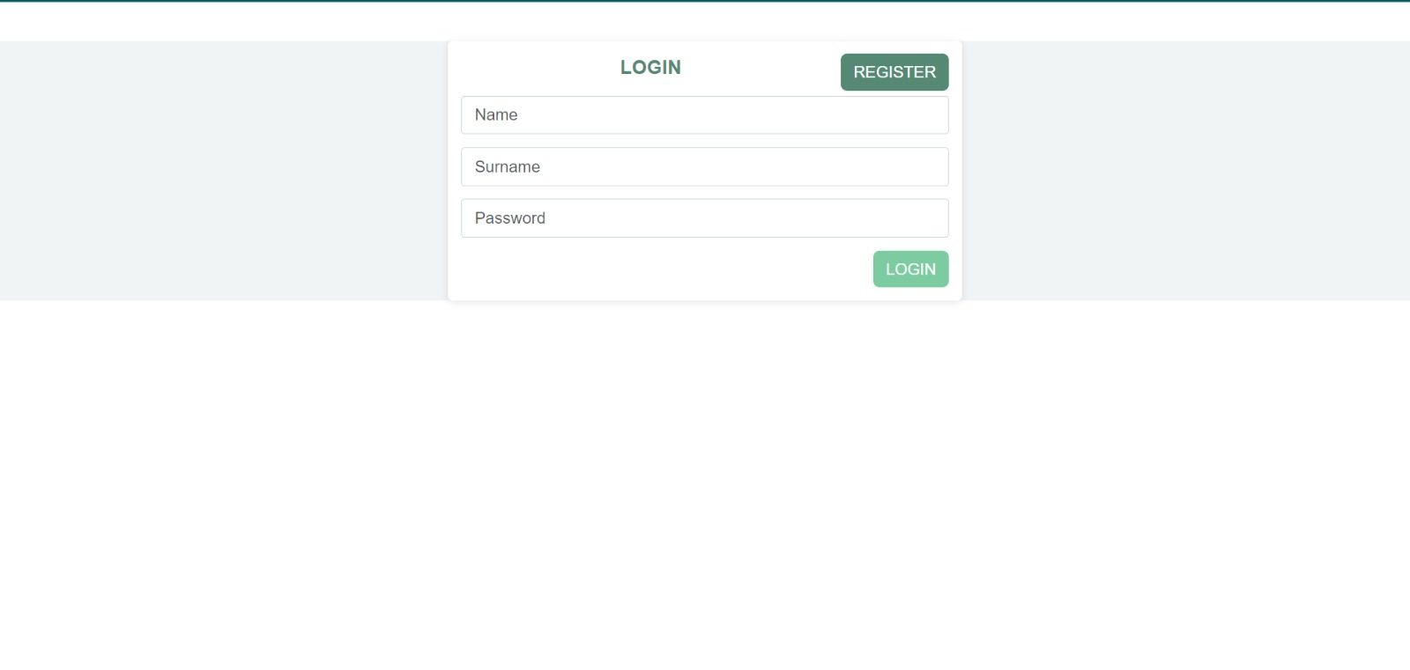

Figure 1 Login Window

Upon accessing our platform, users are greeted with the login window, which serves as the gateway to the main platform. The login window is the initial point of interaction where users authenticate their identity and gain access to their accounts, ensuring that only authorized individuals can utilize the platform's features.

Users are prompted to enter their credentials, consisting of a name, username and password. process verifies the user's identity and safeguards against unauthorized access.

But before that the user must be registered in the platform, which we going to explain in the next segment.

# Register Window

Figure 2 Register Window

The registration window in our platform plays a crucial role in welcoming new users and facilitating their onboarding journey. This window serves as the entry point for individuals who are looking to create an account and access the full suite of features and functionalities offered by our platform.

When users navigate to the registration window, they are presented with a series of fields to input their information and create their account. This includes fields such as:

* Name: Users can enter their full name.
* Username: The name that will be show to other people in the platform.
* Password: Users are prompted to create a secure password.

# Main Menu Window

Figure 3 Main Menu Window

Once we logged in successfully, we encounter the main menu, that consists of the next parts:

* Add a new note button: this button will lead the user to the create notes.
* My friendships button: will redirect the user to the friendships page, that allow us to connect with our friends and manage the friendships that we currently have.
* My collections: this button move the user to the collections page, that are aggrupation of notes that we can classify however we want.
* My Shared Notes: At the bottom of the page, we can find this part and show the notes that we have, or our friends have shared with us.

# Add a New Note Window

Figure 4 Add a New Note Window

Here we can find the creation of our notes that comes with the following fields:

* Title: Provide a short description of the note's subject.
* Note Content: Elaborate on the purpose and details of the note.
* Select a Collection: Choose a predefined category to organize your note. If you haven't set up a collection or prefer not to categorize this note, it will be placed in a default collection.

# My Friendships Window

Figure 5 My Friendships Window

The "My Friendships" window is divided into two sections:

* My Requests: At the top section, you can manage your friend requests. This includes sending friend requests to others or reviewing pending friend requests from other users.
* My Friends: Below, you'll find your friend list where you can view all your current friends. If needed, you can also remove friends to end the relationship and remove them from your friend list.

# My collections Window

## Collection Menu

Figure 6 My collections Window

The window for managing collections can be divided into two parts:

* Create Collections: The upper section is dedicated to creating new collections. Clicking on "add new collection" redirects you to a specific window for this task, allowing you to create a new collection with ease.
* Manage Existing Collections: In the lower section, you can view all the collections you have created. If you wish to modify any aspect such as the collection's name or the notes stored within it, you can do so. We'll explore this function in detail later.

## Create a collection Window

Figure 7 Create a Collection Window

This straightforward window allows you to create collections by adding a title or description to distinguish them from others.

## See a Collection Window

Figure 8 See a Collection Window

When you select a collection from the menu, you will be directed to a window where you can view all the notes stored in that specific collection.

# Admin Window

## Users

Figure 9 Check all users of the application

Here we can check all the users on the app, in case theres been an error or a user has infringed the code of conduct we can delete any user, on the other hand if we want to change some information about a user we can click on the “Edit button” to get into the next window.

## Edit User

Figure 10 Edit the User of choice Window

Here, you can review all the users registered on the app. If there's an error or if a user has violated the code of conduct, you can delete the user. Alternatively, if you need to update information about a user, you can click on the "Edit" button to access the next window for making those changes.

## Notes

Figure 11 List all the Notes by all Users

In this section of the admin window, you can review all notes generated by users, including administrators. Similar to the previous explanation, you have the option to edit or delete these notes as needed.

## Friendships

Figure 12 All Friendships between Users

Here’s the administrator can see all pairs of friendships in the app, the only action we can do is delete, this will erase the friendship of both users involved.

## Collections

Figure 13 All collections in the application

In this section of the admin window, you can review all collections generated by users, including administrators. Additionally, you can delete collections belonging to other users and administrators.