**10675560**

**Buchem Isaac Kwame**

**Project ID: 2**

**CSCD:312**

**Prostate Cancer Detection Using Artificial Neural Networks (RNN)**

Prostate cancer is one of the most common types of cancer in men. Usually prostate cancer grows slowly and is initially confined to the prostate gland, where it may not cause serious harm. However, while some types of prostate cancer grow slowly and may need minimal or even no treatment, other types are aggressive and can spread quickly. When diagnosis is not identified early, it has many negative percussions later. The aim of this project is to predict presence of Prostate Cancer from “csv” inputs with the aid of Artificial Intelligence.

**Packages Imported**

* **Pandas** : This is a high-level data manipulation tool used to manipulate tabular data.
* **Numpy**: This is a numeriacla Python library for performing a number mathematical operations on arrays.
* **Seaborn**: This package was used statistical visualizations.
* **Matplotlib**: This helps embed plots into the notebook.
* **Sklearn**: This is used for predictive analysis.
* **Keras:**

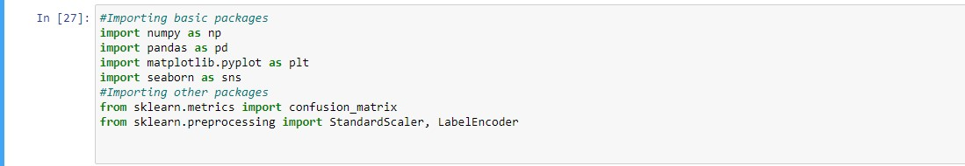

**Data**

Dataset used was downloaded from Kaggle. This data consist of observations of a scan of Cancer Image i.e. the details.

Data was made up of 10 columns (id, diagnosis_result, radius, texture, perimeter, area, smoothness, compactness, symmetry, fractal_dimension) and 100 observations.

Using Pandas, dataset was loaded into the notebook.

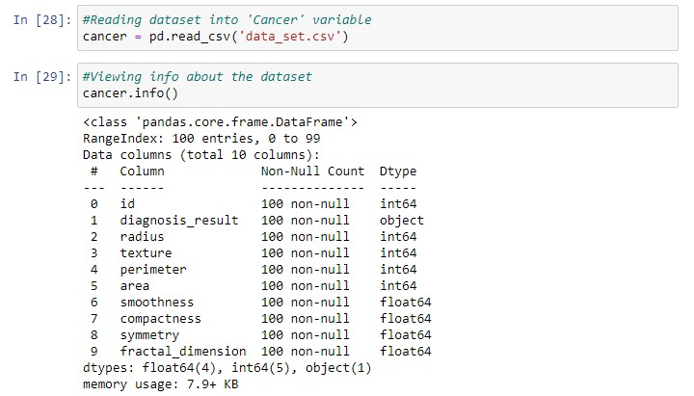First 20 observations of Data:

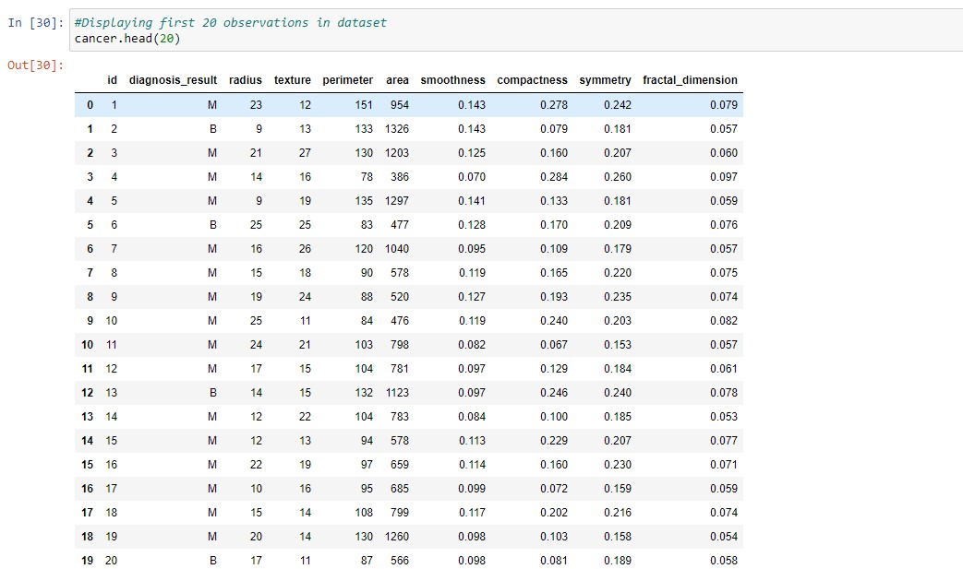

**Exploratory Data Anlysis:**

* Using Seaborn for viewing the heat map pf the Dataset to check for correlations against the diagnosis_result:

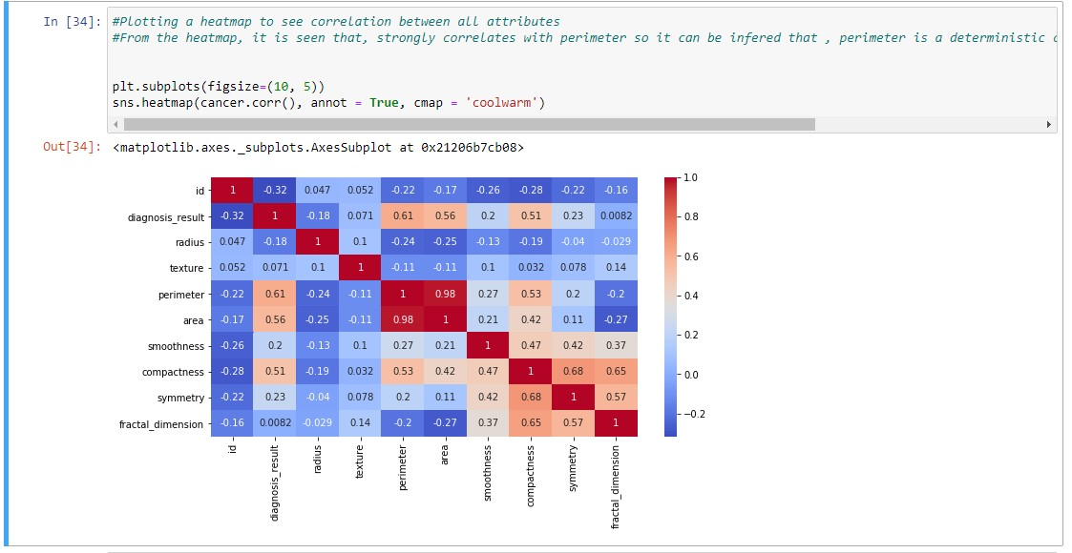

* **Checking for missing values in data**

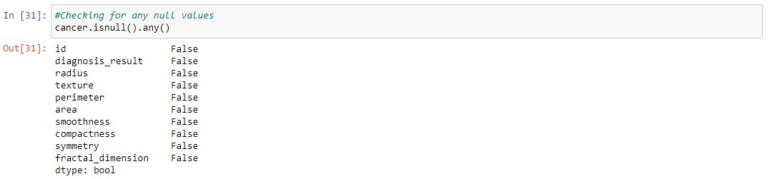

* **Viewing some statistical Analysis:**

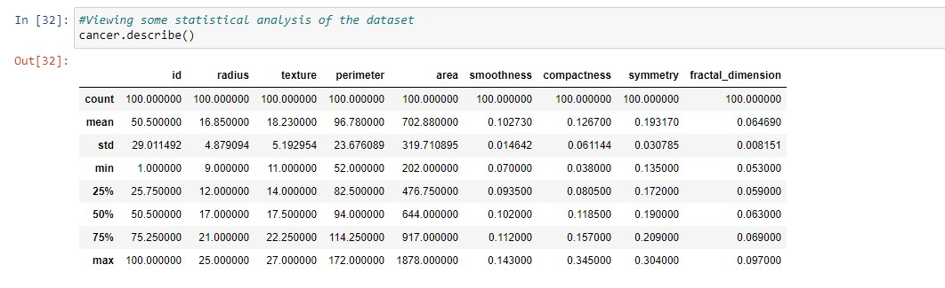

* **Creating the RNN Model and fitting data:**
* 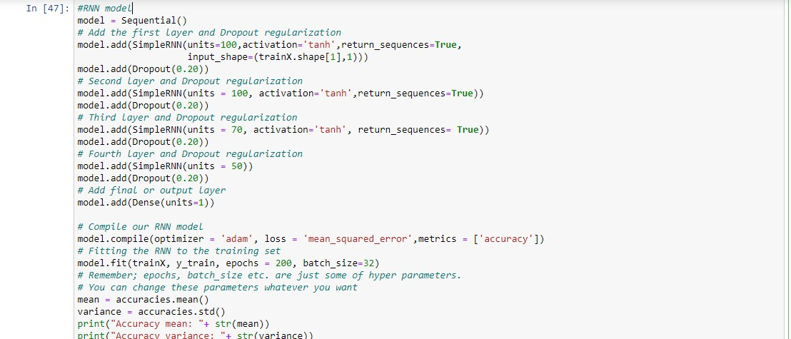
* **Accuracy Score for RNN:** It can be seen in the image below accuracy of RNN is 85%.

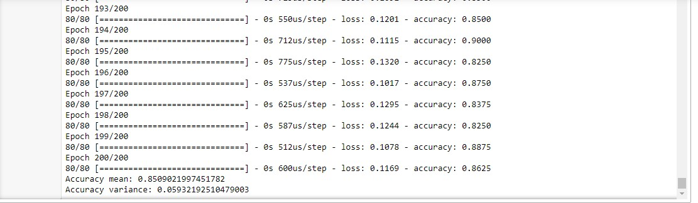

* **Comparison of RNN with other models (KNN, Logistic Regression and SVM)**

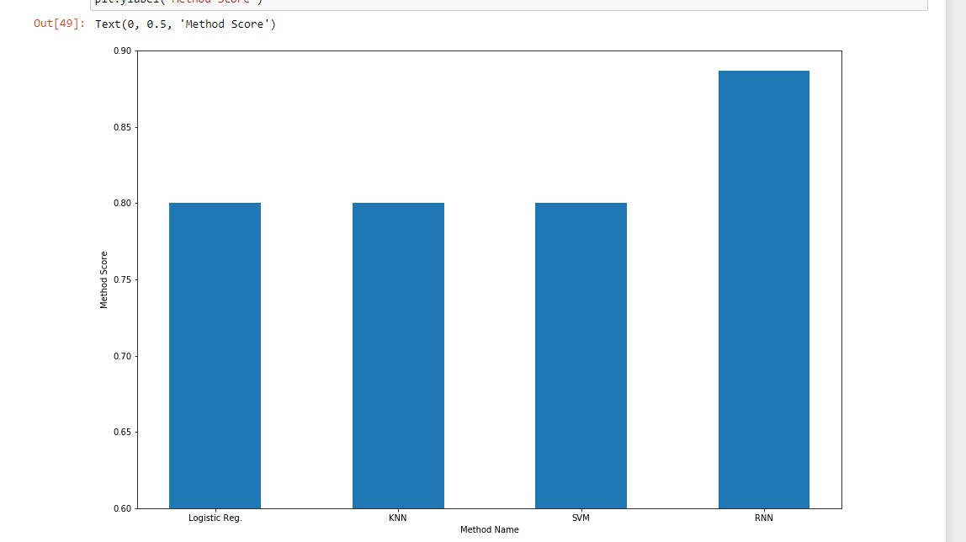

**Graphical User Interface (GUI) using tkinter:**

This GUI was built uising the python package, tkinter.

