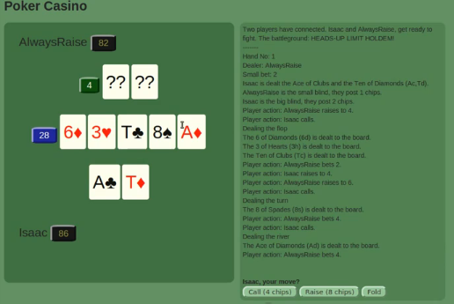
Artificial Intelligence for Texas Holdem Poker
Utilizing Machine Learning Techniques
Isaac Lewis
Advised by Professor Brian Mak

