Software Requirements Specification
for
Yelp Database Project

Team: 2
Project: CPTS 322 & 451 Yelp Database
Team Members:
Isaac Schultz
Rebecca Rothschild
Joshua Bennett

Last Updated: 2-17-2019

9. Use Cases
[Include a header paragraph for your product here. In this section you will specify UML use cases for the user-visible features and functions that you have specified herein. A use case describes a sequence of actions that provide something of measurable value to an actor. Each use case will briefly describe the use case scenario, identify the actor(s), and provide a UML use case diagram. Use case diagrams show the system box containing the feature/function (use case), the actor(s), and the interconnections/associations between these (see example Figure 9-1 below). Use the following format for this section.]

9.1 [Yelp Database Use Case Diagram] 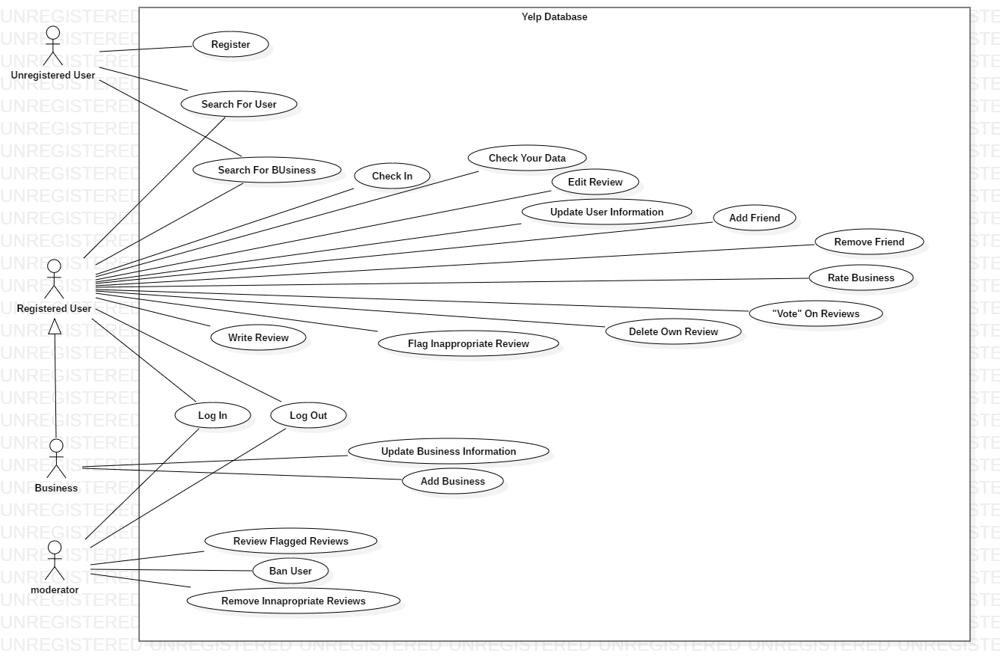
Figure 9-1 Use Case: Make Online Purchase Using Credit Card

9.1.1 [Use Case 1]
Use Case ID ( UC – 1 ) |  | Use Case Name | Register
Created by | Isaac Schultz | Last Updated by | Isaac Schultz
Date Created | 2-17-2019 | Date Last Updated | 2-17-2019
Actor |  | Unregistered user
Description |  | Creating a registered user account.
Preconditions |  | The user is not signed in
Post conditions |  | The user is signed in
Priority: (low/medium/high) |  | High
Frequency of Use |  | Common
Normal Course |  | UC-1: Case
 |  | Actor Actions  1. Create Username + password  3. Input user information (name, age…) |  | System Responses  2. Add user to database.
Alternative Course |  | User will add information later.
 |  | Actor Actions  1. Create Username + password |  | System Responses  2. Add user to database.
Exceptions |  | Username already exists
 |  | Actor Actions  1. Pick a new username |  | System Responses  2. Add user to database
Includes (another use case id) |  | N/A
Special requirements |  | N/A
Assumptions |  | Usernames must be unique
Notes and issues

9.1.1 [Use Case 2]
Use Case ID ( UC – 2 ) |  | Use Case Name | Search For User
Created by | Isaac Schultz | Last Updated by | Isaac Schultz
Date Created | 2-17-2019 | Date Last Updated | 2-17-2019
Actor |  | Registered or Unregistered User
Description |  | Searches the database for users and displays their information and reviews.
Preconditions |  | N/A
Post conditions |  | Displays results of the search
Priority: (low/medium/high) |  | Medium
Frequency of Use |  | Common
Normal Course |  | UC-2: Case
 |  | Actor Actions  1.  3.  5. |  | System Responses  2.  4.  6.
Alternative Course
 |  | Actor Actions |  | System Responses
Exceptions
 |  | Actor Actions |  | System Responses
Includes (another use case id)
Special requirements
Assumptions
Notes and issues

9.1.1 [Use Case 3]
Use Case ID ( UC – xxxxx ) |  | Use Case Name | Search for Business
Created by | Isaac Schultz | Last Updated by | Isaac Schultz
Date Created | 2-17-2019 | Date Last Updated | 2-17-2019
Actor
Description
Preconditions
Post conditions
Priority: (low/medium/high)
Frequency of Use
Normal Course |  | UC-1: Case
 |  | Actor Actions  1.  3.  5. |  | System Responses  2.  4.  6.
Alternative Course
 |  | Actor Actions |  | System Responses
Exceptions
 |  | Actor Actions |  | System Responses
Includes (another use case id)
Special requirements
Assumptions
Notes and issues

9.1.1 [Use Case 4]
Use Case ID ( UC – xxxxx ) |  | Use Case Name | Check in
Created by | Isaac Schultz | Last Updated by | Isaac Schultz
Date Created | 2-17-2019 | Date Last Updated | 2-17-2019
Actor
Description
Preconditions
Post conditions
Priority: (low/medium/high)
Frequency of Use
Normal Course |  | UC-1: Case
 |  | Actor Actions  1.  3.  5. |  | System Responses  2.  4.  6.
Alternative Course
 |  | Actor Actions |  | System Responses
Exceptions
 |  | Actor Actions |  | System Responses
Includes (another use case id)
Special requirements
Assumptions
Notes and issues

9.1.1 [Use Case 5]
Use Case ID ( UC – xxxxx ) |  | Use Case Name | Check Your Data
Created by | Isaac Schultz | Last Updated by | Isaac Schultz
Date Created | 2-17-2019 | Date Last Updated | 2-17-2019
Actor
Description
Preconditions
Post conditions
Priority: (low/medium/high)
Frequency of Use
Normal Course |  | UC-1: Case
 |  | Actor Actions  1.  3.  5. |  | System Responses  2.  4.  6.
Alternative Course
 |  | Actor Actions |  | System Responses
Exceptions
 |  | Actor Actions |  | System Responses
Includes (another use case id)
Special requirements
Assumptions
Notes and issues

9.1.1 [Use Case 6]
Use Case ID ( UC – xxxxx ) |  | Use Case Name | Edit Review
Created by | Isaac Schultz | Last Updated by | Isaac Schultz
Date Created | 2-17-2019 | Date Last Updated | 2-17-2019
Actor
Description
Preconditions
Post conditions
Priority: (low/medium/high)
Frequency of Use
Normal Course |  | UC-1: Case
 |  | Actor Actions  1.  3.  5. |  | System Responses  2.  4.  6.
Alternative Course
 |  | Actor Actions |  | System Responses
Exceptions
 |  | Actor Actions |  | System Responses
Includes (another use case id)
Special requirements
Assumptions
Notes and issues

9.1.1 [Use Case 7]
Use Case ID ( UC – xxxxx ) |  | Use Case Name | Update User Information
Created by | Isaac Schultz | Last Updated by | Isaac Schultz
Date Created | 2-17-2019 | Date Last Updated | 2-17-2019
Actor
Description
Preconditions
Post conditions
Priority: (low/medium/high)
Frequency of Use
Normal Course |  | UC-1: Case
 |  | Actor Actions  1.  3.  5. |  | System Responses  2.  4.  6.
Alternative Course
 |  | Actor Actions |  | System Responses
Exceptions
 |  | Actor Actions |  | System Responses
Includes (another use case id)
Special requirements
Assumptions
Notes and issues

