Isaac Schultz

11583435

Project 2

Output Screenshots:

Publisher Output Window: ( I could not get Select-String to work on PowerShell! So I resorted to good ol’ cmd)

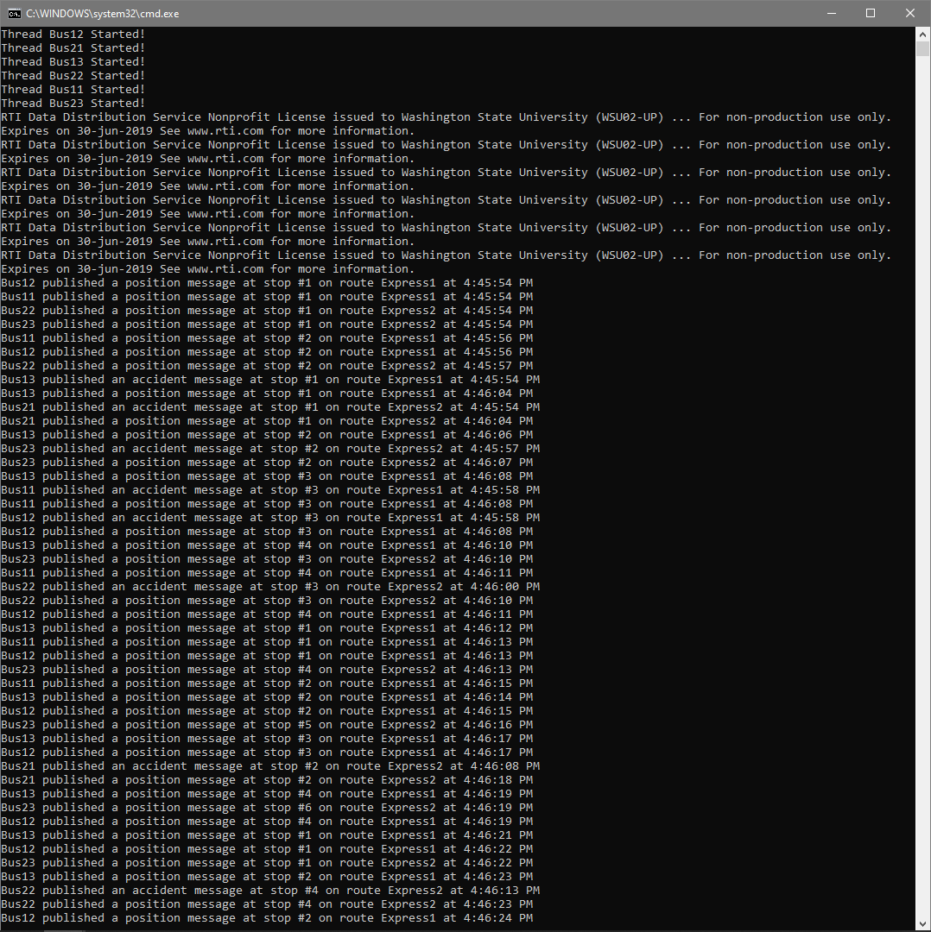

Operator Output Window: (Cannot see all the way to the bottom, but its just more of the same)

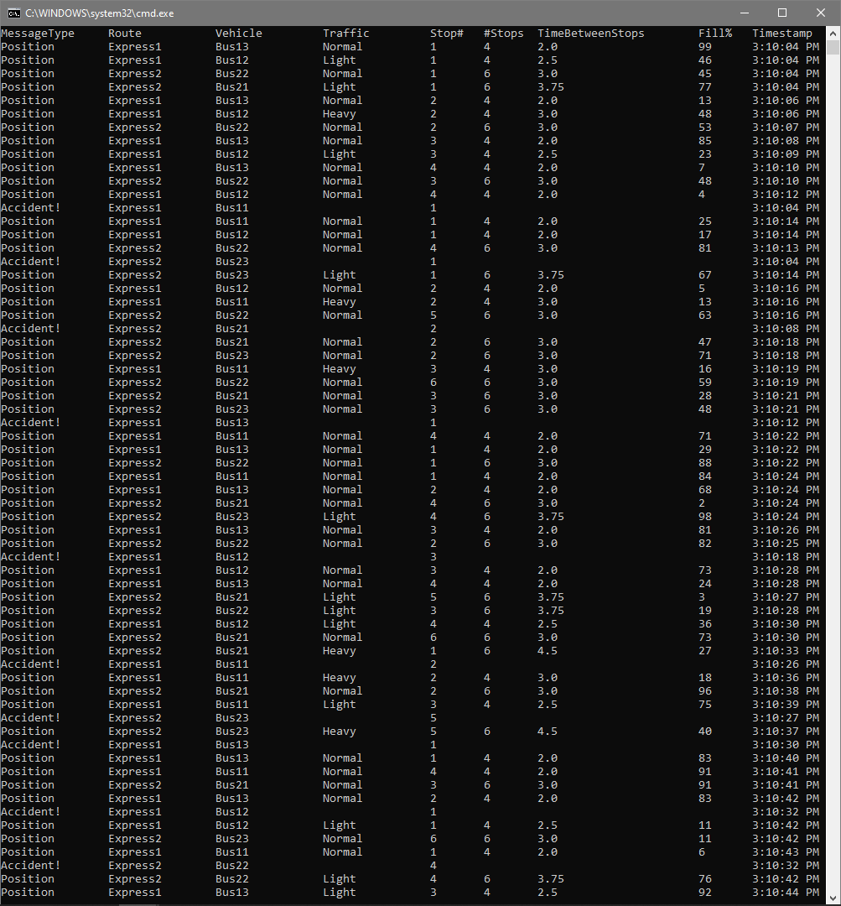

Passenger1 Output Window:

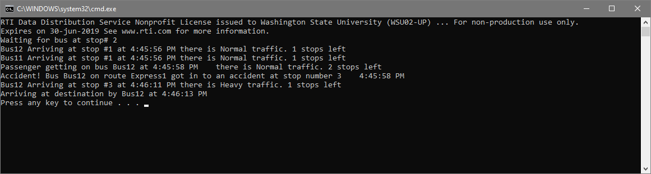

I actually didn’t even modify the properties file to increase the accident percentage for this run, just got lucky!

Passenger2 Output Window:

