System Design Document

1. Architecture Overview
High-Level Architecture Diagram
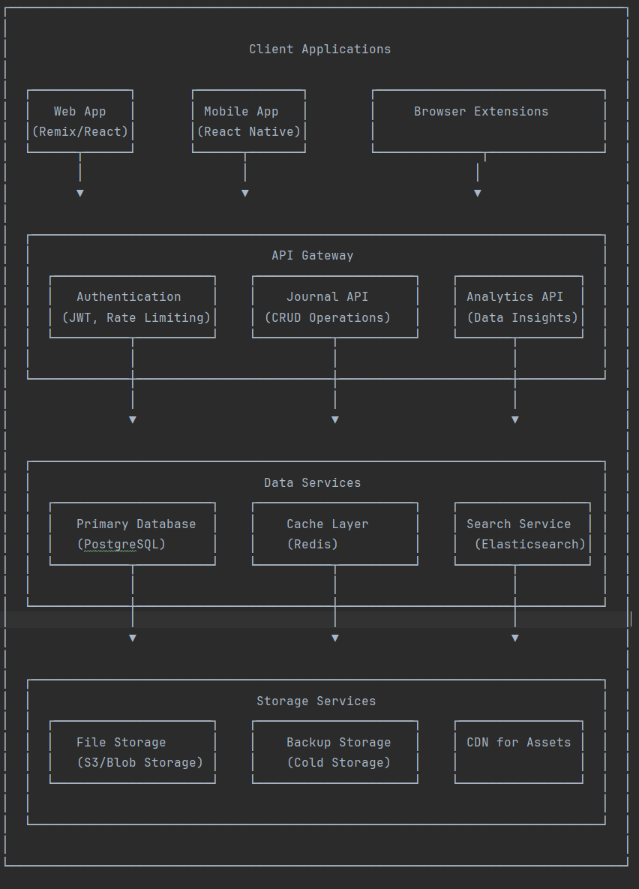
Client Applications:
- Web App: Built with Remix/React for responsive and dynamic UI.
- Future Mobile App: Developed with React Native for cross-platform compatibility.
- Browser Extensions: Provides quick access for journaling features.
API Layer:
- API Gateway: Manages routing, rate limiting, and authentication.
- Microservices Architecture:
  - Authentication Service: Uses JWT and session management.
  - Journal API: Handles CRUD operations for journal entries.
  - Analytics Service: Processes and visualizes user data insights.
Data Layer:
- Primary Database: PostgreSQL for structured transactional data.
- Cache Layer: Redis for fast access to frequently used data.
- Search Service: Elasticsearch for full-text search capabilities.
Storage Layer:
- File Storage: Uses S3-compatible storage for attachments.
- Backup Storage: Cold storage for disaster recovery.
- CDN: Distributes static assets and media for quick access.

2. Data Model Design
Entity Relationship Diagram
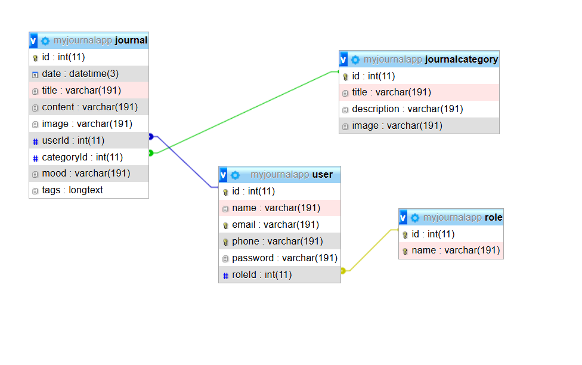
Key Entities and Relationships:
- USER: Contains personal details, login credentials, and roles.
- ROLE: Defines user permissions and access levels.
- JOURNAL: Stores user-created journal entries.
- JOURNAL_CATEGORY: Categorizes journal entries.

erDiagram
USER ||--o{ JOURNAL : writes
USER {
int id PK
string name
string email UK
string phone UK
string password
datetime createdAt
datetime updatedAt
datetime lastLogin
boolean isActive
int roleId FK
}

ROLE ||--o{ USER : has
ROLE {
int id PK
string name UK
string permissions
datetime createdAt
}

JOURNAL_CATEGORY ||--o{ JOURNAL : categorizes
JOURNAL_CATEGORY {
int id PK
string title
string description
string image
int userId FK "Owner for user-specific categories"
boolean isSystem
datetime createdAt
}

JOURNAL {
int id PK
datetime date
string title
text content
string imageUrl
string mood
json tags
int wordCount
datetime createdAt
datetime updatedAt
int userId FK
int categoryId FK
}

Optimizations:
- Indexes on userId and date for fast queries.
- Soft delete for categories to allow restoration.
- GIN indexing for JSON tags to enhance search.
- Partitioning by user ID for large-scale deployments.

3. Security Measures
Data Protection:
- Encryption at Rest: AES-256 encryption for journal content.
- Field-Level Encryption: Protects sensitive user data.
- TLS 1.3: Ensures secure communications.
Authentication:
- Multi-Factor Authentication (MFA): Uses TOTP for security.
- Device Fingerprinting: Identifies devices to prevent unauthorized access.
- Anomaly Detection: Detects unusual login attempts.
Application Security:
- Regular Security Scanning: Automated dependency checks.
- Content Security Policies (CSP): Prevents XSS attacks.
- Rate Limiting: Progressive delays to mitigate brute-force attacks.
- SQL Injection Protection: Uses Prisma ORM.
Compliance:
- GDPR Compliance: Allows data export and deletion.
- Audit Logging: Tracks all modifications.
- Role-Based Access Control (RBAC): Fine-grained permission management.

4. Scaling Challenges and Solutions
Challenge 1: Database Performance
Solution:
- Implement read replicas for analytics queries.
- Use sharding based on user geography.
- Transition to distributed SQL (e.g., CockroachDB, YugabyteDB).
Challenge 2: Real-Time Analytics
Solution:
- Utilize Kafka for stream processing.
- Precompute aggregates using a time-series database.
- Implement columnar storage for analytics data.
Challenge 3: File Storage
Solution:
- Use multi-region S3 buckets with lifecycle policies.
- Implement intelligent tiering for cost optimization.
- Enable client-side compression before uploads.
Potential Bottlenecks & Solutions:
Journal Ingestion:
- Use write-behind caching for optimization.
- Batch process analytics to reduce write load.
- Implement an asynchronous pipeline for handling entries.
Dashboard Performance:
- Use materialized views for precomputed data.
- Implement progressive loading for visualizations.
Search Latency:
- Deploy a dedicated Elasticsearch cluster.
- Enable edge caching of frequently searched terms.
- Utilize Trie-based autocomplete for faster suggestions.
5. Monitoring and Observability
Key Metrics:
Performance:
- API response times (p95, p99)
- Database query latency
- Cache hit/miss ratio
Business Metrics:
- Daily active users
- Average journal entries per user
- Retention rates
System Health:
- Event loop lag in Node.js
- Memory usage trends
- Storage growth rate
Alerting Strategy:
- Immediate Alerts: Authentication failures, database outages.
- Warning Alerts: Performance degradation, high error rates.
- Informational Alerts: Usage spikes, geographic usage changes.

Technical Decision Log

Decision 1: Authentication Strategy
Problem: Needed a secure, scalable authentication system that works across web and future mobile clients while protecting sensitive journal data.
Options Considered:
- Session Cookies with Redis: Traditional server-side sessions
- JWT with Refresh Tokens: Stateless authentication
- OAuth Proxy: Leverage third-party providers
Chosen Approach: JWT with Refresh Tokens implemented via HTTP-only cookies with SameSite strict policy.
Rationale:
- Better scalability than server-side sessions
- Secure against CSRF (via SameSite) and XSS (HTTP-only)
- Simpler to implement than full OAuth initially
- Works well with Remix's SSR capabilities
Trade-offs:
- Stateless architecture scales well
- Simplified mobile client integration
- More complex token invalidation
- Slightly larger payload than sessions
Consequences:
- Implemented token rotation for security
- Added Redis blacklist for immediate invalidation
- Required careful JWT secret management

Decision 2: Data Visualization Architecture
Problem: Needed to display complex analytics (heatmaps, word clouds) without overloading the database or client.
Options Considered:
- Client-Side Processing: Raw data to browser
- Server-Side Rendering: Pre-rendered visualizations
- Hybrid Approach: Pre-aggregated metrics + client rendering
Chosen Approach: Hybrid architecture with:
- Daily pre-aggregated snapshots in PostgreSQL
- Client-side rendering using Chart.js/WordCloud.js
- Web Workers for intensive processing
Rationale:
- Balances server and client load
- Pre-aggregation enables fast dashboard loads
- Still allows dynamic filtering client-side
Trade-offs:
- Reduced server load
- Faster initial render
- Increased bundle size (~150KB)
- More complex data synchronization
Consequences:
- Implemented incremental static regeneration
- Added loading states for large datasets
- Required careful memory management in workers

