TaskFlow – FSD
Document Control
Document | TaskFlow – Functional Specification Document
Author | Isaac Natarajan
Version | V1.3
Created on | 14-07-2026
Status | In-review
Contents
1. Purpose & Scope 1
2. Actors & Roles 1
3. Screen-by-Screen Functional Specs 2
3.1 Login 2
3.2 Dashboard (Employee) 2
3.3 Dashboard – My Team (Manager Only) 3
3.4 Dashboard – My work (Managers) 3
3.5 Log Time 4
3.6 My Tasks 4
3.7 Submissions 5
3.8 Approvals (Managers) 5
3.9 Reports (Directors) 6
3.10 Manage Clients (Directors) 6
3.11 Manage Department (Directors) 7
4. Business Rules & Validation Logic 7
4.1 Empty States 8
5. Workflows 9
5.1 Task Lifecycle 9
5.2 Weekly Submission Lifecycle 10
6. Data Field Reference 10
6.1 Task 10
6.2 Time Entry 10
6.3 Weekly Submission 11
6.4 Audit Log 11
7. Notification & Status Indicators 11
8. Error Handling & Edge Cases 12
9. Traceability 13

1. Purpose & Scope
This document specifies the exact functional behavior of TaskFlow: every screen's fields and validation rules, business rules, state transitions, and error handling. It is the specification engineers and QA build and test directly against. System architecture, database schema, and infrastructure are covered separately in the Technical Documentation; business rationale, KPIs, and rollout planning are covered in the PRD. This document assumes both as background and does not repeat their content — only functional behavior lives here.
A reader with no prior context should be able to build, test, or extend any screen in TaskFlow using this document alone, without needing to ask the original developer for clarification.
This document uses terminology defined in the PRD's Glossary (e.g. Week, P0/P1, Audit Log, Department). Refer there for term definitions; this document does not repeat them.

2. Actors & Roles
Actor | Description | Key Permissions
Employee | Every authenticated user, by default | Create/edit own tasks and time entries; submit own weekly submissions; view all clients/tasks/departments (read-only)
Manager / Lead | Auto-detected: any user who appears as another user's manager in the company directory | Everything Employee can do, plus: Approve/Return direct reports' submissions; see "My Team" dashboard
Director / Sr. Director | Determined by designation field from SSO | Everything Manager can do, plus: view Reports; add/edit/deactivate Clients and Departments
CEO | The single top-of-hierarchy role, with no one above them | Full read-only visibility across the platform (same Reports access as Directors), but fully exempt from time-logging, submission, and approval – does not log time, does not submit weekly, does not appear in anyone’s approval chain

Key distinction to note explicitly (since this trips people up): Manager-level access (Approvals) is based on reporting-line data (who reports to whom). Director-level access (Reports, Manage Clients/Departments) is based on job title/designation, a separate field. A Director with no direct reports still gets Reports access; a Manager with direct reports but a non-Director title does not get Reports access. These two permission sources are independent. The CEO is the only role that combines full visibility with zero operational participation.

3. Screen-by-Screen Functional Specs

3.1 Login
Element | Type | Behavior
Sign in with ProductSquads | Button | Redirects to Microsoft Entra ID. On success, backend matches or creates the local user record using directory data (name, email, department, designation, manager) and issues a session token.

Notes:
- No password field exists on this screen — authentication happens entirely on Microsoft's page.
- First-time login auto-creates the user's TaskFlow profile; no admin setup required.
- If SSO fails or Entra ID is unreachable, a generic "Sign-in failed, try again" message displays — no partial session is ever created (see Error Handling, Section. 8).

3.2 Dashboard (Employee)
Element | Type | Behavior
Hours This Week | Stat card | Sum of the current week's time entries for the logged-in user
Active Tasks | Stat card | Count of the user's own tasks with status Open or In Progress
Reporting To | Stat card | Current manager's name, resolved from directory data
Reminder Banner | Conditional banner | Appears only if the prior week's submission wasn't submitted by Monday 6 PM
Recent Tasks | List | Most recently logged-against tasks, with department and hours
+ Log Time | Button | Navigates to the Log Time screen

Notes:
- This is the default screen for any user with no direct reports. Users with direct reports land on the Manager version instead (Section. 3.3).
- All data here is live/raw — it reflects entries regardless of submission status, not just Approved data (differs from Reports, Section. 3.9, which is Approved-only).

3.3 Dashboard – My Team (Manager Only)
Element | Type | Behavior
Team Members | Stat card | Count of direct reports (users whose manager field matches the current user)
Pending Approvals | Stat card | Count of direct reports' submissions with status Submitted
Total Submissions | Stat card | Total count of all submissions ever made by direct reports, any status
Team Submissions Table | Table | One row per direct report: name, hours this week, status badge
Review | Button (per row, Submitted status only) | Navigates to Approvals, pre-filtered to that specific submission

Notes:
- This is the default landing view for any user with at least one direct report — shown automatically instead of the standard Dashboard.
- Data here reflects all statuses (Submitted/Approved/Returned) — not filtered to Approved-only, since this is an operational view, not a reporting view.
- A user can switch to their own personal view via the "My Work" tab (Section. 3.4) without losing manager-level access.

3.4 Dashboard – My work (Managers)
Same as Section. 3.2 Dashboard — Employee: Hours This Week, Active Tasks, Reporting To, Reminder Banner, Recent Tasks, + Log Time.
Notes:
- Functionally and visually identical to the standard Employee Dashboard (Section. 3.2) — same fields, same behavior, no differences in logic.
- Exists as a separate tab specifically because Managers/Directors still log and submit their own time — reporting authority over others doesn't exempt them from tracking their own hours.
- Accessed via a tab toggle on the Dashboard screen, alongside "My Team" (Section. 3.3). Only visible to users who have at least one direct report; everyone else just sees the single unified Dashboard with no tabs.

3.5 Log Time
Element | Type | Behavior / Validation
Week selector | Control | Navigates between weeks; defaults to the current week
Task rows | List | Only tasks the current user created and has not closed. No task creation from this screen.
Hour cell (per task, per day) | Numeric input | 0–10, decimals allowed (e.g. 1.5). Negative rejected. Hard-blocked above 10 — entry is not saved if it would exceed the daily cap. Auto-saves on blur. Always editable — no locking at any stage, including after the submission is Approved.
Daily total | Computed | Sum of that day's column. Hard block on entry if the day’s total would exceed 10 hours – no separate warning tier
Submit Week | Button | Bundles the week's entries into one weekly_submissions record. Disabled if the week is already Submitted or Approved. If the week is Returned, this button becomes "Resubmit" instead (see Section. 3.7).
Bulk Upload | Button + file input | Alternative to manual entry. Accepts a spreadsheet file (Task Title, Date, Hours, columns). Each row validated against the same rules as manual entry: task must exist and belong to the uploader (unmatched rows rejected, no auto-create), 10-hour daily cap enforced. No week-status restriction — uploads accepted regardless of submission status, since no locking exists. Valid rows save; invalid rows are skipped and listed in a summary. A confirmation summary shows affected date ranges after upload. File format: .xlsx or .csv, with exactly 3 columns (Task Title, Date, Hours) in that order — header row required. Date format: YYYY-MM-DD. Duplicate task titles across rows for the same date are treated as separate entries and summed (not rejected) unless the combined total would exceed the 10-hour daily cap, in which case the row causing the overage is rejected.

Notes:
- Task list only shows the creator's own tasks — single-owner model, no shared tasks.

3.6 My Tasks
Element | Type | Behavior/Validation
Search / filter bar | Controls | Filter by client, department, status
Task list | Table | All tasks visible (read-only for tasks the user doesn't own); shows client, department, priority, status
+ Create Task | Button | Opens Create Task form
Client | Dropdown | Required. Populated from the Clients master list.
Department | Dropdown | Required. Populated from the Departments master list.
Title | Text input | Required
Description | Text area | Optional
Priority | Dropdown | Required. Low / Medium / High / Urgent
Start Date / Deadline | Date pickers | Required. Deadline must not be before Start Date.
Close Task | Action | Only the task's creator. Sets status to Closed; task stays visible in history.
Delete Task | Action | Only the task's creator, and only if zero time entries exist against it.

Notes:
- Single-owner model: only the creator can log time against, edit, close, or delete a task — even Directors cannot edit another employee's task.
- Client and Department are always selected from fixed lists, never free-typed — this is what makes company-wide reporting reliable.

3.7 Submissions
Element | Type | Behavior
Submissions list | Table | The user's own weekly submissions: week, total hours, status
Status badge | Indicator | Submitted / Approved / Returned, color-coded
Manager comment | Text | Full comment shown here when status is Returned (Dashboard shows only the status badge, not the comment text)
Resubmit | Button | Visible only when status is Returned. Sends the corrected week back to the manager; status → Submitted.

Notes:
- This is the only screen where the manager's full return comment is displayed — intentionally not duplicated on the Dashboard, to keep that screen scannable.
- Once Resubmit is clicked, the submission re-enters the manager's Approvals queue exactly as a fresh Submitted entry — no special "resubmitted" flag distinguishes it from a first-time submission.

3.8 Approvals (Managers)
Element | Type | Behavior/Validation
Filter (Pending / All) | Control | Filters the queue by status
Submission List | Table | Direct reports only, never other managers teams
Review panel | Detail View | Task-by-department-by-day hour breakdown for the selected submission
Approve | Button | Sets status to Approved. Only available from Submitted — a Returned submission must be Resubmitted first.
Return | Button | Requires a comment (mandatory, cannot submit empty, max 500 characters). Sets status to Returned — entries remain editable as always, with no unlock step needed.

Notes:
- Server-side enforced, not just hidden in the UI: a manager attempting to act on a submission that isn't their direct report's is blocked with a 403, regardless of what the interface shows.
- Every Approve and Return action writes an entry to the Audit Log (Section. 6) — who did it, when, and the comment if returned.
- Manager routing is resolved fresh each time this screen loads — not cached from the employee's last login — so a manager change takes effect immediately (see Business Rules).
- If a submission remains in Submitted Status for 3 days without action, an automated reminder email is sent to the same manager responsible for approving it. The reminder repeats every 2-3 days. If the submission is still unactioned after 10 days, the system instead notifies the employee directly, letting them know their submission is struck so they can follow up with their manager personally. No escalation to a skip-level manager occurs at any point.
- This screen does not apply to a Director's own submissions — those auto-approve on Submit (see Business Rules) and never appear in anyone's Approvals queue.
- The current reminder count (0-3) for an overdue submission is visible in the review panel, so a manager can see how many reminders have already gone out. If the assigned manager changes mid-escalation (per dynamic routing, Business Rules), the reminder clock resets to day 0 for the new manager — they get a fresh 3-day window before the first reminder, rather than inheriting the previous manager's elapsed time.

3.9 Reports (Directors)
Element | Type | Behavior
Date range filter | Control | Scopes the report to a selected period
Company-wide table | Table | Per client: total approved hours, distinct employee count
Client row (Click) | Action | Clicking any client row opens a drill-down view showing every individual task and employee logged against that client, listed as separate rows – including similarly-name/duplicate-looking tasks, shown exactly as created, not merged
“Download Report” button | Button | Exports the full report as a single .xlsx file. Includes every client with totals, and each client group is collapsible/expandable – expanding reveals the same task-level detail as the drill-down view, but in file form

Notes:
- Built exclusively from submissions with status Approved — Submitted and Returned data is never included, even temporarily.
- Calculated live on each visit — not cached or scheduled, so numbers always reflect the latest approved data.
- Access is automatic based on designation (Director/Sr. Director) — no manual setup.
- Drill-down and export are both included.
- Default date range on load: current month to date. Users can adjust via the date range filter.

3.10 Manage Clients (Directors)
Element | Type | Behavior
Client list | Table | All clients with status (Active/Inactive)
+ Add Client | Button | Creates a new client record
Edit | Action | Updates name/status
Delete | Action | Only allowed if zero tasks reference that client; otherwise blocked with an error — use Deactivate instead

Notes:
- Status meaning: Active clients appear in the task creation dropdown; Inactive clients are hidden from that dropdown but not deleted — all historical tasks and hours logged against them remain fully intact and still appear correctly in Reports. This is the intended way to retire a client relationship without breaking historical data.
- Duplicate client names are blocked at both the database and application level, with a clear error message.
- Every add/edit action writes an Audit Log entry.
- Client name: required, 2–50 characters.

3.11 Manage Departments (Directors)
Element | Type | Behavior
Department list | Table | All departments with status (Active/Inactive)
+ Add Department | Button | Creates a new department record
Edit | Action | Updates the department name
Delete | Action | Only allowed if zero tasks reference that department; otherwise blocked — use Deactivate instead
Deactivate | Action | Sets status to Inactive — hides it from the Department dropdown on new tasks, but keeps all historical tasks/hours referencing it fully intact and correctly reportable

Notes:
- This manages the task classification list (e.g. Development, DataOps, PMO) — not employee organizational departments, which come from SSO and aren't editable here. See Glossary for the disambiguation.
- Duplicate department names are blocked at both the database and application level.
- Every add/edit action writes an Audit Log entry.
- Department name: required, 2–50 characters.
- Status meaning: Active departments appear in the task creation dropdown; Inactive departments are hidden from that dropdown but not deleted — all historical tasks and hours remain intact and still appear correctly in Reports. This mirrors the Client deactivation pattern (Section. 3.10).

4. Business Rules & Validation Logic
Rule | Detail
Single-owner tasks | Only a task's creator can log time against it, edit it, close it, or delete it — no exceptions, even for Directors
Daily hour cap | Hard-capped at 10 hours/day (all tasks combined) – entries exceeding this are rejected outright, with no separate soft-warning tier.
Task Deletion | Allowed only if zero time entries exist against the task. Otherwise, only closing is allowed.
Weekly submission uniqueness | One weekly_submissions record per (user, week) — enforced by a unique database index, not just UI prevention
Mandatory return comment | A submission cannot be Returned without a non-empty comment
Fix & Resend | When a submission is Returned, the employee can correct the relevant entries (which were never locked in the first place) and click Resubmit, setting status back to Submitted for a fresh review. There is no direct Returned-to-Approved path — a manager can only approve from Submitted. Resubmit exists as a clear signal to the manager that a correction has been made and warrants another look, even though the entries themselves were always editable.
Manager routing | Approval routing is resolved dynamically at two points: when the Approvals screen loads, and on each Manager Escalation check — never cached or fixed at submission time. This closes a potential lag where a stale manager reference could otherwise persist until the employee's next login.
Reporting data source | All reports are built only from submissions with status Approved
Client/Department deletion | Blocked if any task references that record — deactivate instead
Duplicate prevention | Client names and Department names must be unique — enforced at both database and application level
General UI feedback rule | Every successful create/edit/delete/status-change action shows a brief confirmation toast (e.g. "Task created," "Submission approved") and the affected list/screen refreshes immediately to reflect the change. This applies uniformly across all screens in Section. 3 and is not restated per-screen.
Task edit auditing (scope decision) | Task field edits (priority, deadline, description, status, etc.) made by the task's own creator are not written to the Audit Log. Audit logging is intentionally scoped to approval-chain actions (Approve, Return, Resubmit) and admin master-data changes (Client/Department create, edit, delete) — not routine task editing by its owner.
Audit logging | Every Approve, Return, Resubmit, and admin action (Client/Department create/edit) writes an immutable Audit Log entry
Client Drill-Down | Clicking a client in Reports reveals every individual task and employee logged against it, as separate rows – no merging of similarly-named tasks
Report Export format | Exports as Excel (.xlsx), not CSV, since the file uses collapsible per-client groups (expand to see task-level detail) – a feature CSV cannot support
Manager Escalation trigger | A submission unactioned for 3 days triggers a reminder email to the same manager, repeating every 2-3 days. If still unactioned after 10 days, the employee is notified directly instead.
Director self-approval | A Director's own weekly submission skips the manual Approve/Return step and auto-approves on Submit. This is logged to Audit Log as "auto-approved" with the Director as performer, distinct from a manager's approval action.

4.1 Empty States
Screen | When Empty | What’s Shown
My Tasks | No tasks created yet | "No tasks yet — create one to get started" with the Create Task button prominent
Log Time | No open tasks exist | "No tasks yet. Create one from My Tasks first."
Submissions | No submissions made yet | "No submissions yet. Log time and submit a week to see it here."
Dashboard — Recent Tasks | No tasks yet | "No tasks yet — create one from My Tasks to get started."
Dashboard — My Team | No direct reports have submitted yet | "No submissions from your team yet."
Approvals | No submissions match the current filter | "No submissions here."
Reports | No approved data exists yet | "No approved data yet."
Manage Clients / Manage Departments | No records created yet | "No clients yet." / "No departments yet."

5. Workflows

5.1 Task Lifecycle
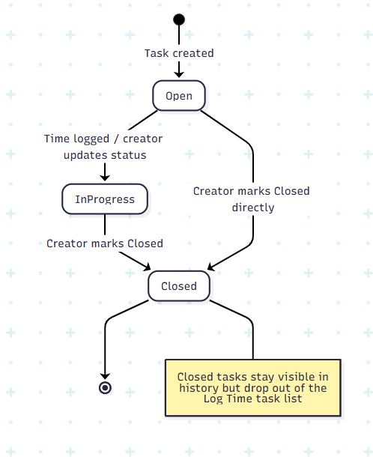
A task starts Open. Logging time against it doesn't automatically change its status — the creator manually moves it to In Progress and later Closed. Closed tasks remain selectable in read-only history views but no longer appear in the Log Time grid.

5.2 Weekly Submission Lifecycle
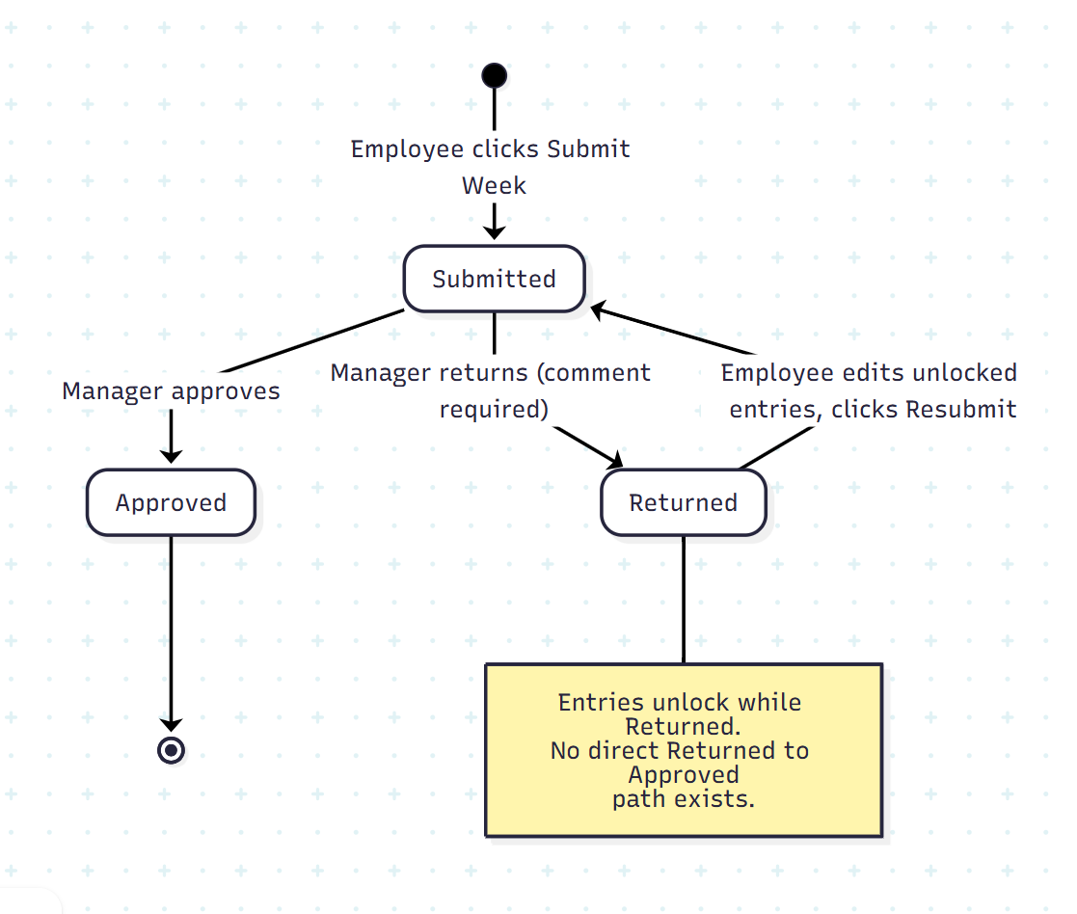
A submission starts as Submitted. The manager moves it to Approved or Returned. If Returned, the employee corrects the relevant entries — which were always editable, since no locking exists — and clicks Resubmit, signalling to the manager that a correction has been made, which sets it back to Submitted for a fresh review. There is no shortcut from Returned directly to Approved — every correction goes through this loop.

6. Data Field Reference

6.1 Task
Field | Type | Required | Source
title | string | Yes | User input
description | string | No | User input
client_id | reference | Yes | User selects from Clients
department_id | reference | Yes | User selects from Departments
priority | enum | Yes | User selects (Low/Medium/High/Urgent)
start_date | date | Yes | User input
deadline | date | Yes | User input
status | enum | System | Open (default) → In Progress → Closed
created_by | reference | System | Current user at creation time
department_name | string | Yes | User input (Director-designated only)
Status | enum | System | active (default) / inactive

6.2 Time Entry
Field | Type | Required | Source
task_id | reference | Yes | User selects from own tasks
date | date | Yes | Any date can be logged against at any time — no restriction based on submission status
hours | number | Yes | User input, 0–10
submission_id | reference | System | Null until bundled into a weekly submission

6.3 Weekly Submission
Field | Type | Required | Source
user_id | reference | System | Current user
week_start_date | date | System | Computed from the week being submitted
status | enum | System | submitted (default) → approved, or → returned → submitted (via Resubmit) → approved
approved_by | reference | System | Set when a manager acts on it
comments | string | Conditional | Required when status is set to Returned

6.4 Audit Log
Field | Type | Required | Source
action | string | System | e.g. "approved", "returned", "resubmitted", "client_created"
entity_type | string | System | e.g. "weekly_submission", "client", "department"
entity_id | reference | System | The specific record affected
performed_by | reference | System | The user who performed the action
timestamp | datetime | System | When the action occurred
details | string | Conditional | e.g. the manager's comment on a Return

7. Notification & Status Indicators
Indicator | Trigger | Where Shown
Submission status badge | Always reflects current status | Dashboard, Submissions screen
Monday reminder banner | Prior week not yet submitted by Monday 6 PM | Employee Dashboard
Manager comment display | Submission status is Returned | Submissions screen only (Dashboard shows just the status badge, not the comment text)

Note: No email or push notifications exist at this stage — in-app indicators only (see PRD, Out of Scope).

8. Error Handling & Edge Cases
Situation | Expected Behavior
SSO login fails or Entra ID unreachable | Generic "Sign-in failed, try again" message; no partial session is created
User's directory data has no manager assigned | Account is created; "Submit Week" is blocked with "No reporting manager assigned — contact an admin" until resolved
Create Task with a missing required field | Inline validation error on the specific field; form does not submit
Delete a task with existing time entries | Blocked with "This task has logged time and cannot be deleted — close it instead"
Non-numeric or negative value in an hours cell | Rejected inline; cell reverts to its last valid value
Daily total would exceed 10 hours | Hard block — the entry is not saved; message explains the cap
Double-click "Submit Week" | Only one weekly_submissions record is created, enforced by a unique index on (user, week); the second attempt is a no-op
Submit a week with zero hours logged | Allowed — a week can legitimately have zero hours (e.g. full-week leave)
Submit a week that's already Submitted or Approved | Blocked — "This week has already been submitted." (A Returned week is submitted again via Resubmit, not Submit Week.)
Manager clicks Return without a comment | Blocked inline — comment field is required before Return is enabled
Manager attempts to act on a submission that isn't their direct report's | Blocked server-side (403) regardless of what the UI shows
Manager attempts to Approve a submission that's currently Returned | Blocked — the button is unavailable; the employee must Resubmit first
Employee clicks Resubmit with no changes made | Allowed — Resubmit only requires status to be Returned; the manager sees it back in their queue regardless
Delete a Client/Department referenced by any task | Blocked with an error — deactivate the Client instead (Departments have no deactivate option, only edit)
Duplicate Client or Department name | Blocked with "A client/department with this name already exists"
JWT expires mid-session | User is redirected to Login on their next action; since entries auto-save on entry, there is no unsaved-work loss
User's manager or designation changes while logged in | Sidebar and permissions reflect the change only on their next login, since directory data is refreshed at login, not live
Uploaded file contains a task title that doesn’t match any existing task owned by the uploader | That row is skipped; listed in the post-upload summary as “Row X skipped: task not found”
Uploaded file contains an hours value exceeding 10 for a given day | That row is skipped; listed as “Row X skipped: exceeds daily hour cap”
Uploaded file is otherwise empty, malformed, or wrong format | Upload rejected entirely with a clear format error – no partial processing attempted
Some rows in the file are valid, others invalid | Valid rows save; invalid rows are skipped and clearly listed – not an all or-nothing rejection

9. Traceability
Every functional requirement in this document maps back to the PRD's Functional Requirements table (Section. 10, FR-01 through FR-19). This section confirms nothing was built without a corresponding PRD requirement, and nothing in the PRD was left unaddressed here.
PRD Requirement | FSD Section(s) | Technical Reference
FR-01 — Company Sign-In | Section. 3.1 Login | GET /auth/sso-callback
FR-02 — Create & Select Tasks | Section. 3.6 My Tasks, Section. 6.1 Task | POST /tasks, GET /tasks
FR-03 — Close Instead of Delete | Section. 3.6 My Tasks, Section. 5.1 Task Lifecycle | PATCH /tasks/{id}
FR-04 — Daily Hours Entry | Section. 3.5 Log Time, Section. 4 Business Rules | POST /time-entries
FR-05 — Daily Logging & Validation | Section. 3.5 Log Time, Section. 4 Business Rules, Section. 5.2 Weekly Submission Lifecycle | POST /time-entries (validation logic)
FR-06 — Weekly Review | Section. 3.8 Approvals | POST /submissions/{id}/approve, POST /submissions/{id}/return
FR-07 — Mandatory Explanation | Section. 3.8 Approvals, Section. 8 Error Handling | POST /submissions/{id}/return (validation)
FR-08 — Fix & Resend | Section. 3.7 Submissions, Section. 4 Business Rules, Section. 5.2 Weekly Submission Lifecycle | POST /submissions/{id}/resubmit
FR-09 — Status Visibility & Reminder | Section. 3.2 Dashboard, Section. 3.7 Submissions, Section. 7 Notifications | GET /submissions/my
FR-10 — Verified Data Only | Section. 3.9 Reports | GET /reports/company-wide
FR-11 — Company-Wide View | Section. 3.9 Reports | GET /reports/company-wide
FR-12 — Managing Clients & Departments | Section. 3.10 Manage Clients, Section. 3.11 Manage Departments | POST/PATCH/DELETE /clients, /departments
FR-13 — Automatic Role Detection | Section. 2 Actors & Roles | Resolved from users.manager_id and users.designation
FR-14 — Audit Logging | Section. 3.8 Approvals, Section. 3.10/3.11 Manage screens, Section. 6.4 Audit Log | Writes to audit_log on every approval/admin action
FR-15 — Manager Routing on Change | Section. 3.8 Approvals, Section. 4 Business Rules | Resolved dynamically from users.manager_id at approval time
FR-16 --- Client Drill-Down | Section. 3.9 Reports | GET /reports/client/{client_id}
FR-17 --- Report Export | Section. 3.9 Reports | GET /reports/company-wide/export
FR-18 --- Manager Escalation | Section. 3.8 Approvals (Notes) | Background job — see Tech Doc §9.1
FR-19 --- Bulk Upload | Section. 3.5 Log Time | POST /time-entries/bulk-upload
FR-20 — Director Self-Approval | Section. 3.8 Approvals (Notes), Section. 4 Business Rules | Auto-approval logic on Submit for Director-designated users; writes to audit_log

