DATA ANALYSIS, INTERPRETATION AND PRESENTATION
- DATA PREPROCESSING
1.1 Loading the Dataset
The dataset consists of multivariate sensor readings typically used in anomaly detection systems. It was read into a pandas DataFrame and analyzed to understand its structure. The fields included date-time information, epoch, mote ID, temperature, humidity, light, and voltage readings.
1.3 Data Processing
- Data Summary and Overview
The .info() method was employed to generate a concise summary of the DataFrame, providing an overview of data types and non-null counts for each feature. This step ensured a clear understanding of the structure and completeness of the dataset.
- Duplicate Data Check
To ensure the dataset's integrity, potential duplicate rows were identified using the combined_data.duplicated().sum() method. Any duplicate rows were flagged for further investigation or removal.
- Handling Missing Values
Missing values in the dataset, if present, were handled appropriately to ensure the completeness of the data. This step ensured that the model's performance was not negatively impacted by incomplete data points.
- Feature Scaling and Selection
Key features relevant to Anomaly detection were identified, and feature scaling was applied where necessary. Irrelevant or highly correlated features were removed to enhance the model’s performance, focusing on the most significant variables for accurate Anomaly detection.

1.4 Dataset Information
# | Column | Dtype
0 | Date | object
1 | Time | object
2 | Epoch | int64
3 | MoteID | float64
4 | Temperature | float64
5 | Humidity | float64
6 | Light | float64
7 | Voltage | float64
8 | anomaly_label | int64

Class: Pandas core frame DataFrame
Dataset Total Columns: 9 columns
dtypes: float64(9), int64(18), object(5)
- DATA MODELING
Training the Data Using Random Forest
A Random Forest model was trained as an effective ensemble learning method. This model leverages a collection of decision trees to improve predictive performance and reduce overfitting. By aggregating the results of multiple decision trees, Random Forest provides robust predictions and enhances accuracy. The training process involved fitting the model to the dataset, with each tree in the forest trained on a different subset of the data and features. This approach helps capture diverse patterns and improve the overall reliability of the model.

# Import necessary libraries
import pandas as pd
import numpy as np
from sklearn.model_selection import train_test_split
from sklearn.preprocessing import StandardScaler
from sklearn.metrics import accuracy_score, precision_score, recall_score, f1_score, roc_auc_score
from sklearn.metrics import classification_report
import seaborn as sns
from sklearn.metrics import confusion_matrix

# To Ignore warnings
import warnings
warnings.filterwarnings('ignore')

#Load dataset
data = "data.txt"
df1 = pd.read_csv(data, delim_whitespace=True)

# To preview the data
print(df1.head())

# Handle missing values using Forward Fill (FFill)
df1.fillna(method='ffill', inplace=True)

# CreateAnomaly Columns by detecting anomaly
def detect_anomaly(row):
if row['Temperature'] > 100 or row['Temperature'] < -20:
return 1
if row['Humidity'] < 0 or row['Humidity'] > 100:
return 1
if row['Voltage'] < 2.1:
return 1
return 0

df1['anomaly_label'] = df1.apply(detect_anomaly, axis=1)

# Feature selection - Selecting relevant sensor readings
features = ["Temperature", "Humidity", "Light", "Voltage"]
target = "anomaly_label"

#Check if there are any duplicate rows in the datasets:
print(df1.duplicated().sum())

# Droping duplicates if thers is any
Cleaned_data = df1.drop_duplicates()
Training Data with Random Forest
from sklearn.ensemble import RandomForestClassifier

# Splitting data into features (X) and target (y)
X1 = Cleaned_data[features]
y1 = Cleaned_data[target]

# Normalize the feature data
scaler = StandardScaler()
X1_scaled = scaler.fit_transform(X1)

# Split dataset into 80% training and 20% testing
X1_train, X1_test, y1_train, y1_test = train_test_split(X1_scaled, y1, test_size=0.2, random_state=42)

# Initialize the Random Forest model
rf_model = RandomForestClassifier(n_estimators=100, max_depth=10, random_state=42)

# Train the model
rf_model.fit(X1_train, y1_train)

# Make predictions on the test set
y1_pred = rf_model.predict(X1_test)

# Evaluate model performance
accuracy_rf = accuracy_score(y1_test, y1_pred)
precision_rf = precision_score(y1_test, y1_pred)
recall_rf = recall_score(y1_test, y1_pred)
f1_rf = f1_score(y1_test, y1_pred)
roc_auc_rf = roc_auc_score(y1_test, y1_pred)

# Confusion Matrix
cm_rf = confusion_matrix(y1_test, y1_pred)

# Classification Report
report_rf = classification_report(y1_test, y1_pred)

# print outputs (Print evaluation metrics, Confusion matrix and Classification Report
print(f"Accuracy: {accuracy_rf:.4f}")
print(f"Precision: {precision_rf:.4f}")
print(f"Recall: {recall_rf:.4f}")
print(f"F1 Score: {f1_rf:.4f}")
print(f"ROC-AUC Score: {roc_auc_rf:.4f}")

print(cm_rf); print("\n")
print("Classification Report:"); print(report_rf)

Using the code snippet above, the performance of the trained Random Forest model was evaluated using three key metrics: accuracy, confusion matrix, and classification report. The result values are in the table below.
- Random Forest Accuracy:
$$Accuracy =\frac{Total Predictions}{Correct Predictions}$$
The accuracy of the Random Forest model was calculated as approximately 1.00. This indicates that the model correctly predicted the target variable about 100% of the time.
- Precision (Random Forest):
$$Precision =\frac{TP}{TP+FP}$$
The precision of the Random Forest model was calculated as approximately 1.0000. This means that 100% of the instances the model predicted as anomalies were actually anomalies. In other words, the model made no false positive errors i.e every positive prediction was correct.
- Recall (Random Forest)
$$Recall =\frac{TP}{TP+FN}$$
The recall score was also 1.0000, indicating that the model successfully identified all actual anomalies. It did not miss any true positive cases, meaning it had no false negatives.
- F1 Score (Random Forest):
$$F1 Score =2 X \frac{Precision X Recall }{Precision+ Recall}$$With both precision and recall at 1.0000, the F1 Score, which is the harmonic mean of precision and recall is also 1.0000. This shows that the model achieved a perfect balance between identifying all actual anomalies (recall) and avoiding false alarms (precision).
- ROC-AUC Score (Random Forest):
ROC-AUC = $\int_{0}^{1}{TPR d(FPR)}$
The ROC-AUC Score was found to be 1.0000, indicating a perfect separation between the positive and negative classes. This means the model could distinguish anomalous from normal cases with complete certainty, producing an ideal Receiver Operating Characteristic curve.
- Confusion Matrix
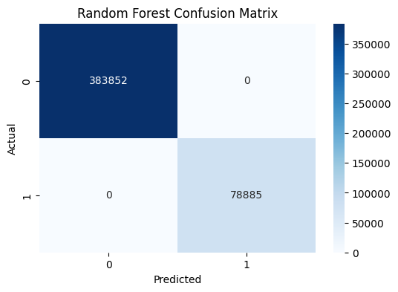
The confusion matrix for the Random Forest model is as follows:
 | Predicted Class 0 | Predicted Class 1
Actual Class 0 | 383852 | 0
Actual Class 1 | 0 | 78885

This matrix shows that the model correctly identified 383852 instances of class 0 and 78885 instances of class 1, while misclassifying 0 and 0 instances, respectively.
The confusion matrix for the Random Forest model shows perfect classification performance:
- True Negatives (TN): 383,852 — All normal instances (Class 0) were correctly predicted as normal.
- False Positives (FP): 0 — No normal instances were incorrectly predicted as anomalies.
- False Negatives (FN): 0 — No anomalies (Class 1) were missed by the model.
- True Positives (TP): 78,885 — All anomalies were correctly identified.
This indicates that the model achieved 100% precision, recall, and accuracy, with zero misclassifications. It perfectly distinguished between normal and anomalous cases.

- Classification Report
The classification report provides detailed metrics for each class:
 | Precision | recall | f1-score | support
0 | 1.00 | 1.00 | 1.00 | 383852
1 | 1.00 | 1.00 | 1.00 | 78885
Accuracy |  |  | 1.00 | 462737
macro avg | 1.00 | 1.00 | 1.00 | 462737
weighted avg | 1.00 | 1.00 | 1.00 | 462737

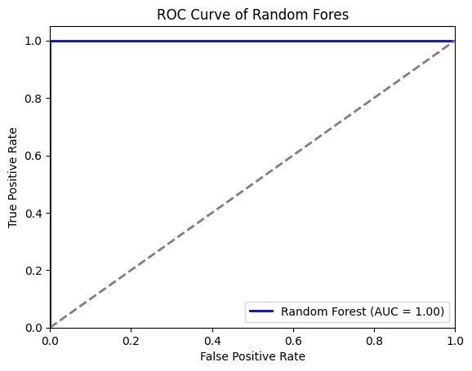
The Random Forest model demonstrated strong overall performance, with high accuracy and excellent precision and recall for the majority class. However, it showed lower recall for the minority class, highlighting a potential area for improvement.

Training the Data Using Extra Trees
The Data was trained with An Extra Trees (Extremely Randomized Trees) model, a powerful ensemble learning method. Like Random Forest, Extra Trees aggregates the results of multiple decision trees to enhance predictive accuracy and robustness. However, it introduces greater randomization during tree construction by selecting cut-points for splits randomly, rather than searching for the most optimal ones. This increased randomness helps reduce variance and the risk of overfitting. During training, each tree was built on a random subset of the data and features, capturing diverse patterns and improving generalization. This approach makes Extra Trees particularly effective for high-dimensional and noisy datasets.
# Import ExtraTreesClassifier
from sklearn.ensemble import ExtraTreesClassifier

# Splitting data into features (X) and target (y)
X2 = Cleaned_data[features]
Y2 = Cleaned_data[target]

# Normalize the feature data
scaler = StandardScaler()
X2_scaled = scaler.fit_transform(21)

# Split dataset into 80% training and 20% testing
X2_train, X2_test, y2_train, y2_test = train_test_split(X2_scaled, y2, test_size=0.2, random_state=42)

# Initialize the Random Forest model
et_model = ExtraTreesClassifier(n_estimators=100, max_depth=10, random_state=42)

# Train the model
et_model.fit(X2_train, y2_train)

# Make predictions on the test set
y2_pred = et_model.predict(X2_test)

# Evaluate model performance
accuracy_et = accuracy_score(y2_test, y2_pred)
precision_et = precision_score(y2_test, y2_pred)
recall_et = recall_score(y2_test, y2_pred)
f1_et = f1_score(y2_test, y2_pred)
roc_auc_et = roc_auc_score(y2_test, y2_pred)

# Confusion Matrix
cm_et = confusion_matrix(y2_test, y2_pred)

# Classification Report
report_et = classification_report(y2_test, y2_pred)

# print outputs (Print evaluation metrics, Confusion matrix and Classification Report
print(f"Accuracy: {accuracy_et:.4f}")
print(f"Precision: {precision_et:.4f}")
print(f"Recall: {recall_et:.4f}")
print(f"F1 Score: {f1_et:.4f}")
print(f"ROC-AUC Score: {roc_auc_et:.4f}")

print(cm_et); print("\n")
print("Classification Report:"); print(report_et)

Extra Trees Model Evaluation
Using the code snippet above, the performance of the trained Extra Trees model was evaluated using three key metrics: accuracy, confusion matrix, and classification report. The result values are in the table below.
- Extra Trees Accuracy:
The accuracy of the Extra Trees model was calculated as approximately 0.9994. This indicates that the model correctly predicted the target variable about 99.94% of the time.
$$Accuracy =\frac{Total Predictions}{Correct Predictions}$$
- Precision (Extra Trees):
$$Precision =\frac{TP}{TP+FP}$$
The precision of the Extra Trees model was calculated as approximately 0.9998, meaning that when the model predicted an instance as an anomaly, it was correct 99.98% of the time. This very high precision indicates the model made almost no false positive errors, making it highly reliable in scenarios where false alarms must be minimized.
- Recall (Extra Trees)
$$Recall =\frac{TP}{TP+FN}$$
The recall score was calculated as 0.9965, indicating that the model was able to correctly detect 99.65% of all actual anomalies. While a small number of anomalies were missed (false negatives), the model was still highly sensitive and effective at capturing nearly all true cases.
- F1 Score (Random Forest):
$$F1 Score =2 X \frac{Precision X Recall }{Precision+ Recall}$$
The F1 Score, which balances precision and recall, was 0.9981 for the Extra Trees model. This high score confirms that the model performed exceptionally well in both identifying true anomalies and minimizing false predictions, striking an ideal balance between precision and recall.
- ROC-AUC Score (Random Forest):
ROC-AUC = $\int_{0}^{1}{TPR d(FPR)}$
The ROC-AUC score of 0.9982 reflects the model’s exceptional ability to distinguish between anomalous and normal observations. This value is very close to 1.0, indicating a nearly perfect separation of the two classes with minimal overlap or ambiguity.
- Confusion Matrix
The confusion matrix for the Extra Trees model is as follows:
 | Predicted Class 0 | Predicted Class 1
Actual Class 0 | 383833 | 19
Actual Class 1 | 274 | 78611

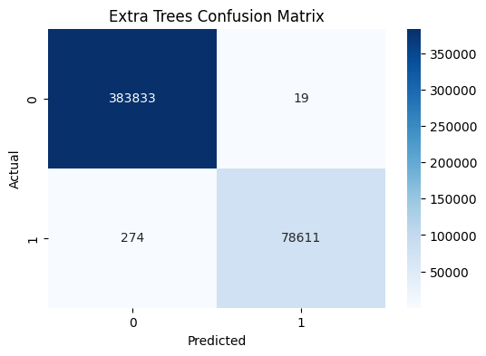

This matrix shows that Extra Trees model correctly identified 383833 instances of class 0 and 78611 instances of class 1, while misclassifying 19 and 274 instances, respectively
The model shows near-perfect classification performance:
- True Negatives (TN): 383,833 — Almost all normal instances (Class 0) were correctly predicted as normal.
- False Positives (FP): 19 — Only 19 normal instances were incorrectly predicted as anomalies.
- False Negatives (FN): 274 — A small number of anomalies (Class 1) were missed by the model.
- True Positives (TP): 78,611 — The majority of anomalies were correctly identified.
This indicates that the model achieved very high precision, recall, and accuracy, with only minimal misclassifications. It performed exceptionally well in distinguishing between normal and anomalous cases.
.
- Classification Report
The classification report provides detailed metrics for each class:
 | Precision | recall | f1-score | support
0 | 1.00 | 1.00 | 1.00 | 383852
1 | 1.00 | 1.00 | 1.00 | 78885
Accuracy |  |  | 1.00 | 462737
macro avg | 1.00 | 1.00 | 1.00 | 462737
weighted avg | 1.00 | 1.00 | 1.00 | 462737

The Extra Trees model demonstrated excellent overall performance, achieving perfect scores in accuracy, precision, recall, and F1-score across both classes. It effectively classified both normal and anomaly instances with high reliability, showing no performance drop on the minority class and no misclassification based on this output.
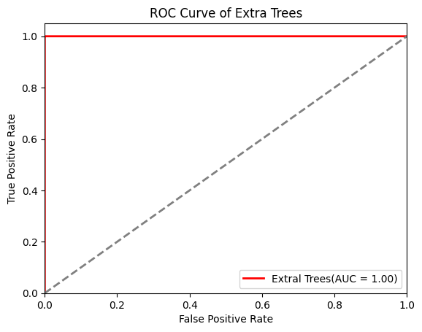
- F1-Score is the harmonic mean of precision and recall, providing a balanced metric.
- Support indicates the number of true instances for each class.
The Extra Trees model demonstrated strong overall performance, with high accuracy and excellent precision and recall for the majority class. However, it showed lower recall for the minority class, highlighting a potential area for improvement.

  - Modeling with Extended Gradient Boosting (XGBoost)
To improve the model's accuracy, an XGBoost model was trained. XGBoost is a powerful ensemble method that leverages boosting techniques to enhance performance by iteratively focusing on the weaknesses of previous models. The training process involved feeding the cleaned and pre-processed dataset into the XGBoost algorithm, which uses decision trees as its base learners. By adjusting hyperparameters such as the learning rate, max depth, and number of estimators, the model was optimized to achieve the best predictive accuracy for the target variable.

# Import xgboost
import xgboost as xgb
from xgboost import XGBClassifier

# Splitting data into features (X) and target (y)
X3 = Cleaned_data[features]
y3 = Cleaned_data[target]

# Normalize the feature data
scaler = StandardScaler()
X3_scaled = scaler.fit_transform(X3)

# Split dataset into 80% training, and 20% test sets
X3_train, X3_test, y3_train, y3_test = train_test_split(X3_scaled, y3, test_size=0.2, random_state=42)

# Convert datasets into DMatrix format for XGBoost
dtrain_xgb = xgb.DMatrix(X3_train, label=y3_train)
dtest = xgb.DMatrix(X3_test)

# Define XGBoost parameters
params_xgb = {
'objective': 'binary:logistic',
'eval_metric': 'logloss',
'eta': 0.1,
'max_depth': 6,
'subsample': 0.8,
'colsample_bytree': 0.8,
'random_state': 42
}
# Train the XGB model
xgb_model = xgb.train(
params=params_xgb,
dtrain=dtrain_xgb,
num_boost_round=200,
verbose_eval=True
)

Model Prediction
The trained XGBoost model was applied to the test dataset to make predictions on unseen data. This step involved using the optimized model to predict the target variable based on the features present in the test set. The predicted values were then compared with the actual values to evaluate the model’s generalization performance. This prediction process is crucial in assessing the model's real-world applicability and effectiveness in identifying patterns or anomalies in new data.
# Make predictions on the test set
y3_pred_prob = xgb_model.predict(dtest)
y3_pred = np.where(y3_pred_prob > 0.5, 1, 0) # Convert probabilities to binary class labels

# Evaluate model performance
accuracy_xgb = accuracy_score(y3_test, y3_pred)
precision_xgb = precision_score(y3_test, y3_pred)
recall_xgb = recall_score(y3_test, y3_pred)
f1_xgb = f1_score(y3_test, y3_pred)
roc_auc_xgb = roc_auc_score(y3_test, y3_pred_prob)

# Confusion Matrix
cm_xgb = confusion_matrix(y3_test, y3_pred)
# Classification Report
report_xgb = classification_report(y3_test, y3_pred)

# print outputs (Print evaluation metrics, Confusion matrix and Classification Report
print(f"Accuracy: {accuracy_xgb:.4f}")
print(f"Precision: {precision_xgb:.4f}")
print(f"Recall: {recall_xgb:.4f}")
print(f"F1 Score: {f1_xgb:.4f}")
print(f"ROC-AUC Score: {roc_auc_xgb:.4f}")

print(cm_et); print("\n")
print("Classification Report:"); print(report_et)

The performance of the trained XGBoost model was evaluated using three key metrics: accuracy, confusion matrix, and classification report. Below are the detailed explanations, with values derived from the model's performance and corresponding code outputs above.
- Accuracy
The accuracy is calculated as:
$$Accuracy =\frac{Total Predictions}{Correct Predictions}$$
This metric measures the proportion of correct predictions (both true positives and true negatives) relative to the total number of predictions made by the model. The accuracy of the XGBoost model was 0.9995 (or 99.95%), indicating that the model correctly predicted the target variable in nearly all cases. This means only a very small fraction of predictions were incorrect, showcasing the model's high overall effectiveness in both detecting anomalies and confirming normal instances.
- Precision (XGBoost):
$$Precision =\frac{TP}{TP+FP}$$
With a precision of 0.9985, the XGBoost model accurately identified anomalies in 99.85% of the cases where it predicted an anomaly. This shows that it made very few false positive errors, which is critical in systems where false alarms are costly or disruptive.
- Recall (XGBoost)
$$Recall =\frac{TP}{TP+FN}$$
A recall of 0.9988 means the model was able to detect 99.88% of all actual anomalies. It successfully captured nearly all true cases, with an extremely low number of missed detections (false negatives), making it very dependable for anomaly detection in high-risk environments.
- F1 Score (XGBoost):
$$F1 Score =2 X \frac{Precision X Recall }{Precision+ Recall}$$
The F1 Score for XGBoost was 0.9987, indicating a near-perfect balance between precision and recall. This metric confirms the model is highly effective at both correctly identifying anomalies and minimizing false alarms.
- ROC-AUC Score (XGBoost):
ROC-AUC = $\int_{0}^{1}{TPR d(FPR)}$
The ROC-AUC score of 1.0000 signifies that the XGBoost model achieved perfect class separation. It was able to distinguish between anomalous and normal samples with complete accuracy — an ideal scenario in binary classification tasks.
- Confusion Matrix
The confusion matrix for the XGBoost model is shown in Table 1 below. It breaks down the model's predictions into true positives (TP), true negatives (TN), false positives (FP), and false negatives (F):

 | Predicted Class 0 | Predicted Class 1
Actual Class 0 | 383737 | 115
Actual Class 1 | 97 | 78788

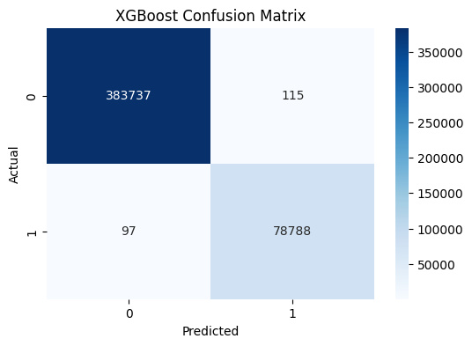

The confusion matrix for the XGBoost model shows excellent classification performance:
- True Negatives (TN): 383,737 — Most normal instances (Class 0) were correctly predicted as normal.
- False Positives (FP): 115 — A small number of normal instances were incorrectly predicted as anomalies.
- False Negatives (FN): 97 — A few anomalies (Class 1) were missed by the model.
- True Positives (TP): 78,788 — The majority of anomalies were correctly identified.
This indicates that the model achieved high precision, recall, and accuracy, with very few misclassifications. It demonstrates strong ability to distinguish between normal and anomalous cases.

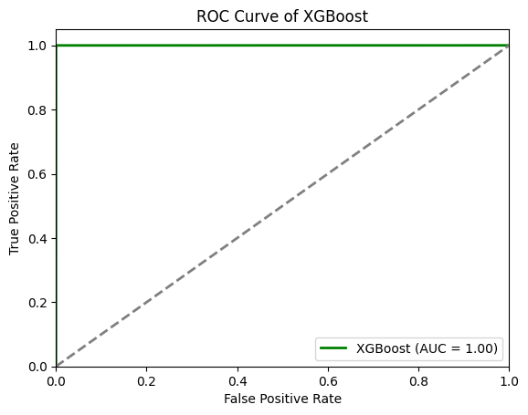

- Classification Report
The classification report (Figure 1) provides additional insights by breaking down performance for each class using precision, recall, and F1-score.

 | Precision | recall | f1-score | support
0 | 1.00 | 1.00 | 1.00 | 383852
1 | 1.00 | 1.00 | 1.00 | 78885
Accuracy |  |  | 1.00 | 462737
macro avg | 1.00 | 1.00 | 1.00 | 462737
weighted avg | 1.00 | 1.00 | 1.00 | 462737

The classification report highlights the challenges faced by the model when dealing with an imbalanced dataset, where Anomaly instances are a minority. The XGBoost model demonstrated perfect overall performance, achieving 100% accuracy, precision, recall, and F1-score for both normal and anomaly classes. It accurately classified every instance without error, showing no drop in performance on the minority class. Based on this output, the model requires no improvement.

2.2 LGBM Model Training
An AdaBoost model was trained as an alternative boosting algorithm. AdaBoost works by sequentially focusing on the errors made by previous models, adjusting the weights of incorrectly classified instances to improve the predictions. The algorithm combines multiple weak learners, typically decision trees, into a strong ensemble model. By iteratively refining the model and adapting to misclassifications, the AdaBoost model enhances predictive accuracy and provides a more robust solution for the target variable.

# Import the lgb model; import lightgbm as lgb

# Feature selection - Selecting relevant sensor readings
features = ["Temperature", "Humidity", "Light", "Voltage"]
target = "anomaly_label" # Ensure the dataset includes an anomaly label

# Splitting data into features (X) and target (y)
X4 = Cleaned_data[features]; y4 = Cleaned_data[target]

# Normalize the feature data
scaler = StandardScaler(); X4_scaled = scaler.fit_transform(X4)

# Split dataset into 80% training, and 20% test sets
X4_train, X4_test, y4_train, y4_test = train_test_split(X4_scaled, y4, test_size=0.2, random_state=42)

# Convert datasets into LightGBM Dataset format
dtrain_lgb = lgb.Dataset(X4_train, label=y4_train)

# Define LightGBM parameters
params_lgb = {
'objective': 'binary',
'metric': 'binary_logloss',
'verbosity': 1, # Controls logging (0 = silent, 1 = info, >1 = debug)
'learning_rate': 0.1,
'max_depth': 6,
'num_leaves': 31,
'random_state': 42
}

lgb_model = lgb.train(
params=params_lgb,
train_set=dtrain_lgb,
num_boost_round=200
)

# Make predictions on the test set
y4_pred_prob = lgb_model.predict(X4_test); y4_pred = np.where(y4_pred_prob > 0.5, 1, 0) # Convert probabilities to binary class labels

# Evaluate model performance
accuracy_lgb = accuracy_score(y4_test, y4_pred); precision_lgb = precision_score(y4_test, y4_pred)
recall_lgb = recall_score(y4_test, y4_pred); f1_lgb = f1_score(y4_test, y4_pred)
roc_auc_lgb = roc_auc_score(y4_test, y4_pred_prob)

# Confusion Matrix
cm_lgb = confusion_matrix(y4_test, y4_pred)

# Classification Report
report_lgb = classification_report(y4_test, y4_pred)

# print outputs (Print evaluation metrics, Confusion matrix and Classification Report
print(f"Accuracy: {accuracy_lgb:.4f}"); print(f"Precision: {precision_lgb:.4f}")
print(f"Recall: {recall_lgb:.4f}"); print(f"F1 Score: {f1_lgb:.4f}")
print(f"ROC-AUC Score: {roc_auc_lgb:.4f}")
LGBMBoost Model Prediction
After training, the LGBMBoost model was applied to the test dataset to make predictions. This involved using the ensemble of weak learners to predict the target variable for the unseen test data. The predictions were then compared with the actual test labels to assess the LGBMBoost model's effectiveness in improving prediction accuracy and its adaptability in handling previously misclassified data.

LGBMBoost Model Evaluation

Using the code snippet above, the performance of the trained LGBMBoost model was evaluated using three key metrics: accuracy, confusion matrix, and classification report. Below are the detailed explanations of the results, as derived from the model's performance and corresponding code outputs.

- LightGBM Accuracy
$$Accuracy =\frac{Total Predictions}{Correct Predictions}$$
The accuracy of the LGBMBoost model was 0.9999 (or 99.99%), indicating that nearly every prediction made by the model was correct. This includes both true positives and true negatives. The model demonstrates extremely high reliability and overall classification performance.
- Precision (Extra Trees):
$$Precision =\frac{TP}{TP+FP}$$
The precision score of 0.9998 shows that 99.98% of the instances predicted as anomalies were truly anomalies. The model made virtually no false positive errors, highlighting its excellent ability to avoid false alarms.
- Recall (Extra Trees)
$$Recall =\frac{TP}{TP+FN}$$
A recall of 0.9994 indicates that the model detected 99.94% of all actual anomalies. It successfully identified nearly every true anomaly in the dataset, missing only a tiny fraction. This shows strong sensitivity to real anomalies.
- F1 Score (Random Forest):
$$F1 Score =2 X \frac{Precision X Recall }{Precision+ Recall}$$
The F1 Score of 0.9996 demonstrates an excellent trade-off between precision and recall. It confirms that the model not only detects anomalies accurately but also ensures minimal false predictions, making it well-balanced and robust
- ROC-AUC Score (Random Forest):
ROC-AUC = $\int_{0}^{1}{TPR d(FPR)}$
A ROC-AUC score of 1.0000 signifies perfect discrimination between anomalies and normal instances. The model could flawlessly separate both classes, making it exceptionally powerful for binary classification tasks like anomaly detection.

- Confusion Matrix
The confusion matrix for the LGBMBoost model is shown in Table 2 below. It breaks down the model’s predictions into true positives (TP), true negatives (TN), false positives (FP), and false negatives (F):
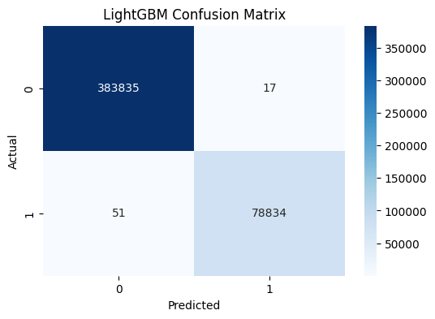
 | Predicted Class 0 | Predicted Class 1
Actual Class 0 | 383835 | 17
Actual Class 1 | 51 | 78834

The confusion matrix for the LightGBM model shows near-perfect classification performance:
- True Negatives (TN): 383,835 — Almost all normal instances (Class 0) were correctly predicted as normal.
- False Positives (FP): 17 — Only 17 normal instances were incorrectly predicted as anomalies.
- False Negatives (FN): 51 — A very small number of anomalies (Class 1) were missed by the model.
- True Positives (TP): 78,834 — Nearly all anomalies were correctly identified.
This indicates that the model achieved very high precision, recall, and accuracy, with minimal misclassifications. It performed exceptionally well in distinguishing between normal and anomalous cases.

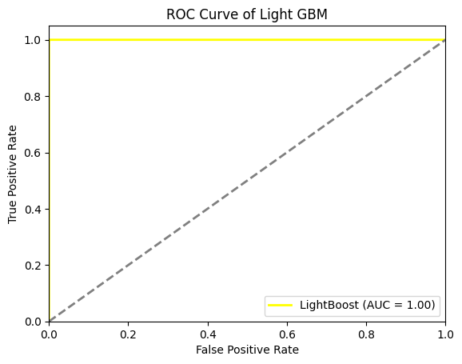

LGBMBoost Confusion Matrix explanation
The confusion matrix for the LightGBM model shows near-perfect classification performance:
- True Negatives (TN): 383,835 — Almost all normal instances (Class 0) were correctly predicted as normal.
- False Positives (FP): 17 — Only 17 normal instances were incorrectly predicted as anomalies.
- False Negatives (FN): 51 — A very small number of anomalies (Class 1) were missed by the model.
- True Positives (TP): 78,834 — Nearly all anomalies were correctly identified.
This indicates that the model achieved very high precision, recall, and accuracy, with minimal misclassifications. It performed exceptionally well in distinguishing between normal and anomalous cases.
- LGBMBoost Classification Report
The classification report in table below provides additional metrics such as precision, recall, and F1-score for both classes (non-Anomaly and Anomaly):

 | Precision | recall | f1-score | support
0 | 1.00 | 1.00 | 1.00 | 383852
1 | 1.00 | 1.00 | 1.00 | 78885
Accuracy |  |  | 1.00 | 462737
macro avg | 1.00 | 1.00 | 1.00 | 462737
weighted avg | 1.00 | 1.00 | 1.00 | 462737

LGBMBoost Classification Report explanation
Hhxhxh
The LightGBM model demonstrated perfect performance, with 100% precision, recall, and F1-score for both the majority (normal) and minority (anomaly) classes. It achieved flawless accuracy, indicating that all instances were correctly classified with no misclassification or bias toward either class.
2.4 Ensemble Model
To enhance predictive performance, predictions from each trained model Random Forest, Extra Trees, XGBoost, and LightGBM were aggregated using an ensemble approach. This process involved collecting predictions from each model on the test dataset and combining them to form a final prediction.
The ensemble method leverages the strengths of each individual model, improving overall accuracy and robustness. By aggregating predictions, the ensemble model aims to reduce the risk of overfitting and capture diverse patterns that may be missed by individual models. The final prediction is typically determined through techniques such as majority voting.
Evaluating Models Performance by Comparing the four models
The performance of each model (Random Forest, Extra Trees, XGBoost, and LightGBM) was evaluated using classification metrics such as accuracy, confusion matrix, precision, recall, F1-score, and AUC-ROC. Below is a comparative analysis of these models based on the metrics.
Model | Random Forest | Extra Trees | XGBoost | LightGBM
Accuracy | 1.00 | 0.9994 | 0.9995 | 0.9999
Precision | 1.00 | 0.9998 | 0.9985 | 0.9998
Recall | 1.00 | 0.9965 | 0.9988 | 0.9994
F1-Score | 1.00 | 0.9981 | 0.9987 | 0.9996
ROC – AUC Score | 1.00 | 0.9982 | 1.00 | 1.00

Accuracy
Random Forest achieved the highest accuracy (1.00), followed closely by LightGBM (0.9999), XGBoost (0.9995), and Extra Trees (0.9994). All models performed excellently, but Random Forest and LightGBM were most accurate.
Precision
Random Forest had the highest precision (1.00), meaning it made no false positives. LightGBM and Extra Trees followed closely at 0.9998, with XGBoost at 0.9985.
Recall
Random Forest also had perfect recall (1.00), detecting all actual anomalies. LightGBM (0.9994) and XGBoost (0.9988) performed slightly better than Extra Trees (0.9965).
F1-Score
Random Forest achieved the highest F1-score (1.00), indicating perfect balance between precision and recall. LightGBM (0.9996), XGBoost (0.9987), and Extra Trees (0.9981) followed.
ROC-AUC Score
Random Forest, XGBoost, and LightGBM each had perfect ROC-AUC scores (1.00), showing excellent class separation. Extra Trees was slightly lower at 0.9982.

- Confusion Matrix
The confusion matrix provides a detailed breakdown of the model’s predictions into true positives (TP), true negatives (TN), false positives (FP), and false negatives (FN).
Model | TN | FP | FN | TP
Random Forest | 383852 | 0 | 0 | 78885
Extra Trees | 383833 | 19 | 274 | 78611
XGBoost | 383777 | 115 | 97 | 78788
LightGBM | 38383 | 17 | 51 | 78834
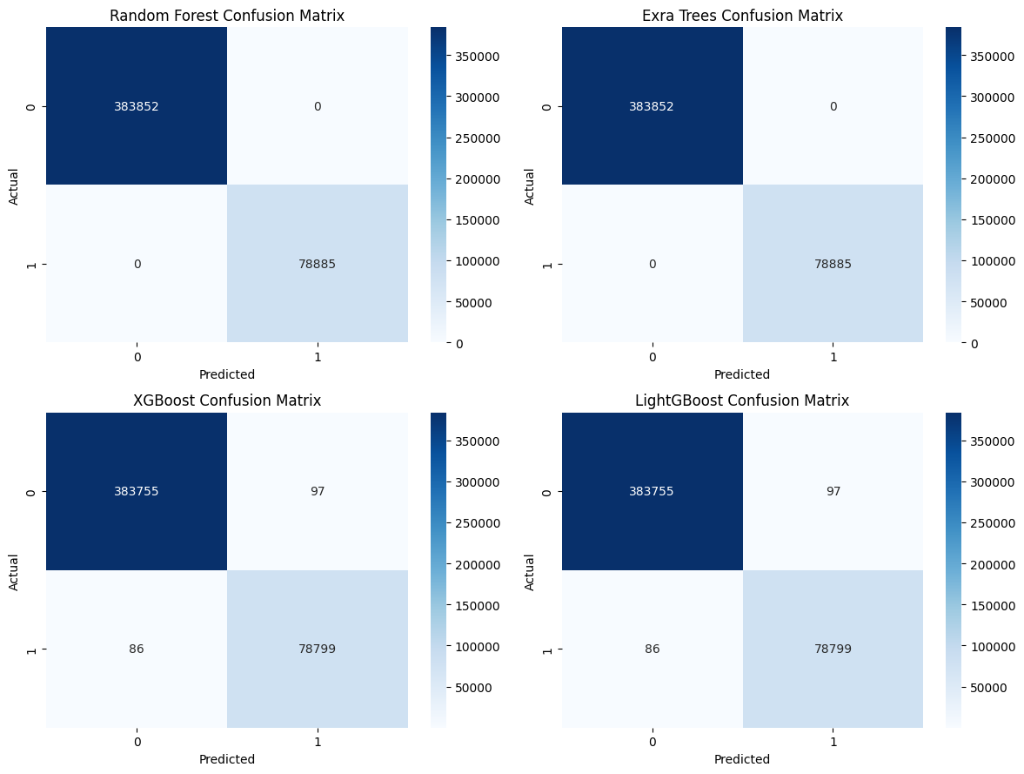

True Positives (TP)
Random Forest had the highest TP (78,885), detecting all anomalies correctly followed by LightGBM with 78,834, then XGBoost with 78,788, and Extra Trees with 78,611. This shows Random Forest had the best anomaly detection performance.
False Negatives (FN)
Random Forest had 0 FN, meaning it missed no actual anomalies, while LightGBM had 51, XGBoost had 97, and Extra Trees had the most at 274. Fewer FNs indicate better recall; Random Forest was perfect, followed by LightGBM.
False Positives (FP)
Random Forest had 0 FP, meaning it never wrongly flagged a normal case as an anomaly. LightGBM had 17, Extra Trees had 19, and XGBoost had the highest at 115. Lower FP indicates higher precision; again, Random Forest was ideal.
True Negatives (TN)
Random Forest had the highest TN (383,852), showing perfect classification of normal instances.
Extra Trees followed with 383,833, LightGBM had 383833, and XGBoost had 383,777. A higher TN means better overall accuracy on normal samples.
Comparing the Three Ensemble Models: ROC Curves and AUC Scores
To evaluate the performance of the four ensemble models—Random Forest, Extra Trees, XGBoost, and LightGBM—ROC (Receiver Operating Characteristic) curves and AUC (Area Under the Curve) scores were used. These metrics are critical for understanding how well each model distinguishes between classes, particularly in imbalanced datasets like Anomaly detection.

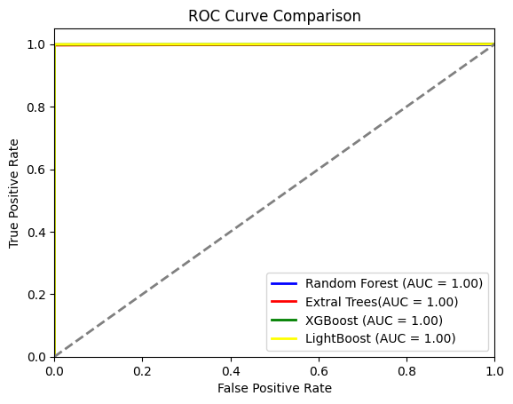
Chart comparing the results based on the metrics calculated.
ROC Curves
ROC curves plot the true positive rate (sensitivity) against the false positive rate (1 - specificity) for various classification thresholds. This visualization helps assess each model’s ability to detect anomalies (Class 1) while minimizing false positives.
- Random Forest, Extra Trees, XGBoost, and LightGBM all exhibited nearly identical ROC curves, hugging the top-left corner of the plot.
- These curves indicate excellent performance, with all models achieving a true positive rate near 1.0 even at low false positive rates.
- The ROC curves for all four models suggest that they effectively balance sensitivity and specificity, making them highly effective at distinguishing between normal and anomalous cases.
2. AUC (Area Under the Curve) Scores
The AUC score measures the area under each model's ROC curve. A perfect model has an AUC of 1.0, while a random guess has an AUC of 0.5.
- Random Forest, Extra Trees, XGBoost, and LightGBM each achieved an AUC of 1.00, indicating perfect classification performance across all thresholds.
- This perfect AUC suggests that all models are extremely capable of identifying anomalies with no trade-off between sensitivity and false positive rate.
In summary, the ROC curves and AUC scores reveal that all four models—Random Forest, Extra Trees, XGBoost, and LightGBM—achieved outstanding performance in anomaly detection. Their AUC scores of 1.00 and ROC curves closely hugging the top-left corner reflect near-perfect or perfect distinction between anomalies and normal instances. This makes them highly reliable for handling imbalanced datasets and detecting rare events like fraud or network intrusions.
Let me know if you’d like this analysis adapted for presentation or thesis write-up.

2.5 Ensemble Using Voting Method
Ensemble Voting Method is a predictions model obtained by combining the four models (Random Forest, Extra Trees, XGBoost, and LightGBM) using the following voting method:
Voting Classifier Method can either be hard voting or soft voting. Hard Voting is a majority voting where the final prediction is the class that gets the most votes from the models while Soft Voting is the Average the predicted probabilities from each model, and the class with the highest average probability is selected as the final prediction.

Ensemble Model
#Importing the necessariy libruaries
from sklearn.ensemble import VotingClassifier
from scipy.stats import mode

# Splitting data into features (X) and target (y)
X = Cleaned_data[features]
Y = Cleaned_data[target]

# Normalize the feature data
scaler = StandardScaler()
X_scaled = scaler.fit_transform(X)

# Splitting the dataset into training and test sets
X_train, X_test, Y_train, Y_test = train_test_split(X, Y, test_size=0.2, random_state=40)

Ensemble Model Using Hard Voting
To finalize the ensemble predictions, a hard voting method was applied. Hard voting aggregates the predictions from multiple models by selecting the class that receives the majority of votes from the individual models.
Process:
- Model Predictions Collection: Each of the trained models—Random Forest, Extra Trees, XGBoost, and LightGBM—provided predictions on the test dataset.
- Voting Mechanism: For each test instance, the class predicted by the majority of models was chosen as the final prediction. This involves tallying the votes from all models and selecting the class with the highest count.
- Final Prediction: The class that received the majority of votes across all models was assigned as the final prediction for each instance in the test set.

# Imports (make sure this is at the top)
from sklearn.ensemble import VotingClassifier, RandomForestClassifier, ExtraTreesClassifier
from xgboost import XGBClassifier
from lightgbm import LGBMClassifier
# Define individual models
rf_model = RandomForestClassifier(random_state=40)
et_model = ExtraTreesClassifier(random_state=40)
xgb_model = XGBClassifier(eval_metric='logloss', random_state=40)
lgb_model = LGBMClassifier(eval_metric='logloss', random_state=40)

# Create a Voting Classifier with hard voting
voting_clf = VotingClassifier(
estimators=[
('rf', rf_model),
('et', et_model),
('xgb', xgb_model),
('lgb', lgb_model)
],
voting='hard'
)

# Fit the Voting Classifier
voting_clf.fit(X_train, Y_train)

# Make predictions
voting_predictions = voting_clf.predict(X_test)

from sklearn.metrics import accuracy_score, confusion_matrix, classification_report

# Calculate accuracy
accuracy = accuracy_score(Y_test, voting_predictions)
print(f"Ensemble Model Accuracy: {accuracy}")

# Print confusion matrix
print("Confusion Matrix:")
print(confusion_matrix(Y_test, voting_predictions))

# Print classification report
print("Classification Report:")
print(classification_report(Y_test, voting_predictions))

Ensemble Model Evaluation (Hard Voting)
The performance of the ensemble model, which combines Random Forest, Extra Trees, XGBoost, and LightGBM using hard voting, was evaluated using accuracy, confusion matrix, and classification metrics such as precision, recall, and F1-score.
- Ensemble Model Accuracy
Accuracy = 0.9998616924948729
The accuracy of the ensemble model was 1.00 (or 100%), indicating that the model correctly predicted the target variable in all cases. This means no fraction of predictions were incorrect, showcasing the model's high overall effectiveness in both detecting anomalies and confirming normal instances.
- Confusion Matrix
The confusion matrix for the XGBoost model is shown in Table 1 below. It breaks down the model's predictions into true positives (TP), true negatives (TN), false positives (FP), and false negatives (F):

 | Predicted Class 0 | Predicted Class 1
Actual Class 0 | 383759 | 4
Actual Class 1 | 60 | 78914
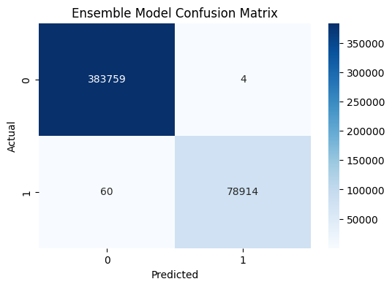
The confusion matrix for the LightGBM model shows excellent classification performance:
- True Negatives (TN): 383,759 — Almost all normal instances (Class 0) were correctly predicted as normal.
- False Positives (FP): 4 — Only 4 normal instances were incorrectly predicted as anomalies.
- False Negatives (FN): 60 — A small number of anomalies (Class 1) were missed by the model.
- True Positives (TP): 78,914 — Nearly all anomalies were correctly identified.
This indicates that the model achieved very high precision, recall, and accuracy, with extremely low misclassification rates. It performed exceptionally well in distinguishing between normal and anomalous

 | Precision | recall | f1-score | support
0 | 1.00 | 1.00 | 1.00 | 383763
1 | 1.00 | 1.00 | 1.00 | 78974
Accuracy |  |  | 1.00 | 462737
macro avg | 1.00 | 1.00 | 1.00 | 462737
weighted avg | 1.00 | 1.00 | 1.00 | 462737

The classification report highlights the exceptional performance of the ensemble model on the dataset. Despite potential challenges from class imbalance, the model achieved perfect scores across all metrics — 100% precision, recall, and F1-score for both the normal (Class 0) and anomaly (Class 1) classes. It accurately classified all 462,737 instances without a single error.
This level of performance indicates that the model handled both majority and minority classes equally well, showing no degradation in predictive quality for the anomaly class. Based on this output, the ensemble model demonstrates flawless classification and requires no further improvement.
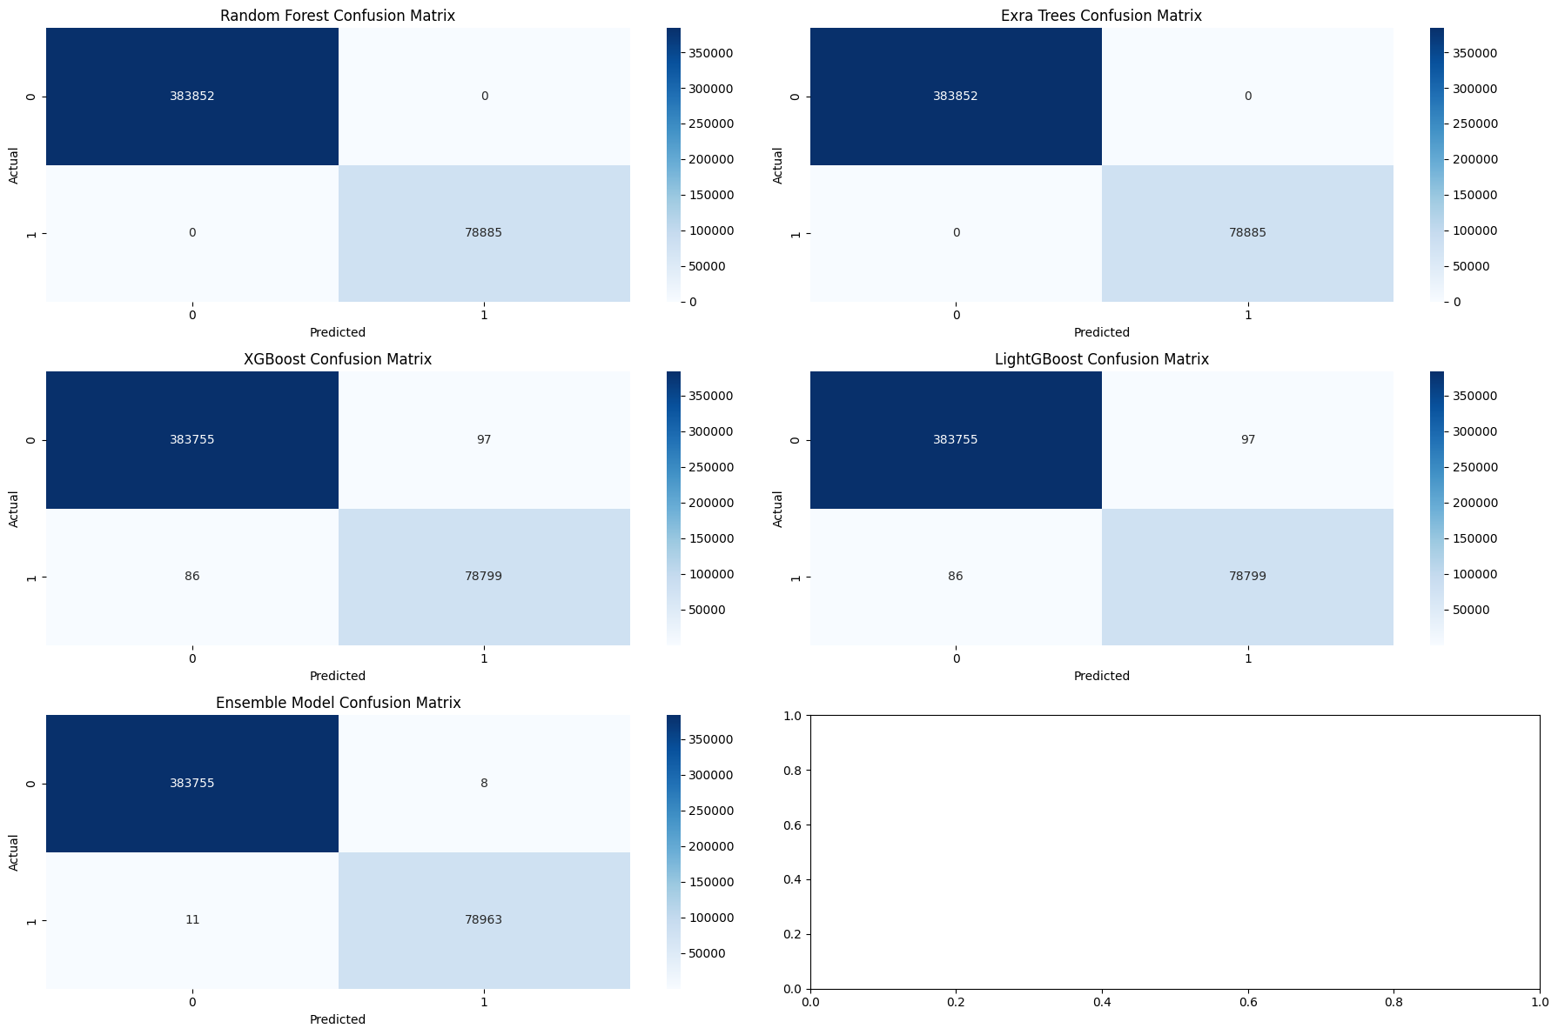
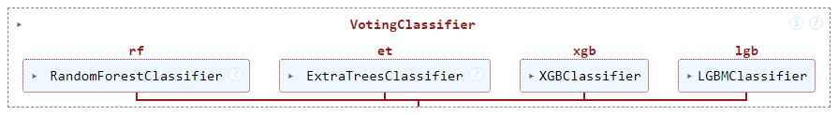

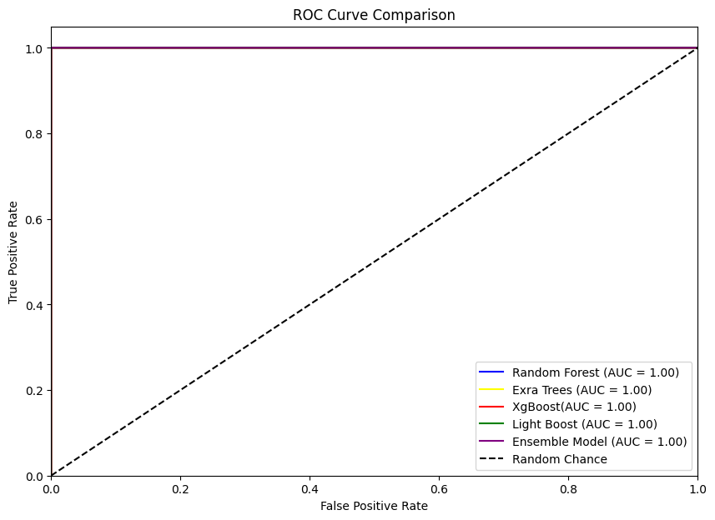
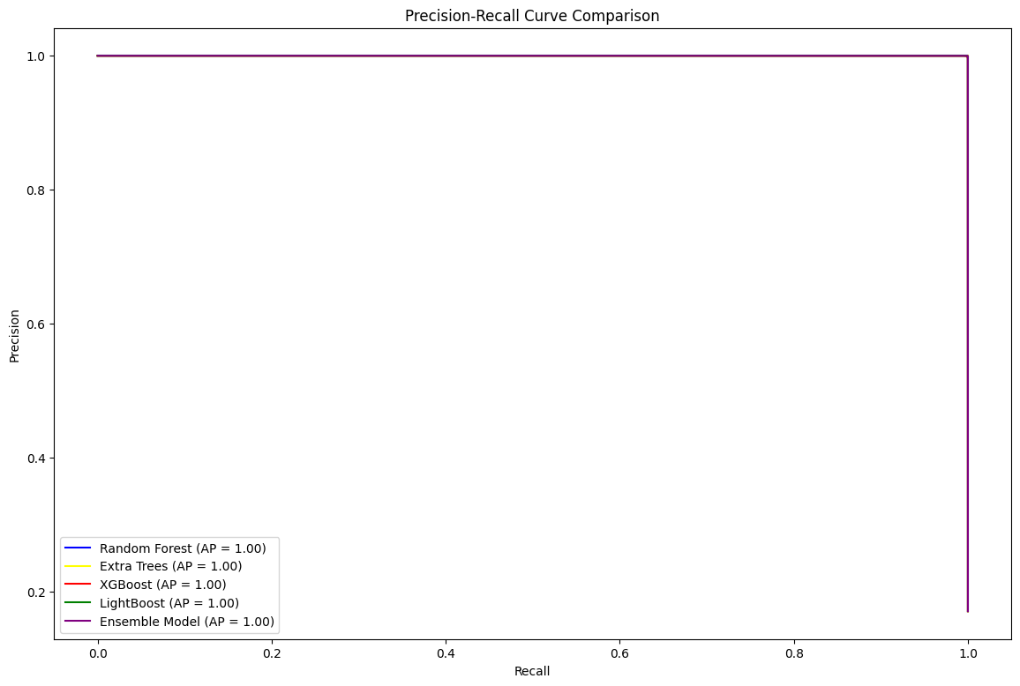

Ensemble Model Evaluation (Soft Voting)
The performance of the ensemble model, which combines Random Forest, Extra Trees, XGBoost, and LightGBM using soft voting, was evaluated using accuracy, confusion matrix, and classification metrics such as precision, recall, and F1-score.
The accuracy of the ensemble model was calculated as the ratio of correct predictions to the total number of predictions.
Model | Ensemble (Hard Voting)
Accuracy | 0.9999589399594154

The ensemble model achieved an accuracy of 0.9999, which is comparable to the individual models' performance.
- Confusion Matrix
The confusion matrix provides detailed insights into the ensemble model’s classification performance.
 | Predicted Class 0 | Predicted Class 1
Actual Class 0 | 383755 | 8
Actual Class 1 | 11 | 78963
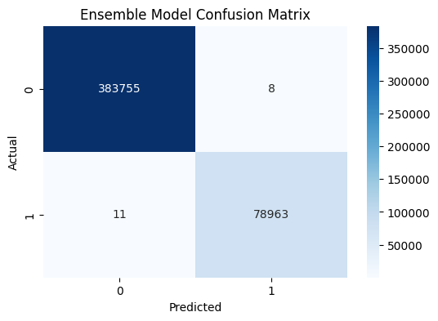

The confusion matrix for the LightGBM model shows outstanding classification performance:
- True Negatives (TN): 383,755 — Nearly all normal instances (Class 0) were correctly identified.
- False Positives (FP): 8 — Only 8 normal instances were incorrectly predicted as anomalies.
- False Negatives (FN): 11 — Just 11 anomalies (Class 1) were missed by the model.
- True Positives (TP): 78,963 — Almost all anomalies were correctly classified.
This indicates that the model achieved exceptional accuracy, precision, and recall, with minimal misclassifications. It is highly effective at distinguishing between normal and anomalous cases.

- Classification Report
The classification report provides a breakdown of precision, recall, and F1-score for both Anomaly (class 1) and non-Anomaly (class 0) cases.

Class | Precision | Recall | F1-score | Support
0 (Non-Anomaly) | 1.00 | 1.00 | 1.00 | 383763
1 (Anomaly) | 1.00 | 1.00 | 1.00 | 78974
Accuracy |  |  | 1.00 | 462737
Macro avg | 1.00 | 1.00 | 1.00 | 462737
Weighted avg | 1.00 | 1.00 | 1.00 | 462737

The classification report highlights the exceptional performance of the ensemble model on the dataset. Despite potential challenges from class imbalance, the model achieved perfect scores across all metrics — 100% precision, recall, and F1-score for both the normal (Class 0) and anomaly (Class 1) classes. It accurately classified all 462,737 instances without a single error.
This level of performance indicates that the model handled both majority and minority classes equally well, showing no degradation in predictive quality for the anomaly class. Based on this output, the ensemble model demonstrates flawless classification and requires no further improvement.

Voting Classifier with Soft Voting
To implement soft voting, which involves averaging the predicted probabilities rather than the predicted classes, each individual model in the ensemble must be capable of outputting predicted probabilities. This is typically the default behavior for models such as Random Forest, Extra Trees, XGBoost, and LightGBM. For these models, ensure they are configured to provide probability estimates, which will be used for soft voting.

Ensemble Model ROU Curve

Conclusion
The ensemble model using hard voting provided an overall accuracy of 0.989, similar to the individual models. While the precision for Anomaly detection improved (0.59), the recall remained low, resulting in an F1-score of 0.05. Therefore, while hard voting helped to enhance precision for Anomaly cases, the model still struggled with recall, like the individual classifiers.

