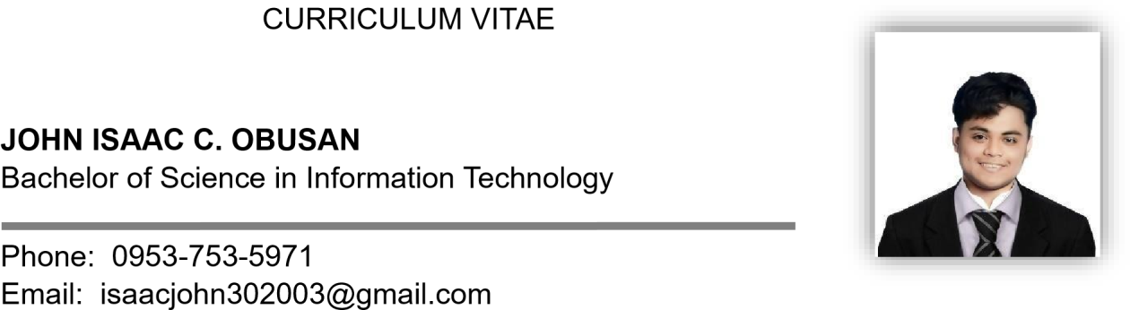

Address: #1 Romero St. Vinzons, Camarines Norte Birthday: July 04, 2003

Place of Birth: #1 Romero St. Vinzons, Camarines Norte Language Spoken: Bicol (Provincial Dialect), Filipino and English

# QUALIFICATIONS

* Outstanding JC Media Committee
* Appcon 2023 Participant
* DMJ 3rd Film Festival : Best in Visual Effects
* With High Honors: Senior High School Level
* With Honors: Junior High School Level

# SKILLS AND KNOWLEDGE

* Frontend Development.
* UI/UX.
* Python.
* React Typescript.
* Vb.net.
* Videography .
* Photography.
* Photo Editing.
* Video Editing.
* Graphic Design.
* Blender.
* Adobe Photoshop.
* Adobe Premiere Pro.
* After Effects.
* Figma.
* Encoding.
* Strong work ethic
* Communication Skills.
* Eager to learn and adapt to new tools, technologies, and workflows.

# EDUCATIONAL ATTAINMENT

## TERTIARY : Bachelor of Science in Information Technology

Camarines Norte State College

S.Y. 2022-Present

## SECONDARY : Vinzons Pilot High School

Vinzons, Camarines Norte

S.Y. 2016-2022

## PRIMARY : Howard Montessori School

Daet, Camarines Norte

S.Y. 2010-2016

# SEMINARS AND TRAININGS ATTENDED

## i-Konek From Scroll to Skill

Our Lady of Lourdes College Foundation March 14, 2025

## Creatives Seminar on Porfolio Making

Camarines Norte State College March 11, 2025

## Udemy: Figma & Beyond : Mastering UX UI Design Tools Smartly

https://[www.udemy.com](http://www.udemy.com/) June 9,2025

## Video Editing Basics

https://olympus.mygreatlearning.com May 22,2025

## Introduction to Typescript

https://olympus.mygreatlearning.com June 10,2025

## Common UX mistakes that kill conversations

Interaction Design Foundation July 13,2025

# WORK EXPERIENCES

## Student Assistant

Camarines Norte State College - Information Technology Services Office May 2023 to July 2023

## JC Media Committee

Camarines Norte State College – Institute of Computer Studies Student Government

S.Y 2022-2023

## Freelancer

Multimedia Specialist / Frontend Developer June 2023 to Present

## Gas Boy

Big Boss Gas Station – Daet Camarines Norte April 2023 to May 2023

# REFERENCE

## Raymond Zaratar

Head

Camarines Norte State College Information Technology Services Office Daet, Camarines Norte

## Daniel E. Maligat JR, DIT

ICS Director

Camarines Norte State College

College of Computing and Multimedia Studies

## Jayferson Liwag Aceron

School Head

Kabatuhan Integrated School Labo, Camarines Norte

## Angelie Hernandez

Contractor

Daet, Camarines Norte