CNQ User Manual
Quick guide for local censored quantile modeling
Start the app, train and save a model, then predict new subjects or project population trends. CNQ runs on your computer and uses a browser as its interface.
After CNQ starts, routine use does not require Python programming.
For company data. Follow your organization's approved software, storage, privacy, and model validation procedures.

1 Start CNQ
The same startup procedure applies on Windows, macOS, and Linux. The first run installs the required packages and can take several minutes.
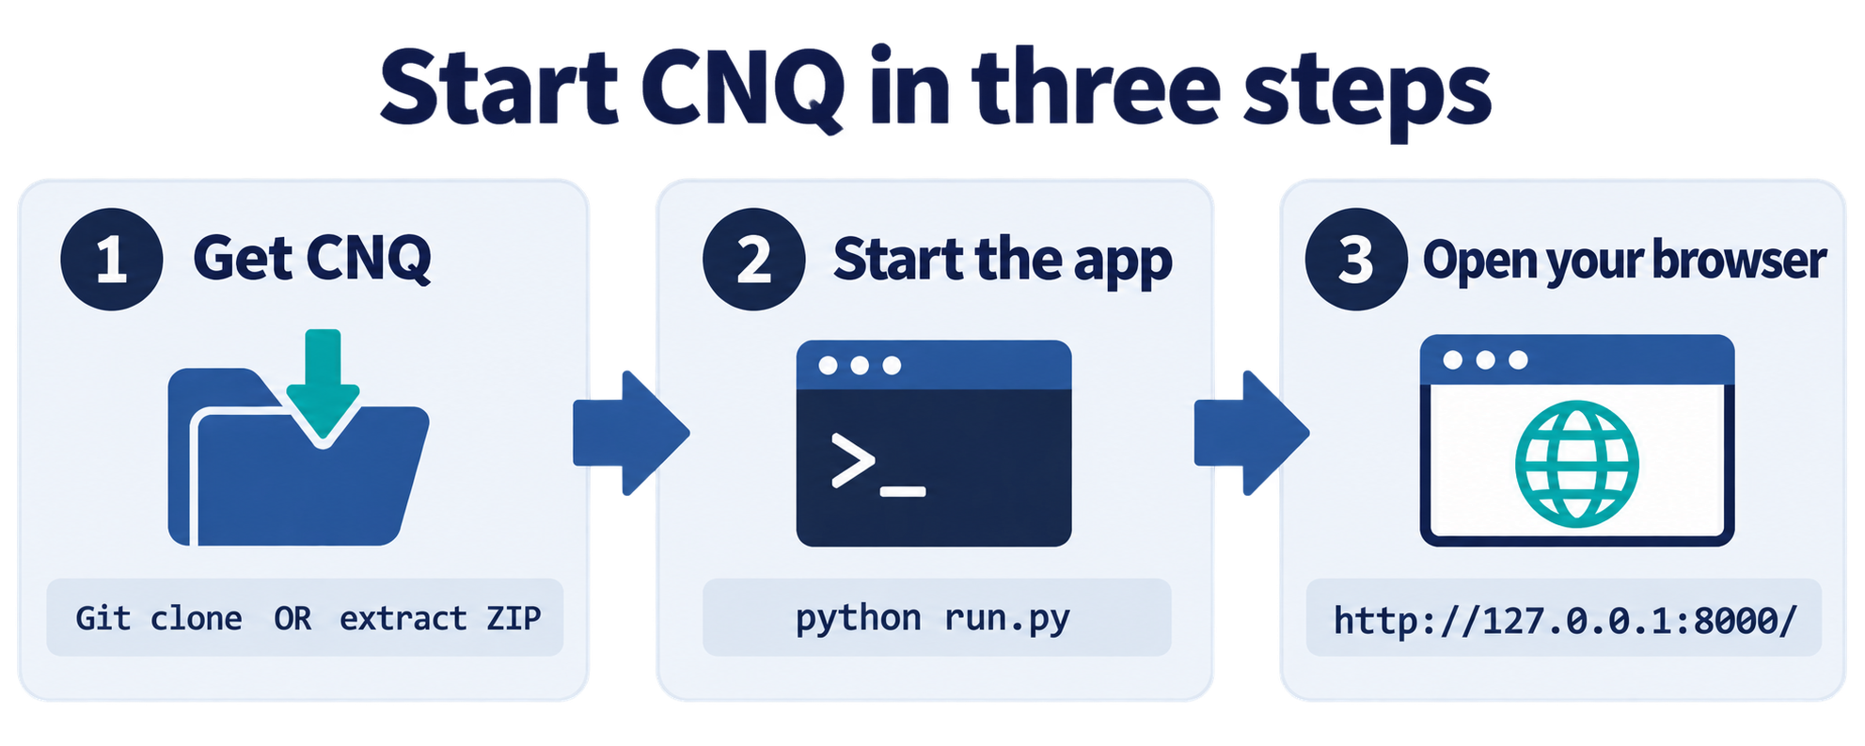
Figure 1. Start CNQ in three steps.

1 1 Obtain the app
- Approved zip: extract the full deepquant package to a local folder that is not synchronized by OneDrive, iCloud, or Dropbox.
- GitHub: clone recursively so the deepcnq submodule is included.
git clone --recursive https://github.com/IsaacPan1/Deepcnq_app
Do not use GitHub Download ZIP for the source repository because it may omit the deepcnq submodule.

1 2 Go to the app folder and run CNQ
Open Terminal on macOS or Linux, or PowerShell or Command Prompt on Windows.
Easiest method. Type cd followed by one space. Drag the Deepcnq_app folder from File Explorer or Finder into the terminal, then press Enter.
cd
Or type the folder path. Put quotation marks around the path, especially when a folder name contains spaces.
cd "C:\Users\YourName\Downloads\Deepcnq_app"
Once the terminal is inside the main Deepcnq_app folder, copy and run:
cd cnq_app
python run.py
The first time you run CNQ, allow 5-10 minutes for packages to download and wait until the terminal prompts you to open http://127.0.0.1:8000/.
To stop CNQ. Return to the terminal and press Ctrl+C.

1 3 Google Cloud (Vertex AI Workbench)
CNQ runs the same way on a Vertex AI Workbench instance. The browser and the app are just on different machines, connected through Google's notebook proxy, so starting it takes one extra step.
1. Google Cloud Console, Vertex AI, Workbench. Select the instance, start it if it is stopped, and click Open JupyterLab.
2. First time only: open a terminal in JupyterLab (File, New, Terminal) and clone the app with the same command as step 1 1.
3. From that terminal: cd Deepcnq_app/cnq_app, then python run.py 8000.
4. Open the app at the same JupyterLab address with /lab replaced by /proxy/8000/, keeping the trailing slash.
From here CNQ works exactly as described below, with one difference: the upload box cannot reach files on your laptop, because the browser and the app are not on the same machine. Upload the CSV into JupyterLab's own file browser first (the upload icon, or drag it in), right-click the file and choose Copy Path, then paste that path into CNQ's "or paste a file path" field next to the upload box and press Enter. See 2 1 Loading your data.

2 Prepare your data
Upload one CSV file with one header row and one row per subject. The app provides a sample dataset and a downloadable template.
- Follow up time: a positive number using one consistent unit, such as days or months.
- Event: 1 for an observed event and 0 for censoring, or two values that you map in CNQ.
- Covariates: numeric predictors. Represent categories with numeric indicator columns.
- Subject ID: an optional unique label that CNQ does not use as a predictor.
- Do not leave blank cells in selected columns, and keep one row per subject.
- Aim for about 100 observed events and at least 10 events in each data split.

2 1 Loading your data
Two ways to get a CSV into CNQ, available on both the Train and the Predict tab:
- Drag the file into the upload box, or click it to browse for the file.
- Or paste a file path into the "or paste a file path" field next to the upload box and press Enter. CNQ reads the file directly from disk on the machine it is running on.
The path field is the only option on Google Cloud Workbench, since the upload box there cannot reach your laptop's files (see 1 3). It is also useful for a large local file, since it has no upload size limit.

2 2 Local storage and privacy
CNQ runs locally, but uploaded files are not temporary. Training, prediction, and cohort CSV files are copied to cnq_app/jobs/uploads. Recent run folders under cnq_app/jobs also contain reports, plots, predictions, model artifacts, and result zip files. A training result zip includes a copy of the uploaded data named input_data.csv.
CNQ keeps the 20 most recent run folders by default, but uploaded files are not removed automatically. Treat the CNQ folder as containing company data and follow your organization's retention and deletion procedures.

3 Train and save a model
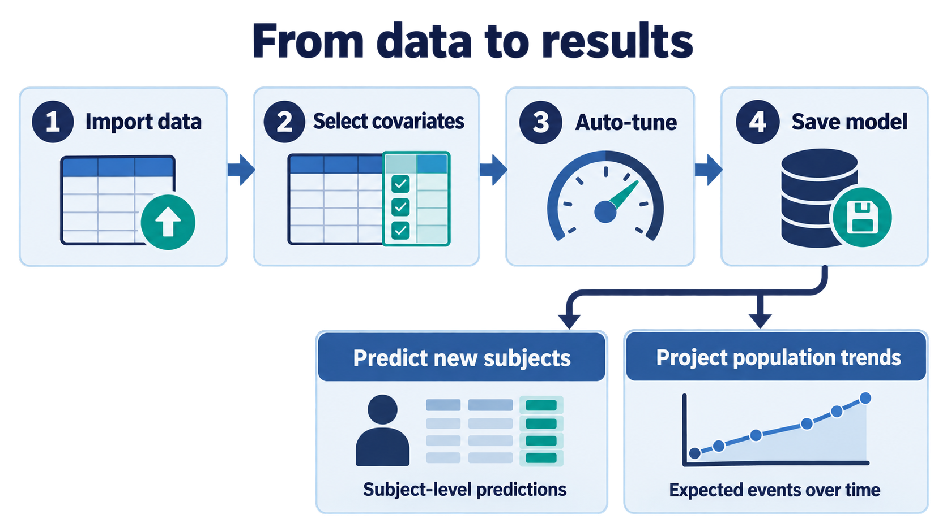
Figure 2. The standard CNQ workflow.
1. Import the training CSV on the Train a model tab.
2. Select the follow up time, event, optional subject ID, and numeric covariates.
3. Leave Auto-tune selected and choose Standard search effort for a typical analysis.
4. Select Find best settings, review the leaderboard, and select Use best settings.
5. Select Start training, resolve any validation warnings, and review the results.
6. When training finishes, select Save model, choose what to save, enter a name, and save it.
Training and Auto-tune do not automatically create a reusable model. Save model writes a self-contained .cnqmodel file to cnq_app/models. It remains available after restarting CNQ and appears in Predict and Project. If it is not listed, select Refresh list.
Saved models are not pruned with old runs. Download and archive any approved model that must be retained outside the app folder.

3 1 Model choices
Model | Use
KAN CNQ | Standard numeric tabular option. Included in Auto-tune.
MLP CNQ | Numeric tabular baseline. Included in Auto-tune.
Trans CNQ or TransKAN CNQ | Advanced option for approved numeric features derived from text or annotations, when attention is scientifically justified.

Advanced settings. Use them only when the analysis plan requires specific model or hyperparameter values. Raw text is not accepted; convert it to approved numeric covariates before creating the CSV.

4 Predict new subjects
1. Choose a saved model or upload a .cnqmodel file.
2. Upload a CSV containing the new subjects.
3. Confirm that every model feature is mapped to the correct column. Use the model template if names do not match.
4. Optionally select an ID column. Select time and event only when known outcomes are available for external validation.
5. Run prediction and download the predictions CSV, HTML report, or results zip.
- The median and interval describe outcome variation among similar subjects, not uncertainty in the fitted model parameters.
- An out_of_range value of 1 means at least one covariate is outside its training range and the prediction is an extrapolation.
- External validation must use subjects that were not used for training or model selection.

5 Project population trends
Use Project trends for aggregate questions such as expected events by a time or the time required to reach a target number of events.
Projection basis | What CNQ uses
Population size N | The training population Kaplan Meier curve, scaled to N subjects. CNQ does not simulate covariates in this mode.
Uploaded cohort | The uploaded subjects and their mapped covariates. Use this when the cohort mix differs from the training population.

Sample cohort button. Select Upload a cohort and then Use simulated sample cohort to load 20 simulated rows with the columns expected by the selected model.
1. Choose the model and projection basis.
2. Enter one or more time points or a target number of events.
3. Run the projection and review the cumulative event curve and uncertainty band.
4. Download the projection CSV, report, or results zip.
CNQ projects only through the last observed event time in the training data. Times or targets beyond that follow up horizon are flagged and not extrapolated.

6 Interpret results safely
- Predictions assume that new subjects resemble the training population. A different site, era, protocol, or inclusion rule can reduce calibration.
- Quantile intervals and projection bands describe outcome variation; neither represents every source of model parameter uncertainty.
- Out of range subjects require additional review, and external validation must use subjects not used for training or model selection.
- Company use requires an approved validation plan and independent assessment on relevant data.

7 Optional simulated demo
The demo is optional, does not open automatically, and is not required each time CNQ starts. All demo records are simulated.
1. On Train a model, select Use demo training data and start training.
2. On Predict new subjects, choose Demo model simulated data. Build it first if prompted.
3. Load 20 new patients and run prediction. The larger demo cohorts illustrate external validation and population shift.

8 Troubleshooting
Problem | Action
Python is not found | Install Python 3.11, open a new terminal, and try python run.py or python3 run.py.
Packages fail to install | Check the internet connection and run python run.py --reinstall.
Port 8000 is in use | Run python run.py 8001 and open http://127.0.0.1:8001/.
Page is unformatted | Use the exact local address and hard refresh with Ctrl+Shift+R or Cmd+Shift+R.
Projection is unavailable | Save or rebuild the model with the current CNQ version so it includes the training curve.
Workbench: blank page or 404/Init failed error | Use the address ending in /proxy/8000/ with the trailing slash, not /lab, then hard refresh with Ctrl+Shift+R.
Workbench: Could not load that path | The path must point to a file already uploaded into JupyterLab on the Workbench instance, not a path on your laptop. See 1 3.

9 Update a GitHub copy
This applies only to Git clones. Stop CNQ and run the following commands from cnq_app:
cd ..
git pull --recurse-submodules
For an approved zip release, use your organization's approved update process.

