ASSIGNMENT COVER SHEET

Student’s name | Isaac | Patrickson
Module name | Software Engineering and Agile
Title of assignment | Final submission point: Software Engineering and Agile end-of-module assessment
Complete Word Count in my assignment | 2168
Date submitted | 11/07/2025

All work must be submitted by the due date. If an extension of time to submit work is required, a Mitigating Circumstances Extension Form must be submitted.
https://canvas.qa.com/courses/1041

Has an extension been approved? Yes No If yes, please give the new submission date: 11/07/2025

IMPORTANT: THIS STATEMENT MUST BE READ & SIGNED

Academic Integrity Statement

Academic integrity and honesty are fundamental to the academic work you produce at the University of Roehampton. You are expected to complete coursework that is your own and which is referenced appropriately. The university has in place measures to detect academic dishonesty in all its forms. If you are found to be cheating or attempting to gain an unfair advantage over other students in any way, this is considered academic misconduct and you will be penalised accordingly.
​
I declare that the work I am submitting is my work, is properly referenced and has not been submitted elsewhere.

Student Signature (Full Name): Isaac Patrickson

Date: 11/07/2025
Summary of Reasonable Adjustments | Please note that I have a summary of reasonable adjustments in place, including considerate marking. This can be confirmed with the DA Specialist Learning Support team. DASpecialist.learningteam@qa.com

Table of Contents
Task 1 5
Problem Statement 5
Scope 5
Application Summary 5
Dependencies 5
Data Models 6
Design Considerations 7
User Manual 7
Admin User Credentials 7
Limited Permissions Credentials 7
Account Disabled Credentials 7
Links 7
Task 2 8
Scrum Sprint Boards 8
Agile Diary 10
Test-Driven Development 11
Task 3 12
Chosen Framework: Scrum Overview 12
Comparison and Critical Analysis: Scrum vs Kanban vs Lean (at Mediaworks) 12
Agile Framework Differences 12
Workflow and Predictability 12
Process Improvement and Fit 12
Roles and Accountability 13
Metrics and Tracking 13
Conclusion: Scrum’s Fit for Mediaworks 13
Improvement for Mediaworks: Scrumban 14
Implementation Strategy 14
References 15
Appendices 17
Appendix A – Screenshot of the Constraints Section in a Functional Specification for the Nichol Associates Project 17
Appendix B – Screenshots of Sprint 1 and Sprint 2 Backlog and Burndown Charts in Jira 18
Appendix C – Screenshots of Seaward and WordPress’ custom CMS login page and dashboard 19
Appendix D – Assistive Screenshots for the Register Journey Section within the README.md in the CRMS Bitbucket Repository 20
Appendix E – Assistive Screenshots for the Limited User Login Journey and CRU Actions Section within the README.md in the CRMS Bitbucket Repository 21
Appendix F – A restricted user (is_staff = False) journey 22
Appendix G – Assistive Screenshots for the Admin User Login Journey and CRUD Actions Section within the README.md in the CRMS Bitbucket Repository 23
Appendix H – Assistive Screenshots for the Logout Journey Section within the README.md in the CRMS Bitbucket Repository 25

Table of Figures
Figure 1: Entity Relationship Diagram showing the custom tables in the PostgreSQL database. 6
Figure 2: Empty Jira sprint board demonstrating the column structure 9
Figure 3: Jira view of Epic 2: Client Management, displaying all completed story tickets. 9
Figure 4: Jira ticket marked [COVERED BY DJANGO]. A quick win ticket. 9
Figure 5: Jira story ticket with subtasks showing a feature broken down into granular tasks. 9
Figure 6: Jira story ticket linked to a Bitbucket commit. 9
Figure 7: Agile Diary Calendar in Notion showing the week Sprint 1 started. 10
Figure 8: Agile Diary Entry for the 18/06/2025. 10
Figure 9: Screenshot of the tests/ directory in the Bitbucket repository. 11
Figure 10: Example test case from test_user_registration_form.py. 11

Task 1

Problem Statement
Mediaworks required a lightweight client request tracker to support their in-house development team. The need arose after many instances of missed tasks resulted in client dissatisfaction. The goal was to ensure nothing was overlooked by providing a simple interface for logging and monitoring client activity. Full visibility was required for all users, with deletion rights restricted to admins to prevent accidental data loss.

Scope
The project followed the Scrum methodology, chosen for its suitability for solo, time-limited development. Work was organised into six epics, grouping related user stories for easier prioritisation (Appendix B). A test-driven development approach was used, with tests focused on custom functionality‒excluding Django’s built-in, well-tested authentication and admin features. Sprint planning was managed in Jira, with daily stand-ups recorded in a Notion Agile diary.
Django was selected for its out-of-the-box support for user management, enabling rapid delivery. Source control was handled in Bitbucket, and development ran in a Docker container to ensure environment consistency. The app was deployed to Render, offering cost-effective hosting, database support, and a generous free tier‒avoiding AWS’s complex setup and Heroku’s free tier limitations.

Application Summary
The Client Request Management System (CRMS) is a Django web application built for the Mediaworks technical development team to assist with tracking client requests by request type and status (pending, in progress, or completed). Each client entry has an inline table showing their associated requests, helping prevent overlooked requests. Django’s built-in User model handles authentication, with deletion restricted to admin users with all permissions.

Dependencies
The application is built with Django and PostgreSQL and is supplemented by third-party packages, including:
- psycopg2 for PostgreSQL connectivity,
- dj-database-url for database configuration,
- whitenoise for static file management,
- gunicorn as the production WSGI (Web Server Gateway Interface) server,
- pytest and pytest-django for testing,
- django-extensions and beautifulsoup4 for development utilities.

Data Models
The application uses three custom Django models to generate tables in PostgreSQL (Figure 1):
- Client: Stores client information.
- RequestType: Defines categories for client requests.
- ClientRequest: Links clients to request types and tracks metadata such as description and status.
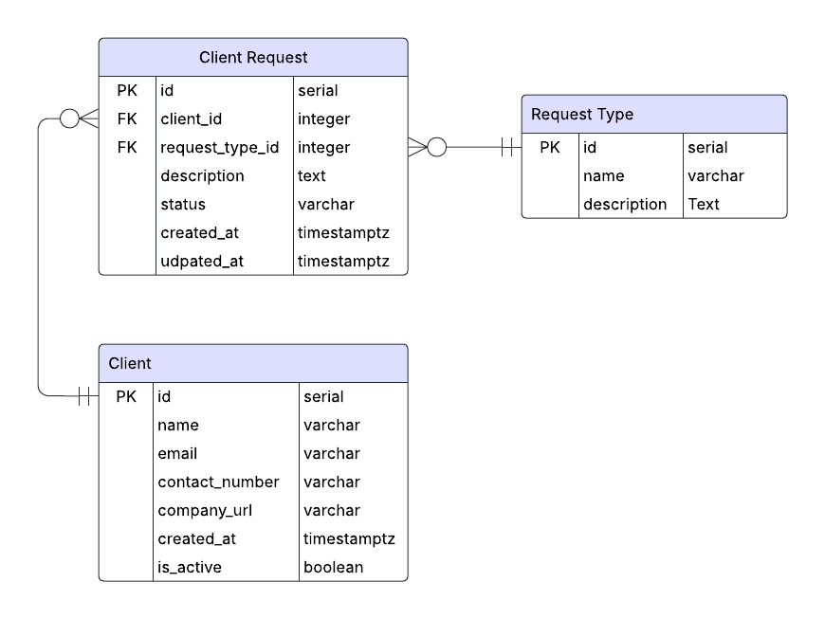
Figure 1: Entity Relationship Diagram showing the custom tables in the PostgreSQL database.

Design Considerations
The application features two user types:
- Admin users (full CRUD permissions via Django admin)
- Limited permissions users (can create, read, and update requests but cannot delete)

Both user types require their is_staff attribute set to True to access the dashboard, or they will be redirected to the account disabled page (Appendix F). Newly registered users are assigned limited permissions by default and must be manually granted admin rights via the Django admin for security. The login/register flow and styling, inspired by CMS platforms like WordPress and Seaward’s portal, includes clear navigation between all auth pages and a background animation (Appendix C). Upon login, users are redirected to the Django administration dashboard and custom views (home, login, register, account disabled) are hidden when logged in.

User Manual
Setup and usage instructions and references to screenshots of the running application are provided in the project’s README.md (Appendix D; Appendix E; Appendix G; Appendix H).

Admin User Credentials
Username: adminuser
Password: adminpass123

Limited Permissions Credentials
Username: Limiteduser
Password: userpass123

Account Disabled Credentials
Username: nopermissionsuser
Password: userpass123

Links
Live site:
https://software-engineering-agile-project-srgm.onrender.com/

Bitbucket repository:
https://bitbucket.org/test_area/sea-web-app/src/main/

Task 2

Scrum Sprint Boards
A sprint board is a Scrum visual ticket tracking tool that shows the real‑time status of user stories (figure 2). The "Testing and Review" column was for tickets that had passed their unit tests and required manual testing, code commenting, or refactoring. Two five‑day sprints were populated with user stories grouped under six epics‒authentication, client management, request management, validation, request‑type management, and environment setup‒and then decomposed into granular tasks (Figure 3; Figure 5). To keep the workload manageable, tickets were tagged as custom functionality or Django functionality (Figure 4): the latter represented quick wins leveraging built-in framework features, while the former signalled higher-effort items that demanded bespoke code (Figure 4). This informal effort‑based categorisation replaced a MoSCoW priority diagram yet still clarified priorities. Bitbucket commits were linked directly to Jira tickets, providing end‑to‑end traceability between planned stories and implemented code (Figure 6).

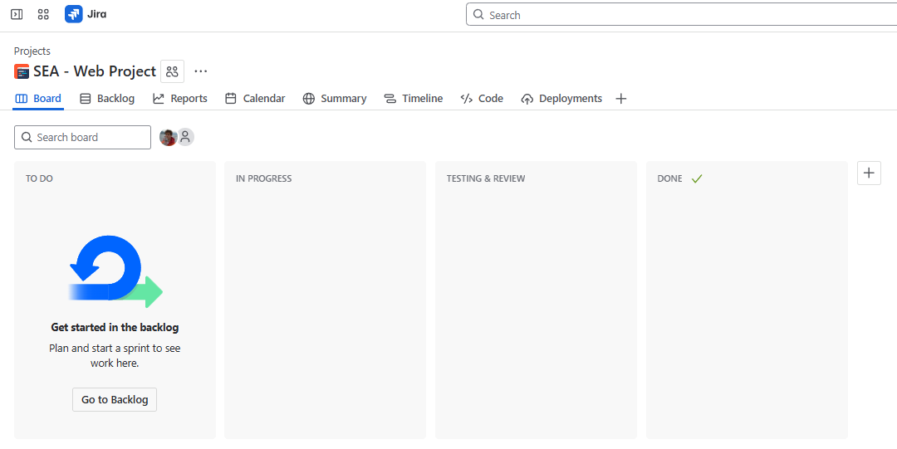
Figure 2: Empty Jira sprint board demonstrating the column structure
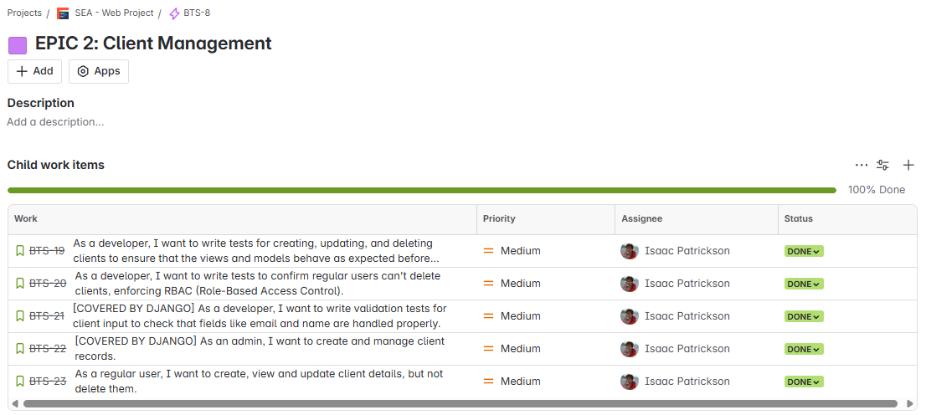
Figure 3: Jira view of Epic 2: Client Management, displaying all completed story tickets.
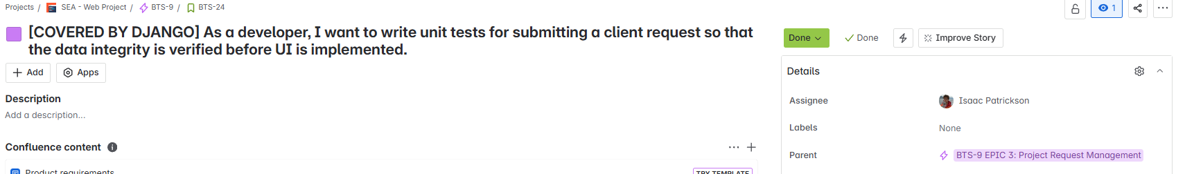
Figure 4: Jira ticket marked [COVERED BY DJANGO]. A quick win ticket.
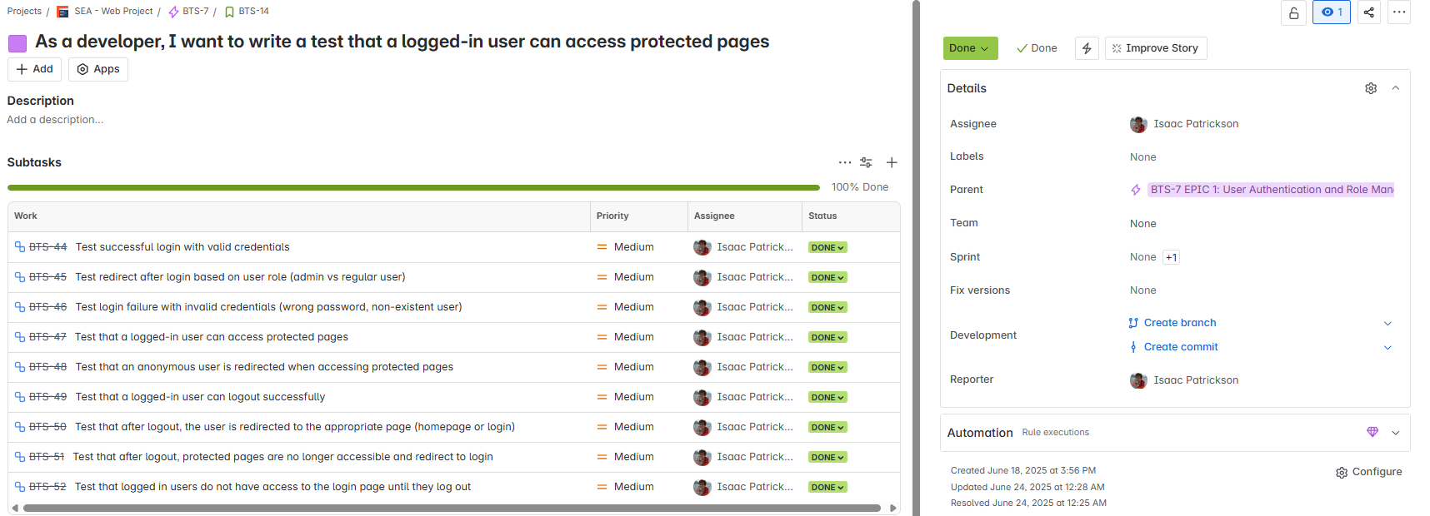
Figure 5: Jira story ticket with subtasks showing a feature broken down into granular tasks.
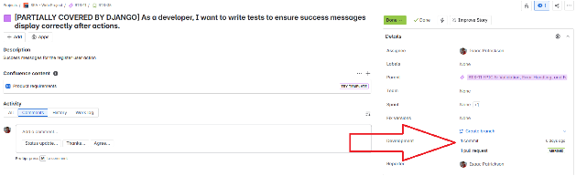
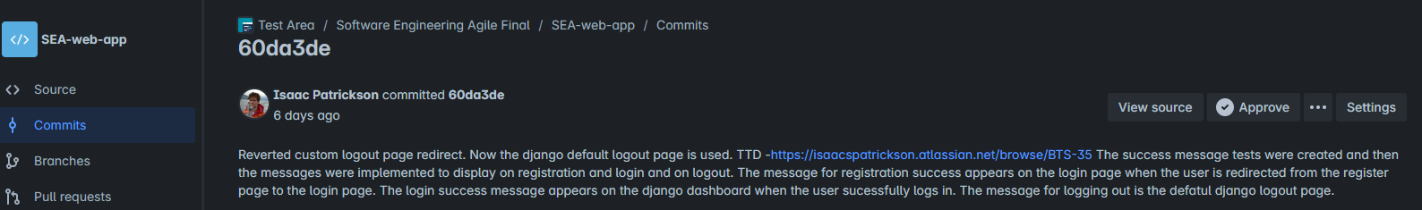
Figure 6: Jira story ticket linked to a Bitbucket commit.

Agile Diary
An agile diary records stand-up notes as part of daily Scrum practice. It supported the Scrum value of transparency by encouraging regular reflection on progress, priorities, and blockers. The digital diary, stored in Notion, was helpful in solo development to maintain discipline and track momentum (Figure 7). Each entry captured structured reflections at the beginning and end of the workday (Figure 8). Morning sections focused on task progress, prioritisation and blocker identification. Evening sections focused on what went well, what went wrong, and possible areas for improvement.


Figure 7: Agile Diary Calendar in Notion showing the week Sprint 1 started.
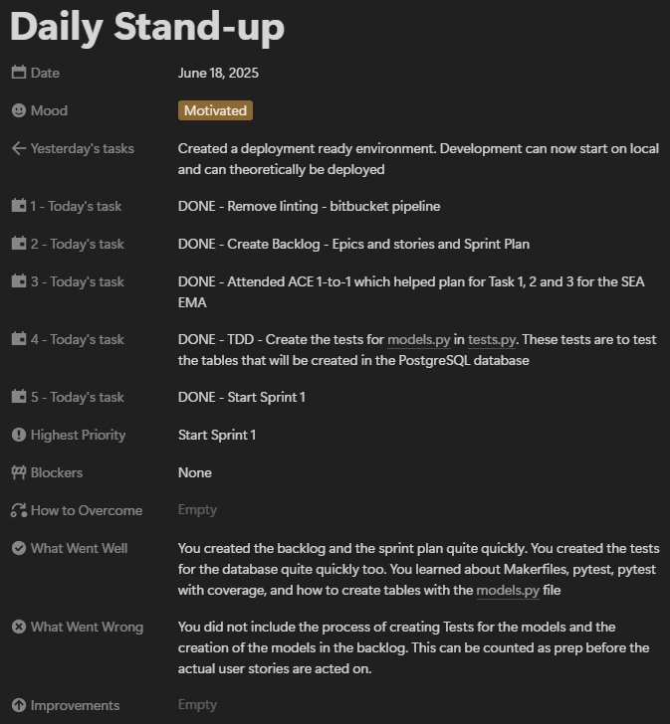
Figure 8: Agile Diary Entry for the 18/06/2025.

Test-Driven Development
Test-driven development (TDD) is an agile practice where tests are written before production code to enable rapid feedback and incremental improvement. Supporting Scrum’s focus on “working software,” TDD ensured each CRMS user story delivered verifiable value. In Jira, testable stories followed the format: “As a developer, I want to write tests for [functionality] so [result] occurs.” Tests were written using pytest and pytest-django, with a dedicated tests/ directory. Each implementation began with a failing test, followed by the minimal code needed to pass it. Stories relying on trusted Django’s built-in features were tagged [COVERED BY DJANGO] and skipped TDD. Over time, generic tests were refined‒for example, replacing basic "create user" tests with more specific form registration checks (Figure 10). The full test suite was run before major changes and deployments, which provided confidence that core functionality remained and also reduced the need for extensive manual testing. Even non-core scripts, like data seeding, were briefly tested to maintain a reliable baseline. The test suite can be found in the project repository under the main/tests/ directory (Figure 9).

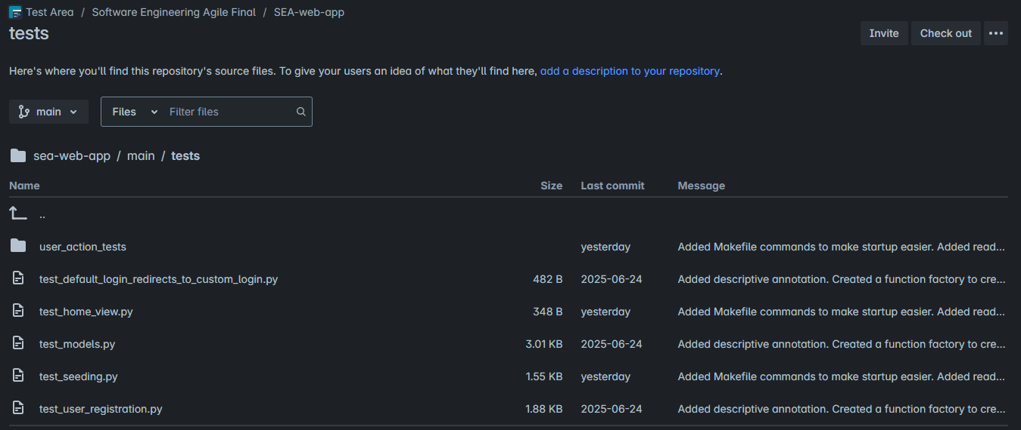
Figure 9: Screenshot of the tests/ directory in the Bitbucket repository.
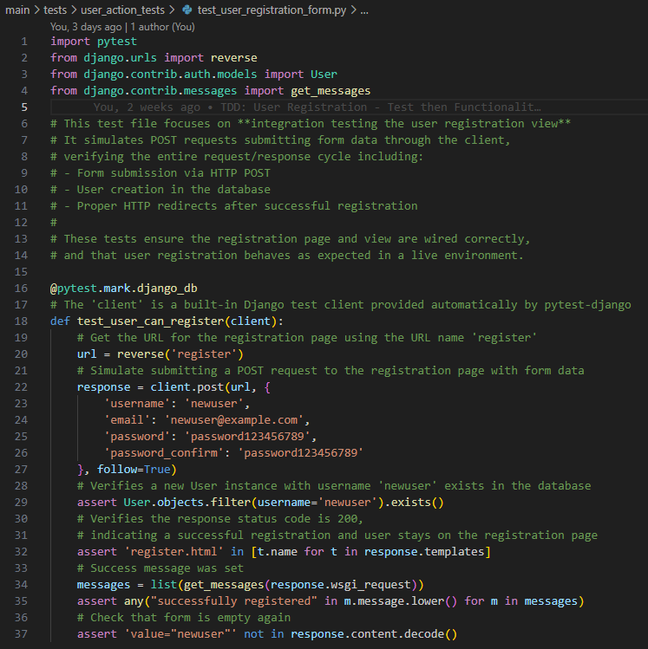
Figure 10: Example test case from test_user_registration_form.py.

Task 3

Chosen Framework: Scrum Overview
Scrum is a time-boxed agile framework centred on short sprints and defined roles: Product Owner, Scrum Master, and Development Team (Cole and Scotcher, 2015). Each sprint delivers a potentially shippable increment, providing regular stakeholder feedback opportunities. At Mediaworks‒where project scopes often shift‒Scrum’s structured ceremonies (planning, stand-ups, reviews, retrospectives) provide a predictable cadence and promote transparency (Cole and Scotcher, 2016). Scrum relies on a single prioritised product backlog‒a list of features required to deliver the product. The development team estimates the effort and complexity of each backlog ticket, while business value is determined by stakeholder needs (Badriyah et al., 2018). This focused work on the backlog ensures effort is directed toward the highest-value tasks‒crucial for delivering software development projects under tight deadlines (Chumpitaz et al., 2020).

Comparison and Critical Analysis: Scrum vs Kanban vs Lean (at Mediaworks)

Agile Framework Differences
Scrum and Kanban are structured agile frameworks, while Lean is a broader philosophy focused on maximising value and eliminating waste (Poppendieck and Cusumano, 2012). Their effectiveness depends on project scope, team size, and organisational maturity (Alqudah and Razali, 2017).

Workflow and Predictability
In Scrum, the Product Owner defines a fixed sprint goal and backlog, which the team commits to completing within that sprint. In contrast, Kanban supports continuous delivery, allowing new task cards to enter the board as capacity becomes available (Atlassian, 2025). Work is managed using work-in-progress (WIP) limits, which are set by the team to avoid overloading (Radigan, 2025). Kanban’s flexibility could benefit Mediaworks by enabling the team to respond to urgent client requests without disrupting a sprint plan (Ahmed et al., 2024; Ereiz and Mušić, 2019; Patil and Neve, 2018). However, the absence of time-boxed sprints in Kanban may hinder delivery forecasting, especially for smaller teams (Ereiz and Mušić, 2019; Hans, 2017). In contrast, Scrum’s greater consistency and predictability with fixed-length sprints (Atlassian, 2025; Schwaber and Sutherland, 2020) is important at Mediaworks, as clients sign technical specifications with strict time constraints and deliverables (Appendix A).

Process Improvement and Fit
Lean’s emphasis on eliminating waste and continuous improvement through tools like value-stream mapping and Kaizen can significantly improve operational efficiency, especially in larger organisations willing to invest in long-term cultural and structural change (Liang et al., 2015). For Mediaworks, implementing Lean would require substantial buy-in and a shift in how work is visualised and measured‒challenges that may outweigh the immediate benefits for a small, fast-moving team.
Scrum, by contrast, embeds continuous improvement through sprint retrospectives. Retrospective ceremonies surface process inefficiencies early and provide teams with an opportunity to reflect and adapt (Cole and Scotcher, 2016). While both frameworks aim to improve how teams work, Scrum's process-improvement mechanisms focus on incremental adjustments rather than organisation-wide transformation‒making Scrum a more practical approach for Mediaworks' scale and culture.

Roles and Accountability
Lean and Kanban are role-agnostic, relying on existing organisational structures. This role-agnostic approach works well for mature teams with well-defined internal dynamics, allowing them to adopt Kanban and Lean without major restructuring (Ahmed et al., 2024).
In contrast, Scrum offers a safer entry point for teams new to agile, as it clearly defines roles, helping prevent ownership ambiguity. Scrum’s roles support shared accountability and can be adapted to organisational needs (Cole and Scotcher, 2016).

Metrics and Tracking
Scrum’s burndown charts offer simple, short-term insights into progress‒ideal for stakeholders to assess progress against short-term goals (Mišković et al., 2024). However, burndown charts can obscure the flow of work across multiple teams or larger features, encouraging a narrow focus on short-term sprint commitments rather than end-to-end value delivery (Power, 2014).
Kanban, by contrast, provides cumulative-flow diagrams (CFDs), which help teams identify bottlenecks in real time and optimise work-in-progress (Saranya and Fumio, 2014). However, CFDs can be difficult for stakeholders to interpret, offer limited visibility into specific user stories, and risk being misused to judge team performance prematurely (Power, 2014).
Lean focuses on improving long-term value flow, using metrics such as cycle time and throughput. While powerful, Lean's metrics often necessitate more profound process changes, making them more challenging to adopt for short-term goals (Liu and Yang, 2017). Scrum's metrics remain the most accessible and actionable as they support short-term delivery planning and are easily understood by non-technical stakeholders, qualities that fit Mediaworks’ quick-turnaround and client-facing workflows (Kortum et al., 2020; Vajda, 2009).

Conclusion: Scrum’s Fit for Mediaworks
While Scrum, Kanban, and Lean each offer valuable approaches to agile software development, their suitability depends on organisational context, team maturity, and delivery goals (Cole and Scotcher, 2016). Lean promotes long-term efficiency through profound structural change, and Kanban offers flexibility for continuous delivery in mature, self-organising teams (Liu and Yang, 2017). For Mediaworks, a small, fast-paced agency managing time-sensitive client deliverables, Scrum provides the most practical balance of structure, predictability, and adaptability. Although not without limitations, Scrum's framework aligns closely with Mediaworks' needs for visibility, focus, and iterative delivery.

Improvement for Mediaworks: Scrumban
To balance predictability with flexibility, Mediaworks could adopt Scrumban to retain Scrum’s sprint structure and review cadence while incorporating Kanban’s WIP limits and continuous flow principles. This hybrid would preserve the familiar sprint rhythm but offer greater adaptability for handling urgent client requests, which currently challenge the rigidity of fixed sprint scopes (Patil and Neve, 2018). The inclusion of cumulative-flow diagrams would also improve real-time visibility into bottlenecks, addressing a limitation of Scrum’s burndown charts, which can obscure flow-based issues across the sprint (Power, 2014). These additions could enhance Mediaworks’ responsiveness without sacrificing the structure and predictability that make Scrum effective in a client‑driven environment. This view is supported by Ereiz and Mušić (2019), who confirm it is necessary to combine Scrum with other methodologies, such as Kanban, in order to achieve maximum efficiency and productivity.

Implementation Strategy
- Select an internal development team working on ongoing client requests to run two Scrumban sprints using existing Jira boards, with the addition of work-in-progress (WIP) limits and a dedicated “Expedite” swim lane for urgent tasks.

- Maintain sprint planning but reduce reliance on detailed estimation. Utilise historical throughput data to forecast capacity, enabling more realistic planning while maintaining sprint structure.

- Keep sprint reviews for stakeholder engagement. Replace time-consuming retrospectives with brief, informal check-ins focused on improving flow and managing blockers.

- Supplement Scrum’s velocity and burndown tracking with cumulative-flow diagrams and cycle time reports to provide better visibility into flow stability and delivery bottlenecks.

- Emphasise that Scrumban does not require a fixed Scrum Master. Core responsibilities, e.g. maintaining the board and facilitating planning, can be shared or assigned based on team needs.

- After the pilot, compare the delivery speed, blocker frequency, and stakeholder satisfaction with those of prior Scrum-only sprints. If outcomes improve, expand Scrumban practices to additional teams, adapting based on workload and project type.

References
Ahmed, I., et al. (2024) ‘The Influence of Kanban Agile Methodology on Software Project Management: A Survey Method’, 2024 International Conference on Engineering and Emerging Technologies (ICEET). 27-28 Dec., Dubai, United Arab Emirates. pp. 1-6. Available at: https://doi.org/10.1109/ICEET65156.2024.10913653 (Accessed: 9 July 2025).
Alqudah, M. and Razali, R. (2017) ‘A comparison of scrum and Kanban for identifying their selection factors’, 2017 6th International Conference on Electrical Engineering and Informatics (ICEEI). 25-27 Nov., Langkawi, Malaysia. pp. 1-6. Available at: https://doi.org/10.1109/ICEEI.2017.8312434 (Accessed: 9 July 2025).
Atlassian (2025) Kanban. Available at: https://www.atlassian.com/agile/kanban (Accessed: 9 July 2025).
Badriyah, T., et al. (2018) ‘Rapid Development of m-Health application with the Sprint Design approach and Scrum process : Application Development for e-Prescribing’, 2018 International Conference on Applied Science and Technology (iCAST). 26-27 Oct., Manado, Indonesia. pp. 336-342. Available at: https://doi.org/10.1109/iCAST1.2018.8751603 (Accessed: 9 July 2025).
Chumpitaz, B., et al. (2020) ‘Application of the scrum framework to optimize time in construction projects’, 2020 Congreso Internacional de Innovación y Tendencias en Ingeniería (CONIITI). 30 Sep. - 2 Oct., Bogota, Colombia. pp. 1-6. Available at: https://doi.org/10.1109/CONIITI51147.2020.9240332 (Accessed: 9 July 2025).
Cole, R. and Scotcher, E. (2016) Brilliant Agile Project Management. Harlow: Pearson Education
Ereiz, Z. and Mušić, D. (2019) ‘Scrum Without a Scrum Master’, 2019 IEEE International Conference on Computer Science and Educational Informatization (CSEI). 16-19 Aug., Kunming, China. pp. 325-328. Available at: https://doi.org/10.1109/CSEI47661.2019.8938877 (Accessed: 9 July 2025).
Hans, R. (2017) ‘Work in Progress - The Impact of the Student Scrum Master on Quality and Delivery Time on Students' Projects’, 2017 International Conference on Learning and Teaching in Computing and Engineering (LaTICE). 20-23 Apr., Hong Kong, China. pp. 87-90. Available at: https://doi.org/10.1109/LaTiCE.2017.22 (Accessed: 9 July 2025).
Kortum, F., et al. (2020) ‘Which Information Help agile Teams the Most? An Experience Report on the Problems and Needs’, 2020 46th Euromicro Conference on Software Engineering and Advanced Applications (SEAA). 26-28 Aug., Portoroz, Slovenia. pp. 306-313. Available at: https://doi.org/10.1109/SEAA51224.2020.00058 (Accessed: 9 July 2025).
Liang, Y., et al. (2015) ‘Criteria for lean practice selection: Development an assessment tool using the rooted arborescence’, 2015 IEEE International Conference on Automation Science and Engineering (CASE). 24-28 Aug., Gothenburg, Sweden. pp. 237-242. Available at: https://doi.org/10.1109/CoASE.2015.7294068 (Accessed: 9 July 2025).
Liu, Q. and Yang, H. (2017) ‘Lean implementation through value stream mapping: A case study of a footwear manufacturer’, 2017 29th Chinese Control And Decision Conference (CCDC). 28-30 May, Chongqing, China. pp. 3390-3395. Available at: https://doi.org/10.1109/CCDC.2017.7979092 (Accessed: 9 July 2025).
Mišković, K., et al. (2024) ‘Implementing Burndown Chart in IT Firms: A Case Study Based on Agile Management Principles’, 2024 23rd International Symposium INFOTEH-JAHORINA (INFOTEH). 20-22 Mar., East Sarajevo, Bosnia and Herzegovina. pp. 1-6. Available at: https://doi.org/10.1109/INFOTEH60418.2024.10495950 (Accessed: 9 July 2025).
Patil, S. and Neve, J. (2018) ‘Productivity Improvement of Software Development Process Through Scrumban: A Practitioner's Approach’, 2018 International Conference On Advances in Communication and Computing Technology (ICACCT). 8-9 Feb., Sangamner, India. pp. 314-318. Available at: https://doi.org/10.1109/ICACCT.2018.8529405 (Accessed: 9 July 2025).
Poppendieck, M. and Cusumano, M. (2012) ‘Lean Software Development: A Tutorial’, IEEE Software. 28(5). pp. 26-32. Available at: https://doi.org/10.1109/MS.2012.107 (Accessed: 9 July 2025).
Power, K. (2014) ‘Metrics for Understanding Flow’, Agile 2014. Available at: https://www.researchgate.net/publication/326347254_Metrics_for_Understanding_Flow (Accessed: 9 July 2025).
Radigan, D. (2025) Putting the 'flow' back in workflow with WIP limits. Available at: https://www.atlassian.com/agile/kanban/wip-limits (Accessed: 9 July 2025).
Rasheed, U., et al. (2025) ‘Implementation of Lean Management in Software Project Management’, 2025 6th International Conference on Advancements in Computational Sciences (ICACS). 18-19 Feb., Lahore, Pakistan. pp. 1-5. Available at: https://doi.org/10.1109/ICACS64902.2025.10937865 (Accessed: 9 July 2025).
Saranya, P. and Fumio, A. (2014) ‘The design of Kanban system for improving Bottleneck Problem of multiproduct’, 2014 IEEE 6th International Conference on Awareness Science and Technology (iCAST). 29-31 Oct., Paris, France. pp. 1-5. Available at: https://doi.org/10.1109/ICAwST.2014.6981834 (Accessed: 9 July 2025).
Schwaber, K. and Sutherland, J. (2020) The 2020 Scrum Guide. https://scrumguides.org/scrum-guide.html (Accessed: 9 July 2025).
Vajda, A. (2009) ‘Project Monitoring and Control Using Burndown Charts’, Interdisciplinarity in Engineering International Conference. pp. 196-200. Available at: https:/inter-eng.umfst.ro/2009/files/proceedings/papers/paper36.pdf (Accessed: 9 July 2025).

Appendices

Appendix A – Screenshot of the Constraints Section in a Functional Specification for the Nichol Associates Project
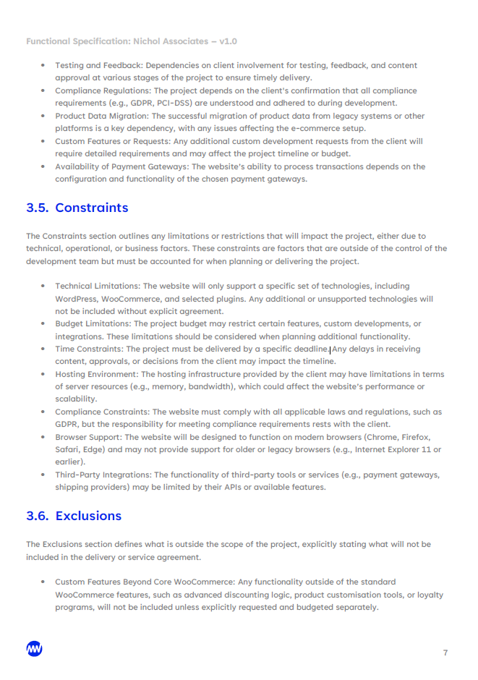

Appendix B – Screenshots of Sprint 1 and Sprint 2 Backlog and Burndown Charts in Jira
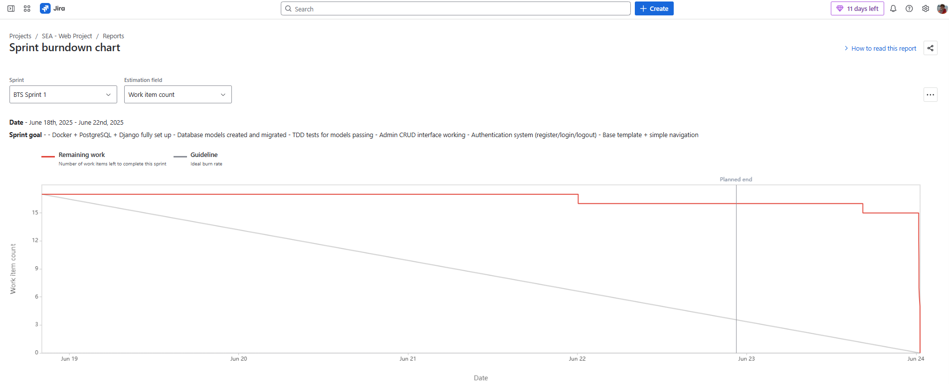
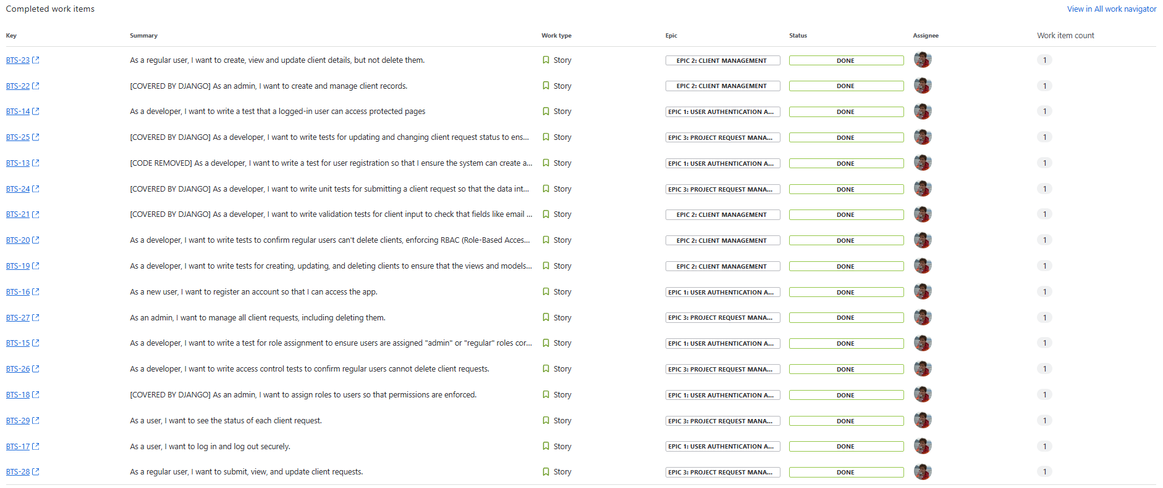
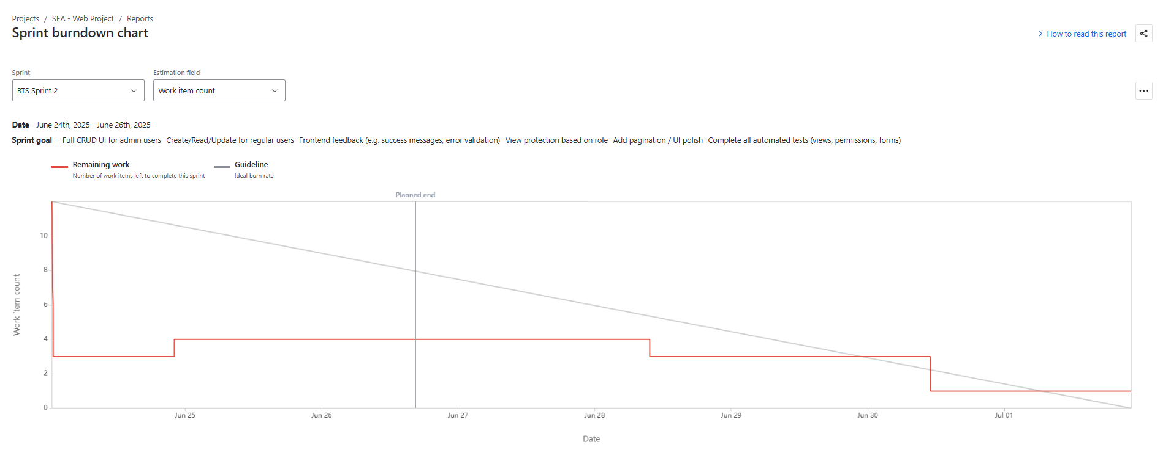
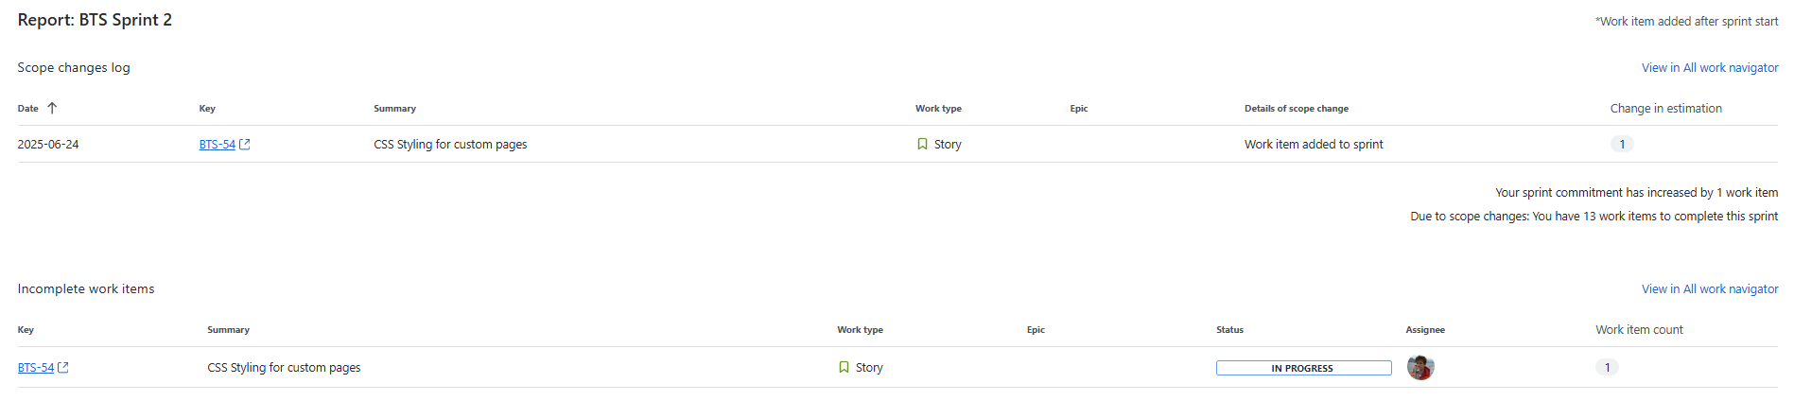
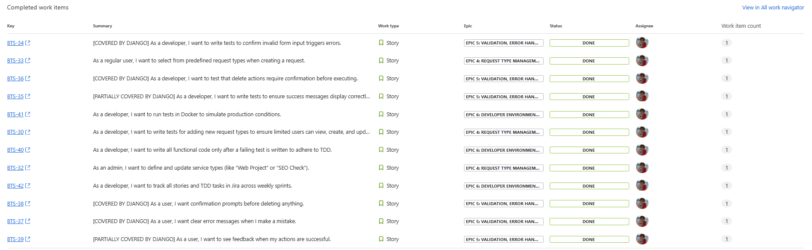

Appendix C – Screenshots of Seaward and WordPress’ custom CMS login page and dashboard
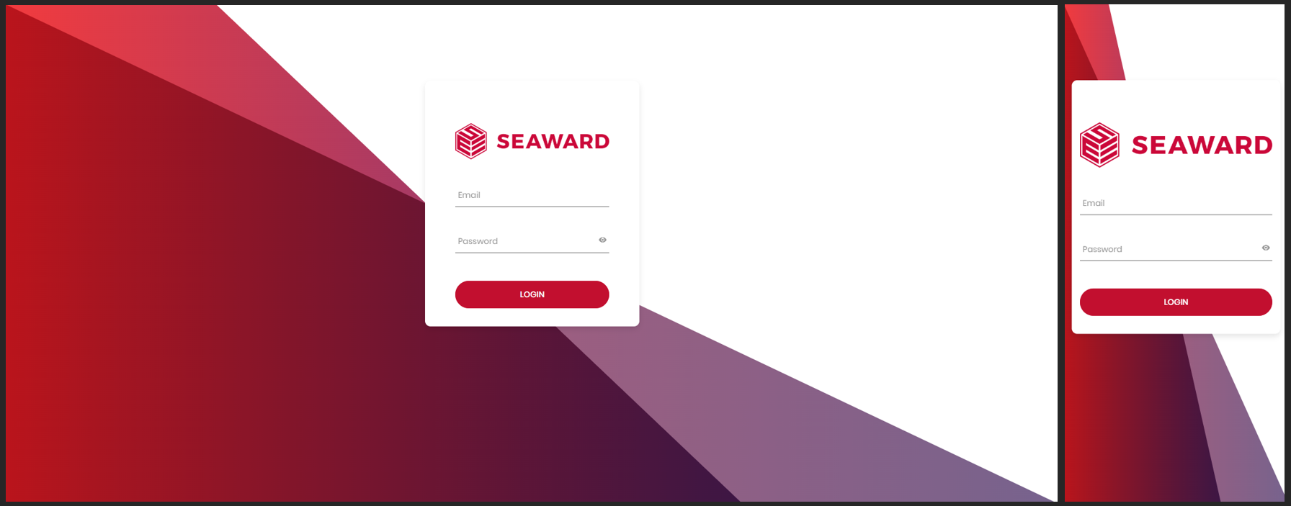
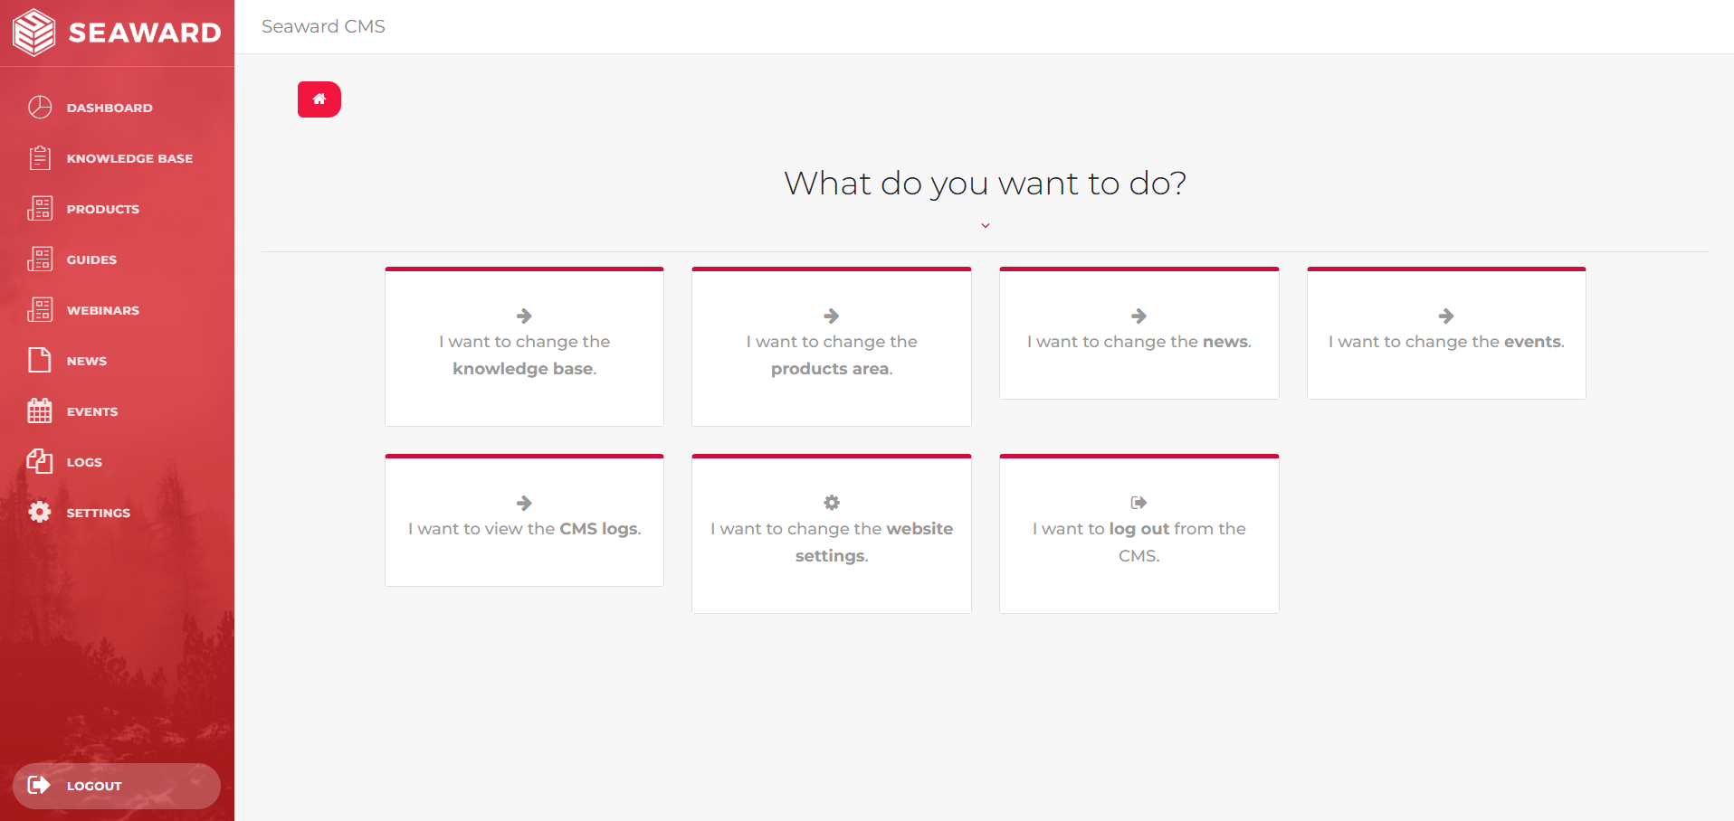
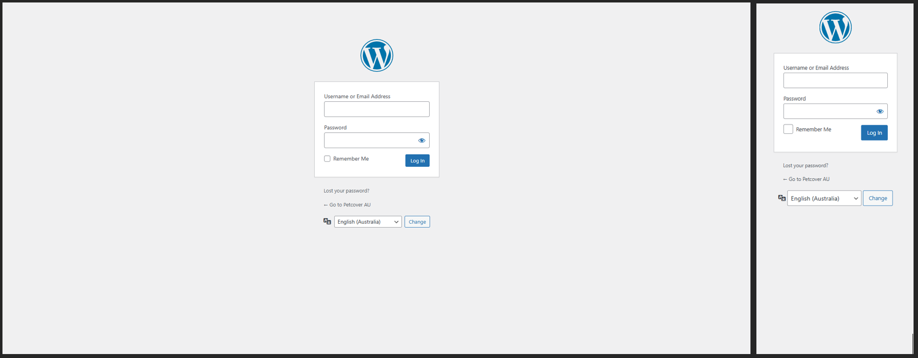
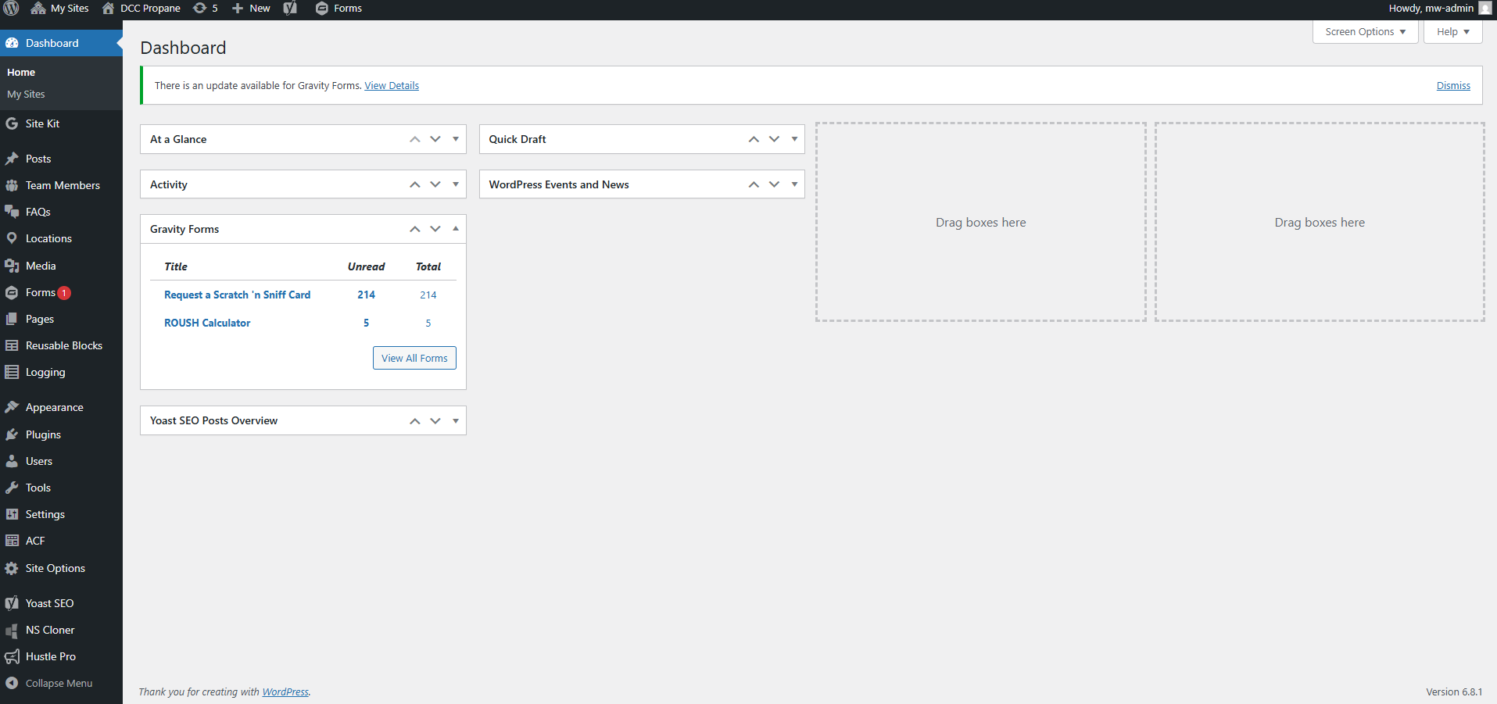

Appendix D – Assistive Screenshots for the Register Journey Section within the README.md in the CRMS Bitbucket Repository
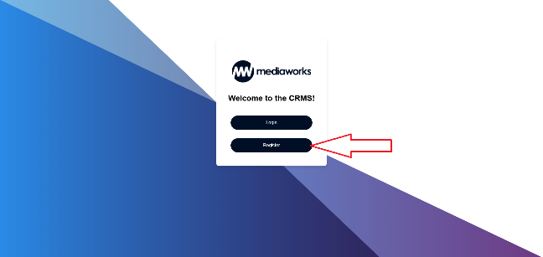
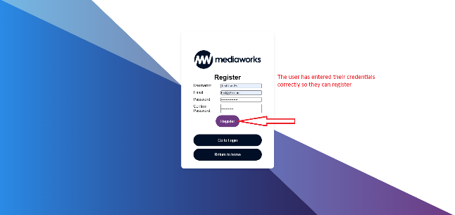
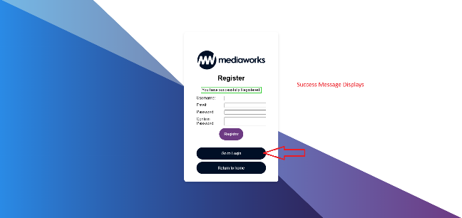

Appendix E – Assistive Screenshots for the Limited User Login Journey and CRU Actions Section within the README.md in the CRMS Bitbucket Repository
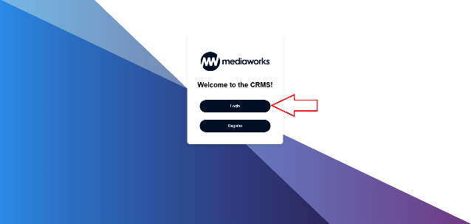
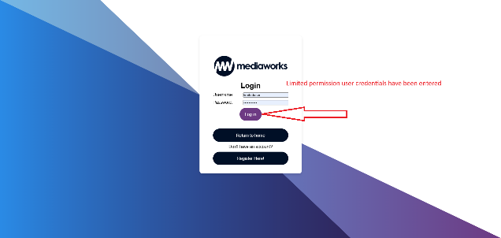
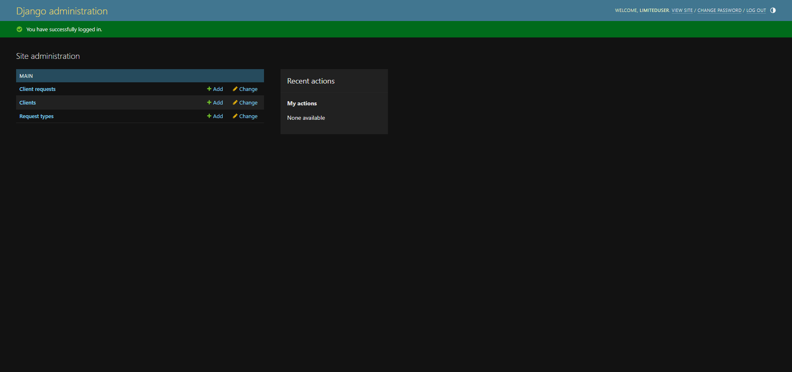
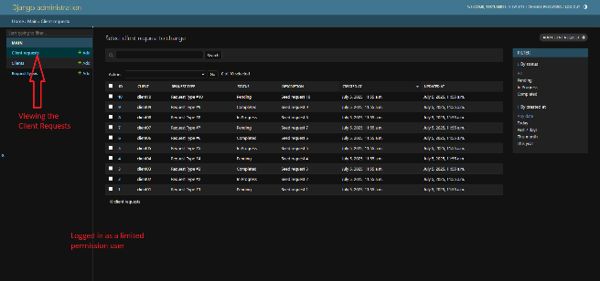
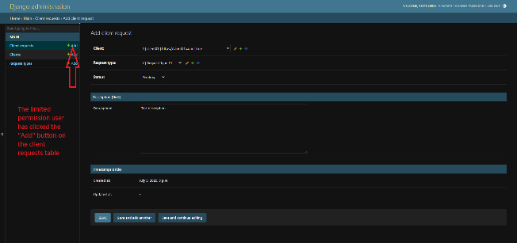
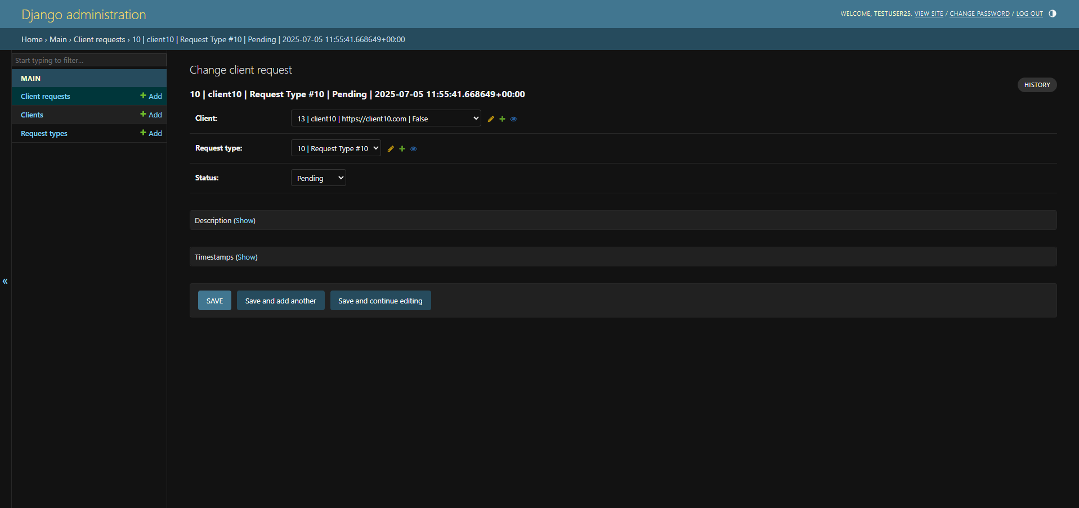

Appendix F – A restricted user (is_staff = False) journey
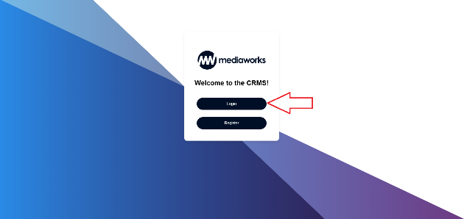
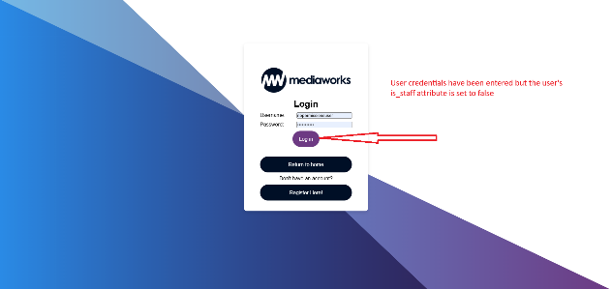
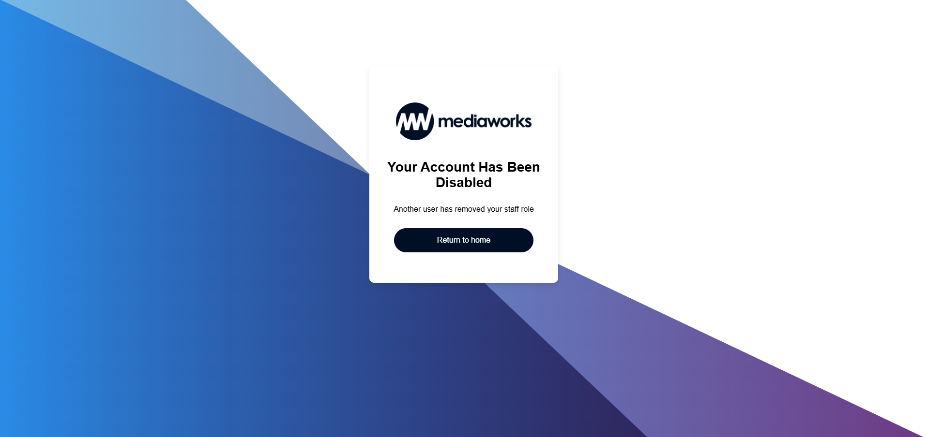

Appendix G – Assistive Screenshots for the Admin User Login Journey and CRUD Actions Section within the README.md in the CRMS Bitbucket Repository
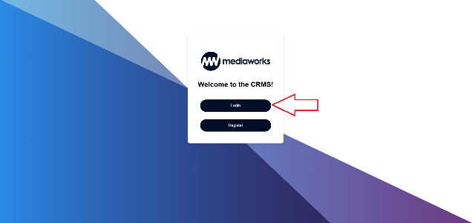
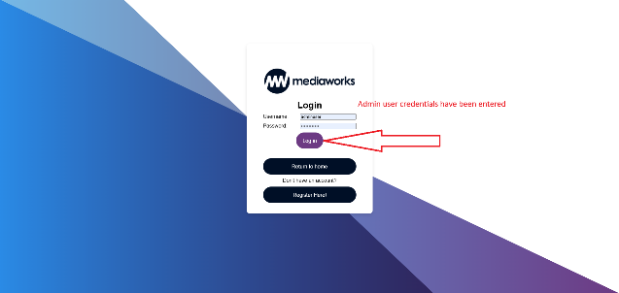
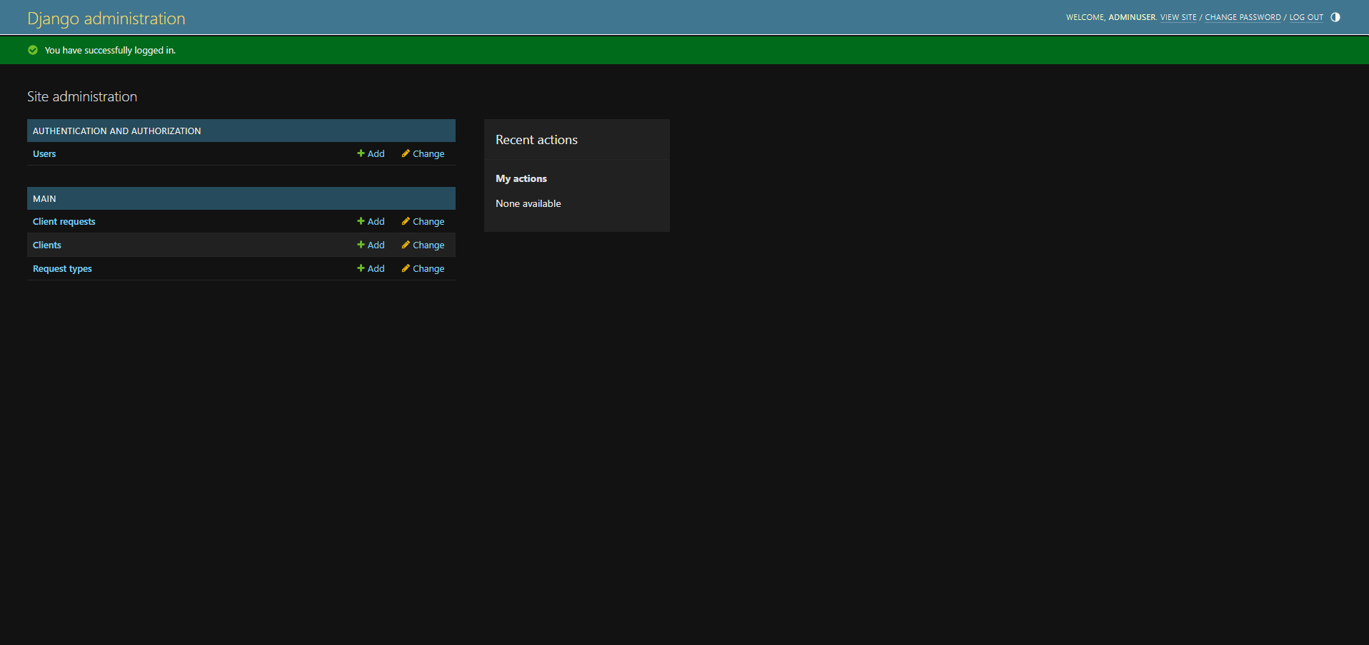
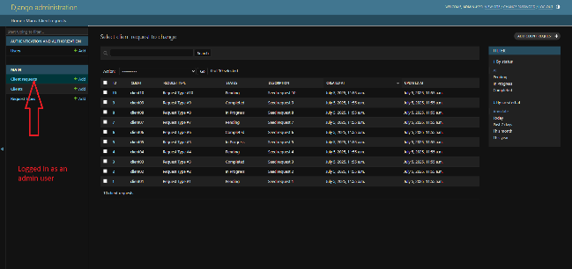
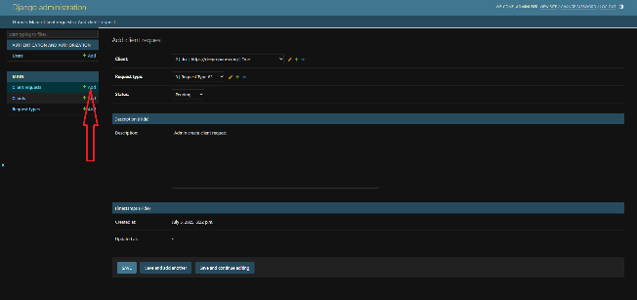
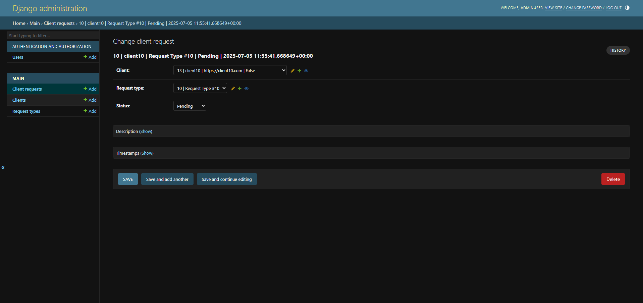
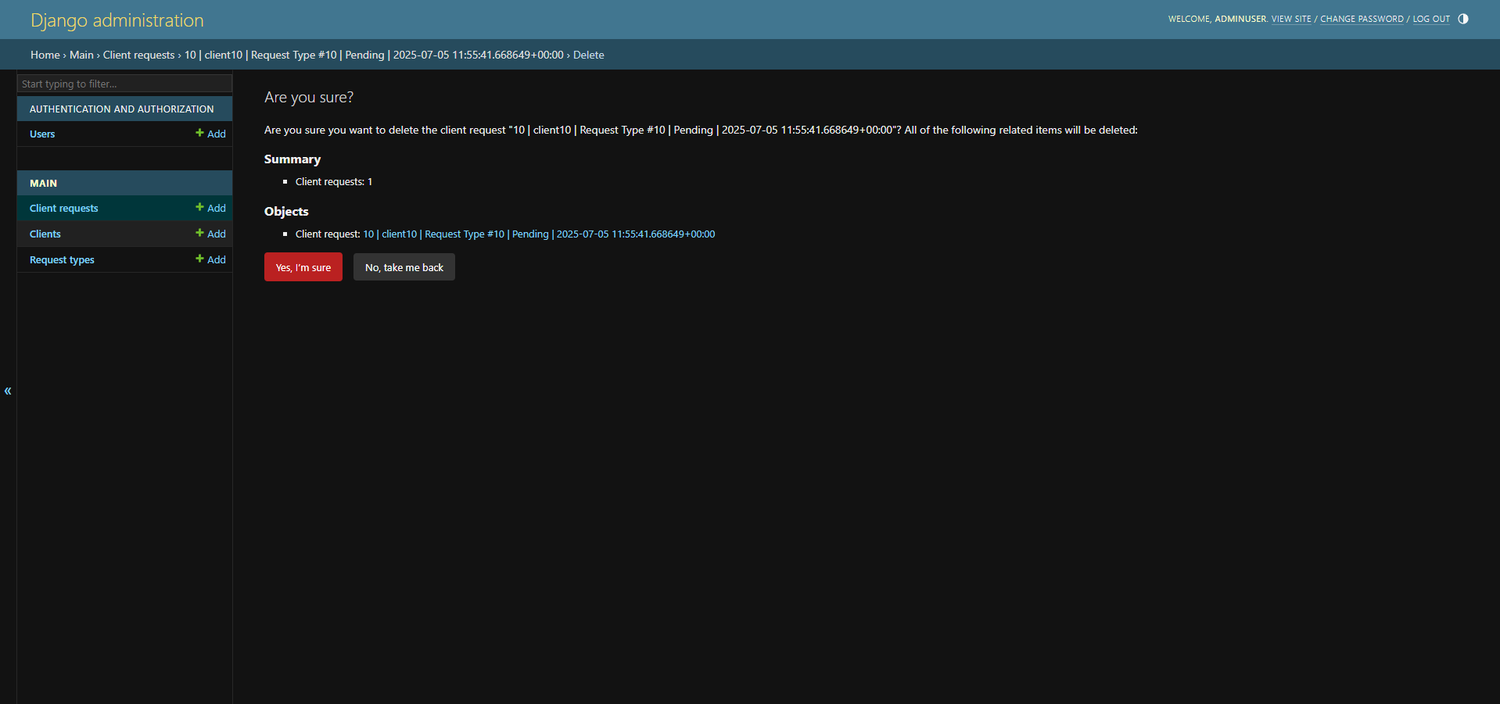

Appendix H – Assistive Screenshots for the Logout Journey Section within the README.md in the CRMS Bitbucket Repository
