BOOKBRIDGE MARKETPLACE
CSC 720 Electronic Commerce Technologies Coursework Project Report

Marketplace niche: Books
Development platform: Python with Flet
Software development model: Waterfall SDLC with secure development practices

Student Name: Isaac Pius
Registration Number: M.Sc/CSC/24/0955

Programme: M. Sc. Computer Science

Lecturer: Prof. E. J. Garba

Date: August 2026

Executive Summary
This report answers the coursework requirement by designing a books marketplace named BookBridge. The application supports buyers, sellers and an administrator in one platform. Buyers register, sign in, search books, add items to a cart, complete checkout and review orders. Sellers list books, manage stock and update fulfilment. The administrator reviews marketplace metrics and provides oversight.
The coursework brief requires a structured software engineering approach before implementation. It also requires feasibility analysis, fact gathering, an SRS, algorithms, flowcharts, pseudocode, system design, source code, testing evidence, screenshots, user documentation and a completed marketplace application. The brief also states that one codebase should support desktop, web and mobile deployment where possible. Source basis: Coursework Assignment, pages 1 to 3.
The lecture notes treat e commerce as a socio technical systems discipline. They emphasize three tier architecture, open Internet security, data interchange, HCI evaluation, payment security and privacy. BookBridge applies those principles to the coursework design. Source basis: CSC 720 Lecture Notes, Units 7 to 11, pages 23 to 38.
The assignment does not name one SDLC model. This solution uses the Waterfall model because the coursework explicitly places feasibility, requirements, algorithms, flowcharts and pseudocode before coding. Each stage produces a defined output before the next stage begins. Secure development controls remain active across the whole life cycle.

Table of Contents
1. Assignment Interpretation and Project Definition
2. Software Development Life Cycle Model
3. Stage 1: Project Initiation and Planning
4. Stage 2: Feasibility Study
5. Stage 3: Fact Finding and Requirements Elicitation
6. Stage 4: Software Requirements Specification
7. Stage 5: System Analysis and Design
8. Stage 6: Algorithms, Flowcharts and Pseudocode
9. Stage 7: Implementation
10. Stage 8: Testing and Quality Assurance
11. Stage 9: Deployment
12. Stage 10: Maintenance and Evolution
13. User Documentation
14. Deliverables Compliance Matrix
15. References
Appendix A: Fact Finding Instruments
Appendix B: Source Code Extracts
Appendix C: Screenshot Evidence Checklist

1. Assignment Interpretation and Project Definition

1.1 Coursework Constraints
The coursework asks for a marketplace e-commerce application developed with Python or Flutter. Buyers and sellers must share one platform in which products or services are listed, searched, purchased and managed. A niche must be selected before development. The required application functions include secure authentication, product management, a shopping cart, checkout and order management. Target deployment covers desktop, web and mobile platforms.
Constraint | BookBridge response
Marketplace niche | Books, including academic, computing, literature and general titles.
Development technology | Python with Flet for one shared user interface codebase.
Desktop | Flet desktop deployment for Windows, Linux and macOS.
Web | Flet web deployment behind HTTPS.
Mobile | Flet mobile packaging after Android or iOS build tooling is installed.
Authentication | Email login, salted PBKDF2 password hashing and role checks.
Product management | Seller book listing, stock management and listing status.
Cart | Buyer cart with quantity and stock validation.
Checkout | Address capture, payment method selection, atomic order creation and stock reduction.
Order management | Buyer order history and seller fulfilment updates.

1.2 Selected Niche: Books
Books fit the assignment well because a marketplace needs rich searchable metadata, multiple sellers, repeat purchasing and structured identifiers. The lecture notes identify ISBN as a shared product identifier and explain that metadata improves product discovery. BookBridge therefore stores title, author, ISBN, category, description, price and stock for each listing.

1.3 Problem Statement
Independent booksellers and buyers often operate through fragmented social channels. Product availability, pricing, seller identity, payment status and delivery state become difficult to track. BookBridge centralizes catalogue search, checkout and order fulfilment in one structured marketplace database.

1.4 Aim and Objectives
The aim is to design and implement a cross platform books marketplace using a structured software engineering process.
1. Provide secure buyer and seller account registration and login.
2. Allow sellers to create and manage book listings and stock.
3. Allow buyers to search by title, author, ISBN and keyword.
4. Provide a shopping cart with quantity and stock controls.
5. Create orders through a transactional checkout process.
6. Support payment status, order status and seller fulfilment status.
7. Provide administrator oversight and basic reporting.
8. Apply three tier architecture, usability, accessibility, security and payment principles
9. Keep business logic separate from the user interface so the same service layer supports multiple Flet targets.

1.5 Scope
The minimum viable product includes buyer, seller and administrator roles, authentication, catalogue management, search, cart, checkout, order history, fulfilment and basic marketplace metrics. The prototype uses SQLite for local execution. A production deployment replaces SQLite with PostgreSQL, adds managed secrets, HTTPS termination, audit logs, external email or SMS services and a hosted payment gateway.
Recommendation engines, reviews, live chat, courier tracking, returns, refunds and multi seller settlement are placed in a later release.

2. Software Development Life Cycle Model

2.1 Model Selection
This coursework uses the Waterfall SDLC. The reason is traceability. The assignment specifies feasibility, fact gathering, SRS, algorithm design, flowcharts and pseudocode before implementation. Waterfall gives each of those outputs a formal place and preserves the requested order.
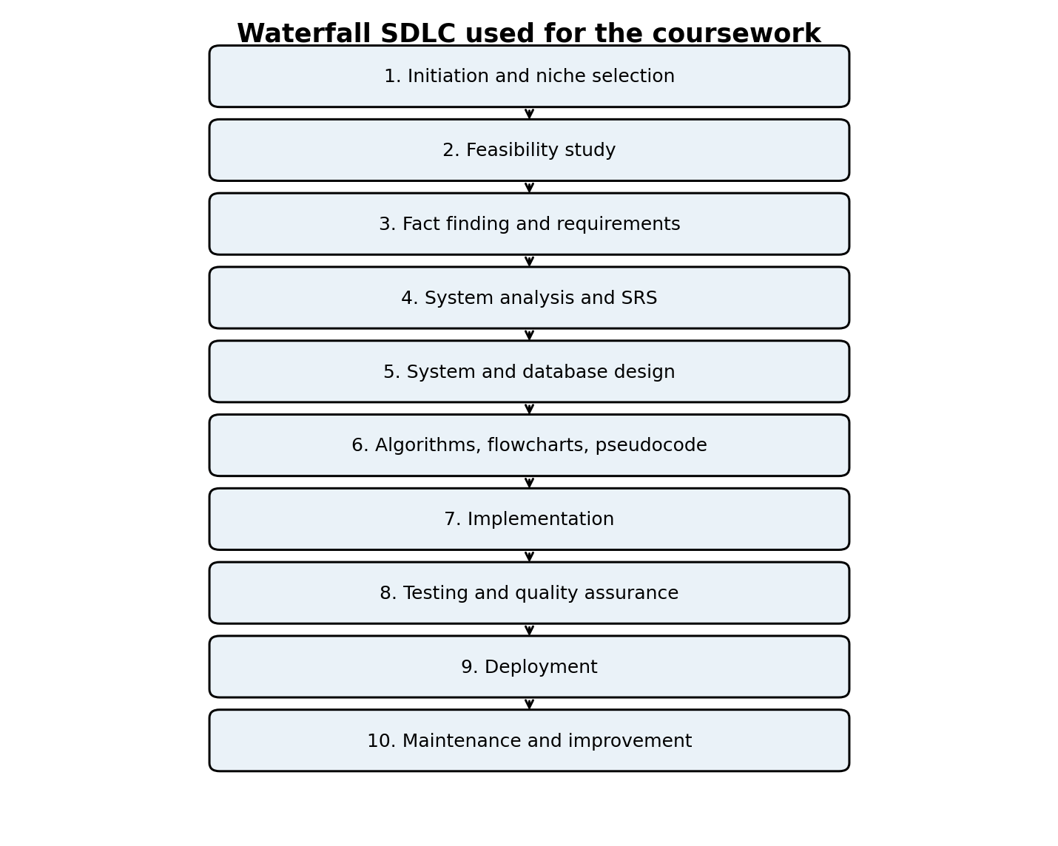
Figure 1. Waterfall SDLC applied to BookBridge.

2.2 Stage Outputs
Stage | Primary output | Exit condition
1. Initiation and planning | Project definition, niche, scope, stakeholders and schedule | Scope and objectives are clear.
2. Feasibility | Technical, economic, operational, legal and schedule findings | Project is judged practical.
3. Fact finding | Interview, questionnaire, observation and document review results | Stakeholder needs and constraints are recorded.
4. Requirements | SRS with functional and nonfunctional requirements | Requirements are testable and prioritized.
5. Design | Architecture, database, interfaces and security design | Design traces to requirements.
6. Logic design | Algorithms, flowcharts and pseudocode | Core process logic is defined before coding.
7. Implementation | Modular Python and Flet source code | Code compiles and core functions execute.
8. Testing | Unit, integration, security, usability and acceptance evidence | Critical test cases pass.
9. Deployment | Install and release procedure for target platforms | Application is installed in the target environment.
10. Maintenance | Monitoring, backup, defect and change process | Operational ownership is defined.

2.3 Cross Cutting Secure Development
BookBridge applies security during requirements, design, coding, testing and deployment rather than treating security as a final stage.

3. Stage 1: Project Initiation and Planning

3.1 Stakeholders
Stakeholder | Interest | Main responsibilities
Buyer | Fast discovery, fair pricing, secure checkout and order visibility | Register, search, purchase, and provide delivery data.
Seller | Simple listing, stock control and fulfilment visibility | Maintain catalogue, confirm fulfilment progress.
Administrator | Marketplace integrity, user management and reporting | Monitor users, products, orders and abuse.
Payment provider | Accurate, secure transaction processing | Authorize or confirm payment.
Logistics provider | Correct fulfilment and delivery details | Move goods and update shipment state.
System owner | Availability, compliance and maintainability | Operate infrastructure and releases.

3.2 Work Breakdown and Schedule
The schedule below is a coursework planning assumption. It gives the required engineering stages enough time while keeping implementation after design.
Week | Activities | Deliverables
1 | Project definition and feasibility | Problem statement, scope, feasibility report.
2 | Fact finding and requirements elicitation | Stakeholder needs, questionnaire, interview guide.
3 | SRS and system analysis | Functional and nonfunctional requirements.
4 | Architecture, database and interface design | ERD, architecture, wireframes.
5 | Algorithms, flowcharts and pseudocode | Logic specification.
6 | Implementation | Database, services and Flet interface.
7 | Testing and defect correction | Test evidence and corrected build.
8 | Deployment preparation and documentation | Installation guide, manuals, FAQ, screenshots.

3.3 Risk Register
Risk | Likelihood | Impact | Treatment
Flet packaging differs across target platforms | Medium | Medium | Keep the UI layer thin and test platform builds early.
Payment integration exposes sensitive card data | Medium | High | Use a hosted payment page and tokenization in production. Do not store PAN data.
Concurrent checkout oversells stock | Medium | High | Use database transactions and stock checks inside checkout.
Weak passwords or credential attacks | Medium | High | Use salted PBKDF2 hashing, rate limiting and MFA in production.
Seller publishes misleading listing | Medium | Medium | Add moderation status, audit logs and administrator controls.
Data loss | Low | High | Use automated backups and restore tests.
Slow response under catalogue growth | Medium | Medium | Use indexes, pagination, caching and production PostgreSQL.

4. Stage 2: Feasibility Study

4.1 Technical Feasibility
Python is suitable for the coursework because the language supports modular application logic, SQLite access and automated testing. Flet provides a shared UI codebase for desktop, web and mobile targets. The prototype separates presentation, application logic and data access, which matches the three tier pattern described in the lecture notes. Three tier architecture protects the database behind the logic tier and centralizes business rules for reuse across channels.
The prototype database is SQLite because it has no separate server dependency. Production use should move the same schema and service logic to PostgreSQL. External payment, email and logistics integrations should use REST APIs. The lecture notes identify REST with JSON as the dominant commerce API style and recommend TLS, signed webhooks and idempotent processing at integration boundaries.

4.2 Economic Feasibility
The following figures are planning assumptions for a small academic prototype. They are not vendor quotations.
Item | Prototype estimate | Comment
Python and SQLite | ₦0 | Open source development stack.
Flet framework | ₦0 | Framework dependency installed through Python package management.
Development computer | Existing resource | Uses the student machine.
Internet and testing data | ₦20,000 | Coursework allowance.
Optional domain name | ₦25,000 per year | Planning allowance only.
Optional basic cloud hosting | ₦15,000 per month | Planning allowance only.
Contingency | ₦20,000 | Testing devices and unexpected expenses.
Prototype cash requirement | About ₦40,000 without domain or hosting | Excludes student labour.

Benefits include central product discovery, reduced manual order tracking, reusable seller inventory records, better buyer visibility and a foundation for transaction reporting. The prototype is economically feasible for coursework because core development uses existing hardware and open source software.

4.3 Operational Feasibility
Operational feasibility depends on ease of use and trust. The lecture notes define usability through effectiveness, efficiency and satisfaction. They also connect e commerce usability failures to cart abandonment and support costs. BookBridge uses familiar controls, visible stock, editable cart quantities, clear order status and direct seller fulfilment actions. Buyers and sellers receive role specific navigation so each user sees only relevant tasks.

4.4 Legal Feasibility
The lecture notes identify the Nigeria Data Protection Act 2023 as part of the privacy context and PCI DSS as the card industry standard for systems storing, processing or transmitting card data. BookBridge minimizes personal data, stores only necessary account and order information, and does not store raw card numbers. A production card flow should use a hosted gateway page, TLS, tokenization and 3 D Secure 2 so the marketplace reduces card data exposure.

4.5 Schedule Feasibility
The eight week plan is feasible for a coursework prototype because scope is limited to the required marketplace functions. Nonessential features remain outside the first release. The software stages are sequenced so implementation starts only after requirements, design and logic are documented.

4.6 Feasibility Decision
BookBridge is feasible as an academic prototype. Technical risk is controlled by a small modular architecture. Economic cost is low. Operational tasks follow familiar e commerce patterns. Legal exposure is reduced through data minimization and hosted payment design. The planned schedule fits a focused coursework release.

5. Stage 3: Fact Finding and Requirements Elicitation

5.1 Techniques Required by the Coursework
The coursework requires interviews, questionnaires, observation, document analysis and online research as fact gathering techniques. This model solution provides the instruments and requirement findings below. Before formal submission, a student should replace scenario based stakeholder statements with evidence from people they personally interviewed or surveyed.
Technique | Target | Purpose | Output
Interview | Buyers, sellers and an administrator | Understand tasks, problems, trust needs and exceptions | Qualitative requirements and business rules.
Questionnaire | Potential buyers and sellers | Rank desired features and usability concerns | Prioritized feature list.
Observation | Current book purchase and seller listing process | Identify manual steps, delays and duplicate data entry | Process map and pain points.
Document analysis | Coursework brief and CSC 720 lecture notes | Extract mandatory functions and engineering constraints | Formal requirement baseline.
Online research | Comparable marketplaces and payment provider documentation | Compare checkout, listing and order patterns | Interface and integration references.

5.2 Scenario Based Requirement Findings
The findings below are requirements assumptions derived from the coursework brief and the lecture note guidance. They provide a complete model for the report while avoiding invented claims about real interview participants.
Finding ID | Finding | Design response
F01 | Buyers need quick book discovery by common bibliographic fields. | Search title, author, ISBN and description. Category filtering is included.
F02 | Buyers need price, seller and stock visibility before purchase. | Product cards display those fields.
F03 | Buyers need cart editing before checkout. | Cart quantities are editable and validated against stock.
F04 | Sellers need self service inventory management. | Seller dashboard supports listing creation and stock control.
F05 | Sellers need fulfilment states after orders arrive. | Order items move through pending, processing, shipped and delivered.
F06 | Administrators need marketplace oversight. | Admin dashboard summarizes users, products, orders and paid revenue.
F07 | Users need secure account handling. | Passwords are salted and hashed. Role checks protect seller and admin actions.
F08 | Checkout must avoid partial orders and overselling. | Checkout uses one database transaction for stock validation, order creation, payment record and cart clearing.
F09 | Payment choices should fit the Nigerian context. | Prototype includes bank transfer and cash on delivery. Real card deployment uses a hosted gateway.
F10 | The interface should support different screen sizes. | Flet layout uses responsive rows, wrapping and scrollable views.

5.3 Business Process Summary
The buyer process is register, sign in, search, select, add to cart, review cart, enter delivery data, choose payment method, place order and review status. The seller process is register, sign in, add or update listings, receive order items, process, ship and mark delivered. The administrator process is sign in, review marketplace metrics, moderate users or listings in the production extension and review incidents.

6. Stage 4: Software Requirements Specification

6.1 Functional Requirements
ID | Requirement
FR01 | The system shall register buyer and seller accounts with full name, email, password and role.
FR02 | The system shall authenticate registered users with email and password.
FR03 | The system shall prevent inactive or invalid accounts from signing in.
FR04 | The system shall enforce buyer, seller and administrator permissions.
FR05 | The seller shall create book listings with title, author, ISBN, category, description, price and stock.
FR06 | The seller shall view and update only the seller owned listings, except administrator override.
FR07 | The buyer shall browse active in stock products.
FR08 | The buyer shall search products by title, author, ISBN or keyword.
FR09 | The buyer shall filter products by category.
FR10 | The buyer shall add an in stock product to a cart.
FR11 | The buyer shall update or remove cart quantities.
FR12 | The system shall reject cart quantities above available stock.
FR13 | The buyer shall enter a delivery address and select a supported payment method.
FR14 | The system shall create an order, order items and payment record during checkout.
FR15 | The system shall reduce product stock only when checkout succeeds.
FR16 | The system shall clear the buyer cart after a successful checkout.
FR17 | The buyer shall view order history, payment status and order status.
FR18 | The seller shall view seller owned order items and buyer delivery information required for fulfilment.
FR19 | The seller shall update fulfilment status.
FR20 | The administrator shall view marketplace counts and paid revenue.

6.2 Nonfunctional Requirements
ID | Requirement
NFR01 Security | Passwords shall never be stored in plain text. PBKDF2 with a random salt is used in the prototype.
NFR02 Security | Database operations shall use parameterized SQL and server side authorization checks.
NFR03 Payment security | Production card payment shall use TLS, a hosted gateway, tokenization and 3 D Secure 2. Raw PAN data shall not enter BookBridge storage.
NFR04 Reliability | Checkout shall run within one transaction so order and stock changes succeed together or roll back together.
NFR05 Performance | Normal catalogue search on the prototype dataset should respond within two seconds on a standard student computer.
NFR06 Usability | Core tasks shall follow familiar marketplace conventions, including search, cart editing and visible system status.
NFR07 Accessibility | Production web interfaces should target WCAG 2.2 AA practices described in the lecture notes.
NFR08 Scalability | Application logic and data access shall remain separate so production deployment may move to PostgreSQL and horizontal web scaling.
NFR09 Maintainability | Source code shall be divided into database, security, service and UI modules with automated unit tests.
NFR10 Availability | Production deployment should include backups, health checks, monitoring and controlled releases.
NFR11 Privacy | Only data needed for account, order and fulfilment functions shall be collected.
NFR12 Portability | One Flet codebase shall serve supported desktop, web and mobile targets.

6.3 Hardware Requirements
Category | Minimum for prototype | Recommended for production
Developer computer | 64 bit computer, 4 GB RAM, 2 GB free disk | 8 GB RAM or more, SSD.
Client device | Desktop, laptop, tablet or smartphone with supported runtime or browser | Current OS and browser with secure updates.
Server | Not required for local SQLite prototype | Cloud Linux host or container platform with managed PostgreSQL.
Network | Internet for dependency installation and web deployment | Reliable broadband with HTTPS and monitoring.

6.4 Software Requirements
Software | Purpose
Python 3.11 or later | Application language and service logic.
Flet | Cross platform user interface.
SQLite | Prototype relational database.
PostgreSQL, production option | Multiuser production database.
Python unittest | Automated business logic tests.
Git | Source control.
HTTPS reverse proxy, production | TLS termination and routing.
Hosted payment gateway, production | Card or account payment without storing raw card data.

6.5 Acceptance Criteria
- A buyer registers and signs in with valid credentials.
- A seller creates a book and the book appears in marketplace search.
- A buyer adds an in stock book to the cart and checkout creates one order.
- Stock decreases by the ordered quantity after successful checkout.
- Checkout rejects an empty cart or insufficient stock.
- A seller sees seller owned order items and updates fulfilment status.
- An administrator sees marketplace metrics.
- Core automated service tests pass without database state leakage between tests.

7. Stage 5: System Analysis and Design

7.1 Architectural Design
The lecture notes describe three tier architecture as the canonical web pattern: presentation, application logic and data. Each tier scales independently, the database stays behind the logic tier and business rules remain centralized. BookBridge follows this structure even though the prototype executes on one computer.
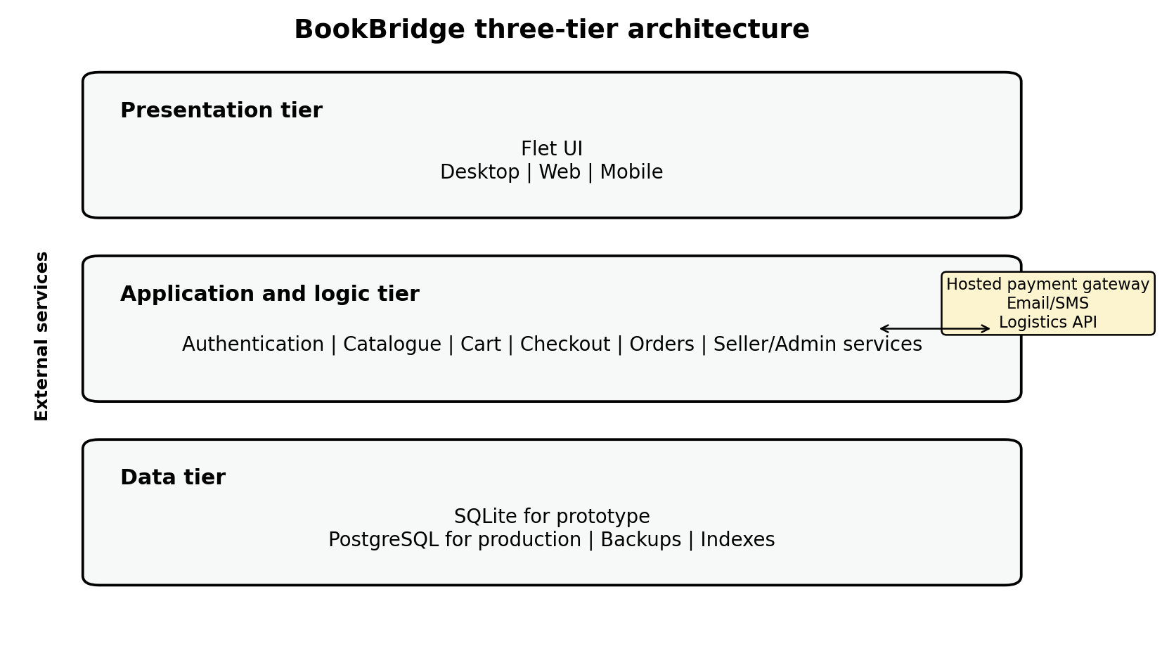
Figure 2. BookBridge three tier architecture.

7.2 Architectural Rationale
The Flet interface is the presentation tier. MarketplaceService is the application and logic tier. Database and SQLite are the data tier. This separation reduces coupling and supports later replacement of SQLite, a web API layer or a different UI client without rewriting the core business rules.
The lecture notes also distinguish two tier designs, where a client talks directly to the database. They describe that pattern as poorly suited to an open Internet community because it exposes the database and couples business logic to clients. BookBridge avoids direct client database access.

7.3 Database Design
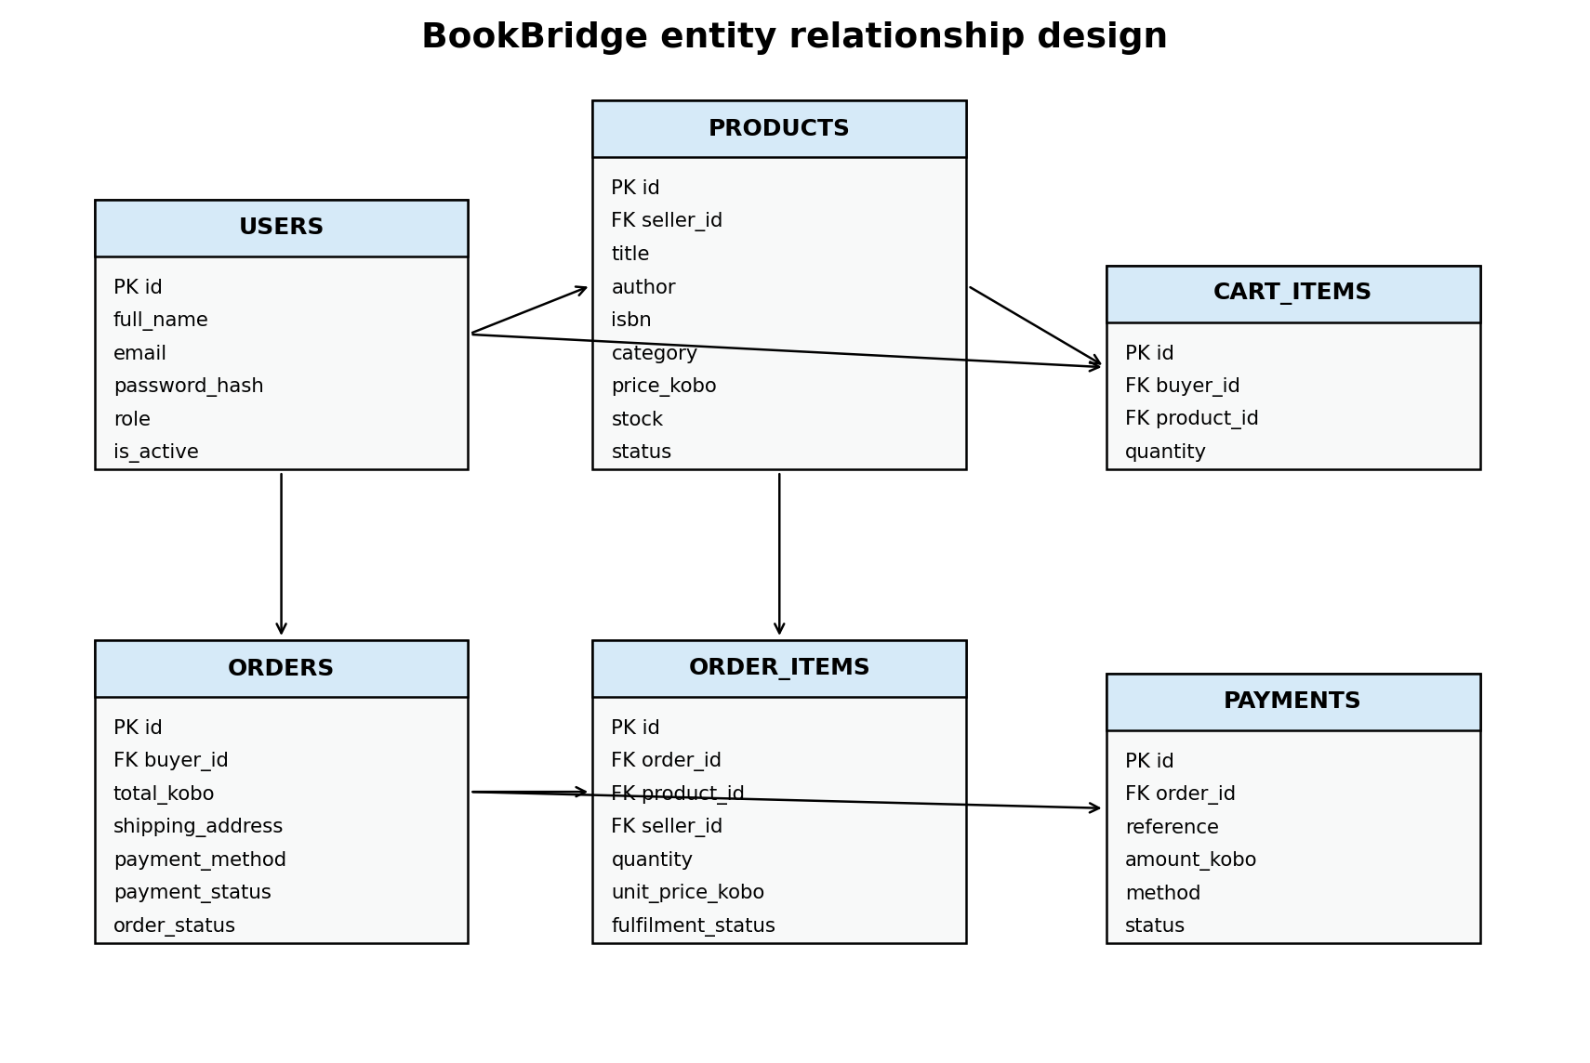
Figure 3. BookBridge entity relationship design.

7.4 Data Dictionary
Table | Purpose | Key fields
users | Stores identities and roles. | id, full_name, email, password_hash, role, is_active.
products | Stores seller book listings. | seller_id, title, author, isbn, category, price_kobo, stock, status.
cart_items | Stores current buyer cart state. | buyer_id, product_id, quantity.
Orders | Stores order header and payment state. | buyer_id, total_kobo, shipping_address, payment_method, payment_status, order_status.
order_items | Stores seller specific order lines. | order_id, product_id, seller_id, quantity, unit_price_kobo, fulfilment_status.
payments | Stores one payment record per order. | order_id, reference, amount_kobo, method, status.

7.5 Important Database Rules
- Email is unique without case sensitivity.
- Roles are limited to buyer, seller and administrator.
- Price and stock values cannot be negative.
- A cart has one row per buyer and product combination.
- Order totals are stored in kobo to avoid binary floating point errors in money calculations.
- Foreign keys preserve relationships among users, products, orders and payments.
- Checkout starts an immediate transaction so competing stock updates are serialized in the prototype.

7.6 Input Design
Screen | Inputs | Validation
Registration | Full name, email, password, role | Valid email, minimum password length, role whitelist, unique email.
Login | Email, password | Account exists, active status, secure password verification.
Product form | Title, author, ISBN, category, description, price, stock | Required text, nonnegative price and stock, seller authorization.
Marketplace search | Keyword and category | Text is used as a parameterized search value.
Cart | Quantity | Positive quantity not above current stock.
Checkout | Delivery address, payment method | Address length and payment method whitelist.
Fulfilment | Status | Status whitelist and seller ownership check.

7.7 Output Design
Output | Information shown
Marketplace cards | Title, author, category, seller, stock, price and description.
Cart | Book, quantity, unit price, subtotal and total.
Order history | Order number, ordered books, total, payment state and order state.
Seller dashboard | Owned products and fulfilment work queue.
Admin dashboard | Counts of users, products, orders and paid revenue.
Validation feedback | Short error message describing the action required.

7.8 Interface Design and Usability
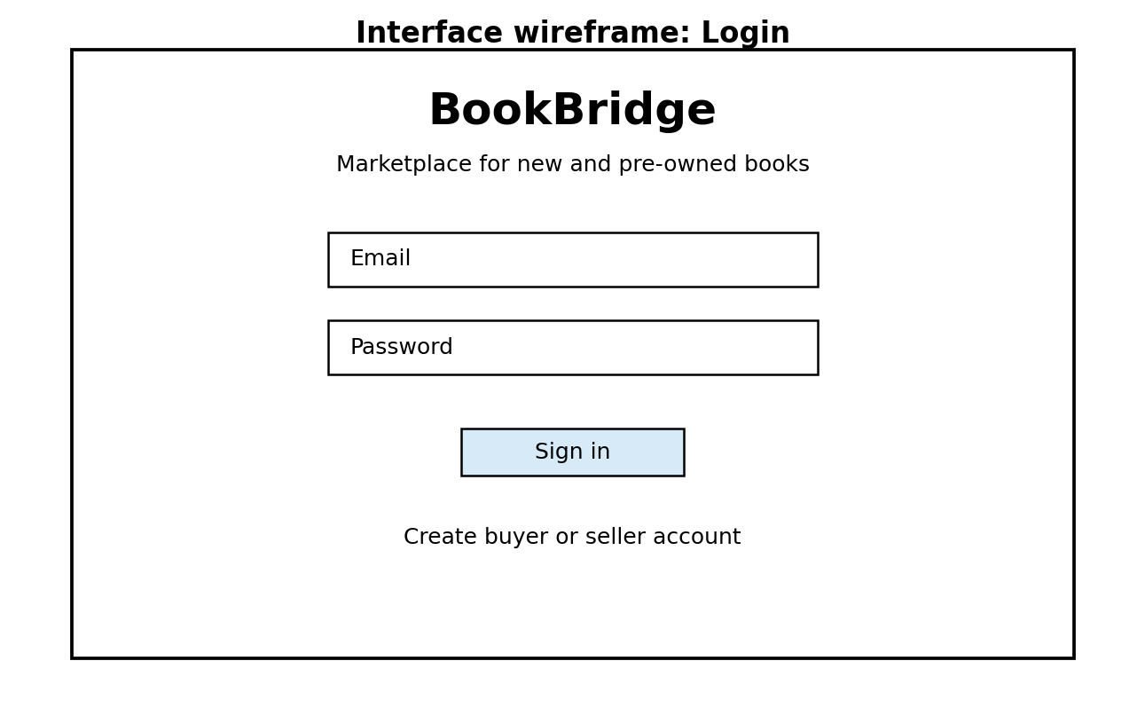
Figure 4. Login interface wireframe.
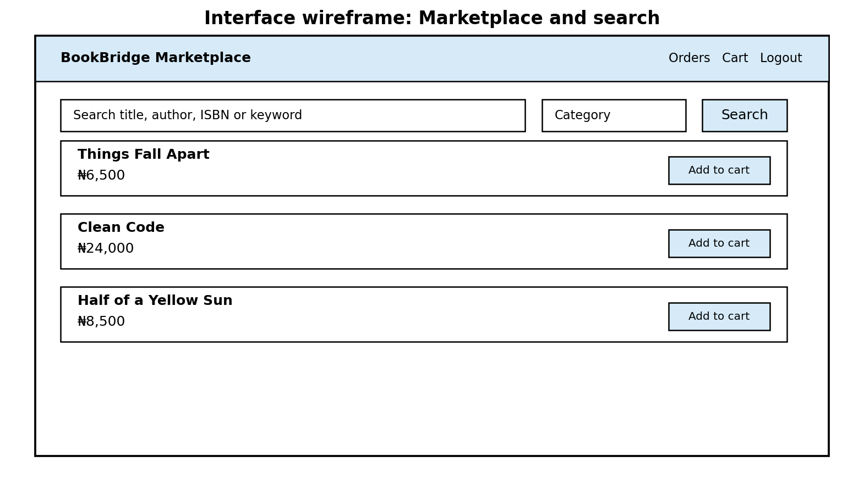
Figure 5. Marketplace and search interface wireframe.
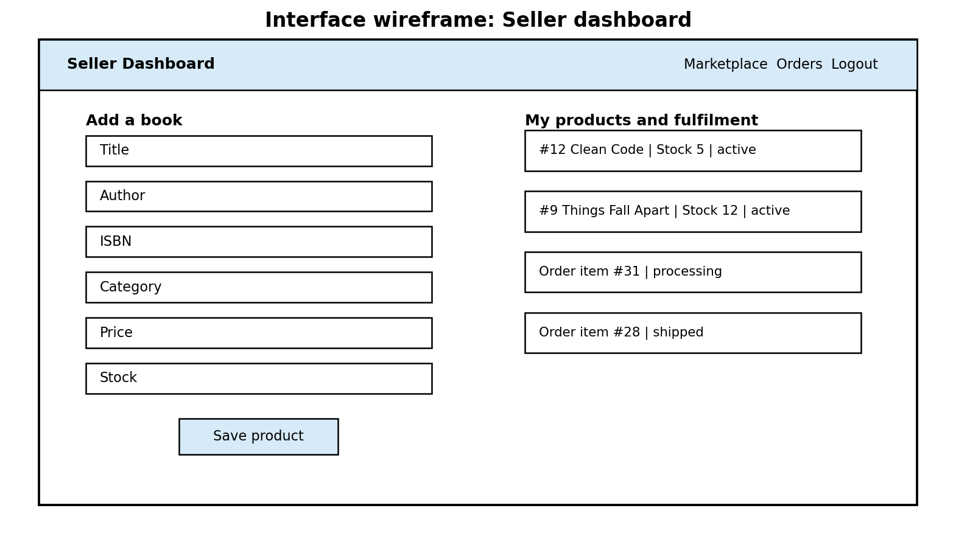
Figure 6. Seller dashboard interface wireframe.

7.9 Accessibility and Inclusive Design
Production BookBridge would provide keyboard operation, sufficient contrast, text alternatives, clear error identification and responsive behavior. Low bandwidth use should receive compact pages, compressed assets and graceful retry behavior.

7.10 Payment Design
The system evaluate payment systems through security, atomicity, privacy, acceptability, cost, convenience, speed, scalability and offline support. They also describe Nigeria bank transfer as a first class e commerce method and list local gateways such as Paystack, Flutterwave and Interswitch. BookBridge therefore models bank transfer and cash on delivery in the prototype and reserves card payment for a hosted provider integration in production.
For a production card flow, BookBridge should use TLS, a hosted payment page, tokenization and 3 D Secure 2. Payment gateway callbacks would use signatures, retries and idempotent processing so duplicate webhooks do not create duplicate payment effects.

7.11 Security Design
Threat or concern | Control in prototype | Production strengthening
Plain text passwords | PBKDF2 salted password hashes | MFA, breached password checks, account lockout and rate limiting.
SQL injection | Parameterized SQL | Database least privilege and monitoring.
Unauthorized seller action | Role and ownership checks in service layer | Central policy enforcement and audit logging.
Overselling | Transactional stock check and decrement | Row locking or serializable stock reservation service.
Card data exposure | No raw card storage | Hosted payment page, TLS, tokenization and PCI DSS controls.
Webhook forgery | Not used by offline prototype | HMAC signature verification, timestamp checks and idempotency keys.
Data loss | Local database file | Automated encrypted backups and restore testing.
Open Internet abuse | Not exposed in local prototype | WAF, bot controls, rate limits and anomaly monitoring.

8. Stage 6: Algorithms, Flowcharts and Pseudocode

8.1 Registration Algorithm
1. Receive full name, email, password and role.
2. Trim text and normalize email to lower case.
3. Validate name, email, role and password length.
4. Generate a random salt and PBKDF2 password hash.
5. Insert the account with a parameterized SQL statement.
6. If the email already exists, return a validation error.
7. Return the new user identifier.

8.2 Login Algorithm
1. Receive email and password.
2. Find the active account by email.
3. If no account exists, reject login.
4. Derive a password hash with the stored salt and iteration count.
5. Compare the result with the stored hash using a constant time comparison.
6. If the password matches, return a session object containing user identifier and role.
7. Use the role to control permitted screens and service operations.
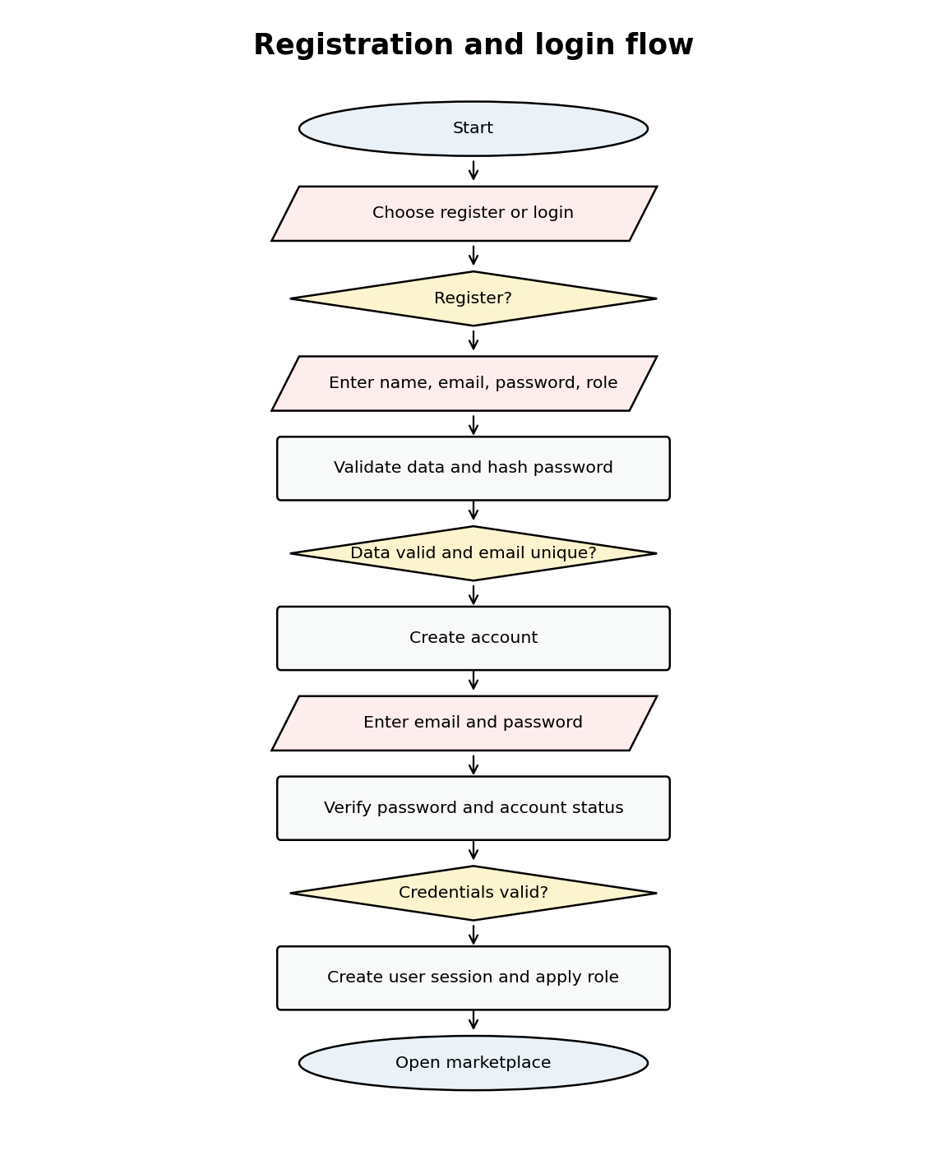
Figure 7. Registration and login flowchart.

8.3 Cart Algorithm
1. Confirm that the current user role is buyer.
2. Read the product and current stock.
3. Add the requested quantity to any existing cart quantity.
4. If new quantity exceeds stock, reject the request.
5. Insert or update the cart row.
6. Return success feedback.

8.4 Checkout Algorithm
1. Confirm buyer role, delivery address and supported payment method.
2. Begin a database transaction.
3. Read every cart item with current product stock and listing status.
4. Reject an empty cart.
5. Reject any inactive or insufficient stock item.
6. Compute total in kobo.
7. Create the order header.
8. Create order item rows with price snapshots.
9. Reduce stock for each ordered item.
10. Create one payment record with a unique reference.
11. Clear cart rows.
12. Commit the transaction and return the order number.
13. If any operation fails, roll back every change.
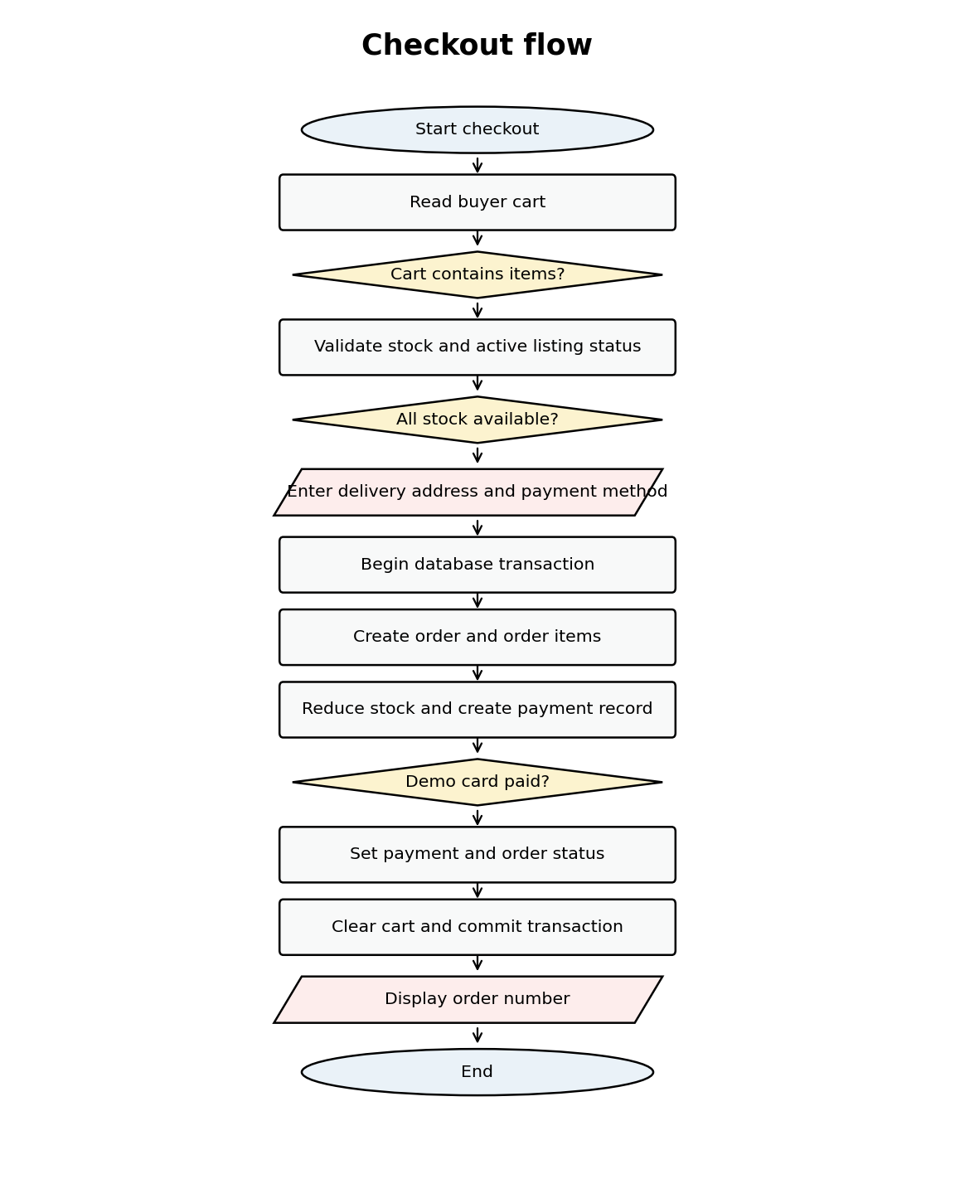
Figure 8. Checkout flowchart.

8.5 Order Fulfilment Algorithm
1. Load seller owned order items.
2. Seller selects a valid fulfilment status.
3. Confirm that the seller owns the order item or has administrator authority.
4. Update the order item status.
5. Read all line statuses for the parent order.
6. Derive the overall order status.
7. Update the order header and show success feedback.
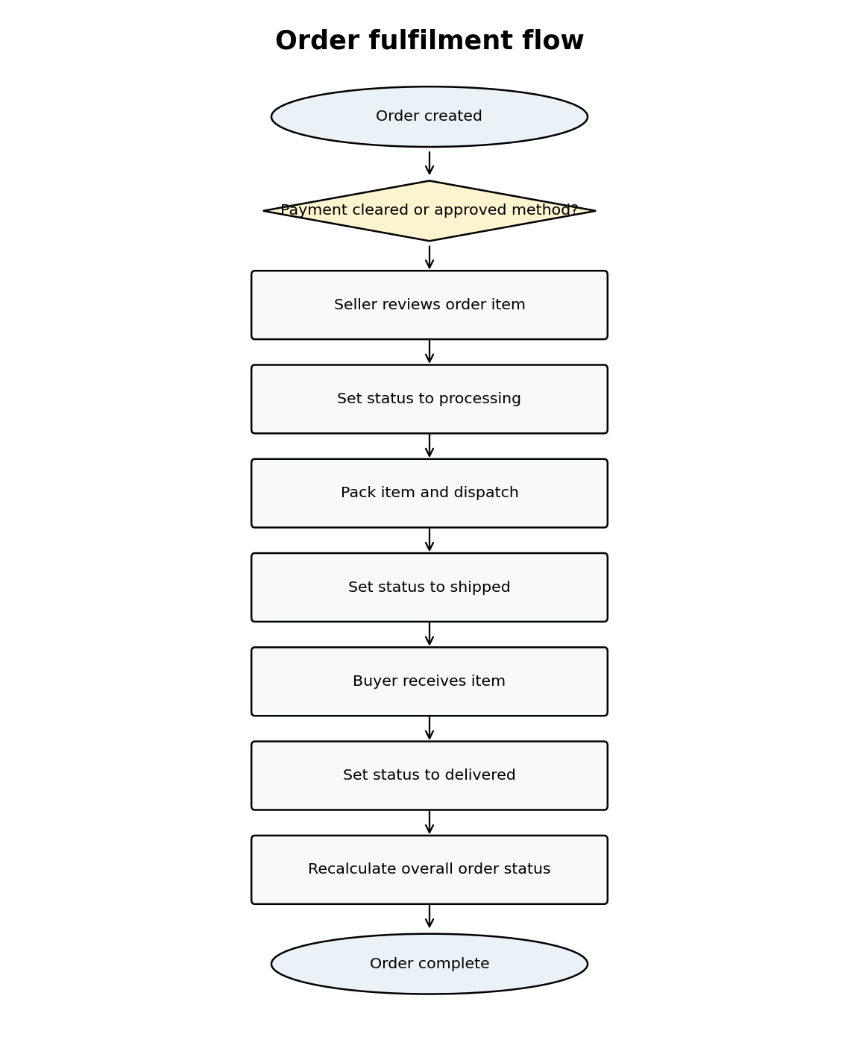
Figure 9. Order fulfilment flowchart.

8.6 Pseudocode
PROCEDURE REGISTER(fullName, email, password, role)
NORMALIZE fullName and email
IF fullName invalid OR email invalid THEN
RETURN error
END IF
IF role is not BUYER or SELLER THEN
RETURN error
END IF
passwordHash = PBKDF2(password, randomSalt)
INSERT user(fullName, email, passwordHash, role)
IF duplicate email THEN
RETURN error
END IF
RETURN userId
END PROCEDURE
PROCEDURE LOGIN(email, password)
user = FIND active user by email
IF user not found THEN
RETURN authentication error
END IF
IF VERIFY(password, user.passwordHash) is false THEN
RETURN authentication error
END IF
RETURN session(user.id, user.role)
END PROCEDURE
PROCEDURE ADD_TO_CART(buyer, productId, quantity)
REQUIRE buyer role
product = FIND active product by productId
currentQuantity = cart quantity or 0
newQuantity = currentQuantity + quantity
IF newQuantity > product.stock THEN
RETURN stock error
END IF
UPSERT cart item with newQuantity
END PROCEDURE
PROCEDURE CHECKOUT(buyer, address, paymentMethod)
REQUIRE buyer role
VALIDATE address and paymentMethod
BEGIN TRANSACTION
items = READ buyer cart joined with current products
IF items empty THEN ROLLBACK and RETURN error
FOR EACH item IN items
IF item inactive OR item.quantity > item.stock THEN
ROLLBACK and RETURN stock error
END IF
END FOR
total = SUM(item.quantity * item.price)
orderId = CREATE order(total, address, paymentMethod)
FOR EACH item IN items
CREATE order item snapshot
REDUCE product stock
END FOR
CREATE payment record with unique reference
DELETE buyer cart
COMMIT TRANSACTION
RETURN orderId
END PROCEDURE

9. Stage 7: Implementation

9.1 Technology Stack
Layer | Technology | Reason
Presentation | Flet | One Python UI codebase for supported desktop, web and mobile targets.
Application logic | Python | Clear service layer, validation and automated testing.
Database | SQLite | Simple coursework prototype with transactional support.
Security | hashlib PBKDF2 and parameterized SQL | No extra security package dependency for prototype password storage.
Testing | Unittest | Standard library unit tests.

9.2 Source Code Organization
Path | Purpose
main.py | Application entry point.
bookbridge/database.py | Schema creation, database connections and seed data.
bookbridge/security.py | Password hashing and verification.
bookbridge/services.py | Authentication, catalogue, cart, checkout, order and admin business logic.
bookbridge/ui.py | Flet views and event handlers.
tests/test_services.py | Automated business logic tests.
requirements.txt | Flet dependency.
README.md | Installation, demo accounts, tests and security notes.

9.3 Secure Password Implementation
import base64
import hashlib
import hmac
import os
PBKDF2_ITERATIONS = 240_000
def hash_password(password: str) -> str:
if len(password) < 8:
raise ValueError("Password must contain at least 8 characters")
salt = os.urandom(16)
digest = hashlib.pbkdf2_hmac("sha256", password.encode("utf-8"), salt, PBKDF2_ITERATIONS)
return "pbkdf2_sha256${}${}${}".format(
PBKDF2_ITERATIONS,
base64.b64encode(salt).decode("ascii"),
base64.b64encode(digest).decode("ascii"),
)
def verify_password(password: str, encoded: str) -> bool:
try:
algorithm, iterations, salt_b64, digest_b64 = encoded.split("$", 3)
if algorithm != "pbkdf2_sha256":
return False
salt = base64.b64decode(salt_b64)
expected = base64.b64decode(digest_b64)
actual = hashlib.pbkdf2_hmac("sha256", password.encode("utf-8"), salt, int(iterations))
return hmac.compare_digest(actual, expected)
except (ValueError, TypeError):
return False

9.4 Transactional Checkout Implementation
def checkout(self, buyer: SessionUser, shipping_address: str, payment_method: str) -> int:
if buyer.role != "buyer":
raise AuthorizationError("Buyer access is required")
if len(shipping_address.strip()) < 8:
raise ValidationError("Enter a complete delivery address")
if payment_method not in {"bank_transfer", "cash_on_delivery", "demo_card"}:
raise ValidationError("Select a valid payment method")
with self.db.transaction() as conn:
rows = conn.execute(
"""SELECT c.product_id,c.quantity,p.title,p.seller_id,p.price_kobo,p.stock,p.status
FROM cart_items c JOIN products p ON p.id=c.product_id
WHERE c.buyer_id=?""",
(buyer.id,),
).fetchall()
if not rows:
raise ValidationError("Your cart is empty")
total = 0
for row in rows:
if row["status"] != "active" or row["quantity"] > row["stock"]:
raise ValidationError(f"Insufficient stock for {row['title']}")
total += row["quantity"] * row["price_kobo"]
payment_status = "paid" if payment_method == "demo_card" else "pending"
order_status = "processing" if payment_status == "paid" else "pending"
cur = conn.execute(
"""INSERT INTO orders(buyer_id,total_kobo,shipping_address,payment_method,payment_status,order_status)
VALUES (?,?,?,?,?,?)""",
(buyer.id, total, shipping_address.strip(), payment_method, payment_status, order_status),
)
order_id = int(cur.lastrowid)
for row in rows:
subtotal = row["quantity"] * row["price_kobo"]
conn.execute(
"""INSERT INTO order_items(order_id,product_id,seller_id,title_snapshot,quantity,unit_price_kobo,subtotal_kobo)
VALUES (?,?,?,?,?,?,?)""",
(order_id, row["product_id"], row["seller_id"], row["title"], row["quantity"], row["price_kobo"], subtotal),
)
conn.execute(
"UPDATE products SET stock=stock-? WHERE id=? AND stock>=?",
(row["quantity"], row["product_id"], row["quantity"]),
)
reference = "BB-" + secrets.token_hex(6).upper()
conn.execute(
"INSERT INTO payments(order_id,reference,amount_kobo,method,status) VALUES (?,?,?,?,?)",
(order_id, reference, total, payment_method, payment_status),
)
conn.execute("DELETE FROM cart_items WHERE buyer_id=?", (buyer.id,))
return order_id

9.5 Application Entry Point
import flet as ft
from bookbridge.database import Database
from bookbridge.services import MarketplaceService
from bookbridge.ui import BookBridgeUI
def main(page: ft.Page) -> None:
db = Database("bookbridge.db")
db.initialize(seed_demo=True)
service = MarketplaceService(db)
BookBridgeUI(page, service).start()
if __name__ == "__main__":
ft.app(target=main)

9.6 Implementation Status
The delivered project folder contains the full modular source code. Static Python compilation succeeds. The automated service tests execute against temporary SQLite databases. The current execution environment used to prepare this report does not include the Flet package, so the Flet interface itself was not launched here. The included installation guide specifies the command required on a machine with internet access and Flet installed. Working screen evidence should be captured after that local run rather than replaced with synthetic images.

10. Stage 8: Testing and Quality Assurance

10.1 Test Strategy
Testing covers business logic, database transactions, role restrictions, boundary validation, UI behavior, usability and security. Automated tests focus on the service layer because this layer contains the rules shared by every target platform. UI checks follow the same requirements after Flet is installed.

10.2 Automated Test Evidence
test_cart_rejects_quantity_above_stock (test_services.MarketplaceServiceTests.test_cart_rejects_quantity_above_stock) ... ok
test_checkout_creates_order_and_reduces_stock (test_services.MarketplaceServiceTests.test_checkout_creates_order_and_reduces_stock) ... ok
test_duplicate_registration_is_rejected (test_services.MarketplaceServiceTests.test_duplicate_registration_is_rejected) ... ok
test_registration_and_login (test_services.MarketplaceServiceTests.test_registration_and_login) ... ok
test_search_finds_product (test_services.MarketplaceServiceTests.test_search_finds_product) ... ok
test_seller_updates_fulfilment (test_services.MarketplaceServiceTests.test_seller_updates_fulfilment) ... ok
----------------------------------------------------------------------
Ran 6 tests in 1.113s
OK

10.3 Test Case Table
ID | Test | Input | Expected result | Evidence
TC01 | Register valid buyer | Unique email, valid password | Account created | Pass, automated
TC02 | Login valid buyer | Correct credentials | Buyer session returned | Pass, automated
TC03 | Duplicate registration | Existing email | Registration rejected | Pass, automated
TC04 | Search by author | Sommerville | Matching book returned | Pass, automated
TC05 | Cart above stock | Quantity 5, stock 4 | Request rejected | Pass, automated
TC06 | Checkout | 2 units, demo card | Order created, payment paid, stock reduced, cart cleared | Pass, automated
TC07 | Seller fulfilment | Set order item to shipped | Seller item status becomes shipped | Pass, automated
TC08 | Invalid login | Wrong password | Authentication rejected | Run during final UI acceptance
TC09 | Buyer tries seller function | Buyer session | Authorization rejected | Run during final UI acceptance
TC10 | Empty cart checkout | No cart items | Checkout rejected | Run during final UI acceptance
TC11 | Responsive marketplace | Desktop, web, mobile target sizes | Controls remain readable and usable | Run after target builds
TC12 | Payment gateway webhook | Signed and duplicate callbacks | Valid signature accepted once | Production integration test

10.4 Usability Evaluation Plan
The system recommend heuristic evaluation, cognitive walkthrough, usability testing and analytics. They state that around five users often expose most problems in an iterative design cycle. The coursework acceptance test should therefore use five representative participants for the first usability round. Each participant completes registration, search, cart editing and checkout. Record task success, completion time, errors and satisfaction.
Task | Effectiveness metric | Efficiency metric | Satisfaction metric
Register and sign in | Successful account and session | Time to completion | Single ease question.
Find a named book | Correct product selected | Time and search attempts | Confidence in result.
Edit cart | Correct quantity stored | Clicks or taps | Perceived control.
Checkout | Correct order created | Time and errors | Checkout satisfaction.

10.5 Security Test Plan
- Attempt duplicate email registration.
- Attempt login with a wrong password.
- Inspect database to confirm passwords are not plain text.
- Attempt SQL metacharacters in search and login fields and confirm parameterized execution.
- Attempt seller update from a buyer account and confirm rejection.
- Attempt one seller to edit another seller listing and confirm rejection.
- Attempt checkout with quantity above stock and confirm rollback.
- For production gateway integration, verify TLS, webhook signatures, replay defense and idempotency.

11. Stage 9: Deployment

11.1 Local Installation
1. Install Python 3.11 or later.
2. Copy the BookBridge project folder to the computer.
3. Create a Python virtual environment.
4. Activate the environment.
5. Run pip install -r requirements.txt.
6. Run python main.py.
7. Sign in with a demo account or create a new buyer or seller account.

11.2 Desktop Deployment
Flet supports desktop execution from the shared Python codebase. Final packaging should follow the command set for the installed Flet release and should be tested on each required operating system before submission.

11.3 Web Deployment
For web deployment, place the application behind HTTPS, use environment variables or a secret manager for credentials, move the database to PostgreSQL and record application logs. The lecture notes emphasize TLS for confidentiality and integrity, redundancy for high availability and observability through metrics and logs for 24 hour operation.

11.4 Mobile Deployment
Android and iOS packaging should use the mobile build workflow supported by the installed Flet release and the relevant platform SDK. The same application service logic remains unchanged. Mobile acceptance testing should check tap target size, screen rotation, small screens, slow networks and error recovery.

11.5 Production Release Checklist
- Use production PostgreSQL rather than a local SQLite file.
- Enable HTTPS everywhere.
- Use a hosted payment provider and avoid raw card storage.
- Add MFA for seller and administrator accounts.
- Add rate limiting, account lockout, WAF rules and bot controls.
- Add structured logs, metrics, error tracking and alerting.
- Automate backups and test restoration.
- Run database migration steps before traffic switch.
- Use staged releases and rollback procedures.
- Complete privacy notice, terms, seller policy and data retention schedule.

12. Stage 10: Maintenance and Evolution

12.1 Maintenance Categories
Category | BookBridge example
Corrective | Fix a checkout defect or wrong order status calculation.
Adaptive | Update Flet, payment gateway API or database driver after platform changes.
Perfective | Improve search filters, add reviews or reduce checkout steps.
Preventive | Refactor modules, rotate secrets, update dependencies and test restores.

12.2 Operational Maintenance
- Review error logs and failed transactions daily in production.
- Review security alerts and suspicious account activity.
- Patch operating system and dependencies on a defined schedule.
- Back up transactional data and verify restoration.
- Archive old logs and follow the data retention policy.
- Measure search success, cart abandonment, checkout completion and support issues.
- Retest key buyer and seller journeys after every release.

12.3 Future Enhancements
- Verified purchase reviews and seller reputation.
- Paystack or Flutterwave hosted checkout with signed webhooks.
- Courier integration and shipment tracking.
- Refund and return workflows.
- Wishlist and saved addresses.
- Book recommendation service using content features and later collaborative filtering.
- Pagination, caching and full text search for a larger catalogue.
- Administrator moderation queues and audit reports.

13. User Documentation

13.1 Buyer Manual
1. Open BookBridge and select Create buyer or seller account if you do not have an account.
2. Choose buyer, enter your details and register.
3. Sign in with email and password.
4. Use the search box or category filter to find books.
5. Select Add to cart for an in stock book.
6. Open Cart, review quantities and update where needed.
7. Enter the delivery address and select payment method.
8. Select Place order.
9. Open Orders to review payment and fulfilment status.

13.2 Seller Manual
1. Register with seller role and sign in.
2. Open Seller from the navigation bar.
3. Enter title, author, ISBN, category, description, price and stock.
4. Select Save product.
5. Review owned listings and available stock.
6. Review order items in the fulfilment section.
7. Change fulfilment from pending to processing, shipped and delivered as work progresses.

13.3 Administrator Manual
1. Sign in with the administrator account.
2. Open Admin to review user, product, order and paid revenue metrics.
3. Open Seller where administrative product controls are extended in a production release.
4. Review audit logs, moderation queues and incident reports in the production deployment.

13.4 FAQ
Question | Answer
Why is my login rejected? | Check email and password. Inactive accounts are also rejected.
Why is Add to cart rejected? | Requested quantity is above current stock or the listing is unavailable.
Why does checkout fail? | The cart is empty, stock changed, the address is incomplete or the payment method is invalid.
Where are card details stored? | The prototype stores no raw card details. Production card payment should use a hosted gateway.
How does a seller see orders? | Open the Seller dashboard after signing in with seller role.
How do I run tests? | Run python -m unittest discover -s tests -v from the project folder.

14. Deliverables Compliance Matrix
Assignment component | Location | Status
1. Feasibility Study | Sections 4.1 to 4.6 | Complete in report.
2. Fact Finding | Section 5 and Appendix A | Instruments and scenario based findings included. Replace scenario statements with real participant evidence before formal submission.
3. System Requirements | Section 6 | Functional, nonfunctional, hardware and software requirements included.
4. Algorithms | Section 8.1 to 8.5 | Registration, login, cart, checkout and fulfilment algorithms included.
5. Flowcharts | Figures 7 to 9 | Registration and login, checkout and order fulfilment flowcharts included.
6. Pseudocode | Section 8.6 | Language independent pseudocode included.
7. System Design | Section 7 | Architecture, ERD, tables, input, output, security and interface design included.
8. Source Code | BookBridge project ZIP plus Appendix B extracts | Complete modular source code delivered separately with this report.
9. Testing Evidence | Section 10 | Six automated service tests pass. Remaining UI and production integration tests are listed.
10. Screenshots | Appendix C checklist | Wireframes are included as design evidence. Working Flet screen captures must be taken after local execution.
11. User Documentation | Section 13 and README.md | Installation guide, buyer, seller, administrator manuals and FAQ included.
12. Completed Application | BookBridge project ZIP | Source code and database setup are delivered. Flet runtime installation is required to launch the UI.

15. References
Modibbo Adama University, Yola. CSC 720: Electronic Commerce Technologies, Postgraduate Lecture Notes, especially Units 7 to 11, pages 23 to 38.
Coursework Assignment: Python / Flet app, Marketplace E commerce Application, pages 1 to 3.
Davis, F. D. (1989). Perceived usefulness, perceived ease of use, and user acceptance of information technology. Listed in the CSC 720 lecture notes.
ISO 9241 11:2018. Ergonomics of human system interaction, usability definitions and concepts. Listed in the CSC 720 lecture notes.
Kohavi, R., Tang, D., and Xu, Y. (2020). Trustworthy Online Controlled Experiments. Listed in the CSC 720 lecture notes.
Laudon, K. C. and Traver, C. G. (2021). E Commerce. Cited in the CSC 720 lecture notes.

Appendix A: Fact Finding Instruments

A.1 Buyer Interview Questions
1. How do you currently search for and buy books?
2. Which information do you need before adding a book to a cart?
3. Which payment methods do you prefer for online purchases?
4. Which problems make you abandon an online checkout?
5. Which order updates do you expect after payment?
6. Which trust signals make a marketplace seller credible to you?

A.2 Seller Interview Questions
1. How do you record titles, prices and stock today?
2. How often does stock change?
3. Which fields are required to describe a book accurately?
4. How do you receive orders and confirm payment?
5. Which fulfilment states match your work process?
6. Which reports would help you manage sales?

A.3 Questionnaire
Question | Response format
How often do you buy books online? | Never, monthly, quarterly, yearly.
Rank the importance of search, price, seller trust, payment options and delivery tracking. | 1 to 5 scale.
Which payment method do you prefer? | Card, bank transfer, wallet, cash on delivery, other.
Would you create an account before checkout? | Yes or no.
Which device do you use most for online shopping? | Phone, tablet, laptop, desktop.
Which problem has caused you to abandon checkout? | Open response.

A.4 Observation Checklist
- Number of steps used to find a specific title.
- How seller stock is recorded and updated.
- How buyer delivery information is collected.
- How payment confirmation reaches the seller.
- How order status is communicated to the buyer.
- Where duplicate entry, delay or error occurs.

Appendix B: Source Code Extracts

B.1 Database Schema
SCHEMA = """
PRAGMA foreign_keys = ON;
CREATE TABLE IF NOT EXISTS users (
id INTEGER PRIMARY KEY AUTOINCREMENT,
full_name TEXT NOT NULL,
email TEXT NOT NULL UNIQUE COLLATE NOCASE,
password_hash TEXT NOT NULL,
role TEXT NOT NULL CHECK(role IN ('buyer','seller','admin')),
is_active INTEGER NOT NULL DEFAULT 1,
created_at TEXT NOT NULL DEFAULT CURRENT_TIMESTAMP
);
CREATE TABLE IF NOT EXISTS products (
id INTEGER PRIMARY KEY AUTOINCREMENT,
seller_id INTEGER NOT NULL,
title TEXT NOT NULL,
author TEXT NOT NULL,
isbn TEXT,
category TEXT NOT NULL,
description TEXT NOT NULL DEFAULT '',
price_kobo INTEGER NOT NULL CHECK(price_kobo >= 0),
stock INTEGER NOT NULL CHECK(stock >= 0),
status TEXT NOT NULL DEFAULT 'active' CHECK(status IN ('active','inactive')),
created_at TEXT NOT NULL DEFAULT CURRENT_TIMESTAMP,
FOREIGN KEY(seller_id) REFERENCES users(id)
);
CREATE TABLE IF NOT EXISTS cart_items (
id INTEGER PRIMARY KEY AUTOINCREMENT,
buyer_id INTEGER NOT NULL,
product_id INTEGER NOT NULL,
quantity INTEGER NOT NULL CHECK(quantity > 0),
UNIQUE(buyer_id, product_id),
FOREIGN KEY(buyer_id) REFERENCES users(id) ON DELETE CASCADE,
FOREIGN KEY(product_id) REFERENCES products(id) ON DELETE CASCADE
);
CREATE TABLE IF NOT EXISTS orders (
id INTEGER PRIMARY KEY AUTOINCREMENT,
buyer_id INTEGER NOT NULL,
total_kobo INTEGER NOT NULL CHECK(total_kobo >= 0),
shipping_address TEXT NOT NULL,
payment_method TEXT NOT NULL,
payment_status TEXT NOT NULL CHECK(payment_status IN ('pending','paid','failed')),
order_status TEXT NOT NULL CHECK(order_status IN ('pending','processing','shipped','delivered','cancelled')),
created_at TEXT NOT NULL DEFAULT CURRENT_TIMESTAMP,
FOREIGN KEY(buyer_id) REFERENCES users(id)
);
CREATE TABLE IF NOT EXISTS order_items (
id INTEGER PRIMARY KEY AUTOINCREMENT,
order_id INTEGER NOT NULL,
product_id INTEGER NOT NULL,
seller_id INTEGER NOT NULL,
title_snapshot TEXT NOT NULL,
quantity INTEGER NOT NULL CHECK(quantity > 0),
unit_price_kobo INTEGER NOT NULL CHECK(unit_price_kobo >= 0),
subtotal_kobo INTEGER NOT NULL CHECK(subtotal_kobo >= 0),
fulfilment_status TEXT NOT NULL DEFAULT 'pending' CHECK(fulfilment_status IN ('pending','processing','shipped','delivered','cancelled')),
FOREIGN KEY(order_id) REFERENCES orders(id) ON DELETE CASCADE,
FOREIGN KEY(product_id) REFERENCES products(id),
FOREIGN KEY(seller_id) REFERENCES users(id)
);
CREATE TABLE IF NOT EXISTS payments (
id INTEGER PRIMARY KEY AUTOINCREMENT,
order_id INTEGER NOT NULL UNIQUE,
reference TEXT NOT NULL UNIQUE,
amount_kobo INTEGER NOT NULL,
method TEXT NOT NULL,
status TEXT NOT NULL CHECK(status IN ('pending','paid','failed')),
created_at TEXT NOT NULL DEFAULT CURRENT_TIMESTAMP,
FOREIGN KEY(order_id) REFERENCES orders(id) ON DELETE CASCADE
);
CREATE INDEX IF NOT EXISTS idx_products_search ON products(title, author, category);
CREATE INDEX IF NOT EXISTS idx_orders_buyer ON orders(buyer_id, created_at);
CREATE INDEX IF NOT EXISTS idx_order_items_seller ON order_items(seller_id, fulfilment_status);
"""

B.2 Automated Tests
import tempfile
import unittest
from pathlib import Path
from bookbridge.database import Database
from bookbridge.services import MarketplaceService, ValidationError
class MarketplaceServiceTests(unittest.TestCase):
def setUp(self):
self.tmp = tempfile.TemporaryDirectory()
self.db = Database(Path(self.tmp.name) / "test.db")
self.db.initialize(seed_demo=False)
self.svc = MarketplaceService(self.db)
self.buyer_id = self.svc.register("Buyer One", "buyer@example.com", "Buyer123!", "buyer")
self.seller_id = self.svc.register("Seller One", "seller@example.com", "Seller123!", "seller")
self.buyer = self.svc.login("buyer@example.com", "Buyer123!")
self.seller = self.svc.login("seller@example.com", "Seller123!")
self.product_id = self.svc.save_product(
self.seller, "Software Engineering", "Ian Sommerville", "9780137035151",
"Computing", "Software engineering text", 12000.00, 4
)
def tearDown(self):
self.tmp.cleanup()
def test_registration_and_login(self):
user = self.svc.login("buyer@example.com", "Buyer123!")
self.assertEqual(user.role, "buyer")
def test_duplicate_registration_is_rejected(self):
with self.assertRaises(ValidationError):
self.svc.register("Another", "buyer@example.com", "Password1!", "buyer")
def test_search_finds_product(self):
products = self.svc.list_products("Sommerville")
self.assertEqual(len(products), 1)
self.assertEqual(products[0]["id"], self.product_id)
def test_cart_rejects_quantity_above_stock(self):
with self.assertRaises(ValidationError):
self.svc.add_to_cart(self.buyer, self.product_id, 5)
def test_checkout_creates_order_and_reduces_stock(self):
self.svc.add_to_cart(self.buyer, self.product_id, 2)
order_id = self.svc.checkout(self.buyer, "12 University Road, Yola", "demo_card")
orders = self.svc.buyer_orders(self.buyer.id)
self.assertEqual(orders[0]["id"], order_id)
self.assertEqual(orders[0]["payment_status"], "paid")
products = self.svc.list_products("Software Engineering")
self.assertEqual(products[0]["stock"], 2)
self.assertEqual(self.svc.cart(self.buyer.id), [])
def test_seller_updates_fulfilment(self):
self.svc.add_to_cart(self.buyer, self.product_id, 1)
self.svc.checkout(self.buyer, "12 University Road, Yola", "demo_card")
seller_items = self.svc.seller_orders(self.seller.id)
self.svc.update_fulfilment(self.seller, seller_items[0]["id"], "shipped")
seller_items = self.svc.seller_orders(self.seller.id)
self.assertEqual(seller_items[0]["fulfilment_status"], "shipped")
if __name__ == "__main__":
unittest.main()

B.3 Full Source Package
The full source code is supplied in the BookBridge project ZIP. It includes main.py, the complete Flet interface, database schema, security functions, business services, tests, README and screenshot checklist.

