

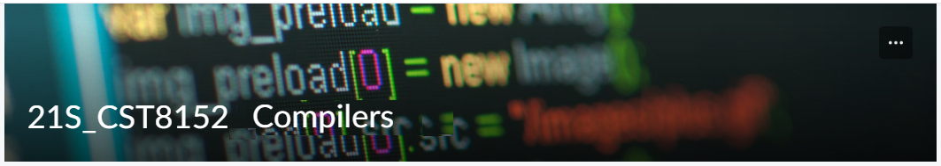

MODEL TASK FOR ASSIGNMENT 2.1 – Arrow

Language: Arrow
Team – Isaac Proulx - Id: 041007853

PART 1: RE – Regular Expression (1.5 mark)

Lexeme Classes: Define the classes to be used in your regular expression:

Upper = [A-Z]
Lower = [a-z]
Let = [A-Za-z]
Dig = [0-9]
Und = _
QuotD = "
QuotS = '
BkTk = `
Dot = .
EOL = <New Line Char>
EOF = <End of File Char>
ComStrt = /*
ComEnd = */
ComSing = //
True = true
False = false

* Comments:
Comment = ComStrt[^ComEnd]*ComEnd = ComSing[^EOL|EOF](EOL|EOF)
* Variables:
VoMID = (Und|Let)(Und|Let|Dig)* //variable or method identifier
* Literals:
- Numbers
IntegerLiteral = Dig(Dig)*
FloatLiteral = Dig(Dig)*Dot(Dig)* = DotDig(Dig)*
- Strings
StringLiteral = QuotD[^QuotDEOL]*QuotD = QuotS[^QuotSEOL]*QuotS = BkTk[^BkTk]*BkTk
- Booleans
BooleanLiteral = True|False
* Keywords:
KeyWord = Lower(Lower)* //result must be in the list of valid keywords, otherwise it is a VoMID
*for the list of valid keywords, refer to A11

PART 2: TD – Transition Diagram (1.5 marks)

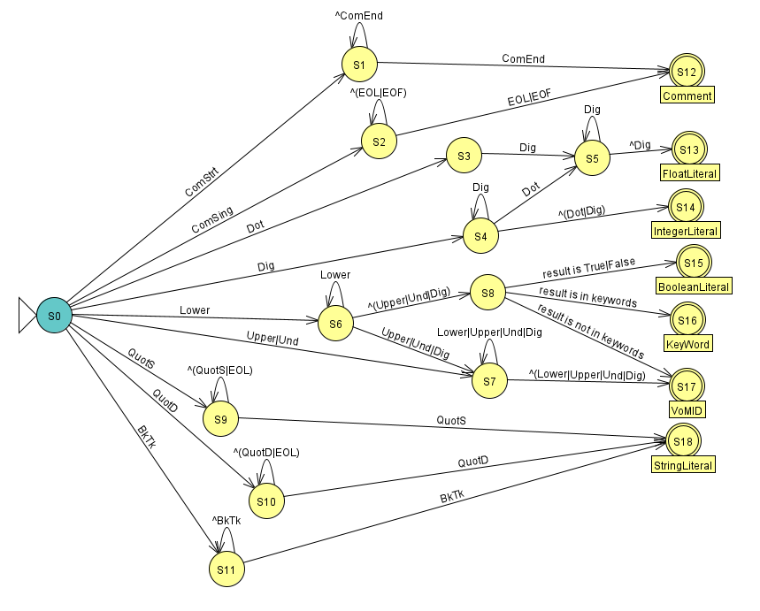

PART 3: TT – Transition Table (2 marks)
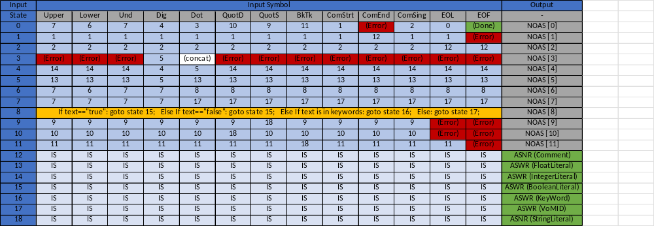

Update: Feb 3rd 2023.

Adapted from resources developed by Prof. Svillen Ranev (Algonquin College, 2019)

