Table 1: Parallel Trends Test of Hospitalization Rates
Variable | Estimates
(Intercept) | 22671.36  (33011.12)
Year | 45.54 **  (16.38)
Vaping Ban | -14856.10  (48672.25)
Year x Vaping Ban | 6.16  (24.15)
Observations | 550
R² / R² adjusted | 0.654 / 0.652
* p<0.05 ** p<0.01 *** p<0.001
Notes. This table is a regression testing the trends of hospitalization rates before 2021, the year vaping bans were enacted, between states that enacted vaping bans and states that did not enact vaping bans. Standard OLS standard errors are reported.

There was no significant difference in hospitalization rates between states that enacted the vaping ban and states that did not enact the vaping ban in the years leading up to the vaping bans, F(3, 546) = 6.16, p = .79.

Figure 1. Difference in Difference Graph
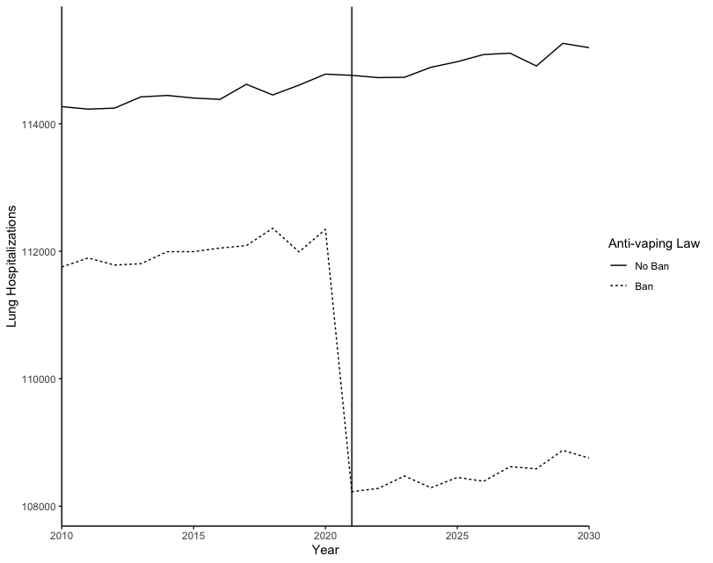
Notes. This figure shows the hospitalization rates across states that enacted vaping bans and did not enact vaping bans before and after vaping bans were put in place.

Table 2:Effect of Vaping Ban on Lung Hospitalizations
 | Model 1 | Model 2
Variable | Estimates | Estimates
(Intercept) | 113860.23 ***  (50.49) | 110787.44 ***  (137.20)
Vaping Ban | -5364.88 ***  (107.87) | -4030.46 ***  (65.38)
Observations | 1050 | 1050
R² / R² adjusted | 0.702 / 0.702 | 0.963 / 0.960
* p<0.05 ** p<0.01 *** p<0.001
Notes. Model 1 is the regression of vaping bans predicting hospitalization rates. Model 2 includes fixed effects of year and state. Standard OLS standard errors are reported.

Hospitalizations decreased by 4030.46 cases on average in states that enacted vaping bans starting in the year 2021.

