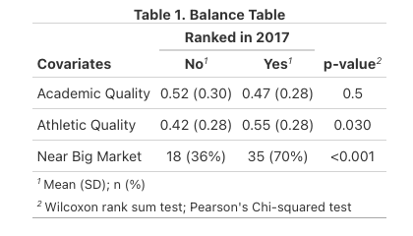
Notes. This table displays the mean and standard deviation of covariates across universities that were ranked or not ranked in 2017.

According to the balance table the universities are similar in academic quality, however they differ in both athletic quality such that schools ranked have significantly higher athletic quality and whether they are near a big market or not; such that schools near a big market are significantly more likely to be ranked.

If the three variables included in the balance table were the only variables used to determine whether schools were ranked, then this would contribute to the credibility of our propensity model. However, based on the prompt it is unclear whether these characteristics were the only ones used to determine if the university was ranked. Given that there are differences in two of the three variables, there may be other unobservable variables that are different across universities that were ranked vs. not ranked which could also affect whether they were ranked.

Table 2: Propensity score model
 | Ranked
Variable | Log-Odds
(Intercept) | -1.38 *  (0.65)
Academic Quality | -0.88  (0.78)
Athletic Quality | 1.96 *  (0.81)
Near Big Market | 1.62 ***  (0.46)
Observations | 100
R² Tjur | 0.179
* p<0.05 ** p<0.01 *** p<0.001

Notes. This table displays the beta coefficients for academic quality, athletic quality, and whether they were near a big market predicting the treatment, whether the university was ranked in 2017.
Standard errors are reported.

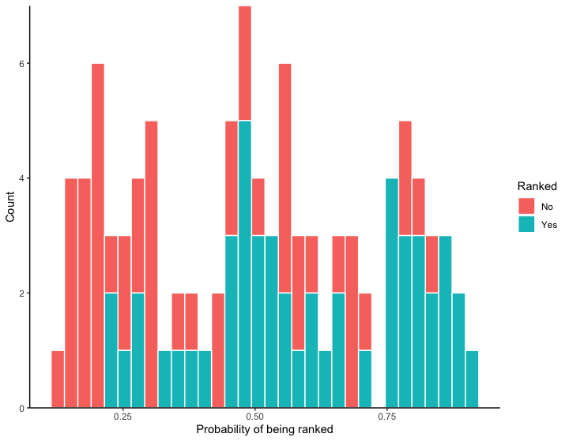
Figure 1. This figure displays the overlap in propensity scores for universities that were ranked and not ranked.

Table 3: Effect of Being Ranked on Donations
 | Model 1 | Model 2
Variable | Estimates | Estimates
(Intercept) | 432.65 ***  (67.36) | 0.09  (0.30)
Ranked | 841.81 ***  (95.27) | 500.46 ***  (0.23)
Academic Quality |  | 99.90 ***  (0.45)
Athletic Quality |  | 50.41 ***  (0.82)
Near Big Market |  | 1000.13 ***  (0.66)
Observations | 100 | 100
R² / R² adjusted | 0.443 / 0.438 | 1.000 / 1.000
* p<0.05 ** p<0.01 *** p<0.001
Notes. This table contains to regression models predicting the effect of being ranked on the number of donations a university receives. Model 1 is the basic model of being ranked predicting donations. Model 2 contains the fixed effect of blocked propensity scores and covariates. Standard errors are reported.

On average, being ranked increases university donations by $500,000 when controlling for blocked propensity scores, academic quality, athletic quality, and whether the university is near a big market.

