Unoptimized:

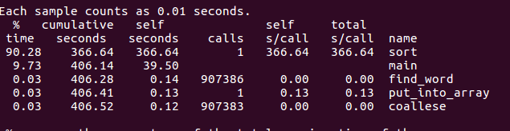
Optimized:

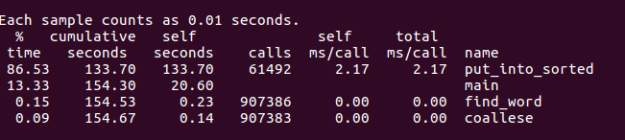
As you can see, there was about a 233 second difference between the programs. This is for three main reasons—in the optimized version, I used a bigger hash, reducing collisions. I also wasted considerable space using a large “sorted” array than necessary instead of running an entire loop counting the number of entires in order to reduce space usage. Finally, I used a version of bubble sort in the unoptimized version, and a version of insertion sort in the optimized version.

