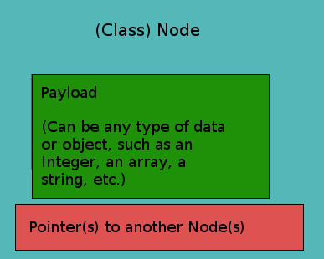
The Node class

Nodes are an extremely simple data structure that have two parts:
- a payload, or in other words the data you’d like to store, and
- one or multiple pointers, or in other words, the address of other nodes.

The payload is where the actual data of whatever application we’re using is stored. This can be as simple as a mere integer or string, or as complex as a custom object (i.e. a cricket team object containing a list of their players, their wins and losses, etc). In most cases, the data type stored in the payload of a Node in most data structures are all going to be the same.

The pointer (or pointers) point to other nodes. In the case of a Singly Linked List, there is one pointer in each node called Next that points to the next Node in the linked list (or is null if it is the last node). In the case of a tree, any single node could have a number of pointers! A pointer is a data structure that points the location of something else in memory. If this explanation isn’t enough, try just reading on, as in high level languages it’s unnecessary to know the nitty-gritty. If you are still baffled, refer to the pointer section in my Need-To-Know Concepts page.

The node can be thought of as a sub-data structure, often a helper structure for larger, more complex data structures. (This will make sense as we move on.) Each data structure will have a variation upon the node, the only difference being the number of pointers each node holds. For each type of data structure requiring a node, I will draw one similar to the format drawn below.

