Ben Fanjoy & Isaac Shoebottom

Database ERD:

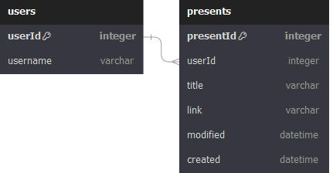

Stored Procedures:

* createUser(newUsername)
  + If no user is found with a given username, create it with the name passed in, returning the userid
* getPresentsByUsername(username)
  + Get all presents associated with a specific username.
* updatePresentById(id, title, link)
  + Update the info of an existing present. Doesn’t change the created date, should update modified date to current time, but not implemented. Replaces title and link field on the given id
* createPresent(username, title, link)
  + Create a present with the provided parameters. Set created and modified date to current time.
* deletePresentById(id)
  + Delete specified present object. Simply removes the present with the given id