Advancing Renewable Energy Efficiency and
Reliability through Artificial Intelligence

By:
Isaac Tsolak

A thesis submitted in partial fulfillment of the requirements
for the degree of Master of Science in Data Science

Department of Computer Science & Networking
Wentworth Institute of Technology

Boston, Massachusetts

April 13, 2026

Thesis Advisor: Mehmet Ergezer
Committee: Steven Morrow, Pang, Weijie

Tsolaki@wit.edu
Abstract
This thesis investigates the application of Artificial Intelligence to improve the accuracy of solar power generation forecasting to reduce the reliance on traditional carbon-based fuels. Traditional forecasting methods often fail to capture the complexity and intermittency of weather data, and this can lead to unreliable forecasting which contributes to energy waste and power grid instability. This research aims to address the limitations of traditional forecasting methods by applying and comparing more modern approaches staring with a persistence model as a baseline and moving to other Machine Learning Models (ML) like Linear regression, Lasso Regression, LSTM, Random Forest, and XGBoosting the goal is to find what models are capable of producing accurate forecasts and identifying what features are most important. All models are trained on historical power generation data from the E.W. Brown Solar facility in Harrodsburg Kentucky, combined with weather data from NASA’s database from the same location. Model performance is evaluated using RMSE, MAE and $R^{2}$on a test set. Out of all the models XGBoost showed the strongest predictive power, attaining a RMSE of 330.79 kW, an $R^{2}$ 0.987, and 71.2% reduction in error over the baseline persistence model. All models demonstrated statistically significant improvements over the baseline, and XGBoost performed superior to all other models by a paired t-test and Diebold-Mariano testing. The findings from this research show that ML can be effective in capturing the non-linear relationships in weather variables and solar power output, providing a pathway toward increasing the use of renewable energy sources rather than traditional carbon-based fuels.
Keywords: Artificial Intelligence, Machine Learning, Renewable Energy, Fossil Fuel, Solar Power, Energy Forecasting, Grid Stability, XGBoost, Gradient Boosting, Solar Irradiance, Predictive Modeling, Time Series Forecasting, Feature Importance

List of Figures
Figure 1. Baseline (Persistence) Model predicted vs. actual power output (first week of January 2022).

Figure 2. Linear Regression predicted vs. actual power output (first week of January 2022).

Figure 3. Random Forest predicted vs. actual power output (first week of January 2022).

Figure 4. XGBoost predicted vs. actual power output (first week of January 2022).

Figure 5. Residual analysis of XGBoost predictions on the 2022 test set.

Figure 6. LSTM predicted vs. actual power output (first week of January 2022).

Figure 7. Top 10 feature importances for the Random Forest and XGBoost models.

Figure 8. Seasonal variation in model performance, showing RMSE and R² scores by season.

List of Tables
Table 1. Model performance comparison on the 2022 test set.

Table of Contents
Abstract
Keywords
List of Figures
List of Tables
1. Introduction
2. Literature Review
- 2.1 Introduction
- 2.2 The Global Energy Transition
  - 2.2.1 The Case for Renewable Energy
  - 2.2.2 Challenges of Replacing Carbon-Based Fuels
  - 2.2.3 The Role of Accurate Forecasting in Accelerating Transition
- 2.3 Solar Energy Systems
  - 2.3.1 How Solar Generation Works
  - 2.3.2 Factors That Affect Solar Output
  - 2.3.3 Why Solar Power Is Particularly Difficult to Forecast
- 2.4 Traditional Forecasting Methods
  - 2.4.1 Statistical Baselines
  - 2.4.2 Known Limitations
  - 2.4.3 Where Traditional Methods Fall Short in Real-World Applications
- 2.5 Machine Learning for Energy Forecasting
  - 2.5.1 Linear and Regularised Regression
  - 2.5.2 Ensemble Methods: Random Forest
  - 2.5.3 Gradient Boosting: XGBoost
  - 2.5.4 Deep Learning: LSTM
- 2.6 AI for Grid Integration and Stability
  - 2.6.1 Reducing Reliance on Carbon-Based Backup Generation
  - 2.6.2 Real-World Deployment
- 2.7 Gaps in Existing Research
  - 2.7.1 Narrow Geographic Focus
  - 2.7.2 Lack of Standardised Evaluation Metrics
- 2.8 Summary
3. Data
- 3.1 Data Sources
  - 3.1.1 Energy Generation Data
  - 3.1.2 Weather Data
  - 3.1.3 Data Scope
- 3.2 Data Preprocessing
  - 3.2.1 Temporal Aggregation
  - 3.2.2 Missing Value Handling
  - 3.2.3 Negative Value Correction
  - 3.2.4 Feature Scaling
- 3.3 Feature Engineering
- 3.4 Limitations
4. Methodology
- 4.1 Research Design
- 4.2 Models
  - 4.2.1 Baseline (Persistence Model)
  - 4.2.2 Linear Regression
  - 4.2.3 LASSO Regression
  - 4.2.4 Random Forest
  - 4.2.5 XGBoost
  - 4.2.6 Ensemble Model
  - 4.2.7 Long Short-Term Memory (LSTM)
- 4.3 Evaluation Metrics
5. Results
- 5.1 Baseline Performance
- 5.2 Linear Regression
- 5.3 LASSO Regression
- 5.4 Random Forest
  - 5.4.1 Random Forest Without POAI
- 5.5 XGBoost
- 5.6 Ensemble Model
- 5.7 Long Short-Term Memory (LSTM)
- 5.8 Model Comparison
- 5.9 Seasonal Performance
- 5.10 Statistical Significance
6. Discussion
- 6.1 Overview of Findings
- 6.2 Explaining XGBoost's Superior Performance
- 6.3 LSTM Performance
- 6.4 The POAI Dominance
- 6.5 Seasonal Performance
- 6.6 Answers to Research Questions
- 6.7 Connections to Existing Literature
- 6.8 Limitations
- 6.9 Practical Implications
7. Conclusion
Reference List

1. Introduction
Since the start of the Industrial Revolution there has been a steady incline of ${CO}_{2}$ released into the air contributing to heat getting trapped in the Earth’s atmosphere, causing long term issues for the environment, with rising temperatures, gradual ocean acidification and ecological changes that are becoming too extreme to control or undo. Most notably of these factors, fossil fuels have been the leading cause of carbon dioxide emissions being pushed into the atmosphere. Fossil fuel production is directly tied to human energy demand, serving as a primary source for electricity generation, heating, cooking, and transportation.
Historically, carbon emissions have always fluctuated from 200 to approximately 280 parts per million(ppm) dating back to the ice age period around 800 BC. According to data compiled by Our World in Data, they are currently around 410ppm. [1] This is cause for concern, and with this concern there is the need to find a new, greener form of energy.
Currently, energy companies are beginning extreme transformation as they are forced to adapt due to climate extremes, increasing scarcity of natural resources, growing global tensions and global warming. The global energy demand continues to rise as population grows and cities make ever needing expansions. Since the Industrial Revolution the necessity of fossil fuels has only exponentially grown, however fossil fuels like coal, oil and natural gases are finite and will become depleted. This will cause significant disruptions in the quality of life, have significant costs, detrimental environmental consequences, and the possible extinction of ecosystems, while also increasing global tensions and cause resource guarding.
Solar energy has become one of the most scalable and accessible renewable energy alternatives available, with new facilities appearing globally. The transition away from carbon-based fuels is no longer a futuristic ambition it is an active and urgent priority being pursued by governments, utilities, and research worldwide. In December 2015, the Consolidated Appropriations Act Extended federal tax credits for wind and solar energy by five years, to incentives the progress and use of renewable energy development in the United States.[2]. While this is one of many initiatives presented in the US to pursue alternative energy forms, the speed and success of that transition have been hard to accurately predict. The largest contingency is the ability to accurately forecast how much energy would be required for cities and their power generation without causing mass disruptions to daily life.
Solar power generation is inherently a varied source of energy given the way that it is harvested. Harvest amount depends heavily on weather conditions that can fluctuate by the hour, change with the seasons, and can be disrupted without warning by cloud cover, atmospheric pressure changes or temperature fluctuations. Grid operators need accurate forecasts well in advance so they can balance supply and demand, determine what amount of energy to store, and decide when to draw on backup generation sources. When those forecasts are not accurate there can be major consequences like wasted energy, gird instability, higher operating costs, and continued dependence on carbon-based fuels.
Prior to the advancements in machine learning and artificial intelligence (AI), solar power forecasts were developed on two primary approaches. Numerical Weather Prediction (NWP) which uses atmospheric physics equations to predict solar irradiance, which would then be used to predict power outputs [3]. Persistence models that assume tomorrow’s solar output will be the same as todays, or the same as a corresponding day in the previous day or week [4]. Inman et al. [5] provides an overview of these traditional forecasting methods and their role in the integration of renewable energy. Solar irradiance is the formal term for solar energy that is hitting the surface and can be used in practice to report on the energy emitted and absorbed by the Earth.
Traditional methods like persistence or NWP forecasting were not designed for this level of complexity and intermittency. Older and more traditional models were forced to assume there was a relatively stable, linear relationship between input and output and consistently underperform when applied to non-linear, high variability dynamics of solar generation data. The result is a gap in the ability to accurately forecast and predict energy generation, leading to hindering success and the inability for accuracy.
Machine learning has shown considerable promise in closing this gap. Lai et al. [6] completed research into many different ML algorithms and found that they perform better than traditional statistical models when applied to more complex weather data. Said and Alanzi [7] demonstrated that AI-driven forecasting models can meaningfully improve grid integration by enhancing reliability and reducing energy waste. Abdelsattar et al. [8] identified the specific environmental variable, including solar, irradiance, temperature and humidity that carry the greatest weight in real world solar applications. Despite the growing amount of evidence, much of the existing research focuses on single model types or narrow geographical regions, and direct comparisons between multiple models trained and evaluated on the same data set under consistent conditions remain limited. A clearer picture of which models perform best, under what conditions, and which features drive those predictions is still needed.
This thesis will address that gap directly. Five machine learning models of increasing complexity were trained on historical solar generations data from the E.W. Brown Solar Facility in Harrodsburg Kentucky, combined with weather data of the same region sourced from NASA’s POWER Database. The models tested were a persistence baseline, Linear Regression, LASSO Regression, Random Forest, and XGBoost, all of which were selected to represent a distinct modeling approach ranging from rule-based benchmark through regularized linear methods to tree based ensemble techniques. All models were evaluated on a left-out test year using RMSE, MAE, and $R^{2}$ as performance metrics, with statistical significance testing applied to confirm that observed differences were not due to chance.
XGBoost emerged as the strongest performer across all the evaluation metrics, achieving a test RMSE of 330.79 kW, an $R^{2}$ of 0.9876, and a 71.2% reduction in forecasting error compared to the persistence model baseline. All five learned models significantly outperformed the baseline (p < 0.001), and XGBoost was confirmed as statistically superior to every other individual model. These results demonstrate that gradient boosting methods can effectively capture the non-linear relationship between environmental conditions and solar output in ways that more simple methods cannot, with meaningful implications for how renewable energy can be managed and integrated into modern power grids.
The remainder of this thesis is structured as follows. Chapter 2 reviews existing literature on this topic of renewable energy forecasting and the application of machine learning to solar predictions. Chapter 3 describes the dataset, preprocessing steps, feature engineering, and the five models used. Chapter 4 looks at the results of the model training and how they were evaluated. Chapter 5 discusses the findings in context of the research question and more of the literature. Chapter 6 concludes with a summary of the contributions and directions for future research.

2. Literature Review
2.1 Introduction
This literature review will look at research regarding the application of artificial intelligence to solar energy forecasting. The review is organized by four themes. The global energy transition, the challenges it presents for power grid management, the physical characteristics of solar energy systems that make predicting power generation difficult, the evolution of the forecasting methods used from traditional approaches to more modern machine learning techniques, and the practical applications of improved forecasting for energy grid management and stability. Together these themes establish the theoretical and empirical foundation for the methods of this research and the models used. The literature review will also identify specific gaps in existing research that this thesis aims to address.
2.2 The Global Energy Transition
2.2.1 The Case for Renewable Energy
The global demand for energy is steadily growing along with the growth of populations and cities. fossil fuels are finite and have powered civilization for over a century, this make the transition to renewable energy source more important and the environmental consequences of this reliance on carbon-based fuels are well documented. The Intergovernmental Panel on Climate Change concluded in its sixth assessment report to prevent temperature rise above 1.5°C above what the temperatures were before the industrial revolution there must progress to make the transition to renewable energy systems to take over a large majority of electricity generation by around 2050 [9] The urgency of this transition is also backed by projections from the International Energy Agency, which forecasts that the solar photovoltaic capacity alone will account for the largest share of new electricity generation additions globally through 2030 [10] Data gathered by REN21 confirms that this shift is already underway, with renewable energy growth becoming more prominent across every major region in the world [11]. Solar energy has proven to be one of the most accessible and scalable clean energy sources available today, this is driven by lessening installation costs, progression in technology, and policy changes in many countries.
2.2.2 Challenges for Replacing Carbon Based Fuels
Despite the progress toward the energy transition, replacing carbon-based fuels at the scale required for actual change presents significant challenges. Fossil fuel power plants can be altered to output more or less power depending on the current demand to match how the energy is being consumed, a task that can be difficult for renewable energy sources to mimic. Solar energy is inherently intermittent, and their output fluctuates based on current weather patterns and cannot be scheduled in a way that conventional power sources can. Lund [12] identified that intermittency as one of the central obstacles to high levels of renewable energy use in power grid systems, arguing that the variability of clean energy sources needs many fundamental changes to how grids are planned and operated. Denholm and Margolis [13] expanded on this by quantifying the grid reliability constraints that show up as solar integration increases, showing that beyond certain thresholds the mismatch between generation and Demand creates instability that must be managed through storage processes, flexible demand, or backup generation. These challenges do not diminish the case for renewable energy, but they do tell us that the transition requires the development of tools that can anticipate and manage variability in renewable energy generation in real time.
2.2.3 The Role of Accurate Forecasting in Accelerating Transition
Accurate forecasting of renewable energy generation is one of the most important tools available for managing the intermittent challenges. When grid operators know in advance how much solar power will be generated at any single facility over the coming hours, they can make informed decisions about energy storage and use, reducing both waste and the need for carbon-based reserves. Ulbrict et al. [14] demonstrated to reduce the amount of backup fossil fuels improved forecasting accuracy is needed for grid operators to reduce operation costs and limit unnecessary carbon emissions. Antonanzas et al. [15] Conducted a review of photovoltaic power forecasting methods and found links between accurate forecasting and grid operation efficiency leading to cost reductions further supporting that accurate forecasts are a practical means to transitioning from fossil fuels rather than just an academic exercise. The improvement in forecasting methodology has given evidence that it translates directly into real world applications and can cause reductions in carbon emissions and operating costs.
2.3 Solar Energy Systems
2.3.1 How Solar Generation Works
Solar power generation relies on the photovoltaic effect; this is when materials inside of solar panels convert incoming solar radiation directly into electrical current. The amount of power produced at any given time is reliant on the intensity of solar irradiance hitting the panel surface, measured as Global Horizontal Irradiance (GHI), which captures the total radiation falling on a horizontal surface, or Plane of Array Irradiance (POAI), which measures the amount of solar radiation hitting the panel at the set angle. Duffie and Beckman [16] provide the foundations of this conversion process, talking about the physical relationship between irradiance, panel temperature, and electrical output that are present in all modern solar forecasting research. The efficiency of this conversion is not fixed, it changes with temperature, shading, and the angle of the incoming radiation, meaning that even when there are identical irradiance conditions two facilities in different locations may produce different power outputs depending on the system setting or current weather conditions.
2.3.2 Factors That Effect Solar Output
The changes in solar output are driven by a combination of atmospheric, geographic, and temporal factors that interact in complex and unpredictable ways. Cloud cover is the most disruptive short-term influence and can reduce the solar irradiance on the panel by up to 80% in a very short period [17]. Temperature affects panel efficiency as well, higher temperatures on the surface of the panel reduce the voltage output of the photovoltaic cells, meaning that in summer months when the sun is present the high irradiance does not always produce higher power output. Humidity and atmospheric pressure all influence the amount of radiation that reaches the surface after passing through the atmosphere. At longer time ranges, the angle of the sun relative to the panel changes with both the time of the day and the seasons, producing the patterns of the annual cycles in any solar generation dataset. Inman et al. [5] provides the field with a detailed overview of these physical drivers of variability, noting that the interaction between short-term atmospheric disturbances and long-term seasonal shifts and patterns is what make solar forecasting a more difficult task than forecasting for more stable generation sources.
2.3.3 Why Solar Power Is Particularly Difficult to Forecast
The forecasting challenge encountered by solar generation is different from that of more conventional power sources. Coal and gas plants produce outputs that are entirely controlled by human decisions about fuel supply and demand, while hydroelectric generation follows a simpler more predictable pattern by observing reservoir levels and season precipitation. Solar output is directly governed by atmospheric conditions that are unplanned during short time periods and only partially predictable even with sophisticated meteorological modeling Kleissl [18] distinguishes between the daily and seasonal components of solar variability, which are highly predictable, and the cloud induced component which is not. It is the second part that creates the biggest challenge when trying to forecast solar energy production. For example, a clear morning can change to heavy cloud coverage within an hour causing generation to significantly reduce in ways that linear models may not be able to read. Lorenz et al. [3] quantified forecasting errors under varying cloud cycles and found that the errors rates increase substantially on partially cloud days compared to clear or fully overcast days, confirming that the transition between clear and overcast days is harder to predict rather than any single condition. These characteristics of solar generation establish the motivation for moving beyond traditional statistical methods toward machine learning approaches capable of learning complex non-linear patterns from historical data.
2.4. Traditional Forecasting Methods
2.4.1 Statistical Baselines
Before the growth of machine learning methods, solar energy forecasting relied on statistical and time series methods developed for general forecasting applications. The simplest of these is a persistence model, which assumes that the coming conditions will be identical to the conditions at the current stage. This means that the future will look exactly like the present. While it is a simple concept, persistence models perform surprisingly well over short periods of time like one to two hours when atmospheric conditions are stable and they remain the standard benchmark more sophisticated approaches. [4].
2.4.2 Known Limitations
The fundamental limitation of traditional statistical forecasting methods is their assumption of linearity. Solar generation data is highly non-linear and the relationship between irradiance and output is not constant, and the interactions between temperature, humidity, cloud cover, and time of day produce patterns that no linear model can fully capture. Pedro and Coimbra [19] directly compared persistence and other naive statistical methods on measured photovoltaic data and found that all of them struggle under non-stationary conditions, particularly during periods of rapid weather change. Mellit and Kalogirou [20] surveyed the gap between the complexity of real photovoltaic systems and the assumptions embedded in traditional statistical methods, concluding that the variability of solar output fundamentally exceeds what these methods were designed to model. A further limitation is sensitivity to data noise statistical models that are fitted to historical patterns can be thrown off by outliers, sensor errors, and the kind of irregular readings that are common in real-world solar datasets, without the ability to distinguish meaningful signal from noise in the way that more flexible models can.
2.4.3 Where Traditional Methods Fall Short in Real-World Applications
In real world applications in grid management the shortcoming of forecasting methods has tangible consequences. Grid operators require forecasts that are accurate not just on average but under specific conditions like days with interment power production and use. A forecast that is reliable on a clear day but fails during cloud coverage transitions provides limited value, since during the transition periods backup generation decisions are most important. [19]. Pedro and Coimbra noted that the inconsistency of traditional methods of performance across different weather regimes makes them unreliable as a sole forecasting tool for grid management. The practical use for simple models like persistence remains as a useful benchmark for very short-term forecasting under stable conditions, they are not useful as standalone solutions for the kind of accurate and robust forecasting that modern energy grids require. This limitation established the motivation for the application of machine learning methods, which can learn complex non-linear relationships from data.
2.5 Machine Learning for Energy Forecasting
The clear limitations of traditional statistical models created a clear opportunity for machine learning approaches, which do not rely on the assumption of linearity in the data and can observe complex patterns in the data. The application of ML to solar energy forecasting has had significant growth over the past decade, with a broad range of model types test across different data sets, regions, and forecasting techniques. Lai et al. [6] conducted a comprehensive survey of ML Models applied to renewable energy prediction and have found that they consistently outperform simpler statistical models when applied to complex weather data, establishing machine learning as a better way to conduct solar forecasting research. Benti et al. [21] similarly reviewed current advances in both machine learning and deep learning for renewable energy forecasting, concluding that ensemble and gradient boosting methods represent the current state of the art for generation prediction tasks.
2.5.1 Linear and Regularized Regression
Linear regression serves as the simplest learned model in the machine learning framework; the model applies different weights to features to minimize square predictions error. While the model is limited to the assumption that the data is linear it’s one step up from Persistence models and can perform reasonably well when dominant predictors like irradiance have a broadly linear relationship with the output. Verma et al [22] applied regression-based approaches to solar power generation forecasting and found that these models can capture substantial portions of the variance when irradiance-based features are included in the dataset. LASSO regression adds feature selection to the regularization by adding a L1 penalty to features that are less important in the prediction. Minimizing features is valuable in solar forecasting where datasets often contain many correlated meteorological variables.
2.5.2 Random Forest
A single decision tree is easily interpretable but unstable and small changes in the training data could produce very different trees. Individual trees have the potential to overfit the data and memorize noise rather than learning genuine patterns. Random forest builds many trees averaging out the errors from each one and when enough of those errors are averaged out the mistakes cancel themselves out, this is called bagging. What makes random forest so good when working with weather data is that it does not need feature scaling with linear based models and it also produces feature importance scores that inform you of which variables are most valuable when making predictions. Abelsattar et al. [8] applied random forest to photovoltaic energy predictions and found that when working with weather data irradiance related variables consistently have high feature importance scores which is a finding this research confirms.
2.5.3 Gradient Boosting: XGBoost
XGBoost is a tree-based model like random forest but it works with the trees in a different way. It builds one tree at a time rather than all at once. Each of the trees it builds works off the mistake the last tree produced, making each tree more correct than the last; after building 100 trees the model has systematically reduced the errors step by step. This process of working off the previous errors is called boosting. Osman et al [23] used XGBoost’s predictive power on complex environmental regression tasks with inputs that have high variability, and Uzir and Banerjee [24] confirmed the effectiveness on tasks that involve high feature interaction. For solar power generation forecasting XGBoost is a great tool for prediction and the errors that simpler linear models miss, like during transitionary periods of weather XGBoost can learn how to pick up those changes.
2.5.4 Deep Learning: LSTM
Long Short-Term Memory (LSTM) networks are a type of neural network that were created to solve a problem that other models struggle with, which was the ability to hold onto information over long sequences of data. Standard neural networks treat each input as if it were on its own, were LSTM’s work differently. They process data one step at a time and keep an internal memory that gets updated as new information passes through the network. At each step three different gates control what happens to the memory. There is a forget gate that decides what information can be thrown away, an input gate that decides what information is worth adding, and an output gate that decides what memories to use for the actual prediction. This design makes an LSTM good when working with time series data where what happened in the recent past could have a large impact on what comes next.
LSTM’s have gotten a fair amount of attention in renewable energy research as deep learning is growing in popularity. Lai et al [6] included recurrent neural networks in the research on machine learning models for renewable energy prediction and found that while these are more complex models they may not actually perform better than simpler approaches in every situation. Benti et al. [21] came to a similar conclusion, stating that in the presence of a very large data set they show great promise but also stating that gradient boosting methods seem to be the leading approach for solar power generation prediction. Mellit and Kalogirou [20] also looked at different neural network methods for solar power generation tasks and found that while these methods may be viable, the complexity of these models introduces more issues with training time and the amount of data required for accurate predictions which did not have much of an effect on the simpler models. An important thing to note in this research is that the set of features used already included processed temporal variables like lag values and rolling averages, which the sequential patterns that LSTMs are designed to learn on their own have already been handled. Although testing an LSTM along with tree-based and linear methods provides further insights into how more complex deep learning methods compare.
2.6 AI for gird integration and stability
2.6.1 Reducing Reliance on Carbon Based Backup Generation
On of the most significant practical uses of Improving solar power generation predictions is reducing the reliance on fossil fuel backup that grid operator needs to keep available. Because solar power is highly variable, gird operators need to have backup energy available that can be called on at any given time. Better forecasting can limit the use of this backup energy if grid operators are correctly informed about how much renewable energy is going to be produced, they can confidently limit the reserves of fossil fuels for back up. Lund et al. [25] reviewed energy system flexibility and concluded that having accurate forecasts reduces renewable energy waste and how much backup fossil fuels are necessary, stating that accurate forecasts are very cost effective and allows for more integration of renewable energy into power grid systems. The connection between improved forecasting and reducing the use of carbon-based fuels is the main practical justification of this research.
2.6.2 Real World Deployment
Improved solar forecasting has shown promise in real world scenarios and is not just theoretical at this time. There is growing evidence from all over the world that shows better forecasts translate into greater grid efficiency. Yang et al. [26] conducted a review on the history and trends of solar forecasting and included case studies from grid deployment in Europe and Asia, documenting how improvements in forecasting methods are being used by grid operators and the reductions in cost and waste that followed integration. Another example of this is the European Network of Transmission System Operators [27] has documented in its annual reports how the integration of renewable energy forecasting has spread into different European grid systems. This study provided real world data on different challenges and outcomes of putting the forecasting models in the real-world settings. These examples reinforce that these forecasting models are not just statistically significant, but they can have a real impact on the transition away from carbon-based fuels.
2.7 Gaps in Existing Research
2.7.1 Narrow Geographical Focus
Despite the growth in the research on solar forecasting techniques that have been published in recent times, a large portion has been conducted in a small number of geographical regions. Yang et al. [29] found that most of the benchmark studies are in Western Europe and California, which are two regions with a large amount of developed solar resources and readily available datasets. Although these regions have been able to produce high quality data this creates a problem for generalizability. Models trained from these specific regions may preform very different when applied to solar data that comes from the central United States, where weather patterns and seasons are fundamentally different. Raza et al. [28] talked about how geographical clustering of study sites is a key limitation to existing solar forecasting literature, stating that the field needs to focus now on data from underrepresented regions to have a full understanding on how forecasting models perform in different regions and environments. This research attempts to fill that gap by using weather data from an underrepresented region from the E.W Brown Solar facility in Harrodsburg Kentucky.
2.7.2 Lack of Standardized Evaluation Metrics
A second gap is the inconsistency of evaluation metrics across different research in the solar forecasting field. Different studies report different error metrics, some use RMSE, other MAE, others skill scores relevant to a persistence baseline, and different combinations of these metrics. This led to challenges when making comparisons between these studies even when working with the same models or similar data. Perdro and Coimbra [19] talked about these issues, noting the lack of consistent benchmarks makes it difficult to see if there is genuine progress being made toward the goal of integrating renewables into energy systems. Yang [26] added to this with a paper that that proposed standardized guidelines when conducting research in this field, stating that the research would greatly benefit from a standardized evaluation process. This research addresses this gap by using the same three, metrics RMSE, MAE, and R² which are all applied consistently through the entire process to all models used in this study.

2.8 Summary
The literature studied for his thesis tells us that the global energy transition is accelerating. The potential for solar energy to power more cites around the world is becoming more feasible and the pressure to make renewable energy reliable enough to replace fossil fuels is growing. Traditional statistical models are not made for complex weather data they assume a linear relationship that is not often present in all-weather variables due to rapid weather changes. These models consistently underperform when weather conditions are unstable. Machine learning has shown to be the best resolution to this gap. Random forest and gradient boosting consistently outperform the statistical and linear methods, with irradiance-based variables domination feature importance rankings in effectively every study. Other temporal features, lag values and other weather variables help by adding useful context, but it can varies based on geographical location. The practical application of better forecasting is clear, the reduction on backup generation, lowering operational costs can both be addressed by making accurate forecasts for grid operators. Literature also has clear weaknesses. Most studies come from specific regions across the globe and inconsistent evaluation methods make these studies difficult to compare. This research addresses these problems by including an underrepresent region in Kentucky and using consistent metrics across all five models trained in the weather and power generation data.

3. Data
3.1 Data Sources
3.1.1 Energy Generation Data
Solar power generation data came from the E.W. Brown Solar Facility located in Harrodsburg, Kentucky. The initial dataset contained second by second record of power output and irradiance measurements, which were aggregated to hourly sections before being sent through the models. The aggregation of the data was done by checking each timestamp to the nearest hour and computing the mean value of power output (kW), Plane of Array Irradiance (POAI), Global Horizontal Irradiance (GHI) and temperature across the entire data set. This approach produces a consistent hourly time series and preserves the readings with each hour.
3.1.2 Weather Data
Supplementary weather data was sourced from NASA’s POWER (Prediction of Worldwide Energy Resources) database, which provides openly available hourly weather observations from all over the world. Two NASA POWER Files were loaded and concatenated to cover the full power generation dataset Timestamps were reconstructed from the year, month, day, and hour columns provided in the NASA format. Four weather variables were extracted: atmospheric pressure (PS, converted to Pressure_kPa), relative humidity at two meters (RH2M, stored as Humidity_pct), wind speed at ten meters (WS10M, stored as WindSpeed_ms), and all-sky surface UV index (ALLSKY_SFC_UV_INDEX, stored as UV_Index). Missing data in the NASA files, indicated by a placeholder value of −999, was replaced with NaN prior to merging.
3.1.3 Data Scope
The combined dataset spans seven years of hourly observations from 2016 through 2022. After the preprocessing, the data contained approximately 52,000 records. The data was then sectioned into 3 non-overlapping parts. Five years for training data from 2016 to 2020, 2021 was reserved for a validation set for hyperparameter tuning, and 2022 was reserved for the test set for the final model evaluation. This chronological split reflects real world forecasting conditions, where the models must predict future values unseen during the training.

3.2 Data Preprocessing
3.2.1 Temporal Aggregation
The raw data was grouped by the timestamps and aggregated into hourly chunks as described in section 3.2.1. Basic temporal features like year, month, day, hour, day of the week, and day of year were extracted from the hourly timestamp immediately after aggregation.
3.2.2 Missing Values Handling
Missing values in the solar generation data were identified and addressed using time based interpolation using pandas interpolate(method='time'), which estimates missing values proportionally based on the elapsed time between surrounding valid observations. This approach is more appropriate for time series data than simple linear or mean imputation, as it respects the temporal spacing between records. The same time-based interpolation was applied to POAI, GHI, and temperature. For NASA weather variables merged in a subsequent step, linear interpolation was applied to pressure, humidity, and wind speed. UV index values that still appeared missing after merging the files were filled with zero, which is physically justified given that UV irradiance is absent at night when most gaps occur. Any records with remaining NaN values after all interpolation steps were dropped.
3.2.3 Negative Value Correction
In the data there were uncommon situations where sensors showed negative numbers for power output and irradiance, this was likely due to measurement noise or issues with how the solar panels were calibrated. Since it is not possible for the panels to generate negative power all negative values in kW, POAI and GHI were changed to zero rather than removed so the data set stays consistent when power was being generated but correcting the impossible negative values.
3.2.4 Feature Scaling
Feature scaling was used selectively based on the requirements of a specific model. Linear regression and LASSO regression both were given standardized inputs produced by applying a StandardScaler to the training set and applying the same transformation to the validation and test sets. This made sure that no information from the validation or test sets influenced the scaling parameters. The tree-based models used in this research (Random Forests and XGBoost) do not require scaling because their split decisions are based on relative feature ordering rather than absolute magnitude. So, these models were trained on the raw preprocessed data without scaling applied.

3.3 Feature Engineering
After the preprocessing and merging of the data sets, additional features were created to improve model performance when attempting to capture temporal patterns and short-term trends in solar generation. The final feature set used for modeling contained 22 variables drawn from four categories.
Onsite and Weather Measurements provided the direct physical drivers of solar output: GHI, POAI, TmpC, Pressure_kPa, Hummidity_pct, WindSpeed_ms and UV_index.
Temporal Features showed the time dependent structure of solar generation. Hour (0-23), month (1 – 12), day of year (1-365), day of week, and season (0 = Winter, 1 = Spring, 2 = summer, 3 = Fall) were included to give the models access to the cyclical and seasonal patterns present in solar irradiance.
Maybe Include equations for this process
Cyclic Encodings were applied to hour and month using sine and cosine transformations to preserve their circular nature. A standard integer encoding of hour would miss handle hour 23 and 0 as being far apart from one another, when they are adjacent. The transformations are:
$$hour_sin = sin(2π × hour / 24)$$
$$hour_cos = cos(2π × hour / 24)$$
$$month_sin = sin(2π × month / 12)$$
$$month_cos = cos(2π × month / 12)$$
These map each value onto a continuous cycle, making sure that the model correctly interprets temporal proximity across day and yar boundaries.
Binary Indicators were made for two conditions. Is_daytime was set to 1 for hours between 6 and 20 inclusive, capturing the time of day for potential solar generation. Is_weekend was set to 1 for Saturday and Sunday, attempting to showcase and differences in consumption or grid behavior on non-working days.
Lag Features provided the models with access to recent generation history.

$$kW_lag1(t) = kW(t - 1)$$
$$kW_lag24(t) = kW(t - 24)$$

kW_lag1 shows the power output from one hour prior, and kW_lag24 captures the output from the same hour the day before. These features are vital for the persistence baseline and provide useful short-term contexts for all other models.
Rolling Averages were computed over a three-hour window for GHI (GHI_rolling_3h) and temperature (TmpC_rolling_3h), smoothing out short term fluctuations and capturing the recent directional trends in some for the most influential drivers of solar output.
$$GHI_rolling_3h(t) = (1/3) Σ(i=0 to 2) GHI(t - i)$$
$$TmpC_rolling_3h(t) = (1/3) Σ(i=0 to 2) TmpC(t - i)$$

3.4 Limitations
In this research there were some limitations encountered, for example weather sensor data is not always accurate and could be affected by measurement noise and reading errors, which could affect the data by including inaccuracies in some of the features even though the data was preprocessed before training. Extreme weather events during any of the years in the data sets are not marked and one would have to assume that an event such as this occurred only based on the data available even though they may have had a significant impact on the amount of power generated. There were also instances where there was zero power generated and this could have been due to maintenance or shutdowns within the facility which were also not marked in the data these issues may reduce model robustness under these uncommon situations. The data also originates from a single facility in Kentucky, which limits the generalizability of the findings to other solar plants anywhere else in the world. Finally, computational constraints restricted the scope of hyperparameter search for the more complex models, meaning that further tuning could potentially yield more performance improvements

4. Methodology
4.1 Research Design
The research conducted uses quantitative predictive modeling to check if ML’s can cause in impact in improving solar power generation. The methods follow a pipeline structure consisting of data collection, preprocessing, feature engineering, model training, and performance evaluation. Five models of increasing complexity are trained and compared against a persistence baseline using a constant set of evaluation metrics throughout. The goal is to identify which model most accurately predicts hourly solar power output and determine which environmental and temporal features contribute most to that prediction.
4.2 Models
4.2.1 Baseline (Persistence Model)
This model served as the performance benchmark in which all other models were compared to for evaluation. It is a very simple model and operates under a single rule: the predicted power output is equal to the actual output from the previous hour, expressed as.
$$ŷ(t) = y(t-1)$$
The model requires no training, has zero parameters and involves no learning of any kind. The sole purpose in this research is to establish a minimum performance threshold and any model that cannot outperform this simple approach cannot be considered useful for solar generation prediction.
4.2.2 Linear Regression
This model works by finding the straight line that best fits the data by minimizing the sum of squared errors between the predicted and actual values. The model learns one weight per input feature, producing a prediction of the form:
$$ŷ = β₀ + β₁x₁ + β₂x₂ + ... + βₙxₙ$$
These weights are interpretable like this, a weight of 3 on any given feature means that for every one unit increases in the feature, the predicted power output increases by three units, holding all the other features constant. Linear regression was trained on standardized features and serves as the simplest model in this research.

4.2.3 LASSO Regression
Lasso (least Absolute Shrinkage and Selection Operator) extends from linear regression by adding an L1 regularization penalty to the loss function.
$$L(β) = Σ(i=1 to n) (yᵢ - ŷᵢ)² + α Σ(j=1 to p) |βⱼ|$$
The penalty can be compared to the sum of absolute values of the model weights, which has the effect of shrinking less important weights toward zero and driving the weakest ones to absolute zero. This makes LASSO a regression model and a feature selection tool. The features that do not justify the cost of processing are dropped from the model completely. The strength of the penalty is controlled by the hyperparameter alpha (α). In this research the optimal alpha was selected via GridSearchCV with 5-fold cross validation, testing six different potential alpha values: (0.001, 0.01, 1, 10, 100) the validation set from 2021 was used to identify the best performing value before the final evaluation on the test set.
4.2.4 Random Forest
Random forest is an ensemble method that builds many decision trees independently and averages out their predictions. Two intentional sources of randomness make sure that the trees are different from each other. First, each tree is trained on a bootstrap sample of the training data, basically a random subset of the data that uses replacement, to ensure that every tree that is being compared appears different. Second, at each split point, only a random subset of features is considered, preventing any single dominant feature from appearing in every tree. Because the trees make different errors, those errors tend to cancel out when the predictions are averaged, resulting in a more stable and accurate forecast than what an individual tree would provide. This technique is known as bagging. In this study, 100 trees were trained with a maximum depth of 20, a minimum of 10 samples required to split a node, and a minimum of 5 samples per leaf. Random forest does not require feature scaling and additionally produces feature importance scores, providing insight into which variables most strongly influence solar generation predictions.
4.2.5 XGBoost
XGBoost (Extreme Gradient Boosting) uses the same tree building block as random forest but takes a different approach to building off each tree. Rather than building trees independently in parallel, XGBoost builds them sequentially. Each new tree Is trained specifically on the residual errors of all the trees that came before it. This means each tree learns from the mistakes of the last and tries to correct them. A learning rate of 0.1 is applied to shrink the contribution of each tree, preventing the model from overcorrecting and reducing the risk of overfitting. This sequential error correction process is known as boosting. In this research like random forest, 100 trees were trained with a maximum depth of 10, a subsample rate of 0.8, and a column subsampling rate of 0.8. Also, like random forest XGBoost produces feature importance rankings and does not require feature scaling.
4.2.6 Ensemble Model
Following individual model evaluation, a simple ensemble was constructed by averaging out the predictions of the best two preforming models, in this case that was Random Forest and XGBoost. The purpose of this ensemble was to determine whether combining model outputs could produce further gains in accuracy potentially advancing what each model accomplishes alone, a common technique in applied forecasting known as model stacking.
4.2.7 Long Short-Term Memory (LSTM)
LSTM was included as the deep learning baseline to test if a model specifically designed for sequential data could outperform the linear and tree-based approaches. Unlike the other models that examine each row of features an individual, the LSTM examines the full 24 hour period allowing it to find patterns during a full day before making a prediction. The model was built with a single LSTM layer with 64 hidden units, a dropout layer rate of 0.2, a dense layer with 32 units and a ReLU activation, a second dropout layer with a rate of 0.1, and a single output which predicts the amount of solar power generated in kW. The training used the Adam optimizer with an initial learning rate of 0.001, a ReduceLROn Plateau that scheduled learning rate reductions after 3 epochs with no improvement in validation loss, and an early stopping process that happens after 7 epochs of no improvement of validation loss to prevent overfitting. The model had a maximum of 50 epochs and a batch size of 512 meaning that it processes the data in chunks calculates their errors and adjust the weights from there. All features were standardized before being shaped into sequences, this is done because neural networks are sensitive to input scale. Like the linear models that scaler was only fit to the training data.
4.3 Evaluation Metrics
All models were evaluated on the left out 2022 test set and using three standard regression metrics.
Root Mean Squared Error (RMSE) Measures the square root of the average squared difference between the predicted and actual values:
$$RMSE = \sqrt{\left[\left(\frac{1}{n}\right)Σ\left(i=1 to n\right){\left(yᵢ - ŷᵢ\right)}^{2}\right]}$$
By squaring the errors before averaging, RMSE penalizes large individual errors more heavily than small ones, making this particularly sensitive to the kinds of forecast misses that cause operational problems in power grid management. It serves as the primary comparison metric in this study.
Mean Absolute error (MAE) Measures the average absolute difference between the predicted values and actual values:
$$MAE = (1/n) Σ(i=1 to n) |yᵢ - ŷᵢ|$$
Unlike RMSE, MAE treats all errors equally regardless of the size of the error. Its units are the same as the actual target variable, in this study that is the actual kW being generated. This makes it directly interpretable in terms of real-world forecasting accuracy.
Coefficient of Determination Measures the proportion of variance in the target variable that is explained by the model:
$$R² = 1 - [Σ(yᵢ - ŷᵢ)² / Σ(yᵢ - ȳ)²]$$
An $R^{2}$ of 1.0 indicates a perfect fit, while an $R^{2}$of 0 indicates that the model performs no better than simply predicting the mean value. provides a normalized measure of model quality that is useful for comparing performance across different datasets and contexts
Improvement over the baseline was calculated by the percentage reduction in RMSE relative to the persistence model:
$$Improvement (\%) = [(RMSE_baseline - RMSE_model) / RMSE_baseline] × 100$$
Training time was also recorded for each model as a practical consideration for deployment at scale.

5. Results
5.1 Baseline Performance
The persistence model, which predicts each hour’s solar output as equal to the hour that came before, achieved a test RMSE of 1,149.28 kW, a test MAE of 652.22 kW, and a test $R^{2}$ of 0.8504. While an $R^{2}$ of 0.85 may appear reasonable on its own, this reflects the strong autocorrection shown in hourly solar data rather than a learned relationship between the features and the output. The persistence model requires no training and involves no parameters, and its performance is used as the minimum threshold that all the learned models must beat to be considered useful in solar power generation prediction. All other results are compared to this baseline score.
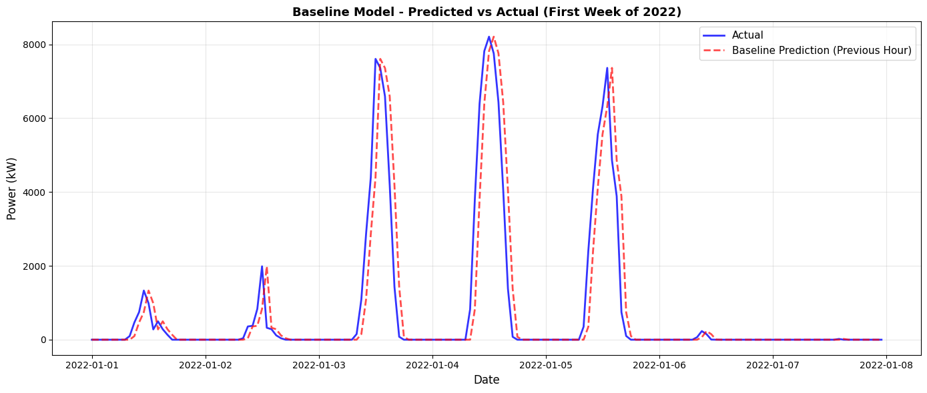
Figure 1: Baseline (Persistence) Model Predicted vs Actual Power Output (First Week of January 2022). The solid blue line represents actual hourly power generation and the dashed red line represents the persistence model's prediction, which uses the previous hour's output as the forecast. The one-hour lag is visible during morning ramp-up and evening decline periods, where the predicted values consistently trail behind actual generation. Days with low cloud cover (January 3–5) produced peak outputs exceeding 7,000 kW, while overcast or low-irradiance days (January 1, 6–7) remained below 2,000 kW.
5.2 Linear Regression
Linear regression was the simplest of all the learned models in the comparison. Training completed in 0.17 seconds on standardized features. ON the validation set the model achieved an RMSE of 868.33 kW and an $R^{2}$ of 0.9111, and on the test set it achieved an RMSE of 413.80 kW, a MAE of 201.62 Kw, and an $R^{2}$ of 0.9806 this is a 64% reduction in RMSE over the baseline. Despite how simple the model is, linear regression was able to capture a significant portion of the variance in solar power generation, meaning there may be a strong linear relationship between irradiance during non-transitionary weather periods and power output. However, the difference in performance between the linear model and the tree-based models shows that there are non-linear interactions presented in the data that the simpler model could not capture.
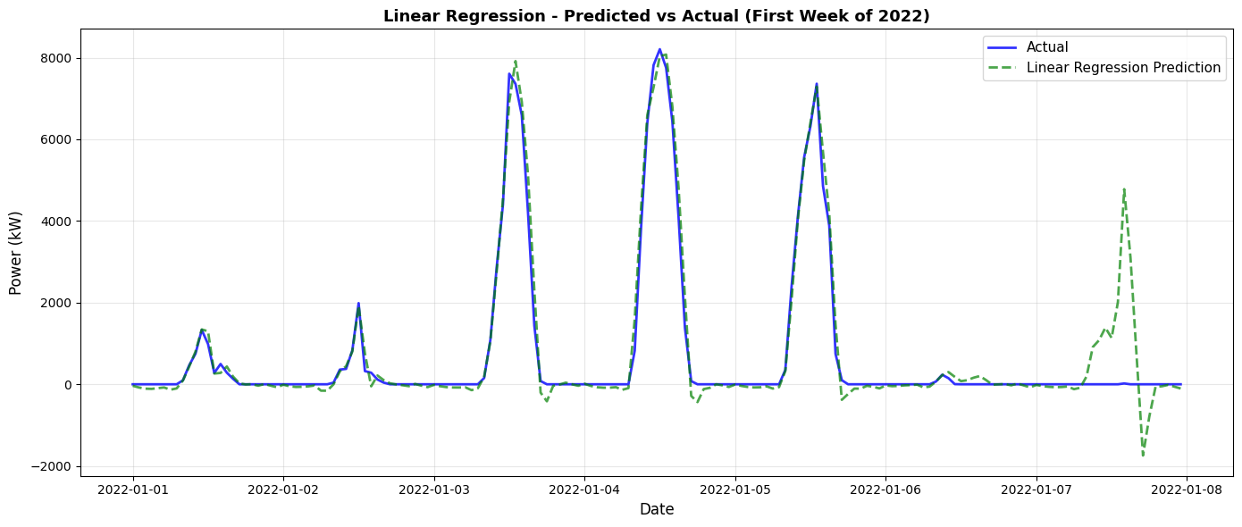
Figure 2: Linear Regression Predicted vs Actual Power Output (First Week of January 2022). The solid blue line represents actual hourly power generation, and the dashed green line represents the linear regression prediction. The model tracks the general shape of daily generation curves closely during high-irradiance days (January 3–5) but produces physically impossible negative predictions during nighttime and low-output periods. A notable anomaly appears on January 7–8, where the model predicts a large spike in generation (~4,800 kW) that did not occur, likely reflecting the model's inability to handle non-linear feature interactions during unusual weather transitions.
5.3 LASSO Regression
LASSO Regression was evaluated across six potential alpha values (α ∈ {0.001, 0.01, 0.1, 1, 10, 100}) using GridSearchCV, with the best model selected based in validation performance. The optimal alpha was 0.01. Training across all candidate values completed in 52.96 seconds. The selected model achieved a validation RMSE of 868.43 kW and an $R^{2}$ of 0.9111, and a test RMSE of 413.81kW, a MAE of 201.58 kW, and a of 0.9806 this model also showed a 64% improvement over the baseline. The performance of LASSO was effectively identical to linear regression across all metrics, suggesting that at the optimal alpha the regularization was mild enough to preserve nearly all of the features used without altering the fitted weights. The marginal difference in MAE between the two models (201.62 kW vs. 201.58kW) is insignificant and not statistically relevant.
5.4 Random Forest
Random forest was trained with 100 trees, a maximum depth of 20, a minimum depth of 10 samples required to split a node, and a minimum of 5 samples per leaf. Training completed in 47.35 seconds. On the validation set the model achieved an RMSE of 921.59 kW and an of0.8999, and on the test set it achieved a RMSE of 360.22 kW, a MAE 155.63 kW, and an $R^{2}$ of 0.9853 this shows a 68.7% improvement over the baseline model. The higher validation RMSE in comparison to the linear models is likely due to the greater sensitivity to year-to-year variation in the validation period, while the stronger test performance reflects the model’s ability to capture non-linear feature interactions that linear models cannot. Also, hyperparameter tuning via randomized search over 20 candidate configurations with 3-fold cross-validation identified an improved configuration (n_estimators=300, max_depth=20, min_samples_split=5, min_samples_leaf=2, max_features=0.7), reducing test RMSE to 354.58kW and improving to 0.9858 a gain of kW over the default configuration.
Feature importance analysis presented that random forest concentrated heavily on a single feature of its predictive power. POAI (Plane of Array Irradiance) alone accounted for 97.82% of total feature importance, with kW_lag1 contributing 1.29%. The remaining 20 features all together accounted for less than 1% of feature importance. This finding was further confirmed through feature subset testing: a model trained on only the top 5 features achieved a test RMSE of 353.74 kW and an of 0.9858, slightly out preforming the full 22-feature model. This confirms that the other features used in the full 22-feature model created more noise rather than assisting in the prediction, meaning that POAI and recent generation history are the most significant predictive information available in this dataset for the random forest approach.
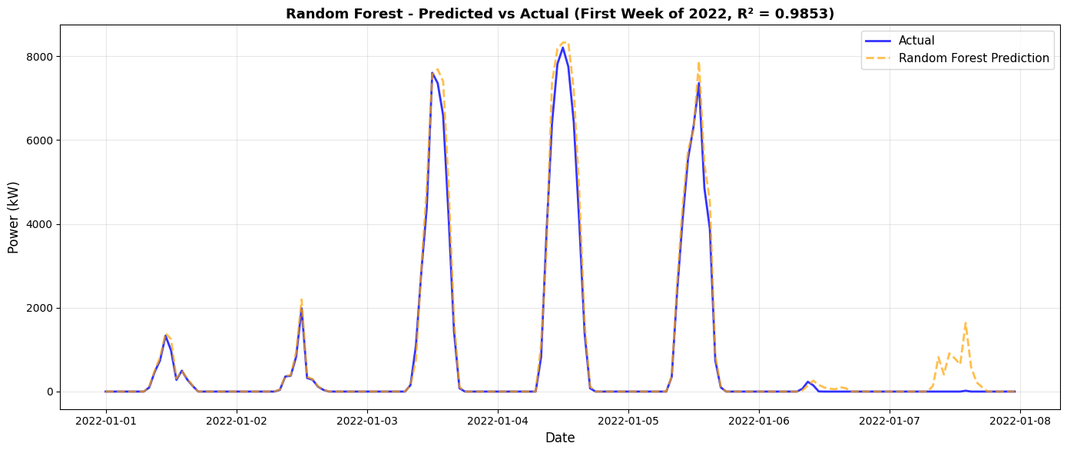
Figure 3: Random Forest — Predicted vs Actual Power Output (First Week of January 2022, R² = 0.9853). The solid blue line represents actual hourly power generation and the dashed orange line represents the random forest prediction. The model closely tracks actual output across all high-irradiance days (January 3–5), with predictions nearly indistinguishable from actual values during peak generation. Unlike linear regression, random forest produces no negative predictions, as tree-based splits naturally constrain outputs within the range of observed training values. A minor overestimation is visible on January 7–8 where the model predicts generation that did not occur, though the magnitude of this error (~1,500 kW) is considerably smaller than the equivalent spike produced by linear regression.

5.4.1 Random Forest Without POAI
To further investigate the dominance of POAI in the feature importance analysis, an additional test was conducted to see if POAI was removed from the feature set and random forest was retrained on the other included features. This was done to find out if the model was completely dependent on the single feature to make its predictions or to see if the other variables could carry more predictive weight without the strongest feature available.
The random forest model that was restricted of the use of POAI achieved a test RMSE of 358.92 kW, a MAE of 159.11 kW, and an R² of 0.9854, compared to 360.22 kW, 155.63 kW, and 0.9853 R² for the full model. The difference between the two models on all the performance metrics was very small, showing that the removal of POAI produced no substantial change in predictive performance on the test set. On the other hand, the feature importance rankings shifted dramatically without the use of POAI, GHI became the dominant predictor at 51.98%, followed by kW_lag1 at 25.71%, and GHI_rolling3h at 8.54%. The new distribution of the feature importance suggests that without POAI the model is forced to rely more on GHI and recent generation history both of which carry overlapping information on the incoming solar radiation.
The practical implications found but completing this experiment are meaningful. Getting a reading on POAI requires a sensor mounted on the panels that is aligned with the angle the panel is set at, which is an additional instrument that is needed to gather this information compared to a general horizontal irradiance sensor. The fact that random forest was able to have comparable predictive performance without the use of POAI, the most dominant predictor suggests that GHI, a more accessible feature from standard weather stations may be a sufficient replacement in deployment scenarios with more complex instruments are not available.
5.5 XGBoost
XGboost was trained with 100 trees like random forest, but with a maximum depth of 10m and a learning rate of 0.1, a subsample rate of 0.8, and a column subsampling rate of 0.8. The training was completed in just 3.07 seconds substantially faster than random forest despite comparable predictive performance. On the validation set the model achieved an RMSE of 824.51 kW and an $R^{2}$ of 0.9198, and on the test set it achieved an RMSE 330.79 kW, MAE of 148.94 kW, and a $R^{2}$ of 0.9876 a 71.2% improvement over the baseline and the strongest performance out of any of the individual models. Also, hyperparameter tuning identified an alternative configuration (n_estimators=200, max_depth=6, learning_rate=0.05, subsample=0.7, colsample_bytree=0.7), but this produced an unimportant change in test RMSE (330.82kW vs. 330.79 kW), confirming that the original configuration was already well optimized for this data.
XGBoost features importance showed a more balanced and distributed pattern than random forest. POAI remained the dominant predictor at 40.76%, followed by GHI at 20.48%, kW_lag1 at 18.76% and is_daytime at 7.64%. This broader distribution reflects XGBoost’s sequential boosting structure, which is more sensitive to interactions among all features and less likely to converge on a single dominant variable than bagging approached used within the random forest model
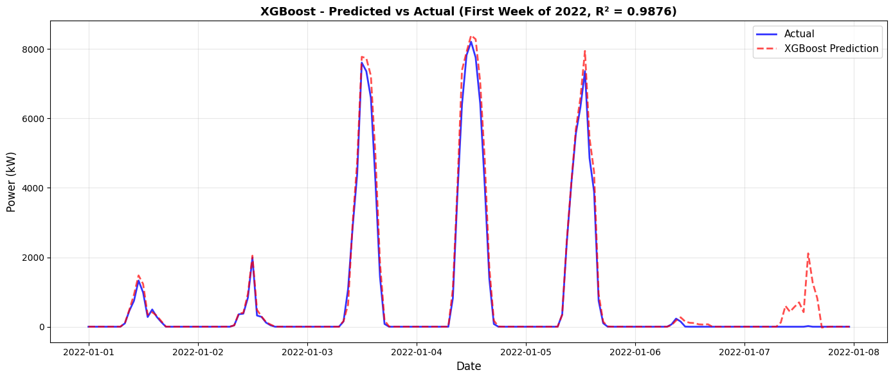
Figure 4: XGBoost Predicted vs Actual Power Output (First Week of January 2022, R² = 0.9876). The solid blue line represents actual hourly power generation, and the dashed red line represents the XGBoost prediction. The model produces the closest fit to actual output of all models tested, tracking both the magnitude and timing of daily generation curves with high accuracy across high-irradiance days (January 3–5) and lower-output days (January 1–2). Like random forest, XGBoost produces no negative predictions. An overestimation appears on January 7–8 (~2,000 kW), slightly larger than random forest's error on the same period but substantially smaller than linear regressions. This isolated error is consistent with the residual analysis findings, which identified rapid weather transitions as the primary source of forecasting difficulty.
Residual analysis on the test set revealed a mean residual of -113.02 kW, indicating a slight systematic tendency to over predict solar output. The standard deviation of residuals was 310.89 kW, with a range 0f -3,595.17 kW to 6,818.19 kW the non-zero mean and the presence of large outliers at the extremes suggest that the model struggles the most with rapid changes in generation such as sudden cloud cover events or morning ramp up periods which can be difficult to anticipate from lagged and rolling features alone.
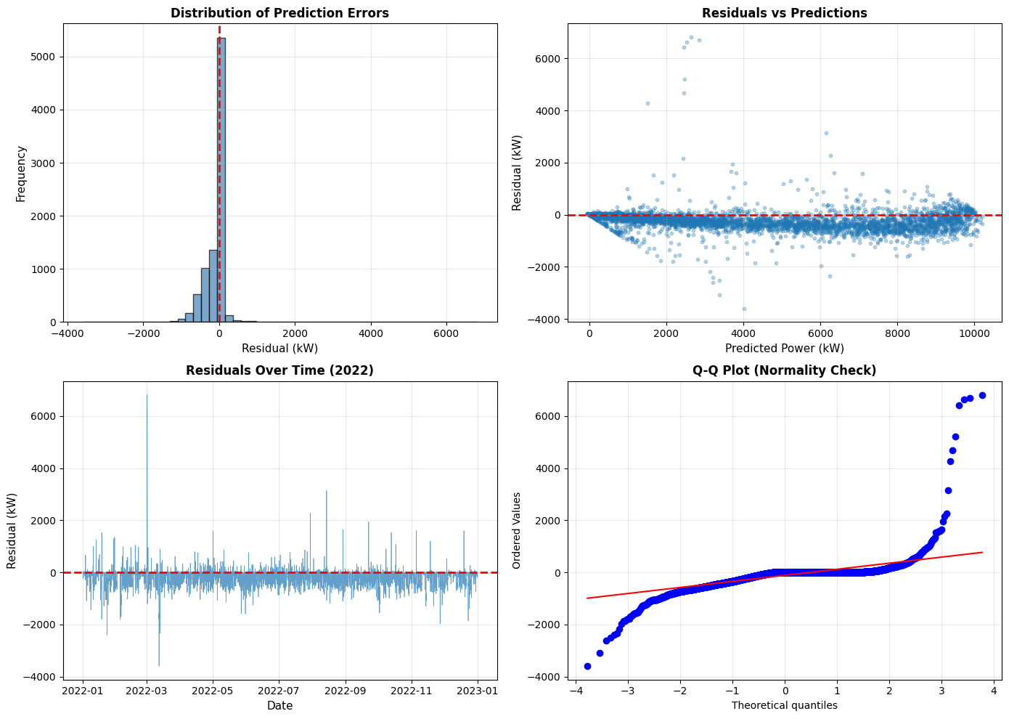
Figure 5: Residual Analysis of XGBoost Predictions on the 2022 Test Set. Four diagnostic plots are presented. Top left: The distribution of prediction errors is centered slightly below zero (mean = −113.02 kW), confirming a mild systematic tendency to over-predict solar output. The majority of residuals cluster within ±500 kW, though a long right tail extends beyond 6,000 kW. Top right: Residuals plotted against predicted power show increasing variance at higher prediction levels, indicating that the model's largest errors occur during peak generation periods when weather conditions are most variable. Bottom left: Residuals over time reveal that the largest forecast errors are concentrated in the spring months (March–May 2022), consistent with the seasonal analysis finding that spring's transitional weather patterns are the most difficult to predict. Error magnitude visibly decreases during the summer and autumn months. Bottom right: The Q-Q plot shows that residuals follow a normal distribution through the central range but deviate substantially at both tails, with the positive tail showing the most pronounced departure. This indicates that while the model's typical errors are well-behaved, extreme forecast misses — particularly large under-predictions — occur more frequently than a normal distribution would suggest.
5.6 Ensemble model
A simple ensemble was constructed by averaging the predictions of random forest and XGBoost. The ensemble achieved a test RMSE of 338.38 kW, a MAE of 149.76 kW, and an $R^{2}$ of 0.9870 making it the second-best model behind XGBoost alone. The training time of this tree-based model was the quickest at 0.001 seconds since no additional modelling was required due to the simple calculation of averaging the error between XGBoost and random forest. While the ensemble improved on random forest, it did not perform better than the XGBoost model, showing that the averaging process just carried over more errors from the weaker tree-based model rather than complementing XGBoost performance
5.7 Long Short-Term Memory (LSTM)
The LSTM model was trained using all 22 features with a 24-hour lookback window and it predicted one hour ahead. The model trained on the for the full 50 epochs with the learning weight reduced twice during the training, once at epoch 39 and again at epoch 50. Training took much longer than every other learned model in comparison at 382.5 seconds. On the test set the model achieved an RMSE of 1,009.61 kW, a MAE of 481.92 kW, and an $R^{2}$ of 0.8847, showing only a 12.2% improvement over the baseline, it performed the worst out of all the learned models and its $R^{2}$ is only slightly above the baseline. While it outperformed the baseline the LSTM’s performance showed that it struggled to learn almost anything beyond the already present patterns in the data. The model was still slightly improving at the end of the 50th epoch but the rate of improvement had shrunk considerably and the gap between the training and validation showed that any further training would likely cause overfitting rather than meaningful improvement.
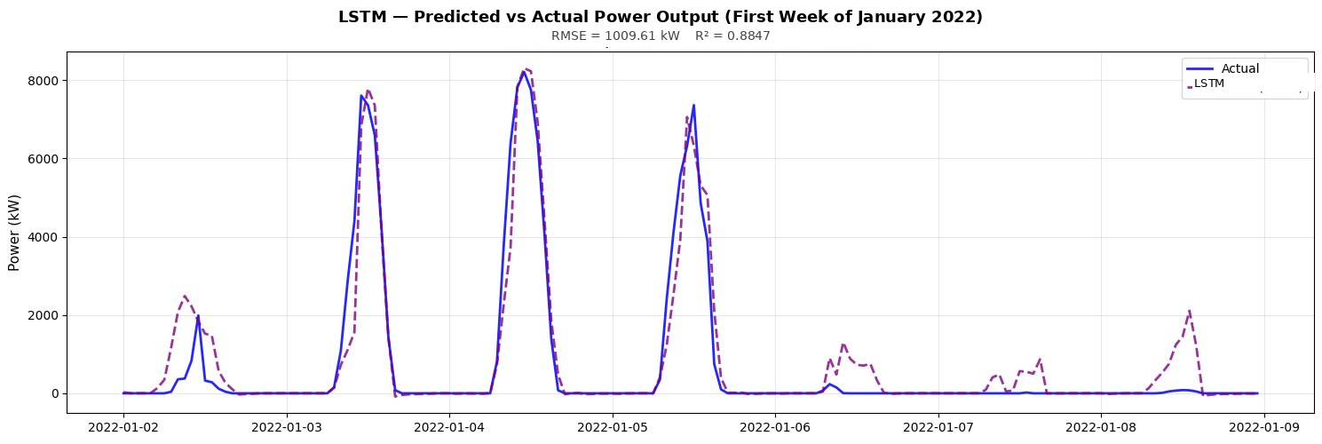
Figure 6: LSTM Predicted vs Actual Power Output (First Week of January 2022, R² = 0.8847). The solid blue line represents actual hourly power generation, and the dashed purple line represents the LSTM prediction. The model tracks peak generation on clear days (January 3–5) but over-predicts during nighttime and low-irradiance periods, with spurious spikes on overcast days (January 6–8) reflecting its overall weak performance (RMSE = 1,009.61 kW

5.8 Model Comparison
Table 1 summarizes the performance of all six models on the held out 2022 test set.
Table 1: Model Performance Comparison on Test Set
Test set results
Model | RMSE (kW) | MAE (kW) | R² | Improvement | Train Time (s) | Inference Time (ms)
XGBoost | 330.79 | 148.94 | 0.9876 | 71.2% | 3.07 | 35.79
Ensemble | 338.38 | 149.76 | 0.9870 | 70.6% | 0.00 | —
Random Forest | 360.22 | 155.63 | 0.9853 | 68.7% | 47.35 | 115.42
Linear Regression | 413.80 | 201.62 | 0.9806 | 64.0% | 0.17 | 4.28
LASSO | 413.81 | 201.58 | 0.9806 | 64.0% | 52.96 | 0.91
LSTM | 1,009.61 | 481.92 | 0.8847 | 12.2% | 382.50 | 1,470.94
Baseline (Persistence) | 1,149.28 | 652.22 | 0.8504 | — | 0.00 | —

All five learned models substantially outperformed the baseline across every metric. XGBoost achieved the lowest RMSE and MAE and the highest, while also being the fastest model of the Three more complex models to train. The tree-based models (random forest and XGBoost) clearly outperformed the linear models, with a gap of approximately 83 kW in RMSE between the best linear model and XGBoost. Linear regression and LASSO regression showed nearly identical results, this shows that finding the best performing alpha value provided no addition predictive performance of linear regression.
5.9 Seasonal Performance
Seasonal analysis of XGBoost predictions revealed meaningful variations in model accuracy across the four seasons. Summer produced the lowest RMSE (275.39 kW) and highest $R^{2}$ (0.9927) despite having the highest power output (2,556.43 kW), suggesting that high irradiance summer days are the most consistently predictable. Fall performance was similarly strong (RMSE 278.87 kW, $R^{2}$ 0.9910). Winter also produced a low RMSE (275.26 kW), though average power output was much lower (1,134.47 kW), meaning the relative error is proportionally larger. Spring showed the weakest performance with an RMSE of 455.47 kW and an $R^{2}$ of 0.9788, likely to reflect the greater variability and unpredictability of rapid weather changes including intermittent cloud coverage and rapid changes in irradiance coming from spring months in Kentucky.
5.10 Statistical Significance
To confirm that the performance observed was not attributed to random variation, three forms of statistical tests were conducted. Statistical significance is reported using p-values, where the p-value represents the probability of observing a result as extreme as the one measured if there were truly no difference between the models. A p-value below 0.001 shown as *** means there is less than a 0.1% chance that the observed improvement over the baseline occurred by random chance alone. In other words, the result is highly unlikely to be a fluke. The threshold levels used in this study follow standard convention: *** indicates p < 0.001, ** indicates p < 0.01, and * indicates p < 0.05. Any result falling below these thresholds is considered statistically significant, meaning the difference in performance between the two models being compared is real and not attributable to random variation in the data.
Paired t-tests comparing each model against the baseline confirmed that all five models produced statistically significant improvements (p < 0.001, *** for all). XGBoost achieved the largest t-statistic (54.72) and the largest Cohen’s D effect size (0.718), classified as a medium effect. All other models also fell into the medium effect range, displaying that they were meaningful but not overwhelming amount of improvement relative to the variability of the data.
Head-to-head paired t-tests between key model pairs confirmed that the XGBoost model was statistically superior to both random forest (p < 0.001) and linear regression (p < 0.001). Random Forest was statistically superior to linear regression (p < 0.001). The comparison between XGBoost and the ensemble model produced a non-significant result (p = 0.254), confirming that the two models perform statistically equal despite the same numerical difference in RMSE.
Diebold-Mariano test, which are specifically designed for comparing forecast accuracy in time series context, showed that these findings were true. XGBoost produced significantly lower squared errors than the baseline (p < 0.001), linear regression (p < 0.001), LASSO (p < 0.001), and random forest (p < 0.001). The comparison with the ensemble reached significance at the 5% level (p == 0.015,*) providing weak but present evidence that XGBoost holds the lead even over the average combination of itself and random forest.

6. Discussion
6.1 Overview of Findings
The result of this research provides clear evidence that the use of ML in solar power generation forecasting is significantly superior to traditional statistical methods. All five of the ML models included surpassed the effectiveness of the baseline by a large amount with error reduction ranging from 64.0% for linear methods to 71.2% for XGBoost. The tree-based models consistently outperformed the baseline persistence model but also preformed linear models as well. XGboost was proven to be the most effective out of all models across every evaluation metric. The findings from this research were able to answer both research questions posed at the beginning of the study and contribute to the field by working with data from an underrepresented region.
6.2 Explaining XGBoost’s Superior Performance
XGBoost being the best performing model is not a surprising result given the nature of the data. Solar generation data contains many different linear interactions between the variables that are challenging for linear models to capture. XGBoost’s sequential boosting structures are well suited to this kind of data because each tree builds off the errors of the previous tree allowing the model to systematically lessen the errors the further it goes down the tree. Cloud transitions, morning ramp up periods, and seasonal conditions are the kinds of rapid changes that cause the most forecasting difficulties, and these are the situations where a model that learns for the prior errors it made has an advantage over one that fits a single line to the entirety of the data.
Both random forest and XGBoost out preformed linear models, XGBoost performing better with a 30-kW reduction to the RMSE scores over random forest. The difference reflects the fundament difference between boosting and bagging; random forest reduces errors by building diverse trees in parallel and averaging each tree’s opinions. XGBoost reduced errors by building trees sequentially, with each tree targeting the errors the last tree produced. In a data set like the one used in this research that has patterns the sequential correction mechanism of boosting is better suited to close the gaps rather than the averaging approach bagging uses. This finding is supported by Benti et al. [21] identified gradient boosting methods as the current state of the art for generation prediction tasks, and with Lai et al. [6] who found ensemble and boosting approaches consistently outperform simpler methods on complex weather-driven datasets.
6.3 LSTM Performance
The LSTM performing weakest out of all the models was a surprising result going into this research, but looking over methods provides more information on why this model underperformed, given the nature of the data and design of the experiment. There are a few reasons that can explain why this was the result.
The most likely explanation is the size of the training set; it only contained 37,800 useable sequences which is a small sample for deep learning standards. LSTMs tend to need much more data to learn the patterns these models are designed to capture. Tree-based models are more sample efficient and can capture more from smaller datasets, giving them an advantage in how this research was structured. The data was also very structured due to preprocessing efforts; this kind of data has shown good results when tree-based models are applied where LSTMs perform better with raw sequential data. Another issue was the feature engineering done within this research. The lag features and rolling averages were specifically designed to give every model an idea of recent temporal patterns, which is the patterns that an LSTM would normally generate on its own from the raw data. This made the capability of LSTMs sequential modeling redundant where the other models benefited from the data processing. Though in this research the LSTM model significantly underperformed it does not mean that LSTMs are unusable in solar power generation forecasting, but it did provide insight on the structure and dataset size needed to make this a viable approach.
6.4 The POAI Dominance
The feature importance analysis produced a significant finding in this research. In the random forest model, Plane of Array Irradiance alone accounted for 97.82% of total feature importance, with one-hour lag contributing 1.29% and all reaming features account for less that 1% combined. POAI measures the amount of solar radiation at the exact angle of the solar panels which makes it the direct explanation for the process of converting the solar radiation into solar power. This finding was consistent with Reikard’s study [30] that demonstrated that irradiance alone accounts for the majority variance in photovoltaic output, agreeing with Abdelsattar et al [8] who confirmed that irradiance related features are consistently dominant in feature importance analysis in many studies.
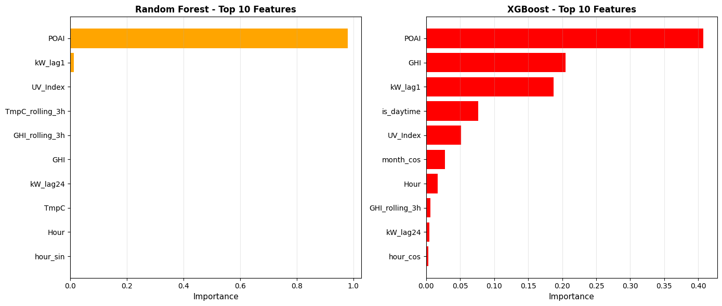
Figure 7. Top 10 feature importances for the Random Forest (left) and XGBoost (right) models. In the Random Forest model, POAI (Plane of Array Irradiance) dominates with an importance score near 1.0, while all remaining features contribute minimally. The XGBoost model distributes importance more broadly: POAI remains the most influential feature (~0.40), followed by GHI (Global Horizontal Irradiance, ~0.22) and kW_lag1 (~0.20). Secondary contributors in XGBoost include is_daytime, UV_Index, and month_cos, each with modest importance (~0.03–0.08). Both models agree that solar irradiance (POAI) is the single strongest predictor of power output, though XGBoost relies more heavily on a combination of irradiance measures, temporal lags, and time-based features.

6.5 Seasonal Performance
The seasonal performance of the XGBoost model showed a clear pattern that aligns with the amount of power generated at the E.W. Brown solar plant in Kentucky. Summer produced the strongest performance with an RMSE of 275.39 kW and an R² of 0.9927, followed by Fall at 278.87 kW and a R² of 0.9910. Winter performance additionally performed positively in RMSE terms, although had lower average power output in the wintertime (1,134.47 kW compared to 2,556.43 kW in the summer). Spring was the weakest performance when looking at seasonal data with an RMSE of 455.47 kW and an R² of 0.9788. These results can be explained by the nature of the transitional weather patterns in Kentucky. During the summer weather trends toward stable high-irradiance conditions that stay constant and make it easy for the models to learn from the historical data. On the other hand, Spring is characterized by rapidly changing weather patterns, which include intermittent cloud cover, variable atmospheric pressure, leading to unpredictable temperatures. These conditions produce sudden weather changes that are difficult for the models to explain from the lagged and rolling features alone. This is consistent with the findings from Lorenz et al [3], who identified that these partial cloudy weather transitions are the source for the highest forecast prediction errors. The residual analysis showed that the mean residual of -113.02 kW and the presence of large outliers during the springtime suggest the errors occur during these kinds of rapid transition in weather.
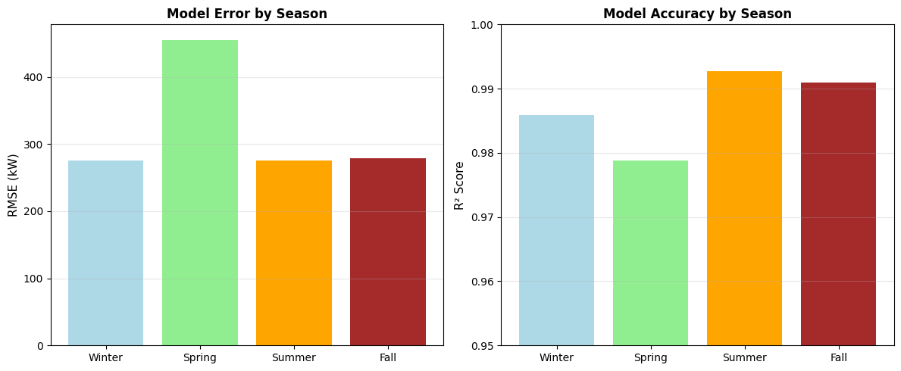
Figure 8. Seasonal variation in model performance. Left: RMSE (kW) by season, showing that Spring exhibits the highest prediction error (~450 kW), while Winter, Summer, and Fall perform comparably (~275 kW each). Right: R² scores by season, where Summer and Fall achieve the highest accuracy (~0.99), followed by Winter (~0.985), and Spring showing the lowest R² (~0.978). The elevated Spring error likely reflects greater variability in weather conditions (e.g., intermittent cloud cover and rapidly changing irradiance patterns) during transitional months, making power output harder to predict. Despite this seasonal disparity, all R² values remain above 0.975, indicating strong model performance year-round.
6.6 Answers to the Research Questions
The first question this research aimed to answer was can AI model improve forecasting accuracy of solar power generation data over baseline statistical models and the models clearly did. All five of the models demonstrated statistically significant improvements over the persistence baseline at the p<0.001 level, with large reductions in error, the Diebold-Mariano test confirmed that these were actual improvements in forecasting accuracy rather than just data noise he medium effect sizes (Cohen's d ranging from 0.629 to 0.718) indicate that the improvements are meaningful in practical terms, not just statistically detectable.
The second question asked which of the weather and environmental features most strongly influence solar generation and how effectively can AI models capture those relationships. The feature importance analysis done using random forest was able to show clear results the POAI is the dominant predictor, followed by GHI and recent generation history. XGBoost feature importance rankings were more distributed between the features because of its ability to find complementary information in secondary features over random forest which completely converges on POAI.
6.7 Connections to Existing Literature
The findings of this research clearly reflect the findings in existing literature while adding its own contributions. The superior performance of the tree-based models over the linear methods supports the findings of Lai et al [6] who found that boosting approaches consistently outperform simpler methods on weather-driven datasets, and the findings of Benti et al [21] who found that gradient boosting is the best method for solar prediction. The dominance of irradiance-based data as the primary predictor confirms the finding of Reikard [30], Adbelattar et al. [8], and Pierro et al. [31], who found that the features used in this study make improvements for gradient boosting performance on solar forecasting tasks. Where this research adds to the literature is the geographic location and the multi-model comparison. The fact that these models performed well on data from a solar power plant in Kentucky, a place outside of mainstream research proves that the tree-based model used in this study are generalizable beyond Western Europe and California datasets. This supports the findings of Raze et al. [28] that validation should come from data from around the world rather than just the places that dominate existing benchmarks.
6.8 Limitations
While the findings of this research are statistically significant, there are some overall limitations worth noting. All of the data comes from a single facility in Kentucky, meaning that the model ranking and feature importance may not be held in different locations with different climates or solar panel configurations. Although this does fill a gap of research done in underrepresented regions. The study only tests predictions one hour ahead, and the model performance could change when examining different time windows where lagged features may become less important and sequential models like LSTM could perform better. Also the models were trained in observed historical data rather than incoming weather forecasts, meaning these results could be inflated over real-world performance since weather forecasting errors would add more uncertainty to the solar power generation predictions. Lastly the LSTM was tested on simple hyperparameter tuning across all models, preprocessing of the data and added features may have caused performance issues, meaning that further optimization and altercation in the data could potentially change the results for the deep learning model.
6.9 Practical Implications
The results of this research show that machine learning models can reduce the error in prediction by over 70% compared to simpler approaches. This means that these forecasts can allow for more accurate scheduling of energy storage and backup generation reducing costs and waste outcomes that Said and Alanzi [7] identified as the main benefits of AI driven solar forecasting for energy grids. The feature importance rankings find that just two of the variables POAI and kW_lag1 explain 99% of the predictive variance in the Random Forest Model has major significance for grid operators. For grid operators working with limited dataset a smaller random forest forecasting model with less features could be comparable to the accuracy of the full 22-feature models, potentially all that would be necessary is a panel level sensor for irradiance and the most recent generation reading. This finding significantly lowers the amount of data that is needed to deploy an ML model in A real-world setting. Lund et al. [25] argues that improved forecasting is one of the most cost-effective ways for increasing the use of renewables and the findings here show that the data requirements for effective forecasts are not as complicated as might be anticipated.

7. Conclusion
This research investigates weather machine learning models can meaningfully improve the accuracy of solar power generation forecasts compared to a simple persistence baseline and which environmental variables carry the most predictive weight. Using seven years of data (2016-2022) of hourly power generation data from the E.W. Brown solar facility in Harrodsburg Kentucky. Combined with meteorological data from the NASA POWER database covering the same coordinates, six models were trained on data from 2016 to 2020, validated in 2021, and evaluated under blind test conditions on the full 2022 calendar year.
The results clearly represented that all six models significantly outperformed the persistence baseline, with error reductions ranging from 64.0% for the linear models to 71.2% for XGBoost. XGBoost achieved the strongest performance across every metric. A test RMSE of 330.79 kW, a MAE of 148.94 kW, and a $R²$ of 0.9876 and was confirmed as statistically superior to all the other models through paired t-tests and Diebold-Mariano testing. These results show that gradient boosting methods are highly capable of capturing the complex non-linear relationships between weather conditions and solar output in ways that persistence, linear and other tree-based methods cannot fully reproduce. The LSTM model, despite being the most complex out of the models tested in this research, achieved an RMSE of 1,009.61 kW and an $R²$ of 0.8847, making its performance slightly better than the baseline but not as good as the linear models. This finding shows that longer training times and more complex models do not always produce better results when working with a dataset of this size and structure.
The feature importance analysis also produced a notable finding. Plane of Array Irradiance alone account for 97.82% of prediction importance in the random forest model, with just two variables explaining 99% of the variance. This shows researchers that accurate forecasts do not necessarily require larges feature sets if the correct variables are present in the data. XGBoost distributed the prediction performance across more of the features used showing that boosting extract complementary information from secondary variables that random forest did not even consider. Season analysis revealed that spring was the most difficult period to forecast, likely due to the transitional weather trends of this season in Kentucky, while summer and fall produced much more consistent predictions.
This research contributes to the existing contributions to this field in three specific ways. It provides empirical evidence from an underrepresent geographical region in solar research. It offers a multi-model comparison on a single dataset with consistent evaluation conditions; this study design remains relatively uncommon in this field and researchers are pushing for uniformity in evaluation metrics to progress this towards more advancements in solar power forecasting to help the transition away from fossil fuels. It confirms that the performance advantages of gradient boosting over linear and bagging methods extend beyond Western Europe and California datasets that are dominant in the completed research.
The findings of this research have practical implications beyond just an academic contribution. A model with comparable accuracy could help grid operators in real-world situations in scheduling, energy storage, reducing backup fossil fuel dispatch and improve confidence in the ability for solar power to be more integrated in power grids. As solar capacity continues to expand globally, the ability to forecast it accurately is becoming more important to the reliability of clean energy grids. This research represents a step toward its capability of renewable energy and toward the large goal of reducing the use of carbon-based fuels and a sustainable future.

Reference List
[1] Our World in Data, "CO₂ concentration over the long term," 2024. [Online]. Available: https://ourworldindata.org/grapher/co2-long-term-concentration
[2] Comello, S., & Reichelstein, S. (2016). The U.S. investment tax credit for solar energy: Alternatives to the anticipated 2017 step-down. Renewable and Sustainable Energy Reviews, 55, 291–302. https://doi.org/10.1016/j.rser.2015.10.108
[3] E. Lorenz, J. Hurka, D. Heinemann, and H. G. Beyer, "Irradiance forecasting for the power prediction of grid-connected photovoltaic systems," IEEE Journal of Selected Topics in Applied Earth Observations and Remote Sensing, vol. 2, no. 1, pp. 2–10, 2009. doi: 10.1109/JSTARS.2009.2020414.
[4] P. Bacher, H. Madsen, and H. A. Nielsen, "Online short-term solar power forecasting," Solar Energy, vol. 83, no. 10, pp. 1772–1783, 2009. doi: 10.1016/j.solener.2009.05.016.
[5] R. H. Inman, H. T. C. Pedro, and C. F. M. Coimbra, "Solar forecasting methods for renewable energy integration," Progress in Energy and Combustion Science, vol. 39, no. 6, pp. 535–576, 2013. doi: 10.1016/j.pecs.2013.06.002.
[6] J.-P. Lai, Y.-M. Chang, C.-H. Chen, and P.-F. Pai, "A survey of machine learning models in renewable energy predictions," Applied Sciences, vol. 10, no. 17, Aug. 2020. doi: 10.3390/app10175975.
[7] Y. Said and A. Alanazi, "AI-based solar energy forecasting for smart grid integration," Neural Computing and Applications, Dec. 2022. doi: 10.1007/s00521-022-08160-x.
[8] M. Abdelsattar, M. A. Ismeil, M. M. A. A. Zayed, A. Abdelmoety, and A. Emad-Eldeen, "Assessing machine learning approaches for photovoltaic energy prediction in sustainable energy systems," IEEE Access, vol. 12, p. 107599, 2024. doi: 10.1109/access.2024.3437191.
[9] IPCC, "Climate change 2022: Mitigation of climate change. Contribution of Working Group III to the Sixth Assessment Report of the Intergovernmental Panel on Climate Change," Cambridge University Press, 2022. [Online]. Available: https://www.ipcc.ch/report/ar6/wg3/
[10] International Energy Agency, "World energy outlook 2023," IEA, Paris, 2023. [Online]. Available: https://www.iea.org/reports/world-energy-outlook-2023
[11] REN21, "Renewables 2023 global status report," REN21 Secretariat, Paris, 2023. [Online]. Available: https://www.ren21.net/gsr-2023/
[12] H. Lund, "Renewable energy strategies for sustainable development," Energy, vol. 32, no. 6, pp. 912–919, 2007. doi: 10.1016/j.energy.2006.10.017.
[13] P. Denholm and R. M. Margolis, "Evaluating the limits of solar photovoltaics (PV) in traditional electric power systems," Energy Policy, vol. 35, no. 5, pp. 2852–2861, 2007. doi: 10.1016/j.enpol.2006.10.014.
[14] R. Ulbricht, U. Fischer, W. Lehner, and H. Donker, "First steps towards a systematical optimized strategy for solar energy supply forecasting," in Proc. European Conf. Machine Learning and Principles and Practice of Knowledge Discovery in Databases (ECML PKDD), 2013. [Online]. Available: https://www.researchgate.net/publication/304777279
[15] J. Antonanzas, N. Osber, R. Escobar, R. Urraca, F. J. Martinez-de-Pison, and F. Antonanzas-Torres, "Review of photovoltaic power forecasting," Solar Energy, vol. 136, pp. 78–111, 2016. doi: 10.1016/j.solener.2016.06.069.
[16] J. A. Duffie and W. A. Beckman, Solar Engineering of Thermal Processes, 4th ed. Hoboken, NJ, USA: Wiley, 2013.
[17] M. Diagne, M. David, P. Lauret, J. Boland, and N. Schmutz, "Review of solar irradiance forecasting methods and a proposition for small-scale insular grids," Renewable and Sustainable Energy Reviews, vol. 27, pp. 65–76, 2013. doi: 10.1016/j.rser.2013.06.042.
[18] J. Kleissl, Ed., Solar Energy Forecasting and Resource Assessment. Academic Press, 2013.
[19] H. T. C. Pedro and C. F. M. Coimbra, "Assessment of forecasting techniques for solar power production with no exogenous inputs," Solar Energy, vol. 86, no. 7, pp. 2017–2028, 2012. doi: 10.1016/j.solener.2012.04.004.
[20] A. Mellit and S. A. Kalogirou, "Artificial intelligence techniques for photovoltaic applications: A review," Progress in Energy and Combustion Science, vol. 34, no. 5, pp. 574–632, 2008. doi: 10.1016/j.pecs.2008.01.001.
[21] N. E. Benti, M. D. Chaka, and A. G. Semie, "Forecasting renewable energy generation with machine learning and deep learning: Current advances and future prospects," Sustainability, vol. 15, no. 9, Apr. 2023. doi: 10.3390/su15097087.
[22] T. Verma, A. P. S. Tiwana, C. C. Reddy, V. Arora, and P. Devanand, "Data analysis to generate models based on neural network and regression for solar power generation forecasting," in Proc. ISMS, p. 97, Jan. 2016. doi: 10.1109/isms.2016.65.
[23] A. I. A. Osman, A. N. Ahmed, M. F. Chow, Y. F. Huang, and A. El-Shafie, "Extreme gradient boosting (XGBoost) model to predict the groundwater levels in Selangor Malaysia," Ain Shams Engineering Journal, vol. 12, no. 2, p. 1545, Jan. 2021. doi: 10.1016/j.asej.2020.11.011.
[24] N. Uzir and S. Banerjee, "Experimenting XGBoost algorithm for prediction and classification of different datasets," unpublished manuscript.
[25] H. Lund, S. Werner, R. Wiltshire, S. Svendsen, J. E. Thorsen, F. Hvelplund, and B. V. Mathiesen, "4th Generation District Heating (4GDH): Integrating smart thermal grids into future sustainable energy systems," Energy, vol. 68, pp. 1–11, 2014. doi: 10.1016/j.energy.2014.02.089.
[26] D. Yang, J. Kleissl, C. A. Gueymard, H. T. C. Pedro, and C. F. M. Coimbra, "History and trends in solar irradiance and PV power forecasting: A preliminary assessment and review using text mining," Solar Energy, vol. 168, pp. 60–101, 2018. doi: 10.1016/j.solener.2017.11.023.
[27] ENTSO-E, "ENTSO-E annual reports on electricity system adequacy and renewable integration," European Network of Transmission System Operators for Electricity. [Online]. Available: https://www.entsoe.eu
[28] M. Q. Raza, M. Nadarajah, and C. Ekanayake, "On recent advances in PV output power forecast," Solar Energy, vol. 136, pp. 125–144, 2016. doi: 10.1016/j.renene.2016.10.007.
[29] D. Yang, "A guideline to solar forecasting research practice: Reproducible, operational, probabilistic or physically-based, ensemble, and skill (ROPES)," Journal of Renewable and Sustainable Energy, vol. 11, no. 2, 2019. doi: 10.1063/1.5087462.
[30] G. Reikard, "Predicting solar radiation at high resolutions: A comparison of time series forecasts," Solar Energy, vol. 83, no. 3, pp. 342–349, 2009. doi: 10.1016/j.solener.2008.08.005.
[31] M. Pierro et al., "Multi-model ensemble for day ahead prediction of photovoltaic power generation," Solar Energy, vol. 134, pp. 132–146, 2016. doi: 10.1016/j.solener.2016.06.073.

