This text has formatting directly applied to achieve its font size, color, line spacing, and paragraph spacing.

# This text is formatted using the Heading 1 paragraph style.

This is a text box with WordArt (text effect) formatting. The text box shape is set to wrap text above and below.

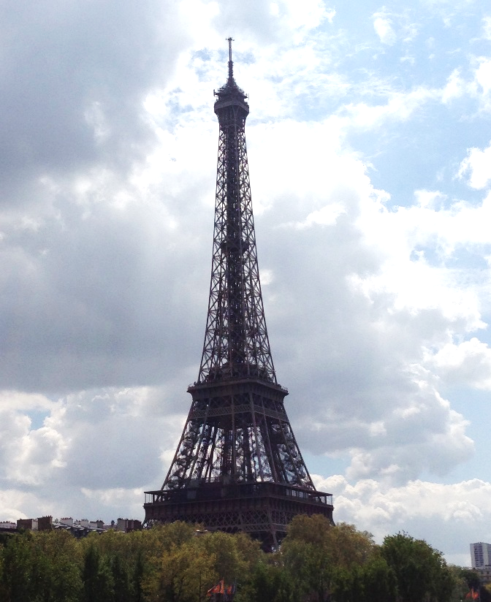

This paragraph is here to demonstrate the text wrap setting of the shape at right. The shape is set to square text wrapping and positioned relative to the right and bottom page margins. To preserve relative position settings in the OOXML when working with a graphic that uses text wrapping, include the paragraph where the graphic is anchored in your selection. Select the shape in this example to see its anchor position.

This is an Office drawing shape

[This text is inside a content control that has its container hidden. You can bind to a content control to add or interact with content at a specified location in the document.]

## Table with formatting directly applied:

|  |  |  |
| --- | --- | --- |
| **Region** | **Q1** | **Q2** |
| **Southeast** | 123,456 | 234,567 |
| **Northwest** | 234,567 | 345,678 |

## Table formatted using a table style:

|  |  |  |
| --- | --- | --- |
| Region | Q1 | Q2 |
| Southeast | 123,456 | 234,567 |
| Northwest | 234,567 | 345,678 |