% Yiyan Yang

% z5183946

% Assignment 1-Prolog and Search

Question 1

|  |  |  |  |  |  |
| --- | --- | --- | --- | --- | --- |
|  | start10 | start12 | start20 | start30 | start40 |
| UCS | 2565 | Mem | Mem | Mem | Mem |
| IDS | 2407 | 13812 | 5297410 | Time | Time |
| A* | 33 | 26 | 915 | Mem | Mem |
| IDA* | 19 | 21 | 952 | 17297 | 112571 |

The simplest algorithm (in this assignment) to find a shortest path is Dijkstra, which is implemented using a priority queue. While the complexity of Dijkstra is where E is equal to V (each state can be converted to two states, so degree of each vertex is 2). Hence the complexity is , which is relatively high. And the space complexity is , which is still high. Because the memory grows faster than time needed, Mem occurred in the table.

Iterative deepening search uses depth first search with an increasing depth bound. As a DFS is performed in each depth, the time complexity is rather higher than that of Dijkstra, where b is estimated to be 2 and d is the depth. The time needed to find the appropriate path is growing exponentially according to the minimum number of moves. However, the growth rate of it is just linear, which is , so we haven’t seen a Mem is the table.

A* algorithm uses heuristic function to guide the algorithm to choose nodes with higher expectation. The time complexity of A* is polynomial if appropriate heuristic is used, as the heuristic usually eliminates most of the bad choices. And the space required is , which is determined by the depth.

Iterative deepening A* algorithm is a modified version of A* with an increasing depth bound. So it has exactly the same time and space complexity as that of A*. But with the help of iterative deepening bound, this algorithm can avoid searching to deep and exceed the memory limit, note that the space complexity is growing exponentially as the depth grows. Thus, we have Mem for A* but finally found all the answers for IDA*.

Question 2

|  |  |  |  |  |  |  |
| --- | --- | --- | --- | --- | --- | --- |
|  | start50 | | start60 | | start64 | |
| IDA* | 50 | 14642512 | 60 | 321252368 | 64 | 1209086782 |
| 1.2 | 52 | 191438 | 62 | 230861 | 66 | 431033 |
| 1.4 | 66 | 116342 | 82 | 4432 | 94 | 190278 |
| 1.6 | 100 | 33504 | 148 | 55626 | 162 | 235848 |
| Greedy | 164 | 5447 | 166 | 1617 | 184 | 217 |

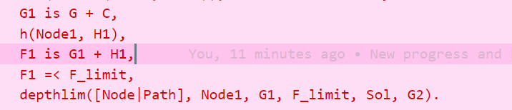

The line highlighted is the code that is modified, which is the heuristic with w equals to 1:

For example, when , the heuristic then becomes:

With higher w, the heuristic is “greedier” as it considers more on *expected* length rather than *passed* length. So, the algorithm is more likely to terminate and tend to backtrack less frequently which makes it faster. As a consequence, the accuracy is lowered as cost of high speed. Hence when accuracy is not that important, a higher is considerable, conversely, if a optimal answer is required, IDA* should be chosen.