Ass 2

## Question 1

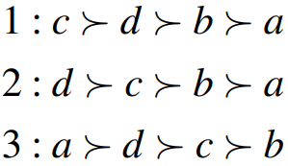

1. Prove or disprove that the preference profile is single-peaked with respect to some order of alternatives*.*

This profile is single-peaked with order a>d>c>b.

2. Prove or disprove that a Condorcet winner exists for the preference profile*.*

The Condorcet winner is d.

It wins two times comparing to a and c, and wins three times comparing to b.

3. Compute the pairwise majority graph for the preference profile*.*

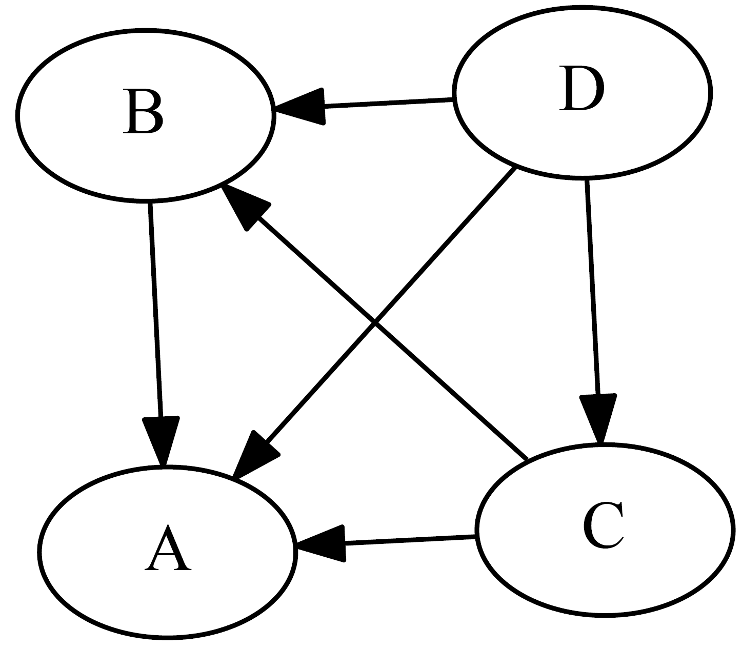

4. Compute the Top Cycle set for the preference profile*.*

The top cycle set is $\left\{d\right\}$.

## Question 2

Consider a resource allocation setting in which n agents havepositive additive utilities over m > n indivisible items. Prove or disprove the following.

1. The allocation that maximizes utilitarian welfare is Pareto optimal.

First, assume that the allocation that maximizes utilitarian welfare is not Pareto optimal.

This means that there exists an allocation where $j$ items can provide a higher utility while not affecting the total utility provided by other items.

Hence there exists an allocation with higher additive utility.

Thus, the utilitarian welfare of the original allocation is not maximized.

2. If an allocation is Pareto optimal, it is envy-free.

|  |  |  |
| --- | --- | --- |
|  | $$o_{1}$$ | $$o_{2}$$ |
| 1 | 5 | 1 |
| 2 | 4 | 2 |

Consider the example above where the pareto optimal allocation is:

$$X_{1}=\left\{o_{1}\right\}, X_{2}=\left\{o_{4}\right\}.$$

However, $u_{2}\left(X_{1}\right)=4>u_{2}\left(X_{2}\right)=2$. So it’s not envy free.

3. If n = 2, envy-freeness and proportionality are equivalent.

Assume that an allocation $X$ is envy-free.

Then for each $i$, we have $u_{i}\left(X_{i}\right)>u_{i}\left(X_{j}\right)$ for all $j$.

Because there are only two agents, we have $u_{i}\left(X_{i}\right)>\frac{Σ^{j=1,2}\left(u_{i}\left(X_{j}\right)\right)}{2}$. So, it implies proportionality.

Also, assume that an allocation $X$ is proportional.

Then for each $i$, we have

$$u_{i}\left(X_{i}\right)>\frac{Σ^{j=1,2}\left(u_{i}\left(X_{j}\right)\right)}{2}⇒\frac{u_{i}\left(X_{i}\right)}{2}>\frac{u_{i}\left(X_{j}\right)}{2}\left(i≠j\right)⇒u_{i}\left(X_{i}\right)>u_{i}\left(X_{j}\right)\left(i≠j\right)$$

So, proportionality implies envy free in this case.

Therefore, we can conclude that envy-freeness and proportionality are equivalent.

4. The sequential allocation algorithm, in which agents arrive in order (1,2,3,...,n) ∗ and are given a most preferred unallocated item, is strategyproof.

Let $n=2,m=4$, and the preference profile are listed below:

|  |  |  |  |  |
| --- | --- | --- | --- | --- |
|  | $$o_{1}$$ | $$o_{2}$$ | $$o_{3}$$ | $$o_{4}$$ |
| 1 | 5 | 3 | 4 | 1 |
| 2 | 4 | 1 | **2** | 3 |

Original preference profile

|  |  |  |  |  |
| --- | --- | --- | --- | --- |
|  | $$o_{1}$$ | $$o_{2}$$ | $$o_{3}$$ | $$o_{4}$$ |
| 1 | 5 | 3 | 4 | 1 |
| 2 | 4 | 1 | **5** | 3 |

“fake” preference profile

The original allocation for this case is:

$$X_{1}=\left\{o_{1}, o_{3}\right\}, X_{2}=\left\{o_{4},o_{2}\right\}.$$

The “fake” allocation is:

$$X_{1}^{'}=\left\{o_{1}, o_{2}\right\}, X_{2}^{'}=\left\{o_{3},o_{4}\right\}.$$

Where $u\left(X_{2}^{'}\right)>u\left(X_{2}\right)$.

Therefore, the sequential allocation algorithm is not strategyproof.

## Question 3

Provide a generator for the leg/2 predicate.

## Question 4