# Algorithm Y

## Part 1

### Assess the desiderata

1. Mutual exclusion
   * Passed – using LTL claim **mutex**
2. Eventual entry
   * Passed for P – using **waitp**
   * Failed for Q – using **waitq**
3. Absence of deadlock
   * Passed – by selecting *invalid endstats (deadlock)* option under Safety tab
4. Absence of unnecessary delay
   * Passed – using **absp** and **absq**

## Part 2

### Transition Diagram

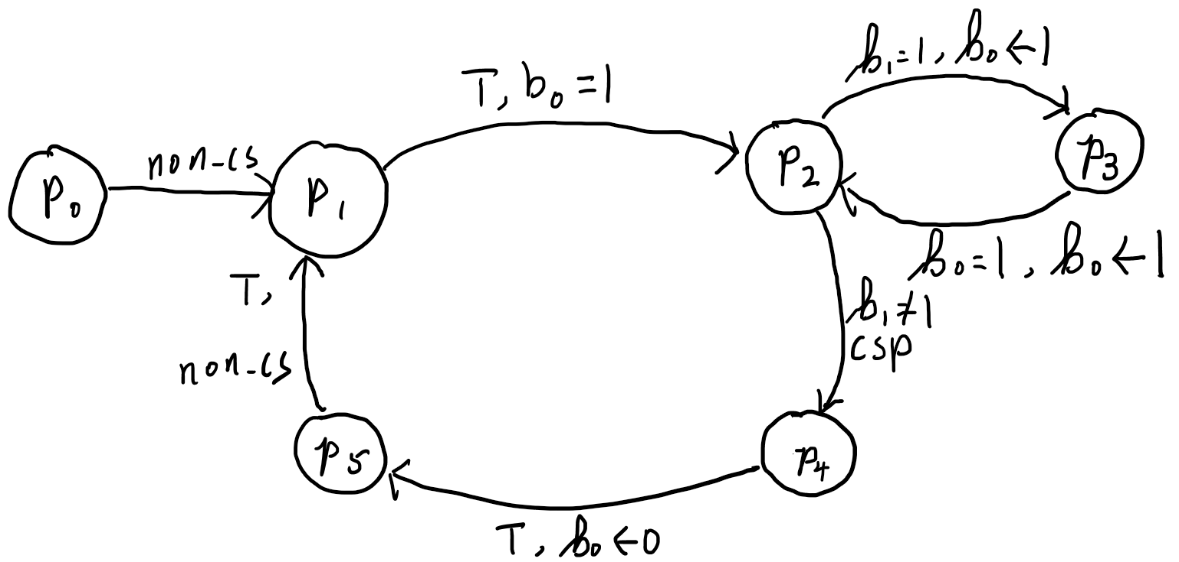

Transition diagram for P

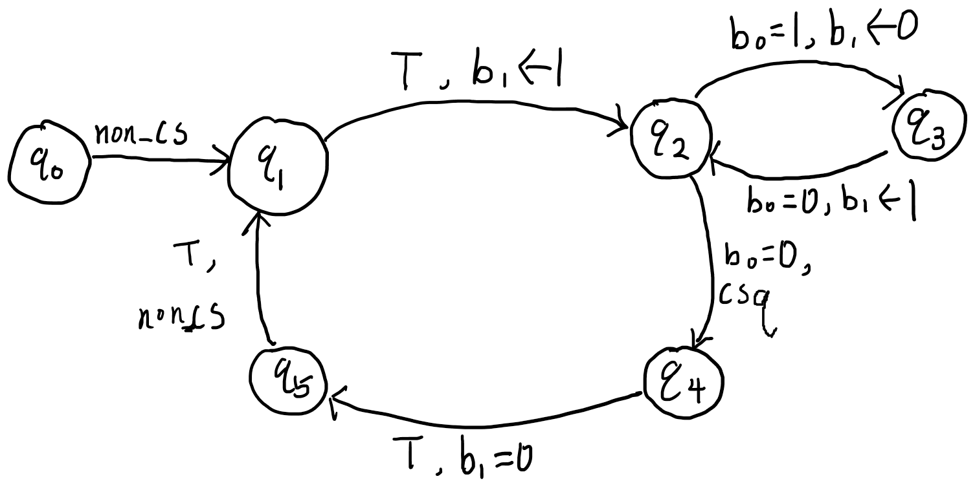

Transition diagram for Q

### Assertion network

$p_{0}$: $b_{0}=0∧b_{1}=0$

$p_{1}$: $b_{0}=0$

$p_{2}$: $b_{0}=1$

$p_{3}$: $b_{0}=1$

$p_{4}$: $b_{0}=1∧b_{1}≠1∧ P@p_{4}$

$p_{5}$: $b_{0}=0$

$q_{0}$: $b_{0}=0∧ b_{1}=0$

$q_{1}$: $b_{1}=0$

$q_{2}$: $b_{1}=1$

$q_{3}$: $b_{0}=1∧ b_{1}=0$

$q_{4}$: $b_{0}=0∧ Q@q_{4}$

$q_{5}$: $b_{1}=0$

In this assertion network, $p_{4}$ and $q_{4}$ are the locations that represent the critical sections. Take the conjunction of $p_{4}$ and $q_{4}$ we have:

$$b_{0}=1∧b_{1}≠1∧P@p_{4}∧b_{0}=0∧Q@q_{4} \\ ⇔{(b}_{0}=0∧b_{0}=1)∧b_{1}≠1∧P@p_{4}∧Q@q_{4} \\ ⟺⊥∧b_{1}≠1∧P@p_{4}∧Q@q_{4} \\ ⟺⊥$$ Which can never be true, which means that only one critical section can be alive at the same time.

#### Proof of inductive

$p_{0}→p_{1}$: $p_{0}∧g:b_{0}=0∧b_{1}=0⟹b_{1}=0,f:non_cs$

$p_{1}→p_{2}$: ${p_{1}:b}_{0}=0, g=⊤$ $f:set b_{0}=1$. After f, the value of $b_{0}$ becomes 1.

$p_{2}→p_{3}$: ${p_{2}∧g:b}_{0}=1∧b_{1}=1$, $f:set b_{0}=1$. After f, the value of $b_{0}$ is still 1

$p_{3}→p_{2}$: $p_{3}∧g:b_{0}=1∧b_{0}=1⟹b_{0}=1, f:set b_{0}=1$. After f, $b_{0}$ is still 1.

$p_{2}→p_{4}$: $p_{2}∧g:b_{0}=1∧b_{1}≠1⟹b_{0}=1∧b_{1}≠1,f:csp$, f has no effect on $b$.

$p_{4}→p_{5}$: ${p_{4}:b}_{0}=1,g:⊤,f:set b_{0}=0.$ After f, the value of $b_{0}$ becomes 0.

$p_{5}→p_{1}$: $p_{t}∧g:b_{0}=0∧⊤⟹b_{0}=0$. $f:non_cs$

$q_{0}→q_{1}$: $q_{0}∧g:b_{0}=0∧b_{1}=0⟹b_{0}=0,f:non_cs$

$q_{1}→q_{2}$: ${q_{1}:b}_{1}=0, g=⊤$ $f:set b_{1}=1$. After f, the value of $b_{1}$ becomes 1.

$q_{2}→q_{3}$: ${q_{2}∧g:b}_{1}=1∧b_{0}=1$, $f:set b_{1}=0$. After f, the value of $b_{1}$ becomes 0.

$q_{3}→q_{2}$: $q_{3}∧g:b_{1}=0, f:set b_{1}=1$. After f, $b_{0}$ is becomes 1.

$q_{2}→q_{4}$: $q_{2}∧g:b_{1}=1∧b_{0}=0⟹b_{0}=0,f:csq$, f has no effect on $b$.

$q_{4}→q_{5}$: ${q_{4}:b}_{0}=0,g:⊤,f:set b_{1}=0.$ After f, the value of $b_{1}$ becomes 0.

$q_{5}→q_{1}$: $q_{t}∧g:b_{0}=0∧⊤⟹b_{0}=0$. $f:non_cs$

Thus, we the assertion network is proved inductive.

## Part 3

Code line $p4$ to $p6$ can be directly replaced by $skip$, because this line is represented by $p_{3}$ in the transition diagram. The cycle $p_{2}→p_{3}→p_{2}$ in the diagram can be replaced by a self-pointing cycle without changing the behaviour of the process.

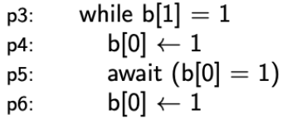

Superfluous code piece

?ASd


Fragment of transition diagram

In addition, according to the transition network, the location $p_{2}$ and $p_{3}$ both specifies $b_{0}=1$. So, the changes will not affect the behaviour of the algorithm.

Thus, code $p3$ to $p6$ can be simplified as:

$p3$: await b[1] = 0