# Homework 5

***Closed product***

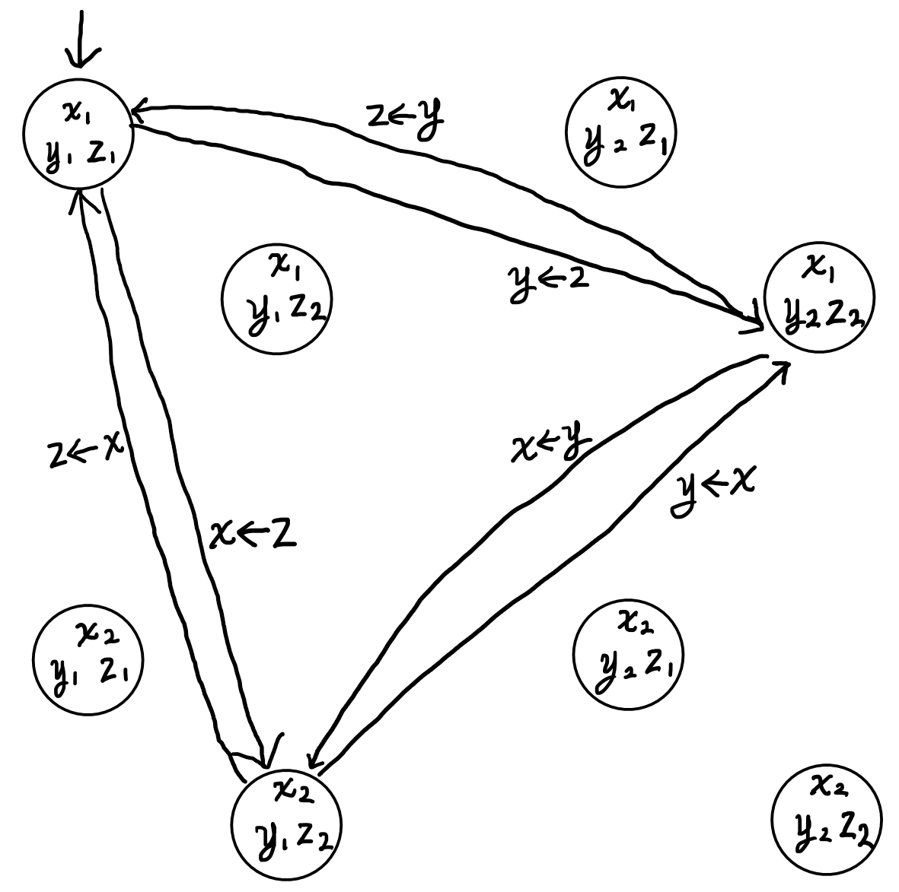

Possible states in execution

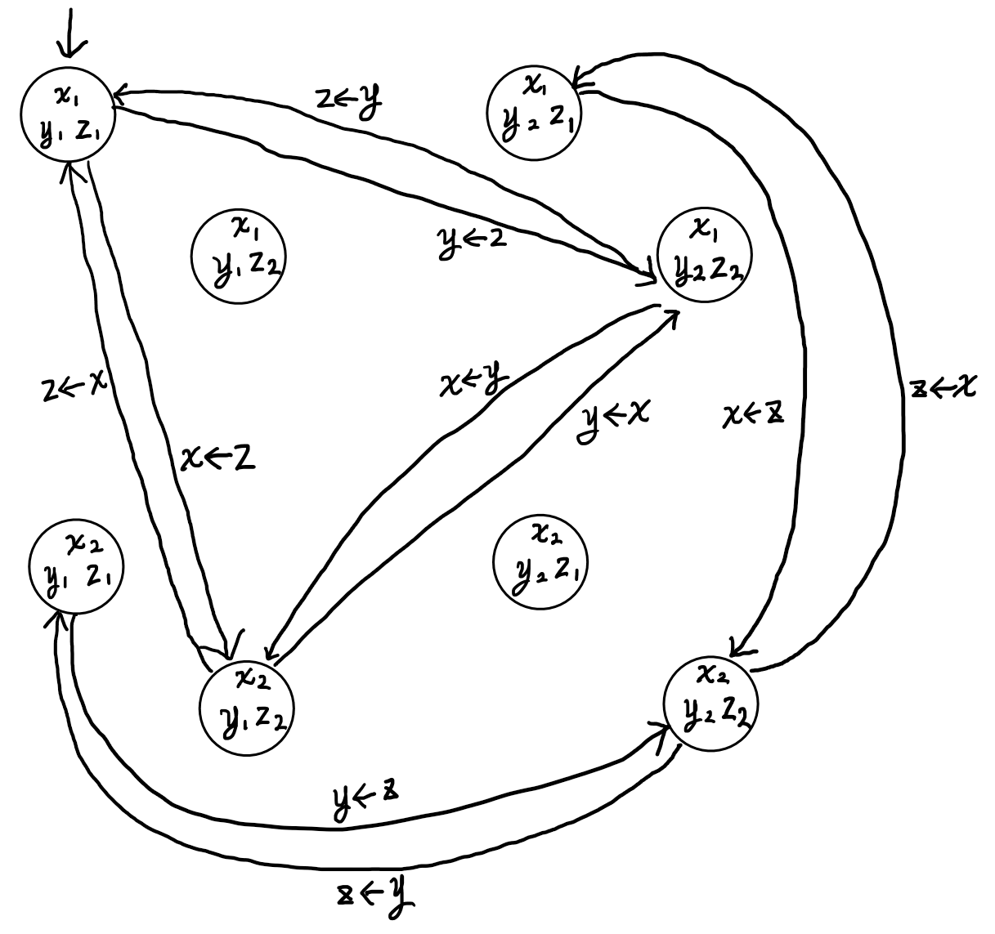

All transitions

***Prove for mutual exclusion***

Yes, because from the diagram, $x_{2}$ and $y_{2}$ don’t exist together in the three possible states.

***Does this algorithm satisfy eventual entry? Briefly motivate***

No, because it is possible that only x and z keep communicate indefinitely. Because of mutual exclusion, y would never enter $y_{2}$.

***Does this algorithm still work if we flip all inputs to outputs, and vice versa? Brifely motivate.***

It still works, because the matching pairs keep unchanged.

***The algorithm behaves oddly if we make ch asynchronous.***

The process z loops forever and x,y don’t have a chance to receive from ch.