# Homework 7

## Non-compositional Verification

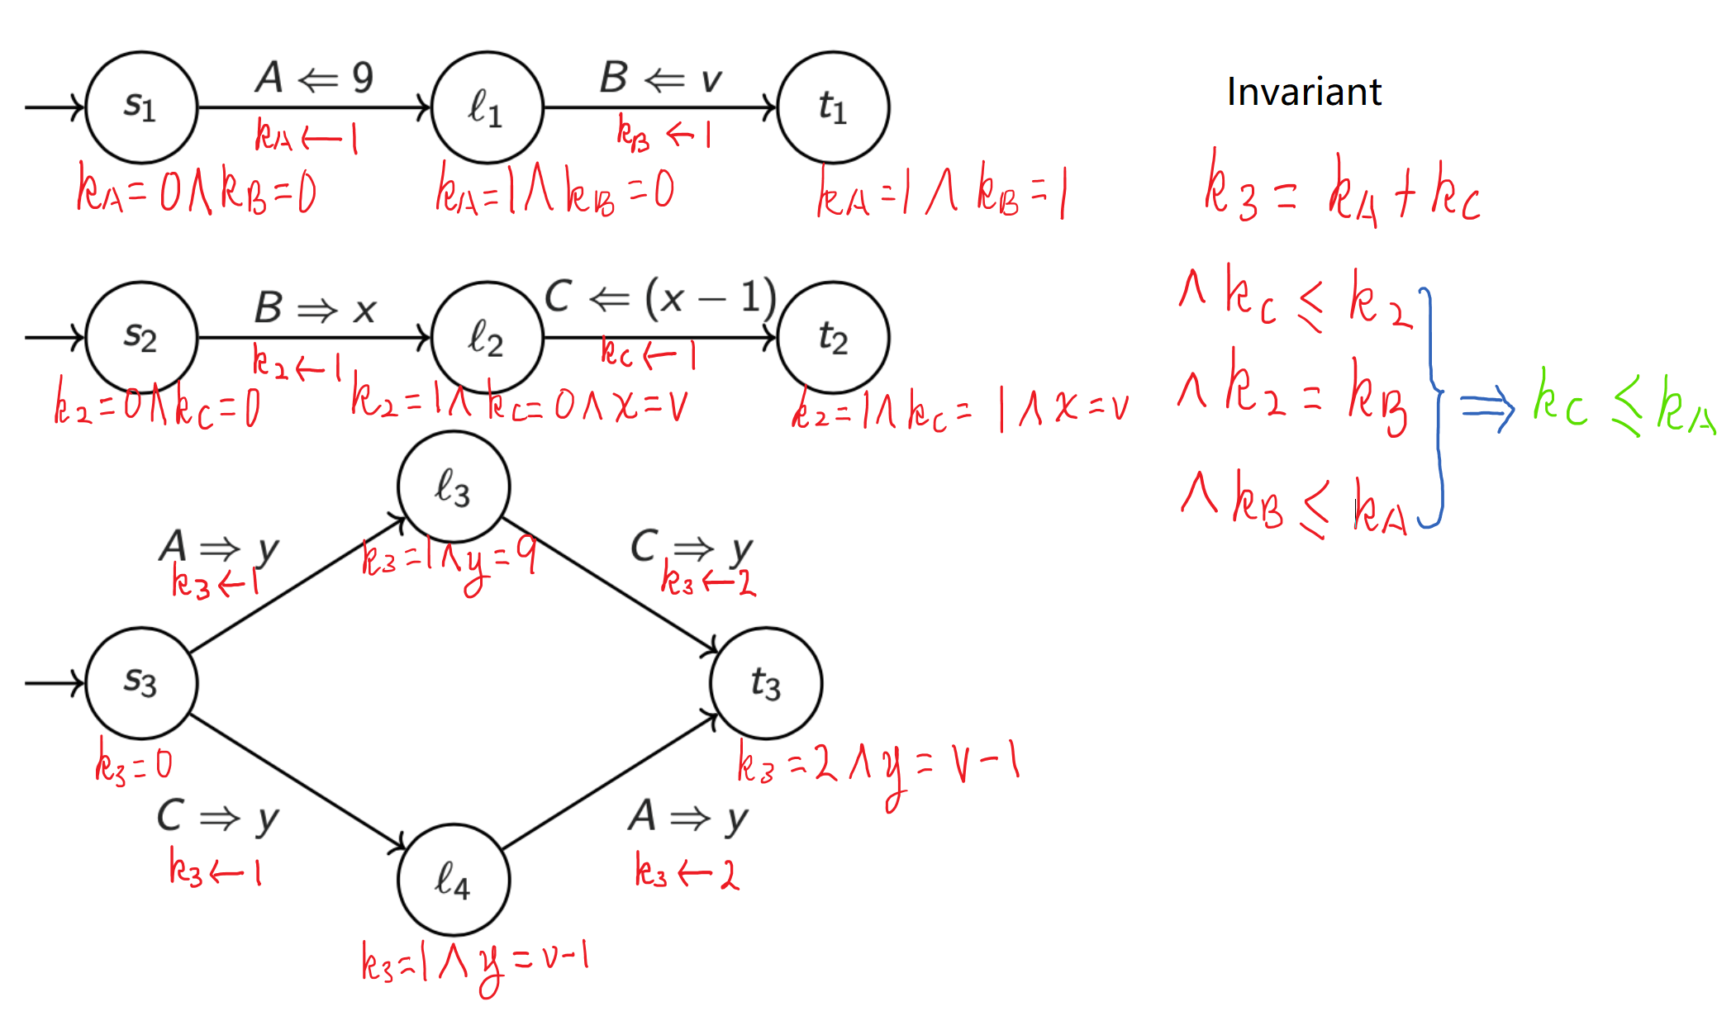

**Diagram for assertion network and communication invariants**

**Explanation of auxiliary variables**

AFR method is used to prove that $\left\{ True\right\}P_{1}\left|\left|P_{2}\right|\right|P_{3}\left\{y=v-1\right\}$ holds.

Firstly, three variables corresponding to the three channels are defined, which are $k_{A},k_{B},k_{C}$ respectively. $k_{channel}=0$ is defined as the default state while $k_{channle}=1$ implies that certain value has been sent into the channel.

Also, we defined $k_{2}$ to indicate whether process 2 has already received a variable from $B$.

Finally, $k_{3}$ is defined to record the “stage” of process 3 where $k_{3}=k_{A}+k{}_{C}$.

**Communication invariant**

$$I: k_{3}=k_{A}+k_{C}∧k_{C}≤k_{2}∧k_{2}=k_{B}∧k_{B}≤k_{A}$$

Notice that $k_{c}≤k_{2}∧k_{2}=k_{b}∧k_{B}≤k_{A}$ implies that $k_{C}≤k_{A}$, which is useful for discharging proof obligation.

## Termination

***1. prove $x≥0$ -convergence***

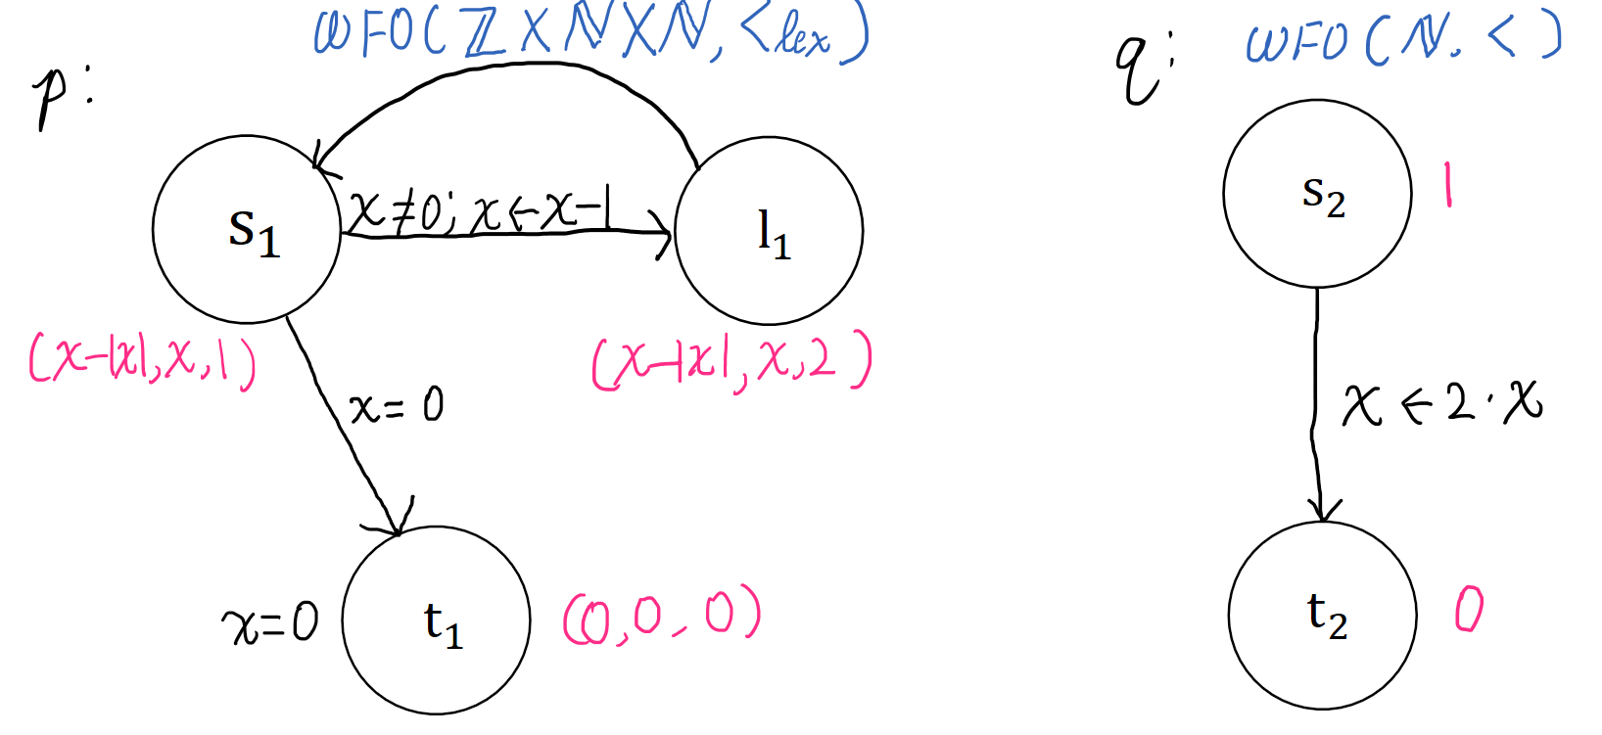

**Diagram for assertion network, well founded set and ranking function**

For $x≥0$, the program is convergent.

This program exits when $x=0$ then $P$ at $t_{1}$ and $Q$ at $t_{2}$.

***2. Is this program ⊤-convergent?***

No, because for $x<0$, this program will stay in the loop $s↔l_{1}$ forever and x will keep going far away the terminate state therefore it never converges.

***2. Is this program ⊥-convergent?***

Yes, because when the precondition is $⊥$, that means that $x≠0$ is false, so