# Homework 8

## The Byzantine Generals Algorithm

1. ***Who is the traitor?***

John. Let’s draw a table:

|  |  |  |  |
| --- | --- | --- | --- |
|  | Reported by | | |
| Basil | John | Leo |
| Basil | R | **A** | R |
| John | A | **R** | A |
| Leo | R | R | R |

If general $X$ is a traitor, it would be possible to make the reported decisions uniform in each single row by flipping part of the decisions in column $X$.

I can only be done by flipping the two highlighted decisions in John’s column. So only John can be the traitor.

1. ***What does Ivan decide about Basil’s and John’s plans? What does Ivan decide about the overall majority plan?***

Basil: **R**

John: **A**

Overall: **R** (if the rule is devide R given a tie)

1. ***screenshot of the main window in DAJ.***

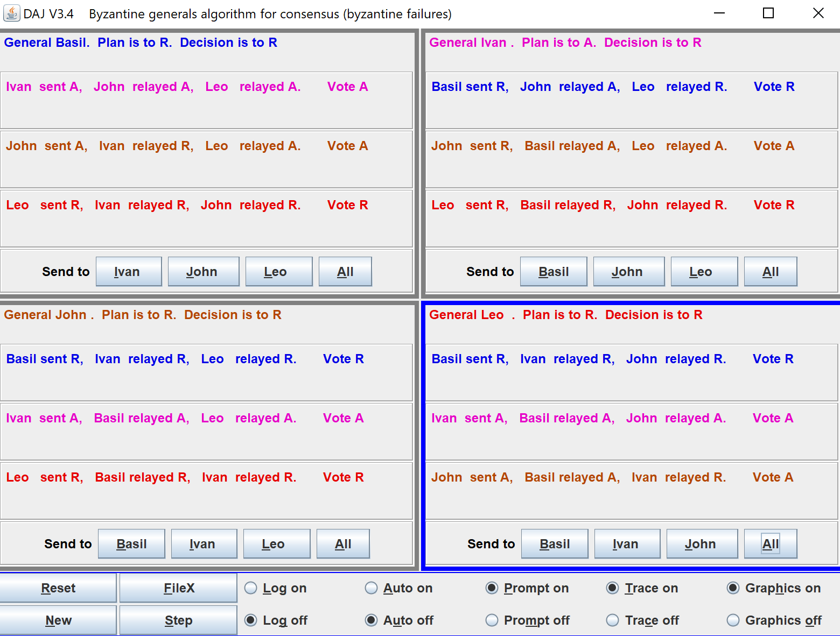

1. 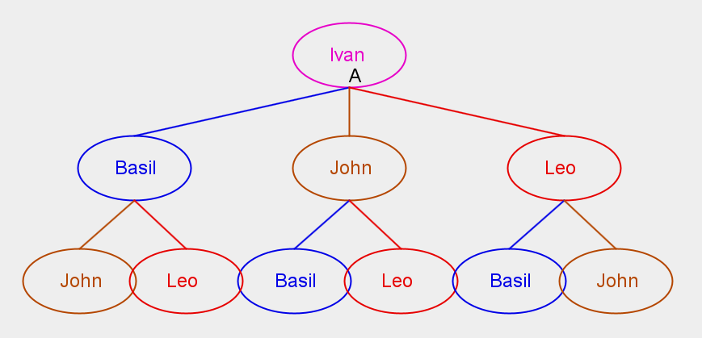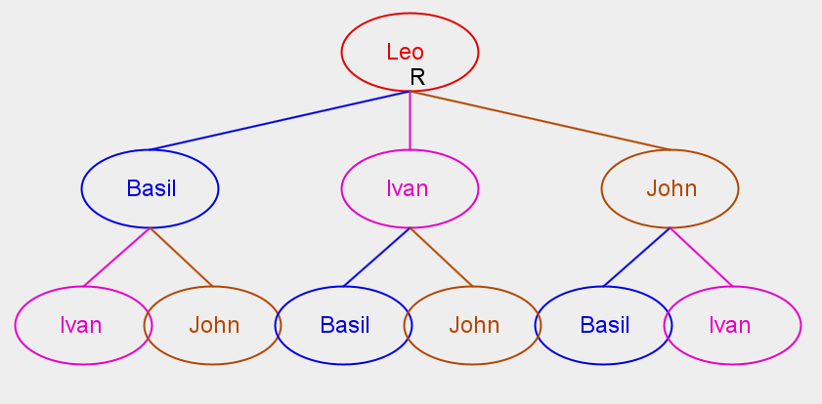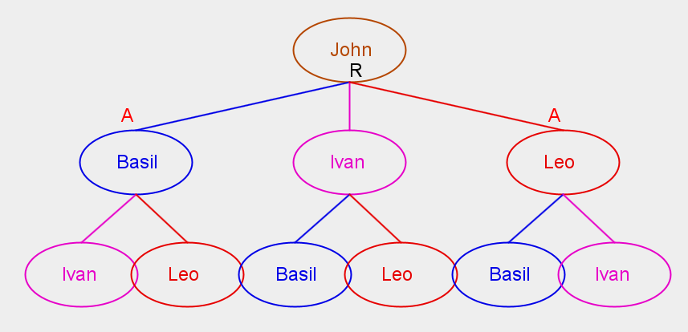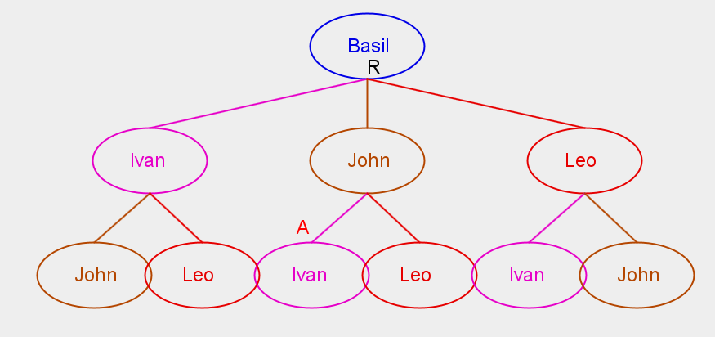***screenshots of the 4 (four) knowledge trees that DAJ constructs about each of the generals.***

## The Dijkstra-Scholten Algorithm

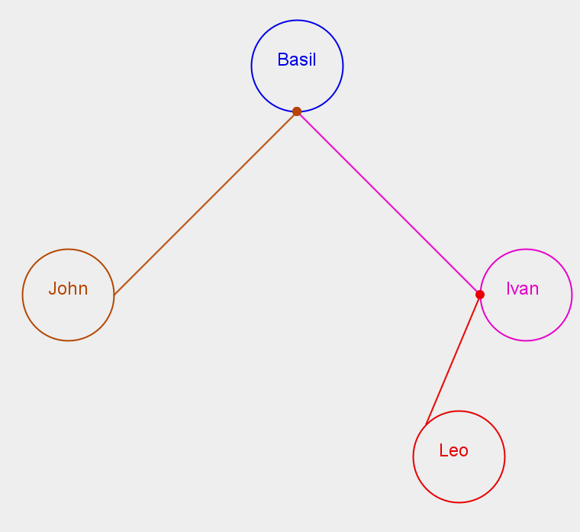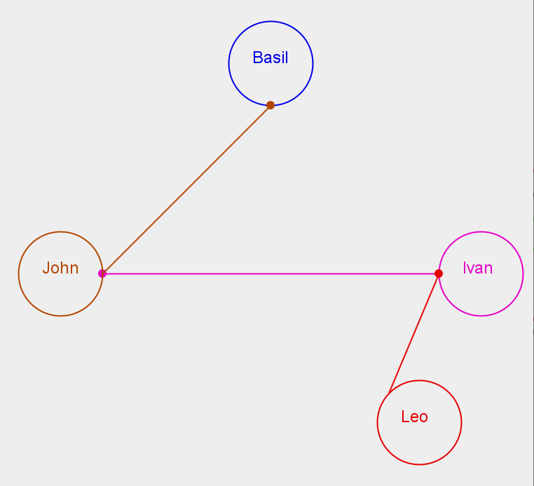

The four spanning trees are listed above.

## Permissionless consensus

All the other nodes would store both chains and pick the first one that they receive to continue to work on. Once one of the two chains becomes longer earlier than the other, all the nodes would move to the newest longer chain and dump the other one.