Exercise 1: nslookup

Use the nslookup command from the "Tools of the Trade" and answer the following questions:

1. *Which is the IP address of the website www.koala.com.au? In your opinion, what is the reason for having several IP addresses as an output?*

The IP addresses of [www.koala.com.au](http://www.koala.com.au) are:

**104.21.45.21** and **172.67.219.46**

With multiple IP addresses, a service provider can use more than one server to handle the requests. Therefore, they can have a higher throughput capacity. They can also guarantee the connectivity when some of the IP addresses are not working (being banned or servers shut down) by using multiple IP. Moreover, they can provide selective service by binding multiple IP to one domain (for choosing nearest server or using a separate server for mobile access).

1. *Find out the name of the IP address 127.0.0.1. What is special about this IP address?*

The name of 127.0.0.1 is **localhost**, and it is the standard loopback address for IPv4. Any packets sent to this address is looped back. This address is commonly used for testing purposes.

#### Exercise 2: Use ping to test host reachability

Are the following hosts reachable from your machine by using ping:

[www.unsw.edu.au](http://www.unsw.edu.au)

Yes

[www.getfittest.com.au](http://www.getfittest.com.au)

**No, unknown host**

[www.mit.edu](http://www.mit.edu)

Yes

[www.intel.com.au](http://www.intel.com.au)

Yes

[www.tpg.com.au](http://www.tpg.com.au)

Yes

[www.hola.hp](http://www.hola.hp)

**No, unknown host**

[www.amazon.com](http://www.amazon.com)

Yes

[www.tsinghua.edu.cn](http://www.tsinghua.edu.cn)

Yes

[www.kremlin.ru](http://www.kremlin.ru)

**No, with 100% Packet loss**

8.8.8.8

Yes

[www.getfittest.com.au](http://www.getfittest.com.au) and [www.hola.hp](http://www.hola.hp) are not reachable from both ping and web browser because they are not registered in the DNS server.

[www.kremlin.ru](http://www.kremlin.ru) is only reachable by web browser, and having no response to ping command. Because it is a government website, host keeper maybe closed the public ping service for security reason. The common way to do that is to block ICMP at the firewall.

#### Exercise 3: Use traceroute to understand the network topology

1. *Run traceroute on your machine to* [*www.columbia.edu*](http://www.columbia.edu)

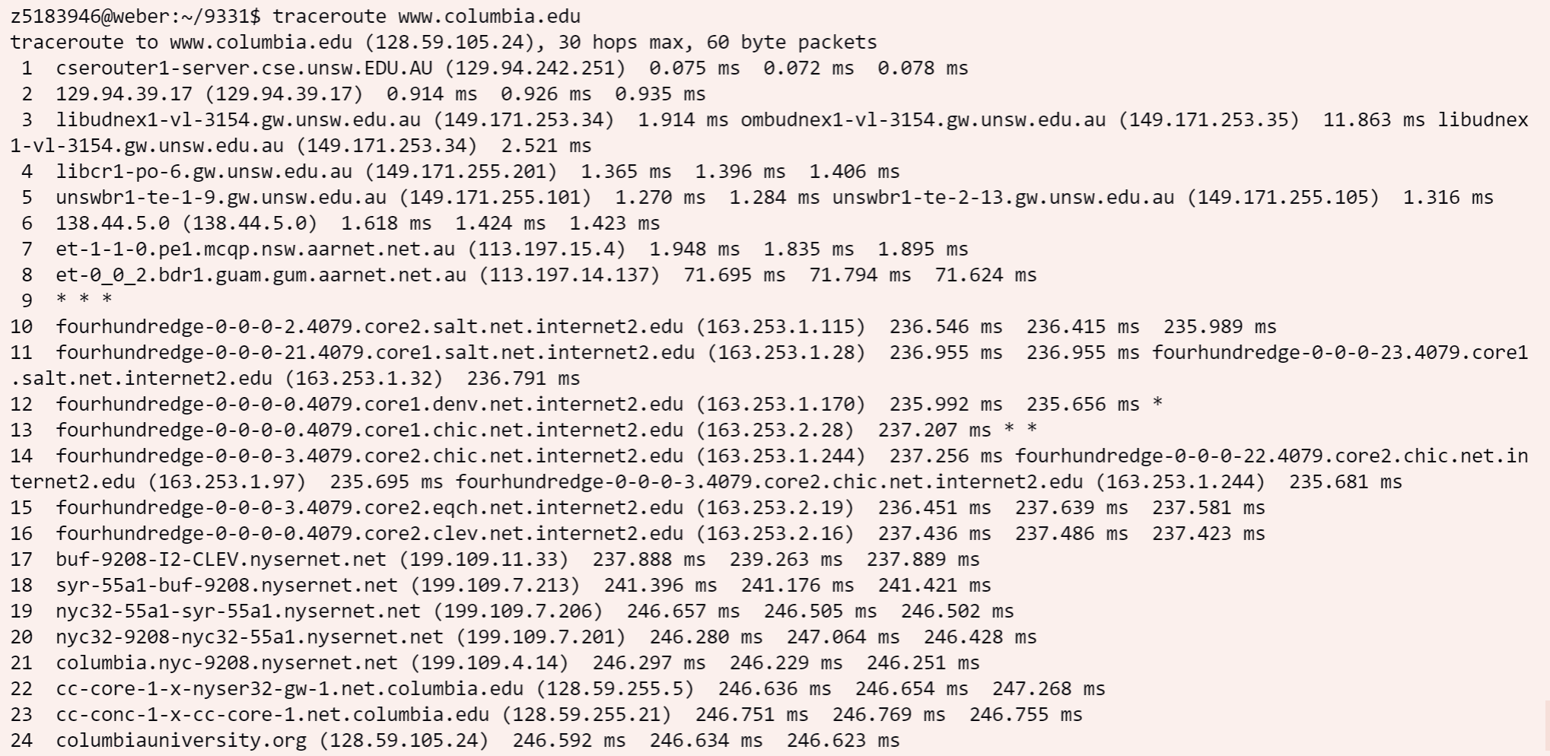

Traceroute outputs of www.columbia.edu

There are **23** routers between my workstation and [www.columbia.edu](http://www.columbia.edu/) (excluding the last one). And there are **5** of them are part of UNSW network as the 6th router is already AARNET router suggested by whois command. The packages between **7th** and **10th** routers crossed the Pacific Ocean. It is deduced that 8th and 9th routers are located on the Pacific Ocean while the 10th sits inside the US.

After some trials, the IP address of ninth router is 138.44.228.5. Then, the delay for 7th to 10th routers by pinging are:

|  |  |  |  |
| --- | --- | --- | --- |
| 7 | 8 | 9 | 10 |
| 2ms | 72ms | 185ms | 236ms |

1. *Run traceroute from your machine to the following destinations: (i)* [*www.ucla.edu*](http://www.ucla.edu) *(ii)* [*www.u-tokyo.ac.jp*](http://www.u-tokyo.ac.jp) *and (iii)* [*www.lancaster.ac.uk*](http://www.lancaster.ac.uk)

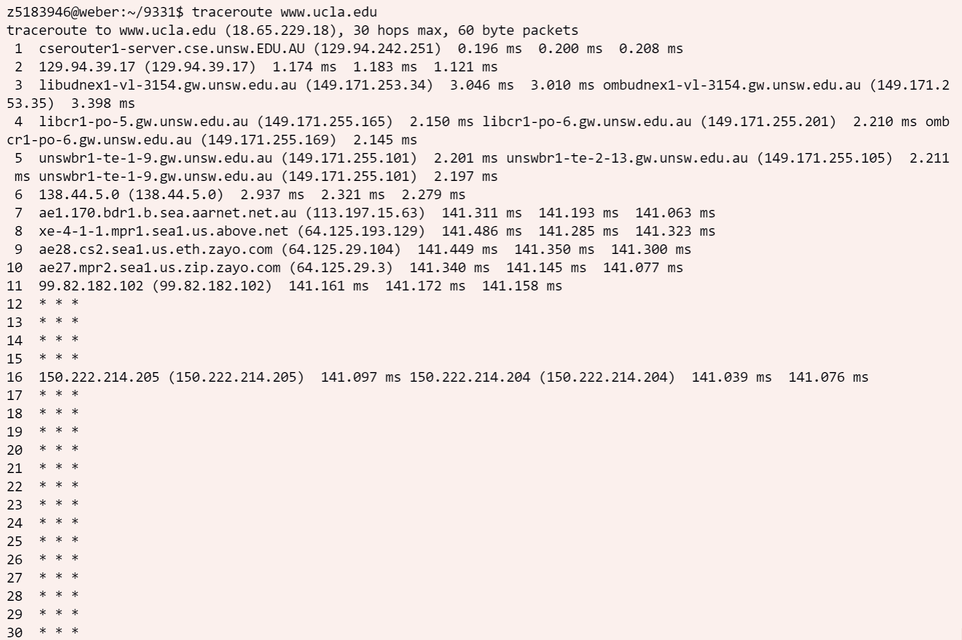

Traceroute output of www.ucla.edu

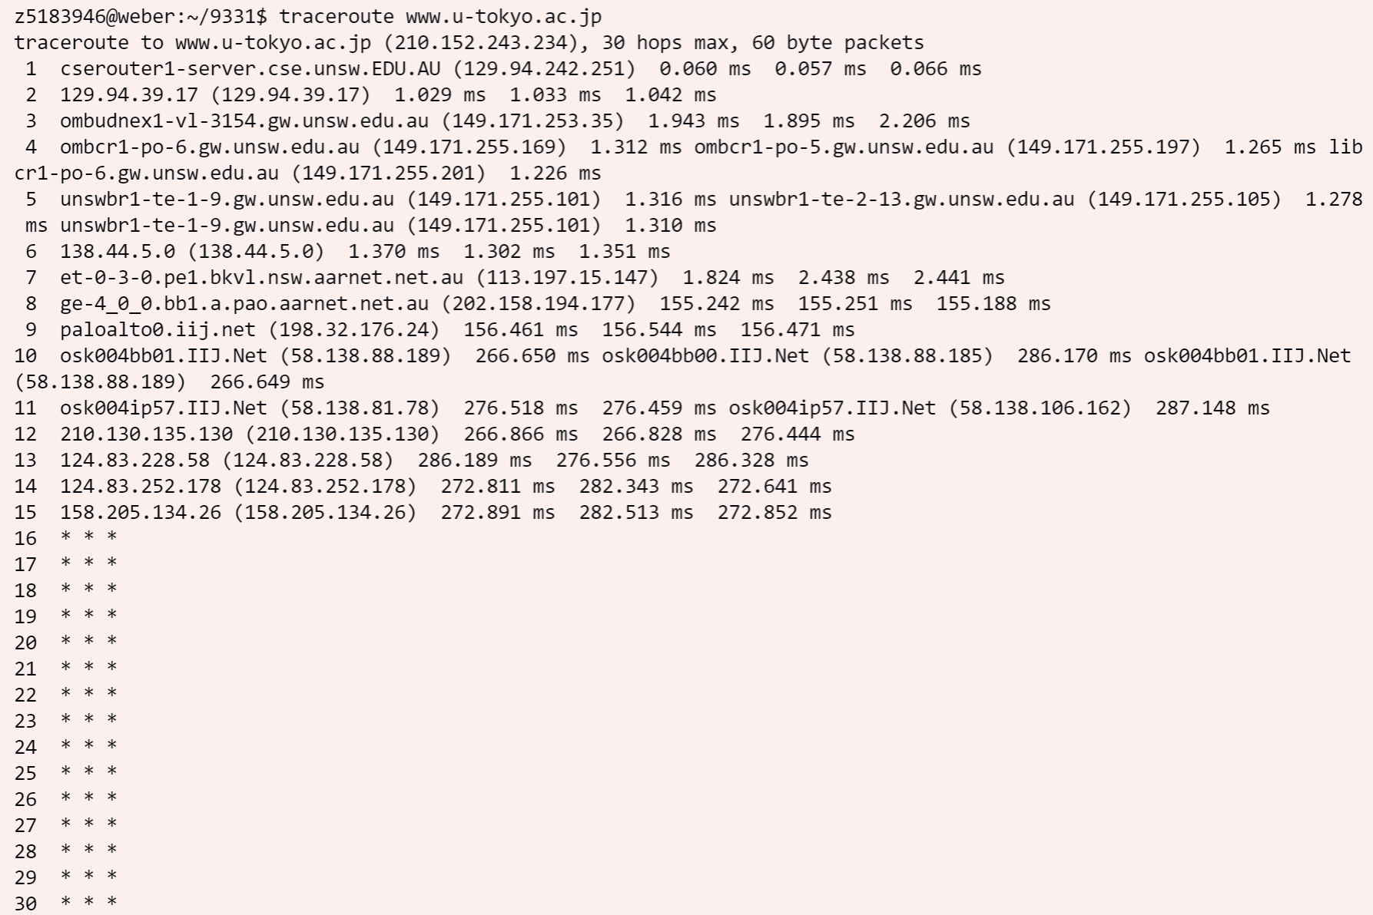

Traceroute output of www.u-tokyo.ac.jp

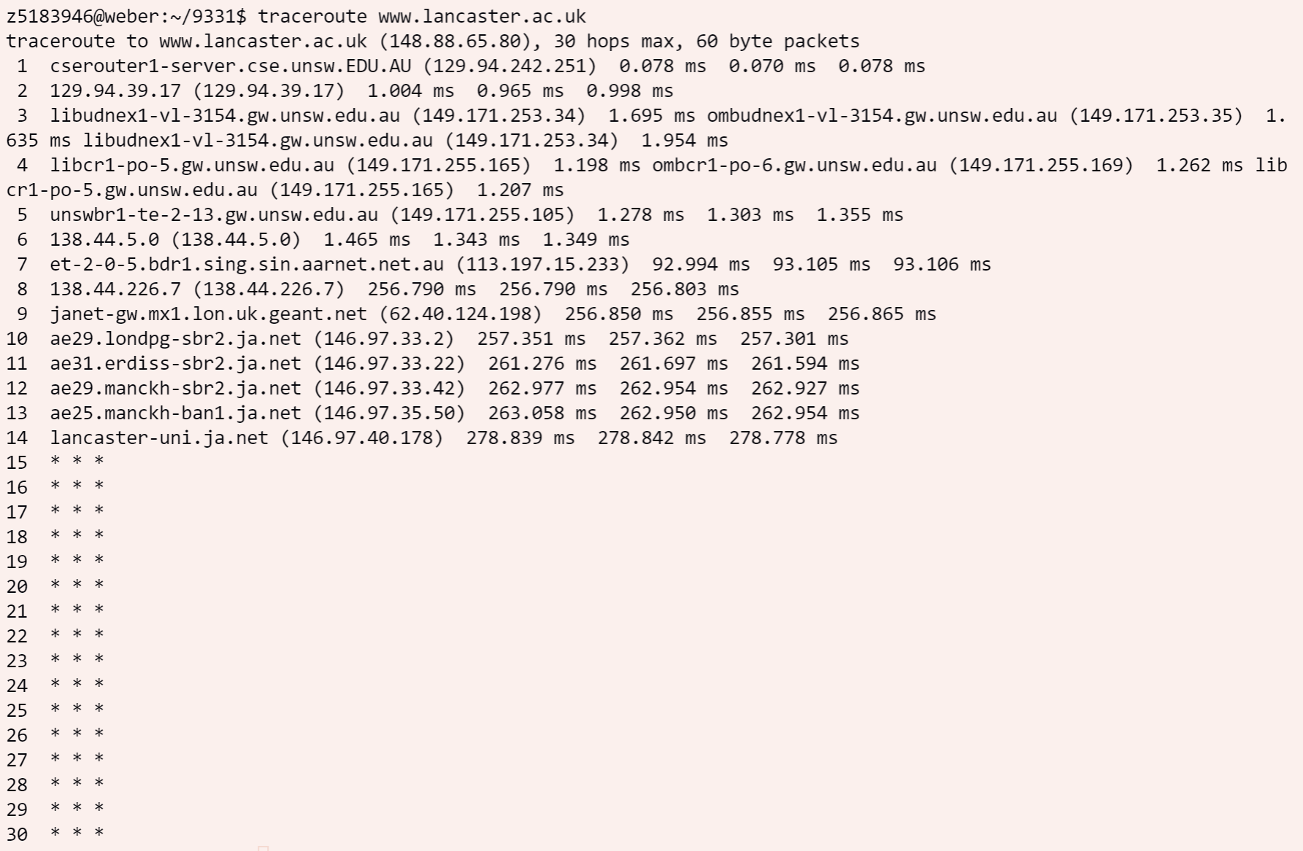

Traceroute output of www.lancaster.ac.uk

It can be observed from the outputs of traceroute command to these three destinations diverges **after 6th** router (138.44.5.0). The Whois command shows that this address sits in the address range of Australian Academic and Research Network (AARN) owned by Asia Pacific Network Information Centre (APNIC).

The number of hops is not proportional to the physical distance. Because although the three path have similar lengths, the distance to the destinations are significantly different as shown below:

|  |  |  |  |
| --- | --- | --- | --- |
| Destination | www.ucla.edu | www.u-tokyo.ac.jp | www.lancaster.ac.uk |
| # of hops | 16 | 15 | 14 |
| Physical Distance | 10659.1 miles | 4369.9 miles | 9542.7 miles |

1. *Several servers distributed around the world provide a web interface from which you can perform a traceroute to any other host on the Internet. Here are two examples: (i)* [*http://www.speedtest.com.sg/tr.php*](http://www.speedtest.com.sg/tr.php) *and (ii)* [*https://www.telstra.net/cgi-bin/trace*](https://www.telstra.net/cgi-bin/trace)*.*

My IP address: **129.94.242.53**

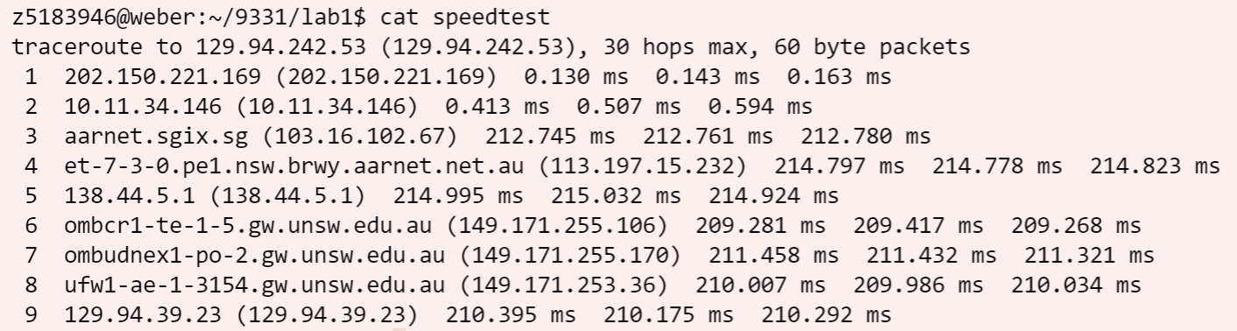

Traceroute output from [*http://www.speedtest.com.sg/tr.php*](http://www.speedtest.com.sg/tr.php)

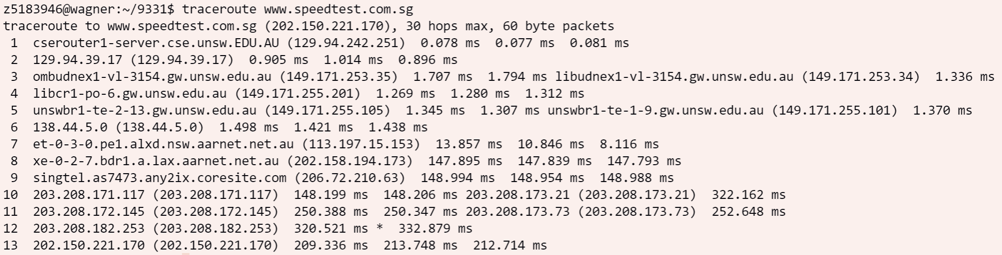

Traceroute output in the reverse direction

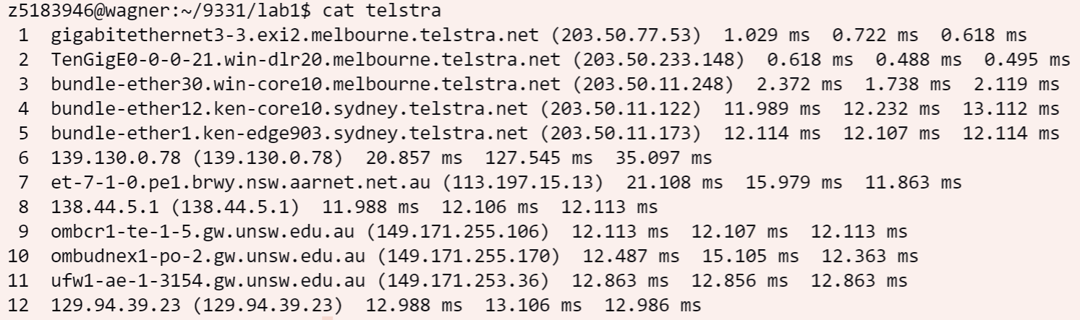

Traceroute output from [*https://www.telstra.net/cgi-bin/trace*](https://www.telstra.net/cgi-bin/trace)

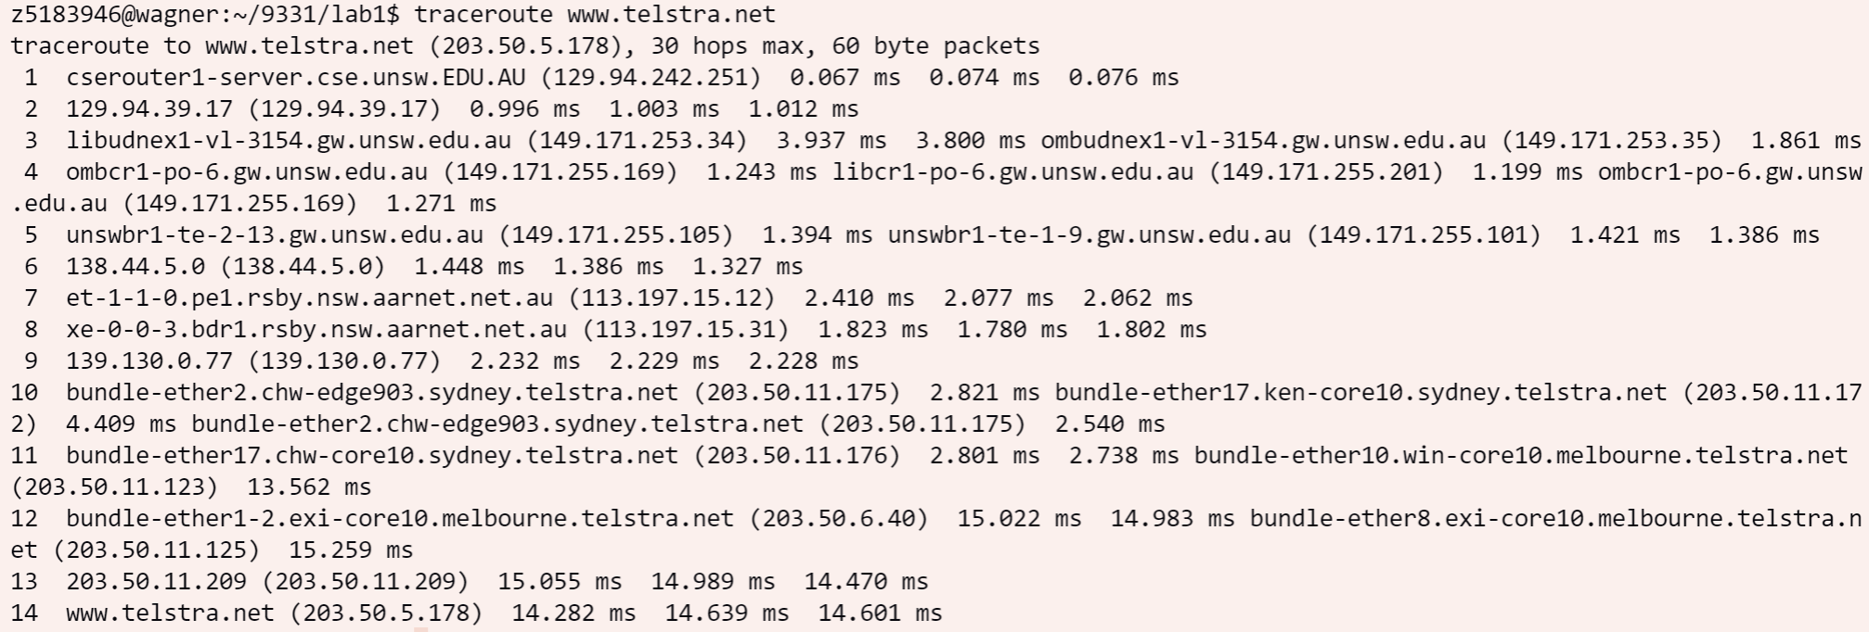

Traceroute output in the reverse direction

The IP address of **speedtest** server is **202.150.221.170** and the IP address of **Telstra** server is **203.50.5.178**. The reverse path went through different routers as forward path. Although they don’t have any routers in common, they still have some very similar addresses, for example, 138.44.5.0 versus 138.44.5.1. The reason why the reverse path is different from forward may be different routers or router interfaces are used to handle outgoing and incoming requests.

#### Exercise 4: Use ping to gain insights into network performance

Use [runping.sh](https://webcms3.cse.unsw.edu.au/COMP3331/22T1/resources/70094) for the following destinations:

(i) [www.uq.edu.au](http://www.uq.edu.au/)(ii) [www.upm.edu.my](http://www.upm.edu.my/) (iii) [www.tu-berlin.de](http://www.tu-berlin.de/).

And then plot the results using [plot.sh](https://webcms3.cse.unsw.edu.au/COMP3331/22T1/resources/70089):

www.uq.edu.au:

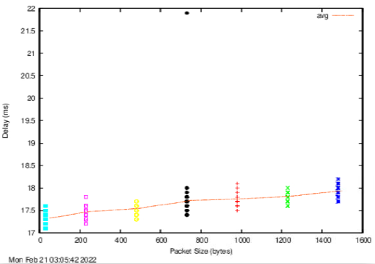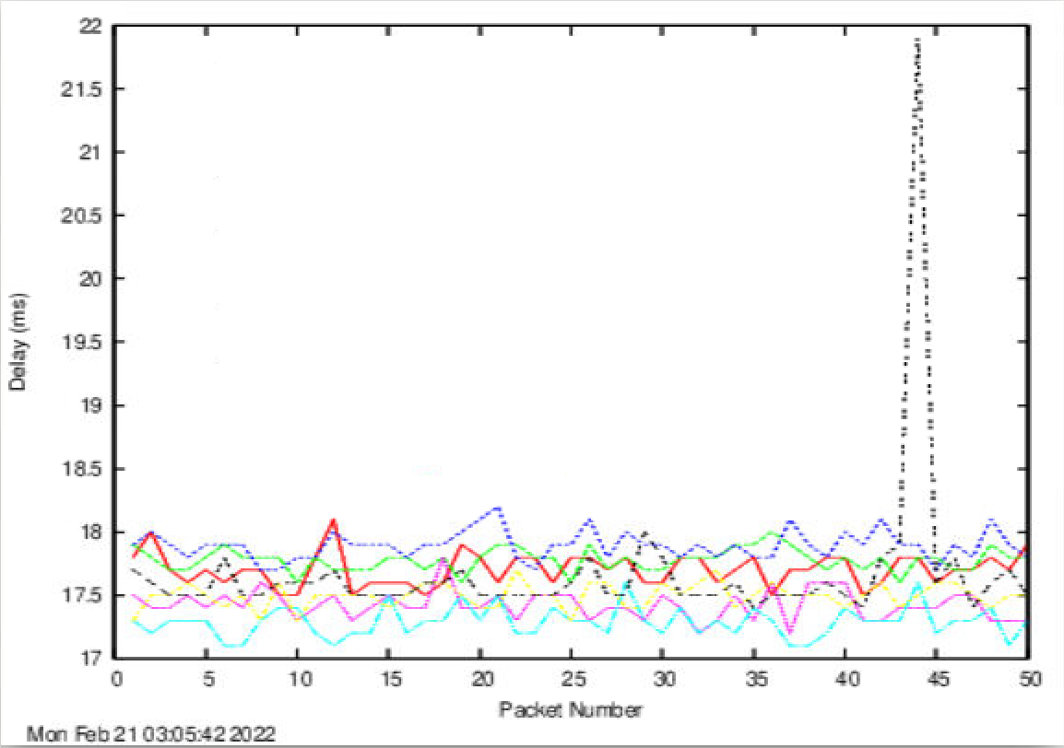

www.upm.edu.my:

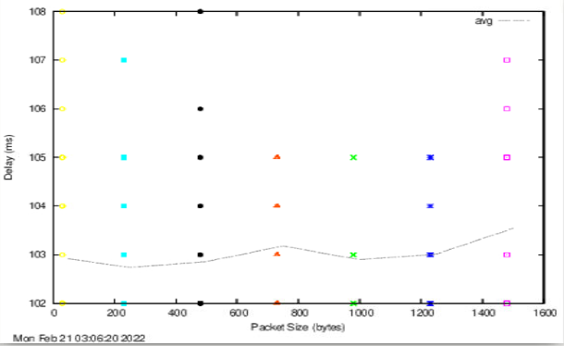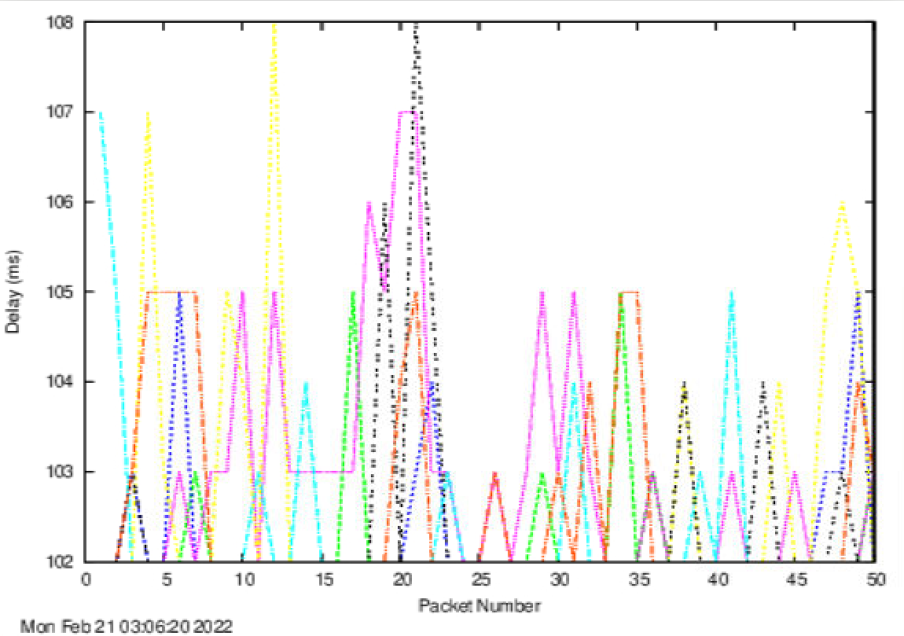

www.tu-berlin.de:

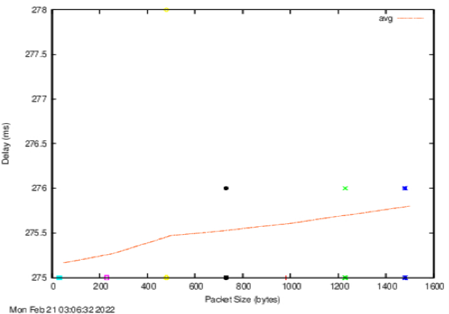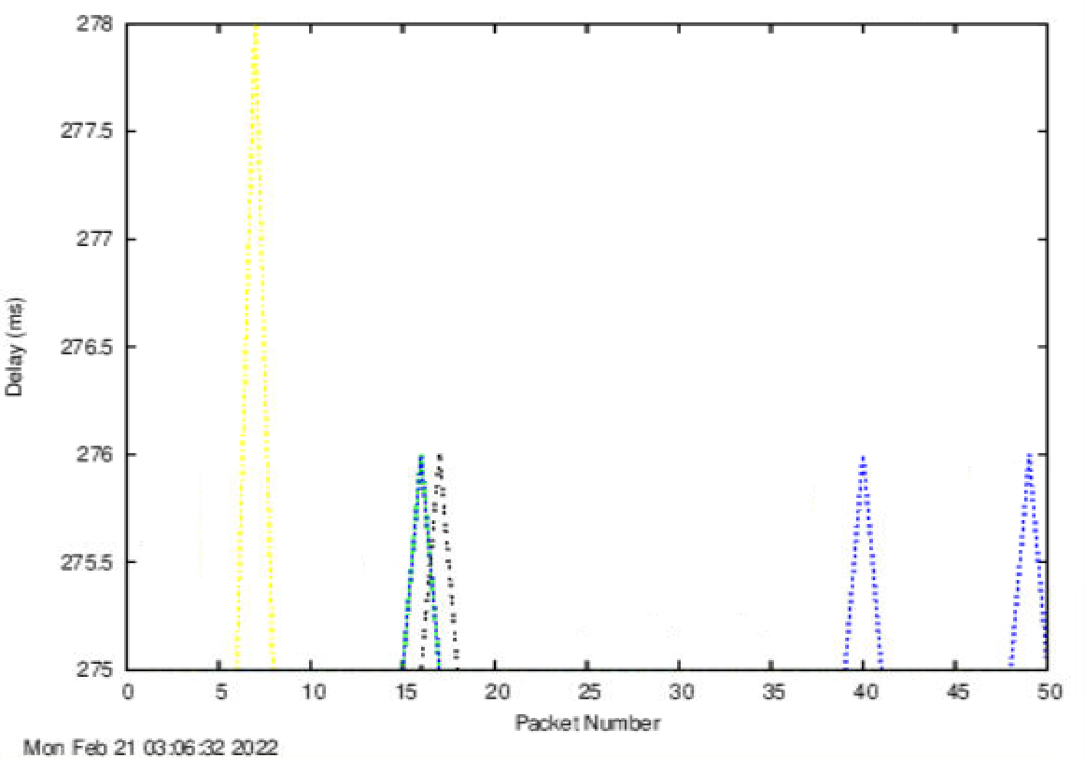

*Q1:*

Approximate Physical distance and Shortest possible time are shown below:

|  |  |  |  |
| --- | --- | --- | --- |
| Institutions | UQ | UPM | TU-Berlin |
| Distance (km) | 733.5 | 6600 | 16100 |
| Shortest Time (ms) | 2.45 | 22 | 53.67 |

There are two possible reasons why the ratios are greater than 2:

1. The physical route is longer than the shortest distance, in real life, it usually takes detours to meet different needs.
2. Delay consists of processing, queueing, transmission and propagation delay, while the calculated delay is only propagation delay. So, the measured delay is certainly higher. Moreover, because processing, queueing and transmission time are not obviously positive related to distance, the ratio tend to be larger when distance is short.
3. The signal may not travel in the full light speed because of the medium used.

*Q2: Is the delay to the destinations constant or does it vary over time? Explain why.*

As observed from the graphs, **the delay varied over time**. It is because delay is affected by the internet traffic which keeps varying from time to time. And the traffic influences queueing time the most.

*Q3:* *The measured delay is composed of propagation delay, transmission delay, processing delay and queuing delay. Which of these delays depend on the packet size and which do not?*

Only **processing delay** and **transmission delay** are directly affected by the packet size because each bit takes approximately constant time to be processed. Although they both depend on the packet size, processing delay is of a much lower order of magnitude than the other one. The other two delays are not positively correlated with packet size.