Comp9417 Final Exam

# Question 1:

## a)

At first, we assume A, B, C and D are mutually independent.

According to the Bayes Assumption, we have:

From the dataset we know that

And the count vector for positive is and that for negative is.

Then the estimated parameter vectors are:

According to the formula given:

Thus,

## b)

With smooth, the estimated parameter vectors are:

Hence,

## c)

Under the Bernoulli distribution, the estimated parameter vectors are:

And we have the bit vector

Thus,

Therefore,

## d)

With smooth, the estimated parameter vectors are:

And we have the bit vector

Thus,

Therefore,

# Question 2

## a)

According to the question, , thus

Then we have:

and

## b)

While condition satisfied (iteration < 100 in this question):

BEGIN

Compute by

and

Then calculate

Finally update

END

## c)

Figure 2.1 Python code for gradient descent

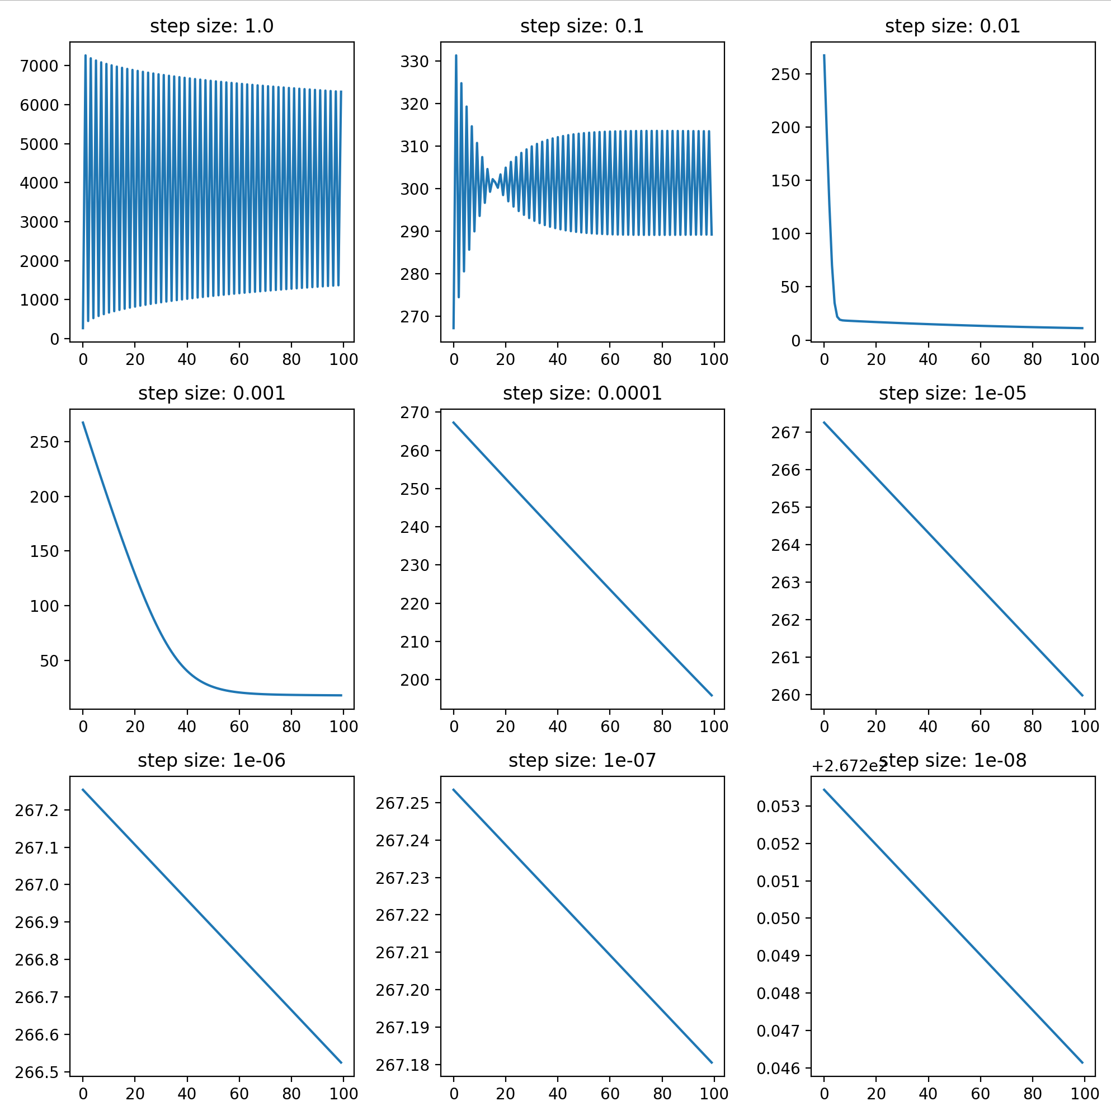

Figure 2.2 Gradient for nine different alphas

## d)

Oscillations appeared for step size of 1.0 and 0.1. And the loss decreased significantly when while the model performs best with . However, when step size became smaller, no obvious change happened to the loss.

The reason for the oscillation is that the learning rate is too high so that the parameters are over adjusted and when it becomes low no significant adjustment could be made. If we change iteration size to a large number (for example 10000) we can observe a significant decrease in losses of a smaller learning rate.

## e)

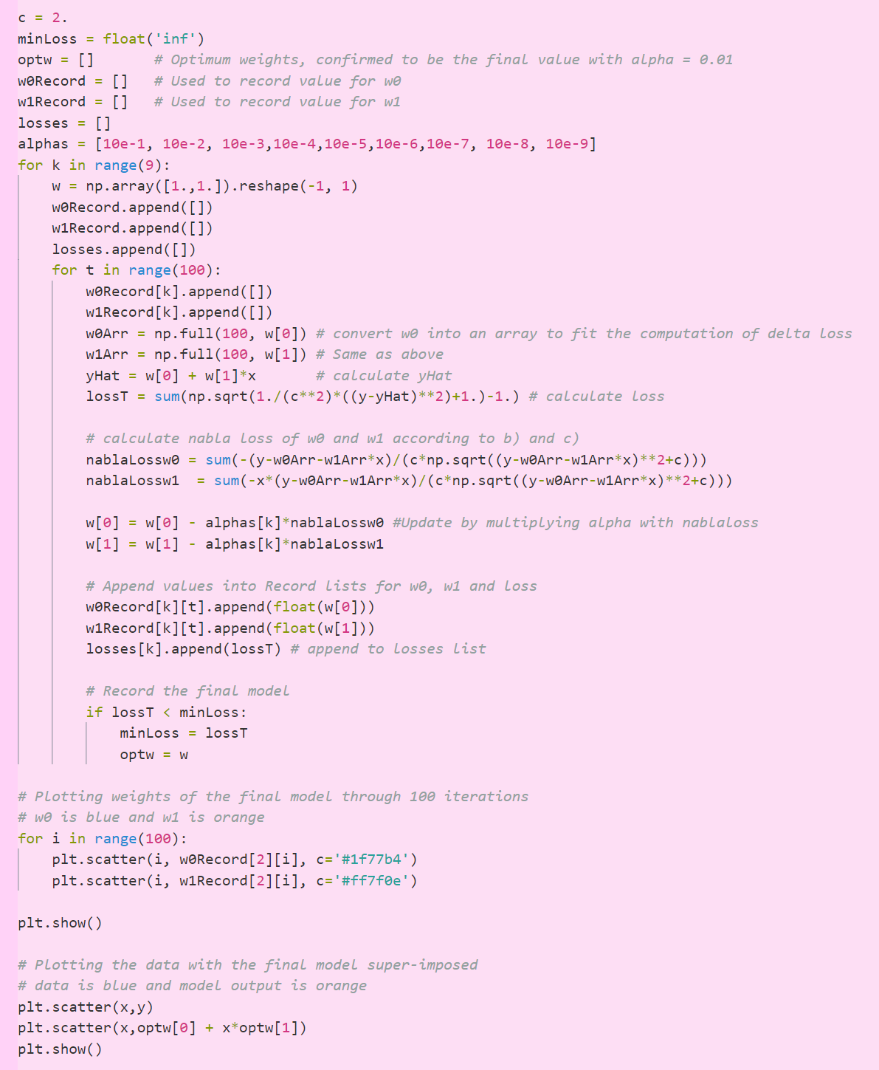The optimal step-size is 0.01, and the final model is

Figure 2.3 Code with two plots

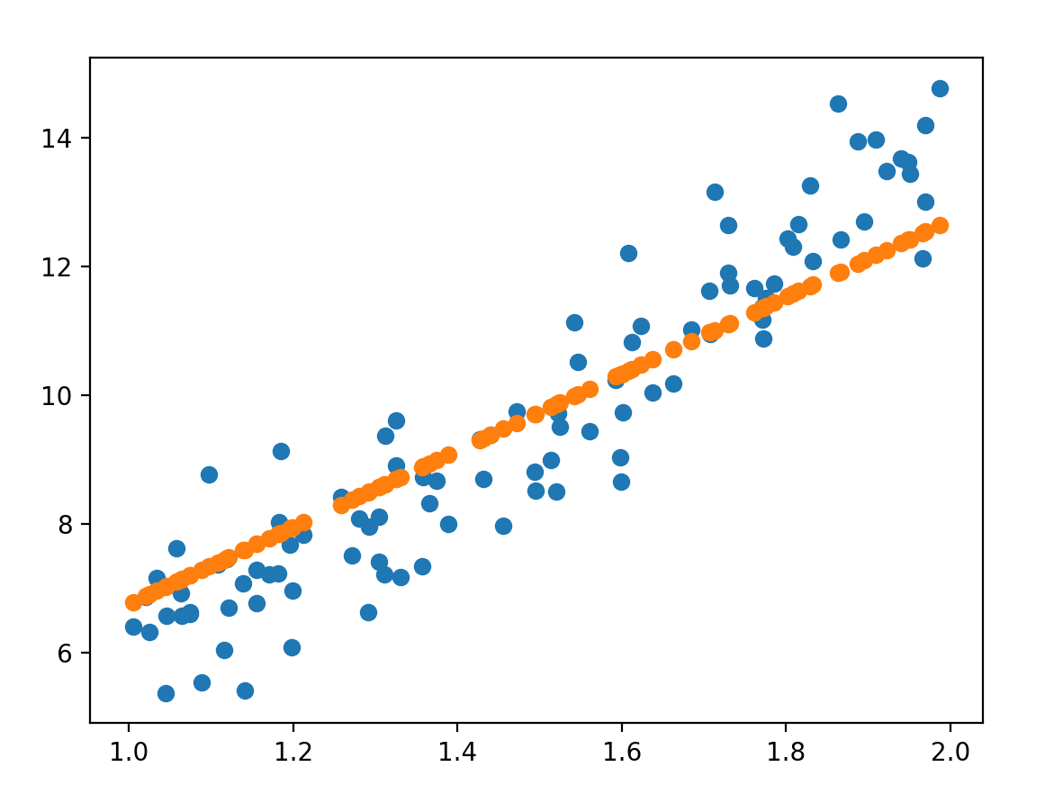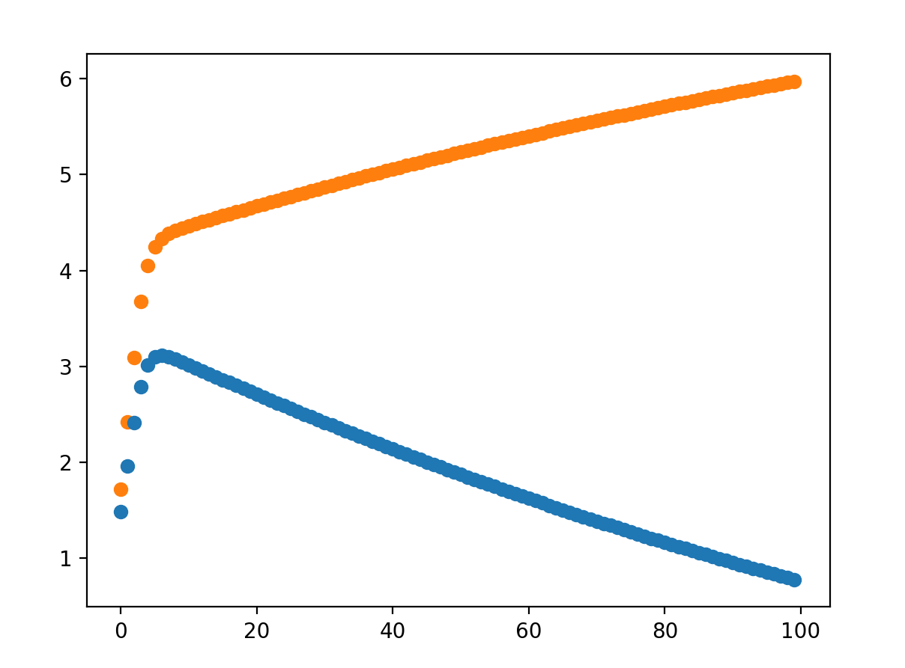Figure 2.4 Plot of final model for w0 and w1 over 100 iterations (w0: blue, w1: orange).

Figure 2.5 Plot of the data with the final model super-imposed (data: blue, predict: orange).

## f)

The value for optimal alpha value increases as c increases, vice versa.

A larger value of c is chosen when we want to reduce the influence of the squared error and reduce the numerical value of SE, vice versa.

The final c chosen should generate a more accurate model and should also produce a more intuitive loss value for human brain.

## Question 3

## a)

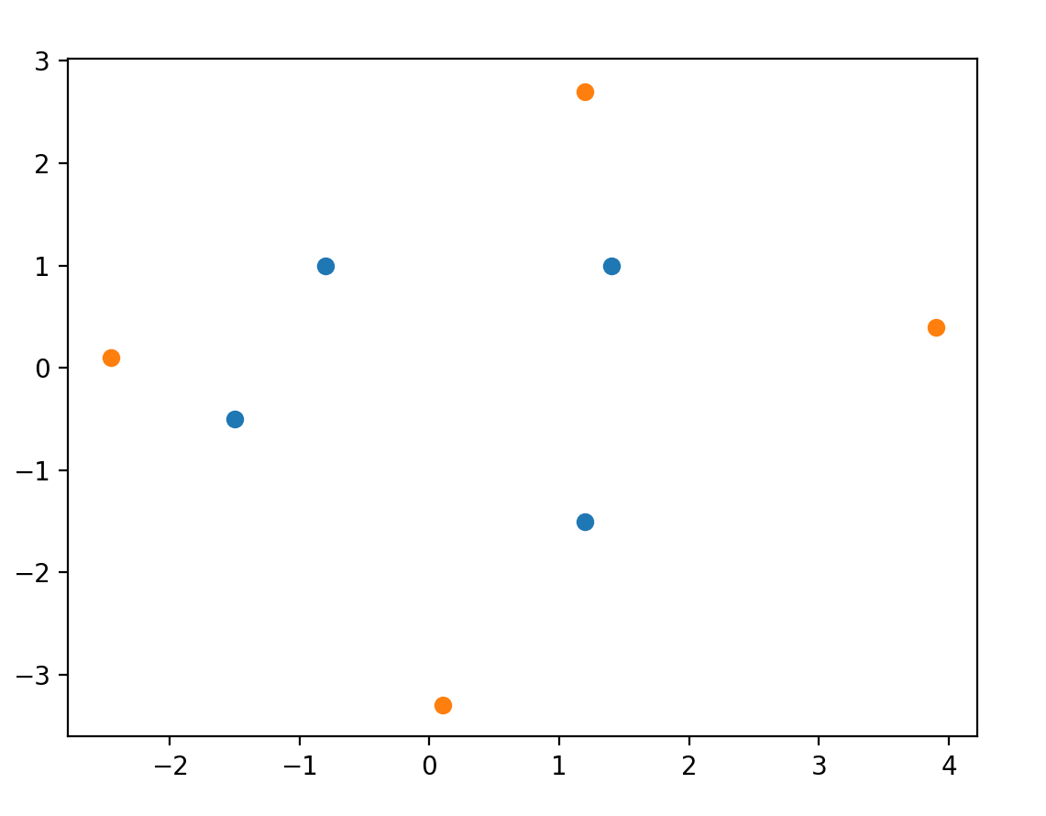Figure 3.1 plot of data (blue: data for y=1, orange: data for y=-1)

The simplest polynomial kernel is

in which .

So, the feature function could be defined as

## b)

According to a), the feature representation is in .

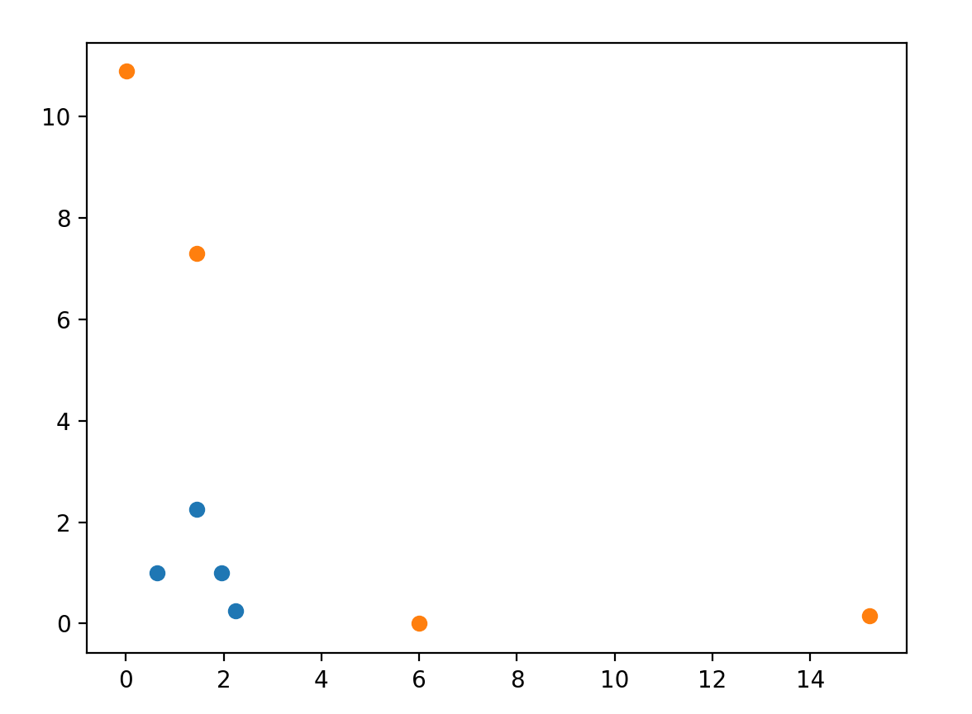And the subset chosen is . The plot is shown in the following figure, and the transformed data is linear separable

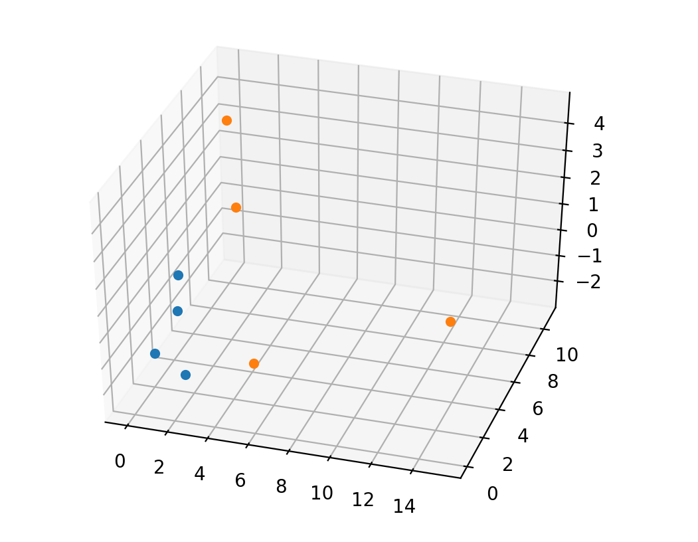Figure 3.2 plot of the subset of the 3-dimensional vector (blue: data for y=1, orange: data for y=-1)

Figure 3.3 plot of transformed data (blue: data for y=1, orange: data for y=-1)

## c)

The table below is the table outlining all updates of the weight vector with the iteration. Notice that the training process terminates after 72 iterations and the weight vector is

|  |  |  |  |  |
| --- | --- | --- | --- | --- |
| Iteration No. | w­０ | w１ | w２ | w３ |
| 0 | 1 | 1 | 1 | 1 |
| 1 | 1 | 1 | 1 | 1 |
| 2 | 0.8 | -2.042 | 0.968 | 0.558765 |
| 3 | 1 | -1.65 | 1.168 | 0.954745 |
| 4 | 0.8 | -1.652 | -1.01 | 1.048083 |
| 5 | 0.8 | -1.652 | -1.01 | 1.048083 |
| 6 | 0.8 | -1.652 | -1.01 | 1.048083 |
| 7 | 1 | -1.202 | -0.96 | 1.260215 |
| 8 | 1.2 | -0.914 | -0.51 | 0.751098 |
| 9 | 1.4 | -0.786 | -0.31 | 0.524824 |
| 10 | 1.4 | -0.786 | -0.31 | 0.524824 |
| 11 | 1.4 | -0.786 | -0.31 | 0.524824 |
| 12 | 1.4 | -0.786 | -0.31 | 0.524824 |
| 13 | 1.2 | -1.074 | -1.768 | -0.39159 |
| 14 | 1.2 | -1.074 | -1.768 | -0.39159 |
| 15 | 1.4 | -0.624 | -1.718 | -0.17945 |
| 16 | 1.6 | -0.336 | -1.268 | -0.68857 |
| 17 | 1.6 | -0.336 | -1.268 | -0.68857 |
| 18 | 1.6 | -0.336 | -1.268 | -0.68857 |
| 19 | 1.8 | 0.056 | -1.068 | -0.29259 |
| 20 | 1.8 | 0.056 | -1.068 | -0.29259 |
| 21 | 1.8 | 0.056 | -1.068 | -0.29259 |
| 22 | 1.6 | -1.1445 | -1.07 | -0.22329 |
| 23 | 1.8 | -0.6945 | -1.02 | -0.01116 |
| 24 | 2 | -0.4065 | -0.57 | -0.52028 |
| 25 | 2 | -0.4065 | -0.57 | -0.52028 |
| 26 | 2 | -0.4065 | -0.57 | -0.52028 |
| 27 | 2.2 | -0.0145 | -0.37 | -0.1243 |
| 28 | 2.2 | -0.0145 | -0.37 | -0.1243 |
| 29 | 2.2 | -0.0145 | -0.37 | -0.1243 |
| 30 | 2 | -1.215 | -0.372 | -0.055 |
| 31 | 2.2 | -0.765 | -0.322 | 0.157129 |
| 32 | 2.4 | -0.477 | 0.128 | -0.35199 |
| 33 | 2.4 | -0.477 | 0.128 | -0.35199 |
| 34 | 2.4 | -0.477 | 0.128 | -0.35199 |
| 35 | 2.4 | -0.477 | 0.128 | -0.35199 |
| 36 | 2.2 | -0.479 | -2.05 | -0.25865 |
| 37 | 2.2 | -0.479 | -2.05 | -0.25865 |
| 38 | 2.2 | -0.479 | -2.05 | -0.25865 |
| 39 | 2.2 | -0.479 | -2.05 | -0.25865 |
| 40 | 2.4 | -0.191 | -1.6 | -0.76777 |
| 41 | 2.4 | -0.191 | -1.6 | -0.76777 |
| 42 | 2.4 | -0.191 | -1.6 | -0.76777 |
| 43 | 2.6 | 0.201 | -1.4 | -0.37179 |
| 44 | 2.6 | 0.201 | -1.4 | -0.37179 |
| 45 | 2.6 | 0.201 | -1.4 | -0.37179 |
| 46 | 2.4 | -0.9995 | -1.402 | -0.30249 |
| 47 | 2.6 | -0.5495 | -1.352 | -0.09036 |
| 48 | 2.8 | -0.2615 | -0.902 | -0.59948 |
| 49 | 2.8 | -0.2615 | -0.902 | -0.59948 |
| 50 | 2.8 | -0.2615 | -0.902 | -0.59948 |
| 51 | 2.8 | -0.2615 | -0.902 | -0.59948 |
| 52 | 2.8 | -0.2615 | -0.902 | -0.59948 |
| 53 | 2.8 | -0.2615 | -0.902 | -0.59948 |
| 54 | 2.6 | -1.462 | -0.904 | -0.53018 |
| 55 | 2.8 | -1.012 | -0.854 | -0.31805 |
| 56 | 2.8 | -1.012 | -0.854 | -0.31805 |
| 57 | 2.8 | -1.012 | -0.854 | -0.31805 |
| 58 | 2.8 | -1.012 | -0.854 | -0.31805 |
| 59 | 3 | -0.62 | -0.654 | 0.077933 |
| 60 | 3 | -0.62 | -0.654 | 0.077933 |
| 61 | 3 | -0.62 | -0.654 | 0.077933 |
| 62 | 3 | -0.62 | -0.654 | 0.077933 |
| 63 | 3 | -0.62 | -0.654 | 0.077933 |
| 64 | 3 | -0.62 | -0.654 | 0.077933 |
| 65 | 3 | -0.62 | -0.654 | 0.077933 |
| 66 | 3 | -0.62 | -0.654 | 0.077933 |
| 67 | 3 | -0.62 | -0.654 | 0.077933 |
| 68 | 3 | -0.62 | -0.654 | 0.077933 |
| 69 | 3 | -0.62 | -0.654 | 0.077933 |
| 70 | 3 | -0.62 | -0.654 | 0.077933 |
| 71 | 3 | -0.62 | -0.654 | 0.077933 |
| 72 | 3 | -0.62 | -0.654 | 0.077933 |

Figure 3.4 table for all updates of weight vector

The following table demonstrates the correcteness:

|  |  |  |  |
| --- | --- | --- | --- |
|  |  |  | positiveness |
| (-0.8 1.) | (0.64 1. -1.13137085) | 1.86102915 | + |
| (3.9 0.4) | (15.21 0.16 2.20617316) | 6.362906843 | + |
| (1.4 1.) | (1.96 1. 1.97989899) | 1.285098987 | + |
| (0.1 -3.3) | (0.01 10.89 -0.46669048) | 4.164630476 | + |
| (1.2 2.7) | (1.44 7.29 4.58205194) | 2.303368058 | + |
| (-2.45 0.1) | (6.0025 0.01 -0.34648232) | 0.755092323 | + |
| (-1.5 -0.5) | (2.25 0.25 1.06066017) | 1.524160172 | + |
| (1.2 -1.5) | (1.44 2.25 -2.54558441) | 0.437315588 | + |

Figure 3.5 table for correctness

Screen shot for code is in next page.

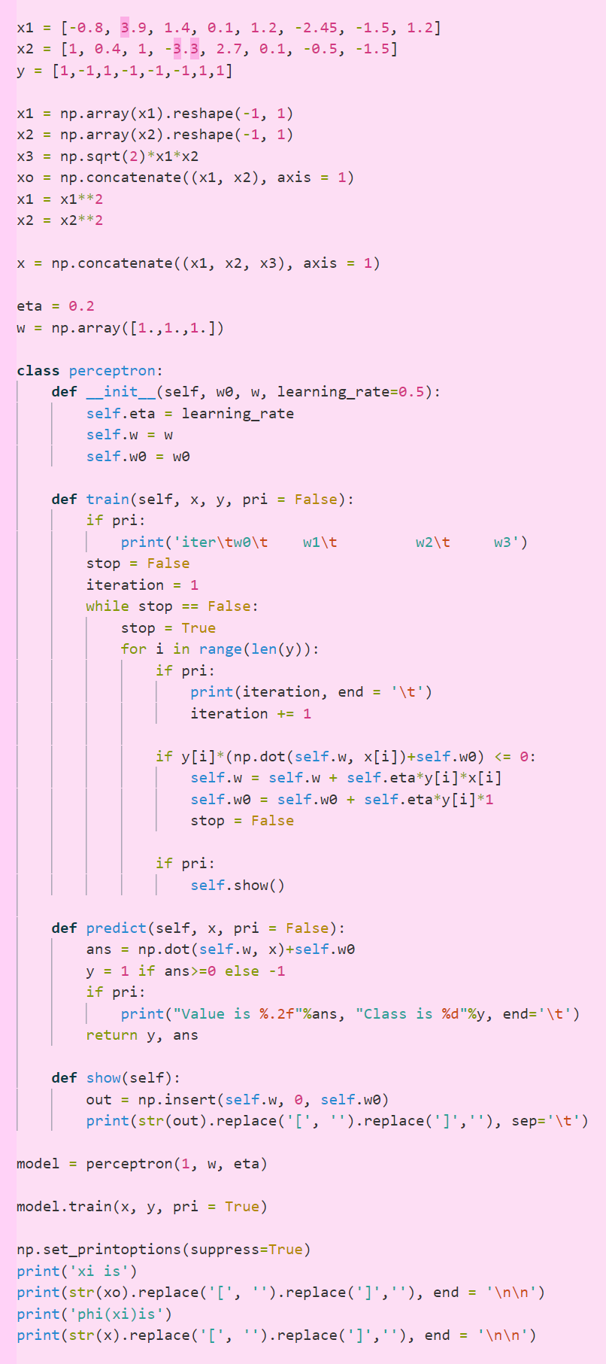

Figure3.6 Code for this question

## d)

From the question, we have:

Therefore,

## e)

The claim is true.

Because the input vectors for positive class and negative class are symmetric along a straight line and there are four points for each class.

From the symmetrical characteristic, we can state that when the model correctly classify data point for the positive class, it means that it can correctly classify data for the negative model. For example, is classified as positive which means that

Then we have

which means that when , we have .

Thus, if is classified as positive, must be classified as negative by the same model.

From the algorithm we can know that after a mistake, the weight would be adjusted and the model would be correctly classified then. And, when a data point is correctly classified, no change would be made.

Therefore, after 4 mistakes, the remaining data would not make mistakes anymore.