For part 1, linear model, 2-layer fully connected model and convolutional network are trained on the same dataset KMNIST to classify 10 kuzushiji characters. Obviously, the performance of convolutional network is better than others while the simplest linear model has the lowest accuracy. Here are the confusion matrices of these three models successively:

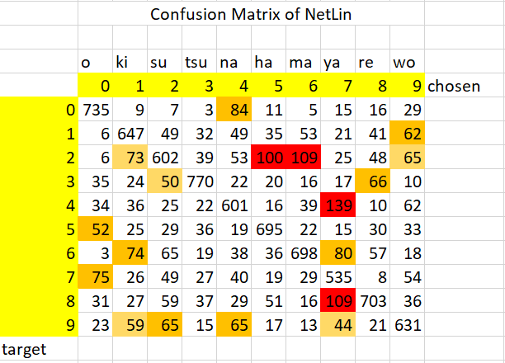

Test set: Average loss: 3.1118, Accuracy: 6617/10000 (66%)

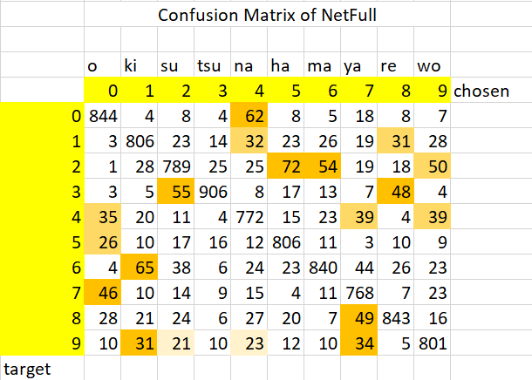

Test set: Average loss: 2.5810, Accuracy: 8175/10000 (82%)

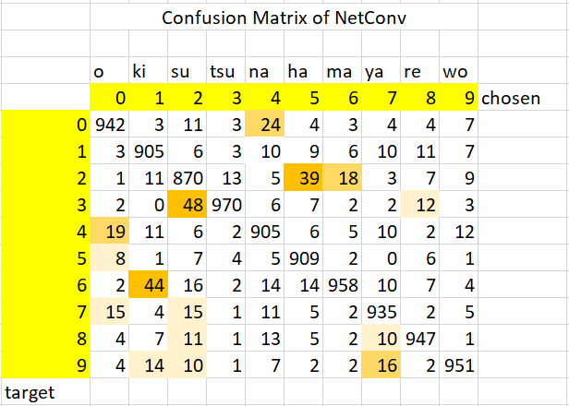

Test set: Average loss: 2,2441, Accuracy: 9292/10000 (93%)

The highlighted cells stand for the characters which are more likely to be mistaken, the deeper the colour, the higher the probability.

There are several characters that are likely to be misclassified by all three models, which are listed below in the (target, output) form:

(0, 4), (2,5), (2, 6), (3, 2), (4, 0), (5, 0), (6, 1), (7, 1), (8, 7), (9, 1), (9, 2), (9, 7)

After careful investigation, the reason for the higher error rate is found: firstly, two characters may have similar structure, secondly, they may contain same subparts.

For example, お is most likely to be misclassified as な, it is obvious that they both have a cross, a dash and an ellipse in the lower right corner. Similar structure and identical subparts are the main reasons of mistake especially when they are written in cursive style.

Another example for structure is れ and や, basically they don’t share any subparts in common, but the error rate for them is substantially high in the first two models. The reason is clear: NetLin and NetFull mainly look at structures as the layers are simpler, but convolution network may look at relatively complex patterns of subparts. These two characters both concentrate on top left corner and extend the stroke to right. When NetConv finds that the character doesn’t hold certain subparts, even its structure strongly suggest that it is some other character, the network still refuses that proposal. Thus, the likelihood of NetFull recognizing れ as やis not significant.

All the pairs listed above follow the same rule, even a convolution network considers structure and subparts at the same time, wrong classifications still exist because the dataset is extracted from cursive human written samples which is not that standard as expected.

Also, a lot of experiments were made on the models, especially on CNN models. Number of filters, size of filter, stride size, paddings, dropouts, maxpool and nodes for fully connected layer are tested. The result was surprising but reasonable: firstly, size of layers or number of nodes and accuracy is not positively correlated, secondly, there is no negative correlation between speed and performance, finally, simplification (maxpool, dropout) does not always lead to worse result.

At first, several tests were performed to derive the number of nodes in the hidden of NetFull to achieve a local minimum for error rate. The relation between number of nodes and error rate looks like a tick, in which there is a local minimum. For this dataset, the pseudo optimum hidden size is 110.