**GMAT9600 Principles of Remote Sensing**

**Lab Demonstration:**

**Differential Radar Interferometry (DInSAR)**

DISCLAIMER

Satellite imagery and software tools provided for this assignment are for teaching GMAT9600 ONLY and hence should not be used for any other purpose. Students should delete the satellite imagery from their storage as soon as the assignment is submitted.

**Group Arrangement:**

The Computer Lab in the Civil Engineering Building Lab 201 and 611 will be used for the assignment. There will be enough computers in the lab for every student. Each student will be allocated with one computer. It is important that each student has to complete the assignment by himself/herself.

**Rules for submitting the Lab Reports and Assignments**

1. The lab reports and assignments need to be submitted by email. (For the student in GMAT9600, email to GMAT9600@geos.org.au)
2. Only one file per assignment in Word format.
3. Name your file as "StudentID-YourLastName-CoureID-*labdemo*.doc". (For example: *z3012345-Charlton-GMAT9600-labdemo.doc*).
4. Your email must have your name, student ID and the assignment name in the subject.
5. Do NOT send multiple submissions for the same assignment. If you have to re-submit, you need to request permission from the course convenor.
6. ***NOTE:******Failing to submit the file with correct format and/or naming convention will result in deduction of 1 mark.***

A. The following figure is the SAR intensity of the master image in this lab. Please specify the along track (azimuth) direction and the range direction and discuss the reason (4 marks). *Hint: This image is in slant-range (radar) coordinate where the upper left corner is the origin (0,0).*

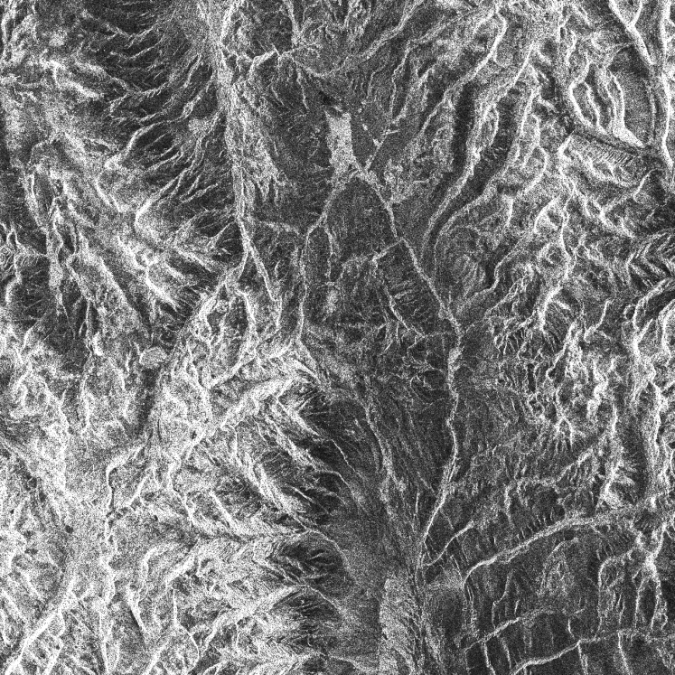

The along track direction is vertically downwards. And the range direction is right.

The along track (azimuth) direction is the flight direction[1]. The flight direction is vertical in the SAR image. The range direction is the look direction (imaging direction) which is perpendicular to the azimuth direction[2]. Because the origin is in the upper left corner, the along tract direction is then downwards. Thus, the range direction is rightward.

This can be confirmed by the colour of the image, where the right part is in shadow due to geometric distortion.

B. During the exercise, three types of products are generated: raw interferogram, flattened interferogram and differential interferogram. Please paste the corresponding image exported from the PhaseViewer in the table below (3 marks).

|  |  |
| --- | --- |
| Raw Interferogram |  |
| Flattened Interferogram |  |
| Differential Interferogram |  |

C. In this lab demo, the simulated topographic phase was obtained using SRTM DEM. The resolution of the SRTM is approximately 90 metres. The PALSAR images used in this lab were acquired in Fine Beam Single polarisation (FBS) mode. In general, the resolution of a FBS PALSAR is around 10 metres. Observe the differential interferogram carefully. Apart from the phase components due to de-correlation, atmospheric disturbances and orbital error, is there any other phase component which may contaminate the DInSAR measurement? Is it possible to further improve the DInSAR result, and if so, how? (3 marks)

Phase component that may contaminate DInSAR measurement:

* Change in climate condition including weather, temperature, humidity and air density.
* Geometrical distortions such as Variation and displacement in terrain relief[3].
* Disturbance of surface plants.
* The quality of Topographic phase may affect the result[4].
* Signal noise may interfere the transmission of radar signal and other transmission loss.

It is possible to improve the result by:

* Increasing the resolution of both topographic phase DEM and PALSAR images.
* Using multiple captures to generate the result.
* Picking an appropriate timestamp with stable atmospheric and climate condition.

**End of lab exercise.**

1. https://topex.ucsd.edu/rs/sar_summary.pdf
2. https://earth.esa.int/eogateway/missions/ers/radar-courses/radar-course-3
3. https://moodle.telt.unsw.edu.au/pluginfile.php/8420277/mod_resource/content/1/RS%20fundamentals_e_CCRS.pdf
4. Analysis of the Effect of Different Resolution DEM on InSAR