# GMAT9600 Assignment – Radar Application

# Flood Mapping with Aerial and Satellite Images

DISCLAIMER

Satellite imagery provided for this assignment is for teaching GMAT9600 ONLY and hence should not be used for any other purpose. Students should delete the satellite imagery from their storage as soon as the assignment is submitted.

**Rules for submitting the Lab Reports and Assignments**

* The lab reports and assignments need to be submitted by email. (For the student in GMAT9600, email to GMAT9600@geos.org.au)
* Only one file per assignment in Word format.
* Name your file as "StudentID-YourLastName-CoureID-assignment2.doc". (For example: *z3012345-Charlton-GMAT9600-assignment2.doc*).
* Your email must have your name, student ID and the assignment name in the subject.
* Do NOT send multiple submissions for the same assignment. If you have to re-submit, you need to request permission from the course convenor.
* ***NOTE:******Failing to submit the file with correct format and/or naming convention will result in deduction of 1 mark.***

# 1. Objective:

This hands-on exercise utilises very high resolution aerial and satellite images in order to identify the flood water extent. In contrast to optical remote sensing imagery, synthetic aperture radar (SAR) is capable of both observing the ground surface day and night, and penetrating through clouds, haze and smoke.

This exercise aims to produce a map showing the flooded region using aerial optical images as well as space-borne SAR intensity and coherence images with the aid of a Geographic Information System (GIS) software.

# 2. Flood event:

On Monday 4 January 2010, Bourke in NSW was declared a natural disaster area due to major floods. In May 2010, St George in Queensland, a rural town of about 2700 people, experienced its worst flood in 120 years. About 500 homes were flood affected. Other regions near the Queensland–New South Wales border, including New Angledool, were also affected by flood. The test site for this exercise is New Angledool, NSW, Australia.

# 3. Data sets:

SAR:

* COSMO-SkyMed intensity images acquired on 19 and 20 March 2010.
* COSMO-SkyMed coherence image generated using the two COSMO-SkyMed images acquired on the above two days.

Optical:

* ADS40 truce colour (ADS40 is a high resolution digital aerial camera of the NSW Land and Property Information (LPI))
* ADS40 colour infrared

Other spatial data: NSW State Emergency Service (SES) flood extend map based on helicopter GPS survey

# 4. Software:

ESRI AcrGIS

# 5. Step-by-step instructions:

1. Start the ArcGIS software.

* Start >> All Programs >> ArcGIS >> ArcMap10.
* Click the ArcMap10.

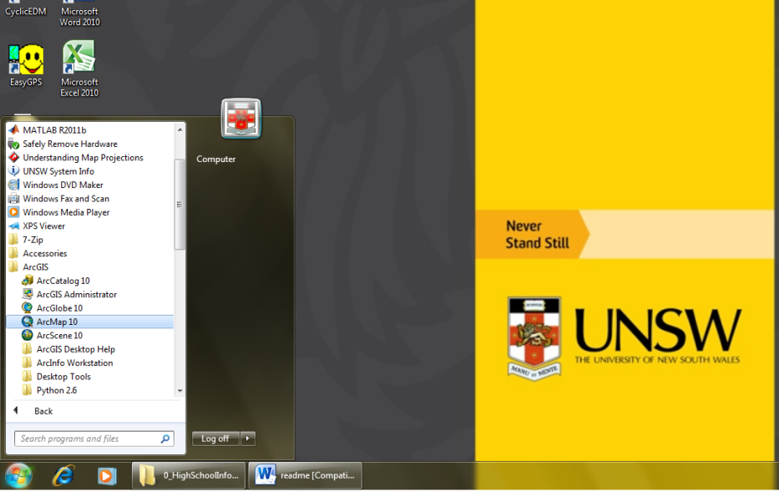

1. **Cancel** the Getting started window

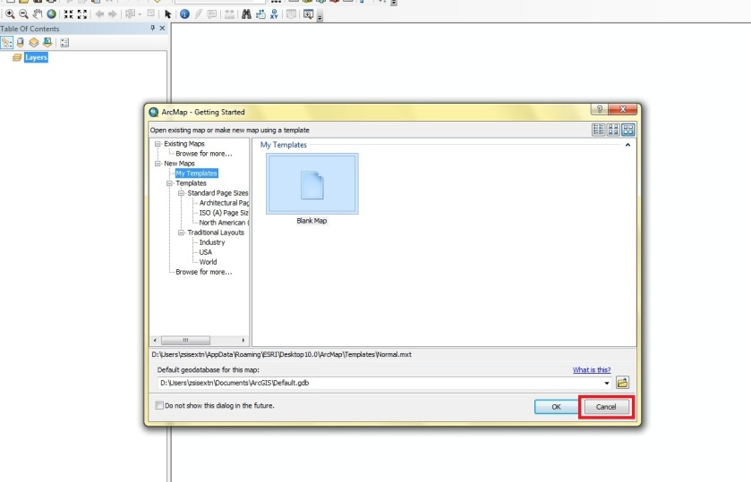

1. After ArcMap is open, the main window should contain at least the **Layers** of the *Data Frame* on the left and the *Data View* on the right.
2. Description: icon_add Add the data

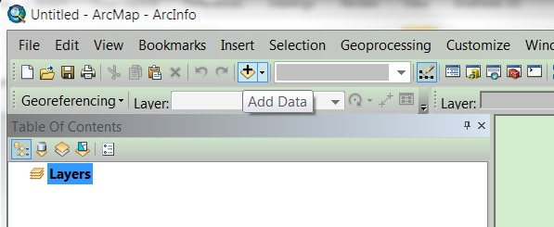

* Click the Connect to Folder 

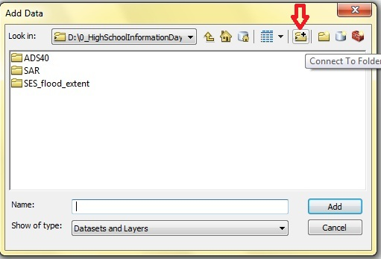

* Find the Data (D: \Lab2\) under Computer.

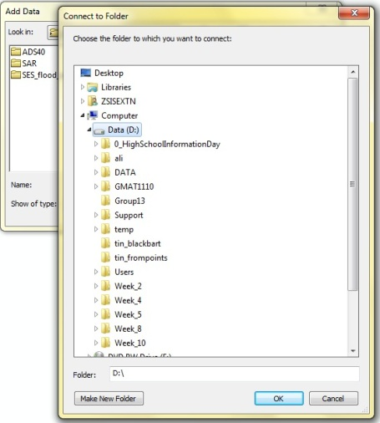

1. Add SAR intensity files “CSK\_intensity\_20110319.img” and “CSK\_intensity\_20110320.img” from Connet to Folder “D:\Lab2\”. Click **NO** to continue if a window about Pyramid building appears.
2. In this exercise, it is assumed that both low and high values in the intensity images are the flooded areas. Therefore, the classification process can be carried out in order to map the flood extent based on the pixels’ value of the intensity images. Double click on the layer “CSK\_intensity\_20110319.img” to bring up the ***Layer Properties***. Click the tab, ***Symbology***, and choose ***Classified***. Selected “3” for the number of ***Classes*** at the right hand side of the window. Click ***Classify*** next to the number of ***Classes***.

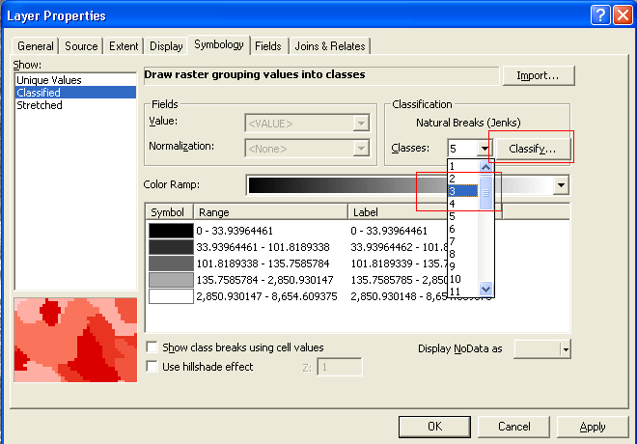

To change the threshold values for the colour ramp, modify the values under the “**Break Values**”. Since the SAR images used in this study are not calibrated, the threshold values are image dependent. The values **80** and **180** are the suitable threshold values (lower and upper thresholds) to start with. Click OK after the threshold values are inserted.

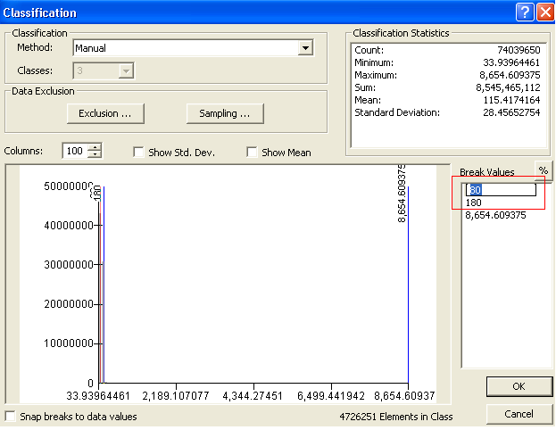

**Double click** the colour maps under the “**Symbol**” and choose a reasonable colour (e.g. blue) for the first and last colour maps. Select “*No colour*” for the centre colour map. Repeat the same process for the layer “CSK\_intensity\_20110320.img”.

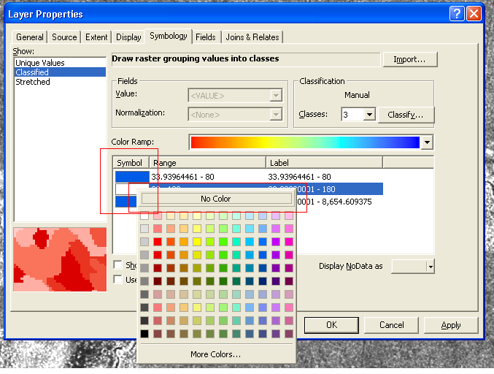

1. icon_add add SAR coherence file “CSK\_coherence\_20110319\_20110320.img” from Connet to Folder “D:\Lab2\”. Click **NO** to continue if a window about Pyramid building appears.
2. Repeat Steps for the layer “CSK\_coherence\_20110319\_20110320.img”. For the case of coherence image, it is assumed that the pixels with low coherence values are the flooded area. Therefore use only **2** colour maps this time. **0.3** is the suitable threshold value to start with.

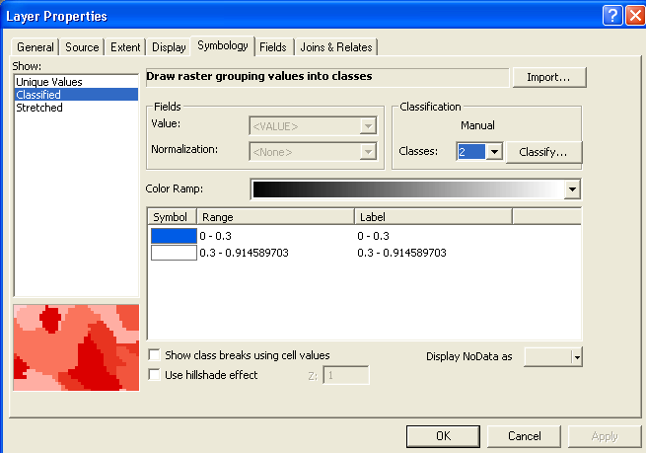

1. In Spatial Analyst tool bar, open Raster Calculator

“**Spatial Analyst Tools**” >> “**Map Algebra”** >> “**Raster Calculator**”

Or if ArcToolbox is not shown, click the “ArcToolbox icon” on top tab

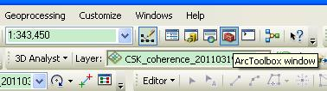

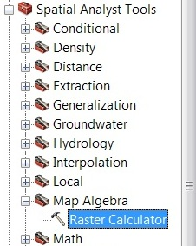

1. Calculate the intensity difference between the SAR images acquired on 19 March 2011 and 20 March 2011 by using the expression:

*[after\_before] = [CSK\_intensity\_20110320.img]-[ CSK\_intensity\_20110319.img]*

The calculated result, “after\_before”, will be added to the ***Layer*** list. Change the symbology and colour ramp (same step as above) for the intensity difference image.

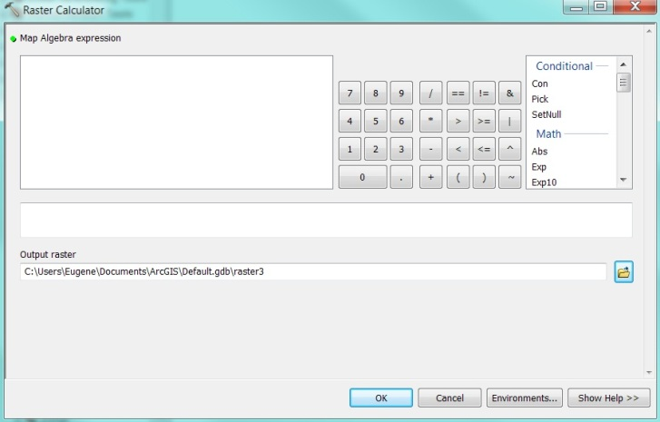

1. icon_add add the ADS40 images, namely,

the true colour image “NewAngledoolFlood\_2010\_03\_20cm.ecw” and

the colour infrared image “NewAngledoolFlood\_2010\_03\_20cm\_cir.ecw” from “D:\Lab2\**ADS40**\”. Please note that the ADS40 images are initially in a different projection, hence a warning message will appear. Just click **Close** to continue. Right click on the ADS40 images layer, “NewAngledoolFlood\_2010\_03\_20cm.ecw” and choose ***Zoom to Layer***.

1. icon_add add the SES flood extent map, “NarranFloodExtent\_20100321.shp” from “D:\Lab2\ SES\_flood\_extent”. Please note that the SES flood extent shapefile is initially in a different projection, hence a warning message will appear. Just click **Close** to continue.
2. Export flood maps to Google Earth, “**ArcToolbox**” >> “**Conversion** **Tools**” >> “**To KML**” >> Double click “**Layer To KML**”

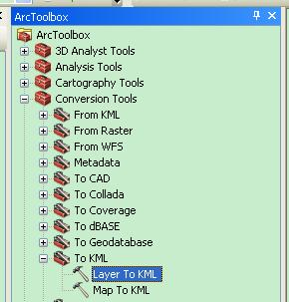

Layer: Select layers by clicking the “▼” icon

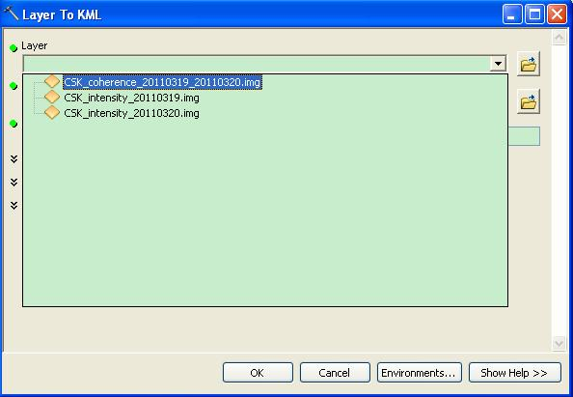

Output file:

* Click the folder icon 
* Find the same directory folder by clicking the “▼” icon
* Tipping file name

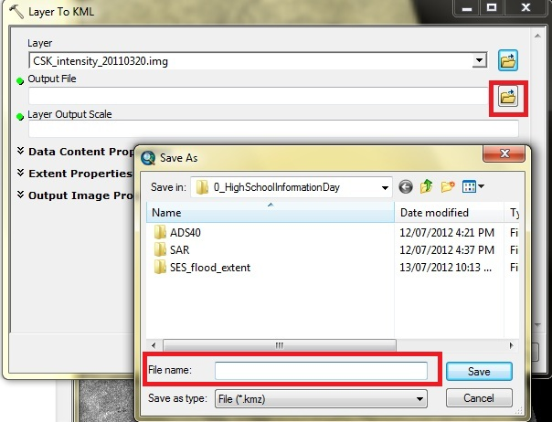

Layer Output Scale: 100,000

Output Image Properties

» Size of returned image: 8000

» DPI of output image: 300

Ok

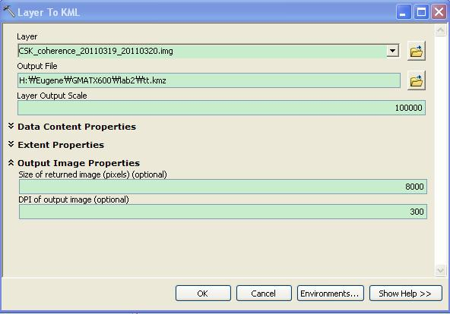

1. Go to the saved directory and double click “.kmz” file. You will see something similar to the following.

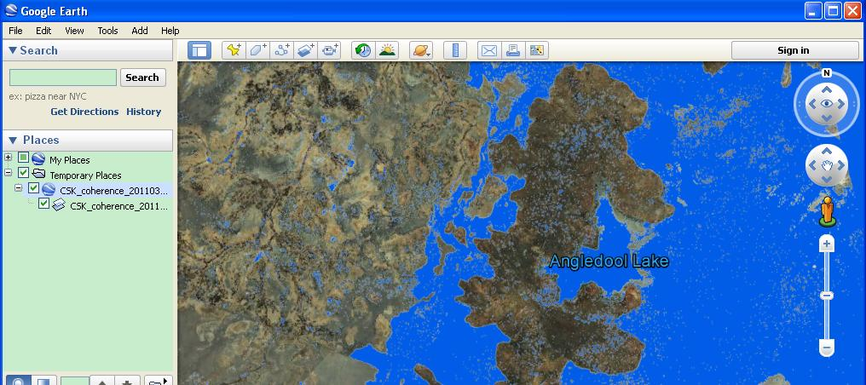

A. How can you identify the flood water extent from SAR intensity/ coherence images? What is the principle of the methods? [/4 marks]

*Method and principle to identify SAR intensity [/2 marks]*

*Method and principle to identify SAR coherence [/2 marks]*

B. Produce SAR intensity images and SAR intensity difference image. Compare the SAR intensity images and the SAR intensity difference image. What do the negative intensity difference and positive intensity difference represent? [Please include the SAR intensity difference image to answer this question] [/6 marks]

*Discuss about positive and negative intensity difference [/2 marks]*

*Include SAR intensity images [/2 marks]*

*Include SAR intensity difference image [/2 marks]*

C. Compare the SAR intensity analysis and SAR coherence analysis. Discuss the pros and cons of these methods in a table. [/6 marks]

*A table including:*

*Pros and Cons for SAR intensity analysis [/2 marks]*

*Pros and Cons for SAR coherence analysis [/2 marks]*

*With images to back up the answers [/2 marks]*

D. Compare the SAR images and optical images. What are the radar intensity and coherence values for the pixels over different surfaces, such as still water, flooded forest, bare soil, farm land, forest and buildings? Are these values reasonable? [Hint: Utilise the optical images] [/6 marks]

*Still water [/1 marks]*

*Flooded forest [/1 marks]*

*Bare soil [/1 marks]*

*Farm land [/1 marks]*

*Non-flooded Forest [/1 marks]*

*Buildings [/1 marks]*

E. Try different threshold values for mapping flood water extent from the SAR intensity and coherence images [i.e. m*odify the value in the colour table*]. What are the best threshold values for the generation of water extent map from the SAR intensity and coherence images? [Please include water extent maps generated from the SAR intensity/coherence images to answer this question] [/6 marks]

*Reasonable threshold values for SAR intensity image 1 and water extent map [/2 marks]*

*Reasonable threshold values for SAR intensity image 2 and water extent map [/2 marks]*

*Reasonable threshold values for SAR coherence image and water extent map [/2 marks]*

G. Compare the SAR images, the optical images and the flood extent map from SES (State Emergency Service). Discuss the pros and cons of these methods with illustrations. [/6 marks]

*Discuss about the accessibility [/1 marks]*

*Discuss about the cost [/1 marks]*

*Discuss about the spatial extent [/1 marks]*

*Discuss about the temporal extent [/1 marks]*

*Discuss about the resolution [/1 marks]*

*Discuss about the accuracy [/1 marks]*

**End of lab exercise.**